Supporting Information

Cetuximab-Induced Changes to Tumor Oral Mucosa Models
Probed by Stimulated Raman Spectromicroscopy

Tamasri Senapati¹, Leonie Schwartze², Christian Zoschke^{2,3}*, Eckart Rühl¹*

¹ Physical Chemistry, Institute of Chemistry and Biochemistry, Freie Universität Berlin, Arnimallee 22, 14195 Berlin, Germany
² Institute of Pharmacy, Freie Universität Berlin, Königin-Luise-Str. 2+4, 14195, Berlin, Germany
³ Department of Veterinary Medicines, Federal Office of Consumer Protection and Food Safety, Gerichtstr. 49, 13347 Berlin, Germany

1. Determination of the cetuximab and protein concentration by using the Linear Decomposition Algorithm
Eq. (3) (see Section 2 (Materials and Methods, see main text) has been used for the decomposition of cellular components and cetuximab, where lipids (j = 1), cetuximab (j = 2), cellular proteins (j = 3), and DNA (j = 4) contribute to the following set of wavenumber values ${\tilde{ν}}_{i}$: ${\tilde{ν}}_{1}=2850 {cm}^{-1}, {\tilde{ν}}_{2}=2930 {cm}^{-1}, {\tilde{ν}}_{3}=2967 {cm}^{-1}, {\tilde{ν}}_{4}=3025 {cm}^{-1}$.
In this case by writing explicitly the 4-dimensional matrices of eq. (3) (Section 2, main text) one obtains,
$\left(\begin{aligned}S_{2850} \\ S_{2930} \\ S_{2967} \\ S_{3025}\end{aligned}\right)= \left(\begin{aligned}M_{Lipid}^{2850} \\ M_{Lipid}^{2930} \\ M_{Lipid}^{2967} \\ M_{Lipid}^{3025}\end{aligned} \begin{aligned}M_{Cetux}^{2850} \\ M_{Cetux}^{2930} \\ M_{Cetux}^{2967} \\ M_{Cetux}^{3025}\end{aligned} \begin{aligned}M_{Protein}^{2850} \\ M_{Protein}^{2930} \\ M_{Protein}^{2967} \\ M_{Protein}^{3025}\end{aligned} \begin{aligned}M_{DNA}^{2850} \\ M_{DNA}^{2930} \\ M_{DNA}^{2967} \\ M_{DNA}^{3025}\end{aligned}\right) \left(\begin{aligned}C_{Lipid} \\ C_{Cetux} \\ C_{Protein} \\ C_{DNA}\end{aligned}\right)$(S1)
After inserting the relative intensity values for the matrix elements, gained from Fig. S5, eq. (S1) yields the expansion coefficients $C_{j}$, which is shown in terms of an inverted matrix.
$\left(\begin{aligned}C_{Lipid} \\ C_{Cetux} \\ C_{Protein} \\ C_{DNA}\end{aligned}\right)= \left(\begin{aligned}0.21807 \\ 5.79207 \\ -7.29829 \\ -0.02286\end{aligned} \begin{aligned}0.90476 \\ -6.70194 \\ 7.54492 \\ -0.09483\end{aligned} \begin{aligned}0.17786 \\ 1.31748 \\ 0.22621 \\ 0.01864\end{aligned} \begin{aligned}-1.07493 \\ 7.96246 \\ -9.52088 \\ 2.94553\end{aligned}\right) {\left(\begin{aligned}S_{2850} \\ S_{2930} \\ S_{2967} \\ S_{3025}\end{aligned}\right)}/M$(S2)
After incorporating the SRS signals at four wavenumbers as S, the relative concentrations of cetuximab and cellular proteins in cells were derived and normalized using the normalization procedure $c_{j}={C_{j}}/{\sum_{j}^{4}{C_{j} }}$(Fig. S4).

2. Supporting Figures

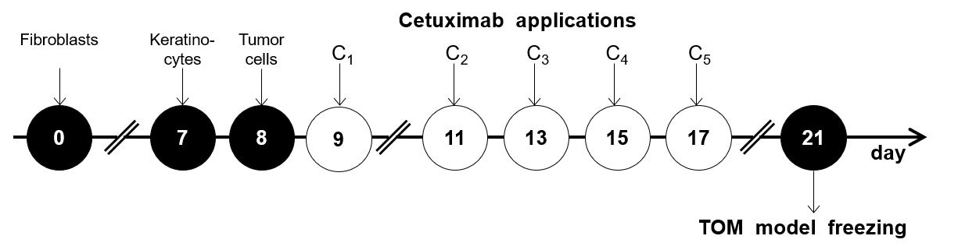
Fig. S1. Schematics of TOM model preparation and cetuximab application.

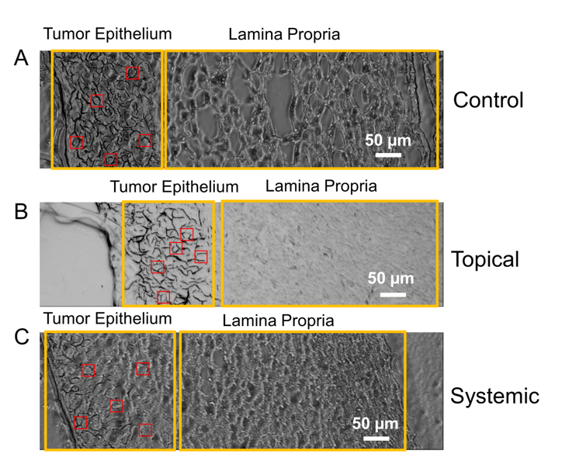

Fig. S2. Optical micrograph of the TOM model with the tumor epithelium (left yellow box) and the lamina propria (right yellow box). Investigated regions are marked by red squares; (A) vehicle control TOM model; (B) cetuximab applied to the TOM model surface (topical drug administration); (C) cetuximab administered to the TOM model nutrient mix below the tissue, for experimental details see Section 2 of the main text; scale bar: 50 µm.

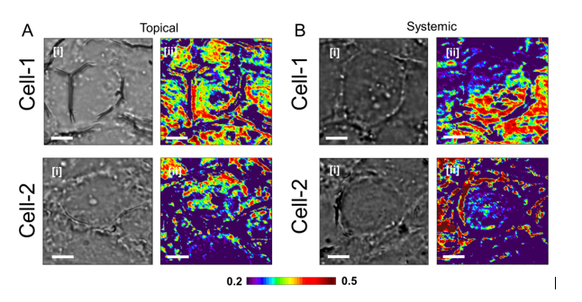

Fig. S3. Cetuximab distribution in TOM models. (A) Cetuximab distribution in topically treated cells; (B) cetuximab distribution in systemically treated cells. For each sample (i) the optical micrographs of cell-1 and cell-2 and (ii) the relative cetuximab concentration maps of these cells are shown; scale bar: 5 µm.
.

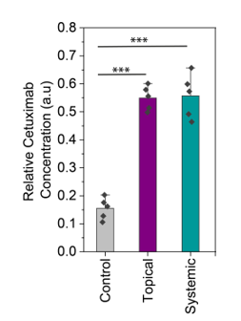

Fig. S4. Relative cetuximab concentration in TOM models. The data are representative for five locations in the TOM model as compared to the vehicle control.

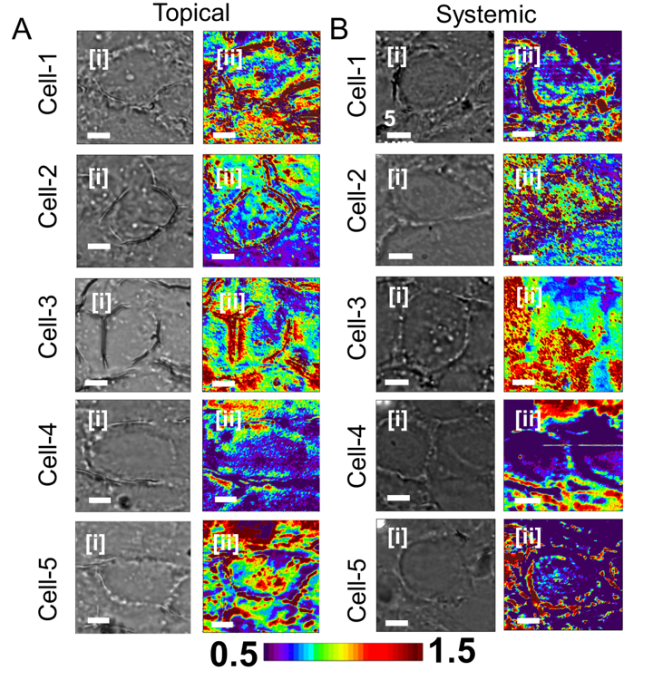

Fig. S5. Cetuximab to cellular protein contrast profiles. (A) cetuximab to cellular protein contrast profiles in topically treated cells; (B) cetuximab to cellular protein contrast profile in systemically treated cells. For each sample (i) the optical micrographs and (ii) the relative cetuximab to cellular protein concentration ratio of the respective cells are shown; scale bar: 5 µm.

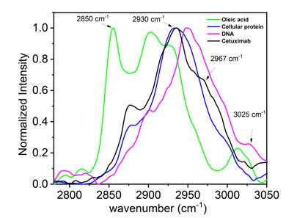

Fig. S6. Spontaneous Raman spectra of DNA (magenta), lipids (green), cellular proteins (blue), and cetuximab (black). Black arrows represent the wavenumbers used in the above-mentioned four-dimensional matrix (cf. eq. (S1)).

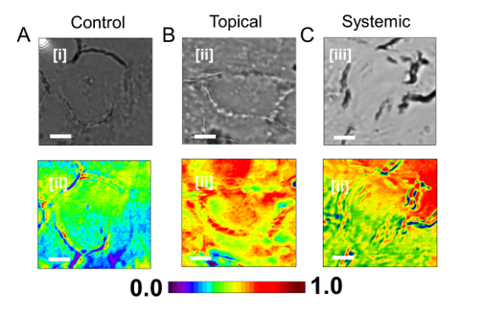

Fig. S7. Protein concentration in cells. (A) vehicle control TOM model; (B) topically treated TOM model; (C) systemically treated TOM model; For each sample the (i) the optical micrographs and (ii) the protein concentration maps of these cells are shown; scale bar: 5 µm.

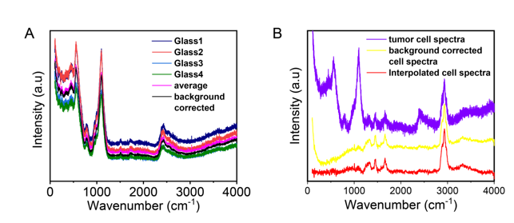

Fig. S8. Spontaneous Raman spectra. (A) glass carrier (Glass1-Glass4) – four Raman spectra of borosilicate glass taken at different locations of the sample; (B) tumor cell; the spectra comprise the average of 55 data sets.

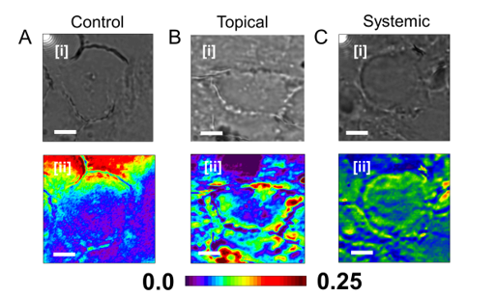

Fig. S9. Lipid concentration in cells. (A) vehicle control TOM model; (B) topically treated TOM model; (C) systemically treated TOM model; For each sample the (i) the optical micrographs and (ii) the lipid concentration maps of these cells are shown; scale bar: 5 µm.

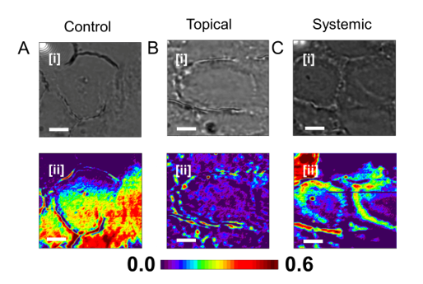

Fig. S10. DNA concentration in cells. (A) vehicle control TOM model; (B) topically treated TOM model; (C) systemically treated TOM model; For each sample the (i) the optical micrographs and (ii) the DNA concentration maps of these cells are shown; scale bar: 5 µm.

