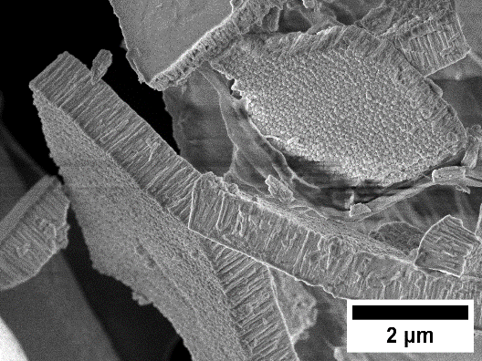 | 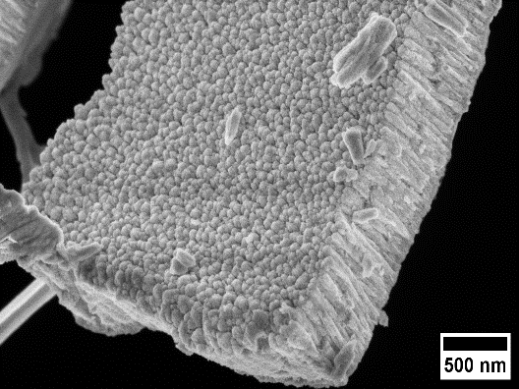
Fig. S1. High-resolution SEM image of $YHO$ sample produced by magnetron sputtering, in powder. Columnar growth of the thin film is visible in the both (right and left) images.

