Suppression of steel corrosion via some gemini cationic surfactant-based Schiff base: Experimental and theoretical investigations
Samy M. Shaban^{1,2}*, S. H. Shafek¹, A. H. Elged¹, Mahmoud Bekhit¹, Ahmed I. Adawy¹, Emad A. Badr¹
¹ Surfactant Laboratory, Petrochemical Department, Egyptian Petroleum Research Institute, Egypt.
² School of Chemical Engineering, Sungkyunkwan University (SKKU), Republic of Korea, Suwon 16419.
Corresponding Author: Samy M. Shaban (dr.samyshaban@yahoo.com)

  - Preparation of cationic inhibitor
Three Gemini surfactants with different hydrophobic tail were synthesized via two simple steps outlined in Scheme S1. Stoichiometric amounts of 1,2-(dimethylamino)ethylamine (100 mM, 8.8 g) and p-dimethylaminobenzaldehyde (100 mM, 14.9 g) were dissolved in 120 mL of absolute ethanol. The reaction mixture was refluxed for 6 h to afford the corresponding Schiff base. The structure of the product was confirmed by Fourier transform infrared (FTIR) and ¹HNMR (Fig. S1 and S2, respectively). The second step involved quaternization of the prepared Schiff base with three different alkyl bromides. Briefly, 10 mM (2.19 g) of the Schiff base was refluxed with 20 mM of decyl bromide (4.4 g), dodecyl bromide (4.68 g), or hexadecyl bromide (6.08 g) for 36 h in 100 mL of ethanol. The progress of the reaction was monitored by thin-layer chromatography and FTIR. Subsequently, the reaction mixture was dried in an oven until obtaining constant weight. The crude product was recrystallized with diethyl ether to afford three Schiff base-based cationic Gemini surfactants, which were denoted as GSBI8, GSBI12, and GSBI16 (Scheme S1).

Fig. S1 illustrates the FTIR spectrum of prepared Schiff base. The small band at 3034 cm⁻¹ corresponded to the C–H bond of the benzene ring, while the bands at 2929 and 2857 cm⁻¹ were ascribed to the symmetric and asymmetric stretching of the C–H bonds in the methylene groups. The band at 1646 cm⁻¹ corresponded to the C=N group, whereas the bands at 1579 and 1518 cm⁻¹ were ascribed to the stretching of the C=C–C.

Fig. S2, illustrate ¹HNMR analysis of the synthesized Schiff base, showing the following signals: δ (ppm) 2.88 (d, 2H, (CH₃)₂N–CH₂–CH₂–N=CH–Ph–N–(CH₃)₂), δ 2.99 (m, 6H, (CH₃)₂N–(CH₂)₂–N=CH–Ph–N–(CH₃)₂), δ 3.29 (m, 6H, (CH₃)₂N–(CH₂)₂–N=CH–Ph–N–(CH₃)₂), δ 3.39 (b, 2H, (CH₃)₂N–CH₂–CH₂–N=CH–Ph–N–(CH₃)₂), δ 6.7 (d, 2H, meta-aromatic protons), δ 7.4 (d, 2H, ortho-aromatic protons), and δ 8.54 (s, 1H, –N=CH–Ph).

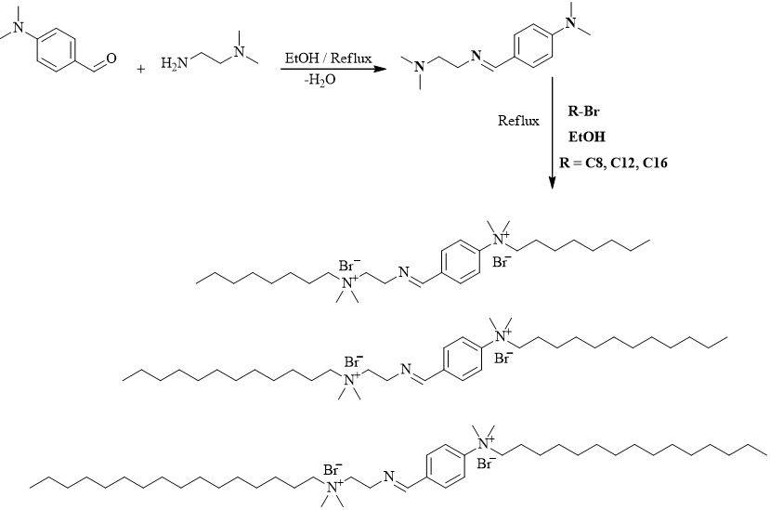
Scheme (S1): Synthesis of Schiff base-based cationic Gemini surfactants GSBI8, GSBI12, and GSBI16.

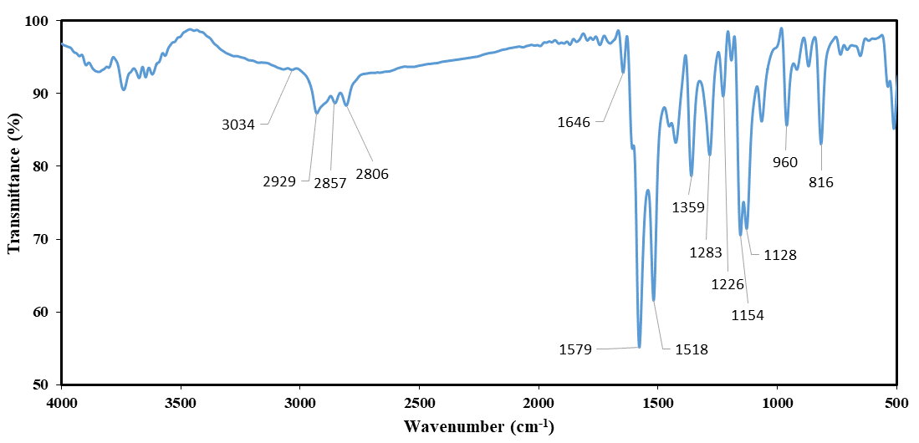 Fig. S1: FTIR spectrum of the synthesized Schiff base.
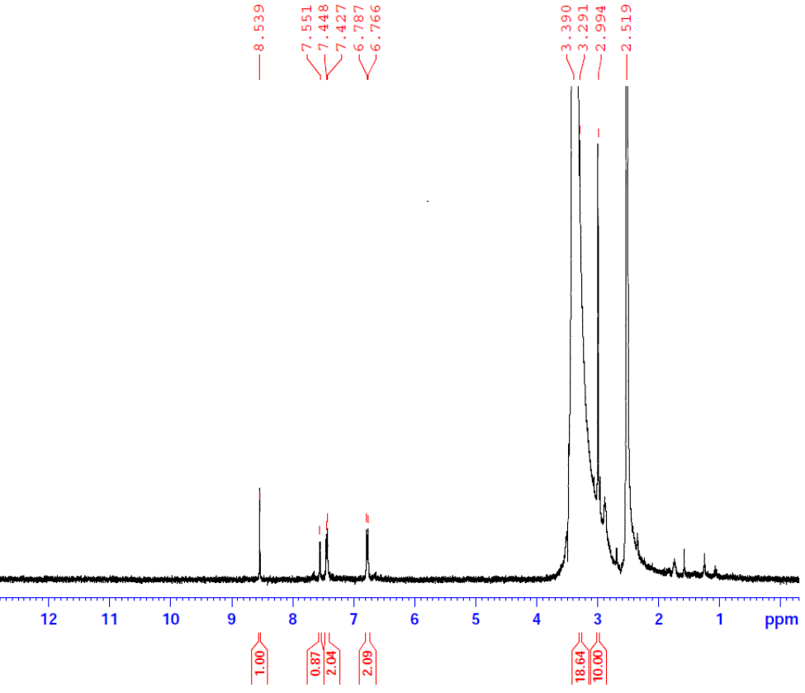
Fig. S2: ¹H NMR spectrum of the synthesized Schiff base.

Fig. S3 illustrates the FTIR spectra of the synthesized Gemini cationic surfactants GSBI8, GSBI8, and GSBI8. The band detected at approximately 1658 cm⁻¹ corresponded to the azomethine group. Moreover, the bands at 2920 and 2820 cm⁻¹ were ascribed to the asymmetric and symmetric vibrational stretching of the aliphatic CH group, respectively. Notably, these bands exhibited higher intensity than the corresponding peaks in the spectra of the Schiff base compounds (Fig. S1). This was attributed to the change in the hydrophobic chain length. The broad band at 3419 cm⁻¹ in the spectra of GSBI8, GSBI8, and GSBI8 corresponded to the vibration of H₂O molecules, which were present due to the hydrophilic nature of the quaternary ammonium salts [1-3].
Fig. S4 illustrates the ¹H NMR spectrum of GSBI16. The NMR data confirmed the structure of the Gemini surfactant. The following signals were detected: δ (ppm) 0.85 (t, 6H, 2 × CH₃), δ 1.25 (m, 52H, 2 × (CH₃)₂⁺NCH₂CH₂(CH₂)₁₃CH₃), δ 1.66 (t, 4H, 2 × (CH₃)₂⁺NCH₂CH₂(CH₂)₁₃CH₃), δ 1.97 (m, 4H, −2 (CH₃)₂⁺NCH₂CH₂ (CH₂)₁₃CH₃), δ 2.88 (d, 2H, CH₃(CH₂)₁₃CH₂CH₂(CH₃)₂N⁺CH₂CH₂N=), δ 3.03 (t, 4H, 2CH₃(CH₂)₁₃CH₂CH₂(CH₃)₂N⁺CH₂CH₂N=), δ 3.29–3.48 (m, 12H, –(CH₃)₂N⁺CH₂CH₂N=CH–Ph–⁺N(CH₃)₂), δ 6.8 (d, 2H, meta-aromatic protons), and δ 7.7 (d, 2H, ortho-aromatic protons), δ 9.68 (s, 1H, –N=CH–Ph–).
Fig. S3: FTIR spectrum of the synthesized gemini inhibitors.

Fig. S4: ¹H NMR spectrum of the synthesized GSBI16 inhibitor.

  - Surface examination of steel
The steel surface before and after treatment with the synthesized zwitterionic surfactants-based Schiff base were conducted via X-ray photoelectron spectroscopy (XPS), scanning electron microscope (SEM), and atomic force microscope (AFM). The mild steel specimens with surface area of 1 cm² were analyzed after immersion in 1M HCl with and without addition of 1000 μM ppm of the GSBO, GSBD, and GSBH inhibitors individually for 24 h at 25 °C. They were taken out from the solution, rinsed with acetone and dried. The surface analysis of the specimens was carried out using AFM. The XPS spectra were recorded with K-ALPHA (Themo Fisher Scientific, USA) with monochromatic X-ray Al K-alpha radiation -10 to 1350 eV spot size 400 micro at pressure 10⁻⁹ mbar with full spectrum pass energy 200 eV and at narrow spectrum 50 eV.

Fig. S5: Relationship between Ln K/T and the reciprocal of the temperature of different concentrations from the inhibitors (a) GSBI8, (b) GSBI12 and (c) GSBI16.

Fig. S6: AFM of the steel surface after immersing in 1000 M of the synthesized gemini cationic inhibitors based on Schiff base GSBI8, GSBI12, and GSBI16.

References

1. Anastassopoulou, J.D., Mass and FT-IR Spectra of Quaternary Ammonium Surfactants, in Chemistry and Properties of Biomolecular Systems, E. Rizzarelli and T. Theophanides, Editors. 1991, Springer Netherlands: Dordrecht. p. 1-9.
2. Mehta, S.K., et al., Nanoscale Research Letters, 2009. 4(10): p. 1197.
3. Cross, J. and E.J. Singer, Cationic Surfactants: Analytical and Biological Evaluation. 2019: CRC Press.

