**Supplementary/Supporting Figures (Not for the Main body of Manuscript)**

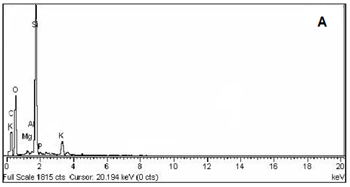

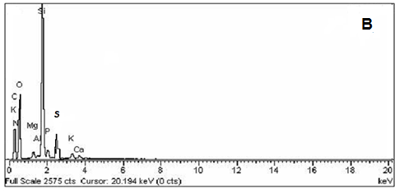

**Fig. S1.** Energy Dispersive X-Ray of: (A) KMRHC, (B)TY Dye Loaded KMRHC.

**Fig. S2.** Effect of initial dye concentration on the adsorption capacity of DB and TY dyes on KMRHC-adsorbent from aqueous media. Experimental conditions: contact time = 40 min, T = 303K, Adsorbent concentration = 2.5g/L, pH = 7.

**Fig.S3.** Effect of initial dye concentration on the %adsorption of DB and TY dyes on KMRHC-adsorbents from aqueous media. Experimental conditions: contact time = 40 min, T = 303K, Adsorbent concentration = 2.5g/L, pH = 7.

**Fig. S4.** Effect of contact time on the adsorption capacity (mg/g) of DB and TY dyes on KMRHC-adsorbent form aqueous media. Experimental conditions: Adsorbent concentration = 2.5g/L, T = 303K, Initial dye concentration = 80mg/L, pH = 7.

**Fig. S5.** Effect of contact time on the %adsorption of DB and TY dyes on KMRHC-adsorbents form aqueous media. Experimental conditions: Adsorbent concentration = 2.5g/L, T = 303K, Initial dye concentration = 80mg/L, pH = 7.

**Fig. S6.** Effect of pH on the adsorption capacity of DB and TY dyes on KMRHC-adsorbent from aqueous media. Experimental conditions: contact time = 40 min, T = 303K, Adsorbent concentration = 2.5g/L, C0 = 80 mg/L.

**Fig. S7.** Effect of pH on the %adsorption of DB, and TY dyes on KMRHC-adsorbents from aqueous solution. Experimental condition: contact time = 40 min, T = 303K, Adsorbent concentration = 2.5g/L, C0=80 mg/L.

**Fig. S8.** Effect of temperature on the adsorption capacity of DB and TY dyes on KMRHC-adsorbent. Experimental conditions: pH=7, contact time = 40 min, Adsorbent dose = 2.5g/L, C0=80 mg/L.

**Fig. S9.** Effect of temperature on the %adsorption of DB and TY on KMRHC-adsorbent from aqueous media. Experimental condition: pH=7, contact time = 40 min Adsorbent concentration = 2.5g/L, initial dye concentration = 80 mg/L.

**Fig. S10**. Temkin Adsorption Isotherms model for the adsorption of (A) DB (B) TY on KMRHC.