Supporting Information

Trap-induced dispersive transport and dielectric loss in PbS nanoparticle films
Alina Chanaewa*, Katarina Poulsen, Alexander Gräfe, Christoph Gimmler, Elizabeth von Hauff

PbS nanoparticles were synthesized in the continuous flow reactor developed by the Centre of Applied Nanotechnology GmbH. A transmission electron micrograph of the particles as well as absorption and emission spectra are presented in figure S1 (a) and (b) respectively.
Fig. S1. (a) Transmission electron micrograph and (b) absorption and emission spectra of PbS nanoparticles obtained from the synthesis in the continuous flow.
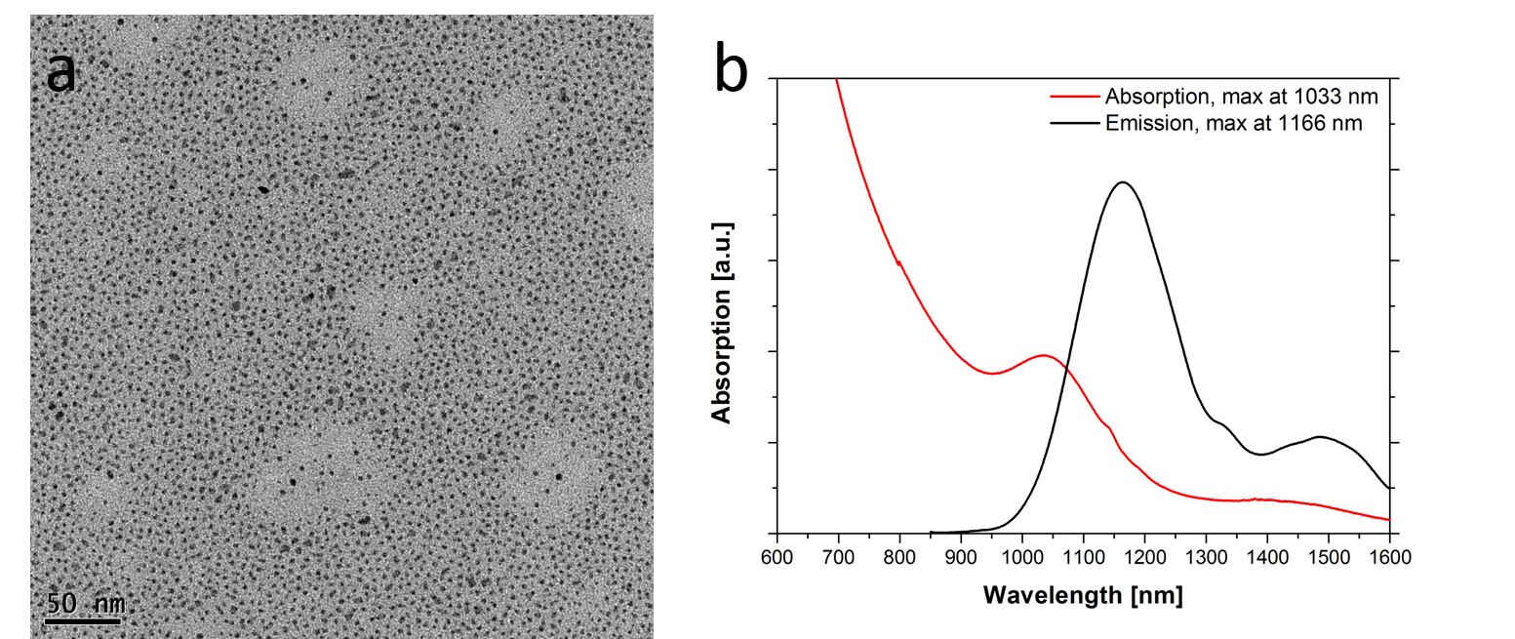

We performed impedance measurements on PbS-EDT and PbS-MPA diodes with and without a PANI:PSS interlayer in dark and under illumination. The obtained data were fitted with ZView software by Scribner Associates Inc. (version 3.3f) assuming the circuit model displayed in figure 2 in the main article.
In the following we present the plots of the values for R_{S}, R1, CPE1(α and Q), R2 and C2 for PbS-EDT and PbS-MPA devices with and without the PANI:PSS interlayer. For comparison values for dark and illuminated conditions are displayed in the same graph.
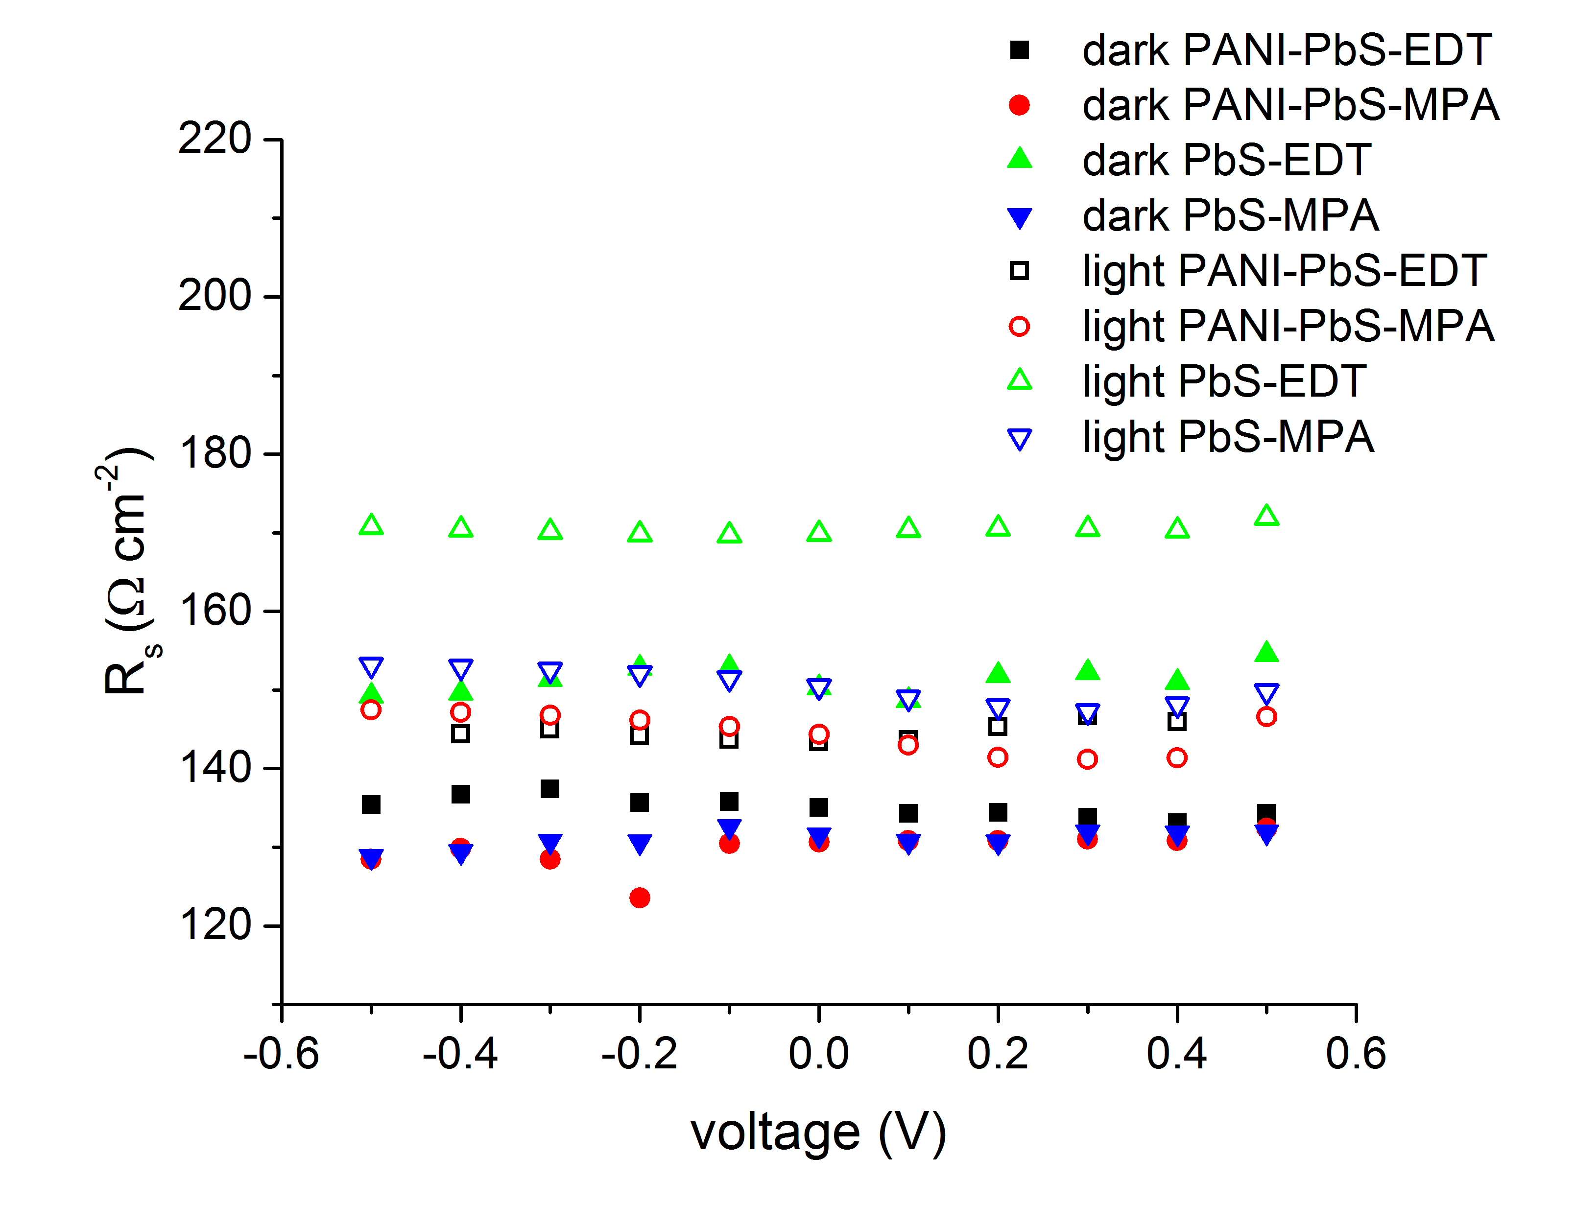
Fig. S2. Values for R_{s} versus voltage are represented for diodes, which were prepared using PbS-EDT with (black squares) and without a PANI:PSS interlayer (green triangles) and PbS-MPA with (red circles) and without a PANI:PSS interlayer (blue triangles). Filled symbols show data collected in dark conditions and open symbols display data acquired under illumination.

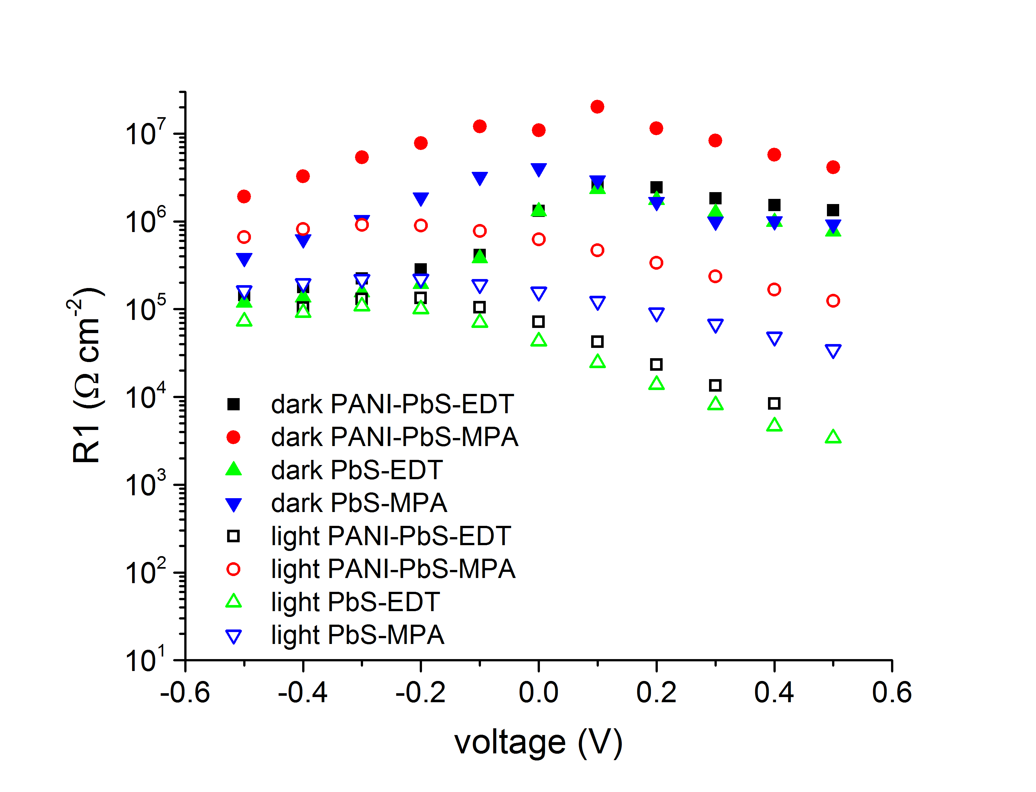
Fig. S3. Values for R1 versus voltage are represented for diodes, which were prepared using PbS-EDT with (black squares) and without a PANI:PSS interlayer (green triangles) and PbS-MPA with (red circles) and without a PANI:PSS interlayer (blue triangles). Filled symbols show data collected in dark conditions and open symbols display data acquired under illumination.

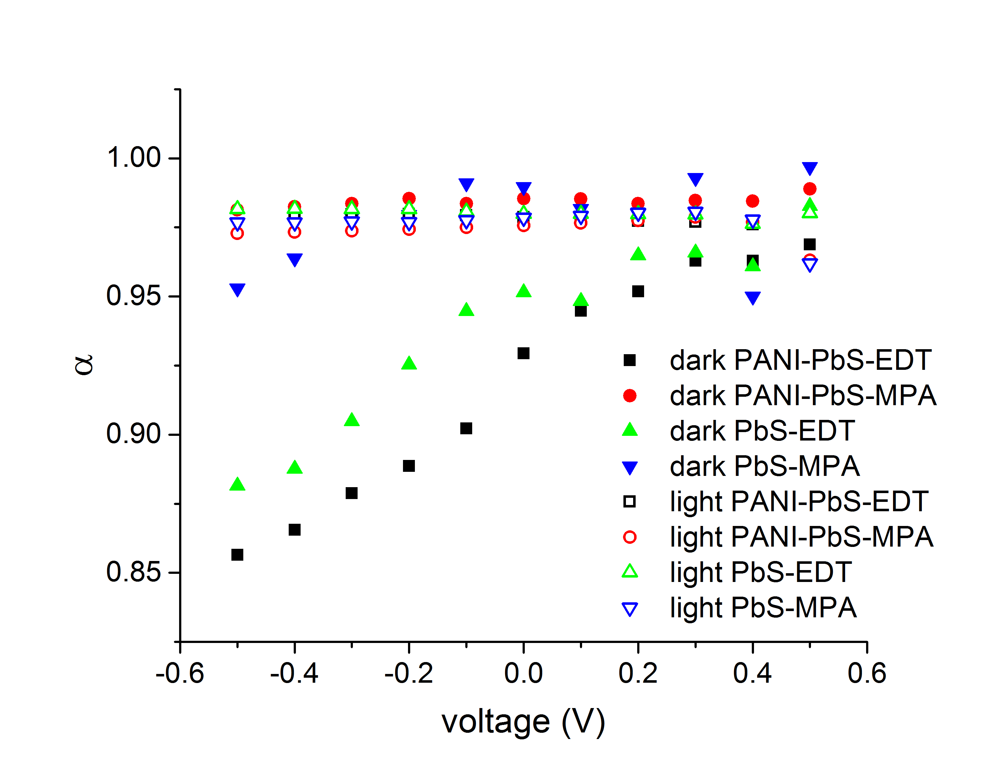
Fig. S4. α values versus voltage are represented for diodes, which were prepared using PbS-EDT with (black squares) and without a PANI:PSS interlayer (green triangles) and PbS-MPA with (red circles) and without a PANI:PSS interlayer (blue triangles). Filled symbols show data collected in dark conditions and open symbols display data acquired under illumination.

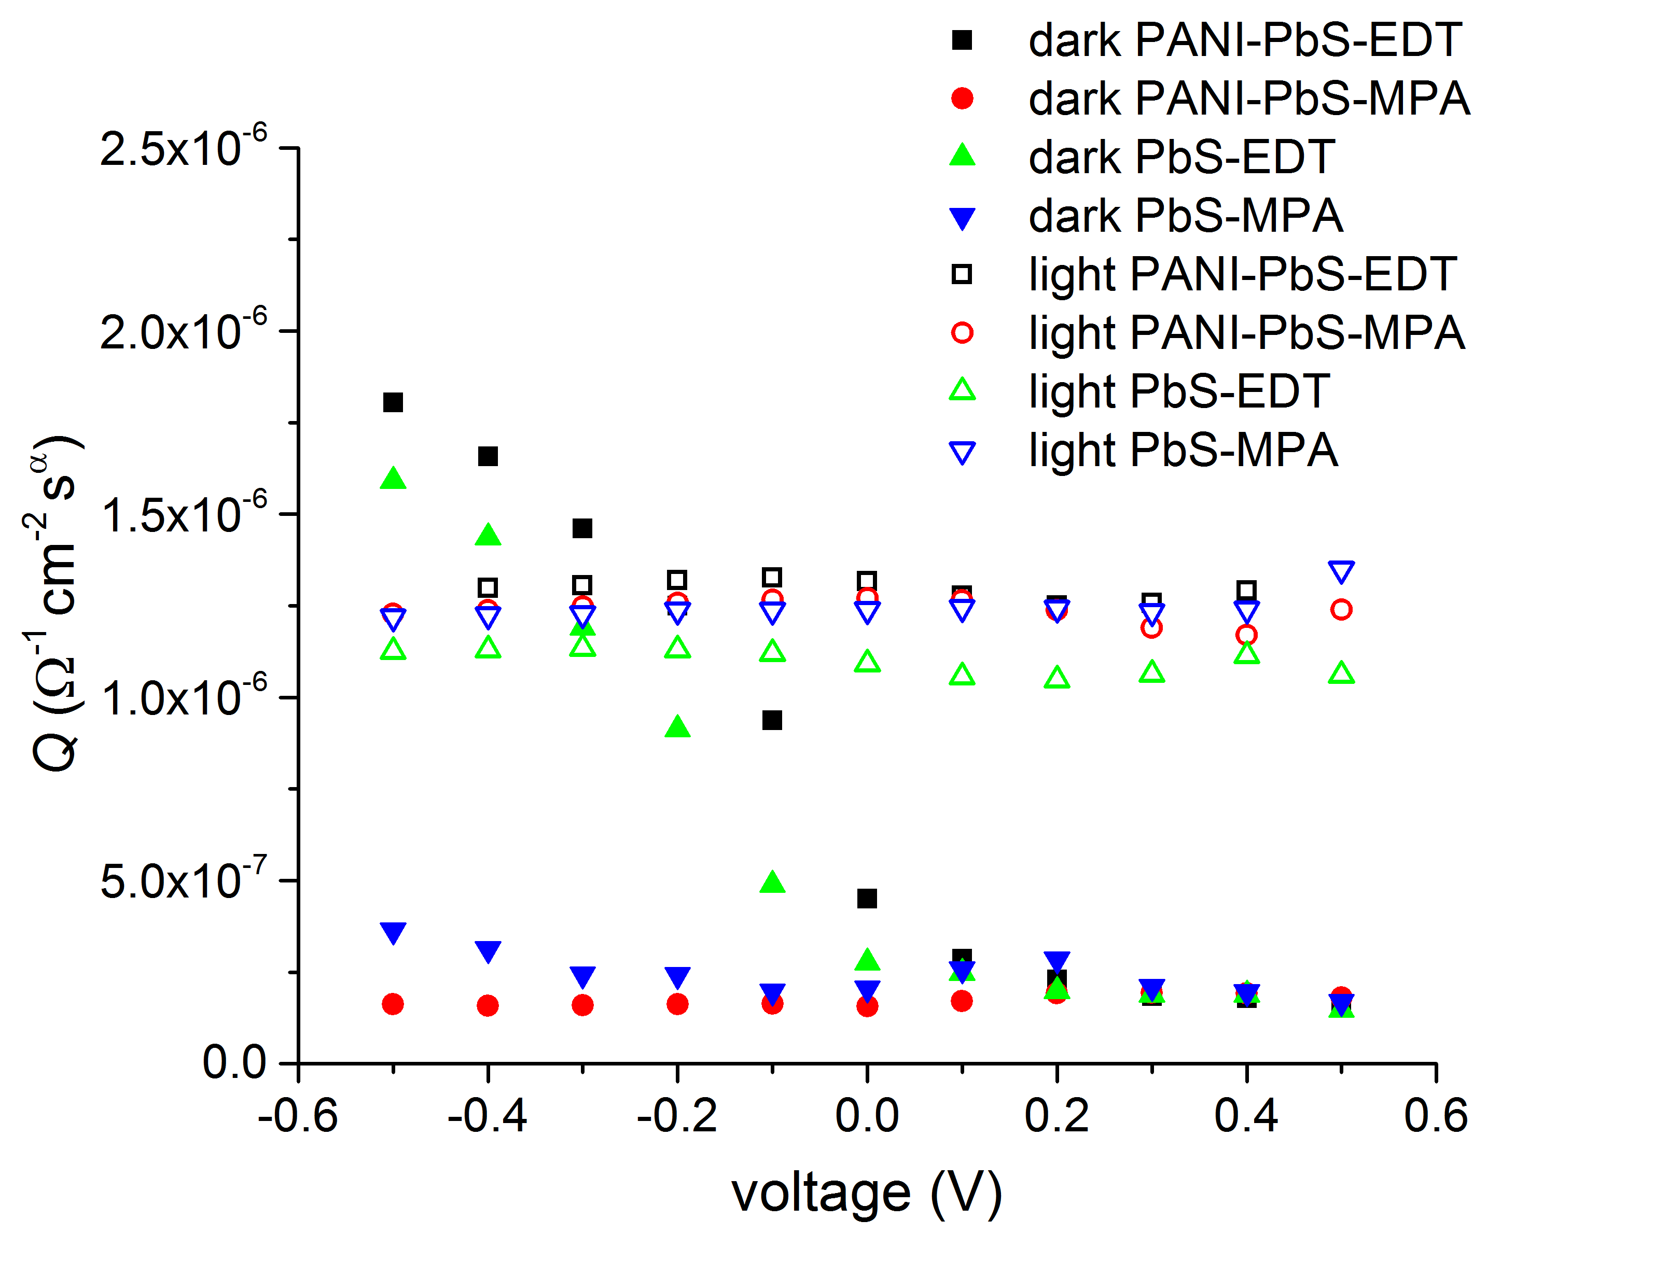
Fig. S5. Q values versus voltage are represented for diodes, which were prepared using PbS-EDT with (black squares) and without a PANI:PSS interlayer (green triangles) and PbS-MPA with (red circles) and without a PANI:PSS interlayer (blue triangles). Filled symbols show data collected in dark conditions and open symbols display data acquired under illumination.

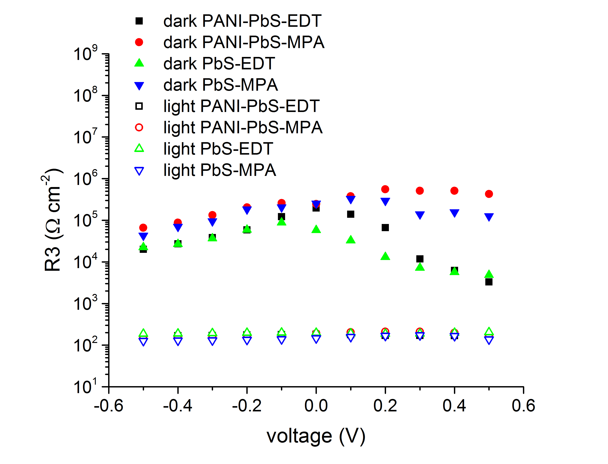Fig. S6. R3 values versus voltage are represented for diodes, which were prepared using PbS-EDT with (black squares) and without a PANI:PSS interlayer (green triangles) and PbS-MPA with (red circles) and without a PANI:PSS interlayer (blue triangles). Filled symbols show data collected in dark conditions and open symbols display data acquired under illumination.

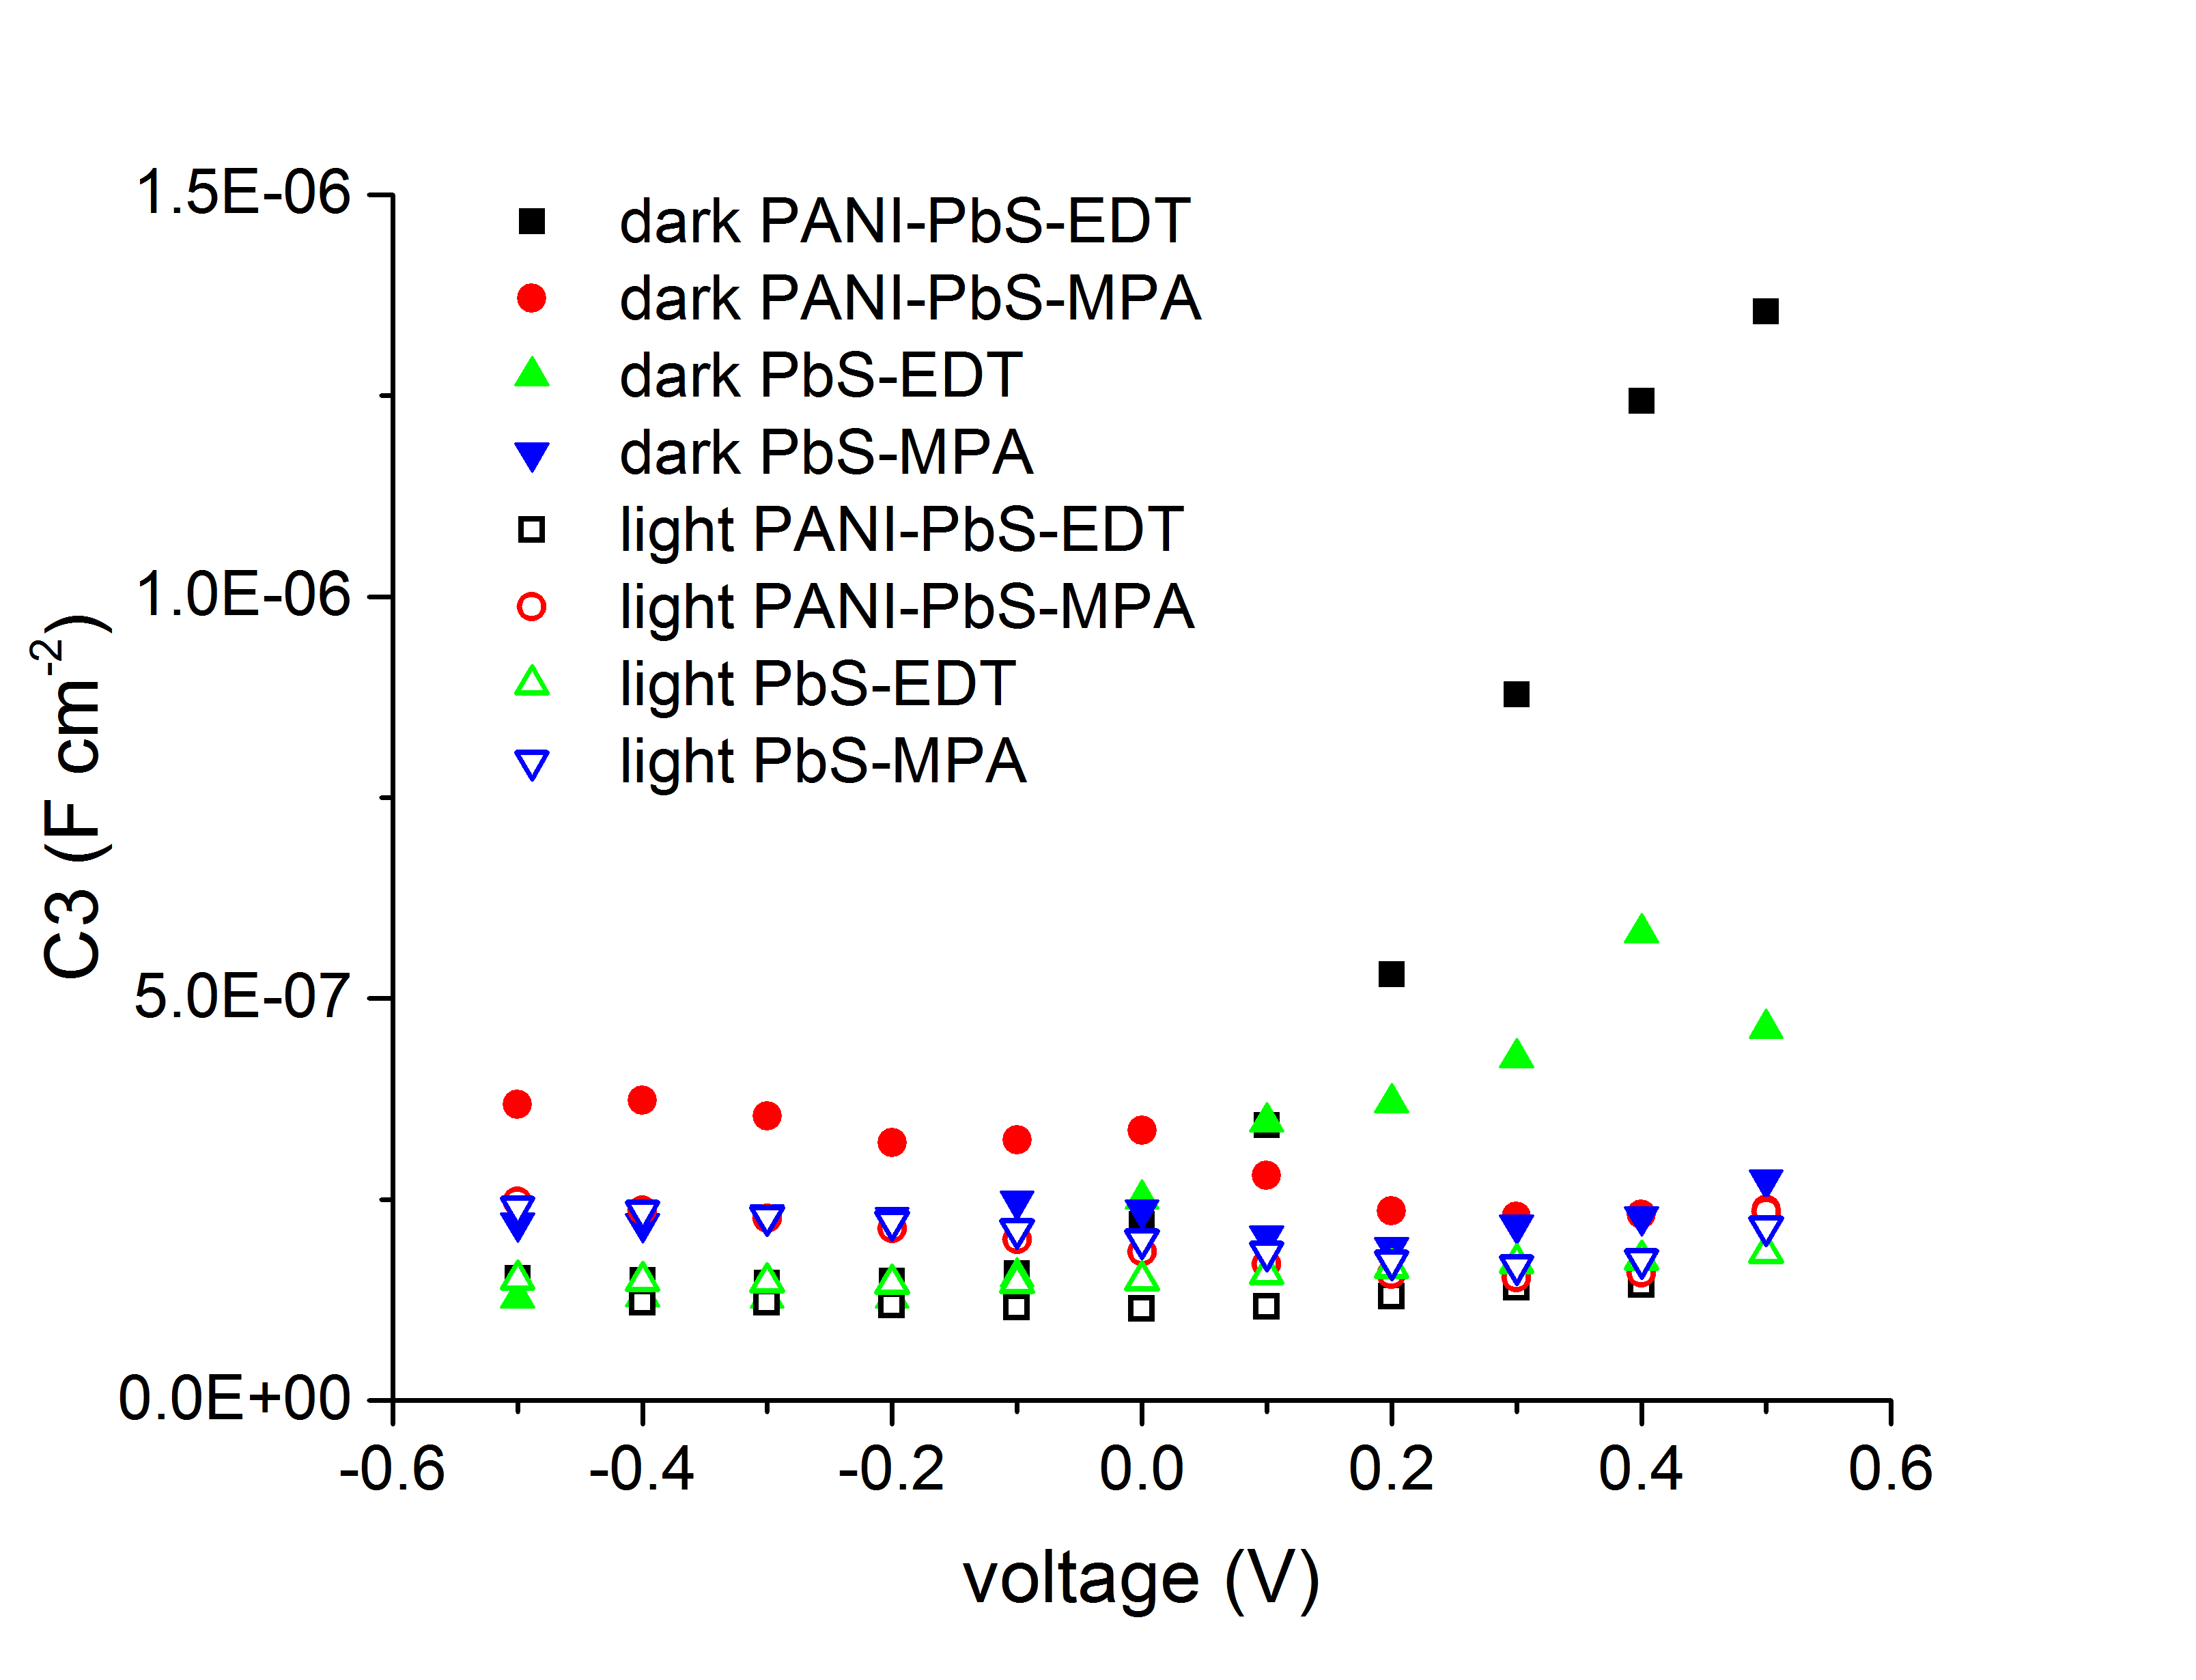

Fig. S7. C3 values versus voltage are represented for diodes, which were prepared using PbS-EDT with (black squares) and without a PANI:PSS interlayer (green triangles) and PbS-MPA with (red circles) and without a PANI:PSS interlayer (blue triangles). Filled symbols show data collected in dark conditions and open symbols display data acquired under illumination.

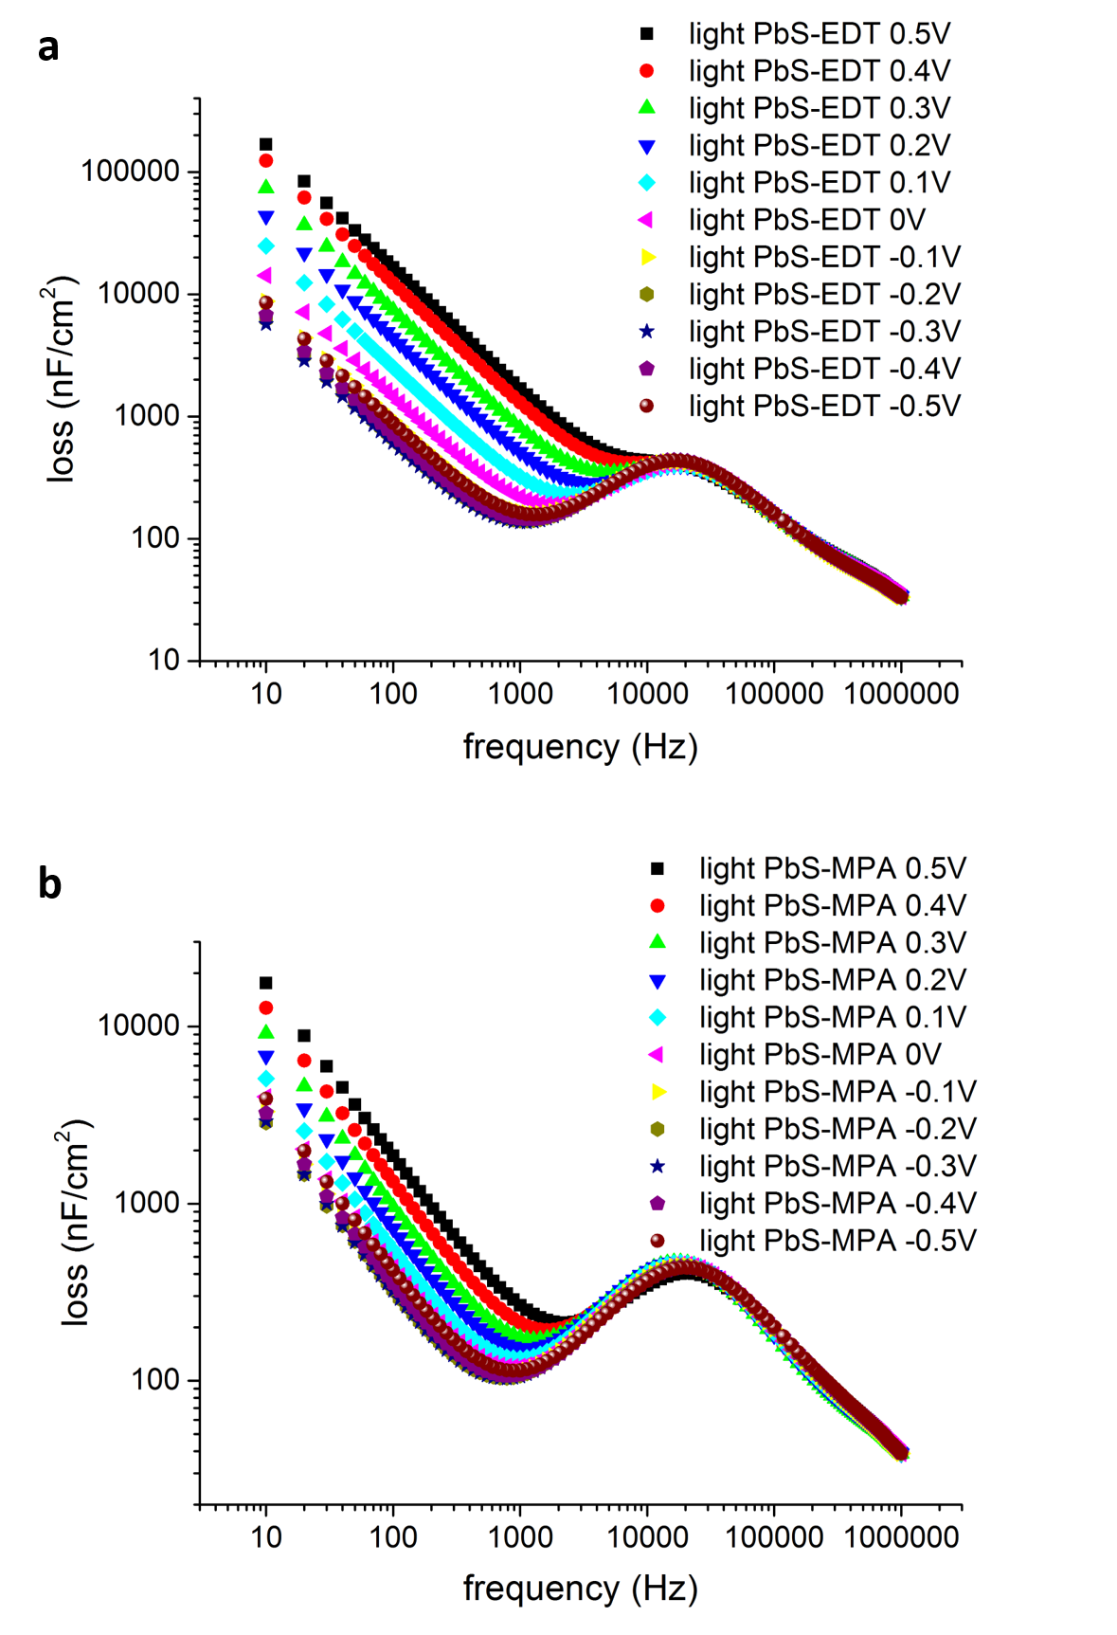
Fig S8. . Representation of loss versus frequency for (a) PbS-EDT and (b) PbS-MPA diodes without the PANI:PSS interlayer for bias voltages in the range between +0.5 V and -0.5 V and under illumination.

