Supplementary information to accompany

Triarylmethyl Radical: EPR Signal to Noise at Frequencies between 250 MHz and 1.5 GHz and Dependence of Relaxation on Radical and Salt Concentration and on Frequency

Yilin Shi,¹ Richard W. Quine,² George A. Rinard,² Laura Buchanan,¹
Sandra S. Eaton,¹ and Gareth R. Eaton^{1 *}
¹ Department of Chemistry and Biochemistry, University of Denver, Denver, CO 80210
² School of Engineering and Computer Science, University of Denver, Denver, CO 80210
Boris Epel,³ Simone Wanless Seagle,³ and Howard J. Halpern³
³ Department of Radiation and Cellular Oncology, University of Chicago, Chicago, IL 60637

Table S1. Dependence of T₁ (μs) for OX063 in 10 mM HEPES buffer or water on radical concentration and frequency at room temperature
 | OX063 concentration
Fre-quency (MHz) | 0.05 mM  + 154 mM NaCl  +HEPES | 0.1 mM  + 154 mM NaCl  +HEPES | 0.2 mM  + 154 mM NaCl  +HEPES | 0.4 mM  + 154 mM + NaCl  +HEPES | 0.2 mM  +HEPES | 0.2 mM  in water
9200 |  |  |  |  |  | 15*
3100 |  |  |  |  |  | 14*
1500 | 12.6 | 12.3 | 12.3 | 11.7 | 12.7 | 12.1
970 | 10.9 | 10.6 | 10.9 | 10.4 | 11.1
900 |  | 10.7 | 10.7 | 10.1 | 10.8
800 |  | 10.0 | 9.9 | 9.8 | 10.2
730 |  |  |  |  |  | 9.4†
700 |  | 9.8 | 9.4 | 9.1 | 9.7
610 |  |  |  |  |  | 9.0†
600 |  | 8.9 | 8.8 | 8.3 | 8.9
500 |  | 8.2 | 8.0 | 7.6 | 8.3
250 |  |  |  |  |  | 6.2*
* Data from R. Owenius et al. [1]
† Unpublished results from Joshua R. Biller, University of Denver.

Table S2. Dependence of T₁ (μs) for OX063 in 10 mM HEPES buffer or water on salt concentration, radical concentration, and temperature at 700 MHz
 | OX063 concentration
Temper-ature | 0.2 mM, no salt | 0.2 mM+  77 mM NaCl | 0.2 mM+  154 mM NaCl | 0.4 mM, no salt | 0.4 mM+  77 mM NaCl | 0.4 mM  + 154 mM NaCl
19º C | 9.8 | 9.5 | 9.5 | 9.6 | 9.4 | 9.3
37º C | 8.5 | 8.3 | 8.2 | 8.4 | 8.0 | 7.8

Table S3. Dependence of T₂ (μs) for OX063 in 10 mM HEPES buffer or water on radical concentration and frequency at room temperature
 | OX063 concentration
Fre-quency (MHz) | 0.05 mM  + 154 mM NaCl  +HEPES | 0.1 mM  + 154 mM NaCl  +HEPES | 0.2 mM  + 154 mM NaCl  +HEPES | 0.4 mM  + 154 mM NaCl  +HEPES | 0.2 mM  +HEPES | 0.2 mM  in water
9200 |  |  |  |  |  | 6.4*
3100 |  |  |  |  |  | 6.6*
1500 | 6.6 | 6.0 | 5.7 | 5.1 | 6.6 | 7.3
970 | 6.5 | 6.6 | 6.0 | 5.1 | 6.7
900 |  | 6.4 | 5.9 | 5.1 | 6.7
800 |  | 6.5 | 5.8 | 5.0 | 6.6
700 |  | 6.2 | 5.7 | 4.9 | 6.4
600 |  | 6.2 | 5.7 | 4.7 | 6.3
500 |  | 5.9 | 5.6 | 4.7 | 6.2
250 |  |  |  |  |  | 5.3*
* Data from R. Owenius, et al.[1]

Table S4. Dependence of T₂ (μs) for OX063 in 10 mM HEPES buffer on salt concentration, radical concentration, and temperature at 700 MHz
 | OX063 concentration
Temper-ature | 0.2 mM, no salt | 0.2 mM+  77 mM NaCl | 0.2 mM+  154 mM NaCl | 0.4 mM, no salt | 0.4 mM+  77 mM NaCl | 0.4 mM  + 154 mM NaCl
19 ºC | 6.3 | 5.8 | 5.7 | 5.9 | 5.0 | 4.8
37 ºC | 7.1 | 6.4 | 6.2 | 6.7 | 5.6 | 5.3

Table S5. Dependence of T₂ (μs) for OX063 solutions on radical concentration at 250 MHzª
 | T₂ (μs)
OX63 concentration (mM) | water | PBhS | PBS | 10×PBS | Saline
0.2 | 5.52
0.5 | 5.35 | 3.79 | 3.8
1 | 3.79 | 3.16 | 2.78 | 2.58
2 | 3.34 | 2.27 | 1.89 | 1.62 | 2.01
3 |  |  | 1.35
4 | 2.70 |  | 1.14
5 | 2.03 | 1.14 | 0.92 | 0.84 | 0.97
7 |  |  | 0.67
10 | 1.01 |  | 0.57
15 | 0.56 |  | 0.42
ª PBhS is phosphate buffer half saline, PBS is phosphate buffered saline (137 mM NaCl and 2.7 mM KCl, 10mM Na₂HPO₄ and 1.8 mM KH₂PO₄), and 10xPBS is phosphate buffer with 10x saline, saline is 154 mM NaCl.

Table S6. Dependence of T₂ (μs) for 0.5 mM OX063 solutions on O₂ concentration at 250 MHz, room temperature
O₂ concentration | T₂ (μs)
0 | 3.8
3% | 2.03
6% | 1.46
9.28% | 1.22
21% | 0.64

Table S7. Frequency dependence of S/N (normalized by √Q) for OX063 solutions at room temperature

 | 0.2 mM OX063+154 mM NaCl + 10 mM HEPES |  | 0.4 mM OX063 +154 mM NaCl + 10 mM HEPES
frequency  (MHz) | Q | S/N  (normalized by √Q) | Q | S/N  (normalized by √Q)
990 | 12.7 | 5.7 | 11.0 | 13.6
900 | 17.1 | 5.4 | 12.8 | 11.0
800 | 18.6 | 4.6 | 14.7 | 9.9
700 | 21.8 | 4.3 | 17.7 | 8.7
600 | 30.2 | 3.3 | 22.0 | 7.1
500 | 32.4 | 2.9 | 27.6 | 5.9
440 | 40.0 | 2.0 | 32.5 | 4.7

Table S8. Dependence of S/N (normalized by √Q) on salt concentration for OX063 solutions at 700 MHz
 | OX063 concentration
Temper-ature | 0.2 mM, no salt | 0.2 mM+  77 mM NaCl | 0.2 mM+  154 mM NaCl | 0.4 mM, no salt | 0.4 mM+  77 mM NaCl | 0.4 mM  + 154 mM NaCl
19º C | 7.1 | 4.9 | 5.0 | 13.1 | 8.7 | 8.7
37º C | 5.8 | 4.7 | 4.9 | 12.2 | 9.0 | 9.7

Table S9. Relaxation times (T₁, T₂, μs) for two trityl radicals (0.2 mM in water) at 250 MHz
Trityl-CD₃
 | T₁ μs | Δ(1/T₁)ª | T₂ μs | Δ(1/T₂)^{b}
no added salt | 12 |  | 11
118 mM NaCl | 9.5 | 0.022 | 6.9 | 0.054
150 mM NaCl | 7.9 | 0.043 | 5.7 | 0.084
150 mM LiCl | 9.0 | 0.028 | 6.7 | 0.058
150 mM Me₄NCl | 9.8 | 0.019 | 5.1 | 0.105
Trityl-CH₃
no added salt | 7.9 |  | 7.4
118 mM NaCl | 6.3 | 0.033 | 5.0 | 0.065
ª Δ(1/T₁) = 1/T₁ in solution with salt – 1/T₁ without salt
^{b} Δ(1/T₂) = 1/T₂ in solution with salt – 1/T₂ without salt
Trityl OX063 hyperfine splittings measured with X-band CW EPR

Zhelin Yu, Tengzhi Liu, Gareth R. Eaton
01/26/2015

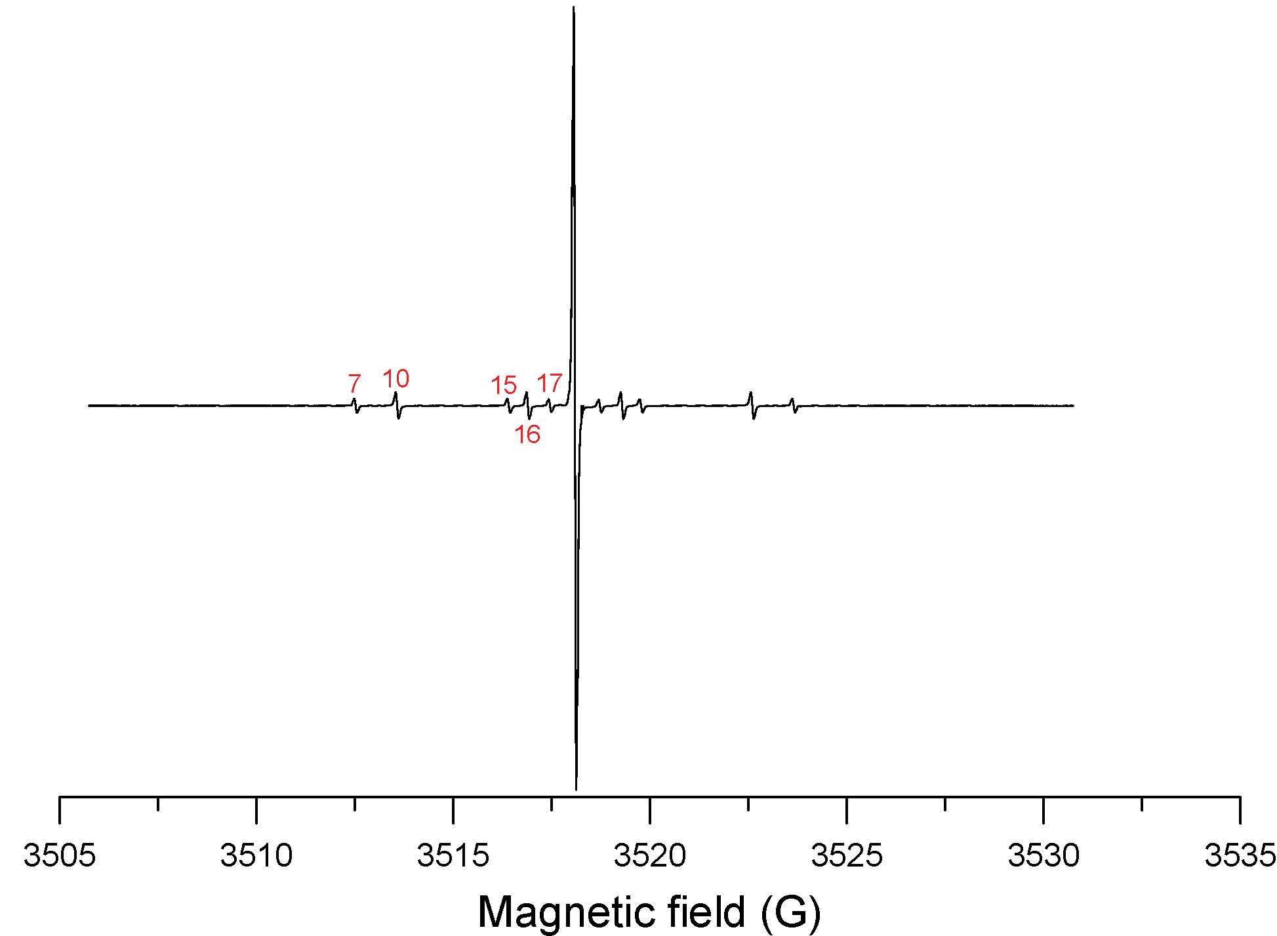

Figure S1. X-band (9.858 GHz) CW spectrum of OX063 in water obtained with 0.201 mW power, 0.1 G modulation amplitude at 100 kHz, 167 s scan time, and averaged for 10 scans. Assignments for the numbered lines are listed in Table S10.

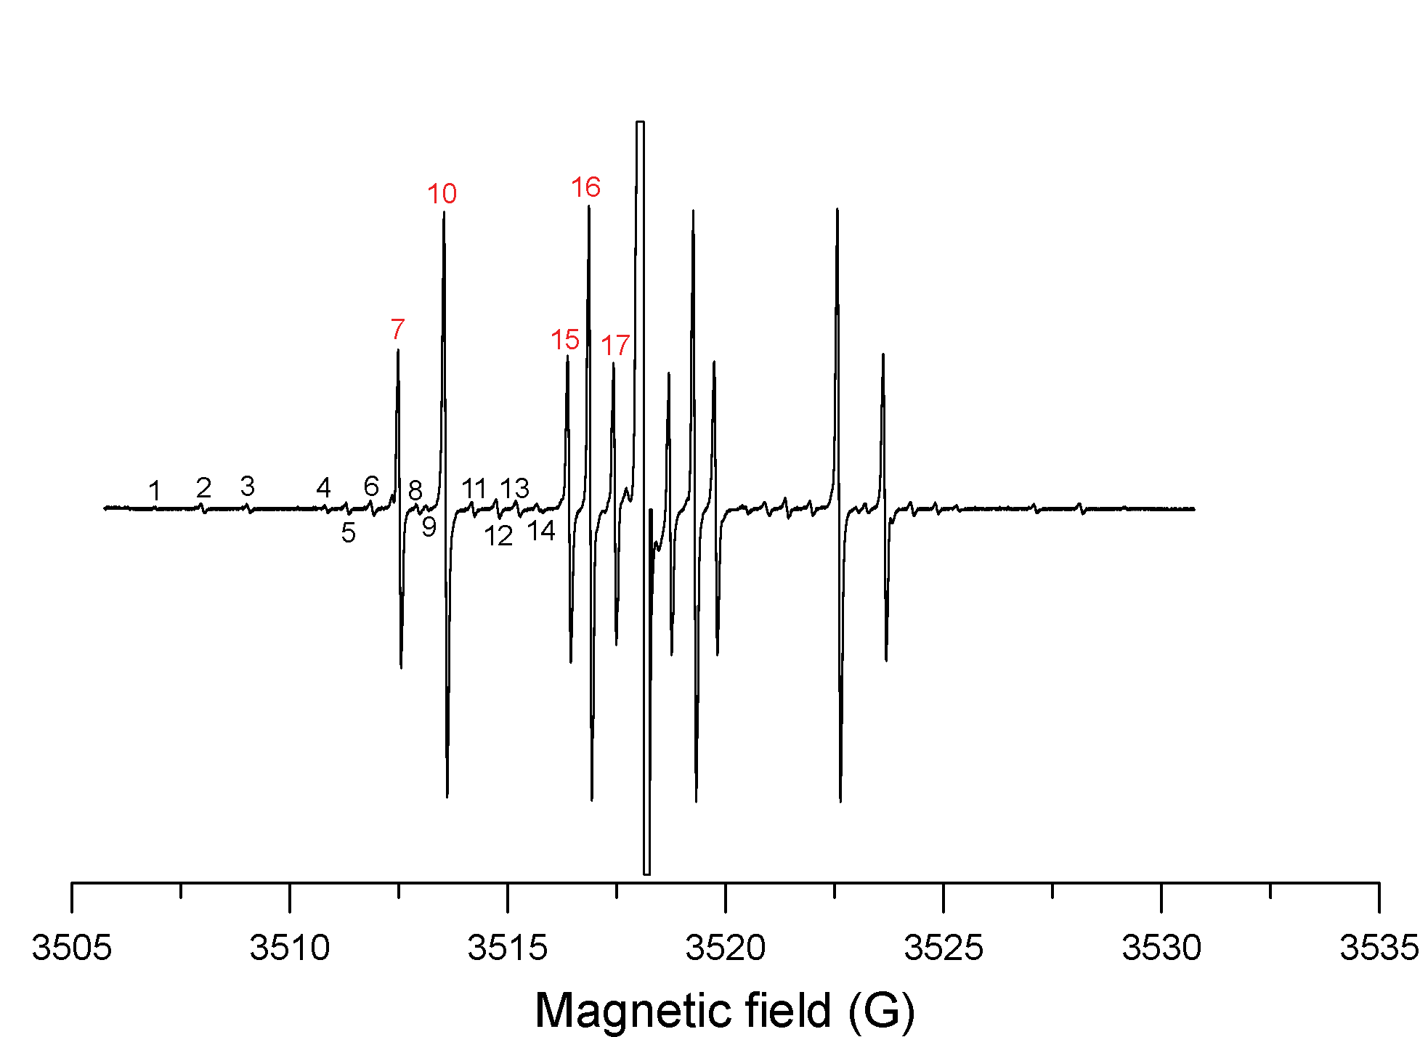

Figure S2. The data in Figure S1 are plotted in Figure S2 with expanded y-axis scale to emphasize the lines with lower amplitude. Assignments for the numbered lines are listed in Table S10.

Table S10. The ¹³C hyperfine splittings in the Trityl OX063 spectrum

No. of ¹³C  line* | Hyperfine splitting / G | assignment
1 | 22.3 | 11.1 + 11.1
2 | 20.2 | 11.1 + 9.1
3 | 18.1 | 9.1 + 9.1
4 | 14.5 | 11.1 + 3.4
5 | 13.6 | 11.1 + 2.4
6 | 12.4 | 11.1 + 1.3
7 ** | 11.1
8 | 10.3 | 9.1 + 1.3
9 | 9.9 | 11.1 – 1.3
10 | 9.1
11 | 7.8 | 9.1 – 1.3
12 | 6.7 | 9.1 – 2.4
13 | 5.8 | 9.1 – 3.4
14 | 4.8 | 2.4 + 2.4
15 | 3.4
16 | 2.44
17 | 1.3

* Each ¹³C line was labeled in figure 1 and figure 2.
** The strong ¹³C lines are highlighted with red color in the table. These are the ¹³C hyperfine couplings. Since there are so many carbons in the molecule there is a significant probability that two of these carbons are ¹³C. For these molecules the hyperfine splittings are the sum or difference of two hyperfine coupling constants.

References

1. R. Owenius, G.R. Eaton, S.S. Eaton: J. Magn. Reson. 172, 168-175 (2005).

