Supplementary data

Anti-Dengue fever activity of a mixed extract from
medicinal plants of Vietnam
Vo Hoai Bac¹, Le Thi Xoan², Nguyen Thi Thu Thuy³, Vu Thi Bich Hau³, Hayeong Kim⁴, Dong Van Quyen¹, Doman Kim^{4,5}, Nguyen Thi Phuong Trang⁶, Nguyen Van Tam⁷, Nguyen Van Dung⁷, Nguyen Thi Mai Phuong¹*

¹Institute of Biology, Vietnam Academy of Science and Technology, 18 Hoang Quoc Viet Road, Cau Giay, Hanoi, Vietnam.
²National Institute of Medicinal Materials, 3B Quang Trung Street, Hoan Kiem, Hanoi, Vietnam
³National Institute of Hygiene And Epidemiology, 1 Yecxanh, Hai Ba Trung, Hanoi, Vietnam.
⁴Institute of Food Industrialization, Institutes of Green Bio Science and Technology, Seoul National University, Pyeongchang-gun, Gangwon-do, 25354, Republic of Korea.
⁵Graduate School of International Agricultural Technology, Seoul National University, Pyeongchang-gun, Gangwon-do, 25354, Republic of Korea.
⁶Vietnam-Korea Institute of Science and Technology (VKIST), Hoa lac High-tech Park, km29 Thang Long Boulevard, Hanoi.
⁷VPO PHARCO Company, 688 Nguyen Thi Minh Khai Road, Vinh Yen, Phu Tho, Vietnam

- Apigenin: (RT=20.69)
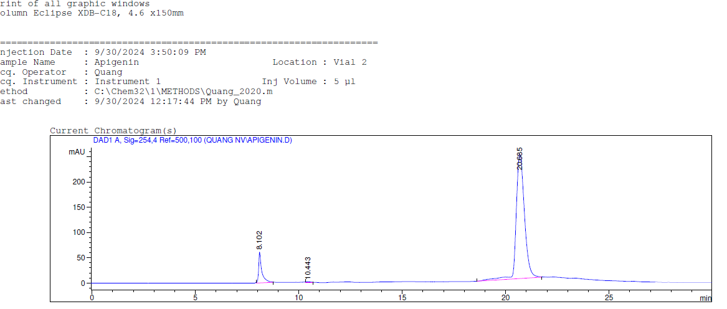
Fig 1A. HPLC HPLC chromatogram of Apigenin

- Caffeic acid: (RT=15.68)
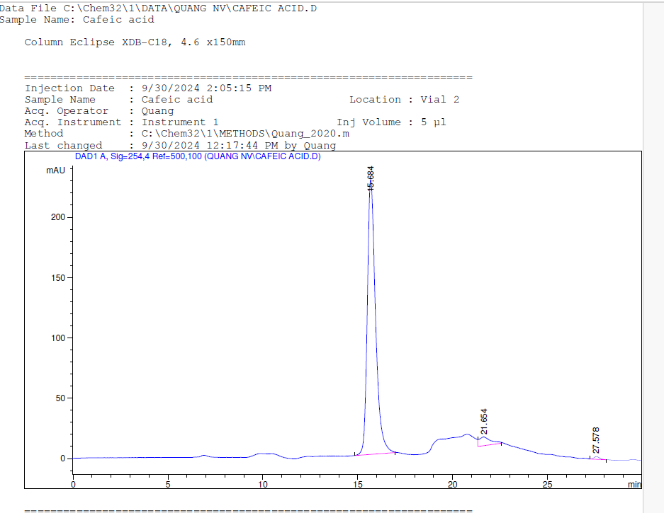
Fig 1B. HPLC chromatogram of Caffeic acid

- Luteolin: (RT=18.67)
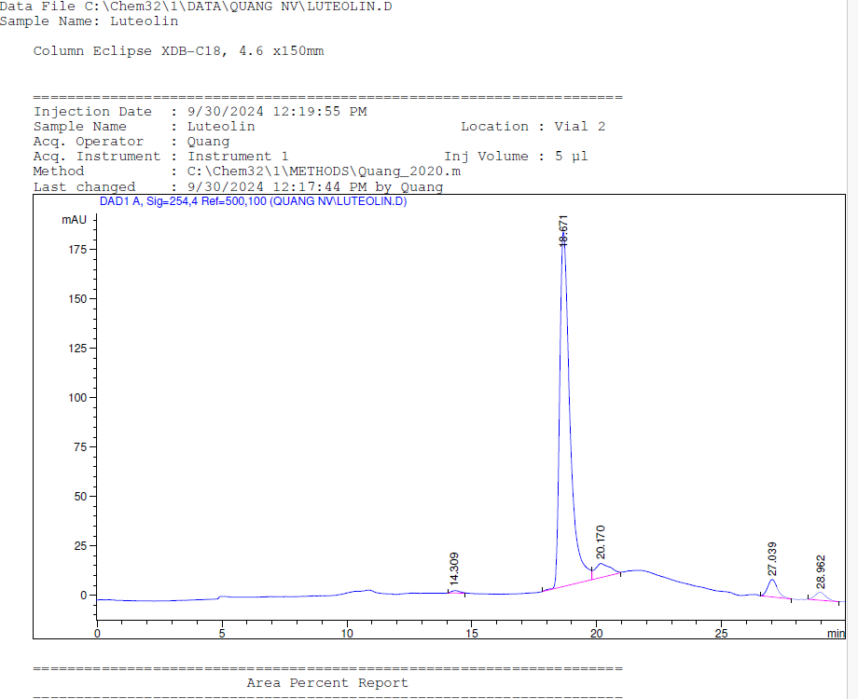
Fig 1C. HPLC chromatogram of Luteolin

- Quecertin: (RT=19.69)
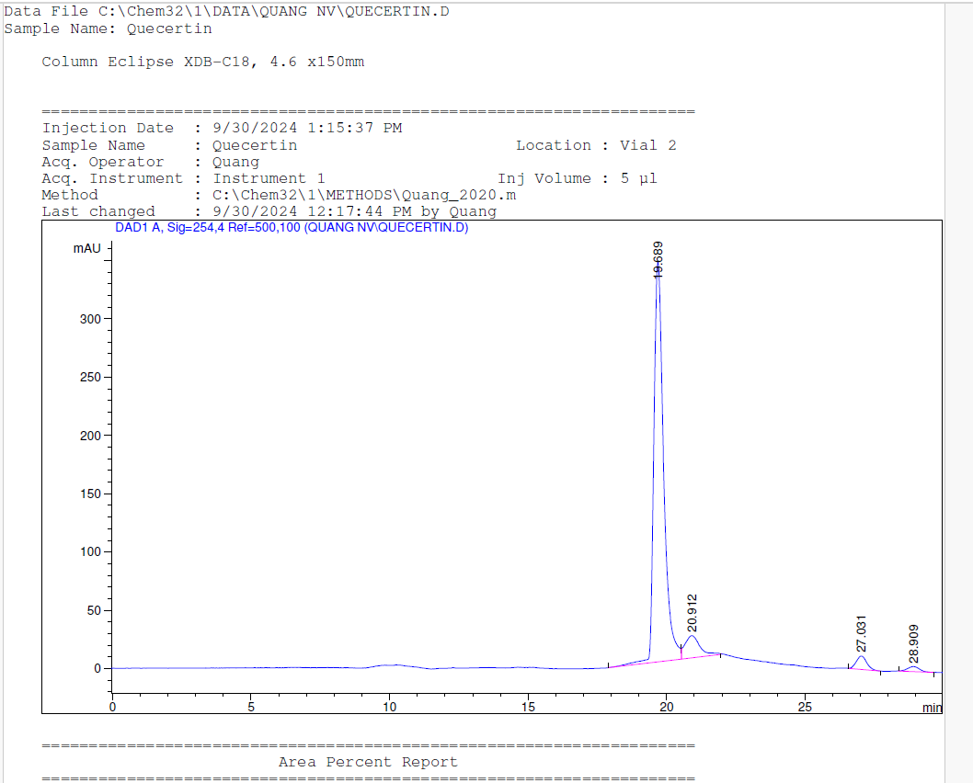

Fig 1D. HPLC chromatogram of Quecertin

- Astilbin: RT= 8.16
- 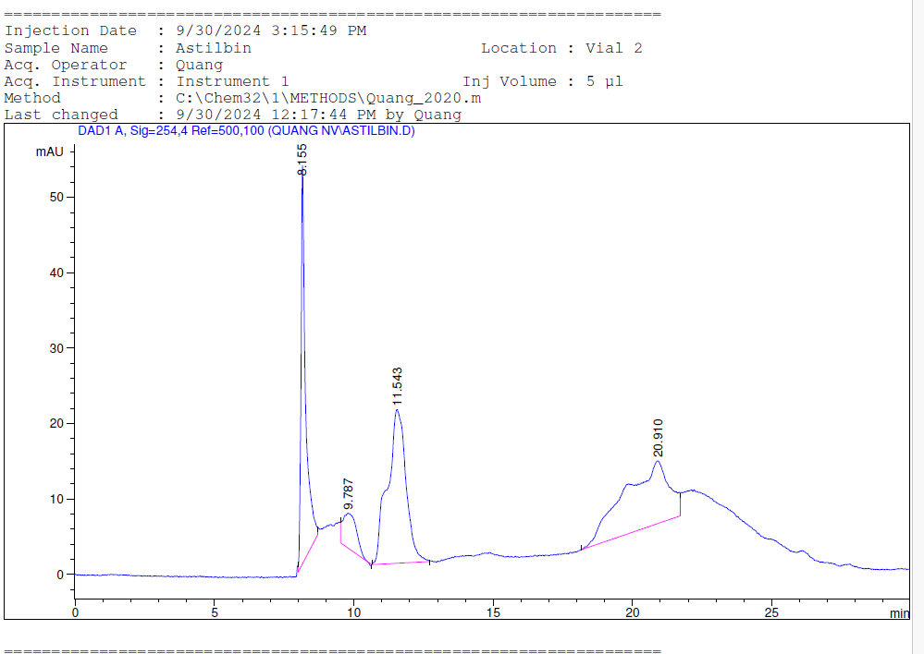
Fig 1E. HPLC chromatogram of Astilbin

Table 1. Concentration (mg/mL) of Hemoshield (HE) on cell plate testing activity against DENV-1, DENV-2, DENV-3, DENV-4. Ethanol 25% extract of Hemoshield (EE); Aqueous (water) extract of Hemoshield (WE). DENV = dengue virus
DENV-1
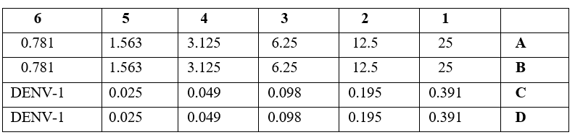
EE
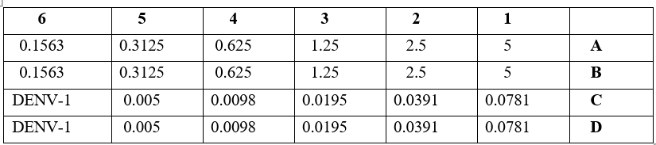
WE

DENV-2
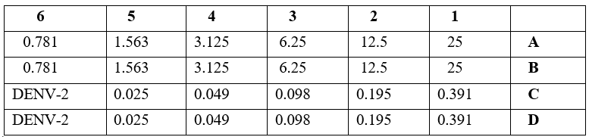
EE
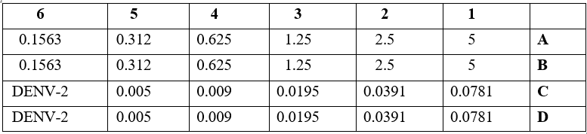
WE

DENV-3
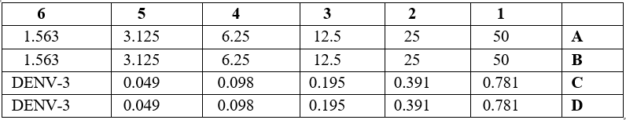
EE
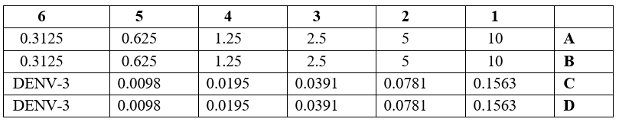
WE

DENV-4
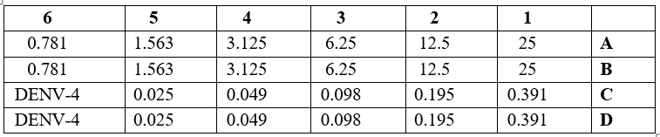
EE
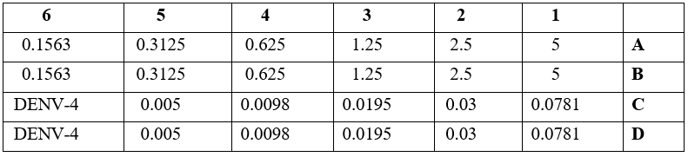
WE

