Supplementary Data
Table S1. Molecules with their SMILES.
Compound | SMILES
P3 | CC[C@H]1CCCN(C1)c1nc2ccc(Br)cc2c(C(=O)NC[C@H](CCC(O)=O)c2ccccc2C(F)(F)F)c1C
P8 | Cc1c(nc2ccc(Br)cc2c1C(=O)NC[C@H](CCC(O)=O)c1ccccc1OC(F)(F)F)N1CCCCC1
P9 | CC[C@@H]1CCCN(C1)c1nc2ccc(Br)cc2c(C(=O)NC[C@@H](CCC(O)=O)c2ccccc2Cl)c1C
P10 | CCC1CCCN(C1)c1nc2ccc(Br)cc2c(C(=O)NCC(CCC(O)=O)c2ccccc2Cl)c1C
P11 | Cc1c(nc2ccc(Br)cc2c1C(=O)NC[C@@H](CCC(O)=O)c1ccccc1OC(F)(F)F)N1CCCCC1
P13 | Cc1c(nc2ccc(Br)cc2c1C(=O)NC[C@H](CCC(O)=O)c1ccccc1OC(F)(F)F)N1CCCCCC1
P18 | Cc1c(nc2ccc(Br)cc2c1C(=O)NC[C@H](CCC(O)=O)c1c(F)cccc1C(F)(F)F)N1CCCCC1
P20 | COc1ccccc1[C@@H](CCC(O)=O)CNC(=O)c1c(C)c(nc2ccc(Br)cc12)N1CCCCCC1
P21 | COc1ccccc1[C@@H](CCC(O)=O)CNC(=O)c1c(C)c(nc2ccc(Br)cc12)N1CCCCC1
P22 | CCC1CCCN(C1)c1nc2ccc(Br)cc2c(C(=O)NCC(CCC(O)=O)c2ccccc2OC(F)(F)F)c1C
P23 | Cc1c(nc2ccc(Br)cc2c1C(=O)NC[C@H](CCC(O)=O)c1c(Cl)ccc(F)c1F)N1CCCCC1
P24 | Cc1c(nc2ccc(Br)cc2c1C(=O)NC[C@H](CCC(O)=O)c1c(F)cccc1OC(F)F)N1CCCCC1
P26 | C[C@H]1CCCN(C1)c1nc2ccc(Br)cc2c(C(=O)NC[C@@H](CCC(O)=O)c2ccccc2C(F)(F)F)c1C
P27 | Cc1c(nc2ccc(Br)cc2c1C(=O)NCC(CCC(O)=O)c1ccccc1OC(F)(F)F)N1CCCCC1
P28 | Cc1c(nc2ccc(Br)cc2c1C(=O)NC[C@H](CCC(O)=O)c1ccccc1OC(F)(F)F)N1CCC[C@@H](F)C1
P29 | CC1CCCN(C1)c1nc2ccc(Br)cc2c(C(=O)NCC(CCC(O)=O)c2c(F)ccc(F)c2Cl)c1C
P30 | CC[C@@H]1CCCN(C1)c1nc2ccc(Br)cc2c(C(=O)NC[C@H](CCC(O)=O)c2cc(F)ccc2F)c1C
P34 | Cc1c(nc2ccc(Br)cc2c1C(=O)NCC(CCC(O)=O)c1c(Cl)ccc(F)c1F)N1CCCCC1
P37 | CC1CCCN(C1)c1nc2ccc(Br)cc2c(C(=O)NCC(CCC(O)=O)c2ccccc2OC(F)(F)F)c1C
P38 | Cc1c(nc2ccc(Br)cc2c1C(=O)NC[C@@H](CCC(O)=O)c1ccccc1OC(F)(F)F)N1CCCC1
P39 | COc1ccccc1[C@@H](CCC(O)=O)CNC(=O)c1c(C)c(nc2ccc(Br)cc12)N1CCCC(F)(F)C1
P40 | Cc1c(nc2ccc(Br)cc2c1C(=O)NCC(CCC(O)=O)c1c(F)ccc(F)c1Cl)N1CCCC(F)C1
P43 | CC[C@@H]1CCCN(C1)c1nc2ccc(Br)cc2c(C(=O)NC[C@@H](CCC(O)=O)c2ccccc2C(F)(F)F)c1C
P48 | Cc1c(nc2ccc(Br)cc2c1C(=O)NC[C@H](CCC(O)=O)c1ccccc1C(F)(F)F)N1CCCCC1
P49 | Cc1c(nc2ccc(Br)cc2c1C(=O)NC[C@@H](CCC(O)=O)c1c(F)cccc1C(F)(F)F)N1CCCC1
P50 | Cc1c(nc2ccc(Br)cc2c1C(=O)NC[C@@H](CCC(O)=O)c1c(F)ccc(F)c1Cl)N1CCCC1
P51 | Cc1c(nc2ccc(Br)cc2c1C(=O)NCC(CCC(O)=O)c1c(F)cccc1OC(F)F)N1CCCCC1
P53 | Cc1c(nc2ccc(Br)cc2c1C(=O)NC[C@H](CCC(O)=O)c1ccccc1C(F)(F)F)N1CCCCC1
P54 | Cc1c(nc2ccc(Br)cc2c1C(=O)NCC(CCC(O)=O)c1ccccc1Cl)N1CCCC(F)(F)C1
P62 | CC[C@H]1CCCN(C1)c1nc2ccc(Br)cc2c(C(=O)NC[C@H](CCC(O)=O)c2cc(F)ccc2F)c1C
P63 | Cc1c(nc2ccc(Br)cc2c1C(=O)NC[C@@H](CCC(O)=O)c1ccccc1C(F)(F)F)N1CCCCC1
P67 | Cc1c(nc2ccc(Br)cc2c1C(=O)NC[C@@H](CCC(O)=O)c1ccccc1OC(F)(F)F)N1CCCCCC1
P71 | Cc1c(nc2ccc(Br)cc2c1C(=O)NC[C@H](CCC(O)=O)c1ccccc1Cl)N1CCCCCC1
P75 | CC1CCCN(C1)c1nc2ccc(Br)cc2c(C(=O)NCC(CCC(O)=O)c2cc(F)ccc2Cl)c1C
P76 | Cc1c(nc2ccc(Br)cc2c1C(=O)NC[C@H](CCC(O)=O)c1cccc(F)c1Cl)N1CCCCC1
P79 | Cc1ccc(F)cc1[C@@H](CCC(O)=O)CNC(=O)c1c(C)c(nc2ccc(Br)cc12)N1CCCCC1
P82 | CC1CCCN(C1)c1nc2ccc(Br)cc2c(C(=O)NCC(CCC(O)=O)c2ccccc2Cl)c1C
P83 | Cc1c(nc2ccc(Br)cc2c1C(=O)NC[C@@H](CCC(O)=O)c1ccccc1Cl)N1CCCCC1
P84 | Cc1c(nc2ccc(Br)cc2c1C(=O)NC[C@@H](CCC(O)=O)c1ccccc1OC(F)(F)F)N1CCCC(F)(F)C1
P86 | CC1CCCN(C1)c1nc2ccc(Br)cc2c(C(=O)NCC(CCC(O)=O)c2ccccc2C(F)(F)F)c1C
P87 | Cc1c(nc2ccc(Br)cc2c1C(=O)NCC(CCC(O)=O)c1c(F)cccc1C(F)(F)F)N1CCCCC1
P88 | Cc1c(nc2ccc(Br)cc2c1C(=O)NC[C@H](CCC([O-])=O)c1ccccc1Cl)N1CCCC1
P89 | Cc1c(nc2ccc(Br)cc2c1C(=O)NC[C@H](CCC(O)=O)c1ccccc1Cl)N1CCCCC1
P90 | Cc1c(nc2ccc(Br)cc2c1C(=O)NC[C@H](CCC(O)=O)c1ccccc1Cl)N1CCCCCC1
P92 | Cc1c(nc2ccc(Br)cc2c1C(=O)NC[C@H](CCC(O)=O)c1ccccc1Cl)N1CCCCC1
P94 | Cc1c(nc2ccc(Br)cc2c1C(=O)NCC(CCC(O)=O)c1cccc(F)c1Cl)N1CCCCC1
P95 | Cc1c(nc2ccc(Br)cc2c1C(=O)NC[C@@H](CCC(O)=O)c1ccccc1Cl)N1CCC[C@@H](F)C1
P98 | C[C@H]1CCCN1c1nc2ccc(Br)cc2c(C(=O)NC[C@@H](CCC(O)=O)c2ccccc2Cl)c1C
P99 | Cc1c(nc2ccc(Br)cc2c1C(=O)NCC(CCC(O)=O)c1ccccc1C(F)(F)F)N1CCCCC1
P100 | Cc1c(nc2ccc(Br)cc2c1C(=O)NC[C@H](CCC(O)=O)c1ccccc1Cl)N1CC[C@@H](F)C1
P101 | Cc1c(nc2ccc(Br)cc2c1C(=O)NC[C@@H](CCC(O)=O)c1cc(F)ccc1Cl)N1CCCCC1
P102 | Cc1c(nc2ccc(Br)cc2c1C(=O)NC[C@@H](CCC(O)=O)c1ccccc1Cl)N1CCCC1
P103 | Cc1c(nc2ccc(Br)cc2c1C(=O)NCC(CCC(O)=O)c1ccccc1Cl)N1CCCCC1
P104 | CCC1CCCN(C1)c1nc2ccc(Br)cc2c(C(=O)NCC(CCC(O)=O)c2c(Cl)ccc(Cl)c2Cl)c1C
P106 | C[C@H]1CCCN(C1)c1nc2ccc(Br)cc2c(C(=O)NC[C@H](CCC(O)=O)c2ccccc2OC(F)(F)F)c1C
P107 | Cc1c(nc2ccc(Br)cc2c1C(=O)NC[C@@H](CCC(O)=O)c1ccccc1Cl)N1CCCC(F)(F)C1
P108 | Cc1ccccc1C(CCC(O)=O)CNC(=O)c1c(C)c(nc2ccc(Br)cc12)N1CCCCC1
P109 | Cc1c(nc2ccc(Br)cc2c1C(=O)NC[C@H](CCC(O)=O)c1ccccc1Cl)N1CCCC1
P111 | CC[C@H]1CCCN(C1)c1nc2ccc(Br)cc2c(C(=O)NC[C@@H](CCC(O)=O)c2ccccc2Cl)c1C
P112 | CC1CCCN1c1nc2ccc(Br)cc2c(C(=O)NCC(CCC(O)=O)c2ccccc2Cl)c1C
P113 | Cc1c(nc2ccc(Br)cc2c1C(=O)NC[C@@H](CCC(O)=O)c1c(Cl)ccc(Cl)c1Cl)N1CCCC1
P114 | Cc1c(nc2ccc(Br)cc2c1C(=O)NC[C@H](CCC(O)=O)c1cc(F)ccc1Cl)N1CCCCC1
P116 | Cc1c(nc2ccc(Br)cc2c1C(=O)NC[C@H](CCC(O)=O)c1c(Cl)ccc(Cl)c1Cl)N1CCC[C@H](F)C1
P117 | Cc1c(nc2ccc(Br)cc2c1C(=O)NC[C@H](CCC(O)=O)c1cc(F)ccc1F)N1CCCCC1
P118 | Cc1c(nc2ccc(Br)cc2c1C(=O)NC[C@H](CCC(O)=O)c1ccccc1C(F)(F)F)N1CCCC(F)(F)C1
P119 | Cc1c(nc2ccc(Br)cc2c1C(=O)NC[C@H](CCC(O)=O)c1ccccc1Cl)N1CCC[C@@H](F)C1
P120 | Cc1c(nc2ccc(Br)cc2c1C(=O)NC[C@H](CCC(O)=O)c1ccccc1Cl)N1CCC=CC1
P122 | Cc1c(nc2ccc(Br)cc2c1C(=O)NCC(CCC(O)=O)c1c(F)cccc1C(F)(F)F)N1CCCC(F)C1
P123 | Cc1c(nc2ccc(Br)cc2c1C(=O)NC[C@@H](CCC(O)=O)c1cccc(F)c1Cl)N1CCCCC1
P124 | Cc1c(nc2ccc(Br)cc2c1C(=O)NC[C@@H](CCC(O)=O)c1c(F)cccc1F)N1CCCC(F)(F)C1
P125 | Cc1c(nc2ccc(Br)cc2c1C(=O)NC[C@@H](CCC(O)=O)c1c(F)cccc1F)N1CCCC1
P128 | Cc1c(nc2ccc(Br)cc2c1C(=O)NCC(CCC(O)=O)c1c(F)cccc1C(F)(F)F)N1CCCC(F)(F)C1
P130 | Cc1c(nc2ccc(Br)cc2c1C(=O)NC[C@@H](CCC(O)=O)c1ccccc1Cl)N1CCCC1
P131 | Cc1c(nc2ccc(Br)cc2c1C(=O)NC[C@@H](CCC(O)=O)c1ccccc1OC(F)(F)F)N1CCCC1
P133 | Cc1c(nc2ccc(Br)cc2c1C(=O)NC[C@@H](CCC(O)=O)c1ccccc1C(F)(F)F)N1CCCCC1
P135 | Cc1c(nc2ccc(Br)cc2c1C(=O)NC[C@@H](CCC(O)=O)c1ccccc1Cl)N1CCCC1
P136 | Cc1c(nc2ccc(Br)cc2c1C(=O)NCC(CCC(O)=O)c1c(Cl)ccc(Cl)c1Cl)N1CCCC(F)(F)C1

Table S2. Correlation plot showing Inter correlation among the descriptors.
 | FNSA-2 | WV.mass
FNSA-2 | 1.0000
WV.mass | -0.5009 | 1.0000

Table S3. Predicting capability of the model.
Compound | FNSA-2 | WV.mass | Actual pIC50 | Predicted pIC50 |  | Binding Energy (kcal/mol)
 |  |  |  | MLR | ANN | Binding Energy (kcal/mol)
P3 | -1.093761226 | 466.0459928 | 9.2076 | 9.0150 | 9.134166 | -10.83
P8 | -1.289875215 | 483.6443439 | 9.1024 | 8.9735 | 8.95946 | -9.65
P9 | -0.941801377 | 440.8019842 | 9.0809 | 8.9955 | 9.110247 | -11.59
P10 | -1.000300907 | 474.8909539 | 9.0757 | 9.1116 | 9.388171 | -12.43
P11 | -1.268224374 | 486.4081662 | 9.0706 | 8.9991 | 8.996106 | -10.65
P13 | -1.251181191 | 431.2045232 | 8.9586 | 8.7635 | 8.816758 | -10.08
P18 | -1.351835612 | 490.7503393 | 8.8539 | 8.9673 | 8.922818 | -9.81
P20 | -0.893970711 | 403.5977236 | 8.8539 | 8.8589 | 8.870273 | -11.29
P21 | -0.812127576 | 369.1126695 | 8.8539 | 8.7553 | 8.828000 | -10.08
P22* | -1.177004265 | 390.0600205 | 8.8239 | 8.6255 | 8.598856 | -11.45
P23* | -1.20006543 | 390.5418833 | 8.8239 | 8.6136 | 8.603560 | -10.52
P24 | -1.24433874 | 447.7893047 | 8.7959 | 8.8416 | 8.882089 | -10.37
P26 | -1.153354576 | 430.8595705 | 8.7959 | 8.8218 | 8.751764 | -10.60
P27 | -1.275169355 | 455.8909449 | 8.7696 | 8.8588 | 8.898611 | -9.61
P28 | -1.461569905 | 454.5207114 | 8.7696 | 8.7387 | 8.767857 | -9.68
P29 | -1.190765937 | 398.3589492 | 8.7696 | 8.6541 | 8.623892 | -11.34
P30* | -1.009717859 | 437.5845905 | 8.7447 | 8.9396 | 8.856750 | -11.21
P34 | -1.19474898 | 388.5519883 | 8.6576 | 8.6080 | 8.597840 | -11.55
P37 | -1.147905307 | 425.7529167 | 8.6383 | 8.8024 | 8.715576 | -10.27
P38 | -1.305532191 | 380.4872362 | 8.6198 | 8.5043 | 8.497436 | -9.55
P39 | -1.188670281 | 365.2730822 | 8.6198 | 8.5079 | 8.543291 | -9.86
P40 | -1.357287308 | 396.1555578 | 8.6021 | 8.5424 | 8.585701 | -10.18
P43 | -1.120263031 | 394.9823862 | 8.5850 | 8.6822 | 8.582583 | -11.81
P48 | -1.139924452 | 383.7015121 | 8.5528 | 8.6199 | 8.574855 | -10.22
P49* | -1.288558338 | 374.782219 | 8.5376 | 8.4892 | 8.476587 | -10.67
P50* | -1.221047154 | 395.4994553 | 8.5376 | 8.6228 | 8.622611 | -10.63
P51 | -1.278914128 | 396.2643524 | 8.5376 | 8.5909 | 8.633924 | -8.12
P53 | -1.171120006 | 393.1069977 | 8.5229 | 8.6427 | 8.604127 | -9.72
P54 | -1.282724216 | 392.2670612 | 8.5229 | 8.5707 | 8.606561 | -10.55
P62 | -1.037759835 | 293.1599556 | 8.4949 | 8.2789 | 8.313978 | -11.29
P63 | -1.149504802 | 326.4239944 | 8.4815 | 8.3588 | 8.441147 | -10.99
P67 | -1.20084904 | 312.8005781 | 8.4202 | 8.2667 | 8.258354 | -9.83
P71* | -0.956451929 | 292.9381378 | 8.3979 | 8.3276 | 8.271011 | -12.05
P75 | -1.030556155 | 290.9164702 | 8.3872 | 8.2733 | 8.302343 | -10.76
P76 | -1.071743288 | 288.4980653 | 8.3665 | 8.2373 | 8.30468 | -12.07
P79 | -0.866302184 | 312.2077148 | 8.3468 | 8.4686 | 8.315915 | -10.79
P82* | -0.967528189 | 311.8649 | 8.3279 | 8.4052 | 8.295174 | -11.35
P83 | -0.950561985 | 269.4200154 | 8.3098 | 8.2264 | 8.235284 | -11.14
P84 | -1.608742901 | 402.3371364 | 8.3098 | 8.4162 | 8.297123 | -9.81
P86 | -1.22358509 | 348.3130716 | 8.2840 | 8.4110 | 8.432605 | -11.54
P87 | -1.277298748 | 284.6712429 | 8.2757 | 8.0946 | 8.043711 | -9.84
P88 | -0.956734155 | 295.5433274 | 8.2757 | 8.3391 | 8.274075 | -10.79
P89* | -0.907824495 | 275.4206809 | 8.2757 | 8.2793 | 8.254304 | -10.10
P90 | -0.951518061 | 275.3156307 | 8.2676 | 8.2521 | 8.246003 | -11.00
P92 | -0.946018155 | 271.8296685 | 8.2518 | 8.2400 | 8.241018 | -11.30
P94* | -1.048608527 | 302.1807046 | 8.2366 | 8.3125 | 8.349448 | -11.21
P95 | -1.141258974 | 287.9637263 | 8.2147 | 8.1925 | 8.225118 | -10.92
P98 | -1.004057097 | 259.4315125 | 8.1938 | 8.1492 | 8.174846 | -12.29
P99 | -1.200350531 | 294.9664349 | 8.1938 | 8.1875 | 8.154387 | -10.12
P100 | -1.087821216 | 290.7514952 | 8.1871 | 8.2376 | 8.311175 | -11.16
P101 | -1.020503872 | 289.0435336 | 8.1805 | 8.2711 | 8.290839 | -10.89
P102 | -0.960001084 | 225.4055513 | 8.1805 | 8.0245 | 8.063005 | -11.85
P103 | -0.914044276 | 262.5898194 | 8.1805 | 8.2183 | 8.237408 | -11.64
P104 | -1.205720956 | 305.780399 | 8.1805 | 8.2324 | 8.202967 | -11.87
P106 | -1.153615043 | 249.3103523 | 8.1549 | 8.0127 | 8.061519 | -10.62
P107 | -1.203736849 | 287.2440067 | 8.1487 | 8.1510 | 8.114839 | -10.73
P108 | -0.77195456 | 275.5836452 | 8.1487 | 8.3631 | 8.314827 | -11.01
P109 | -0.993181655 | 276.7251125 | 8.1427 | 8.2329 | 8.246725 | -11.26
P111 | -0.925413461 | 299.5132431 | 8.1249 | 8.3759 | 8.275596 | -10.28
P112* | -0.962969559 | 256.2498565 | 8.1079 | 8.1602 | 8.193182 | -10.23
P113 | -1.136107738 | 276.2691692 | 8.1079 | 8.1435 | 8.163742 | -11.53
P114 | -1.037563997 | 247.5404471 | 8.1079 | 8.0757 | 8.0837 | -11.17
P116 | -1.254534001 | 246.0736112 | 8.0757 | 7.9365 | 8.054519 | -10.59
P117 | -1.038259938 | 240.2081497 | 8.0757 | 8.0427 | 8.045579 | -11.14
P118* | -1.430161894 | 284.335968 | 8.0706 | 7.9996 | 8.021752 | -9.440
P119 | -1.137785757 | 295.8139121 | 8.0655 | 8.2296 | 8.282284 | -10.85
P120 | -1.059477554 | 246.8985607 | 8.0605 | 8.0595 | 8.070634 | -10.51
P122 | -1.420891716 | 315.6397377 | 8.0410 | 8.1448 | 8.028005 | -10.54
P123 | -1.065614807 | 273.7036687 | 8.0315 | 8.1752 | 8.22324 | -10.26
P124 | -1.313138149 | 299.2411275 | 8.0269 | 8.1376 | 8.04168 | -9.560
P125 | -0.904854153 | 212.3289842 | 8.0269 | 8.0000 | 8.122219 | -11.61
P128 | -1.519990151 | 322.6341677 | 8.0223 | 8.1153 | 8.07369 | -10.03
P130* | -0.959072161 | 216.5824496 | 8.0132 | 7.9858 | 8.027516 | -10.95
P131 | -1.297645439 | 248.2613617 | 8.0088 | 7.9199 | 8.052354 | -10.02
P133 | -1.141999364 | 277.1807916 | 8.0044 | 8.1440 | 8.160203 | -10.23
P135 | -0.946001952 | 218.5351590 | 8.0000 | 8.0025 | 8.059788 | -10.98
P136 | -1.400156611 | 304.8889248 | 8.0000 | 8.1096 | 8.022396 | -11.55
*Predicted compounds

Table S4. pIC50 values of designed compounds predicted by the best model equation and their binding energies
Compound | FNSA-2 | WV.mass | Predicted pIC50 (nM) |  | Binding Energy (kcal/mol)
Compound | FNSA-2 | WV.mass | MLR | ANN | Binding Energy (kcal/mol)
P10af | -1.2192 | 440.7754 | 8.845146111 | 8.849258538 | -10.94
P10ai | -0.93176 | 501.7573 | 9.295335793 | 9.680514129 | -13.21
P10bc | -0.98456 | 409.1279 | 8.846218992 | 8.623016391 | -12.31
P10bh | -1.00309 | 424.1284 | 8.902391159 | 8.723383384 | -13.22
P10bj | -1.05531 | 445.6104 | 8.967125525 | 8.884579411 | -10.65
P10bs | -0.75363 | 367.6237 | 8.800664493 | 9.068374529 | -13.20
P10bv | -1.13827 | 442.1241 | 8.900703416 | 8.832800781 | -12.64
P10cm | -0.98772 | 422.4636 | 8.904296182 | 8.741999614 | -11.25
P10ct | -1.06724 | 417.432 | 8.833026584 | 8.626171682 | -12.84
P10dd | -1.14364 | 433.1255 | 8.856927930 | 8.762173879 | -11.84
P10ez | -1.1666 | 439.3852 | 8.871059601 | 8.820359062 | -10.87
P10ff | -1.03232 | 424.7502 | 8.887311717 | 8.686336309 | -11.20
P10r | -1.1823 | 465.6107 | 8.979471188 | 9.008881883 | -11.29
P10w | -0.90609 | 370.2442 | 8.719227196 | 8.505922497 | -11.47
P9b | -1.05457 | 399.2919 | 8.759141370 | 8.534101973 | -11.82
P9bq | -1.1071 | 409.4255 | 8.772621943 | 8.613207520 | -10.94
P9q | -1.08142 | 430.0888 | 8.881313318 | 8.715844936 | -12.78
P9r | -1.02687 | 385.2083 | 8.712707755 | 8.464640490 | -12.20
P9s | -1.11193 | 407.4276 | 8.760676784 | 8.609677800 | -11.03
P9x | -0.9513 | 601.5272 | 9.732349409 | 9.902472241 | -13.54
P3aa | -1.21981 | 436.3761 | 8.824980048 | 8.826671411 | -6.80
P3ad | -1.27199 | 415.903 | 8.700938803 | 8.752123096 | -10.54
P3ba | -1.28229 | 459.7245 | 8.891840077 | 8.904661064 | -11.94
P3bb | -1.26525 | 445.0463 | 8.836207445 | 8.871583960 | -11.86
P3bc | -1.21902 | 465.0159 | 8.954340026 | 8.964634810 | -12.34
P3bs | -1.11374 | 494.9644 | 9.153485301 | 9.484249625 | -12.66
P3bt | -1.4864 | 504.934 | 8.970466744 | 8.869290037 | -11.69
P3s | -1.32809 | 479.5948 | 8.953247448 | 8.917996540 | -11.64

Table S5. Designed compounds having binding energies and various type of interaction with the receptor.
Compounds | Binding Energy (kcal/mol) | H-Bond interaction
P3bs | -12.66 | Asp50 (2 Å), Tyr55 (2.1 Å), His117 (2 Å)
P9q | -12.78 | Gln222 (1.9 Å), Asp224, Tyr319 (2.6 Å)
P9x | -13.54 | Gln190 (2.5 Å), Gln222 (1.8 Å), Asp224 (2 Å)
P10bh | -13.22 | Tyr24 (1.7 Å), Tyr55 (2.1 Å)
P10bs | -13.20 | −
P10ct | -12.84 | Ser166 (2.3 Å), Gln190 (2.2 Å)
P10ai | -13.21 | Gln190 (2.1 Å)

Table S6. ADME and toxicity properties of the designed molecules.
Compound | Absorption | Distribution |  | Metabolism |  | Excretion | Toxicity
Compound | Human Intestinal absorption (%) | BBB permeability (log BB) | CNS permeability (log PS) | CYP3A4 substrate | CYP1A2 inhibitor | Total clearance (log mL/min/kg) | Maximum tolerated dose (log mg/kg/day)
P3bs | 86.522 | -0.345 | -1.392 | Yes | No | -0.058 | -0.122
P9q | 80.772 | -1.287 | -1.695 | Yes | No | -0.167 | -0.021
P9x | 91.272 | -0.236 | -1.443 | Yes | No | -0.113 | 0.112
P10bs | 89.228 | -0.131 | -1.438 | Yes | No | -0.178 | -0.170
P10ct | 89.144 | -0.465 | -1.789 | Yes | No | -0.008 | 0.014
P10ai | 89.044 | -0.157 | -1.464 | Yes | No | -0.181 | -0.167
P10bh | 91.443 | -0.217 | -1.445 | Yes | No | -0.168 | 0.108

Table S7. Calculated energy values of designed derivatives using restricted B3LYP/6-311++G(d,p) basis set.
Compound | E_{HOMO} (eV) | E_{LUMO} (eV) | ΔE_{HL} (eV) | Dipole Moment (Debye) | I (eV) | A (eV) | µ (eV) | ƞ (eV) | S (eV⁻¹) | σ (eV) | ω (eV)
P3bs | -6.16 | -1.99 | 4.17 | 8.32 | 6.16 | 1.99 | -4.07 | 2.09 | 0.48 | 4.07 | 3.97
P9q | -5.77 | -1.69 | 4.08 | 7.49 | 5.77 | 1.69 | -3.73 | 2.04 | 0.49 | 3.73 | 3.40
P9x | -5.68 | -1.63 | 4.05 | 8.45 | 5.68 | 1.63 | -3.65 | 2.02 | 0.49 | 3.65 | 3.30
P10bs | -5.83 | -1.80 | 4.03 | 6.03 | 5.83 | 1.80 | -3.81 | 2.01 | 0.50 | 3.81 | 3.61
P10ct | -6.12 | -2.02 | 4.10 | 6.35 | 6.12 | 2.02 | -4.07 | 2.05 | 0.49 | 4.07 | 4.04
P10ai | -6.04 | -1.85 | 4.20 | 9.91 | 6.04 | 1.85 | -3.94 | 2.10 | 0.48 | 3.94 | 3.71
P10bh | -5.78 | -1.72 | 4.06 | 10.73 | 5.78 | 1.72 | -3.75 | 2.03 | 0.49 | 3.75 | 3.46

Figure S1. Scatterplot of the biological activities (pIC50) with their molecular descriptors. The orange circles represent the training set compounds and the green circles represent the prediction set.

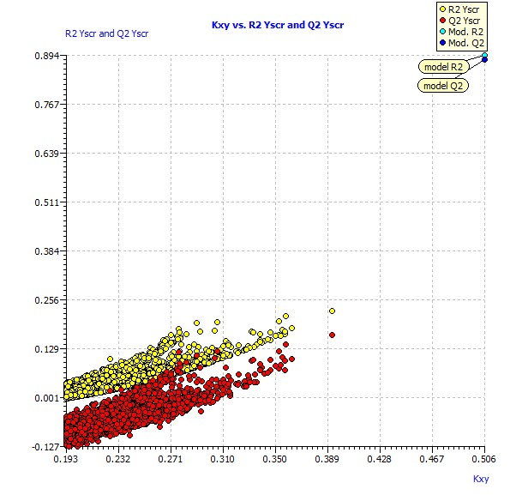
Figure S2. Y-scrambling graph in the internal validation.

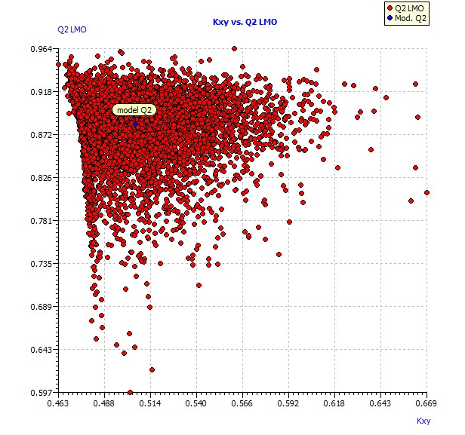
Figure S3. LMO scatter plot.

Figure S4. Applicability domain. Hat diagonal values versus standardized residuals. The orange circles represent the training set compounds and the green circles represent the prediction set.

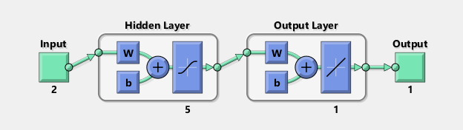
Figure S5. Artificial neural network diagram for prediction of pIC50.

Figure S6. Correlation coefficient between the experimental and estimated pIC50 in training, validation, testing and all data samples.
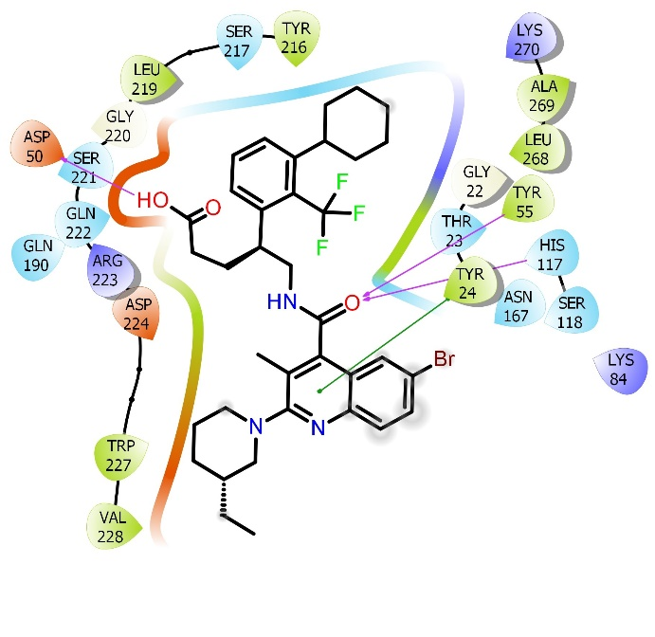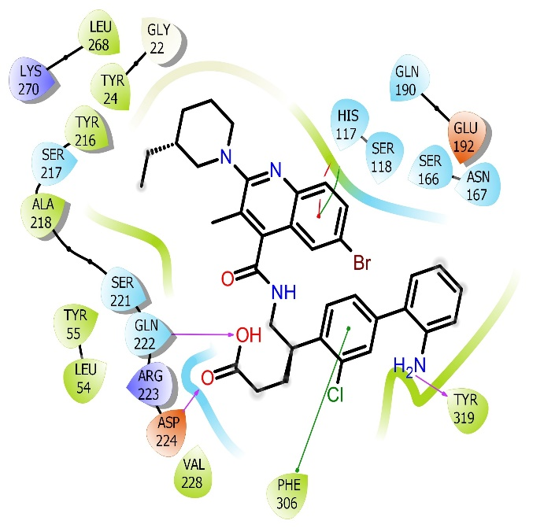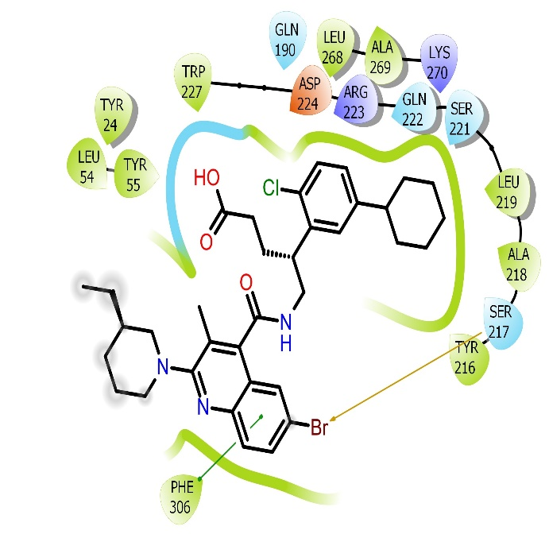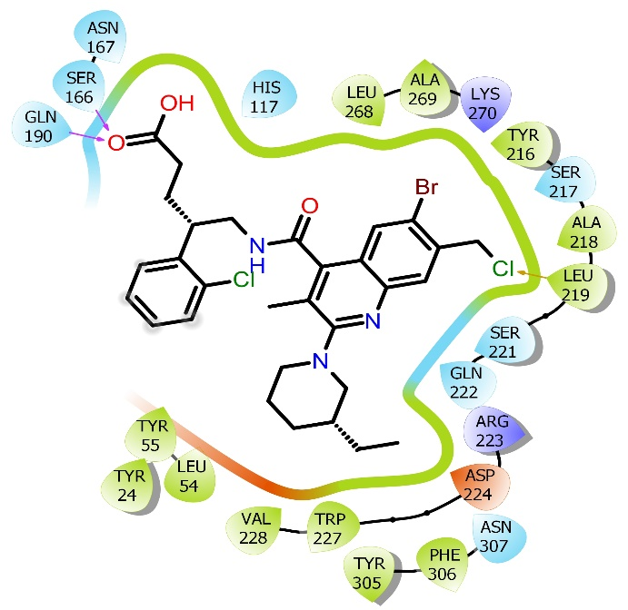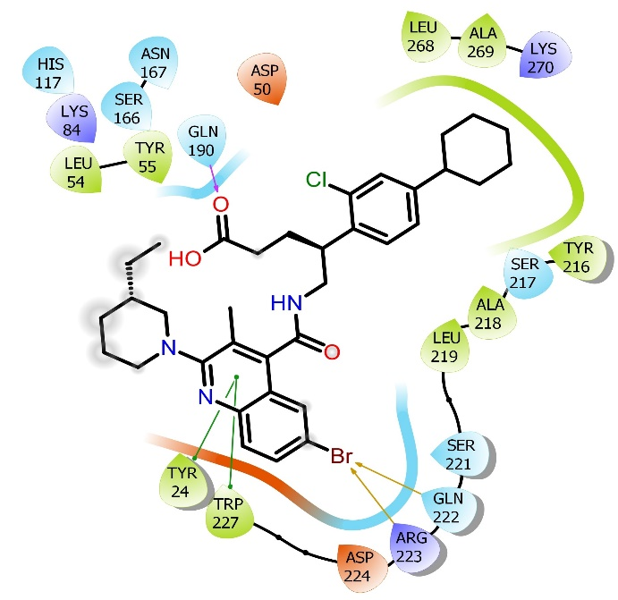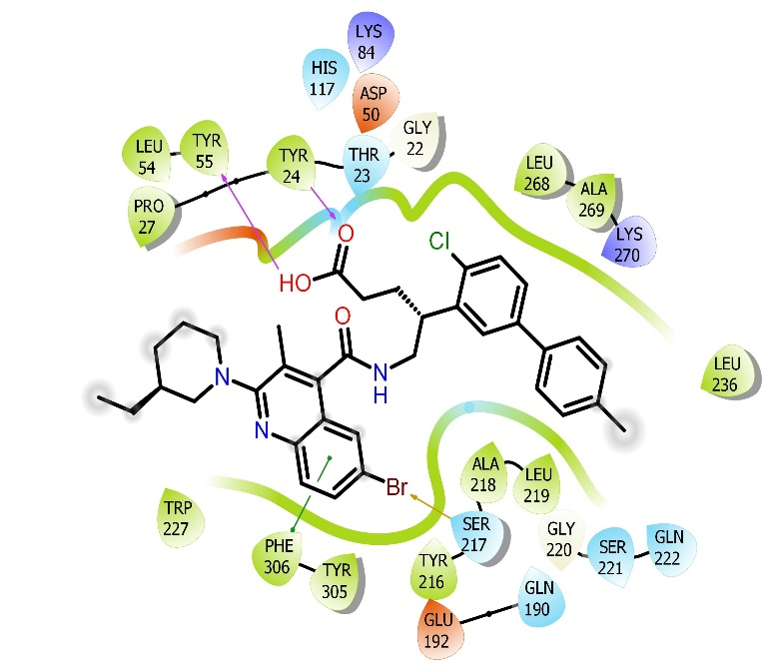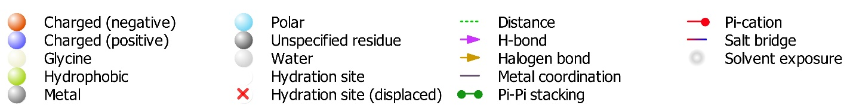
P10ct
P10bs
P3bs
P9q
P10bh
P10ai
Figure S7. Molecular docking interactions of designed compounds with the target receptor of prostaglandin F synthase (PDB ID: 2F38)
Figure S8. Frontier molecular orbital maps of the designed compounds.

MEP-P3bs | MEP-P9q
MEP-P9x | MEP-P10ai
MEP-P10bh | MEP-P10bs
MEP-P10ct
Figure S9. MEP maps of the designed compounds

Figure S10. Best designed compounds with PGF2α inhibitory activity.

