Saporting data
Synthesis and Antibacterial Activity of 8-Nitro-7-(aryl/alkyl) and Tetracyclic Fluoroquinolones Encompassing Thiophene, Furan, and Related Congeners
Ala’a A. Al-Akhras¹⁺², Shaima' K. Alsawaleha², Salma A. Musameh², Jalal A. Zahra²*, Mustafa M. El-Abadelah², Marwan abu-halaweh³ and Monther A. Khanfar

NMR SPECTRUM 7
Figure 1.1: The 1H-NMR spectrum of compound 12a (DMSO-d6). 7
Figure 1.2: The 13C-NMR spectrum of compound 12a (DMSO-d6). 7
Figure 1.3: The DEPT (135) spectrum of compound 12a (DMSO-d6). 8
Figure 1.4: The COSY spectrum of compound 12a (DMSO-d6). 8
Figure 1.5: The HMQC spectrum of compound 12a (DMSO-d6). 9
Figure 1.6: The HMBC spectrum of compound 12a (DMSO-d6). 9
Figure 1.7: The 1H-NMR spectrum of compound 15a (DMSO-d6). 10
Figure 1.8: The 13C-NMR spectrum of compound 15a (DMSO-d6). 10
Figure 1.10: The COSY spectrum of compound 15a (DMSO-d6). 11
Figure 1.11: The HMQC spectrum of compound 15a (DMSO-d6). 12
Figure 1.12: The HMBC spectrum of compound 15a (DMSO-d6). 12
Figure 1.13: The 1H-NMR spectrum of compound 19a (DMSO-d6). 13
Figure 1.14: The 13C-NMR spectrum of compound 19a (DMSO-d6). 13
Figure 1.15: The DEPT (135) spectrum of compound 19a (DMSO-d6). 14
Figure 1.16: The COSY spectrum of compound 19a (DMSO-d6). 14
Figure 1.17: The HMQC spectrum of compound 19a (DMSO-d6). 15
Figure 1.18: The HMBC spectrum of compound 19a (DMSO-d6). 15
Figure 1.19: The 1H-NMR spectrum of compound 20a (DMSO-d6). 16
Figure 1.20: The 13C-NMR spectrum of compound 20a (DMSO-d6). 16
Figure 1.23: The HMQC spectrum of compound 20a (DMSO-d6). 18
Figure 1.24: The HMBC spectrum of compound20a (DMSO-d6). 18
Figure 1.25: The 1H-NMR spectrum of compound 11b (DMSO-d6). 20
Figure 1.26: The 13C-NMR spectrum of compound 11b (DMSO-d6). 20
Figure 1.27: The DEPT (135) spectrum of compound 11b (DMSO-d6). 21
Figure 1.28: The COSY spectrum of compound 11b (DMSO-d6). 21
Figure 1.29: The HMQC spectrum of compound 11b (DMSO-d6). 22
Figure 1.30: The HMBC spectrum of compound 11b (DMSO-d6). 22
Figure 1.33: The DEPT (135) spectrum of compound 13b (DMSO-d6). 24
Figure 1.34: The COSY spectrum of compound 13b (DMSO-d6). 24
Figure 1.35: The HMQC spectrum of compound 13b (DMSO-d6). 25
Figure 1.36: The HMBC spectrum of compound 13b (DMSO-d6). 25
Figure 1.39: The DEPT (135) spectrum of compound 14b (DMSO-d6). 27
Figure 1.40: The COSY spectrum of compound 14b (DMSO-d6). 27
Figure 1.41: The HMQC spectrum of compound 14b (DMSO-d6). 28
Figure 1.42: The HMBC spectrum of compound 14b (DMSO-d6). 28
Figure 1.45: The DEPT (135) spectrum of compound 16b (DMSO-d6). 30
Figure 1.46 The COSY spectrum of compound 16b (DMSO-d6). 30
Figure 1.47: The HMQC spectrum of compound 16b (DMSO-d6). 31
Figure 1.48: The HMBC spectrum of compound 16b (DMSO-d6). 31
Figure 1.51: The DEPT (135) spectrum of compound 18b (DMSO-d6). 33
Figure 1.52: The COSY spectrum of compound 18b (DMSO-d6). 33
Figure 1.53: The HMQC spectrum of compound 18b (DMSO-d6). 34
Figure 1.54: The HMBC spectrum of compound 18b (DMSO-d6). 34
Figure 1.57: The DEPT (135) spectrum of compound 15b (DMSO-d6). 36
Figure 1.58: The COSY spectrum of compound 15b (DMSO-d6). 36
Figure 1.59: The HMQC spectrum of compound 15b (DMSO-d6). 37
Figure 1.60: The HMBC spectrum of compound 15b (DMSO-d6). 37
Figure 1.63: The DEPT (135) spectrum of compound 20a (DMSO-d6). 39
Figure 1.64: The COSY spectrum of compound 20a (DMSO-d6). 39
Figure 1.65: The HMQC spectrum of compound 20a (DMSO-d6). 40
Figure 1.66: The HMBC spectrum of compound 20a (DMSO-d6). 40
Figure 1.69: The DEPT (135) spectrum of compound 19b (DMSO-d6) 42
Figure 1.70: The COSY spectrum of compound 19b (DMSO-d6). 42
Figure 1.71: The HMQC spectrum of compound 19b (DMSO-d6). 43
Figure 1.72: The HMBC spectrum of compound 19b (DMSO-d6). 43
Figure 1.73: The 1H-NMR spectrum of compound 12a (DMSO-d6). 44
Figure 1.74: The 13C-NMR spectrum of compound 12a (DMSO-d6). 44
Figure 1.75: The DEPT (135) spectrum of compound 12a (DMSO-d6) 45
Figure 1.76: The COSY spectrum of compound 12a (DMSO-d6). 45
Figure 1.77: The HMQC spectrum of compound 12a (DMSO-d6). 46
Figure 1.78: The HMBC spectrum of compound 12a (DMSO-d6). 46
Mass SPECTRUM 47
Figure 2.1: The Mass spectrum for compound 11b, [M+Na]⁺. 47
Figure 2.2: The Mass spectrum for compound 14b, [M+Na]⁺. 47
Figure 2.3: The Mass spectrum for compound 12a, [M+H]⁺. 47
Figure 2.4: The Mass spectrum for compound 12b, [M+H]⁺. 48
Figure 2.5: The Mass spectrum for compound 20a, [M+H]⁺. 48
Figure 2.6: The Mass spectrum for compound 20b, [M+H]⁺. 49
Figure 2.7: The Mass spectrum for compound 19a, [M+H]⁺. 49
Figure 2.8: The Mass spectrum for compound 19b, [M+Na]⁺. 49
IR-SPECTRUM 50
Figure 3.1: The IR spectrum for compound 14b. 50
Figure 3.2: The IR spectrum for compound 13b. 50
Figure 3.3: The IR spectrum for compound 11b. 51
Figure 2.4: The IR spectrum for compound 12a. 51
Figure 3.5: The IR spectrum for compound 12b. 52
Figure 3.6: The IR spectrum for compound 20a. 53
Figure 3.7: The IR spectrum for compound 20b. 53
Figure 3.8: The IR spectrum for compound 19a. 54
Figure 3.9: The IR spectrum for compound 19b. 54
Figure 3.10: The IR spectrum for compound 18b. 55
Figure 3.11: The IR spectrum for compound 16b. 55

NMR SPECTRUM
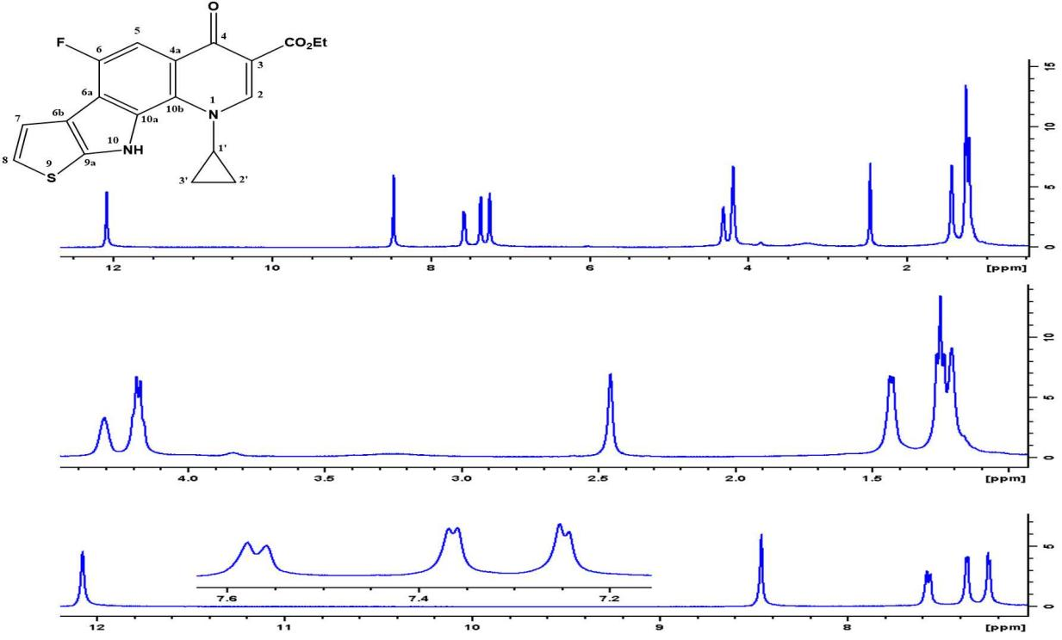

Figure 1.1: The 1H-NMR spectrum of compound 12a (DMSO-d6).

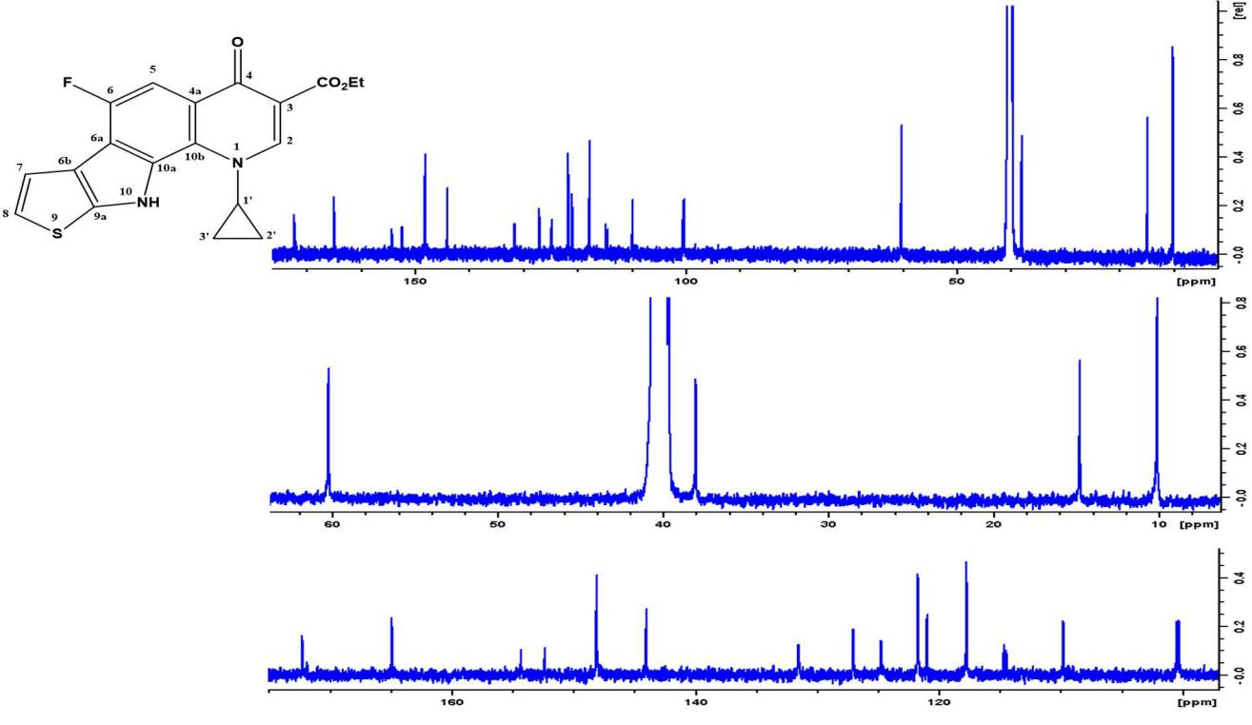

Figure 1.2: The 13C-NMR spectrum of compound 12a (DMSO-d6).

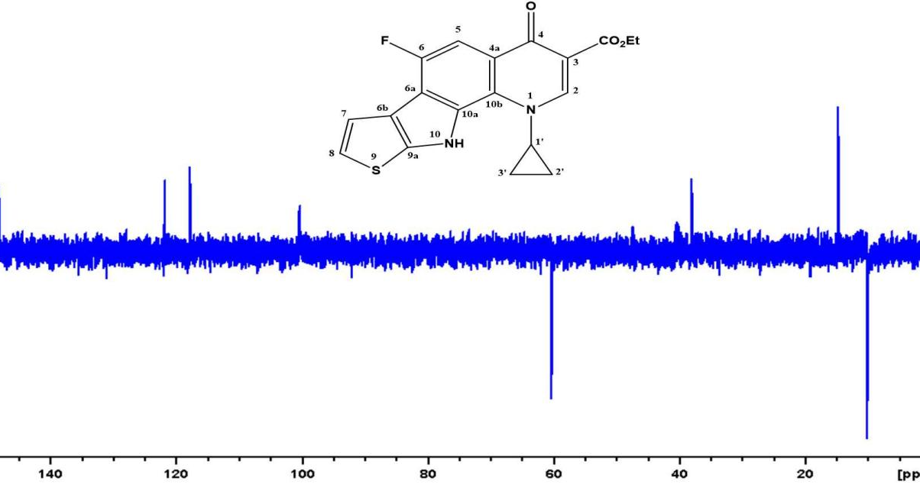

Figure 1.3: The DEPT (135) spectrum of compound 12a (DMSO-d6).

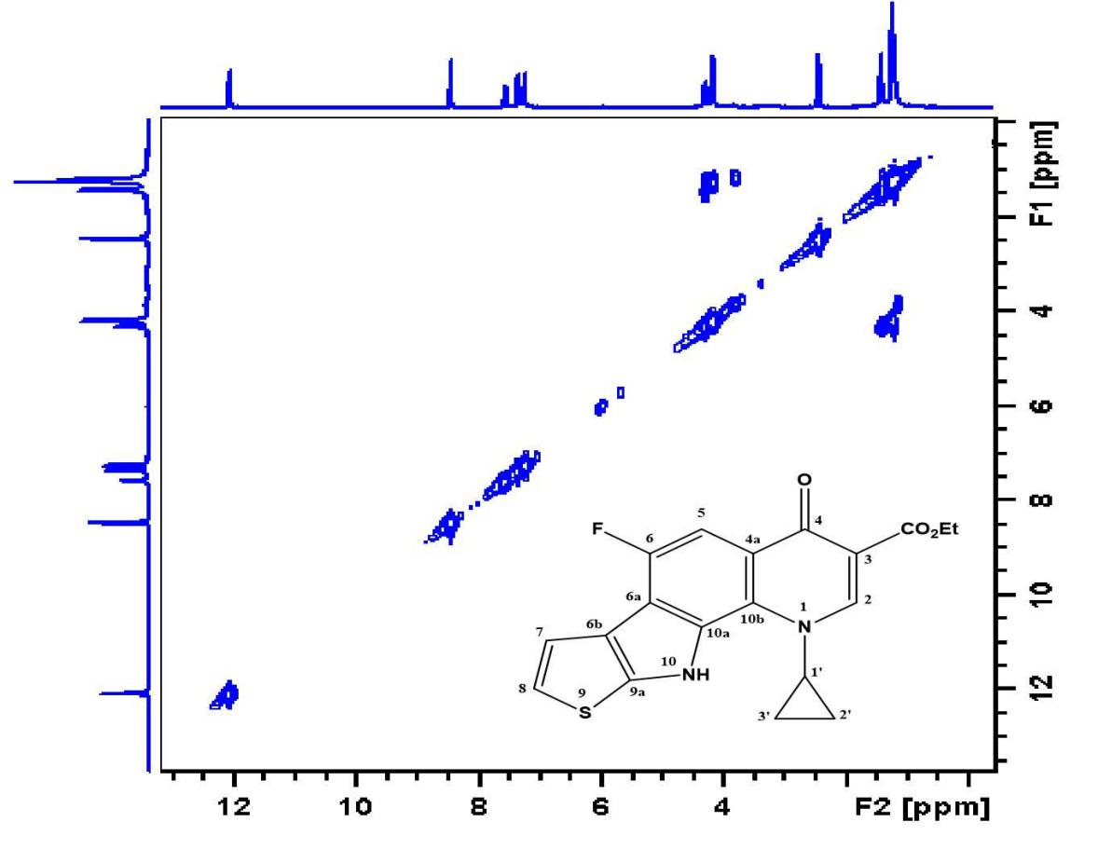

Figure 1.4: The COSY spectrum of compound 12a (DMSO-d6).

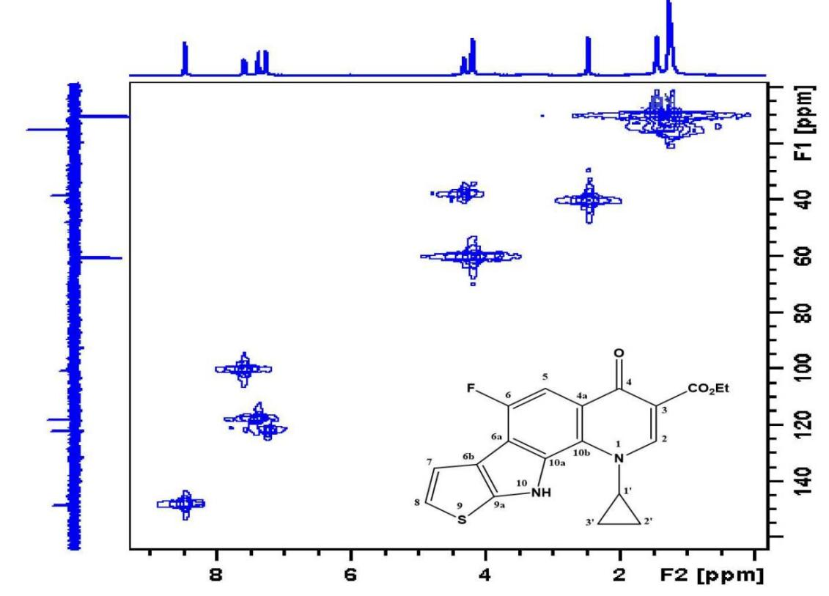

Figure 1.5: The HMQC spectrum of compound 12a (DMSO-d6).

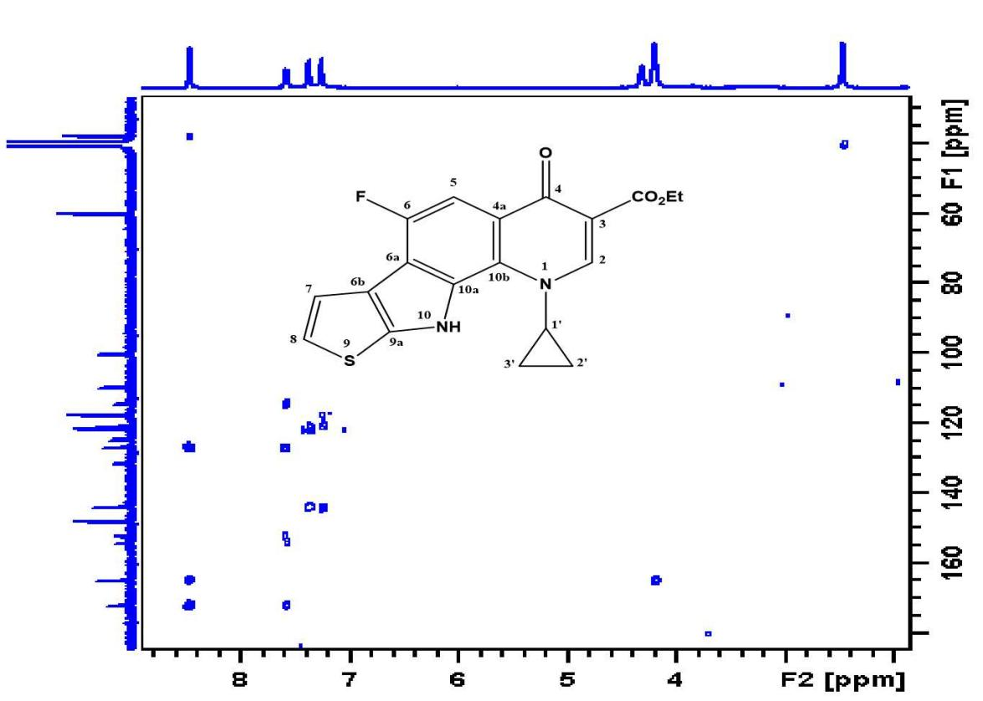

Figure 1.6: The HMBC spectrum of compound 12a (DMSO-d6).

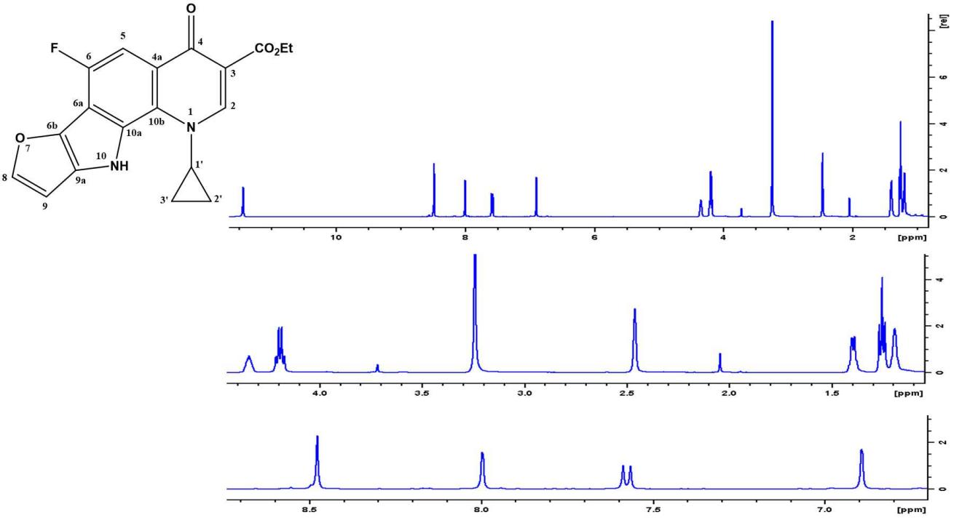

Figure 1.7: The 1H-NMR spectrum of compound 15a (DMSO-d6).

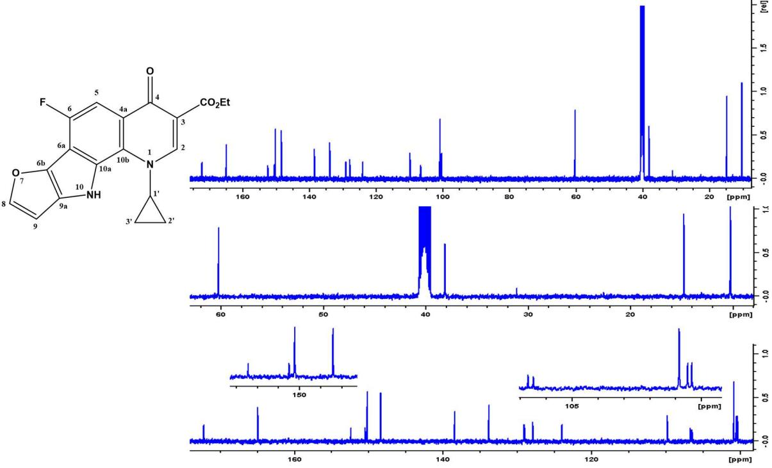

Figure 1.8: The 13C-NMR spectrum of compound 15a (DMSO-d6).

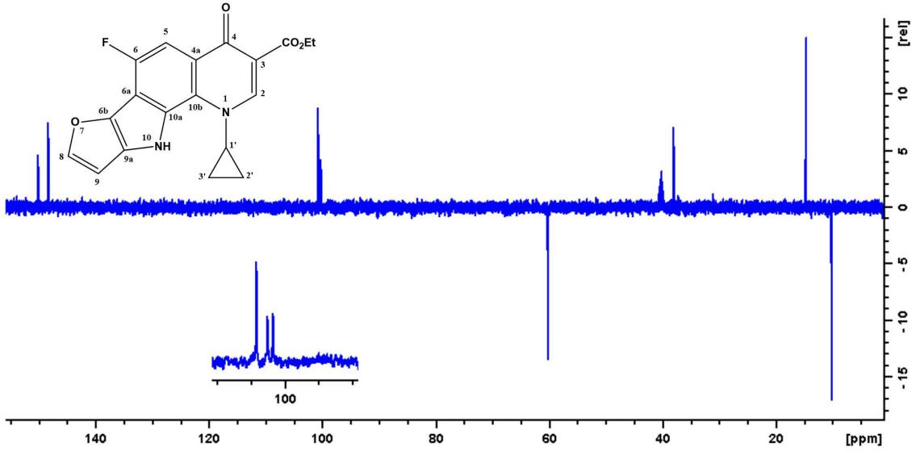

Figure 1.9: The DEPT (135) spectrum of compound 15a (DMSO-d6).

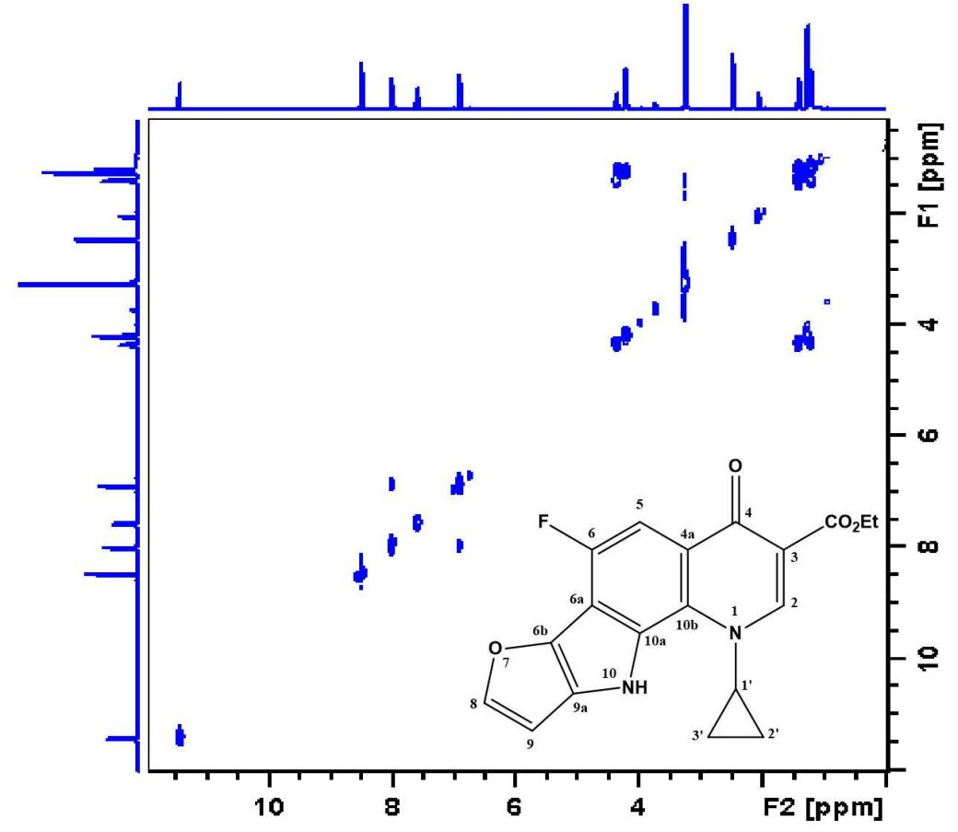

Figure 1.10: The COSY spectrum of compound 15a(DMSO-d6).

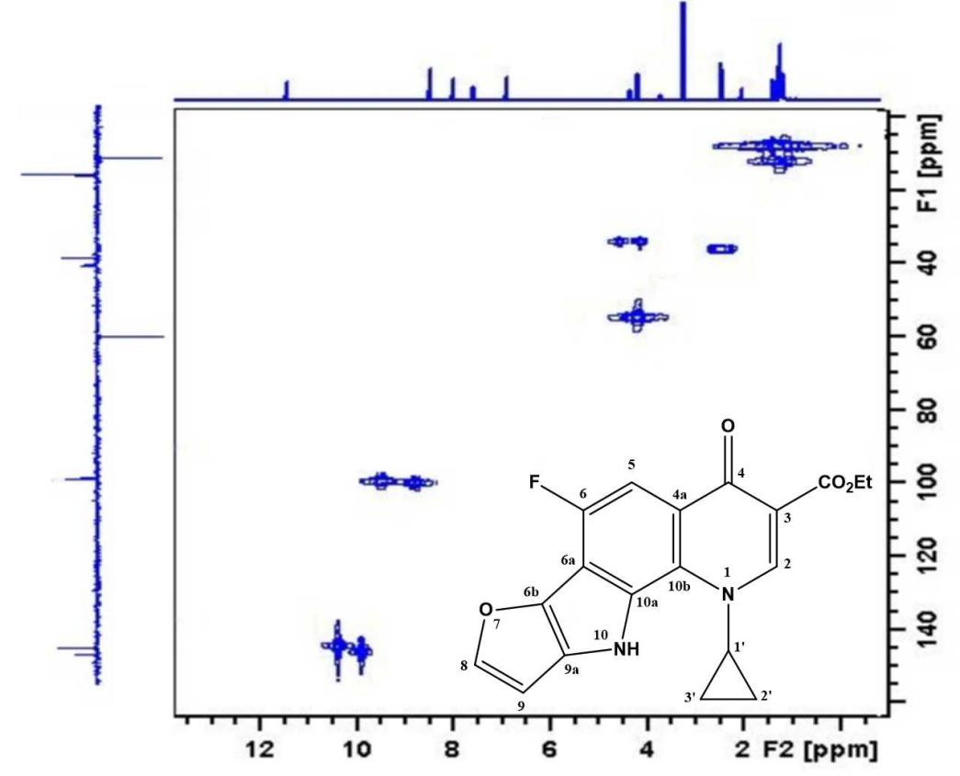

Figure 1.11: The HMQC spectrum of compound 15a (DMSO-d6).

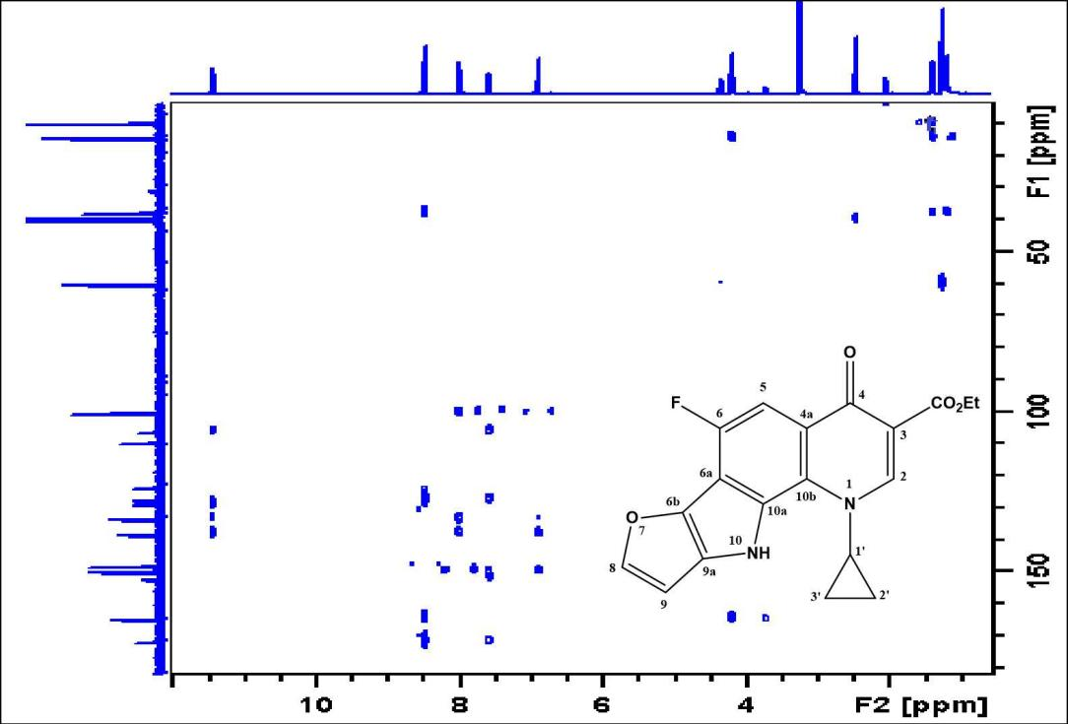

Figure 1.12: The HMBC spectrum of compound 15a (DMSO-d6).

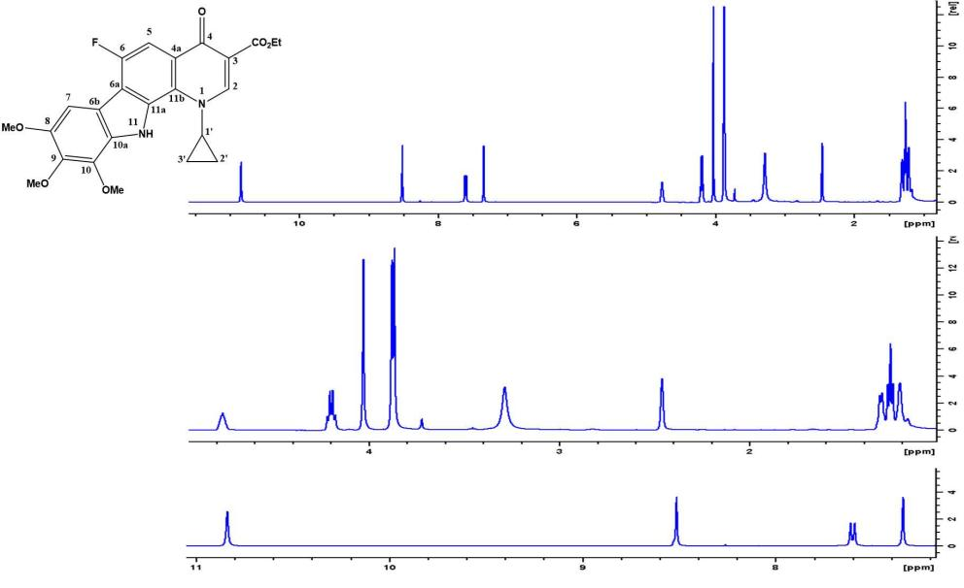

Figure 1.13: The 1H-NMR spectrum of compound 19a (DMSO-d6).

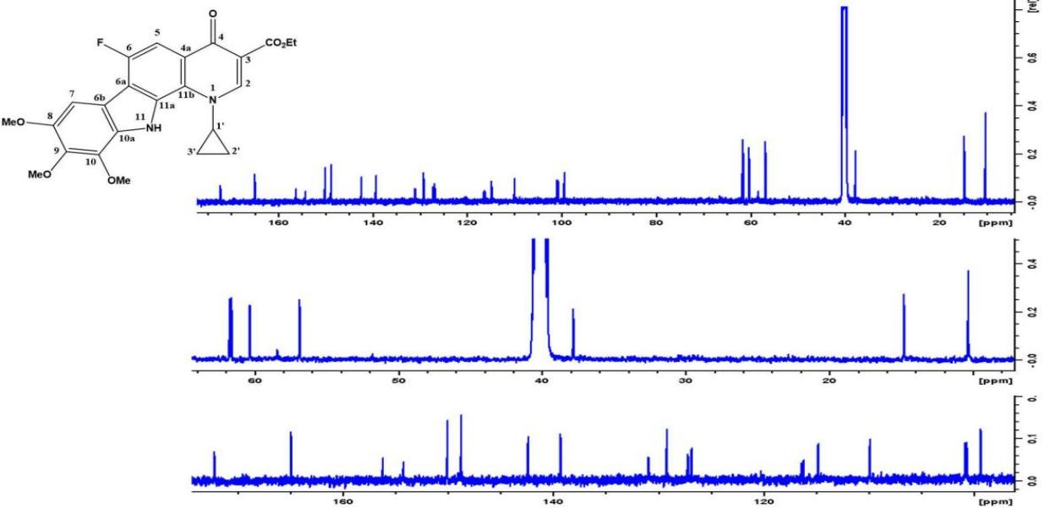

Figure 1.14: The 13C-NMR spectrum of compound 19a (DMSO-d6).

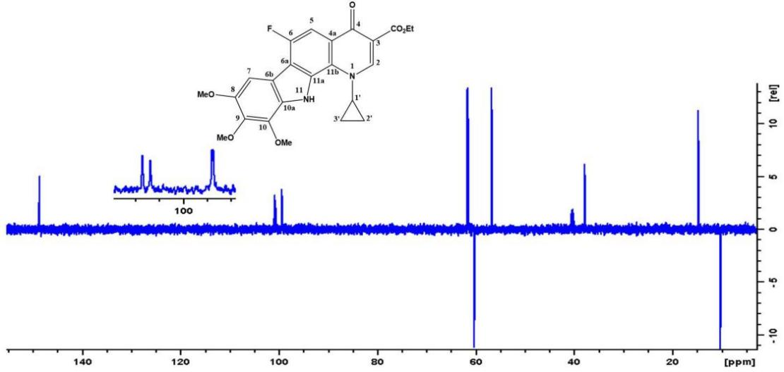

Figure 1.15: The DEPT (135) spectrum of compound 19a (DMSO-d6).

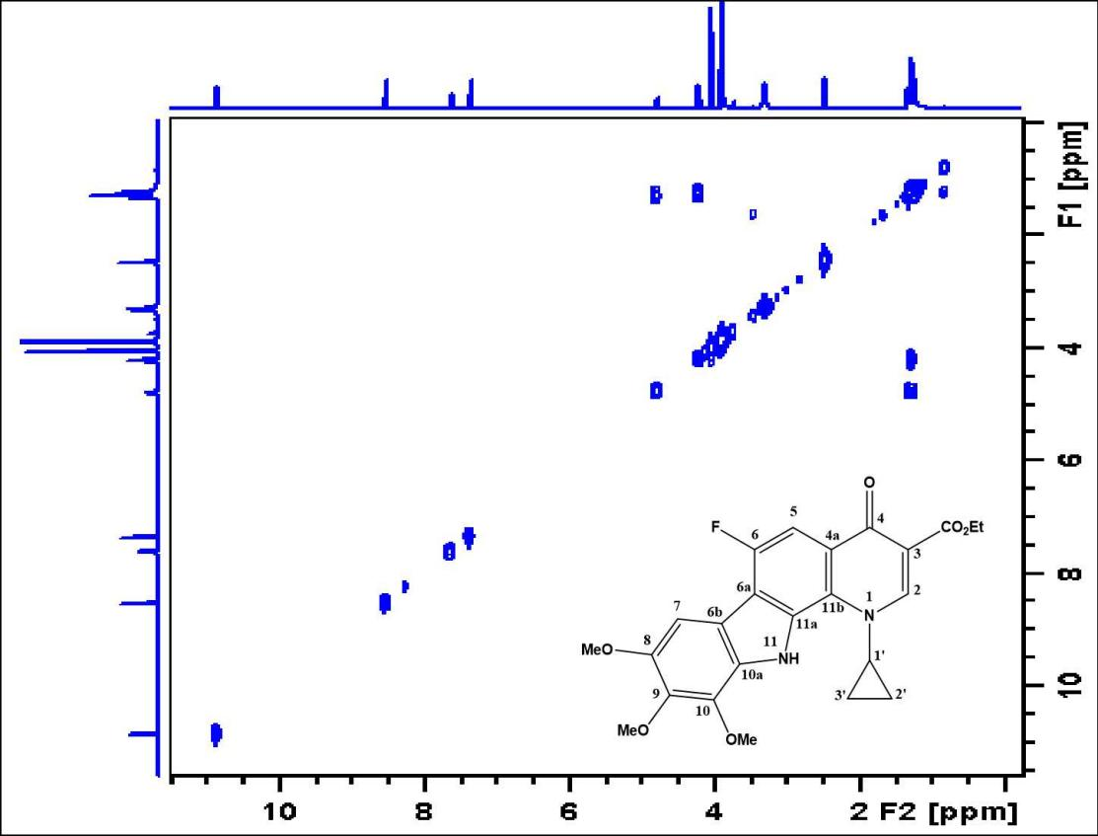

Figure 1.16: The COSY spectrum of compound 19a (DMSO-d6).

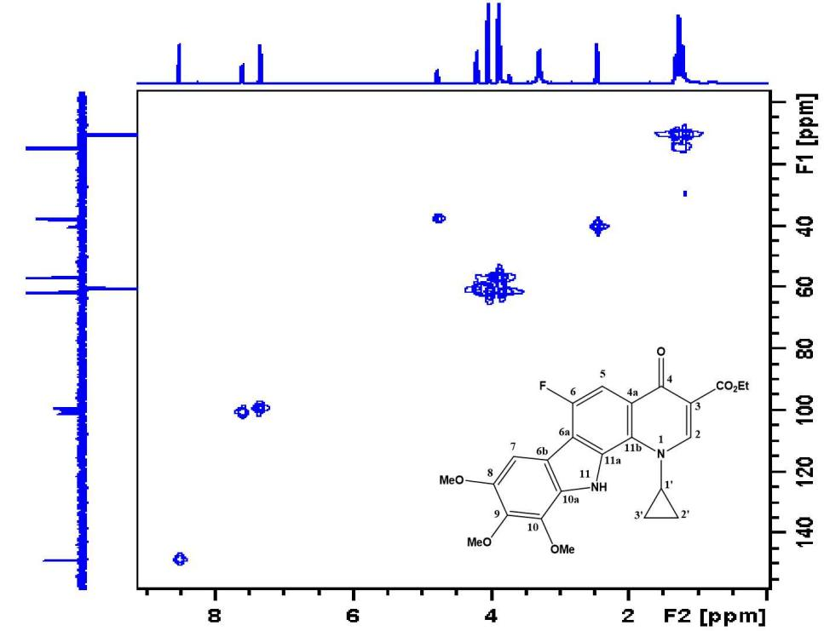

Figure 1.17: The HMQC spectrum of compound 19a (DMSO-d6).
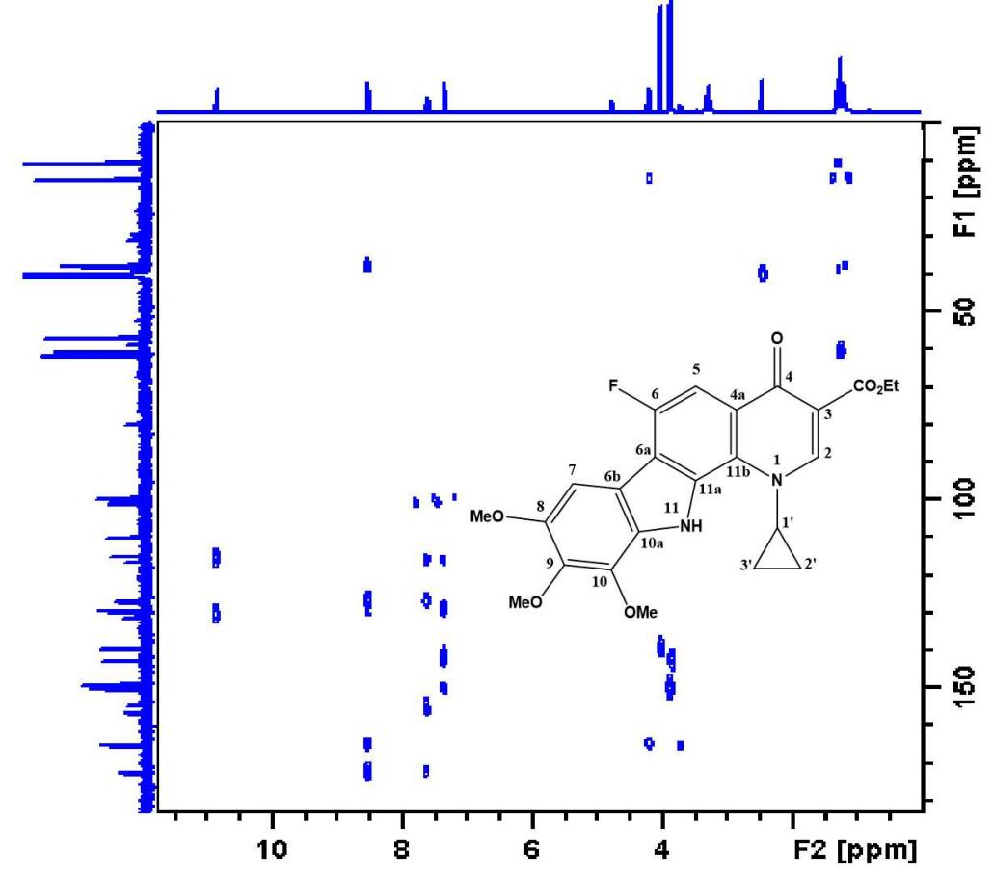

Figure 1.18: The HMBC spectrum of compound 19a (DMSO-d6).

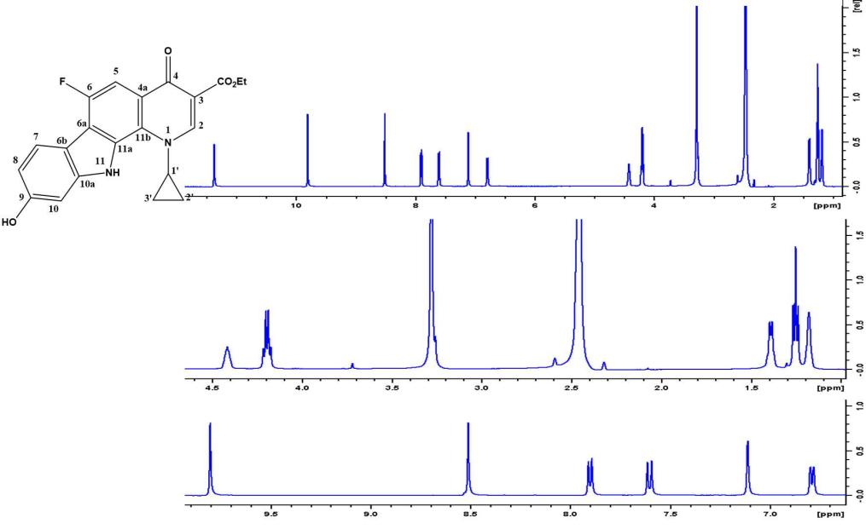

Figure 1.19: The 1H-NMR spectrum of compound 20a (DMSO-d6).

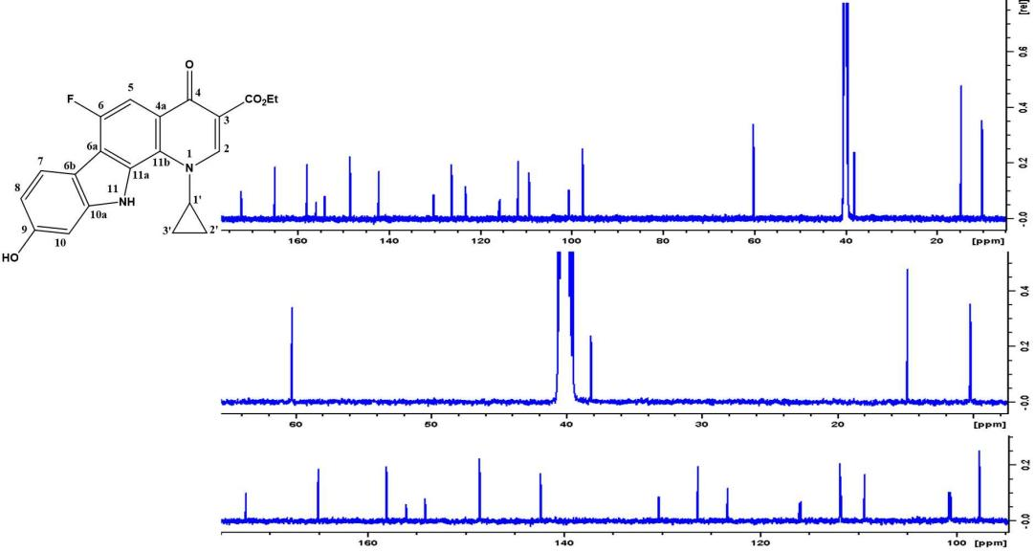

Figure 1.20: The 13C-NMR spectrum of compound 20a (DMSO-d6).

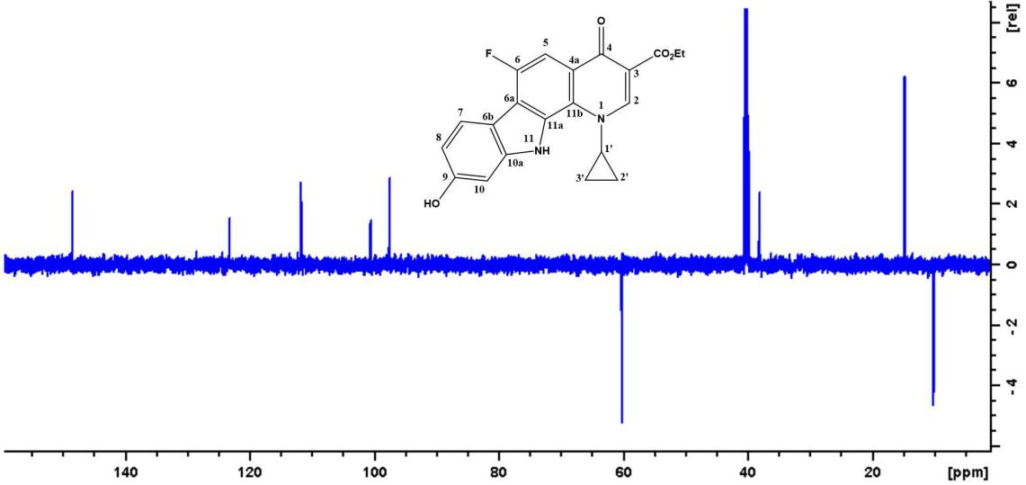 Figure 1.21: The Dept (135) spectrum of compound 20a (DMSO-d6)
.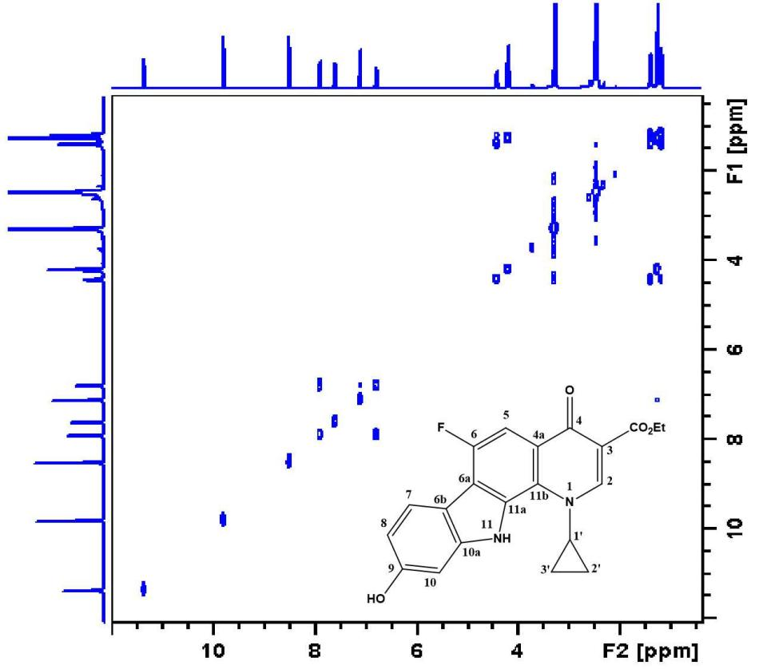 Figure 1.22: The COSY spectrum of compound 20a (DMSO-d6).
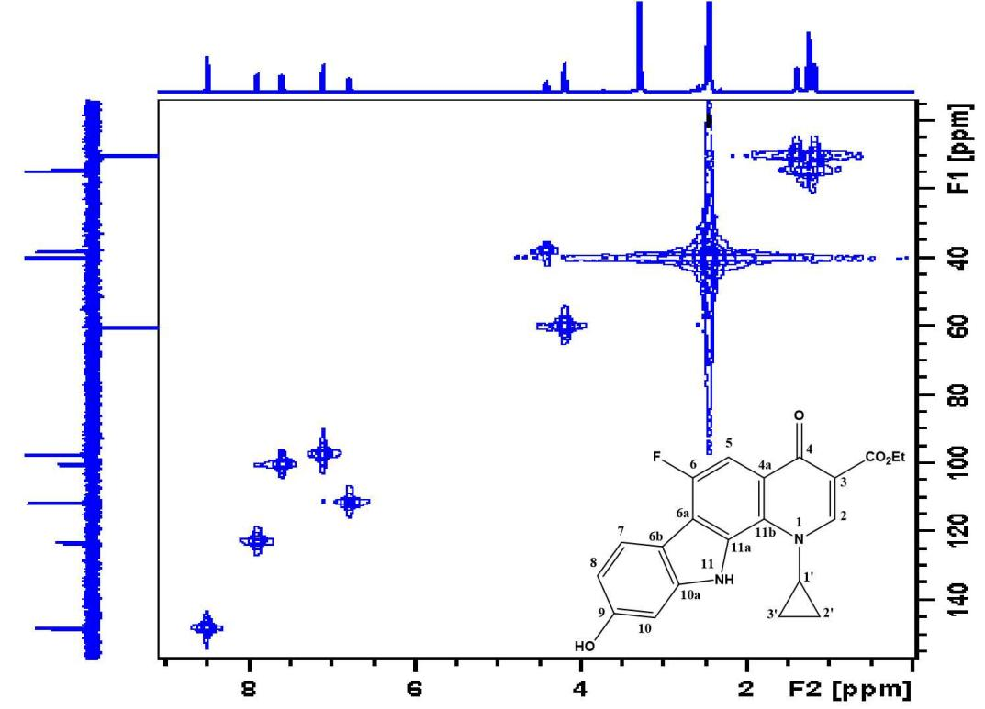

Figure 1.23: The HMQC spectrum of compound 20a (DMSO-d6).

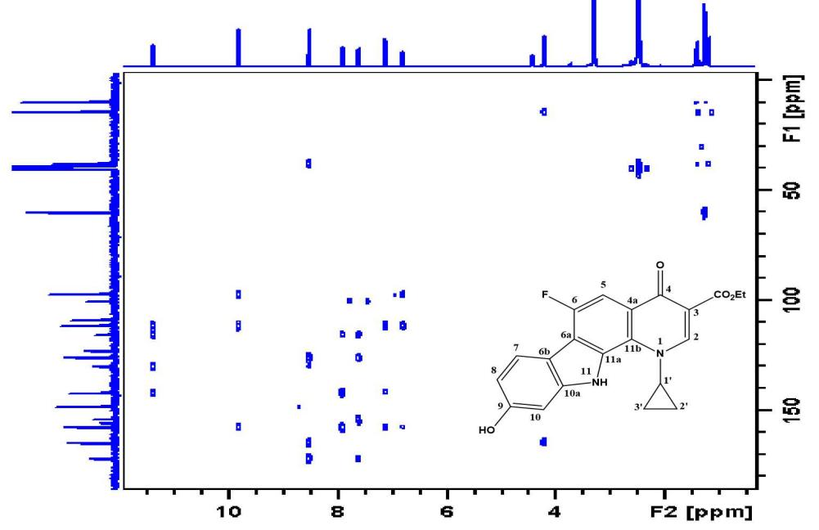

Figure 1.24: The HMBC spectrum of compound20a (DMSO-d6).

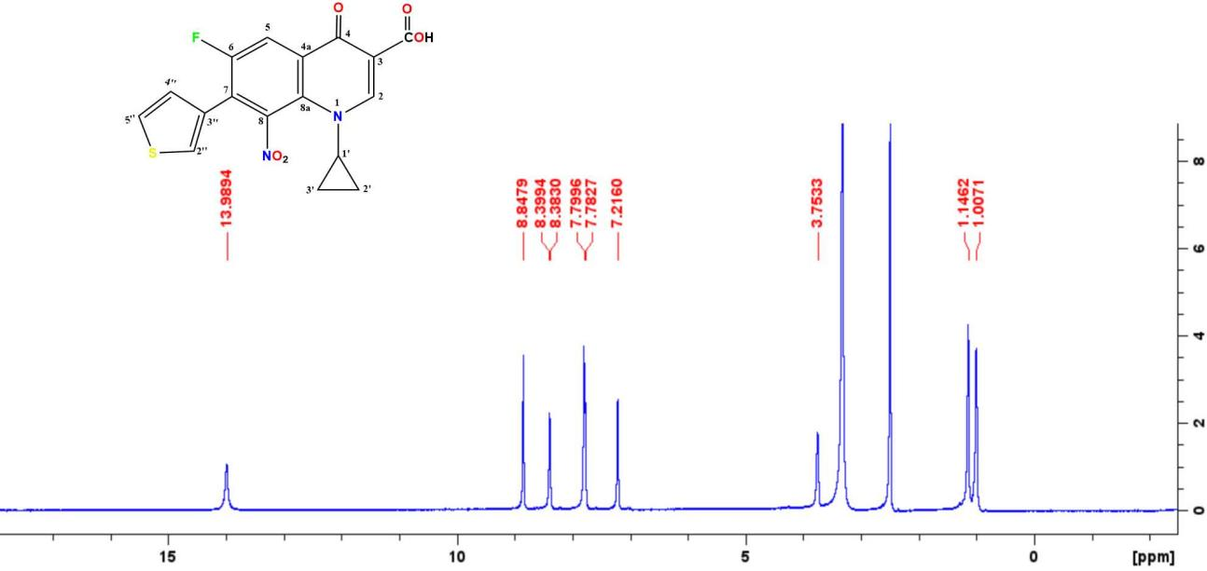

Figure 1.25: The 1H-NMR spectrum of compound 11b (DMSO-d6).
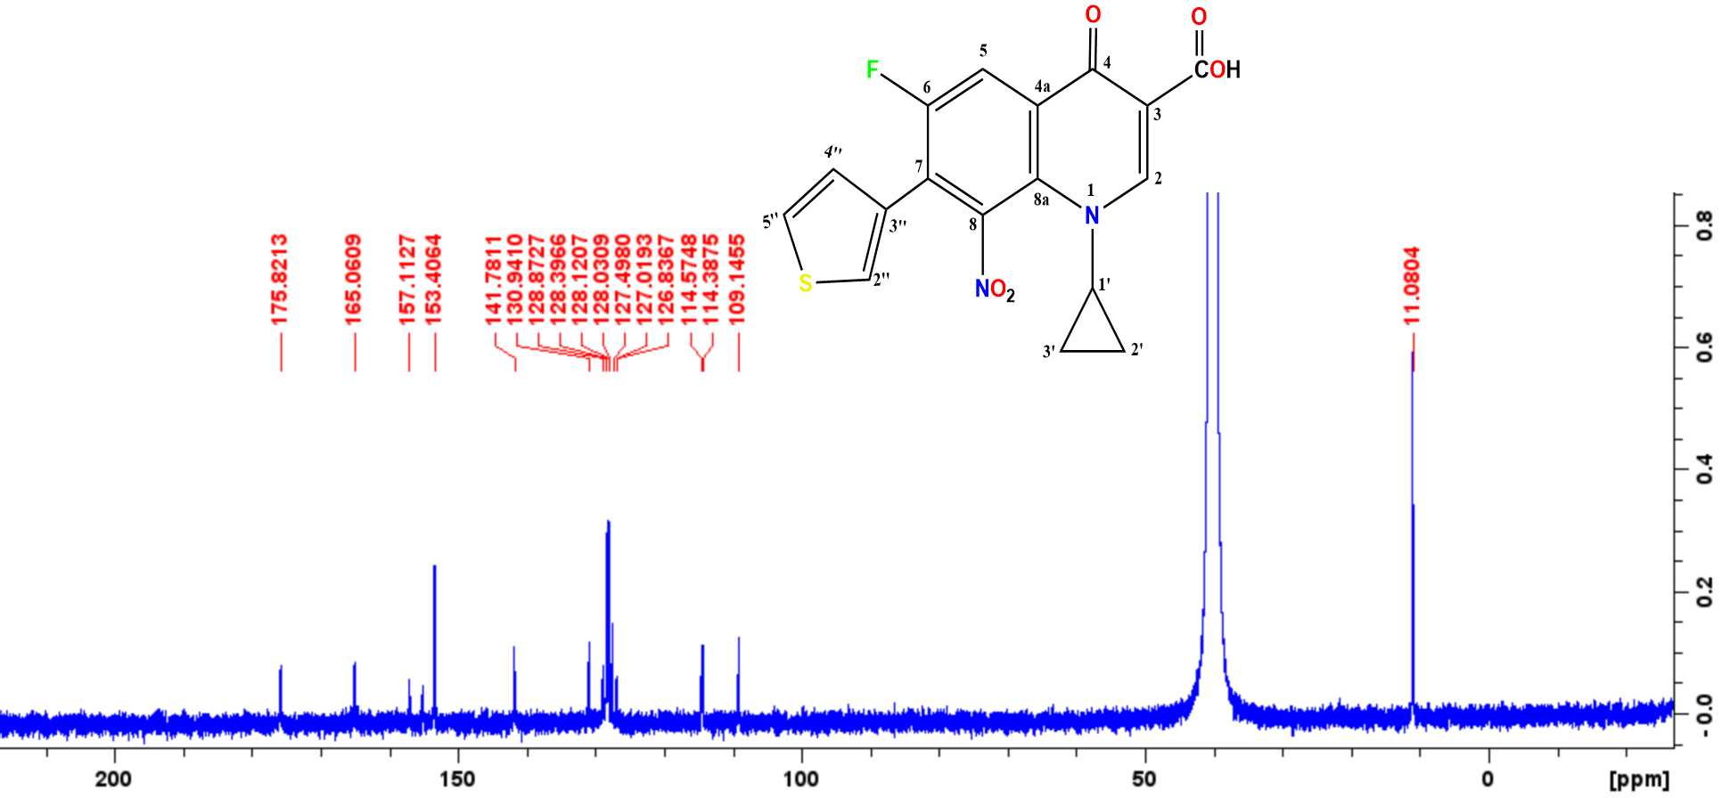

Figure 1.26: The 13C-NMR spectrum of compound 11b (DMSO-d6).
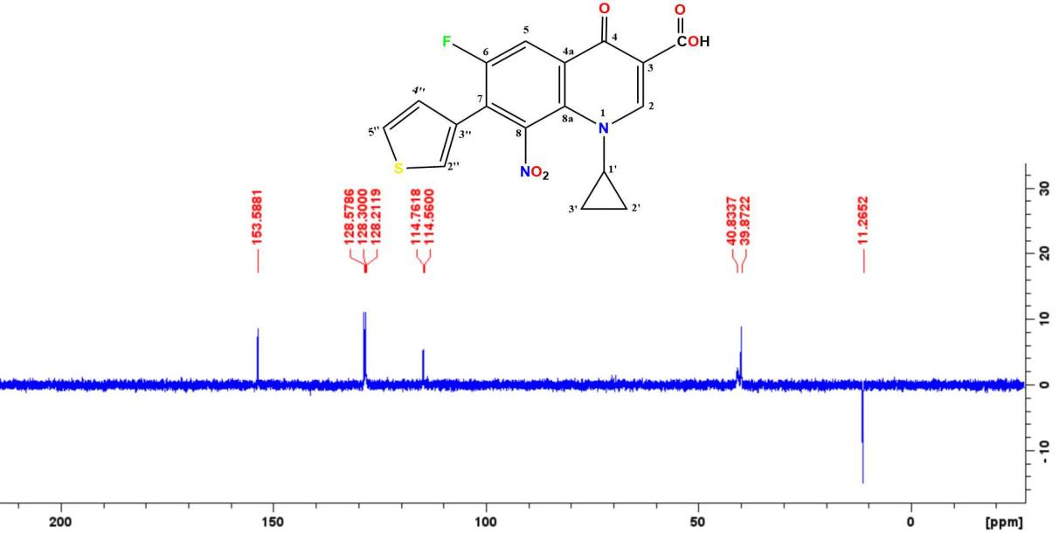

Figure 1.27: The DEPT (135) spectrum of compound 11b (DMSO-d6).

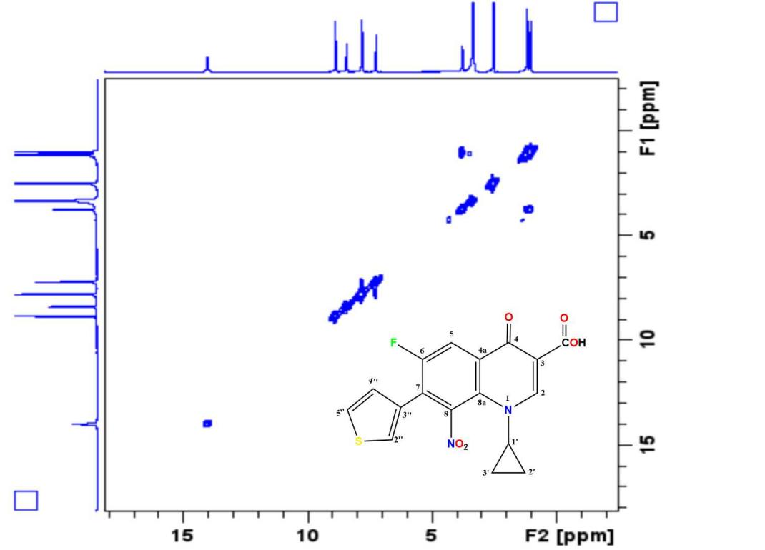

Figure 1.28: The COSY spectrum of compound 11b (DMSO-d6).

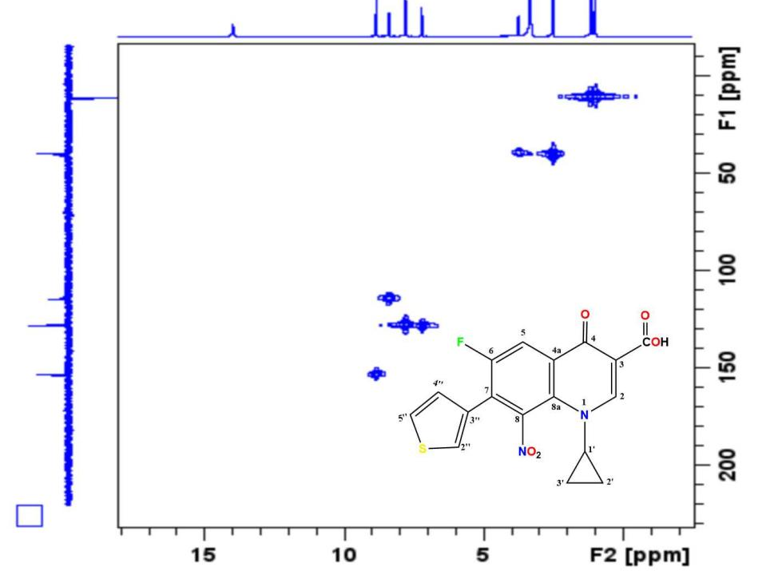

Figure 1.29: The HMQC spectrum of compound 11b (DMSO-d6).

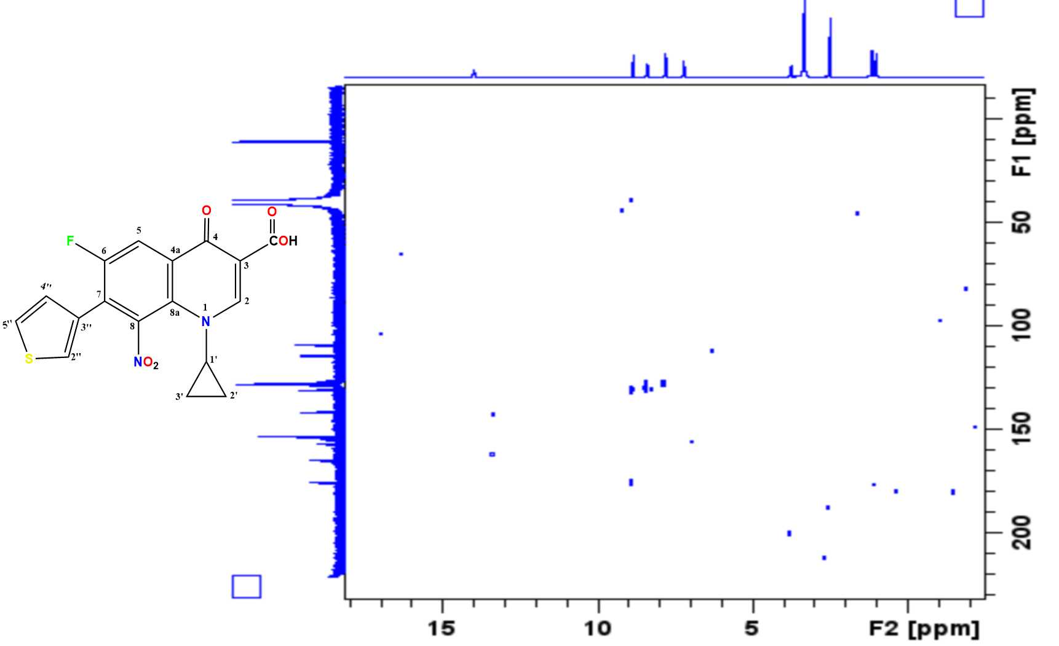

Figure 1.30: The HMBC spectrum of compound 11b(DMSO-d6).

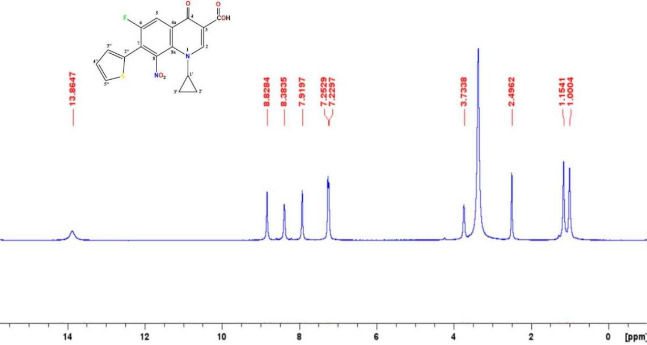 Figure 1.31: The 1H-NMR spectrum of compound 13b (DMSO-d6)

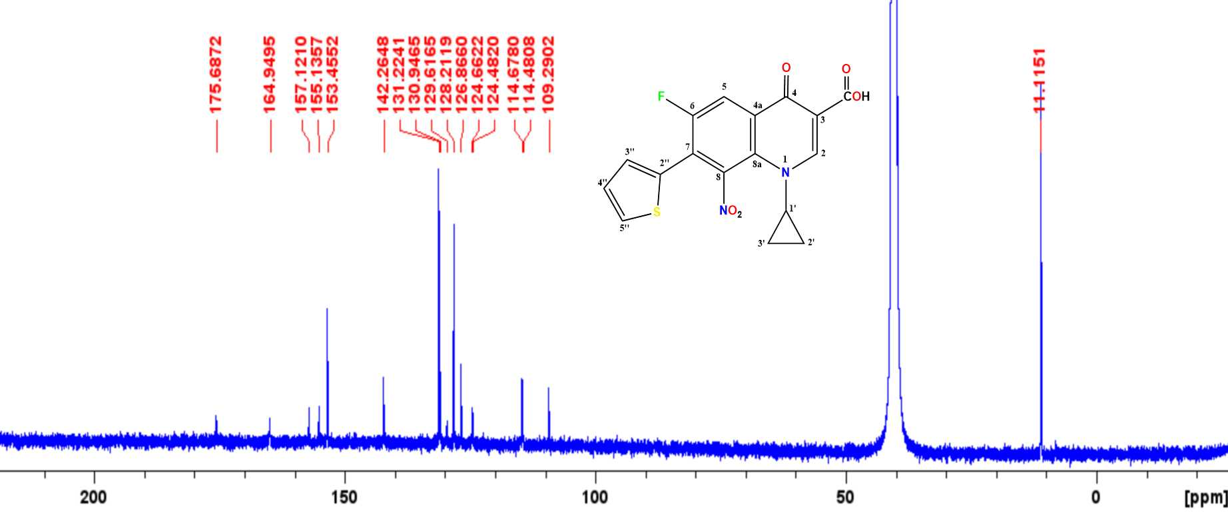 Figure 1.32: The 13C-NMR spectrum of compound 13b (DMSO-d6).
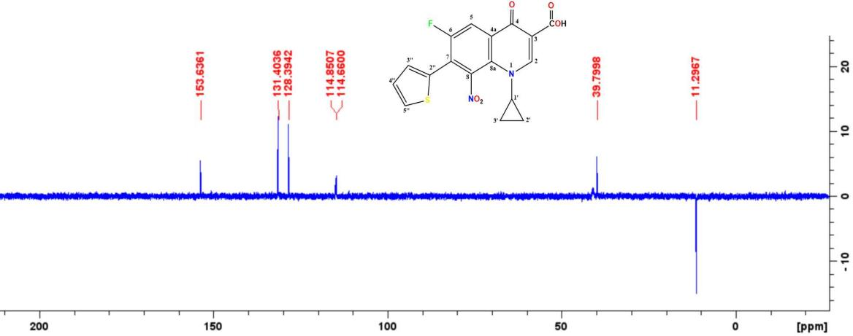

Figure 1.33: The DEPT (135) spectrum of compound 13b (DMSO-d6).

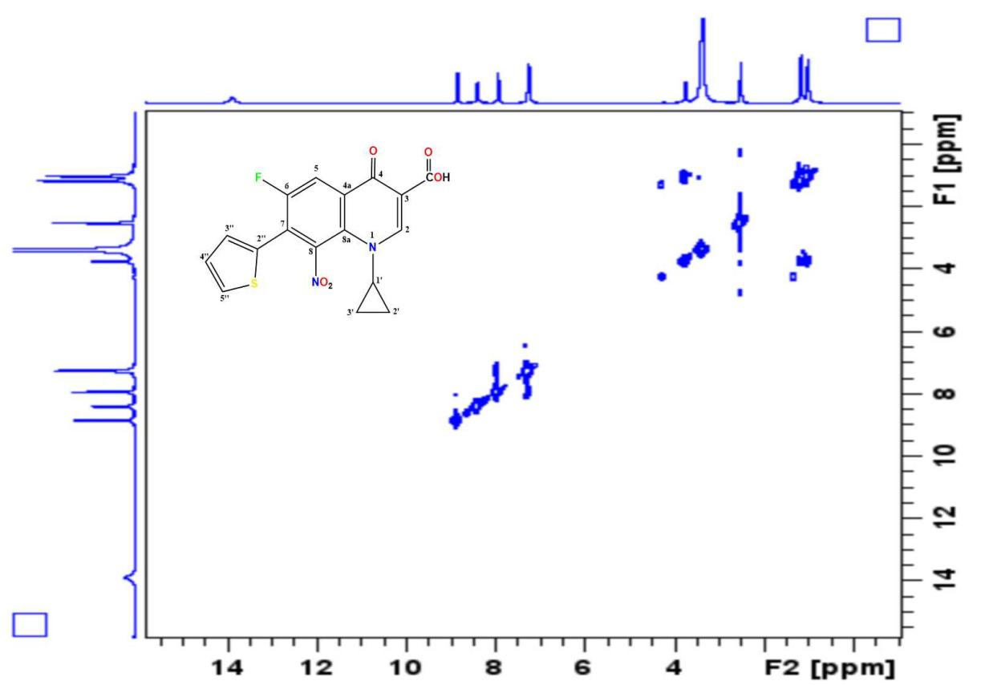

Figure 1.34: The COSY spectrum of compound 13b (DMSO-d6).

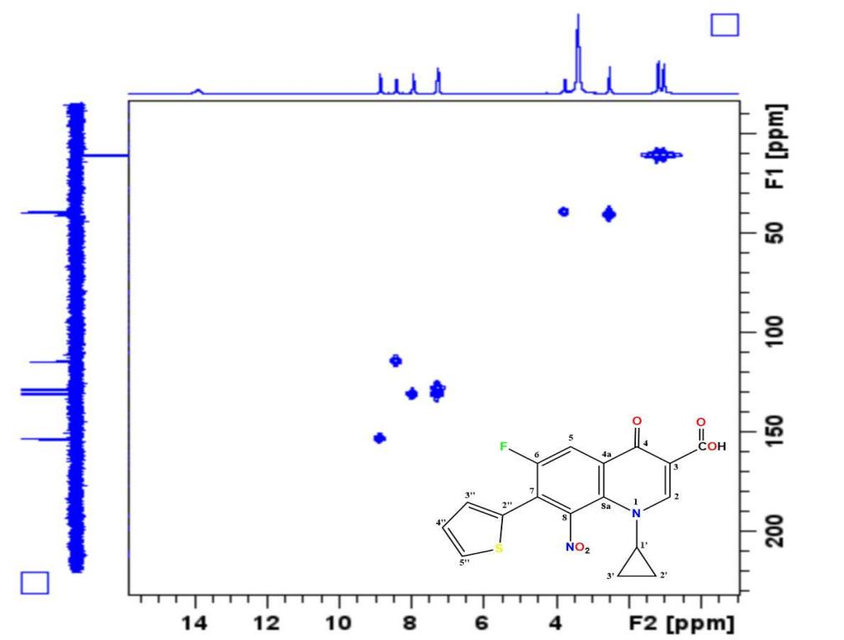

Figure 1.35: The HMQC spectrum of compound 13b (DMSO-d6).

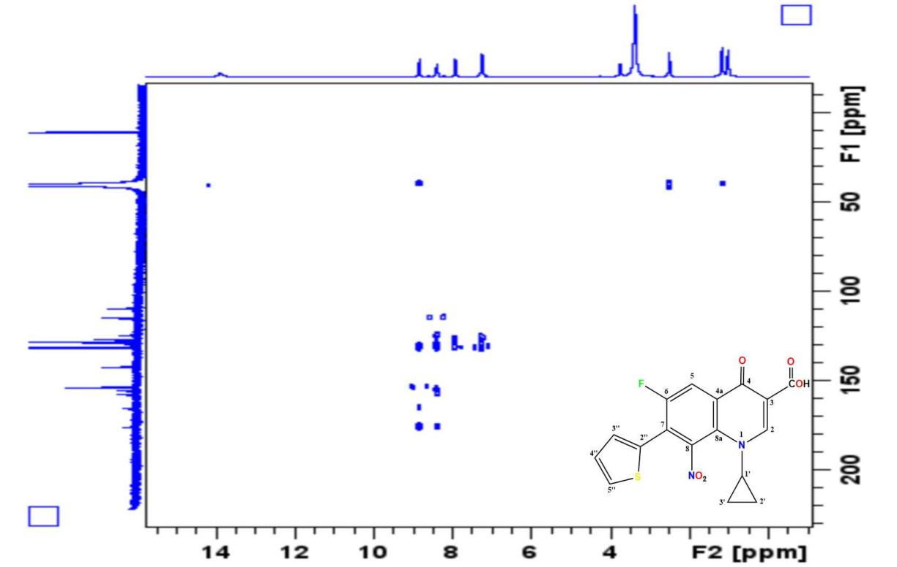

Figure 1.36: The HMBC spectrum of compound 13b (DMSO-d6).

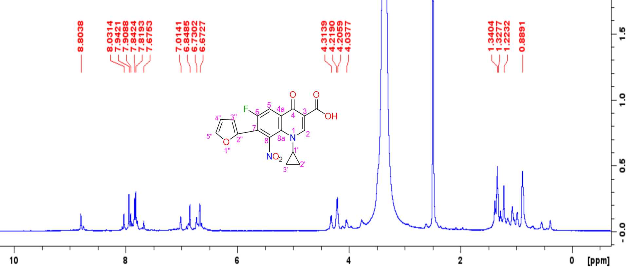Figure 1.37: The 1H-NMR spectrum of compound 14b (DMSO-d6)

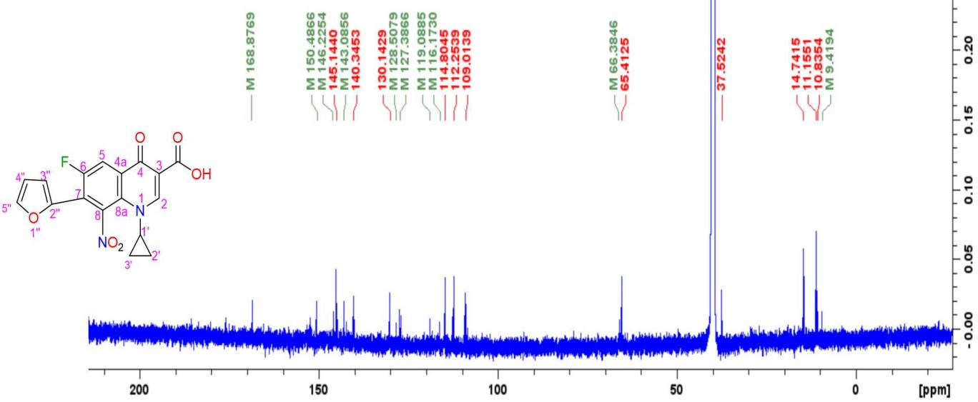 Figure 1.38: The 13C-NMR spectrum of compound 14bb (DMSO-d6).
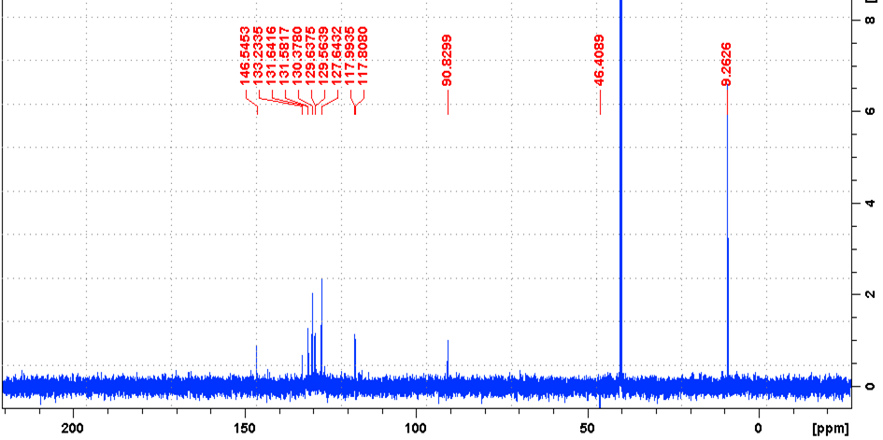

Figure 1.39: The DEPT (135) spectrum of compound 14b (DMSO-d6).

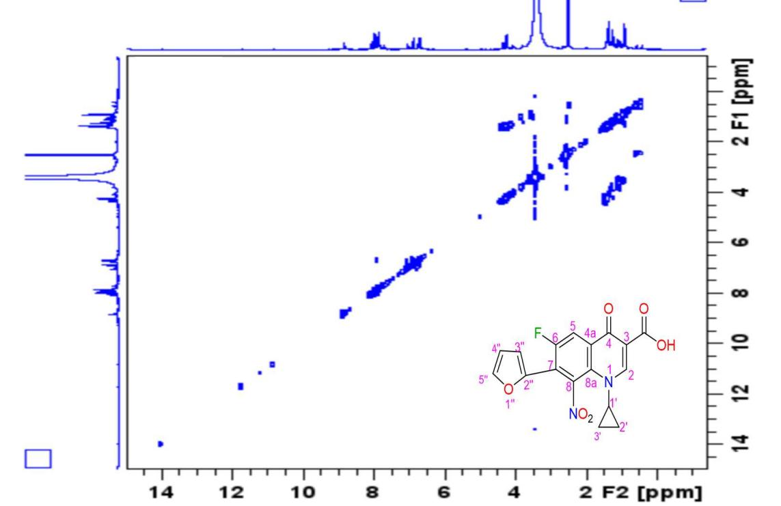

Figure 1.40: The COSY spectrum of compound 14b (DMSO-d6).

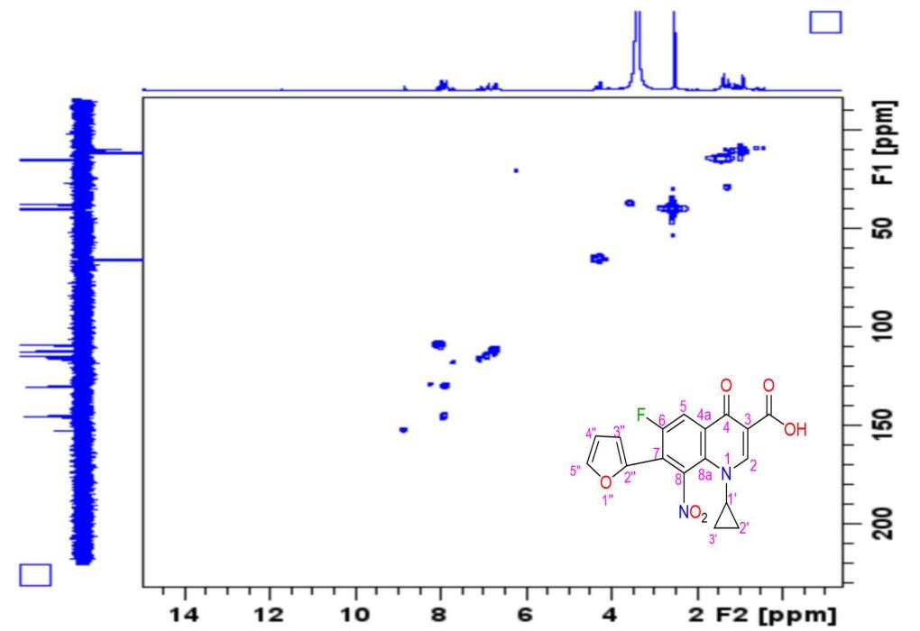

Figure 1.41: The HMQC spectrum of compound 14b (DMSO-d6).

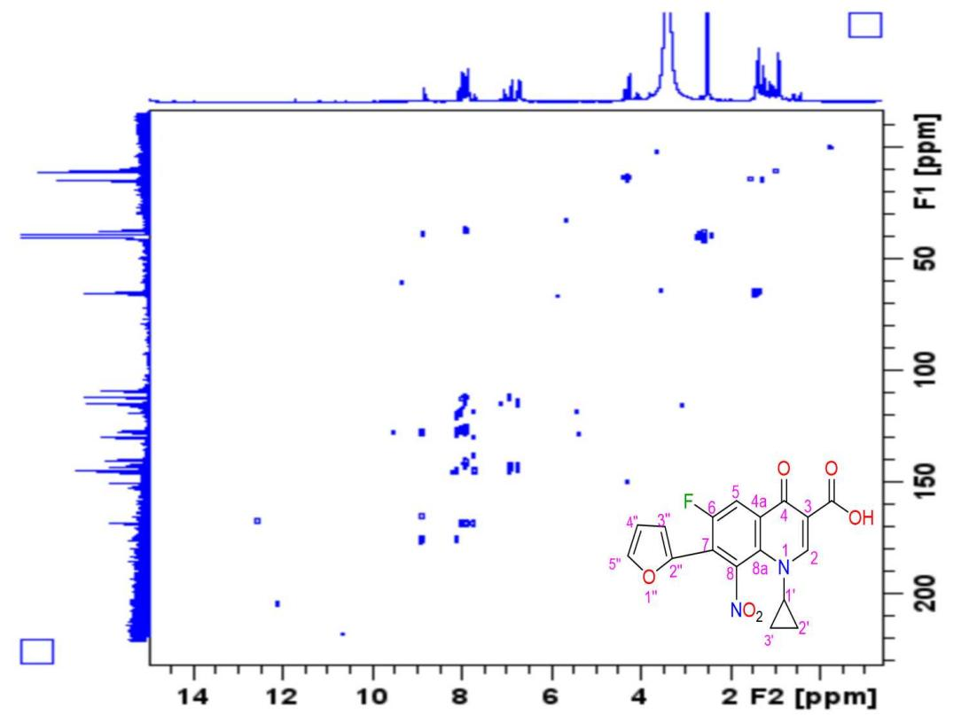

Figure 1.42: The HMBC spectrum of compound 14b (DMSO-d6).

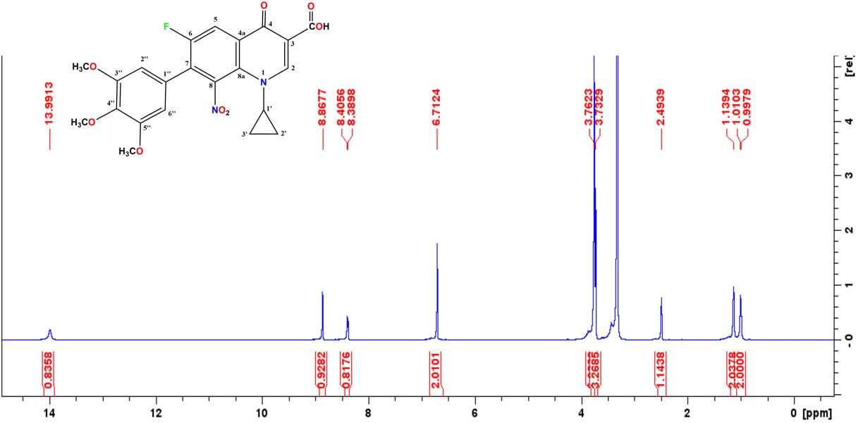 Figure 1.43: The 1H-NMR spectrum of compound 16b (DMSO-d6).

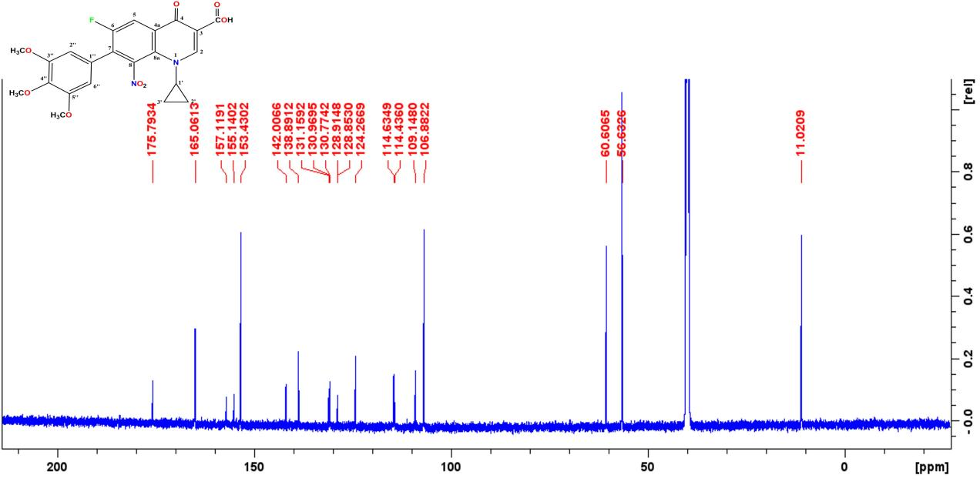 Figure 1.44: The 13C-NMR spectrum of compound 16b (DMSO-d6).
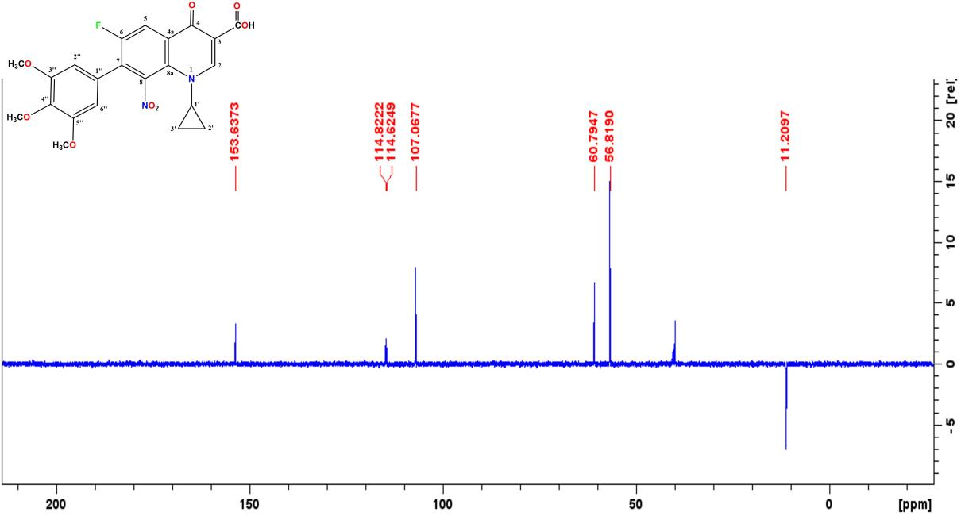

Figure 1.45: The DEPT (135) spectrum of compound 16b (DMSO-d6).

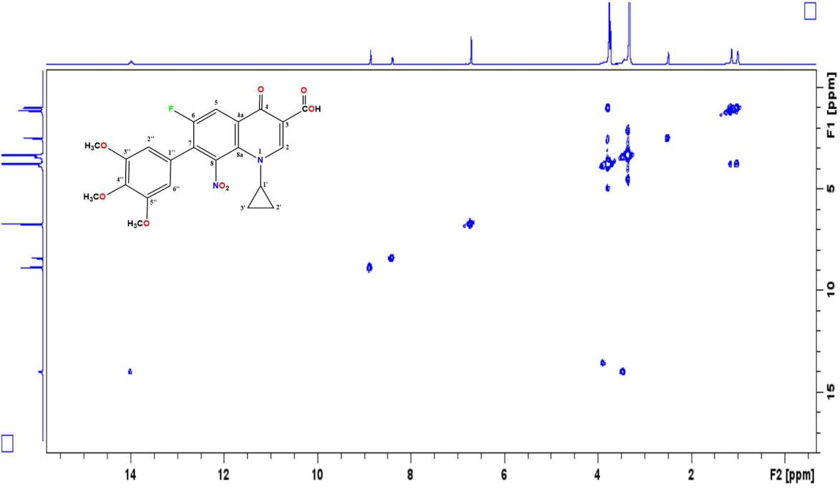

Figure 1.46 The COSY spectrum of compound 16b (DMSO-d6).

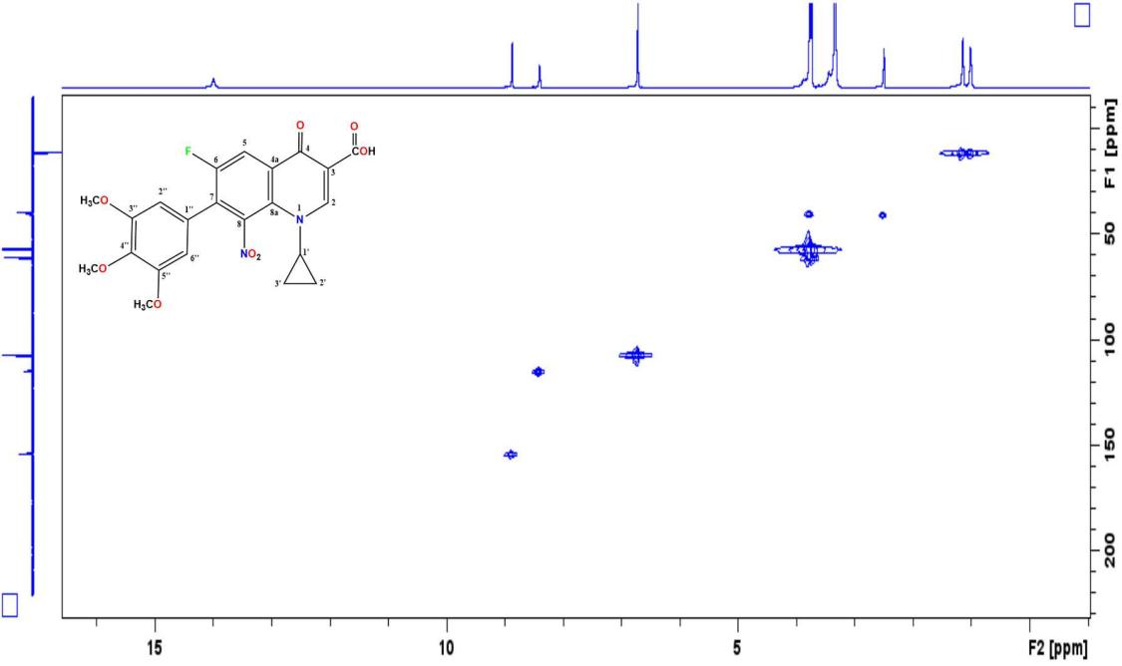

Figure 1.47: The HMQC spectrum of compound 16b (DMSO-d6).

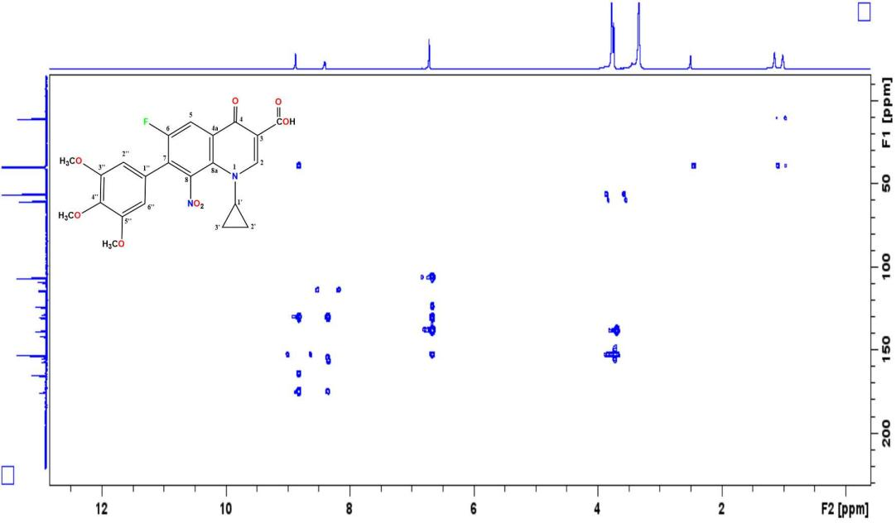

Figure 1.48: The HMBC spectrum of compound 16b (DMSO-d6).

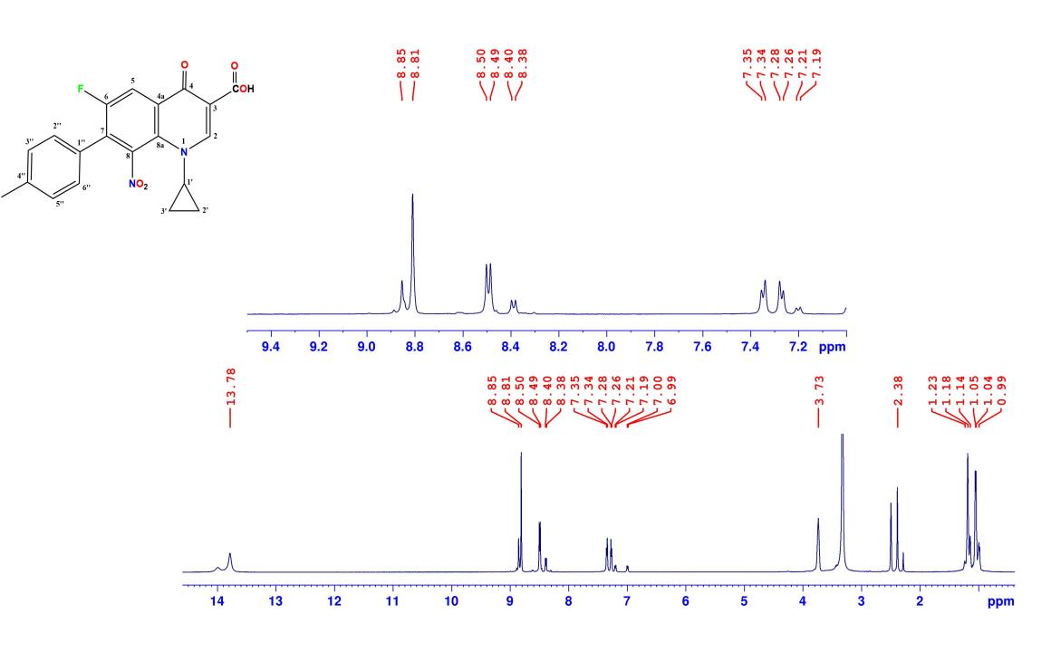 Figure 1.49: The 1H-NMR spectrum of compound 18b (DMSO-d6).

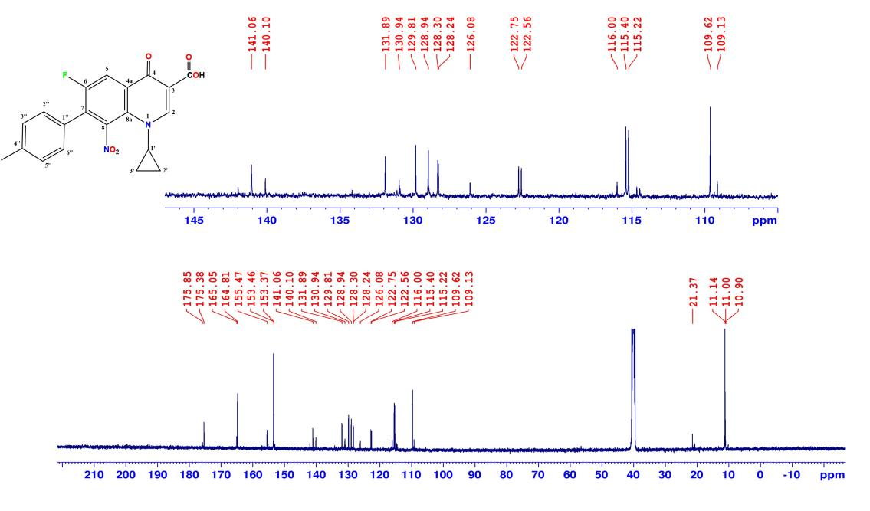 Figure 1.50: The 13C-NMR spectrum of compound 18b (DMSO-d6).
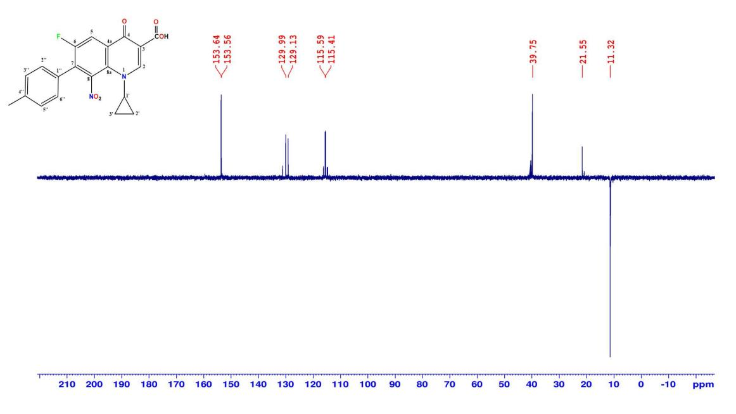

Figure 1.51: The DEPT (135) spectrum of compound 18b (DMSO-d6).

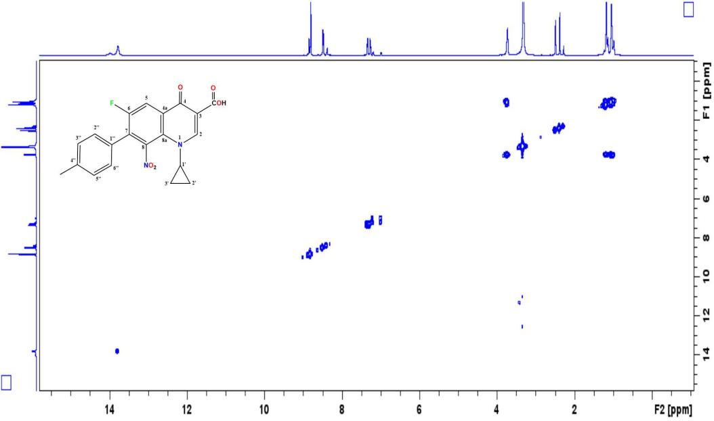

Figure 1.52: The COSY spectrum of compound 18b (DMSO-d6).

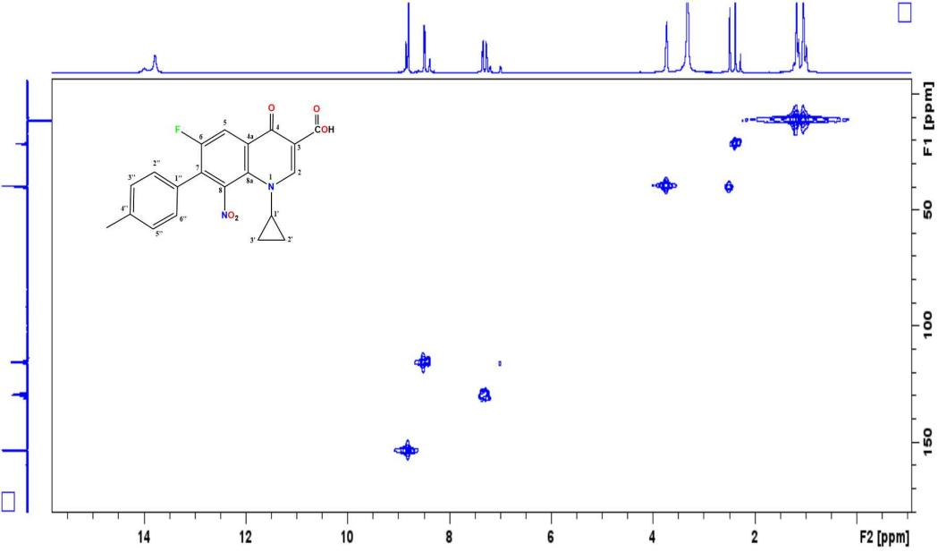

Figure 1.53: The HMQC spectrum of compound 18b (DMSO-d6).

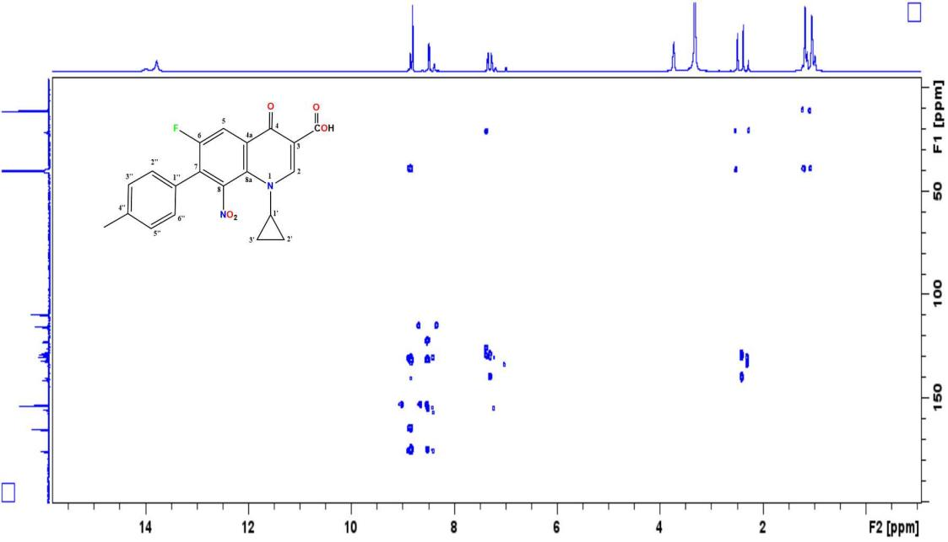

Figure 1.54: The HMBC spectrum of compound 18b (DMSO-d6).

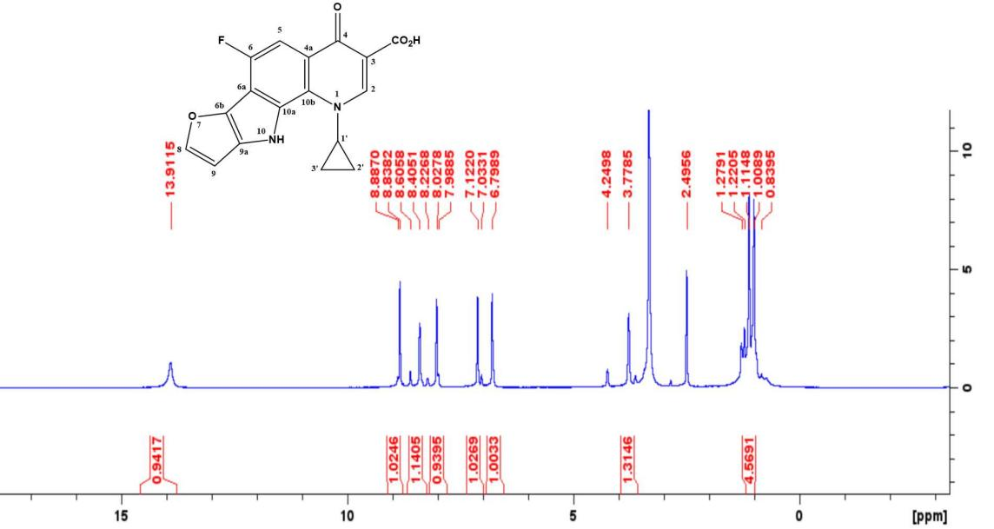 Figure 1.55: The 1H-NMR spectrum of compound15b (DMSO-d6).

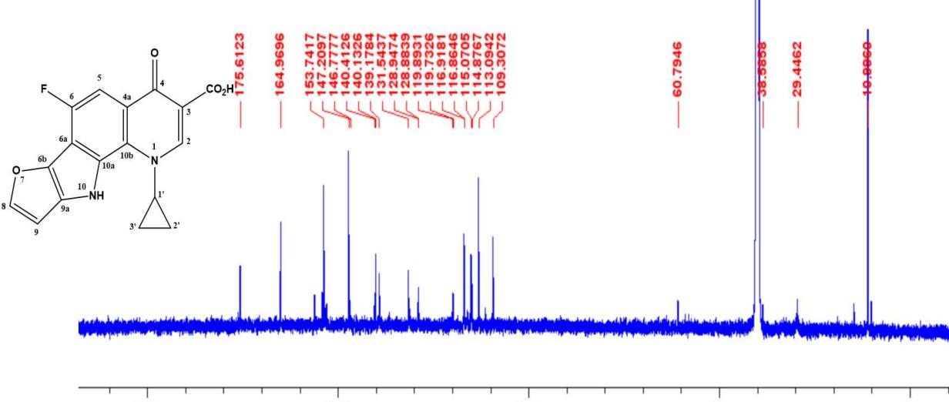 Figure 1.56: The 13C-NMR spectrum of compound 15b (DMSO-d6).
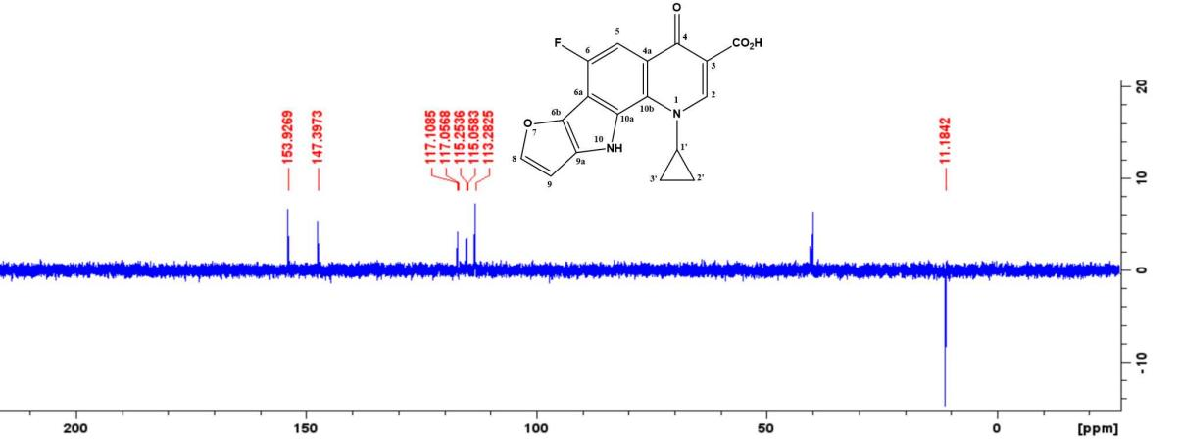

Figure 1.57: The DEPT (135) spectrum of compound 15b (DMSO-d6).

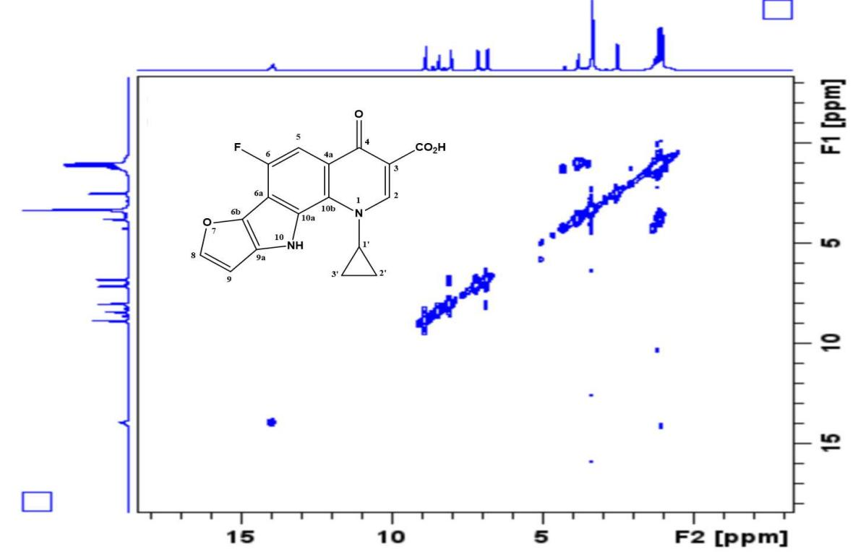

Figure 1.58: The COSY spectrum of compound 15b (DMSO-d6).

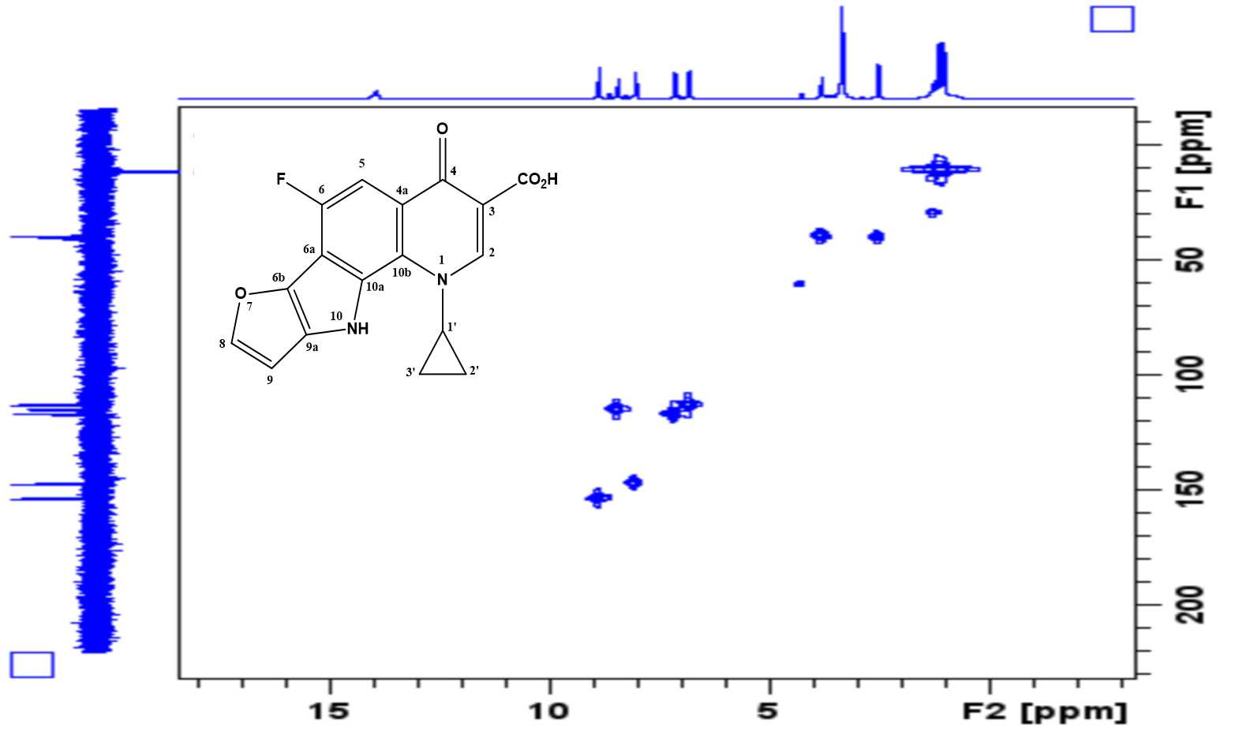

Figure 1.59: The HMQC spectrum of compound 15b (DMSO-d6).
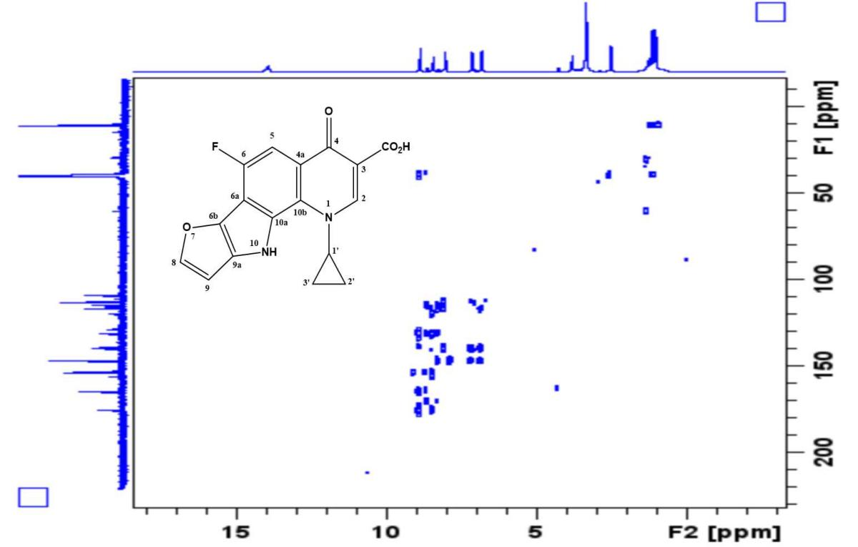

Figure 1.60: The HMBC spectrum of compound 15b (DMSO-d6).

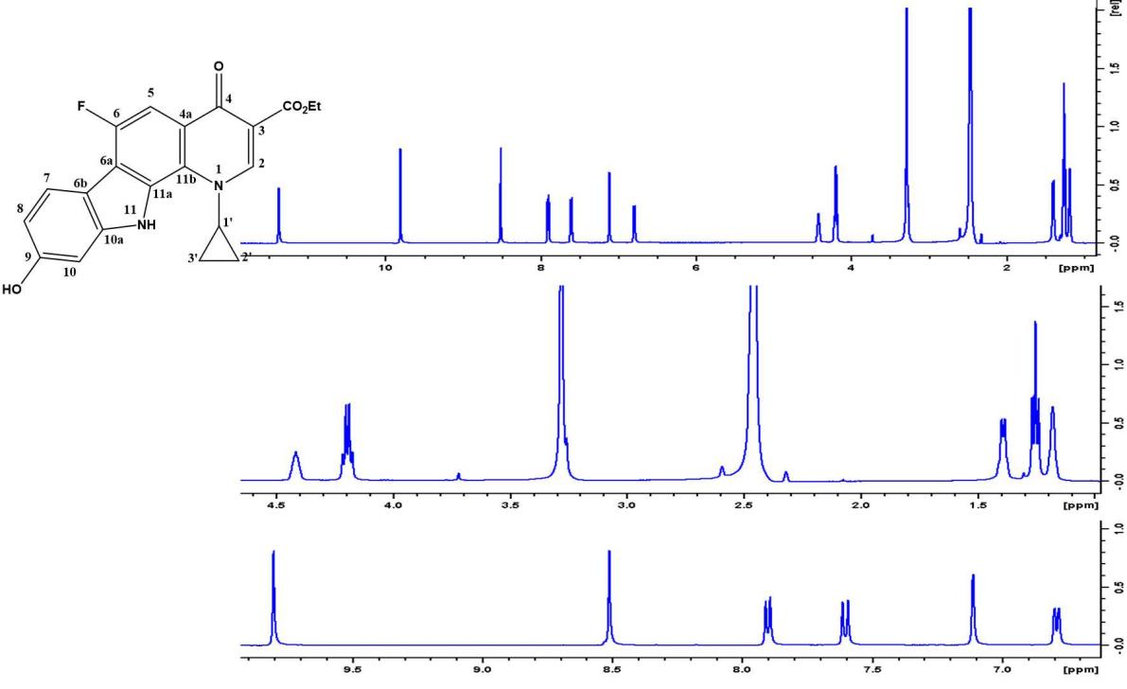 Figure 1.61: The 1H-NMR spectrum of compound 20a (DMSO-d6

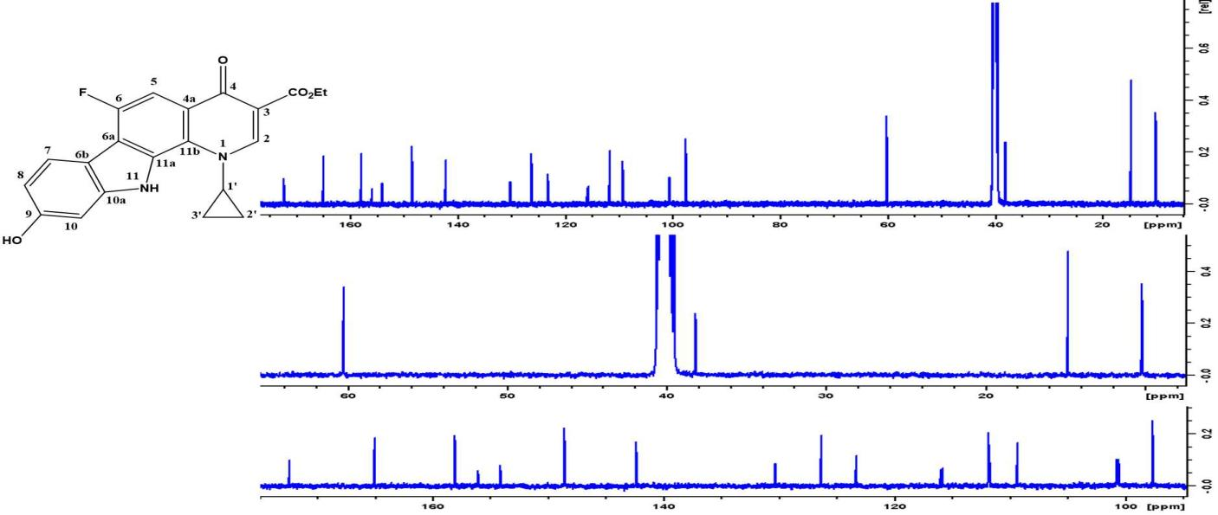 Figure 1.62: The 13C-NMR spectrum of compound 20a (DMSO-d6).
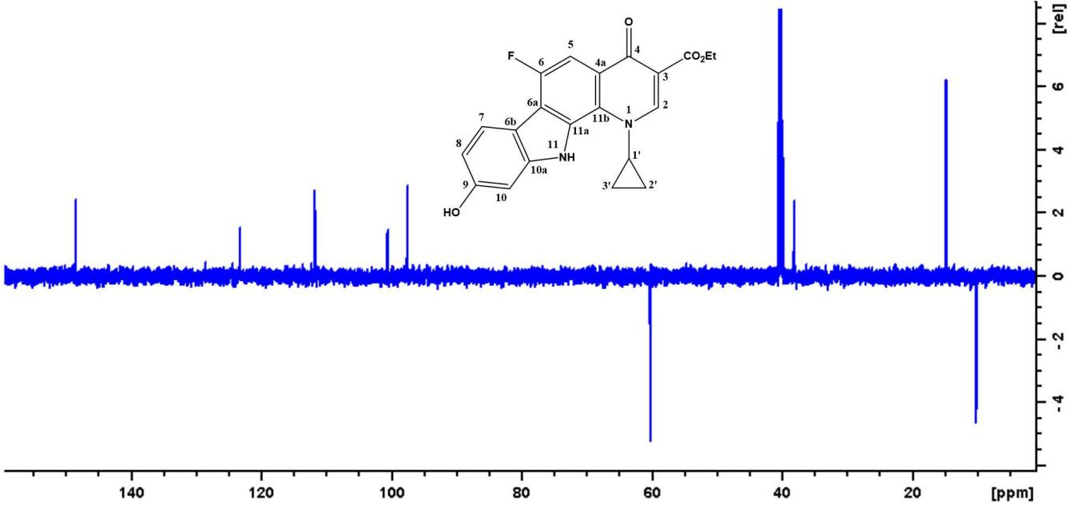

Figure 1.63: The DEPT (135) spectrum of compound 20a (DMSO-d6).

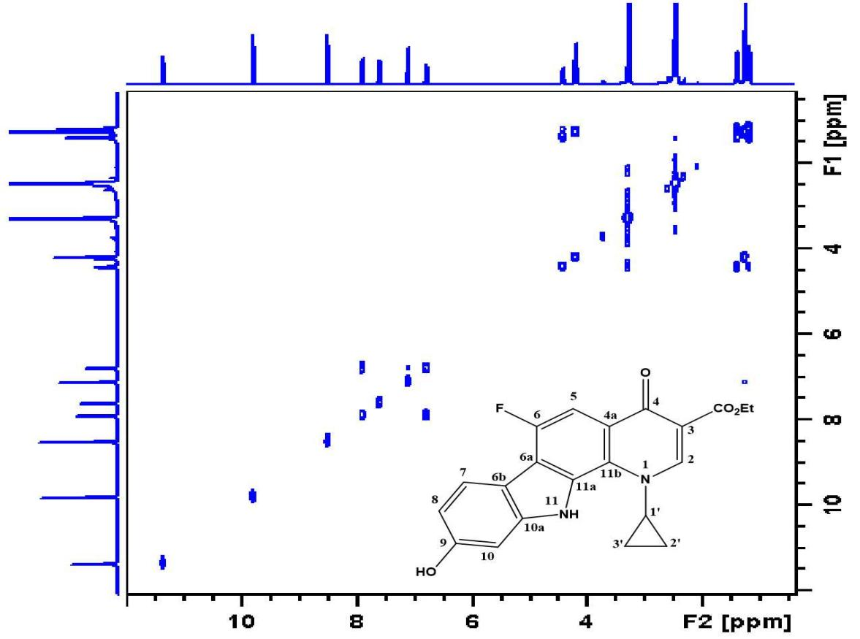

Figure 1.64: The COSY spectrum of compound 20a (DMSO-d6).

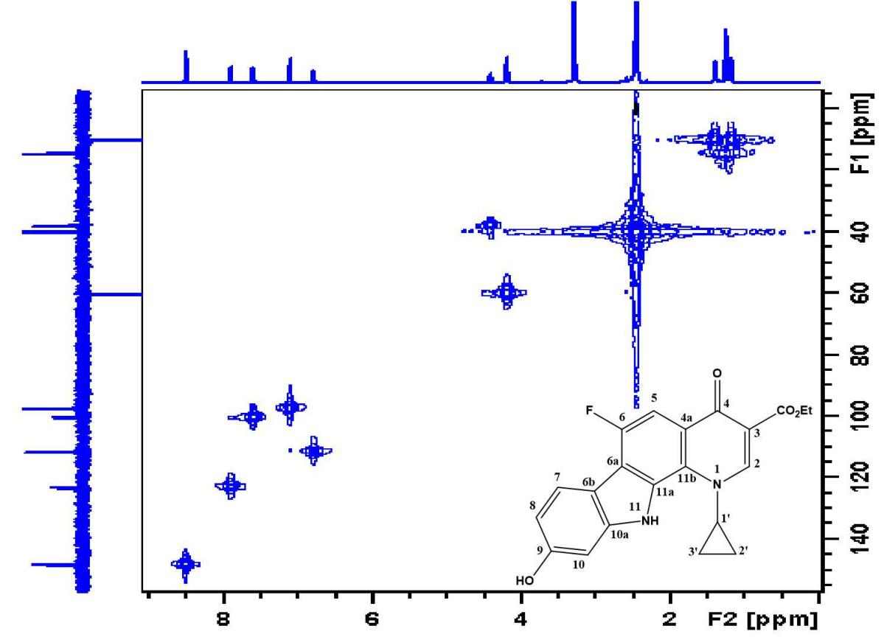

Figure 1.65: The HMQC spectrum of compound 20a (DMSO-d6).

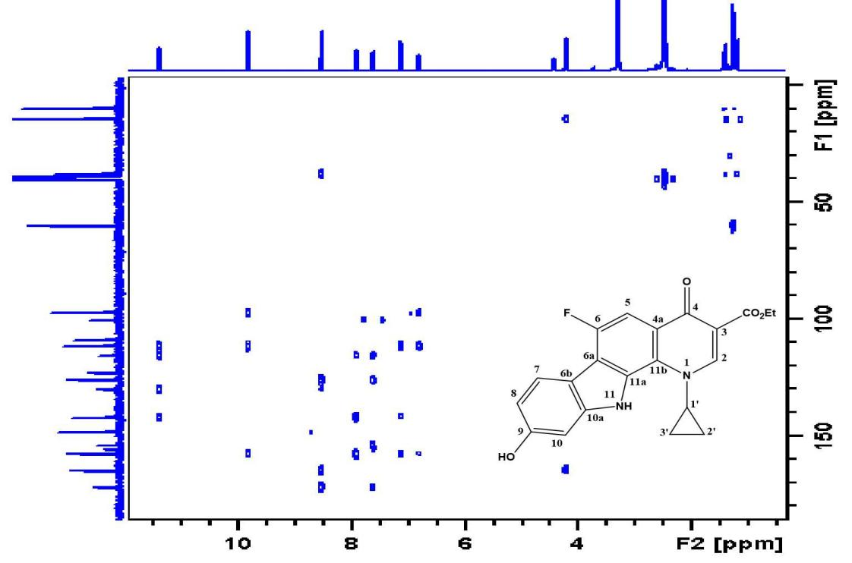

Figure 1.66: The HMBC spectrum of compound 20a (DMSO-d6).

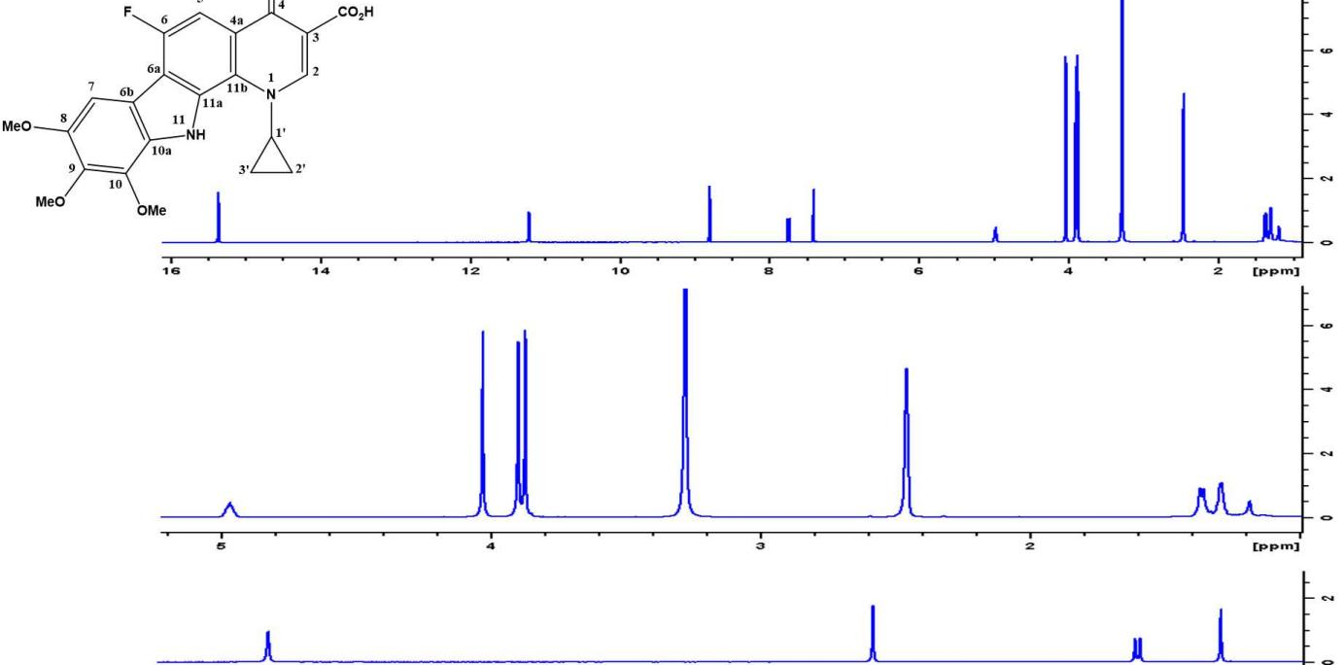 Figure 1.67: The 1H-NMR spectrum of compound 19b (DMSO-d6)
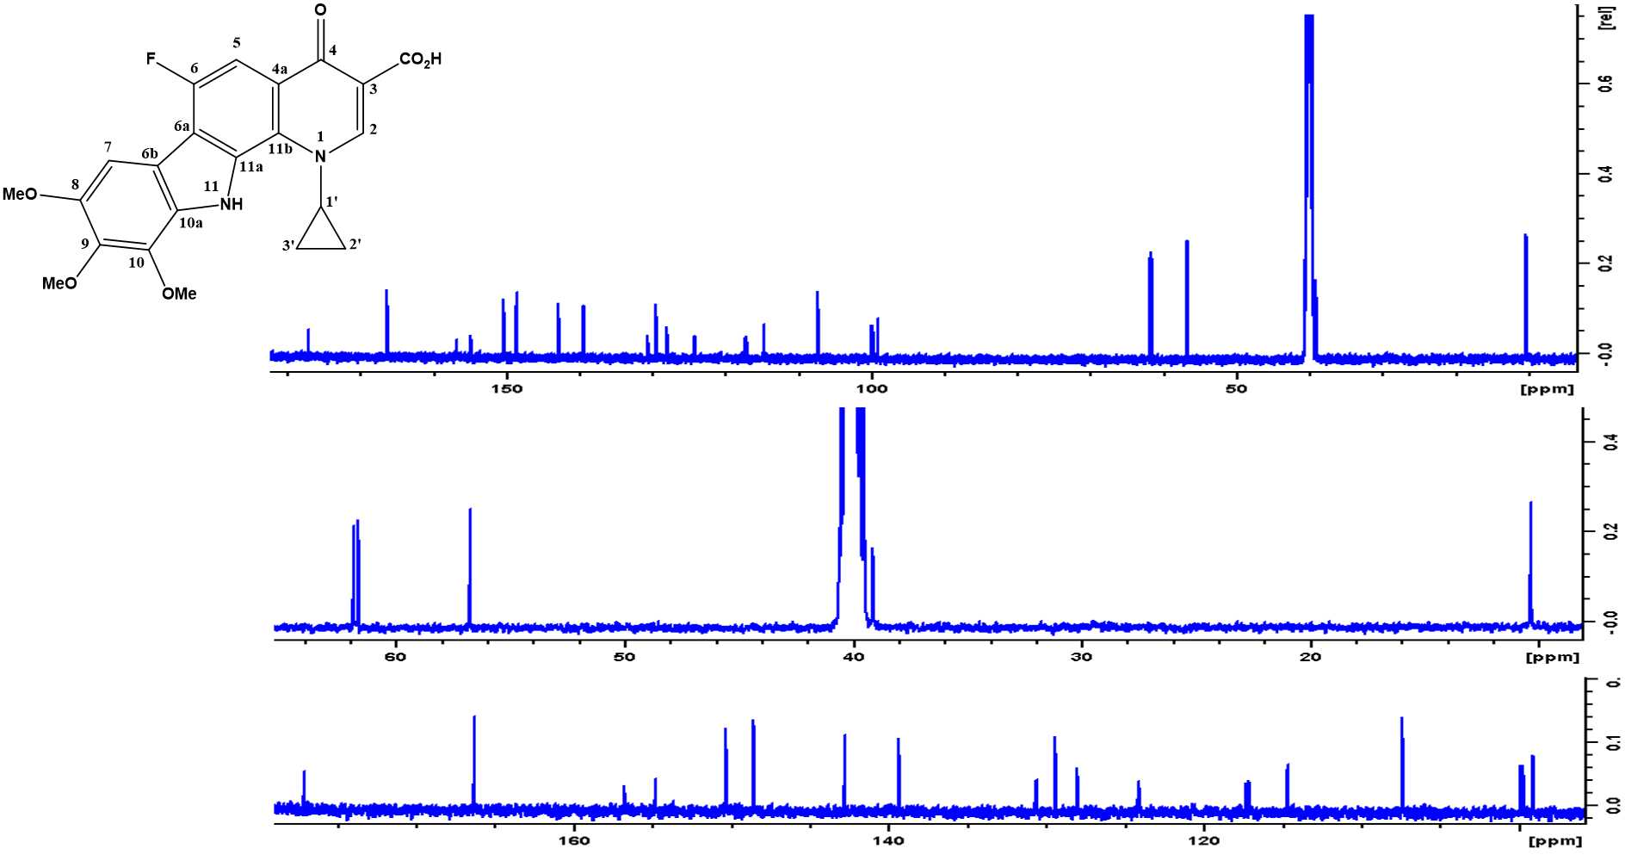 Figure 1.68: The 13C-NMR spectrum of compound 19b (DMSO-d6).
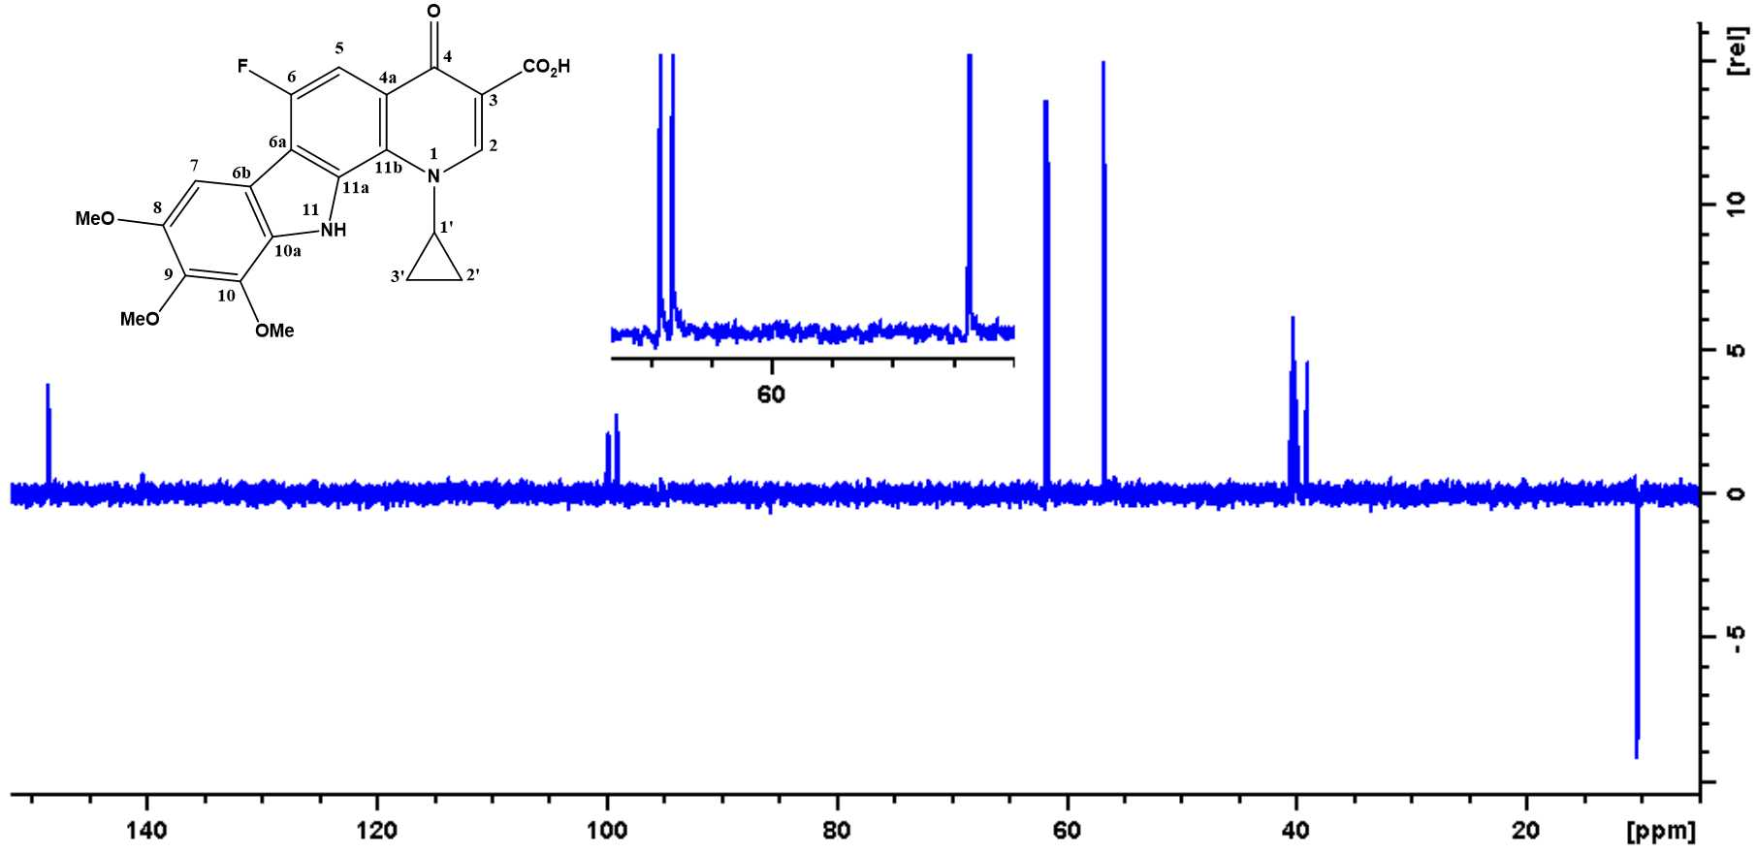

Figure 1.69: The DEPT (135) spectrum of compound 19b (DMSO-d6)

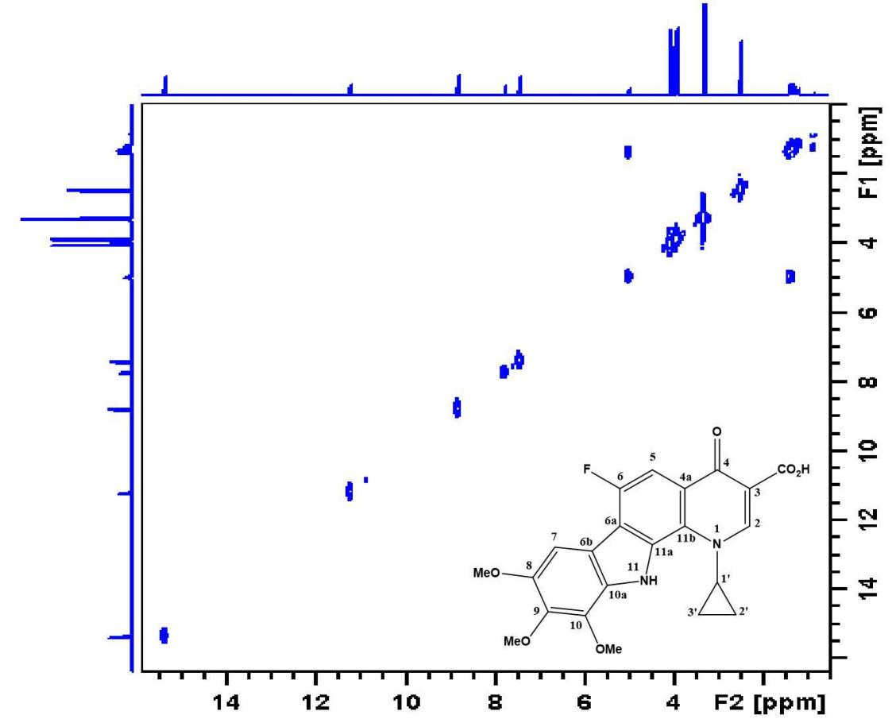

Figure 1.70: The COSY spectrum of compound 19b (DMSO-d6).
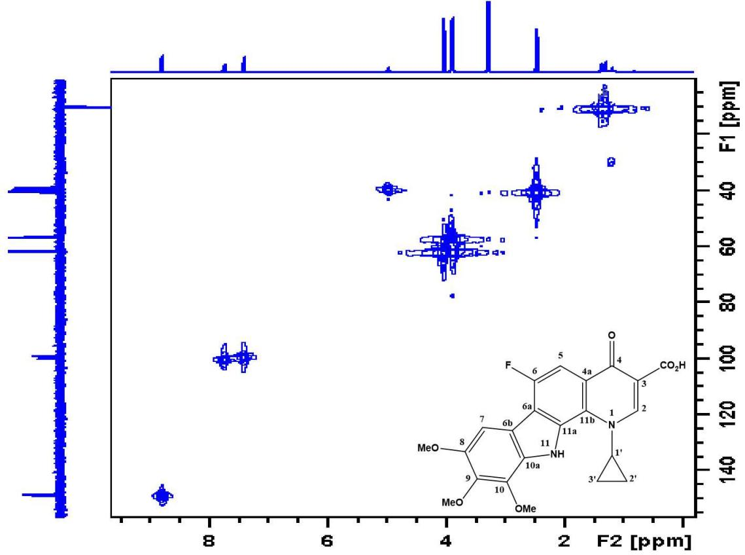

Figure 1.71: The HMQC spectrum of compound 19b (DMSO-d6).
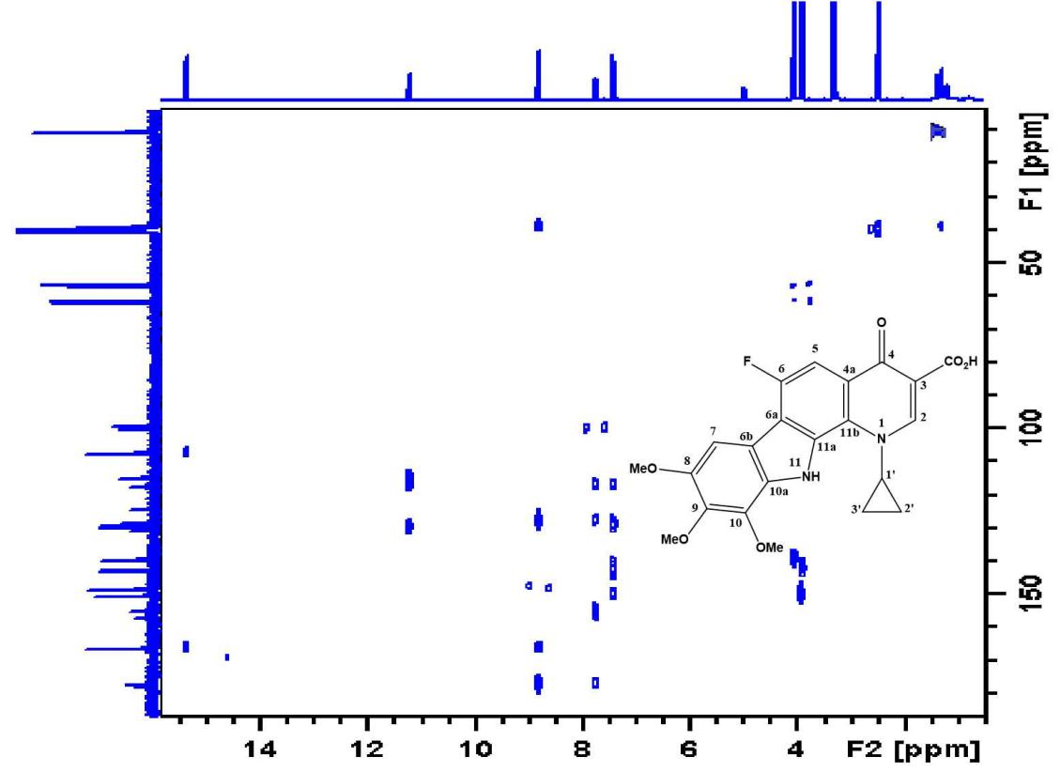

Figure 1.72: The HMBC spectrum of compound 19b (DMSO-d6).

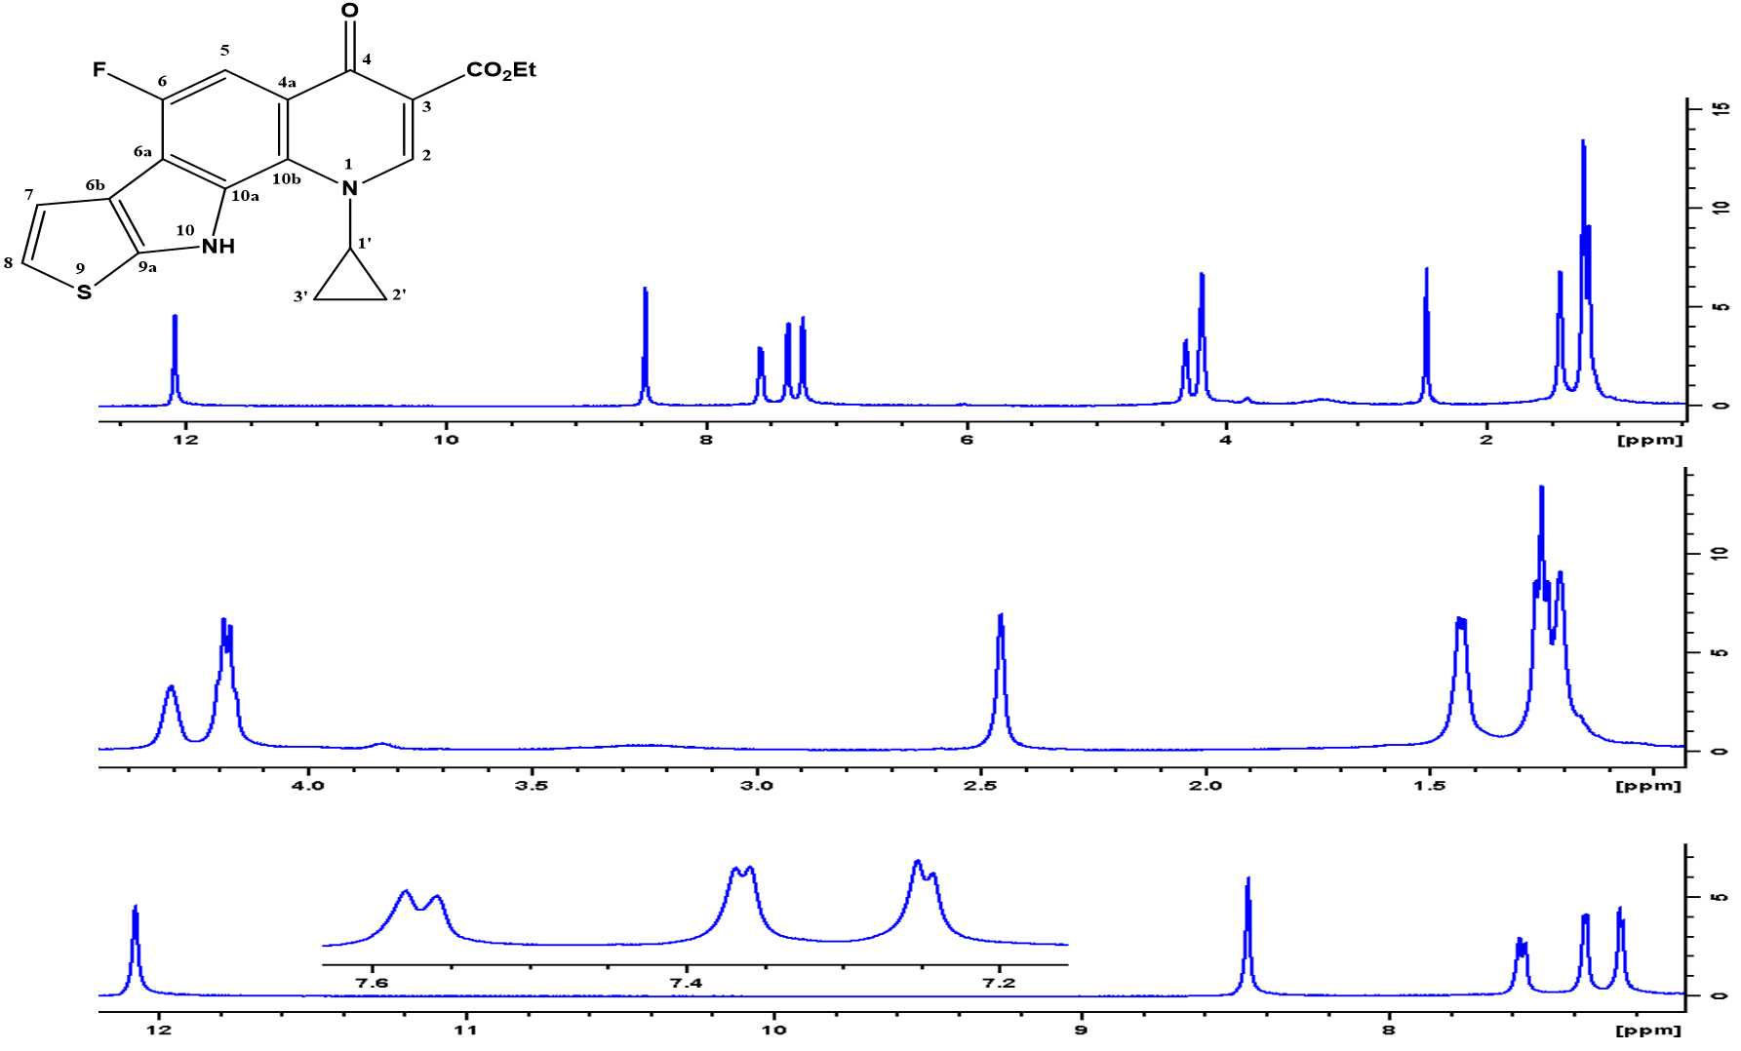Figure 1.73: The 1H-NMR spectrum of compound 12a (DMSO-d6).

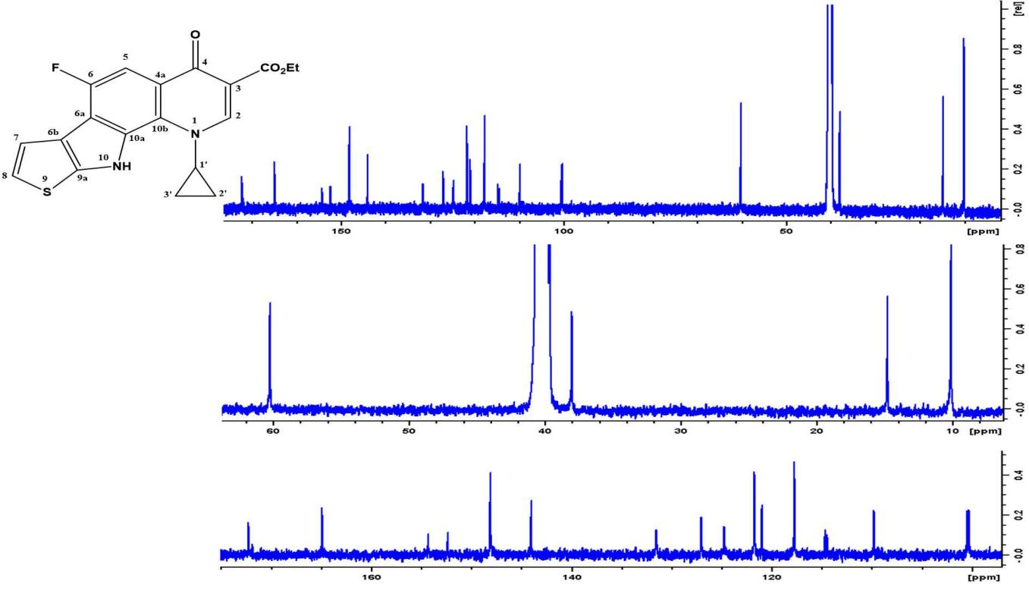

Figure 1.74: The 13C-NMR spectrum of compound 12a (DMSO-d6).
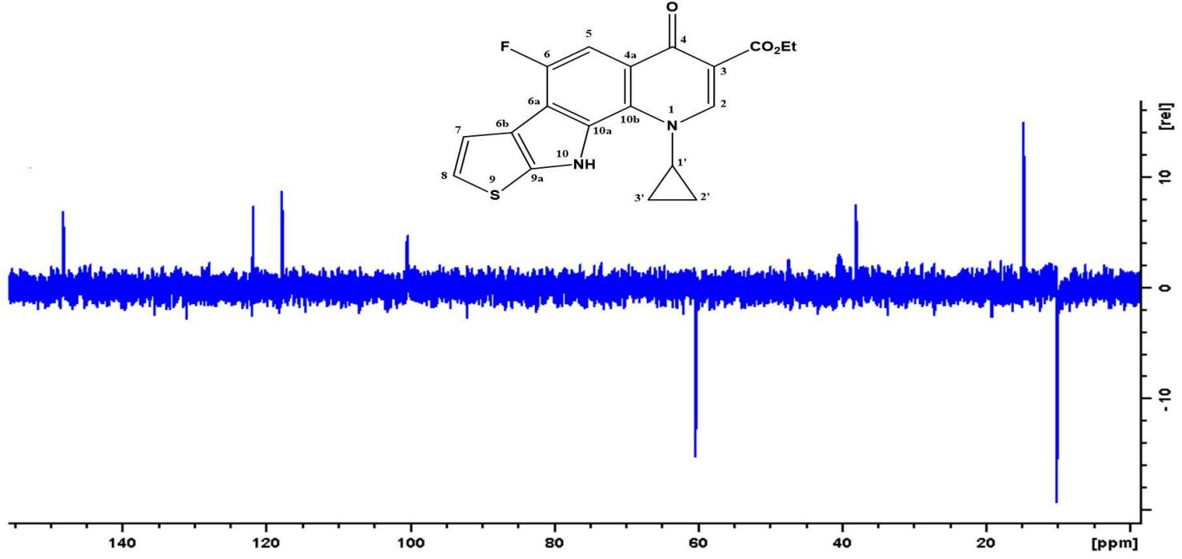

Figure 1.75: The DEPT (135) spectrum of compound 12a (DMSO-d6)

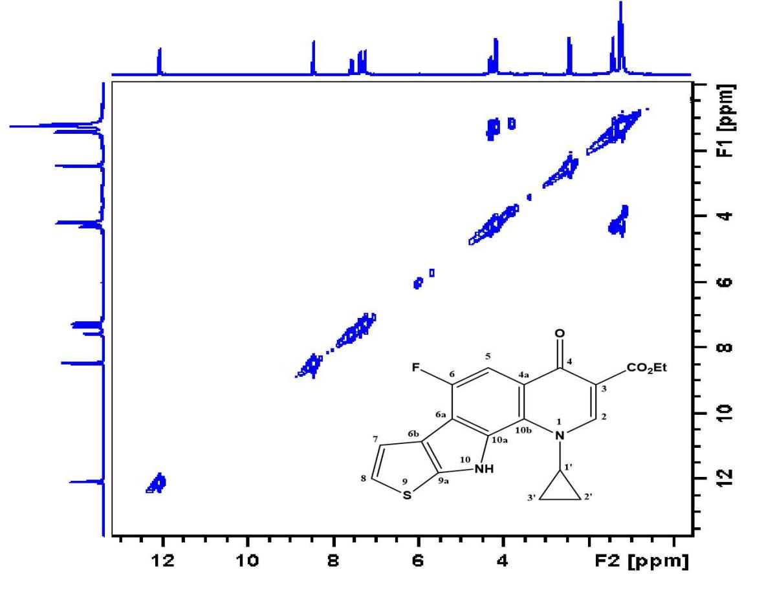

Figure 1.76: The COSY spectrum of compound 12a (DMSO-d6).

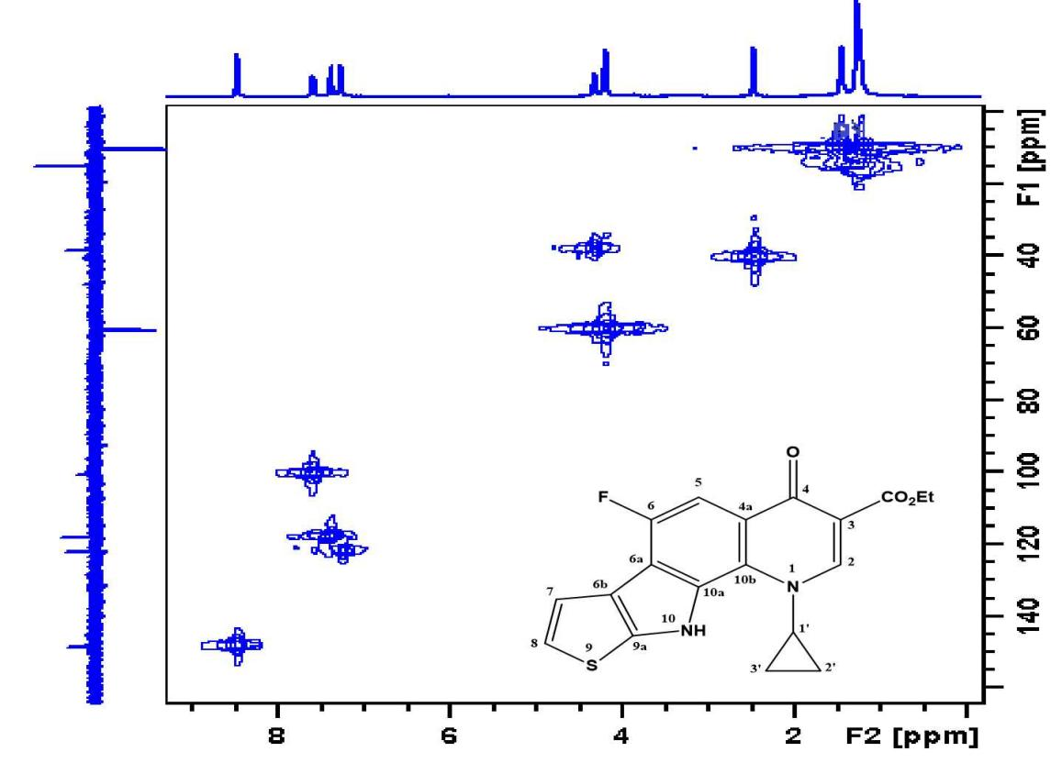

Figure 1.77: The HMQC spectrum of compound 12a (DMSO-d6).
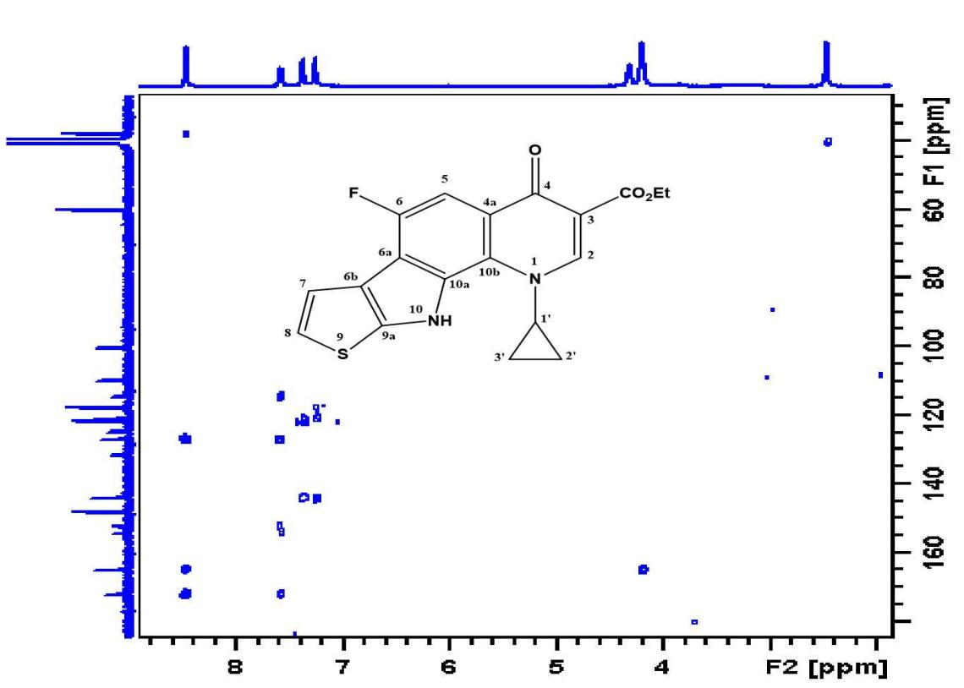

Figure 1.78: The HMBC spectrum of compound 12a (DMSO-d6).

Mass SPECTRUM
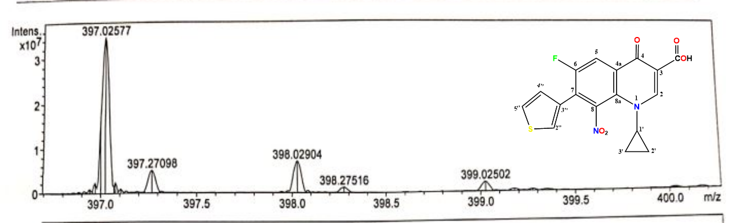

Figure 2.1: The Mass spectrum for compound 11b, [M+Na]⁺.
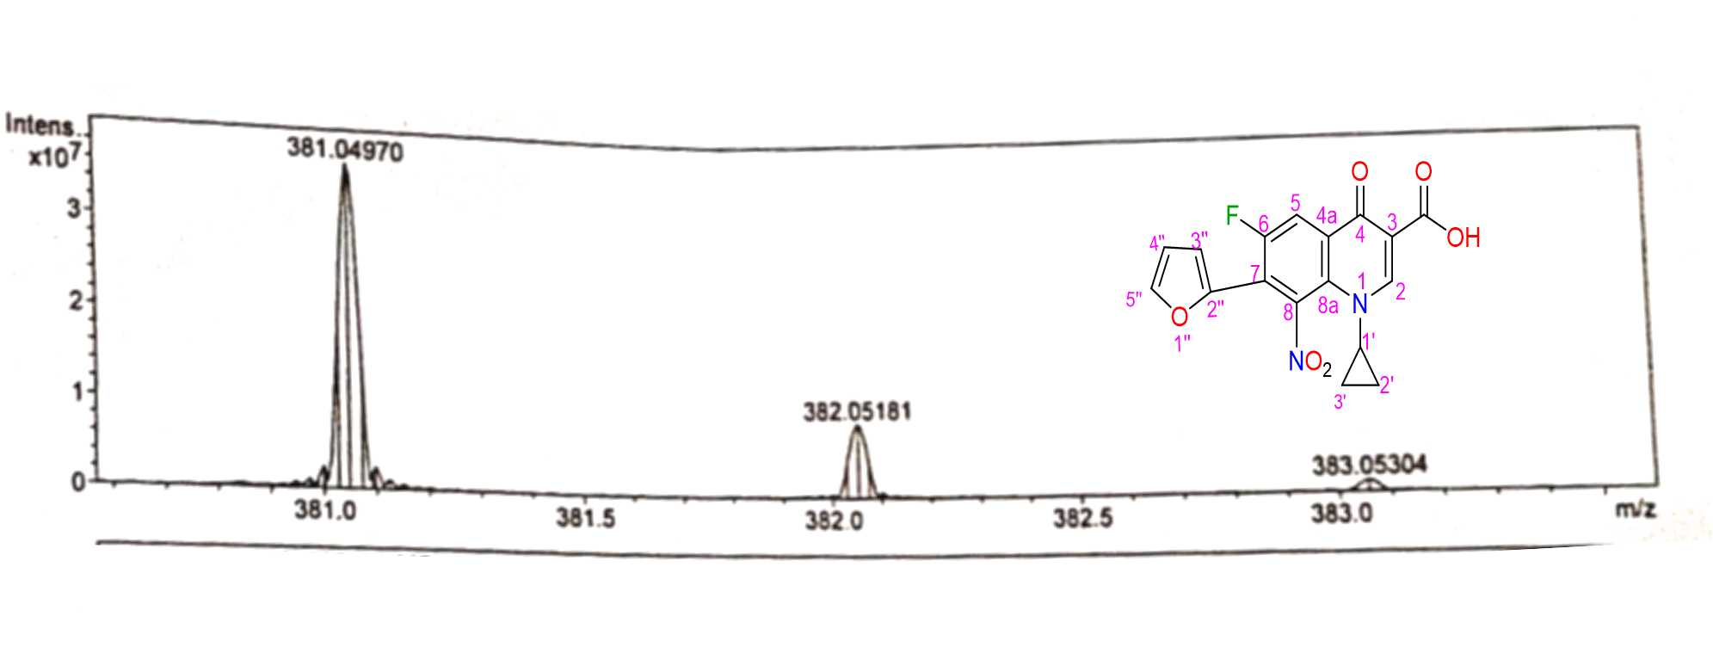

Figure 2.2: The Mass spectrum for compound 14b, [M+Na]⁺.
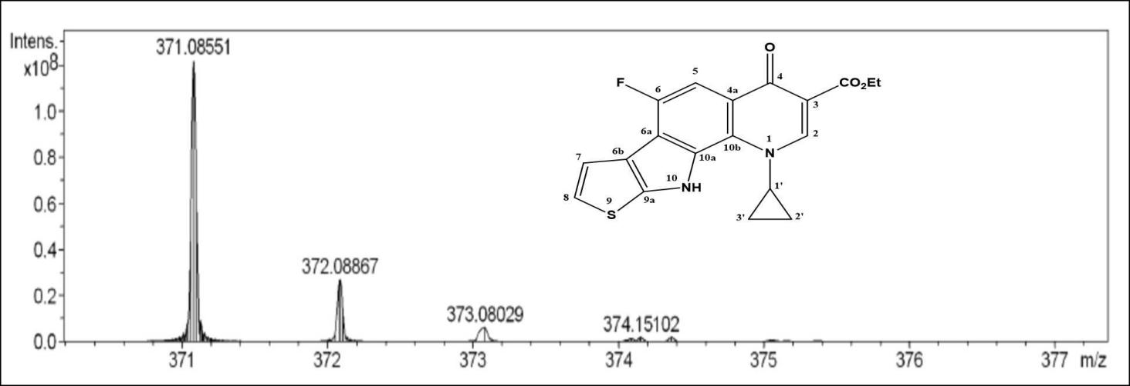

Figure 2.3: The Mass spectrum for compound 12a, [M+H]⁺.
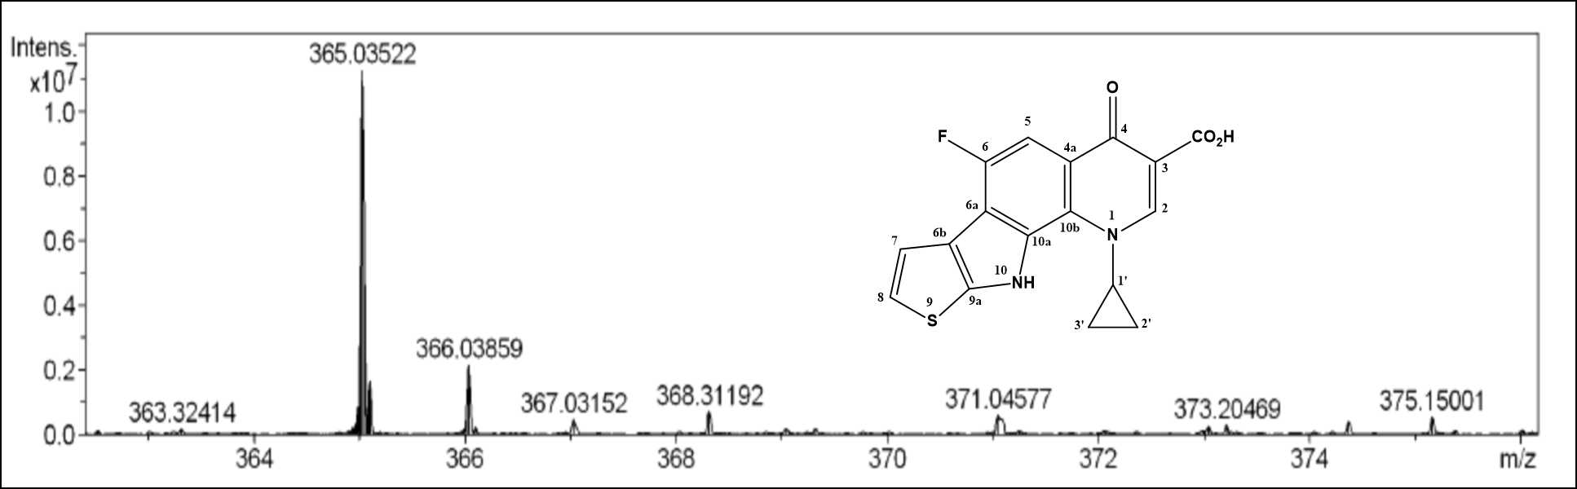

Figure 2.4: The Mass spectrum for compound 12b, [M+H]⁺.

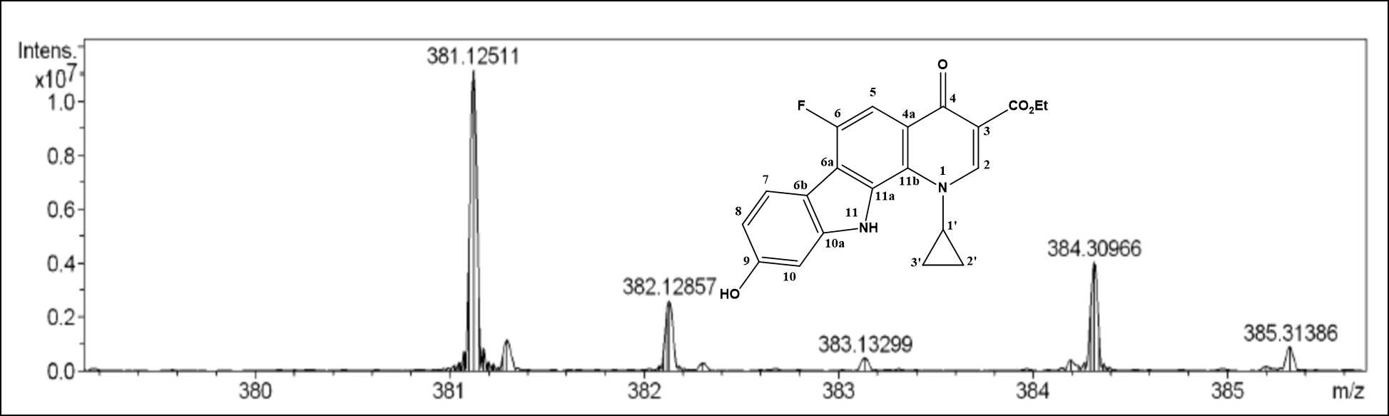

Figure 2.5: The Mass spectrum for compound20a, [M+H]⁺.

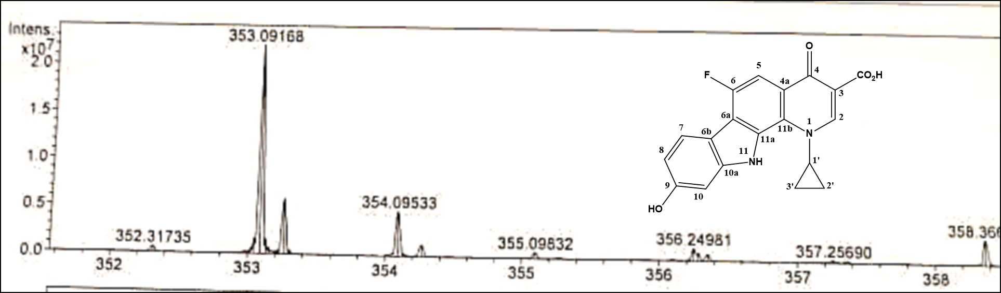

Figure 2.6: The Mass spectrum for compound 20b, [M+H]⁺.
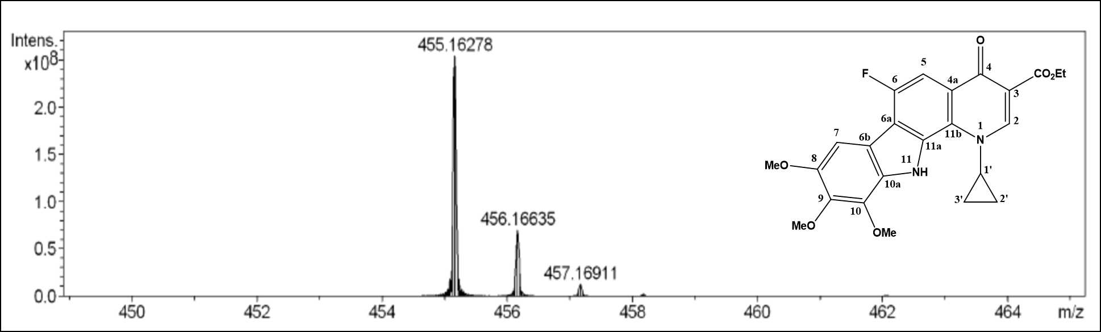

Figure 2.7: The Mass spectrum for compound 19a, [M+H]⁺.

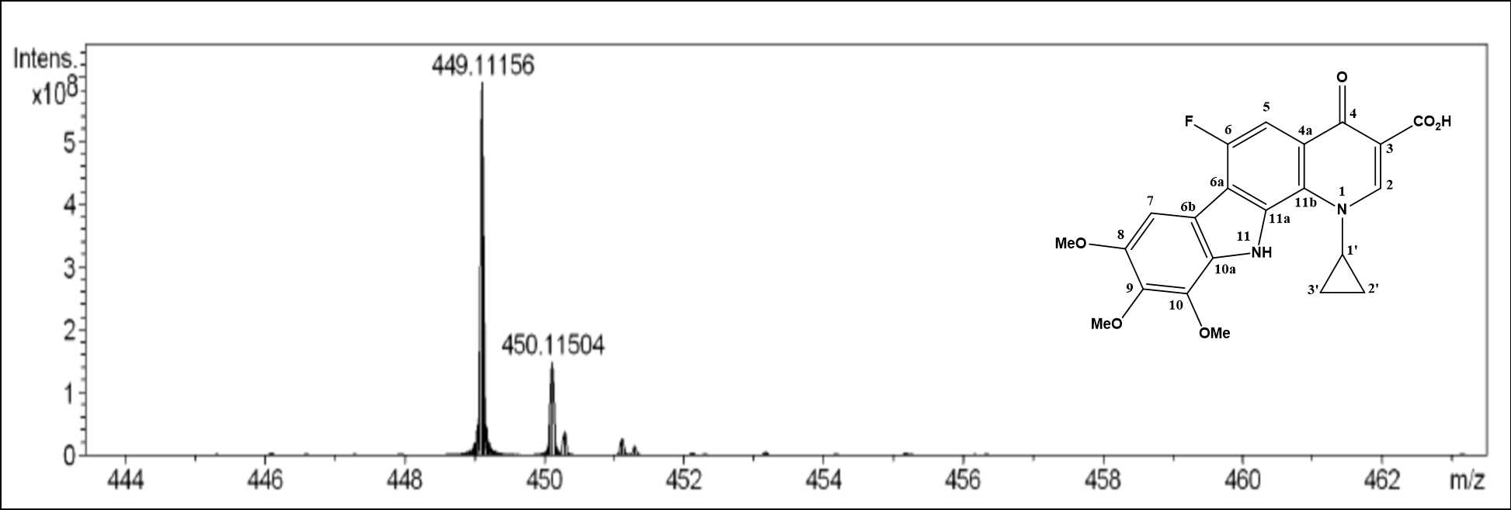

Figure 2.8: The Mass spectrum for compound 19b, [M+Na]⁺.

IR-SPECTRUM
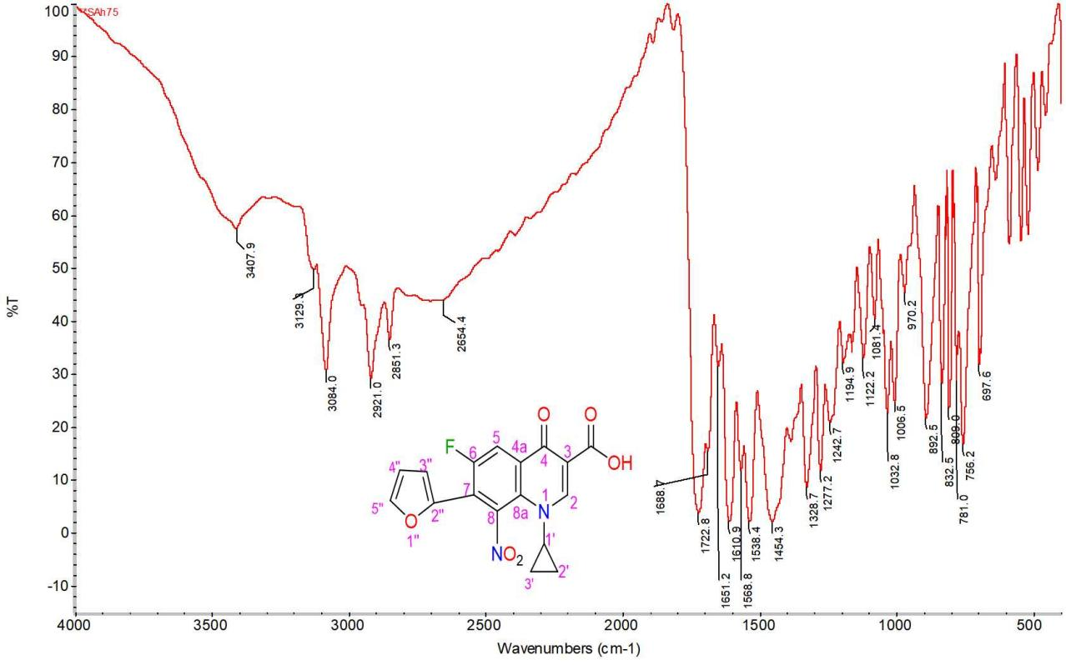

Figure 3.1: The IR spectrum for compound 14b.
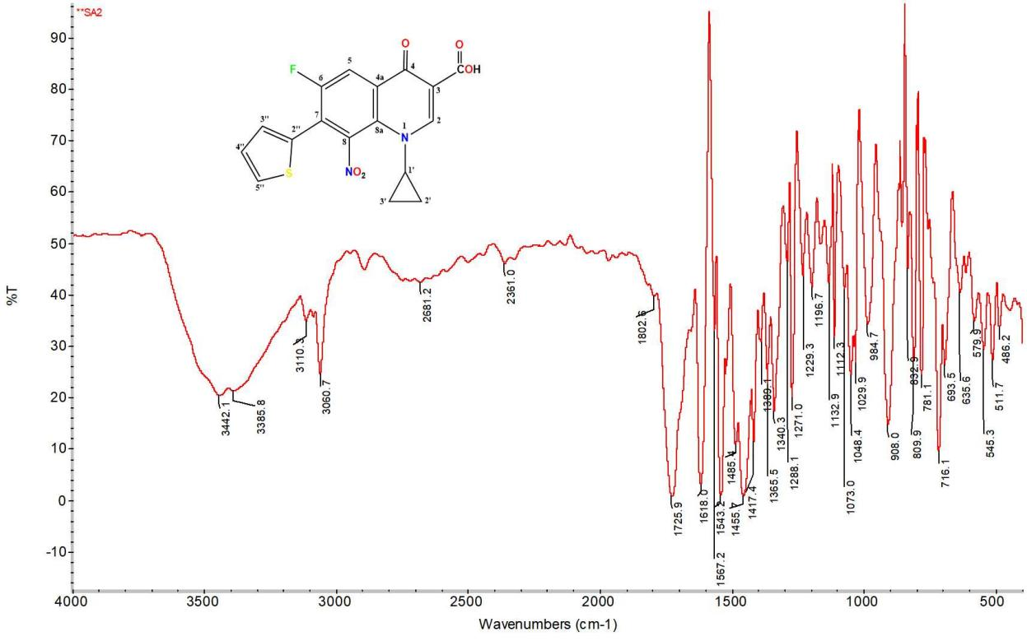

Figure 3.2: The IR spectrum for compound 13b.
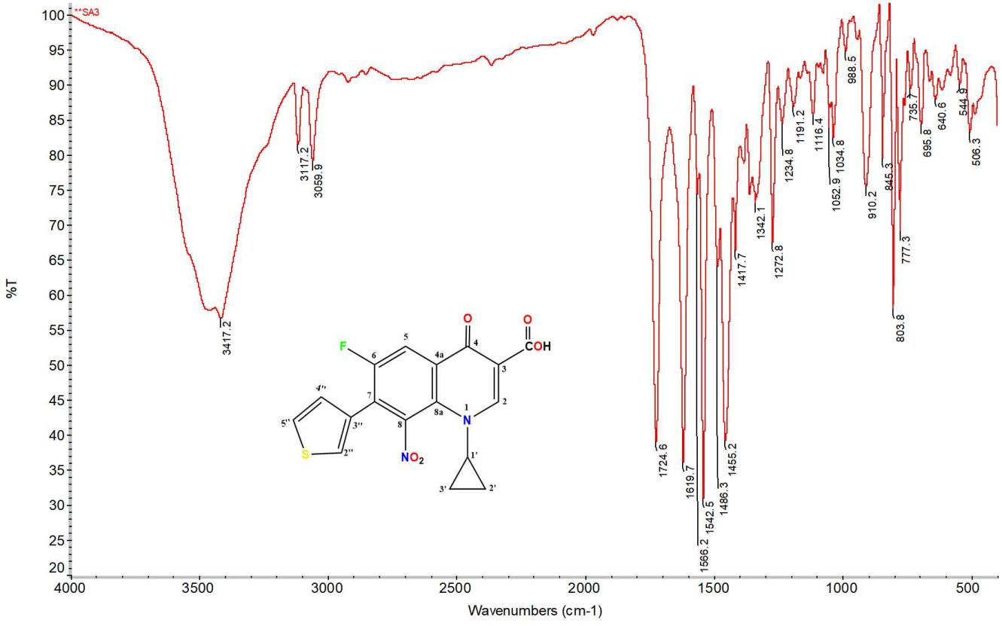

Figure 3.3: The IR spectrum for compound 11b.
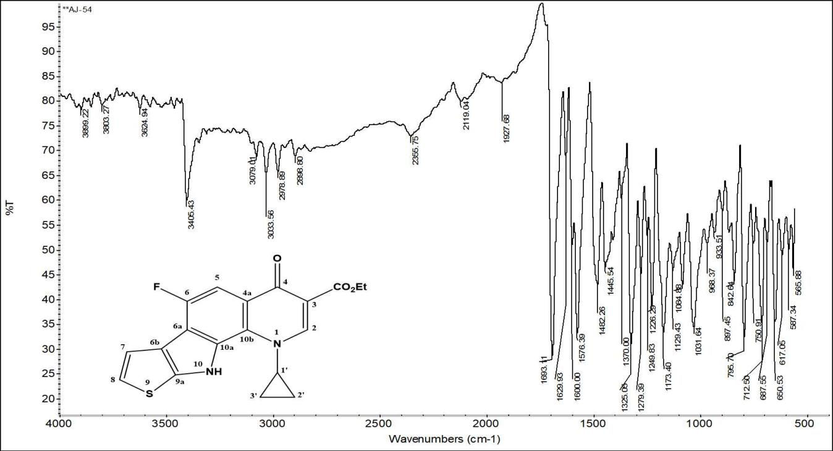

Figure 2.4: The IR spectrum for compound 12a.

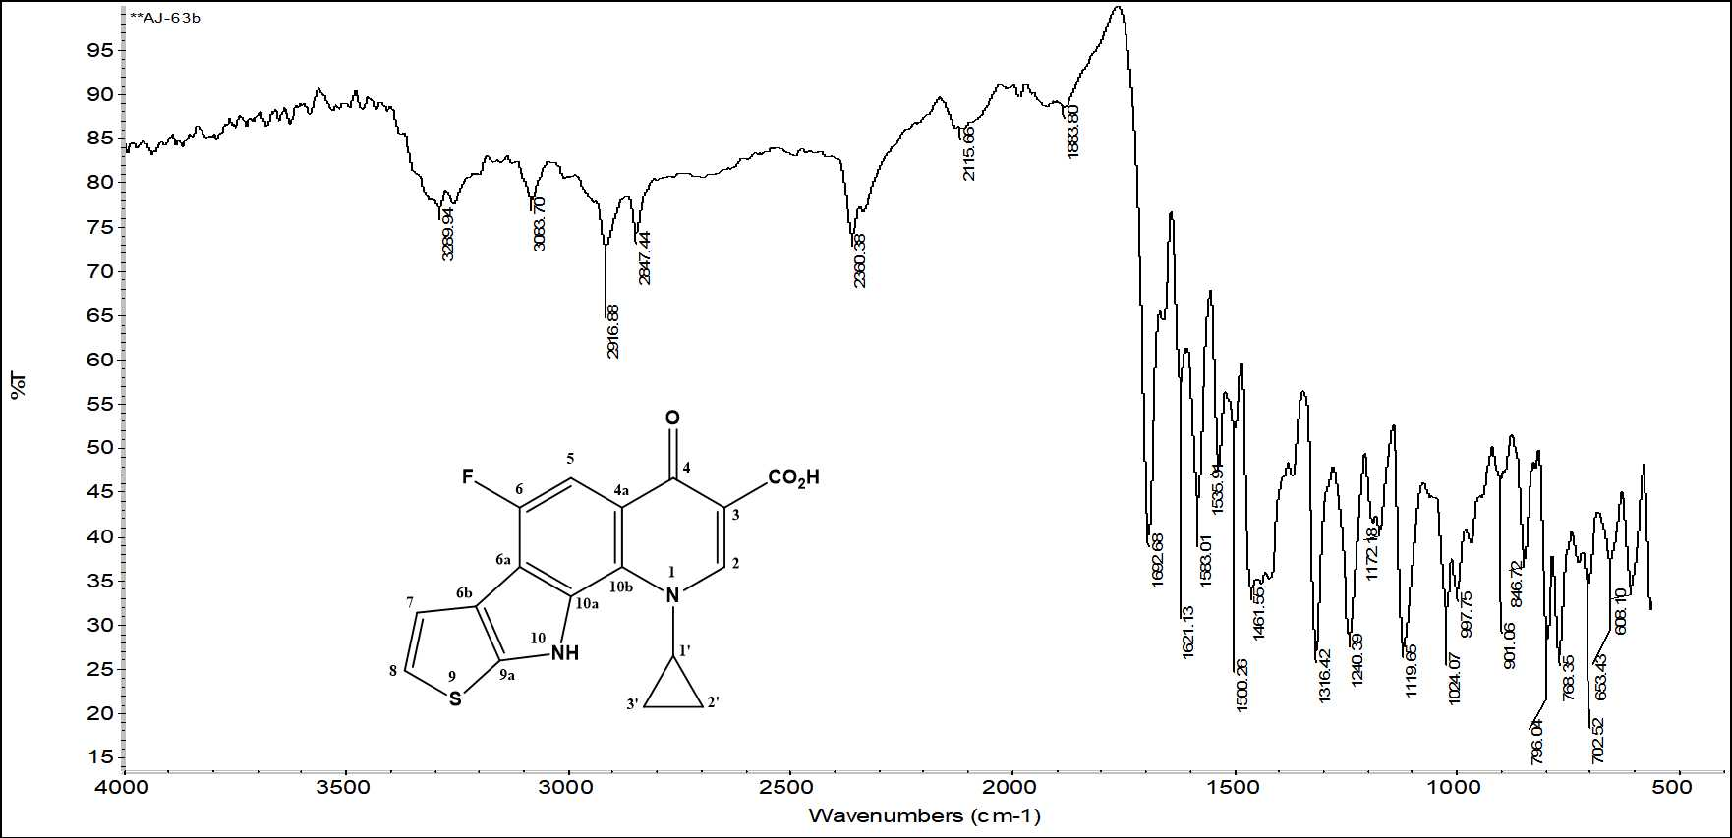

Figure 3.5: The IR spectrum for compound12b.

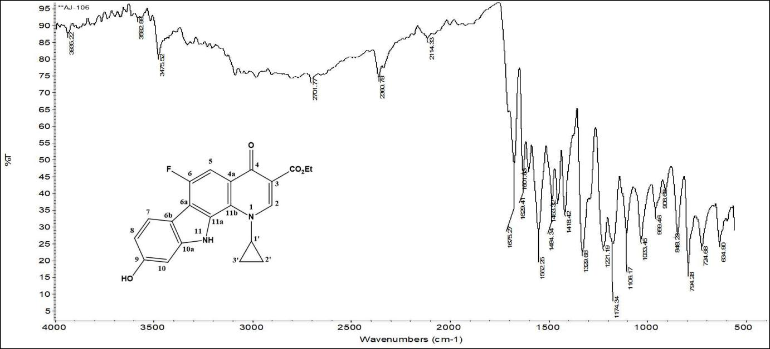

Figure 3.6: The IR spectrum for compound 20a.
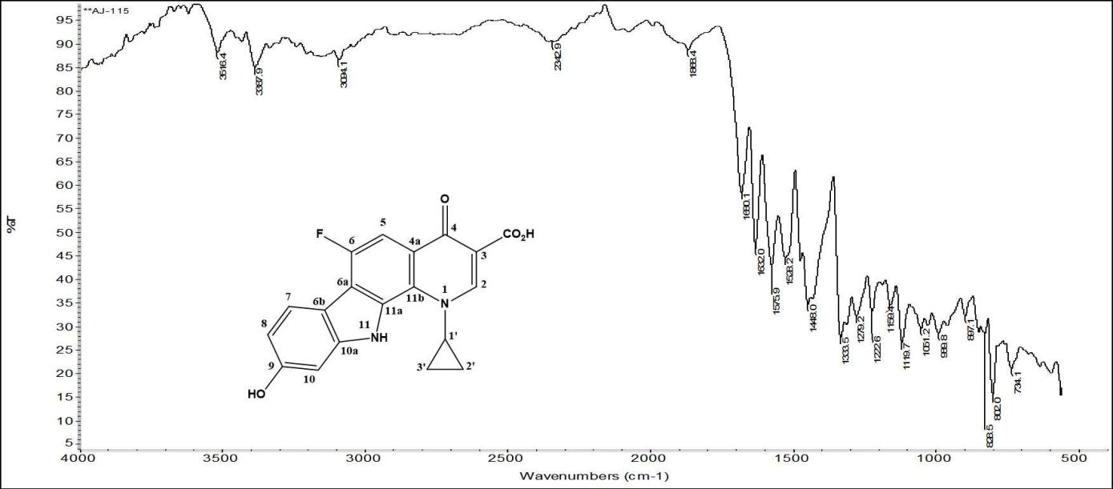

Figure 3.7: The IR spectrum for compound 20b.

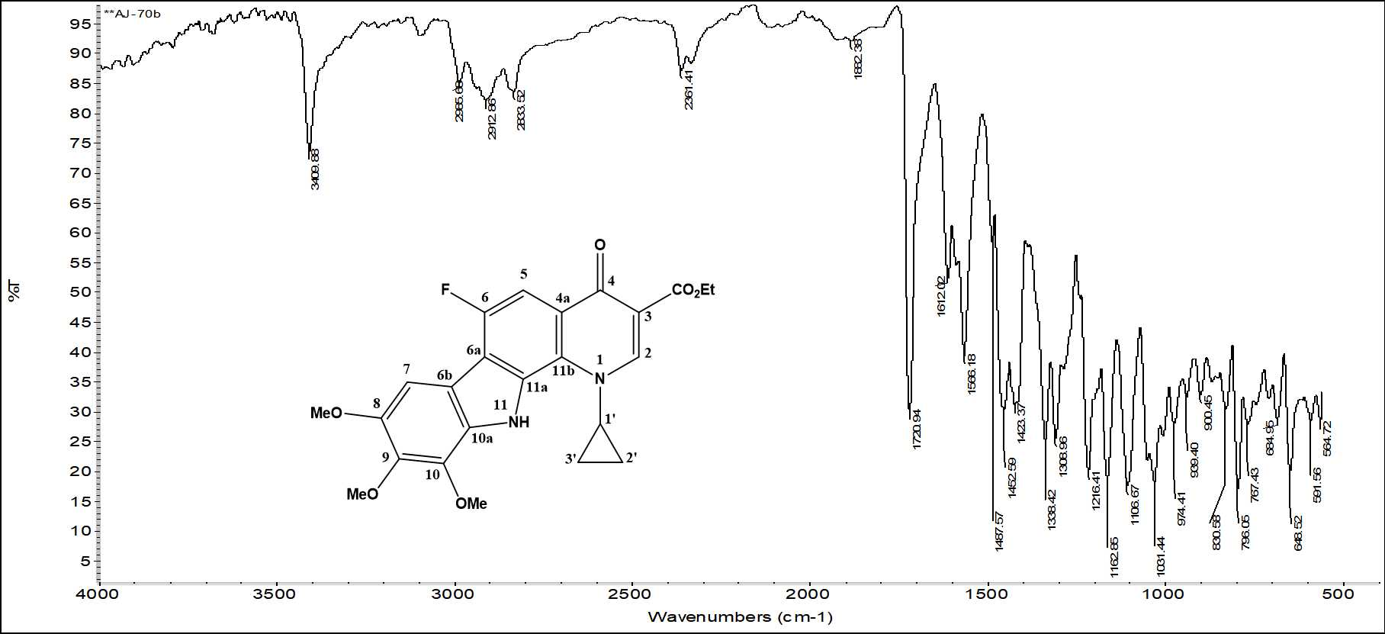

Figure 3.8: The IR spectrum for compound 19a.
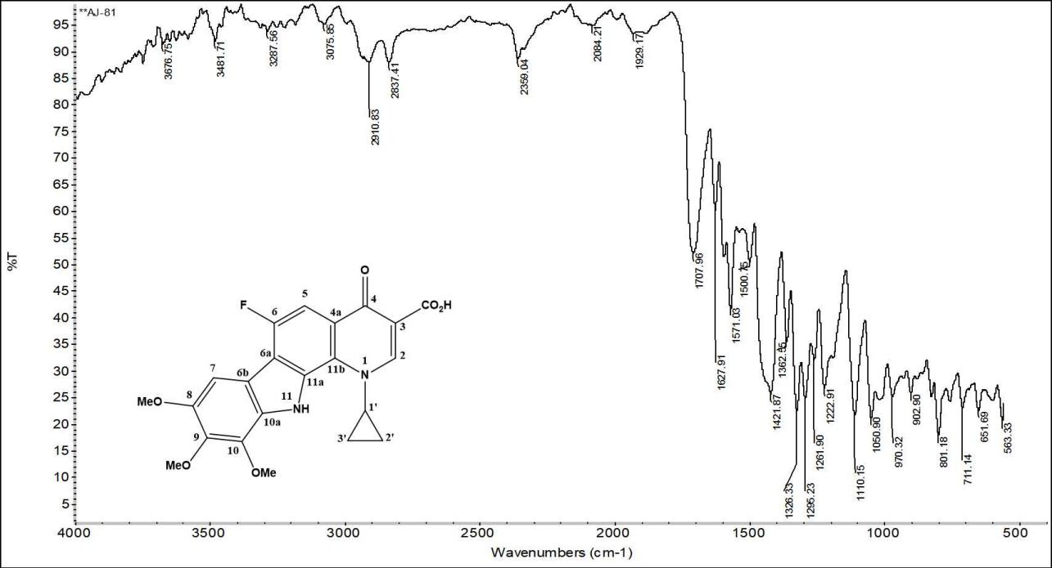

Figure 3.9: The IR spectrum for compound 19b.

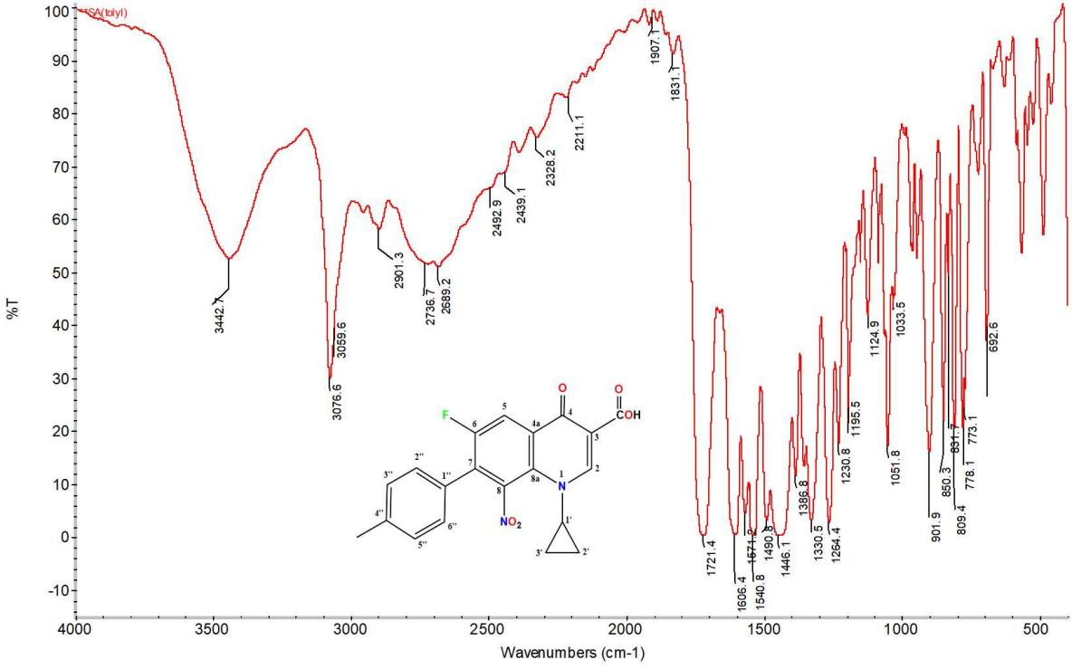

Figure 3.10: The IR spectrum for compound 18b.

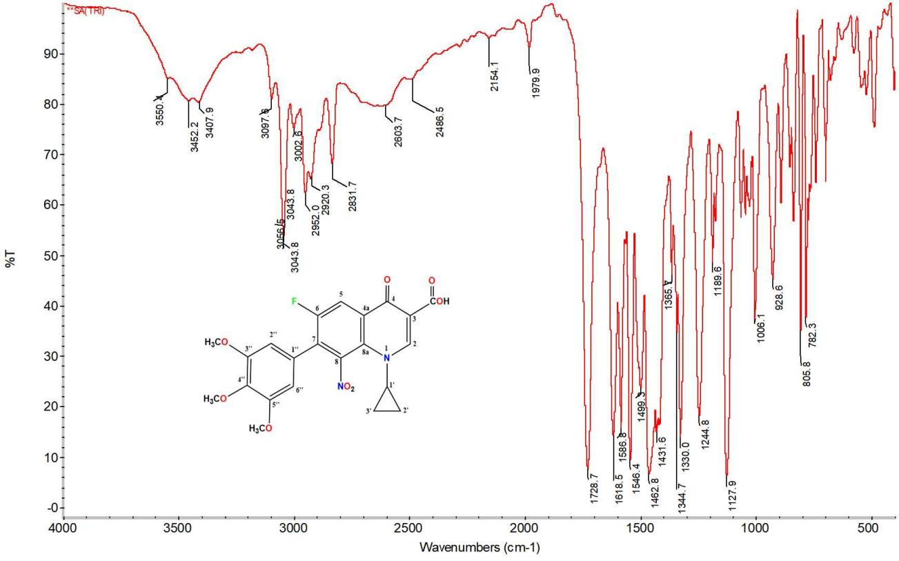

Figure 3.11: The IR spectrum for compound 16b.

