Supplementary material

Flavonoid derivatives from red propolis: In silico predictions of their interactions with Staphylococcus aureus sortase A and studies on their antibiofilm potential

Dipto Kumer Sarker^{1⸷}, Emma Ratcliffe², Fraser Burnett², Shaikh Jamal Uddin¹, Jamil A. Shilpi¹, Georgios Efthimiou³, and Veronique Seidel^{2*}

¹Pharmacy Discipline, Life Science School, Khulna University, Khulna 9208, Bangladesh
⸷Department of Pharmacy, Atish Dipankar University of Science & Technology, Dhaka-1230, Bangladesh
²Natural Products Research Laboratory, Strathclyde Institute of Pharmacy and Biomedical Sciences, University of Strathclyde, Glasgow, UK
³Centre for Biomedicine, Hull York Medical School, University of Hull, Hull, UK

*Corresponding author:
veronique.seidel@strath.ac.uk (V. Seidel), ORCID ID number 0000 0003 3880 5261

Table S1: Docking scores and predicted SILE values of red propolis flavonoids and erianin (control) towards S.aureus sortase A

Ligand | Docking score (kcal/mol) | Number of heavy atoms | SILE value
Galangin | -7.6 | 20 | 3.09
Chrysin | -7.4 | 19 | 3.06
Thevetiaflavone | -7.6 | 21 | 3.05
Vestitone | -7.6 | 21 | 3.05
Apigenin | -7.4 | 20 | 3.01
Acacetin | -7.5 | 21 | 3.01
Kaempferol | -7.5 | 21 | 3.01
Luteolin | -7.5 | 21 | 3.01
Kaempferide | -7.6 | 22 | 3.01
Isorhamnetin | -7.7 | 23 | 3.01
Quercetin | -7.5 | 22 | 2.97
Medicarpin | -7.1 | 20 | 2.89
3-hydroxy-8,9-dimethoxypterocarpan | -7.2 | 22 | 2.85
Retusapurpurin A | -8.5 | 39 | 2.83
3,4-dihydroxy-9-methoxypterocarpan | -7 | 21 | 2.81
Rhuschalcone V | -8.3 | 38 | 2.79
Eriodictyol | -6.9 | 21 | 2.77
Homopterocarpin | -6.9 | 21 | 2.77
Isoliquiritigenin | -6.6 | 19 | 2.73
Pinocembrin | -6.6 | 19 | 2.73
2-hydroxy-4-methoxychalcone | -6.6 | 19 | 2.73
Vesticarpan | -6.8 | 21 | 2.73
3,8-dihydroxy-9-methoxypterocarpan | -6.8 | 21 | 2.73
Naringenin | -6.7 | 20 | 2.73
7-O-beta-glucopyranosyl-4’hydroxyl-5-methoxyisoflavanone | -7.7 | 32 | 2.72
Calycosin | -6.7 | 21 | 2.69
Catechin | -6.7 | 21 | 2.69
2-hydroxyformononetin | -6.7 | 21 | 2.69
Liquiritigenin | -6.5 | 19 | 2.69
Pinostrobin | -6.6 | 20 | 2.69
2’,6’-dihydroxy-4’-methoxydihydrochalcone | -6.6 | 20 | 2.69
6-methoxyluteolin 7-rhamnoside | -7.6 | 33 | 2.66
Violanone | -6.8 | 23 | 2.65
Ligand | Docking score (kcal/mol) | Number of heavy atoms | SILE value
Rutin | -8.2 | 43 | 2.65
Formononetin | -6.5 | 20 | 2.65
Erianin (control) | -6.7 | 23 | 2.62
Mucronulatol | -6.6 | 22 | 2.61
Pratensein | -6.6 | 22 | 2.61
(3S)-7-O-methylvestitol | -6.5 | 21 | 2.61
Formonetin/isoformonetin | -6.4 | 20 | 2.61
Pinobanksin | -6.4 | 20 | 2.61
Vestitol | -6.4 | 20 | 2.61
4,4’-dihydroxy-2-methoxychalcone | -6.4 | 20 | 2.61
Daidzein | -6.3 | 19 | 2.60
Dalbergioidin | -6.4 | 21 | 2.57
Epicatechin | -6.4 | 21 | 2.57
Sativan | -6.4 | 21 | 2.57
7,3’-Dihydroxy-4’-methoxy-8-methylflavan | -6.4 | 21 | 2.57
Retusapurpurin B | -7.7 | 39 | 2.57
Genistein | -6.3 | 20 | 2.56
Biocanin A | -6.3 | 21 | 2.53
Isosativan | -6.3 | 21 | 2.53
Neovestitol | -6.2 | 20 | 2.52
Hesperetin 7-rhamnoglucoside | -7.7 | 43 | 2.49
Quercetin-3-glucoside | -7.1 | 33 | 2.49
3’,4’-di-O-benzyl-7-O-(2-hydroxyethyl)-3-O-methylquercetin | -7.1 | 40 | 2.35

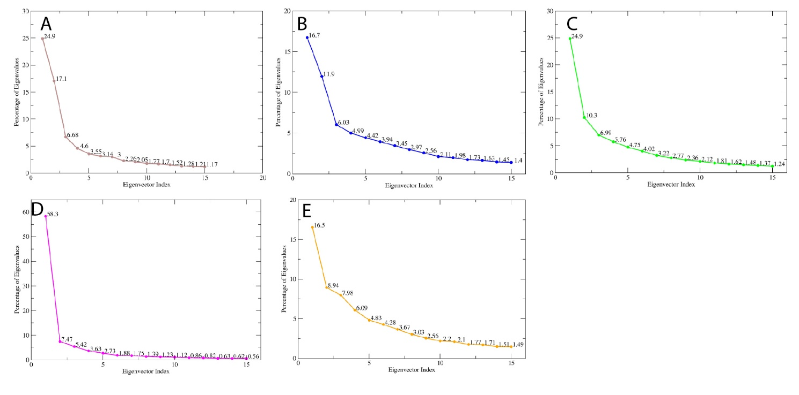Figure S1: Percentage of eigenvalues vs eigenvector index plots of the (A) apo protein, (B) chrysin-bound protein, (C) thevetiaflavone-bound protein, (D) galangin-bound protein, and (E) erianin-bound protein.

