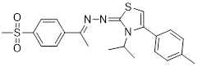
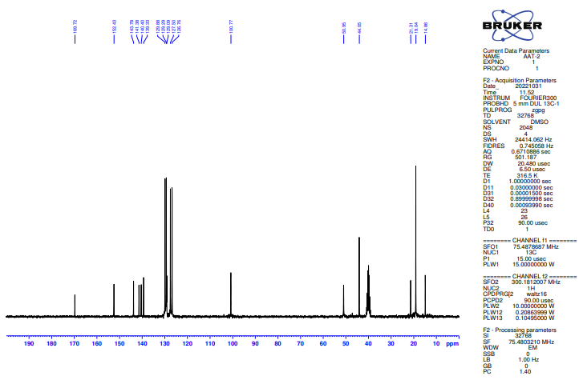
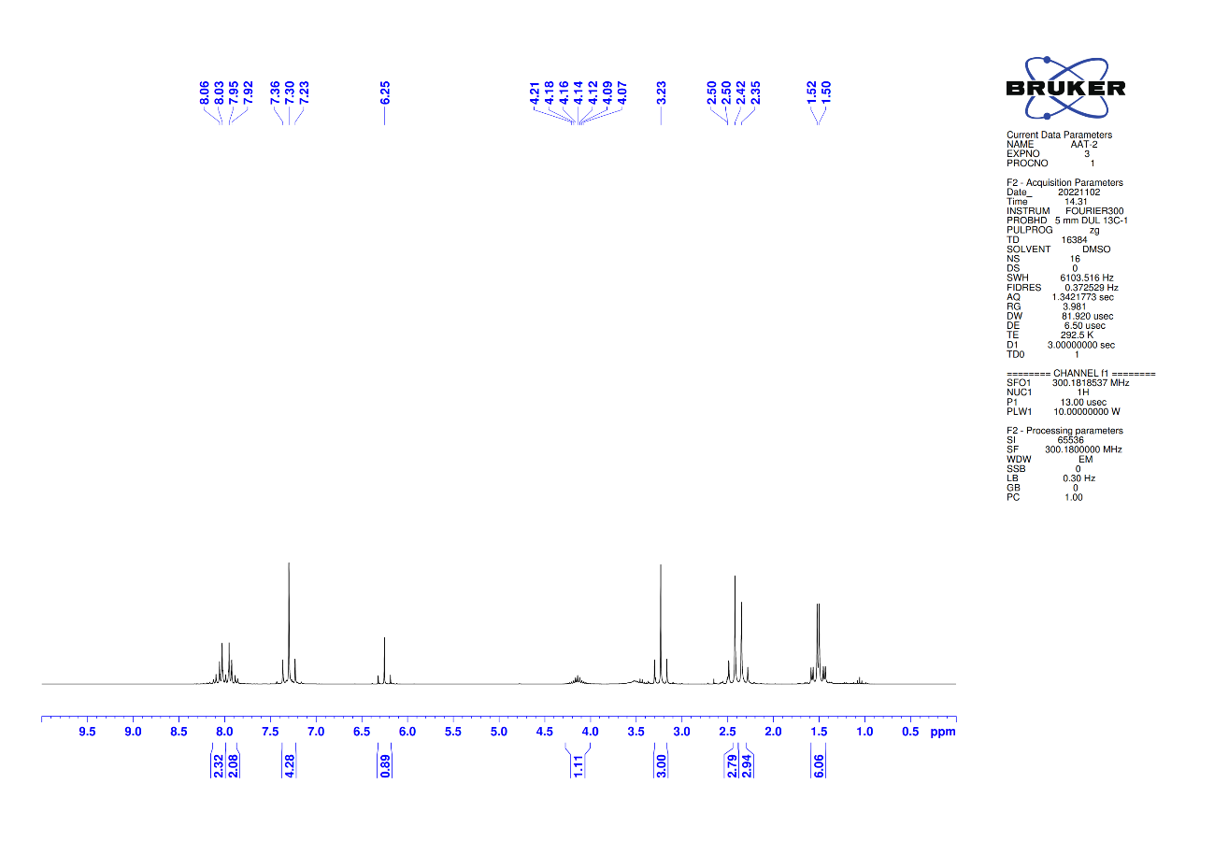
Figure S1. ¹H-NMR spectrum of compound 3a
Figure S2. ¹³C-NMR spectrum of compound 3a
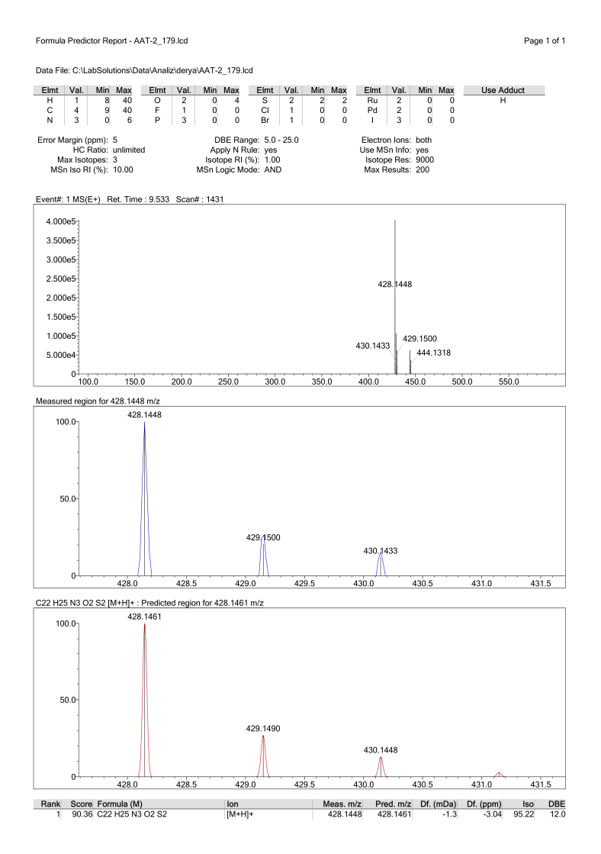
Figure S3. HRMS spectrum of compound 3a
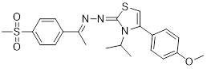
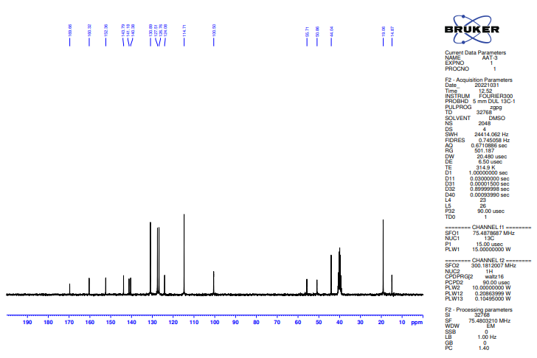
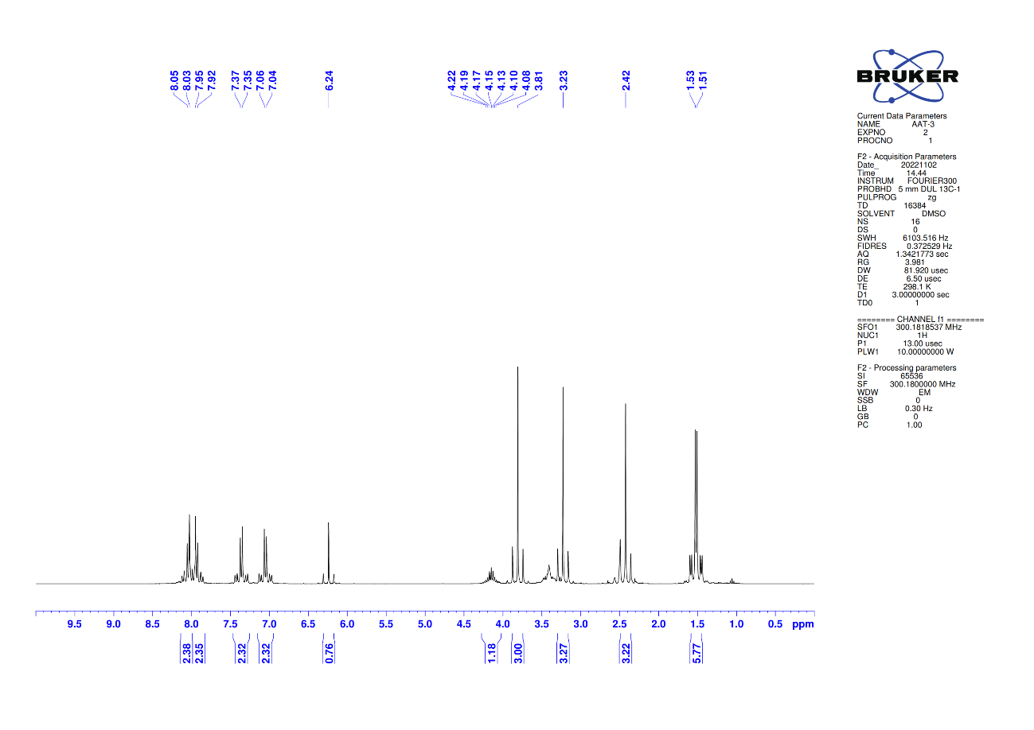
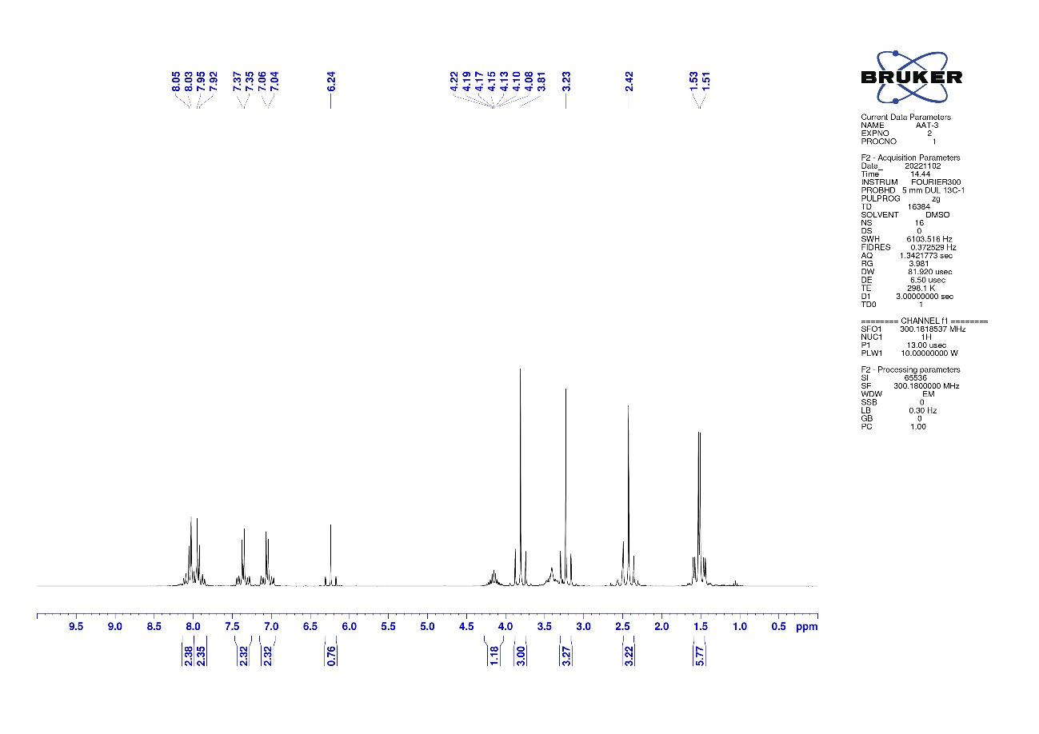
Figure S4. ¹H-NMR spectrum of compound 3b
Figure S5. ¹³C-NMR spectrum of compound 3b
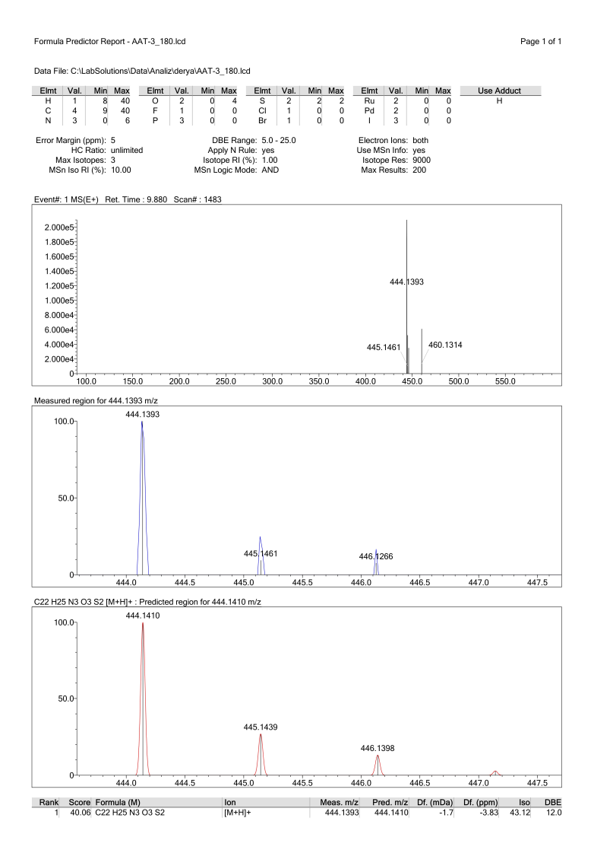
Figure S6. HRMS spectrum of compound 3b

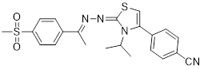
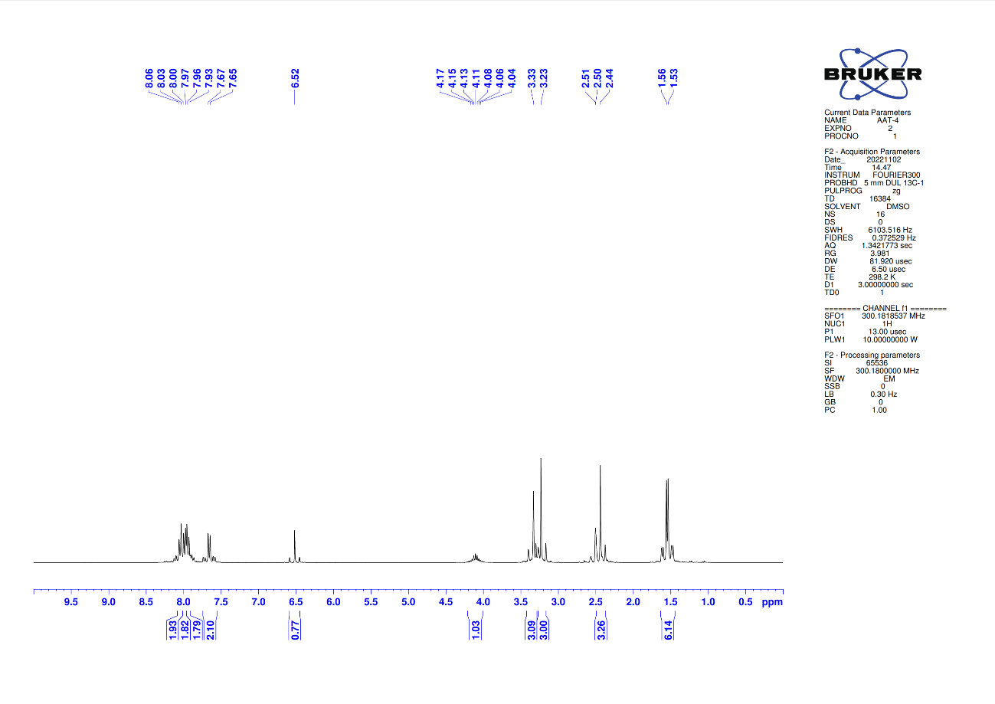
Figure S7. ¹H-NMR spectrum of compound 3c
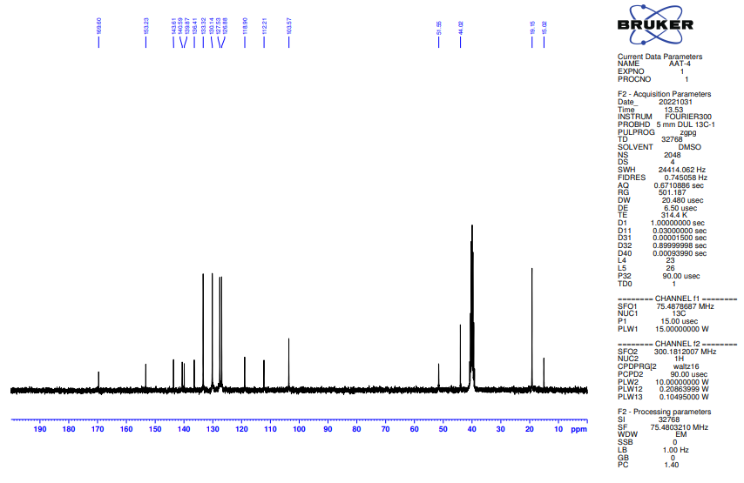
Figure S8. ¹H-NMR spectrum of compound 3c
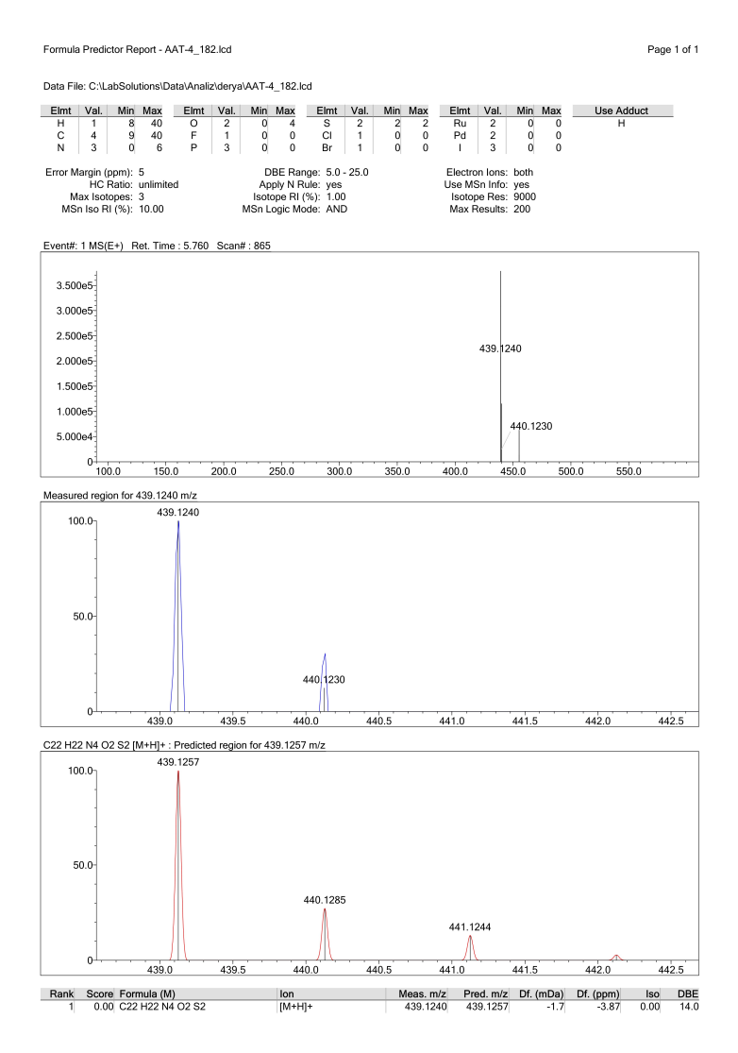
Figure S9. HRMS spectrum of compound 3c
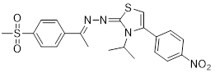
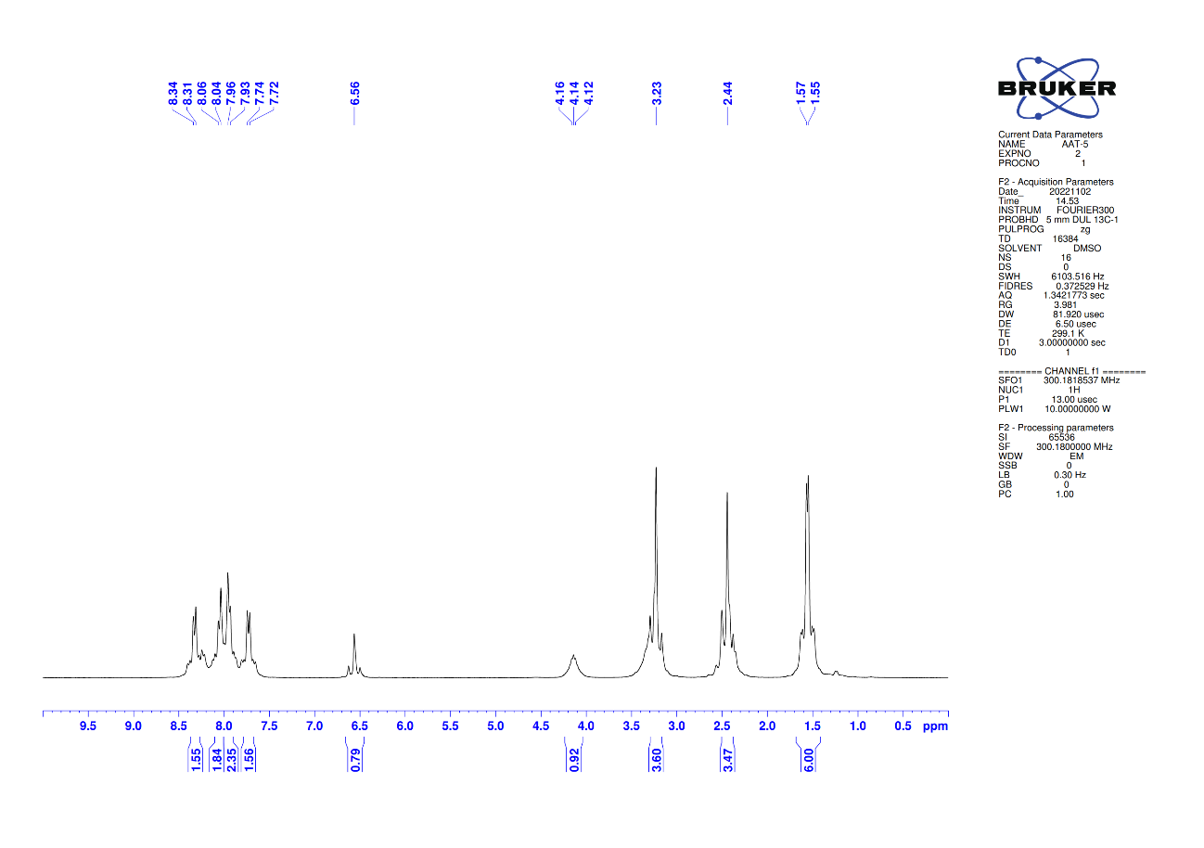
Figure S10. ¹H-NMR spectrum of compound 3d

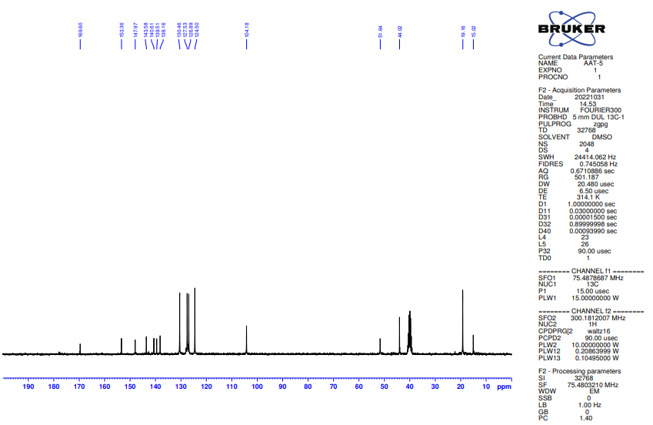
Figure S11. ¹³C-NMR spectrum of compound 3d
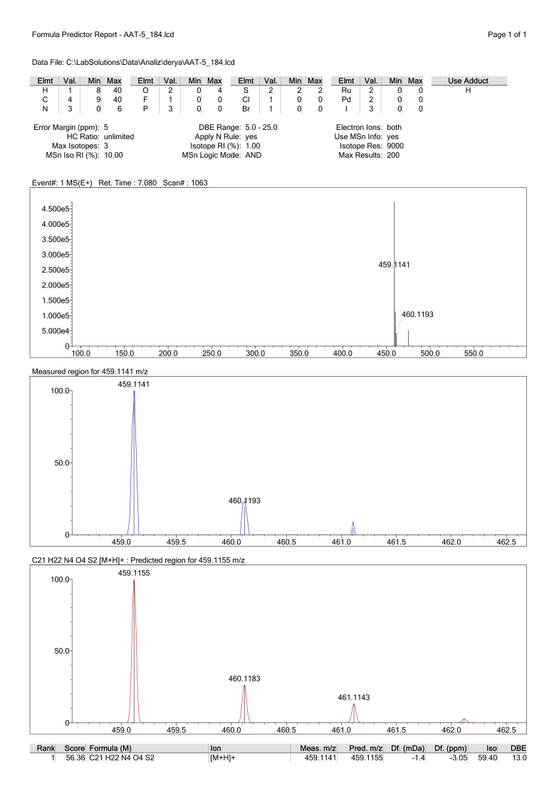
Figure S12. HRMS spectrum of compound 3d

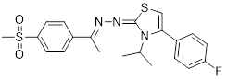
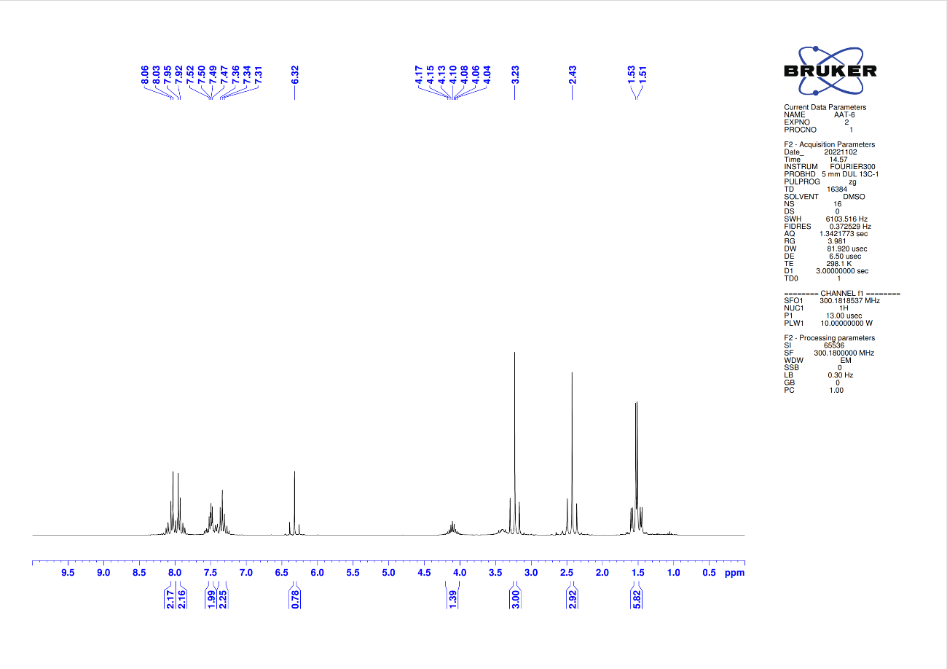
Figure S13. ¹H-NMR spectrum of compound 3e
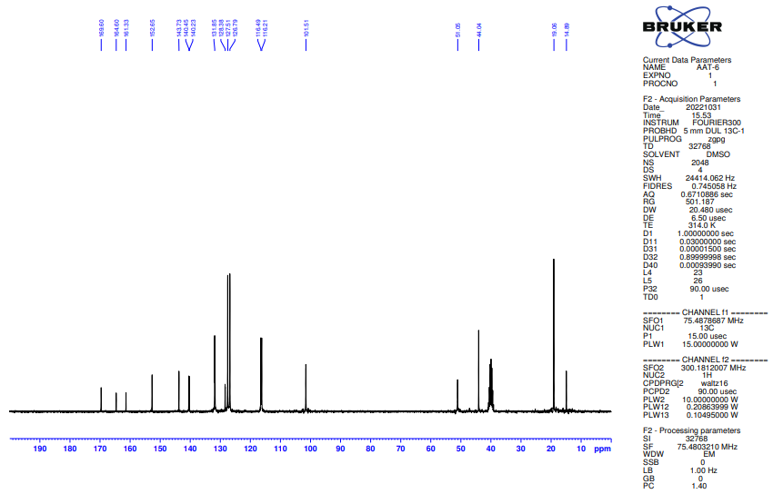
Figure S14. ¹³C-NMR spectrum of compound 3e
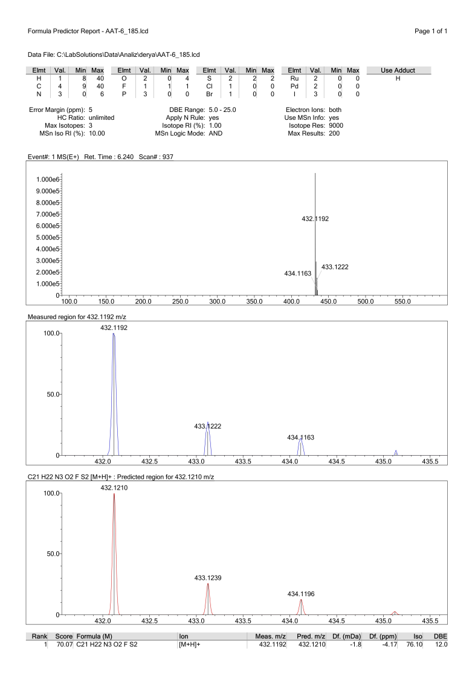
Figure S15. HRMS spectrum of compound 3e
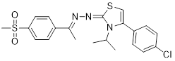
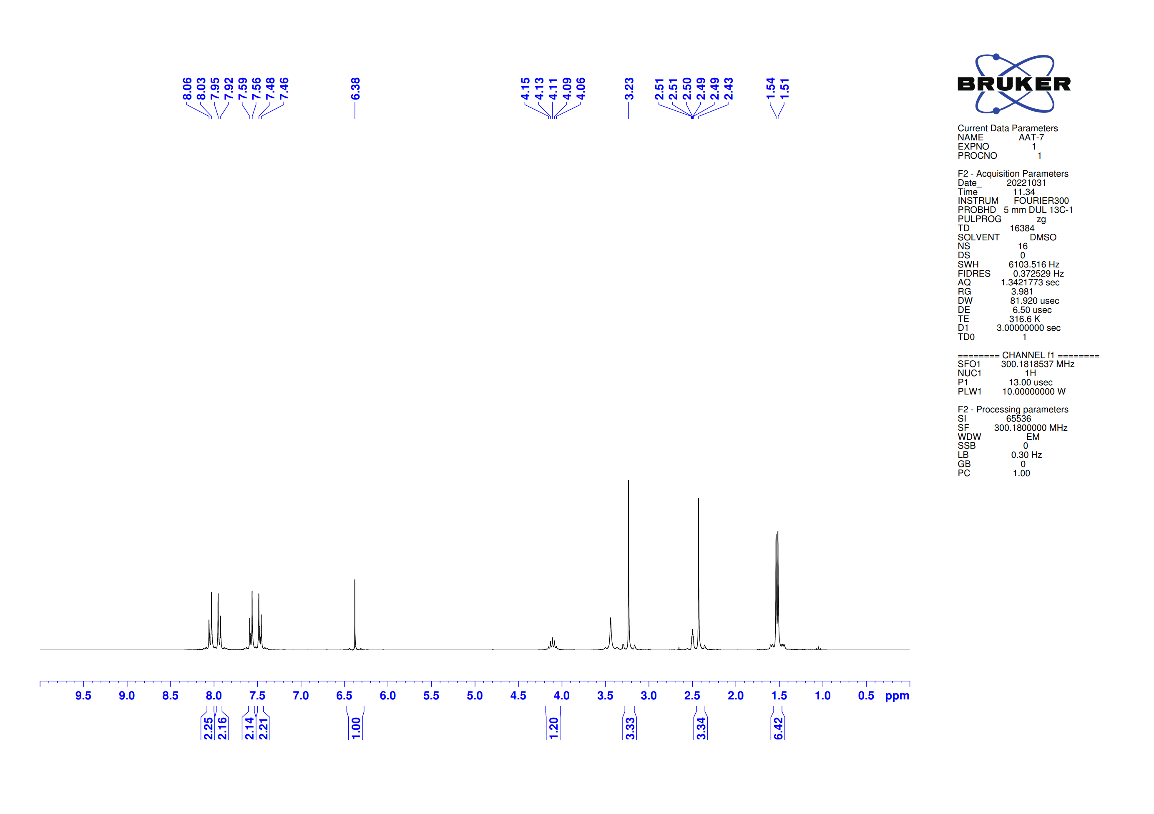
Figure S16. ¹H-NMR spectrum of compound 3f

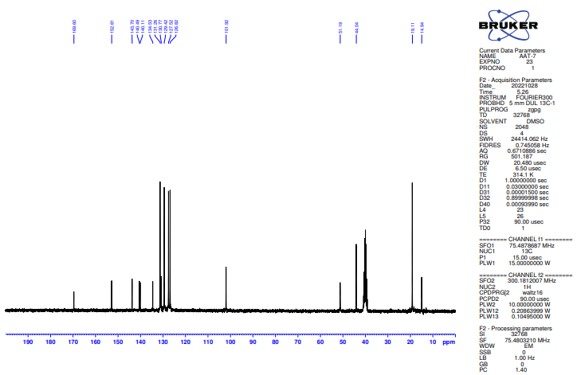
Figure S17. ¹³C-NMR spectrum of compound 3f
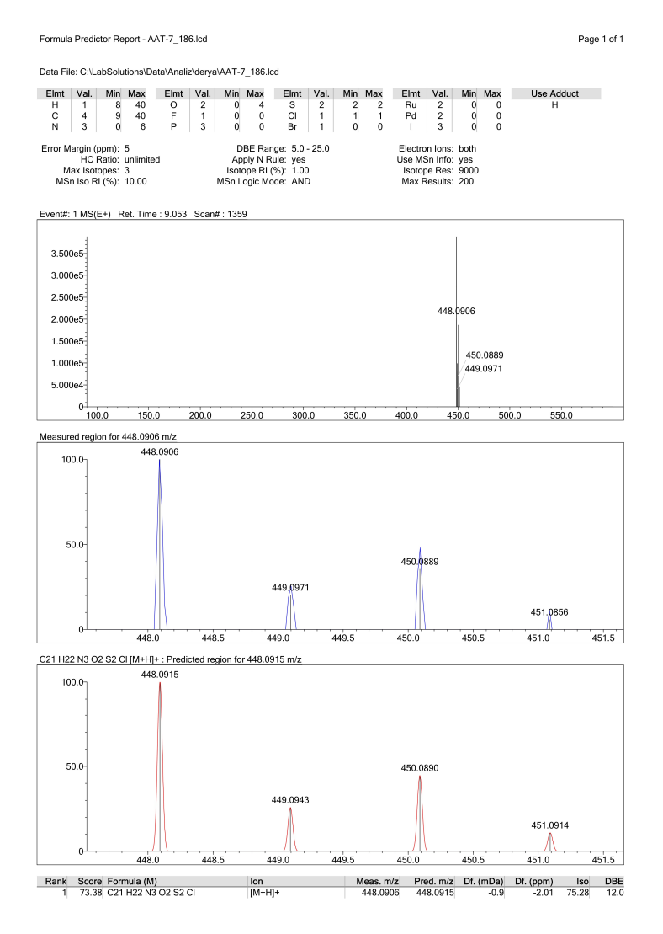
Figure S18. HRMS spectrum of compound 3f
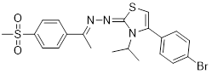
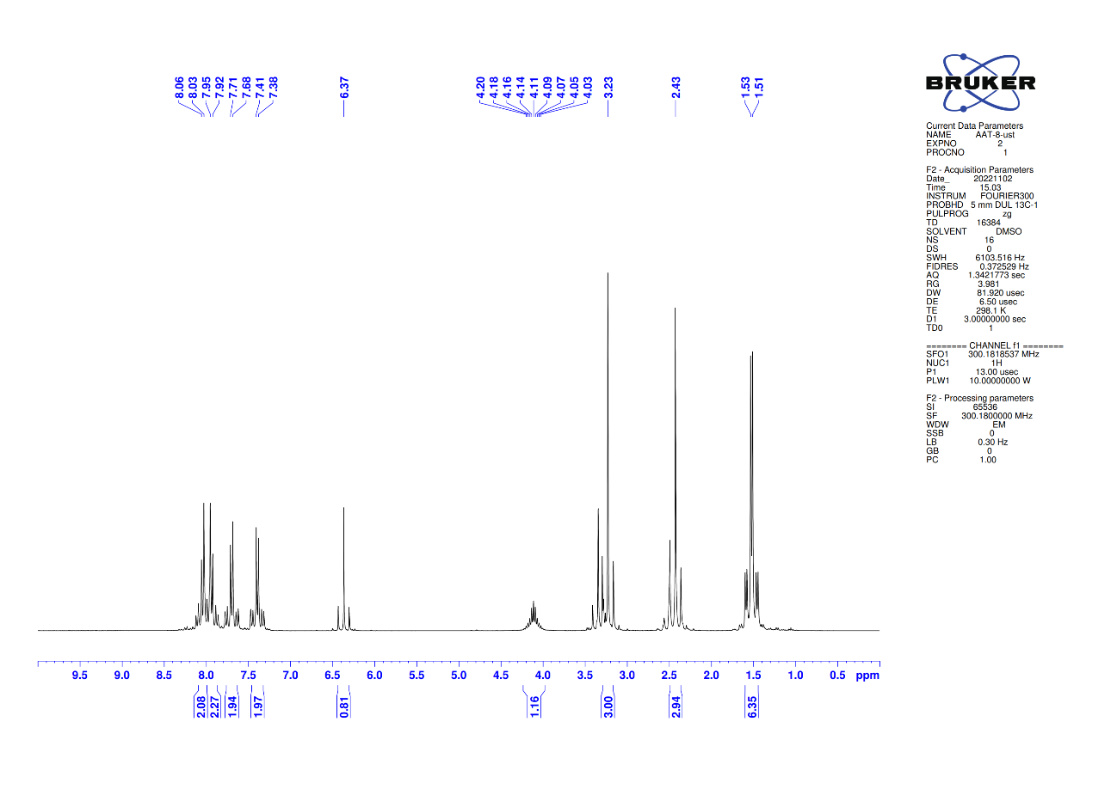
Figure S19. ¹H-NMR spectrum of compound 3g
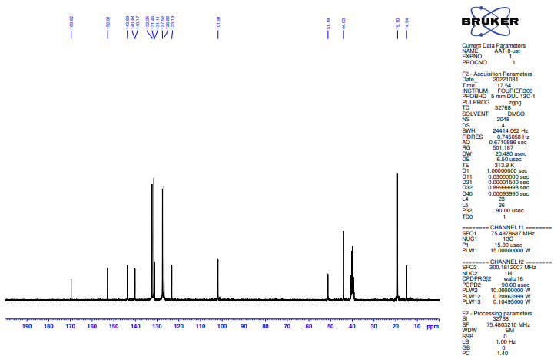
Figure S20. ¹³C-NMR spectrum of compound 3g
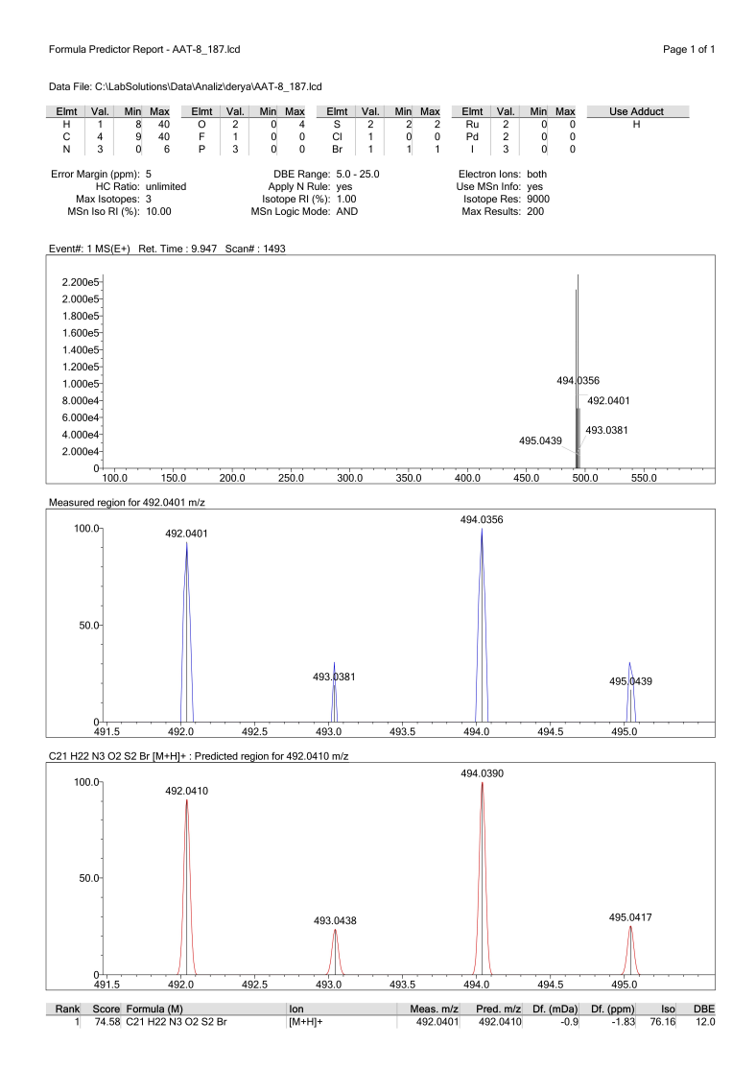
Figure S21. HRMS spectrum of compound 3g
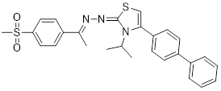
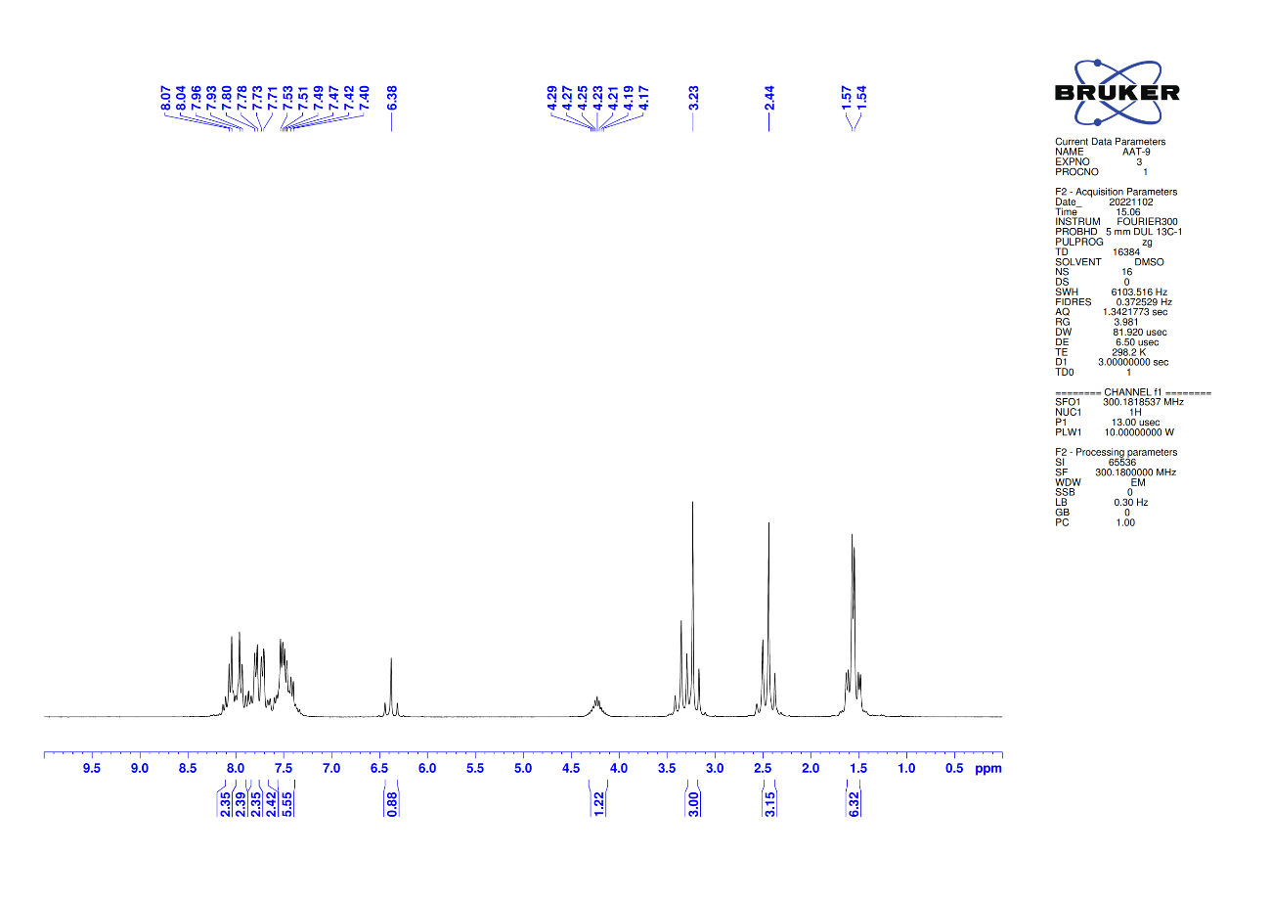
Figure S22. ¹H-NMR spectrum of compound 3h
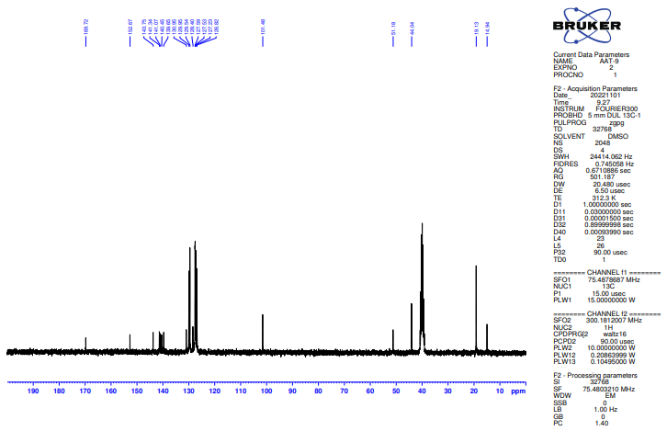
Figure S23. ¹³C-NMR spectrum of compound 3h
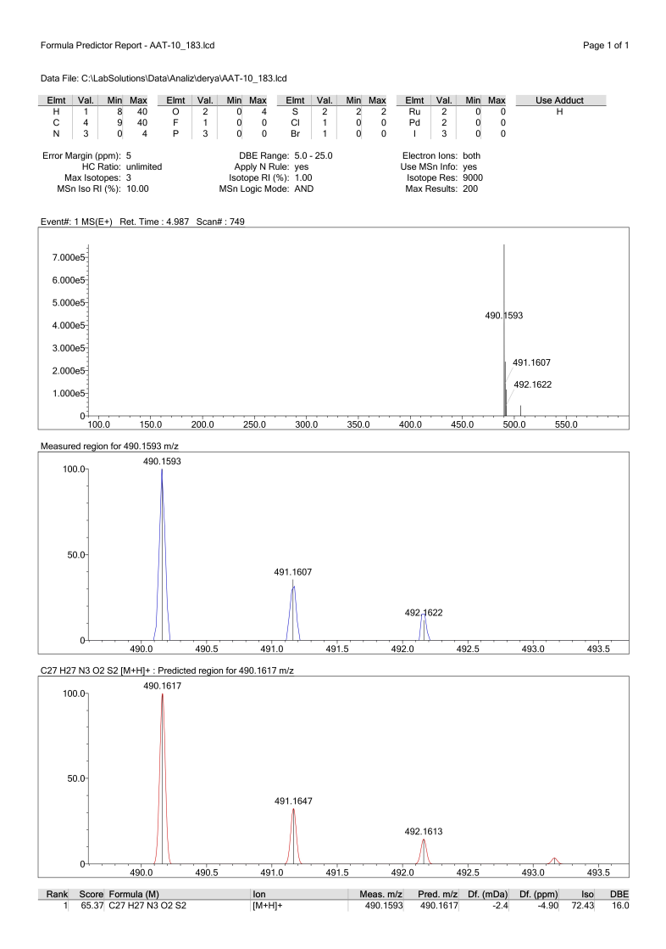
Figure S24. HRMS spectrum of compound 3h
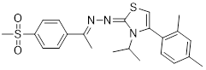
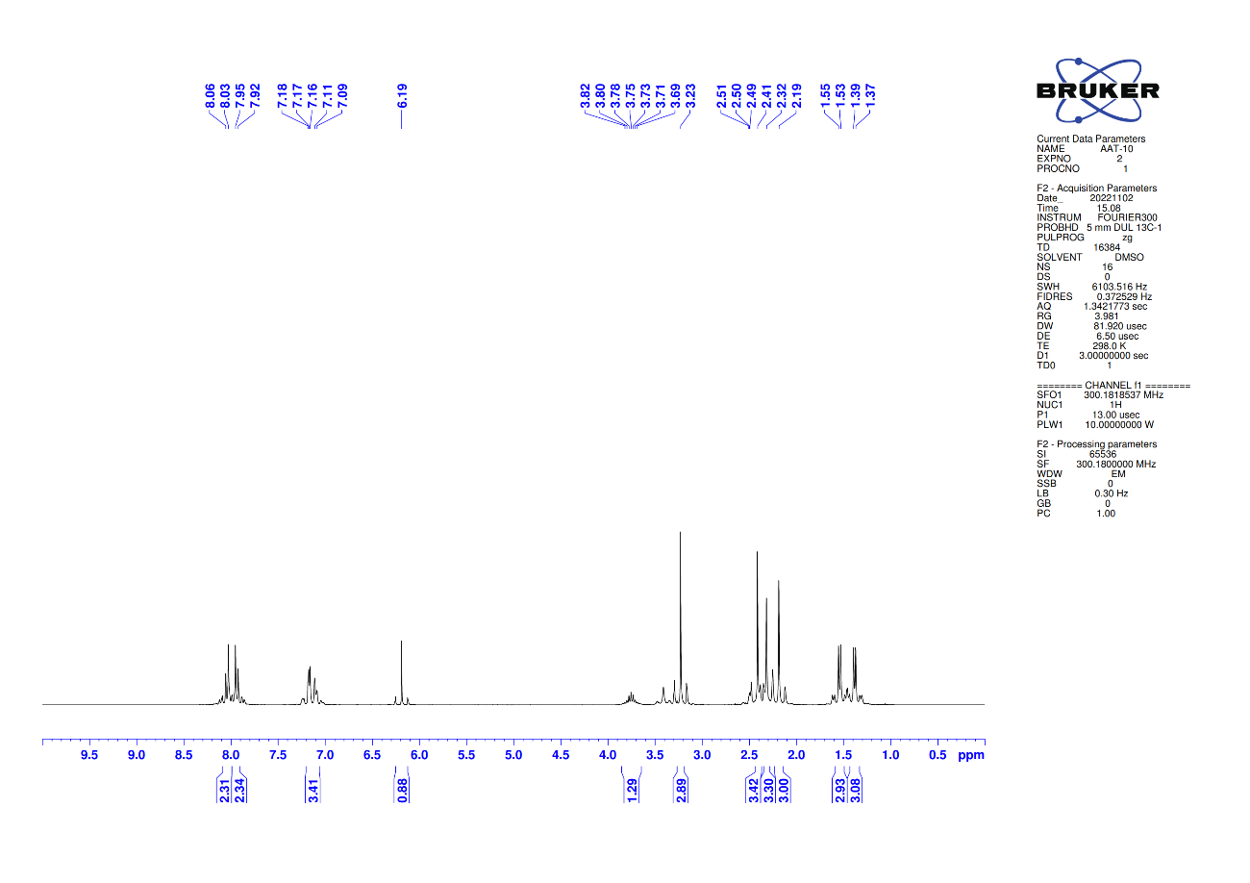
Figure S25. ¹H-NMR spectrum of compound 3i
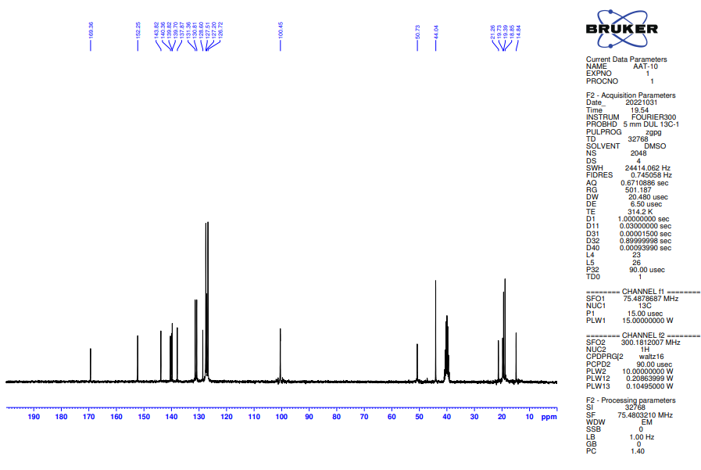
Figure S26. ¹³C-NMR spectrum of compound 3i
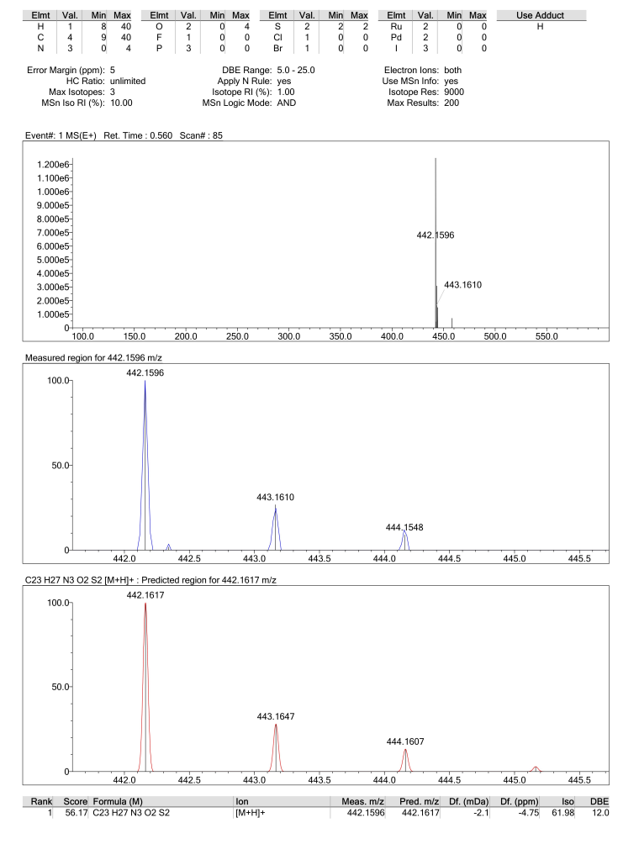
Figure S27. HRMS spectrum of compound 3i

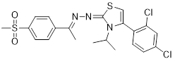
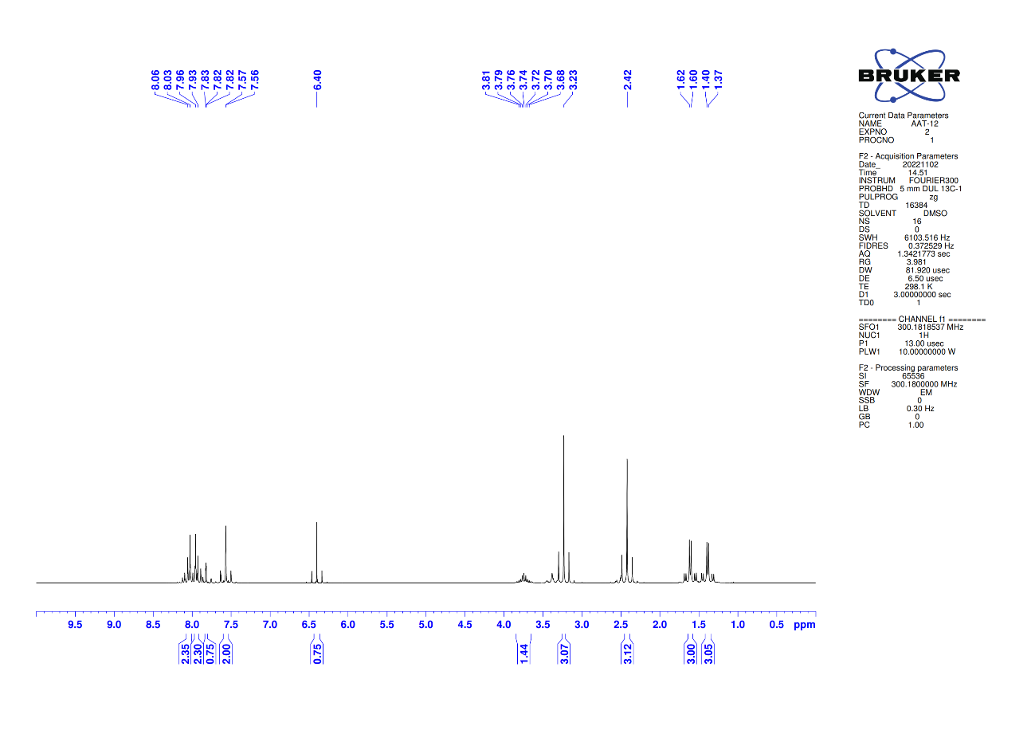
Figure S28. ¹H-NMR spectrum of compound 3j
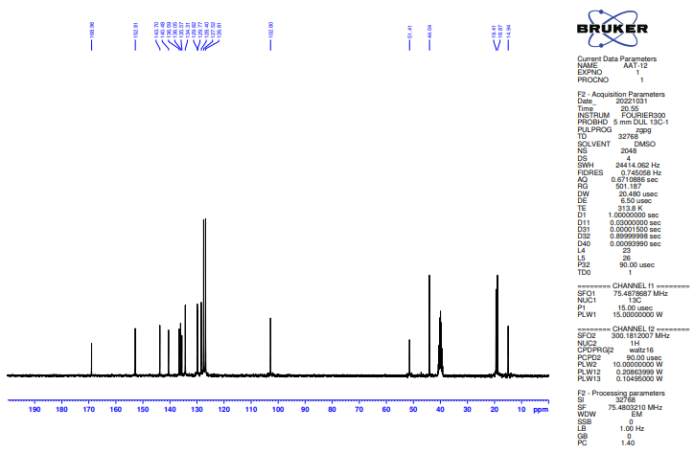
Figure S29. 13C-NMR spectrum of compound 3j
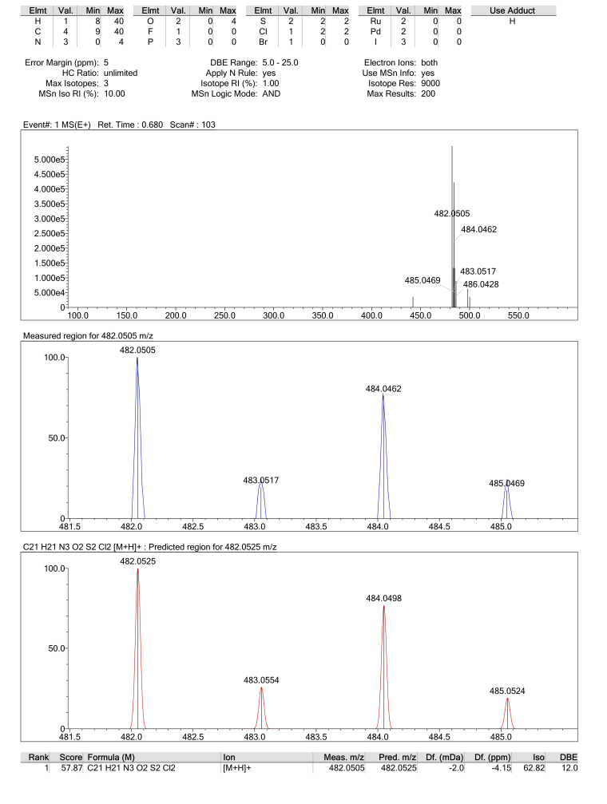
Figure S30. HRMS spectrum of compound 3j

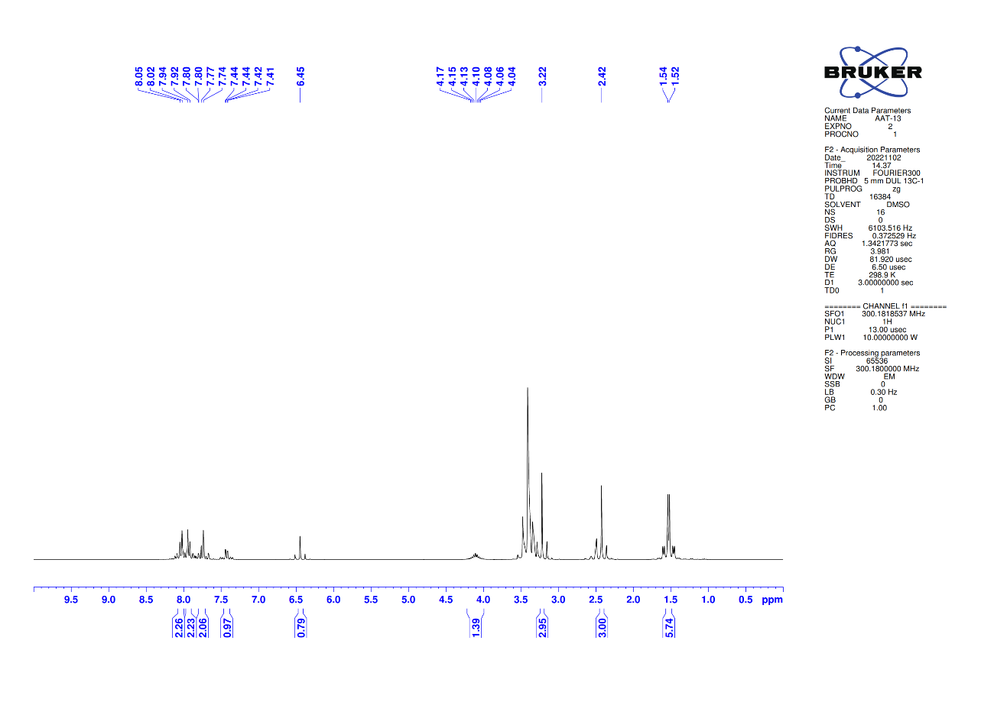
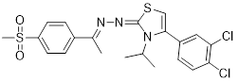
Figure S31. ¹H-NMR spectrum of compound 3k
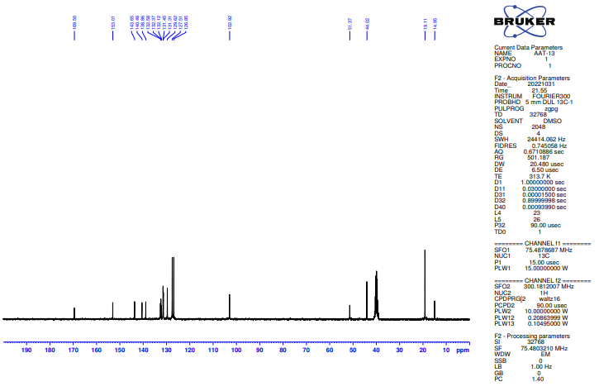
Figure S32. ¹³C-NMR spectrum of compound 3k
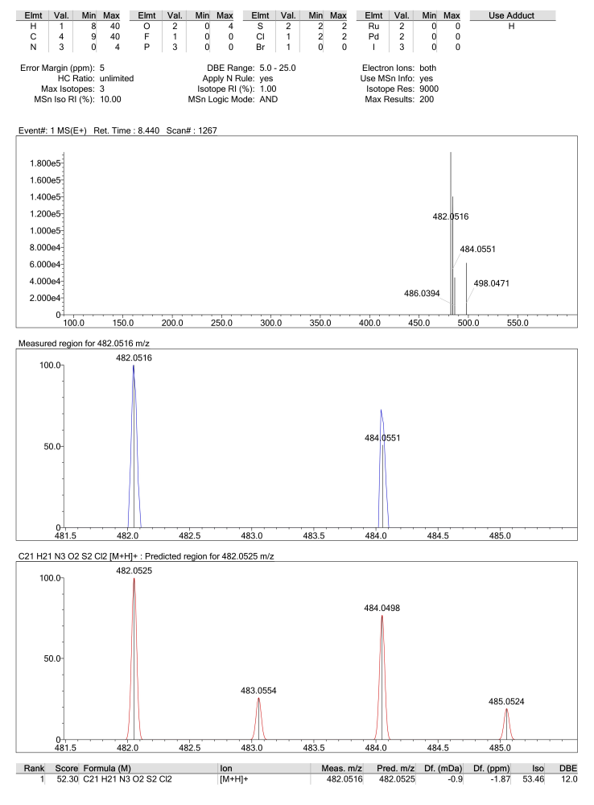

Figure S33. HRMS spectrum of compound 3k

