Length: 1915620bp, Contigs: 4
General Info
Genome ID | 1254.584
Genome Name | Pediococcus acidilactici BCB1H
Taxonomy Info
Taxon ID | 1254
Superkingdom | Bacteria
Phylum | Bacillota
Class | Bacilli
Order | Lactobacillales
Family | Lactobacillaceae
Genus | Pediococcus
Species | Pediococcus acidilactici
Status
Genome Status | WGS
Type Info
Strain | BCB1H
Database Cross Reference
Completion Date | 1/24/2022
BioProject Accession | PRJNA794945
BioSample Accession | SAMN24664208
Assembly Accession | GCA_021568595.1
Genbank Accessions | JAKGSE000000000
Sequence Info
Sequencing Status | WGS
Sequencing Platform | Illumina HiSeq
Sequencing Depth | 12.0x
Assembly Method | ABySS v. MAY-2021
Genome Statistics
Contigs | 4
Genome Length | 1915620
GC Content | 42.37396
Contig L50 | 1
Contig N50 | 1820736
Annotation Statistics
tRNA | 56
rRNA | 12
CDS | 1905
CDS Ratio | 0.9944561
Hypothetical CDS | 379
Hypothetical CDS Ratio | 0.2992126
Partial CDS | 7
Partial CDS Ratio | 0.0036745407
PLFAM CDS | 1817
PLFAM CDS Ratio | 0.95380574
Genome Quality
Coarse Consistency | 99.7
Fine Consistency | 99.2
Genome Quality | Good
Table S1: Genomic features and genome summary obtained by PATRIC

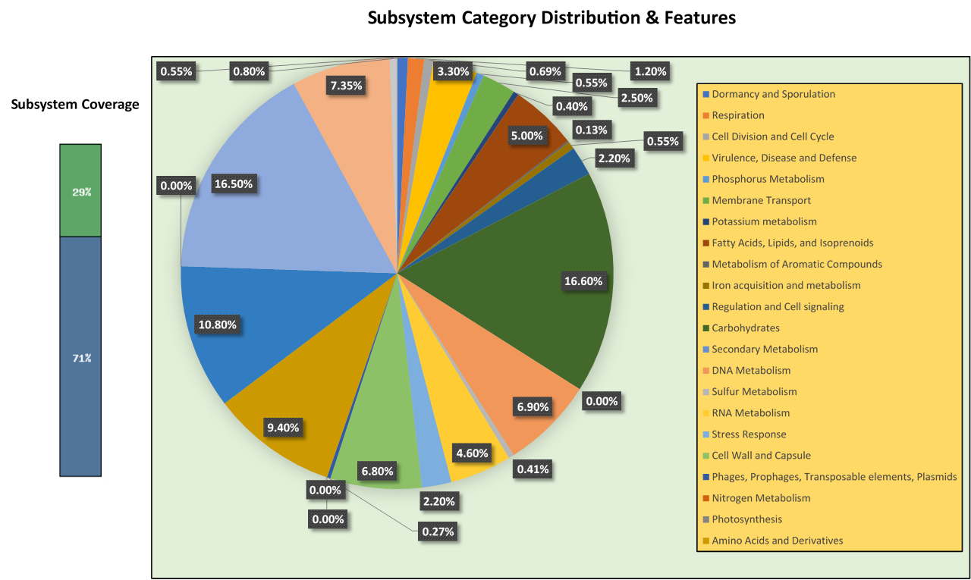

Figure S1: Subsystem Distribution & Subsystem Coverage of Pediococcus acidilactici BCB1H genome obtained from RAST

