Supplementary materials
Analysis of Cytotoxicity of Halfabar (Cymbopogon proximus) extracts: An In-silico and In-vitro Study
Noha A. Seif-Eldein ¹, Salwa A. Abu El Wafa ^{1,} *, Esraa Z. Mohammed ², and Abeer Temraz ¹
¹ Pharmacognosy and Medicinal Plants Department, Faculty of Pharmacy for Girls, Al Azhar University, Cairo, Egypt
² Pharmaceutical Chemistry Department, Faculty of Pharmacy, October 6 University, Giza 12585, Egypt

* Correspondence: Salwa A. Abu El Wafa, salwaabuel-wafa.pharmg@azhar.edu.eg

 | Contents
Figure S1 | (I) Effect of petroleum ether (Pet.Eth) fraction on A549 lung cancer cells at different concentrations. (II) Microscopic images of the A549 cells treated with the Pet. Eth fraction of the Cymbopogon proximus extract, subjected to cytotoxicity assay. (A) Control A549 cells and (B) A549 cells treated with different concentrations of the Pet.Eth fraction.
Figure S2 | (A) Bar graph showing the DNA content of the petroleum ether (Pet.Eth) fraction-treated versus control A549 cells. Flow cytometric results showing the distribution of the DNA content of propidium iodide-stained (B) Pet.Eth-treated A549 cells and (C) controlled cells at different cell cycle phases.
Figure S3 | (A) Bar graph showing the proportion of apoptotic control and petroleum ether (Pet.Eth) fraction-treated A549 cells subjected to the annexin V–fluorescein isothiocyanate/propidium iodide assay. Concentration of (B) Pet.Eth fraction treated A549 cells and (C) controlled A549 cells in the early apoptosis, late apoptosis, and necrotic phases.
Figure S4 | Gas chromatography–mass spectrometric results of the (A) unsaponifiable and (B) saponifiable matter of the petroleum ether fraction of Cymbopogon proximus.
Figure S5 | Structures of the major constituents in the petroleum ether fraction of Cymbopogon proximus.
Figure S6 | Mass spectra of the identified compounds in the petroleum ether fraction of Cymbopogon proximus. (A) Elemol, (B) β-eudesmol, (C) di-N-octyl phthalate, (D) 3-β-hydroxylean-11.13(18)-dien-30-oic acid methyl ester, and (E) palmitic acid.
Figure S7 | (I) Two-dimensional (2D) ligand interaction diagram of the native ligand superimposed (green) and its redocking pose (red) within the cyclin-dependent kinase-2 (CDK2) adenosine triphosphate (ATP)-binding site. (II) 2D and three-dimensional (3D) ligand contact figures of the compounds (a) elemol, (b) β-eudesmol, (c) di-N-octyl phthalate, (d) 3-β-hydroxylean-11.13(18)-dien-30-oic acid methyl ester, (e) linoelaidic acid, (f) oleic acid, (g) palmitic acid, and (h) linoleic acid. “Green” indicates their interactions with the CDK2 ATP-binding site.
Figure S8 | 2D and three-dimensional (3D) ligand contact figures of different identified fatty acids. “Green” indicates their interactions with the CDK2 ATP-binding site.
Figure S9 | 2D and three-dimensional (3D) ligand contact figures of different identified hydrocarbons. “Green” indicates their interactions with the CDK2 ATP-binding site.
Figure S10 | Western blot profiles, with β-actin as the control protein, demonstrating the effects of the petroleum ether fraction on cyclin-dependent kinase-2 (CDK2) and cyclin A2 levels in A549 cells compared with control cells. (A) CDK2 level, (B) cyclin A2 level, and (C) computerized analysis of the samples. Cropped blots are displayed in this figure and the ‘full-length blots are presented in Supplementary Material, Figure S3-S5.'
Figure S11 | (I) Photograph of β- actin expression level for sample. (II) computerized analysis of β- actin proein expression level for samples.
Figure S12 | (I) Photograph of CDK2 protein expression level for sample. (II) computerized analysis of  CDK2 protein expression level for samples. (III) dendogram of samples.
Figure S13 | (I) Photograph of Cyclin A2 protein expression level for sample. (II) computerized analysis of  Cyclin A2 protein expression level for samples. (III) dendogram of samples.

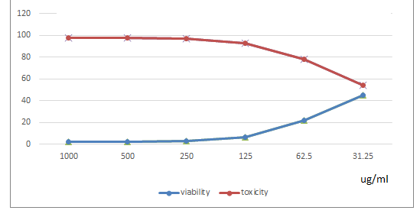
(I)
(II)
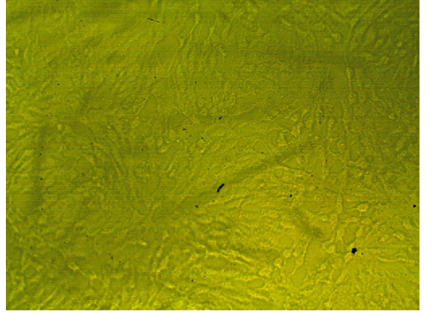
(A)
(B)
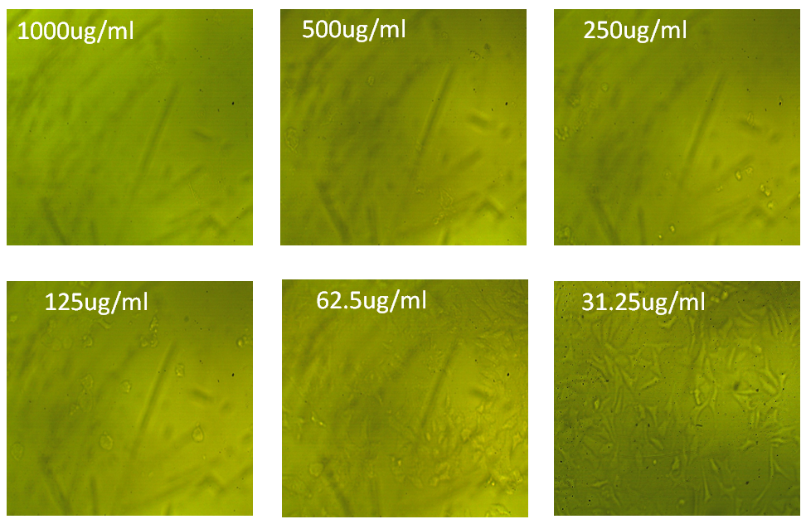
Figure S1. (I) Effect of petroleum ether (Pet.Eth) fraction on A549 lung cancer cells at different concentrations. (II) Microscopic images of the A549 cells treated with the Pet. Eth fraction of the Cymbopogon proximus extract, subjected to cytotoxicity assay. (A) Control A549 cells and (B) A549 cells treated with different concentrations of the Pet.Eth fraction.

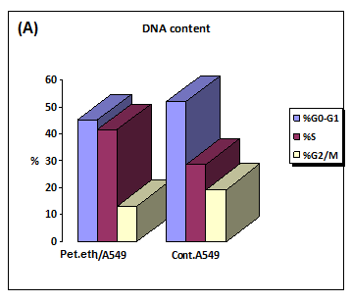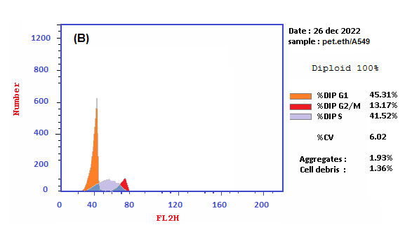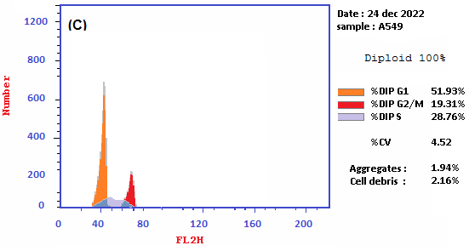
Figure S2. (A) Bar graph showing the DNA content of the petroleum ether (Pet.Eth) fraction-treated versus control A549 cells. Flow cytometric results showing the distribution of the DNA content of propidium iodide-stained (B) Pet.Eth-treated A549 cells and (C) controlled cells at different cell cycle phases.

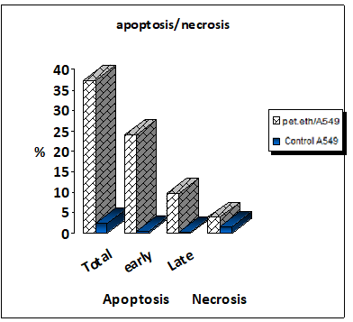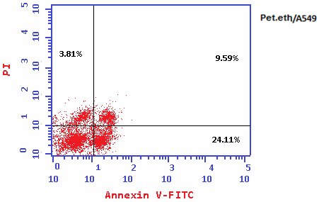
(A)

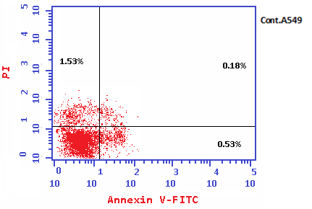
(B)
(C)
Figure 3. (A) Bar graph showing the proportion of apoptotic control and petroleum ether (Pet.Eth) fraction-treated A549 cells subjected to the annexin V–fluorescein isothiocyanate/propidium iodide assay. Concentration of (B) Pet.Eth fraction treated A549 cells and (C) controlled A549 cells in the early apoptosis, late apoptosis, and necrotic phases.

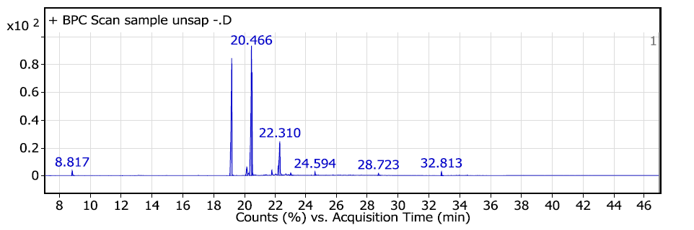
(A)
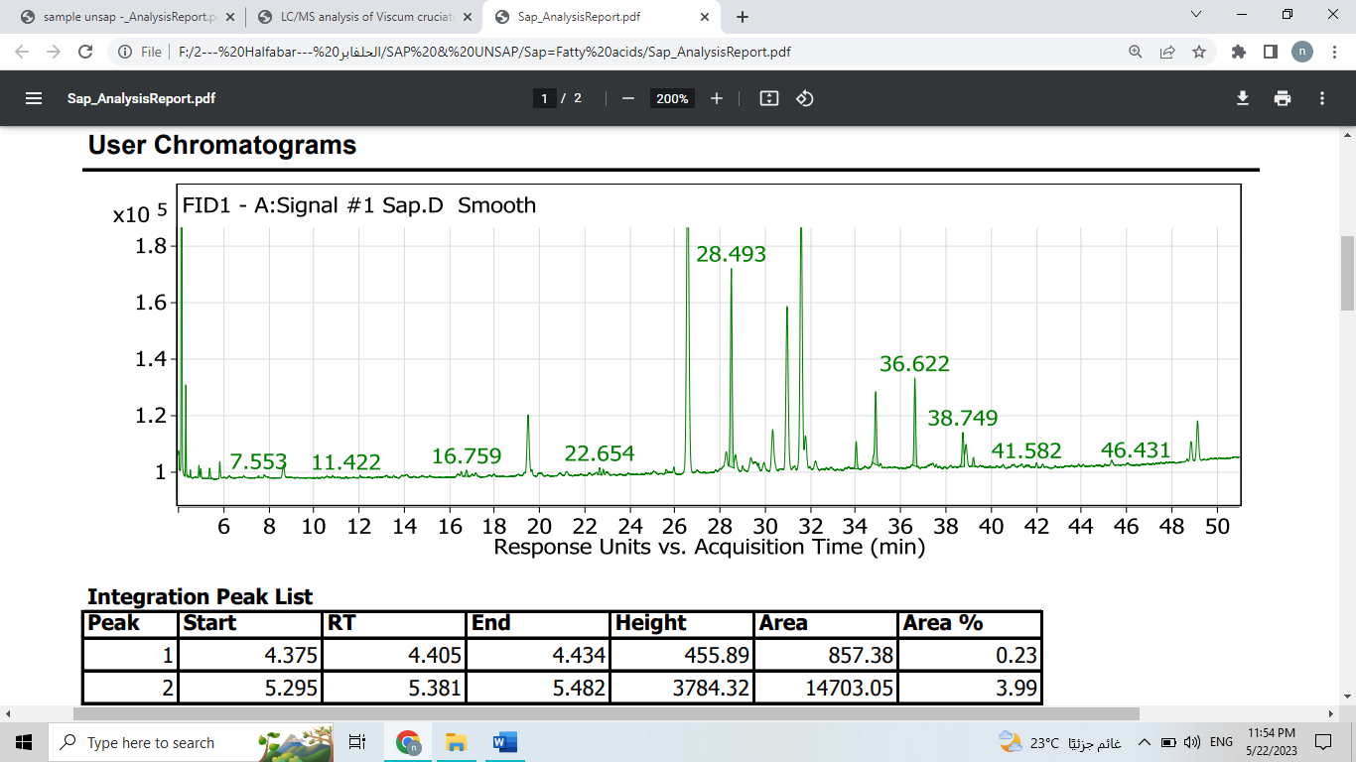
(B)

Figure S4. Gas chromatography–mass spectrometric results of the (A) unsaponifiable and (B) saponifiable matter of the petroleum ether fraction of Cymbopogon proximus.

Palmitic acid | Linoleic acid | Oleic acid
Stearic acid | Linolenic acid  (omega 3) | Arachidic acid
Linoelaidic acid | Lauric acid | Myristic acid
Di-n-octyl phthalate | Proximadiol | 3-beta. -Hydroxylean-11.13(18)-dien-30-oic acid methyl ester
β-Eudesmol | Elemol | α-Eudesmol

Figure S5. Structures of the major constituents in the petroleum ether fraction of Cymbopogon proximus.

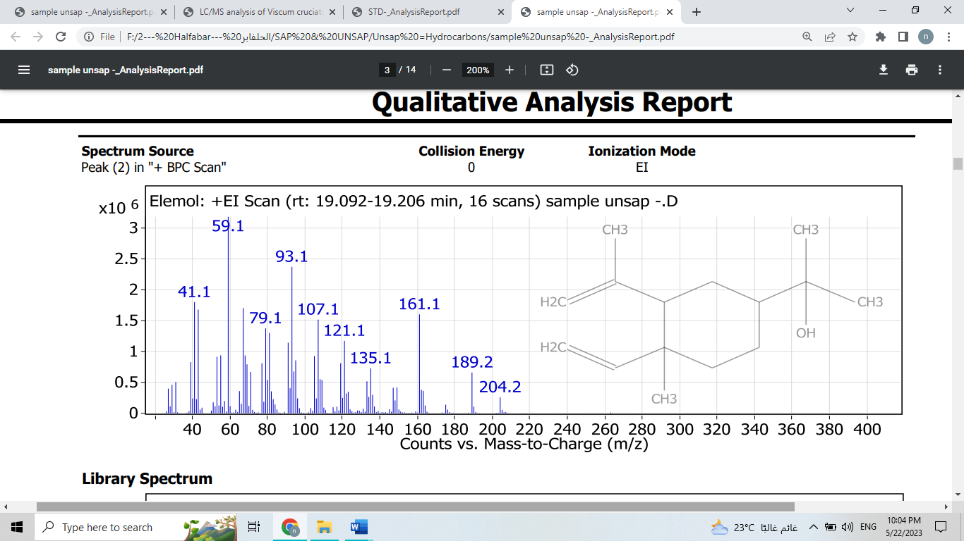
(A)
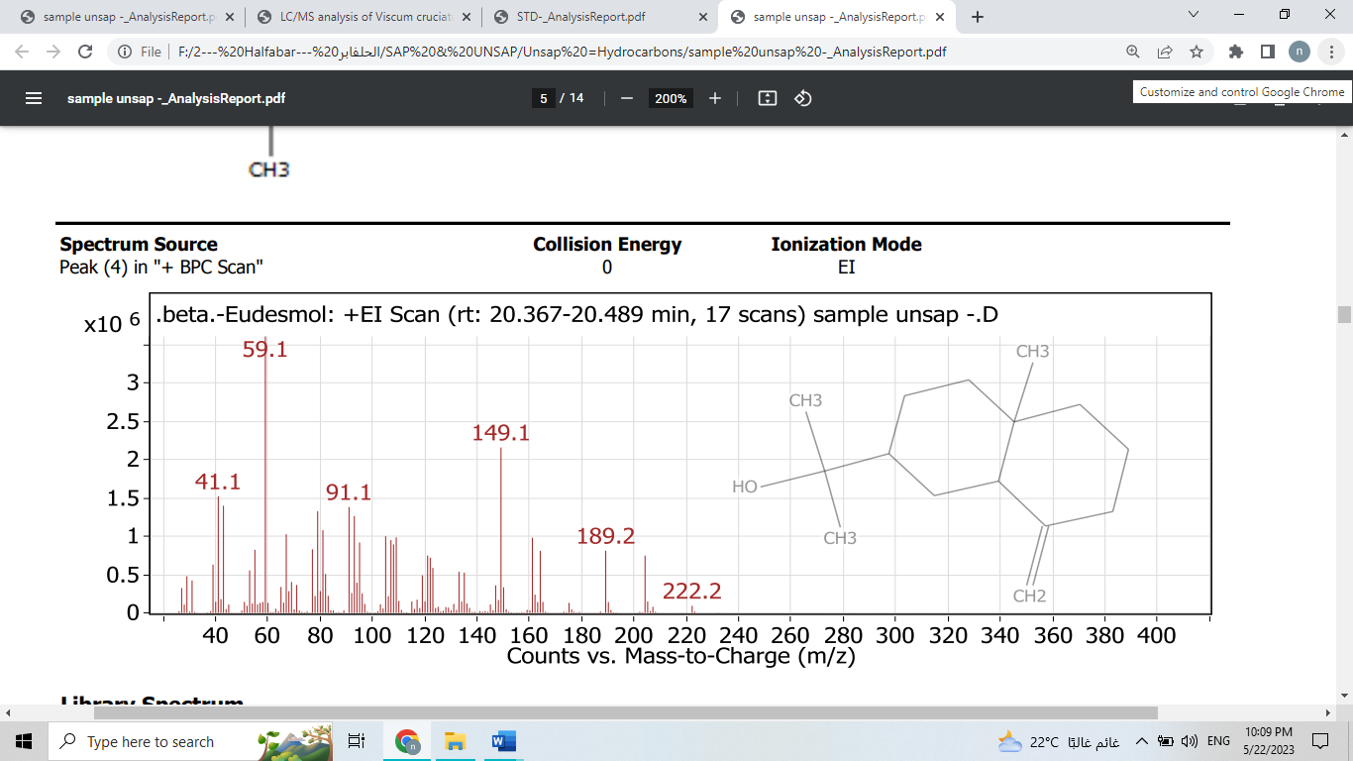
(B)
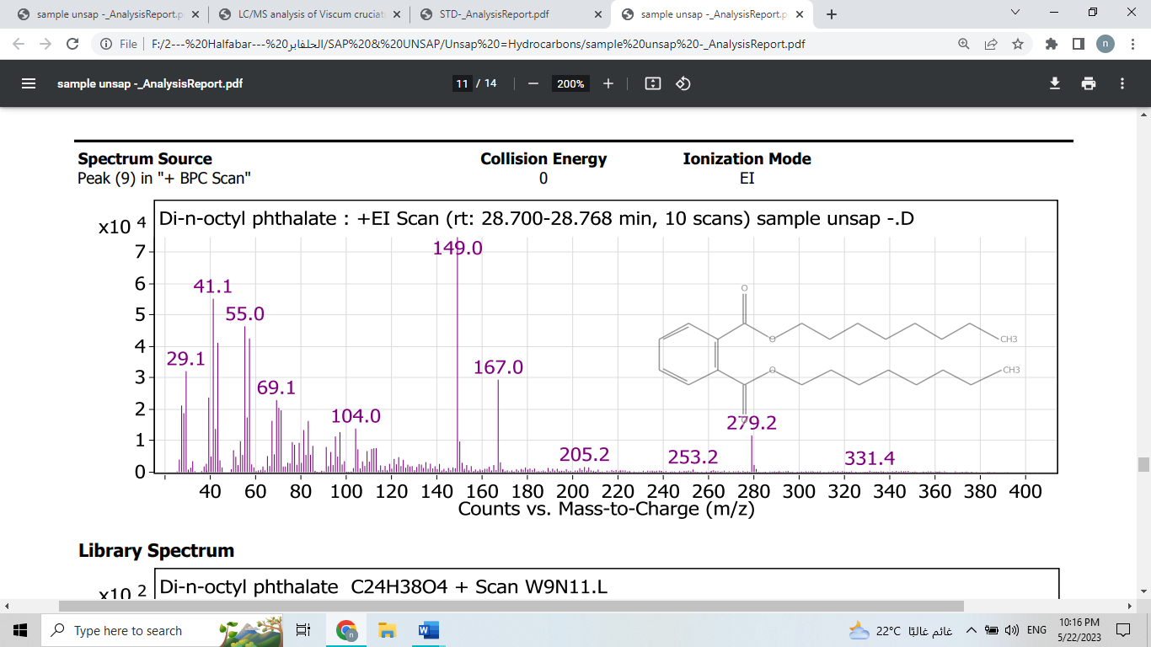
(C)
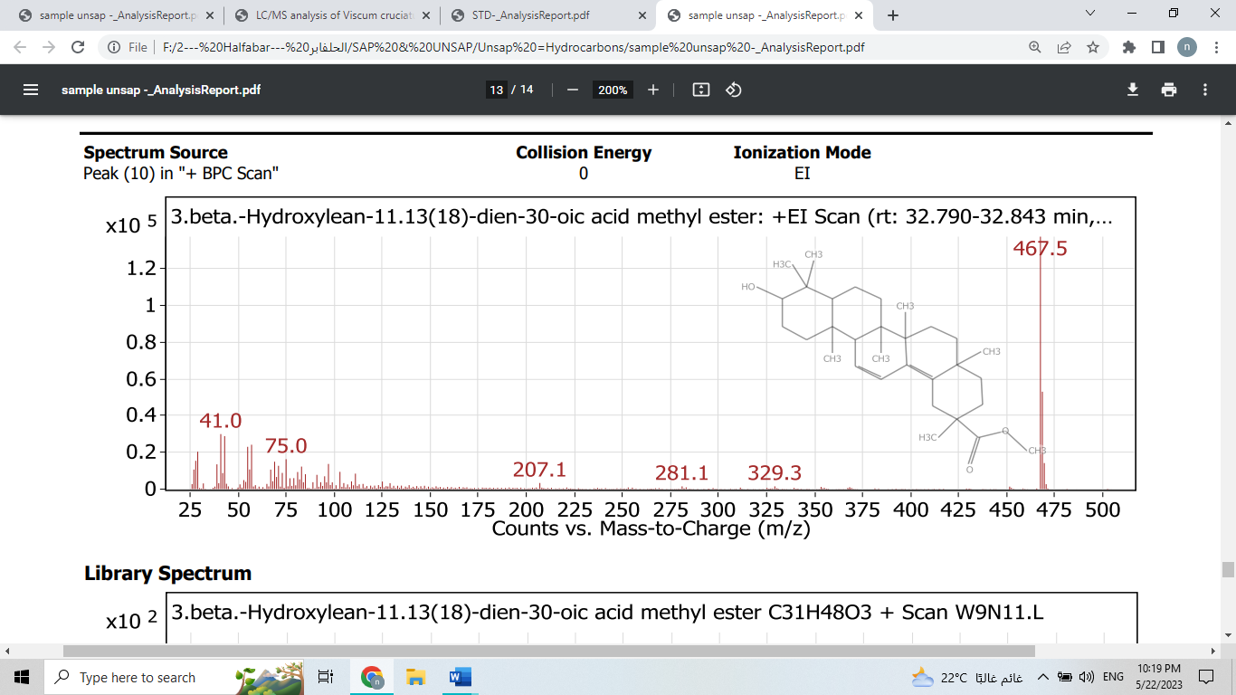
(D)
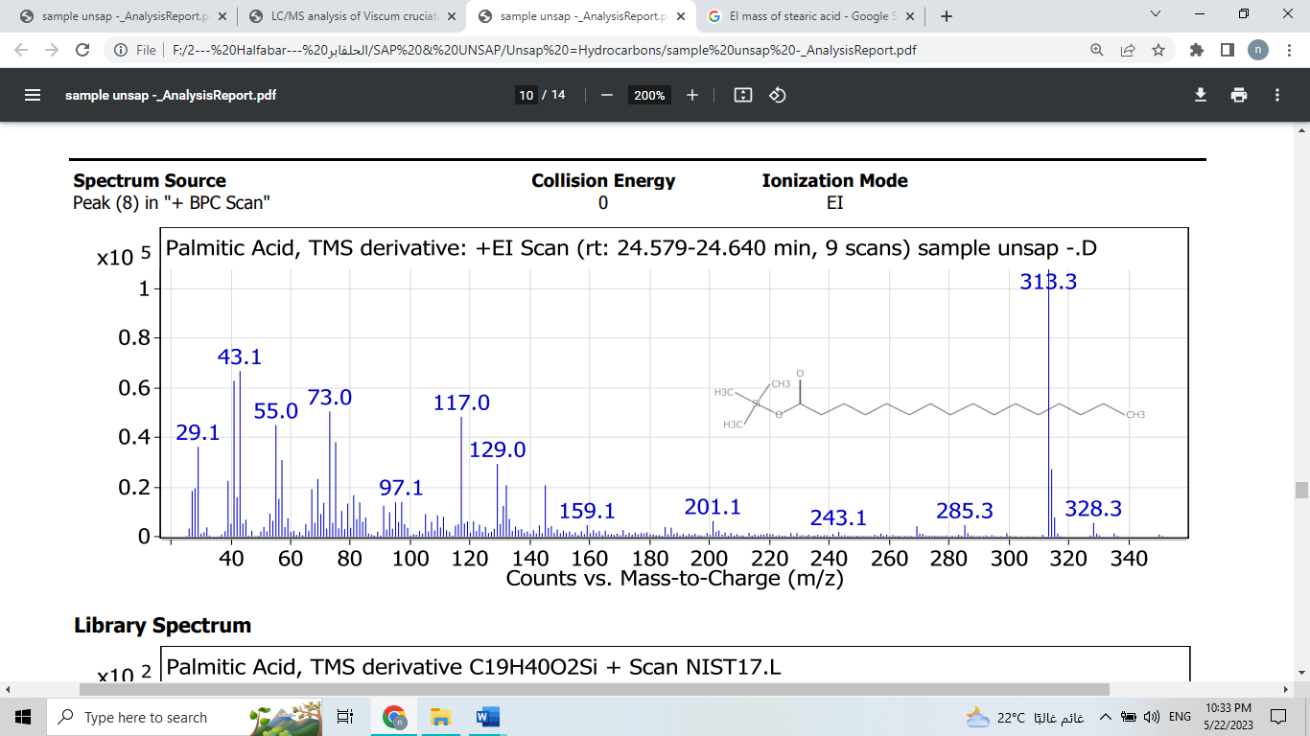
(E)
Figure S6. Mass spectra of the identified compounds in the petroleum ether fraction of Cymbopogon proximus. (A) Elemol, (B) β-eudesmol, (C) di-N-octyl phthalate, (D) 3-β-hydroxylean-11.13(18)-dien-30-oic acid methyl ester, and (E) palmitic acid.

(I)
(II)

A) | 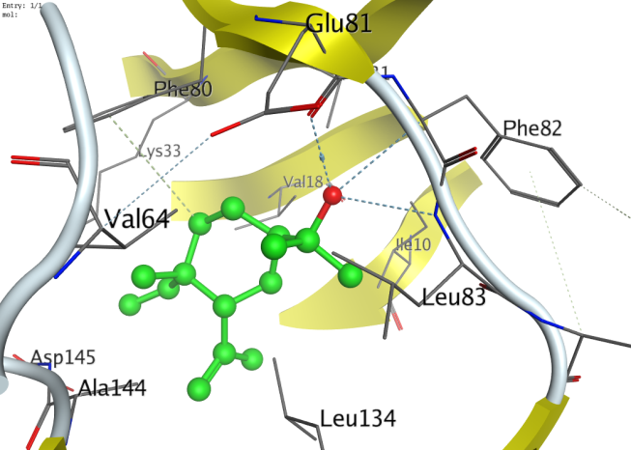
B) | 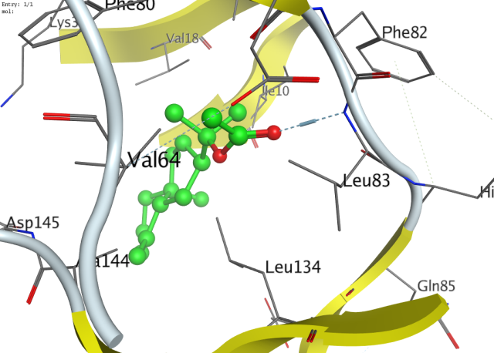
C) | 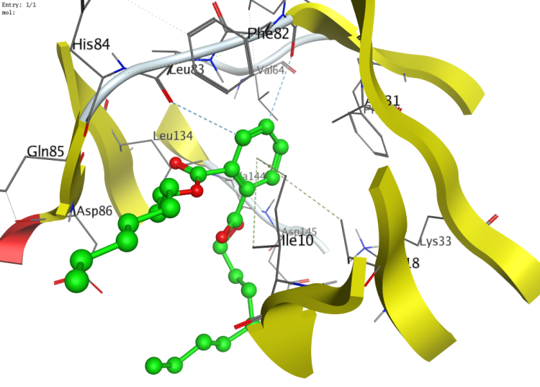
D) | 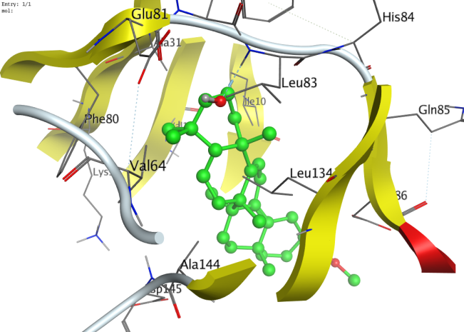
E) | 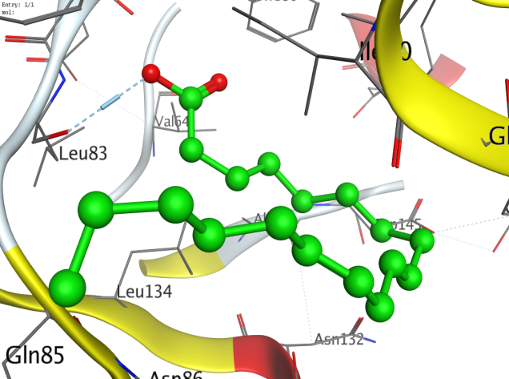
F) | 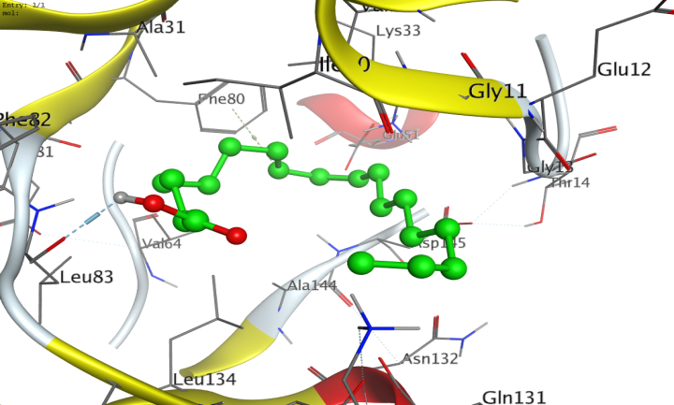
G) | 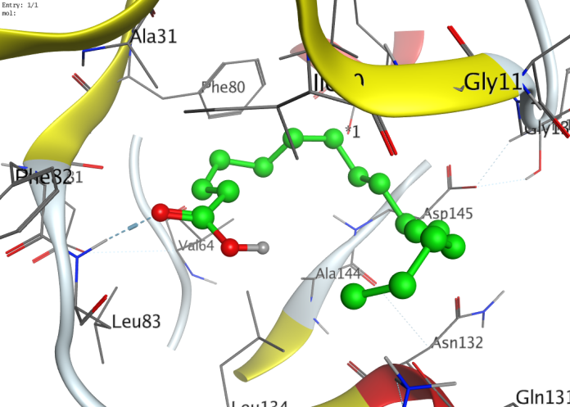
H) | 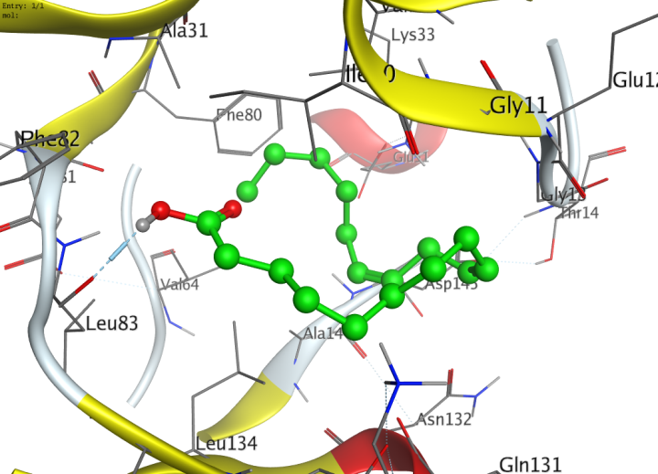
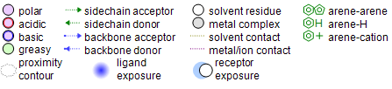

Figure S7. (I) Two-dimensional (2D) ligand interaction diagram of the native ligand superimposed (green) and its redocking pose (red) within the cyclin-dependent kinase-2 (CDK2) adenosine triphosphate (ATP)-binding site. (II) 2D and three-dimensional (3D) ligand contact figures of the compounds (a) elemol, (b) β-eudesmol, (c) di-N-octyl phthalate, (d) 3-β-hydroxylean-11.13(18)-dien-30-oic acid methyl ester, (e) linoelaidic acid, (f) oleic acid, (g) palmitic acid, and (h) linoleic acid. “Green” indicates their interactions with the CDK2 ATP-binding site.

No. | 2D-dimensional | 3D-dimensional
1 | Palmitic acid
 |  |  | 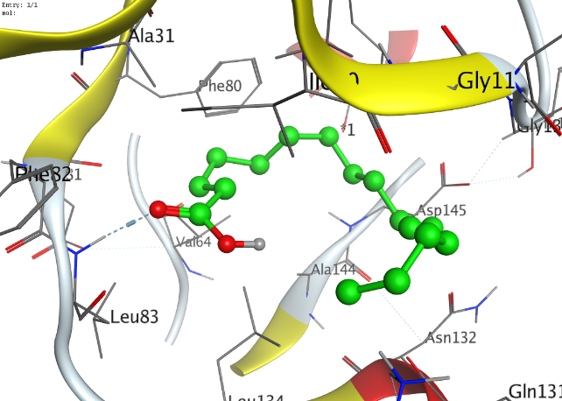
2 | Stearic acid
 |  |  | 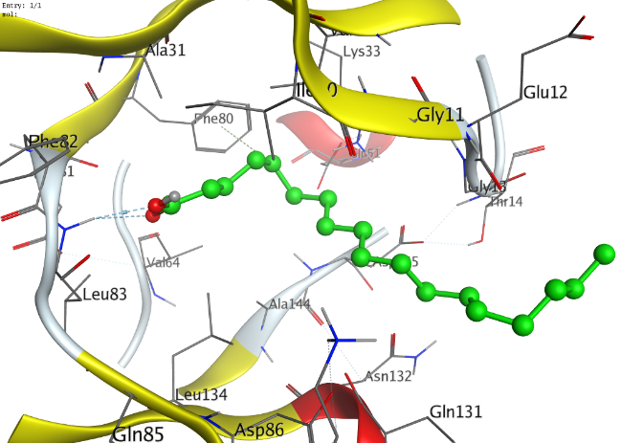
3 | Oleic acid
 |  |  | 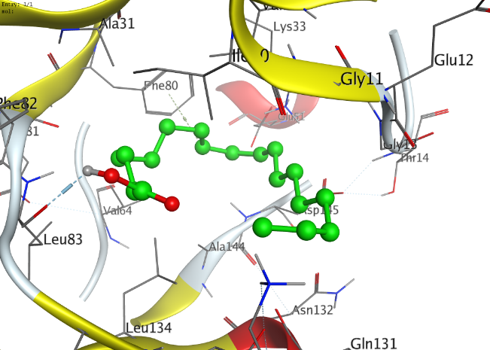
4 | Linoleic acid
 |  |  | 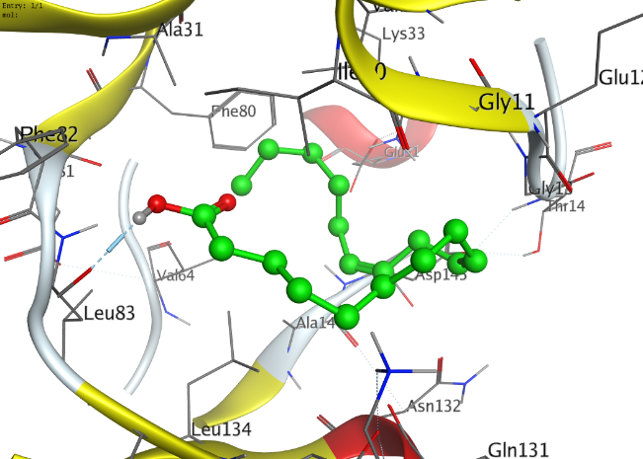
5 | Linolenic acid (omega 3)
 |  |  | 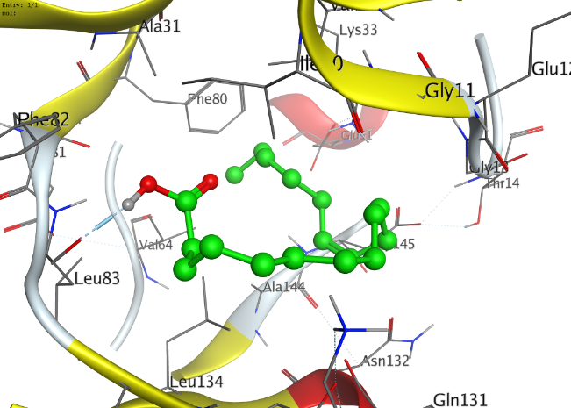
6 | Caprylic acid
 |  |  | 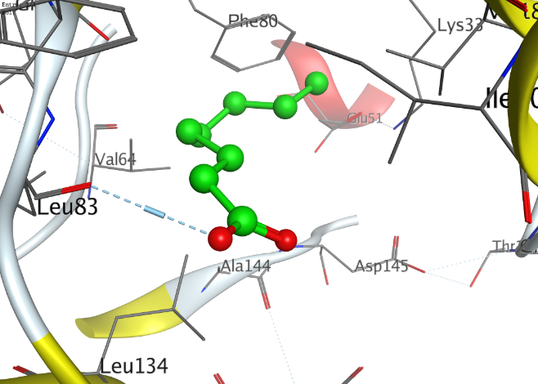
7 | Capric acid
 |  |  | 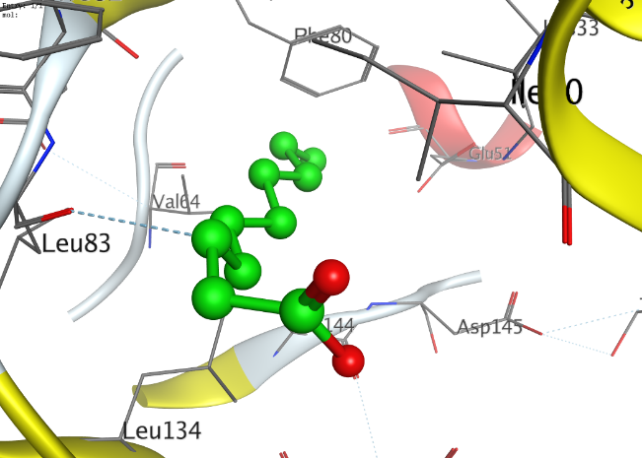
8 | Linoelaidic acid
 |  |  | 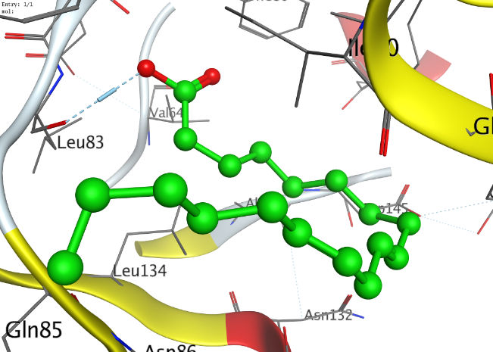
Figure S8. 2D and three-dimensional (3D) ligand contact figures of different identified fatty acids. “Green” indicates their interactions with the CDK2 ATP-binding site.

No | 2D-dimensional | 3D-dimensional
1 | 2-Ethylhexanol
 |  | 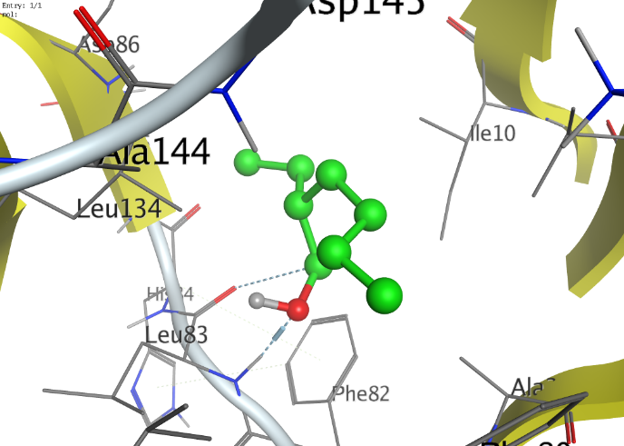
2 | Elemol
 |  | 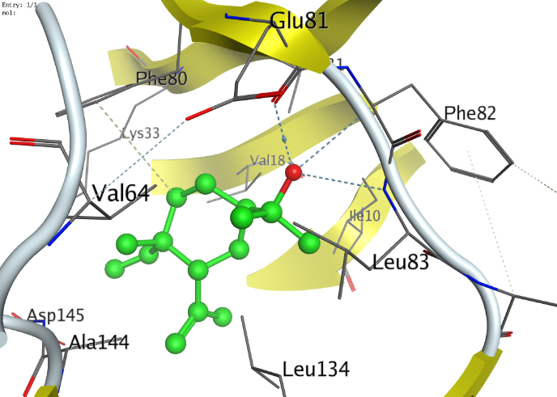
3 | Gamma-Eudesmol
 |  | 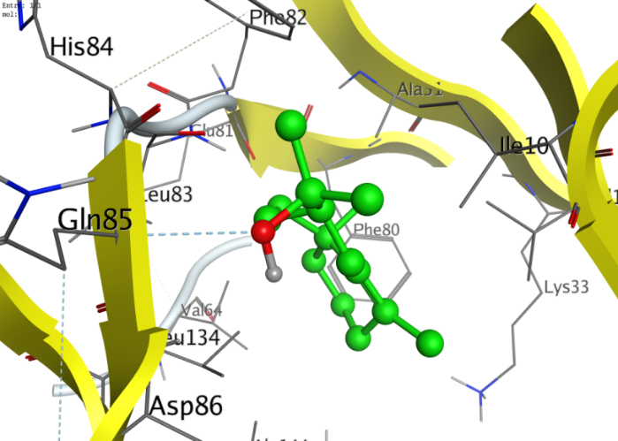
4 | Beta-Eudesmol
 |  | 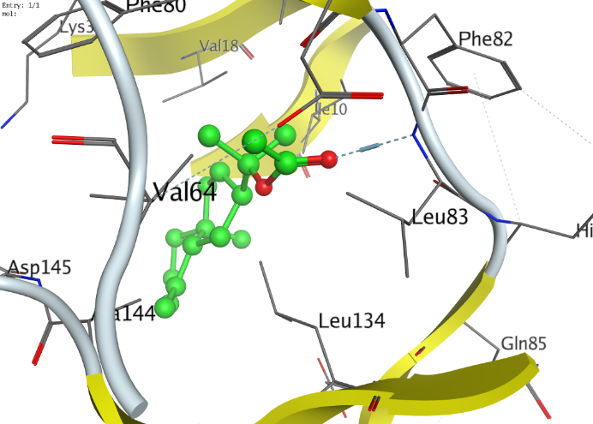
5 | Alpha-Eudesmol
 |  | 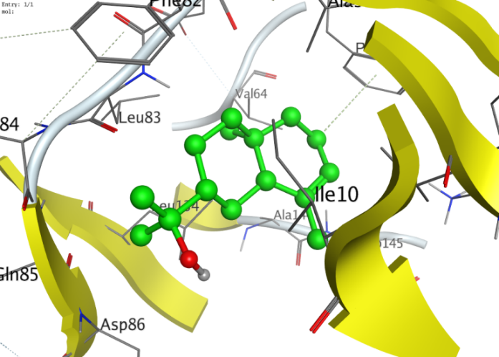
6 | Proximadiol
 |  | 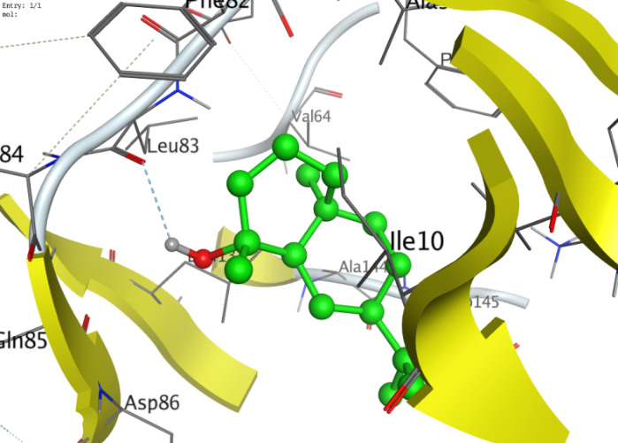
7 | Ledene oxide-(II)
 |  | 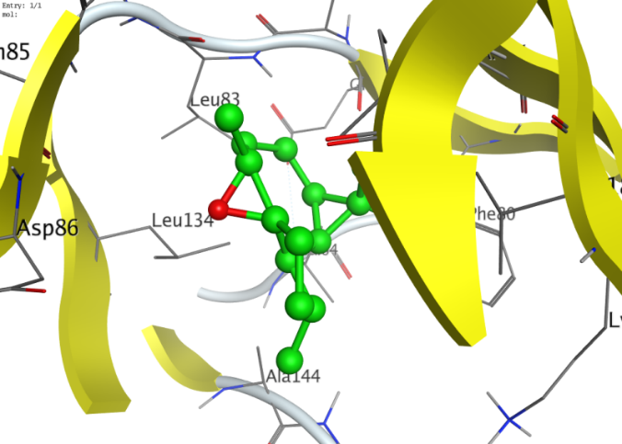
8 | Di-n-octyl phthalate
 |  | 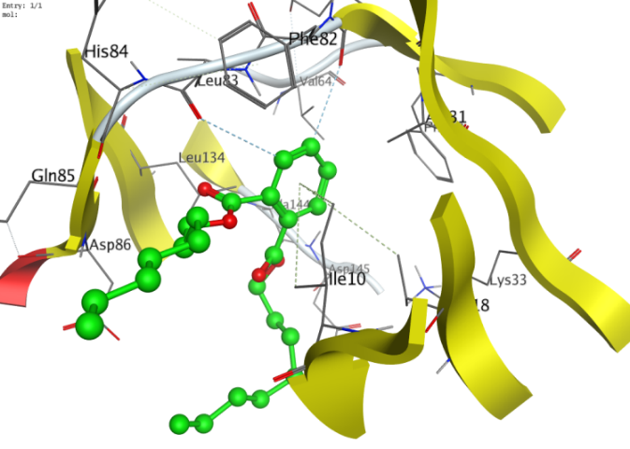
9 | 3-Beta.-hydroxylean-11.13(18)-dien-30-oic acid methyl ester
 |  | 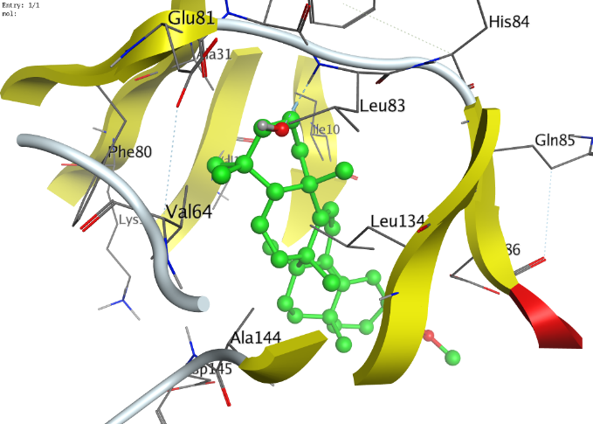
Figure S9. 2D and three-dimensional (3D) ligand contact figures of different identified hydrocarbons. “Green” indicates their interactions with the CDK2 ATP-binding site.

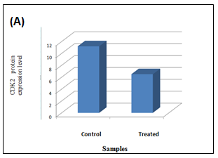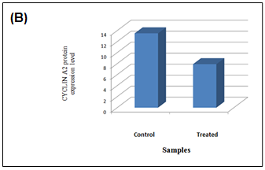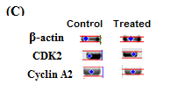

Figure S10. Western blot profiles, with β-actin as the control protein, demonstrating the effects of the petroleum ether fraction on cyclin-dependent kinase-2 (CDK2) and cyclin A2 levels in A549 cells compared with control cells. (A) CDK2 level, (B) cyclin A2 level, and (C) computerized analysis of the samples. Cropped blots are displayed in this figure and the ‘full-length blots are presented in Supplementary Material, Figure S3-S5.'

  (I) | 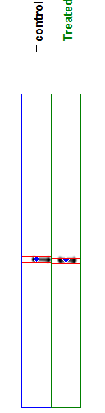  (II)
Figure S11. (I) Photograph of β- actin protein expression level for sample. (II) computerized analysis of
β- actin protein expression level for samples.

  (I) | 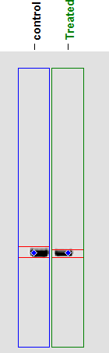  (II)
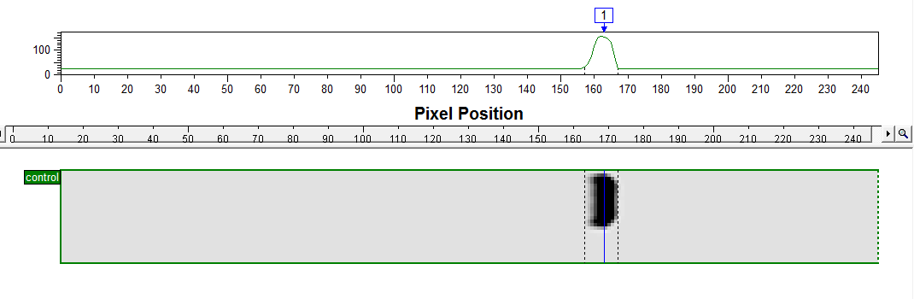
(III)
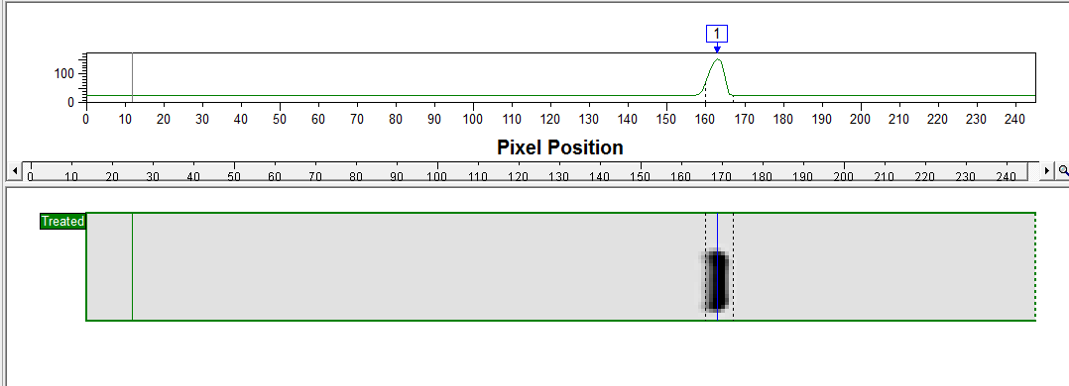
Figure S12. (I) Photograph of CDK2 protein expression level for sample. (II) computerized analysis of
CDK2 protein expression level for samples. (III) dendogram of samples.

  (I) | 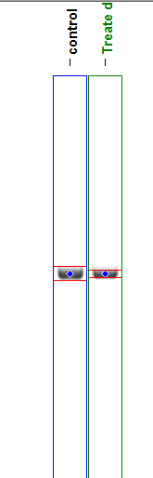  (II)
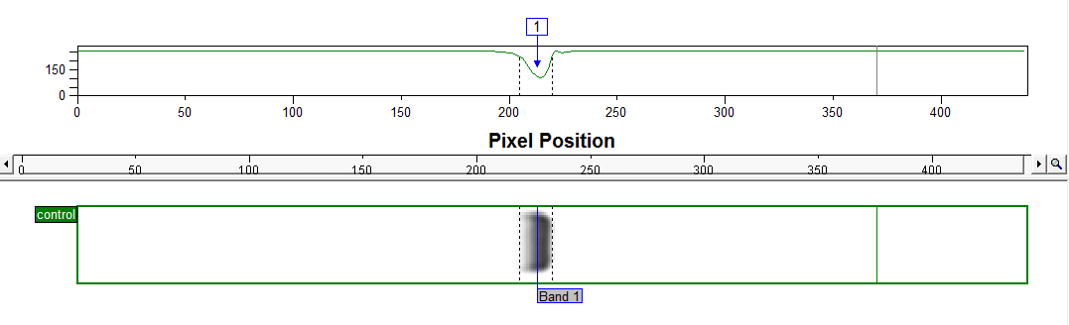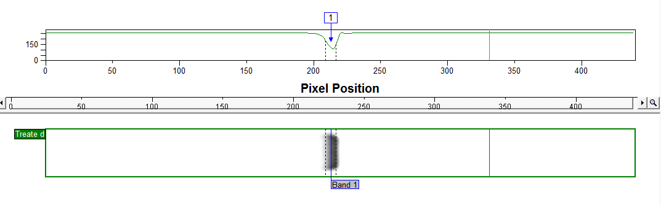
(III)

Figure S13. (I) Photograph of Cyclin A2 protein expression level for sample. (II) computerized analysis of
Cyclin A2 protein expression level for samples. (III) dendogram of samples.

