**Bihon Abera1, Yadessa Melaku1, Kebede Shenkute1, Sileshi Degu2, Abiy Abebe2,Worku Gemechu2, Milkyas Endale2*, Messay Woldemariam3, Mo Hunsen4, Ahmed A. Hussein5, Aman Dekebo1,6**

1Department of Applied Chemistry, School of Applied Natural Science, Adama Science and Technology University, P.O.Box 1888, Adama, Ethiopia.

2Traditional and Modern Medicine Research and Development Directorate, Armauer Hansen Research Institute, P.B.Box 1242, Addis Ababa, Ethiopia.

3Pharmaceutical Industry Development, Armauer Hansen Research Institute, Po.Box 1242, Addis Ababa, Ethiopia.

4Department of Chemistry, Kenyon College, Gambier, OH 43022, USA.

5Department of Chemistry, Cape Peninsula University of Technology, Bellville Campus,   
 Bellville 7535, Western Cape, South Africa.

6Institute of Pharmaceutical Sciences, Adama Science and Technology University, P.O.Box 1888, Adama, Ethiopia.

Correspondence author: milkyasendale@yahoo.com

Appendix 1A: 1H NMR spectrum (CDCl3) of compounds **1a** and **1b**.

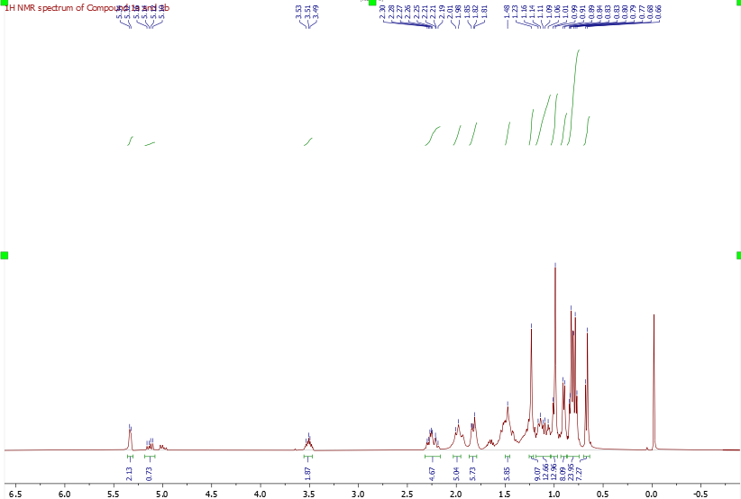

Appendix 2A: 13C NMR spectrum (CDCl3) of compounds **1a** and **1b**.

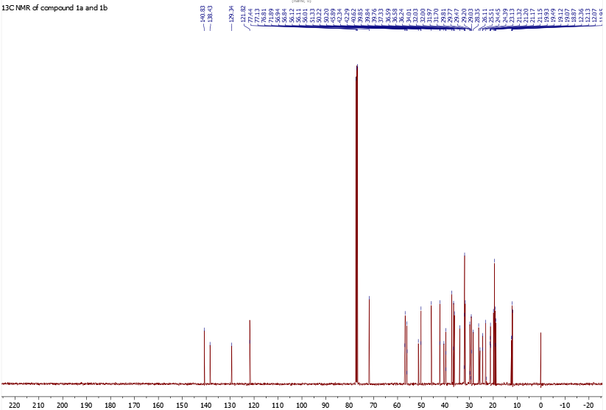

Appendix 1C: DEPT-135 spectrum (CDCl3) of compounds **1a** and **1b**.

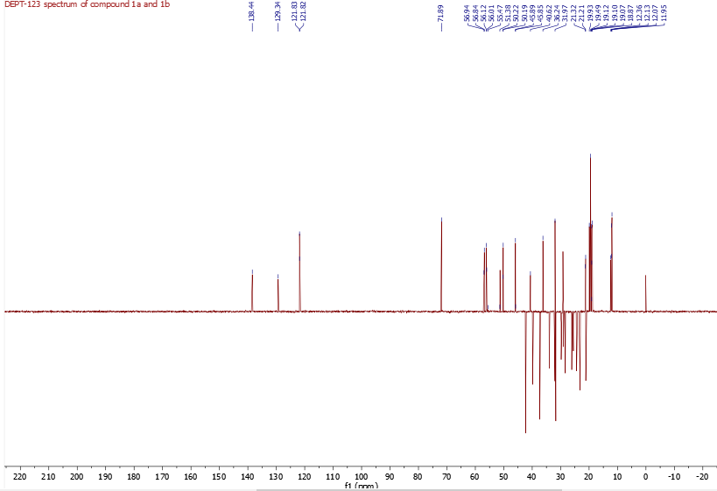

Appendix 2A: 1H NMR spectrum (CDCl3) of compound **2**.

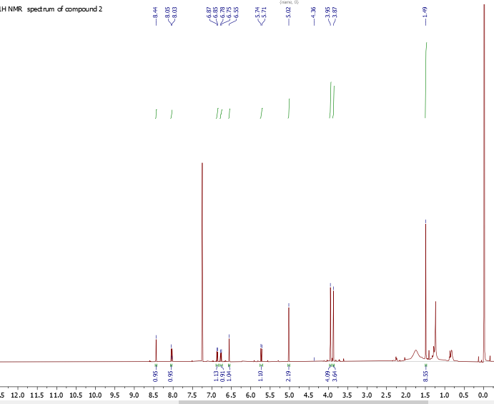

Appendix 2B: 1H-1H COSY spectrum (CDCl3) of compound **2**.

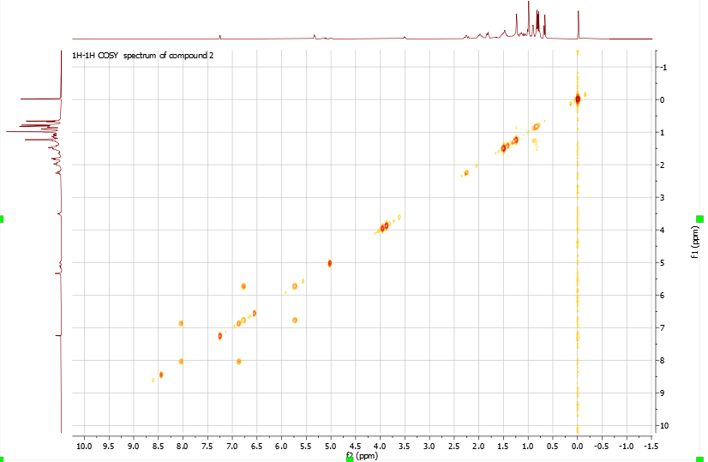

Appendix 2C: 13C NMR spectrum (CDCl3) of compound **2**.

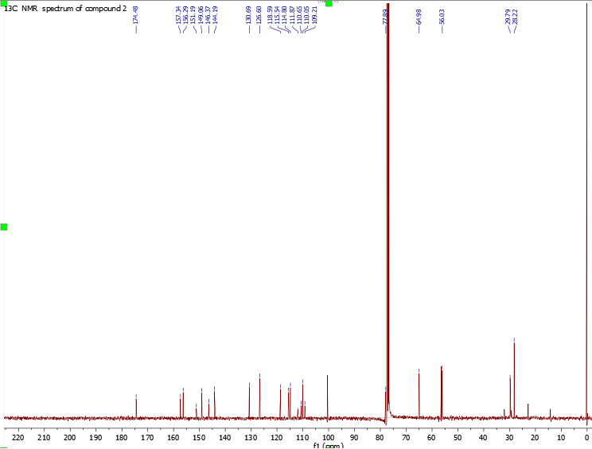

Appendix 3A:1H NMR spectrum (CDCl3) of compound **3**.

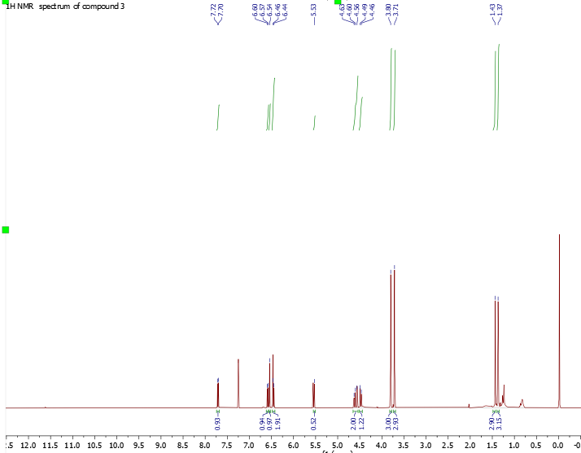

Appendix: 3B: 1H-1H COSY spectrum (CDCl3) of compound **3**.

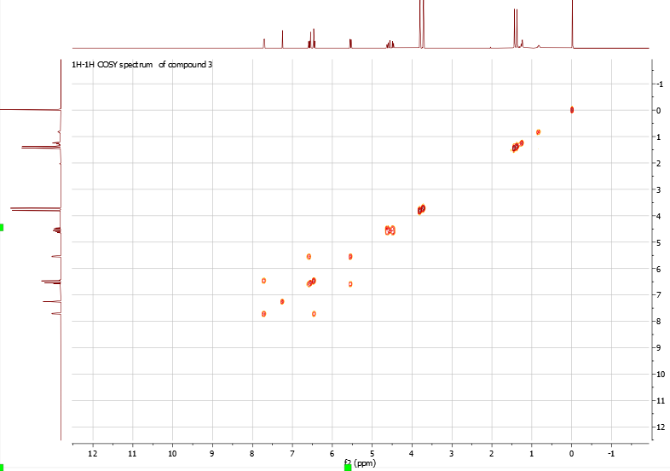

Appendix 3C; 13C NMR spectrum (CDCl3) of compound **3**.

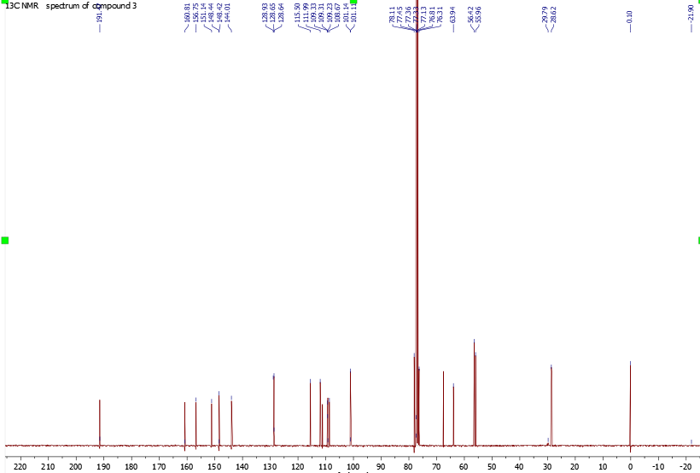

Appendix 3D: DEPT-135 spectrum (CDCl3) of compound **3**.

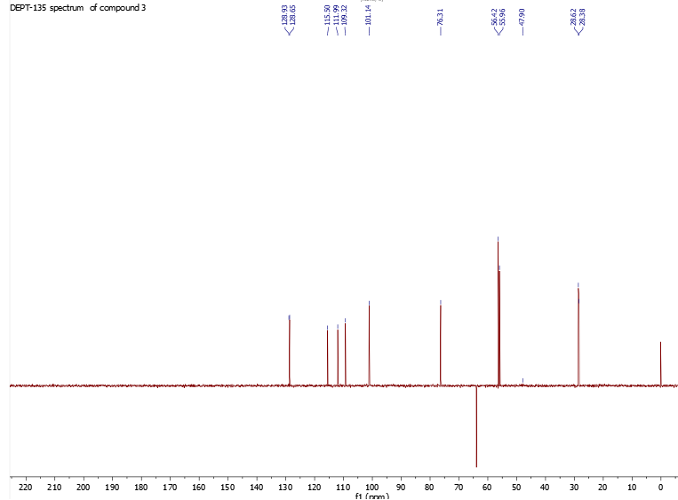

Appendix 4A: 1H NMR spectrum (MeOD) of compound **4**.

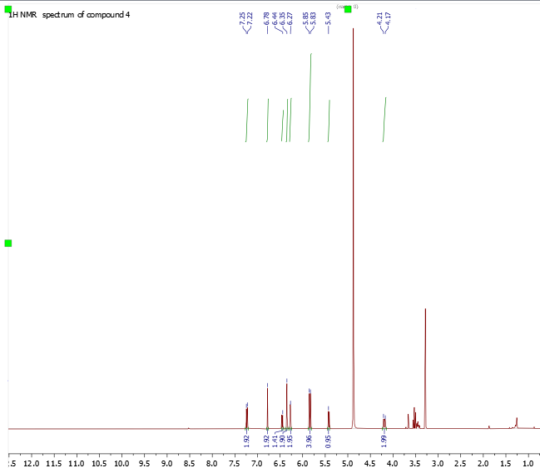

Appendix 4B: 1H-1H COSY spectrum (MeOD) of compound **4**.

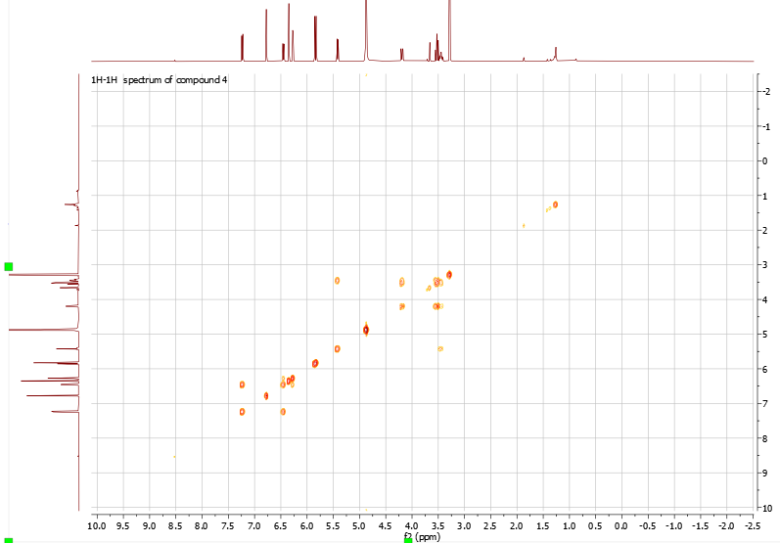

Appendix 4C: 13C NMR spectrum (MeOD) of compound **4**.

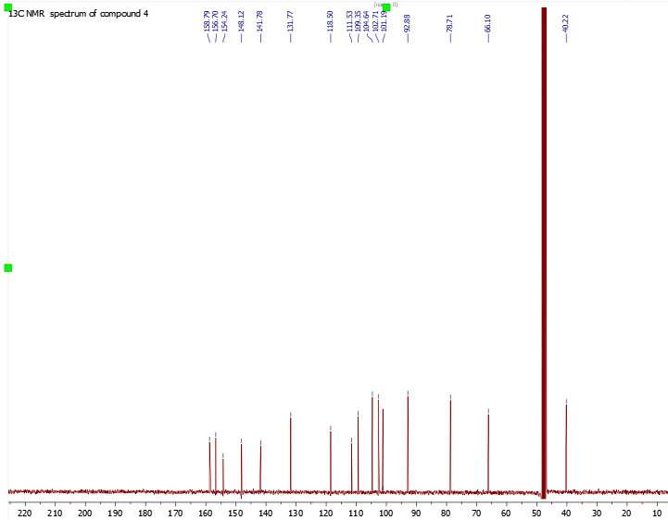

Appendix 4D: DEPT-135 spectrum (MeOD) of compound **4**.

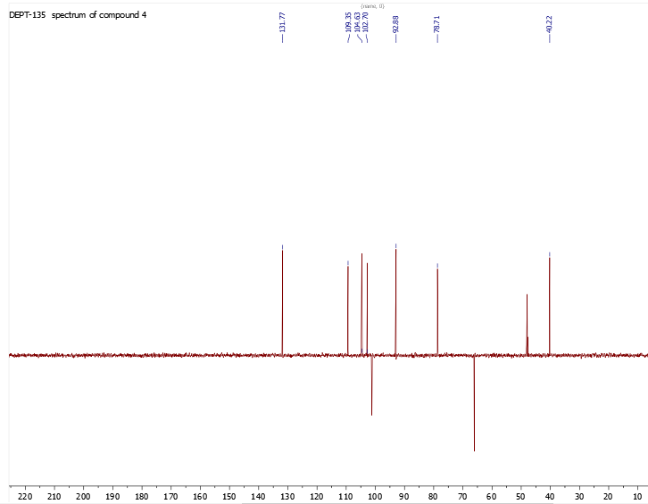

Appendix: 5A: 1H NMR spectrum (CDCl3) compound **5**.

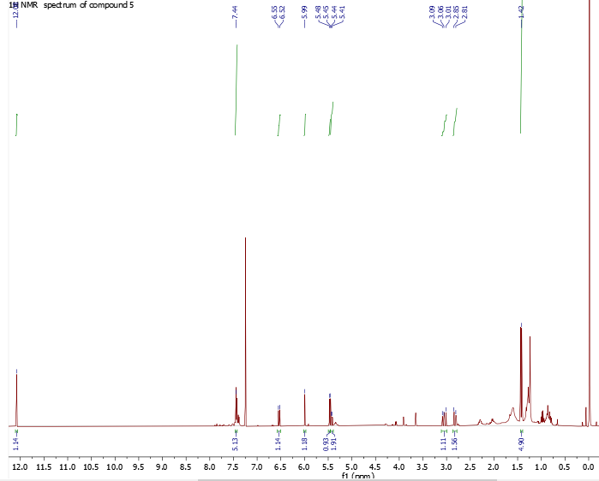

Appendix 5B: 13 C NMR spectrum (CDCl3) of compound **5**.

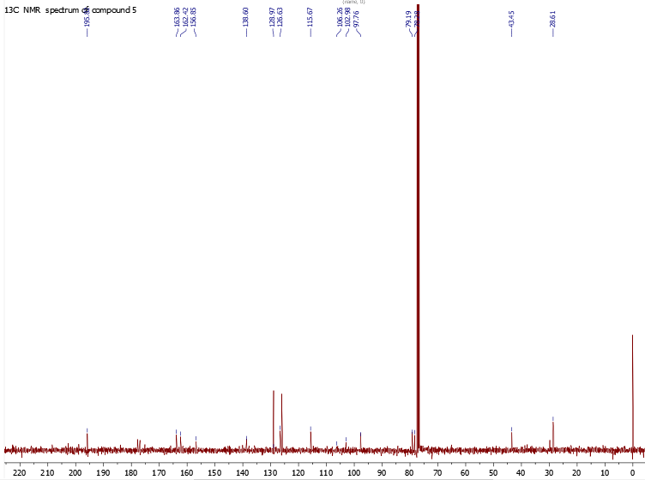

Appendix 5C: DEPT-135 spectrum (CDCl3) of compound **5**.

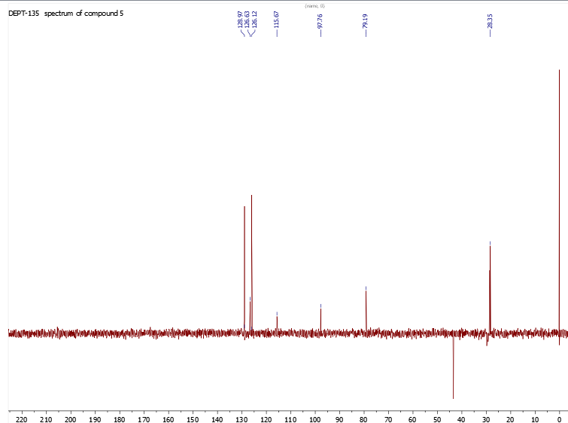

Appendix 6A: 1H NMR spectrum (CDCl3) of compound **6**.

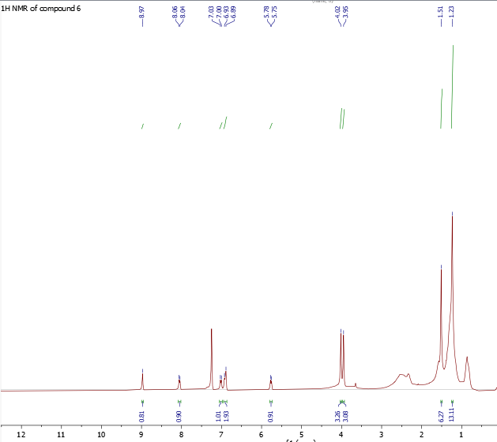

Appendix 6B: 1H-1H COSY spectrum (CDCl3) of compound **6**.

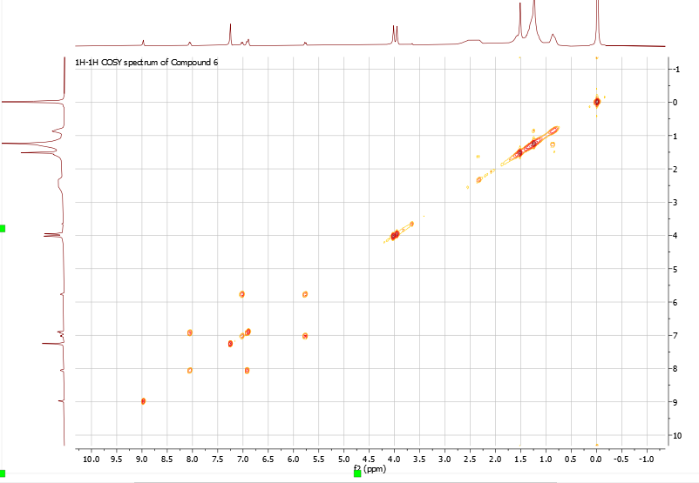

Appendix 6C: 13C NMR spectrum (CDCl3) of compound **6**.

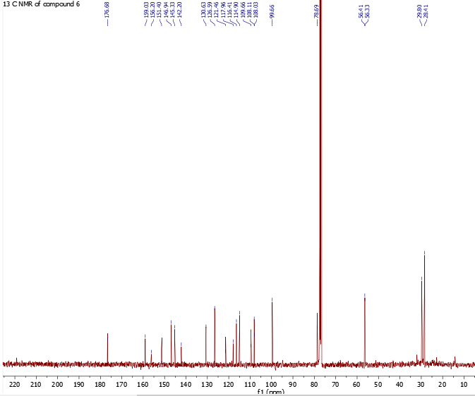

Appendix 6D:13C NMR spectrum (CDCl3) of compound **6**.

