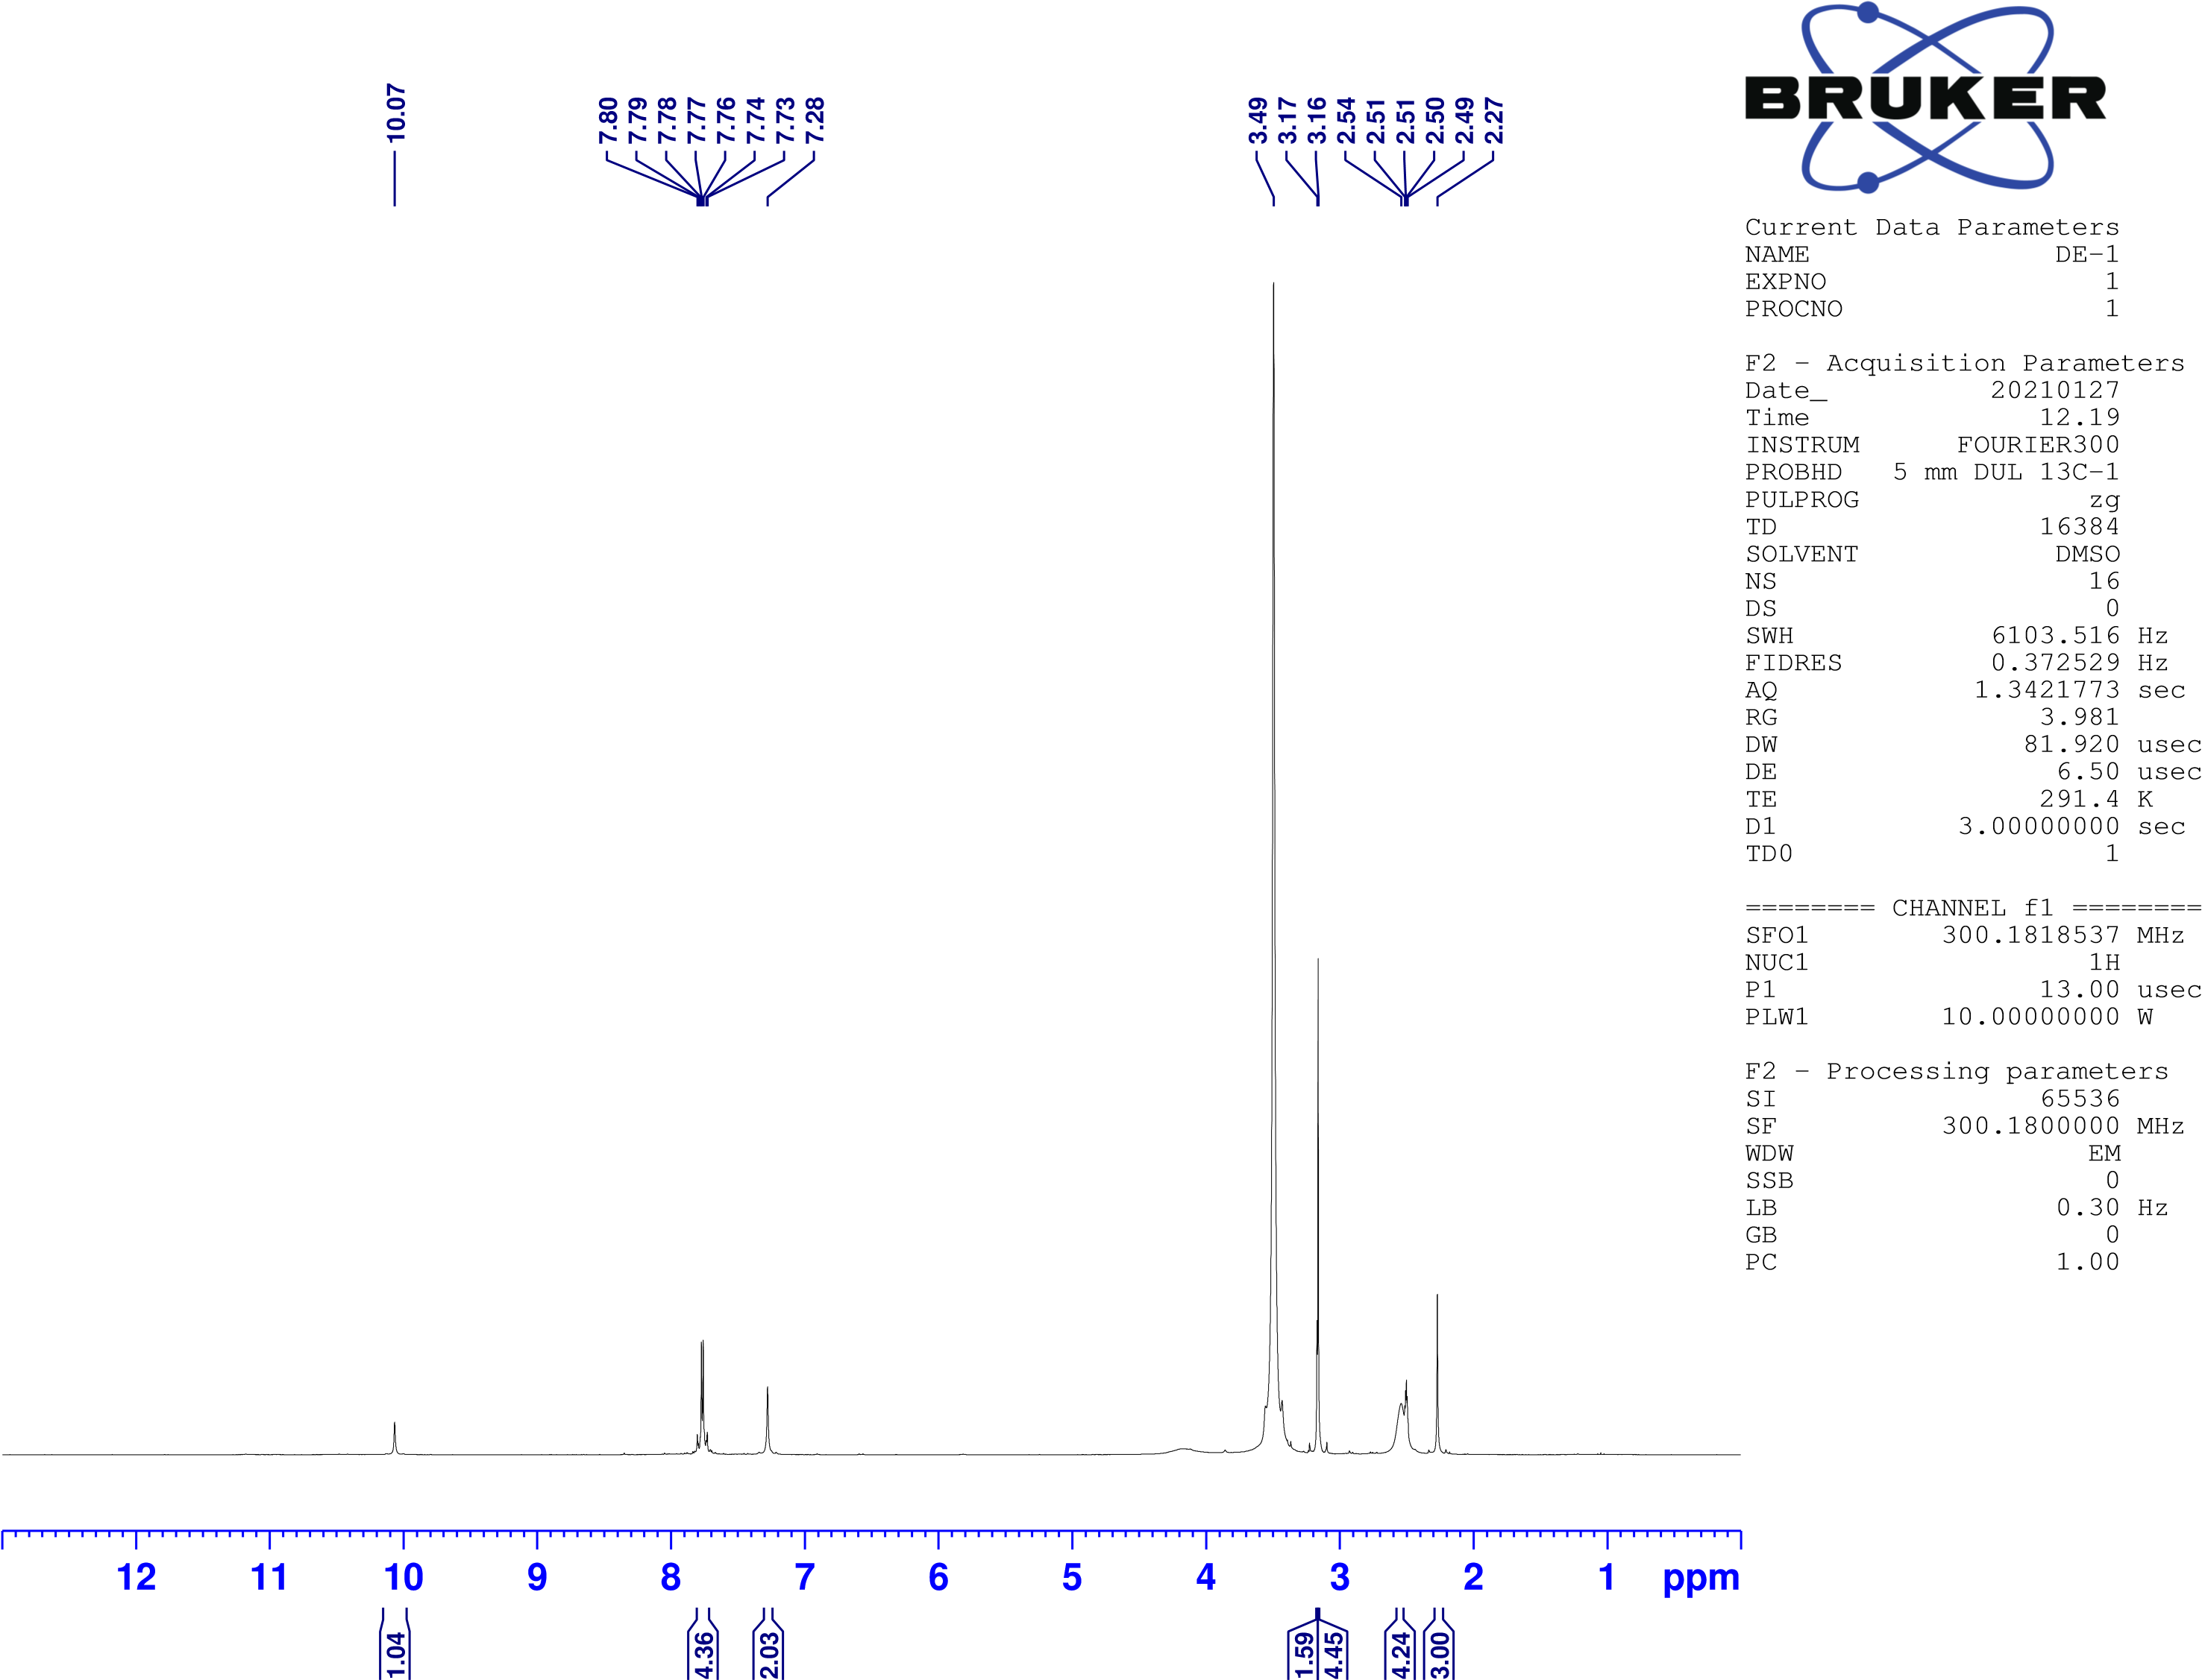

Figure S1. Compound 2a ¹H-NMR spectrum

Figure S2. Compound 2a ¹³C-NMR spectrum
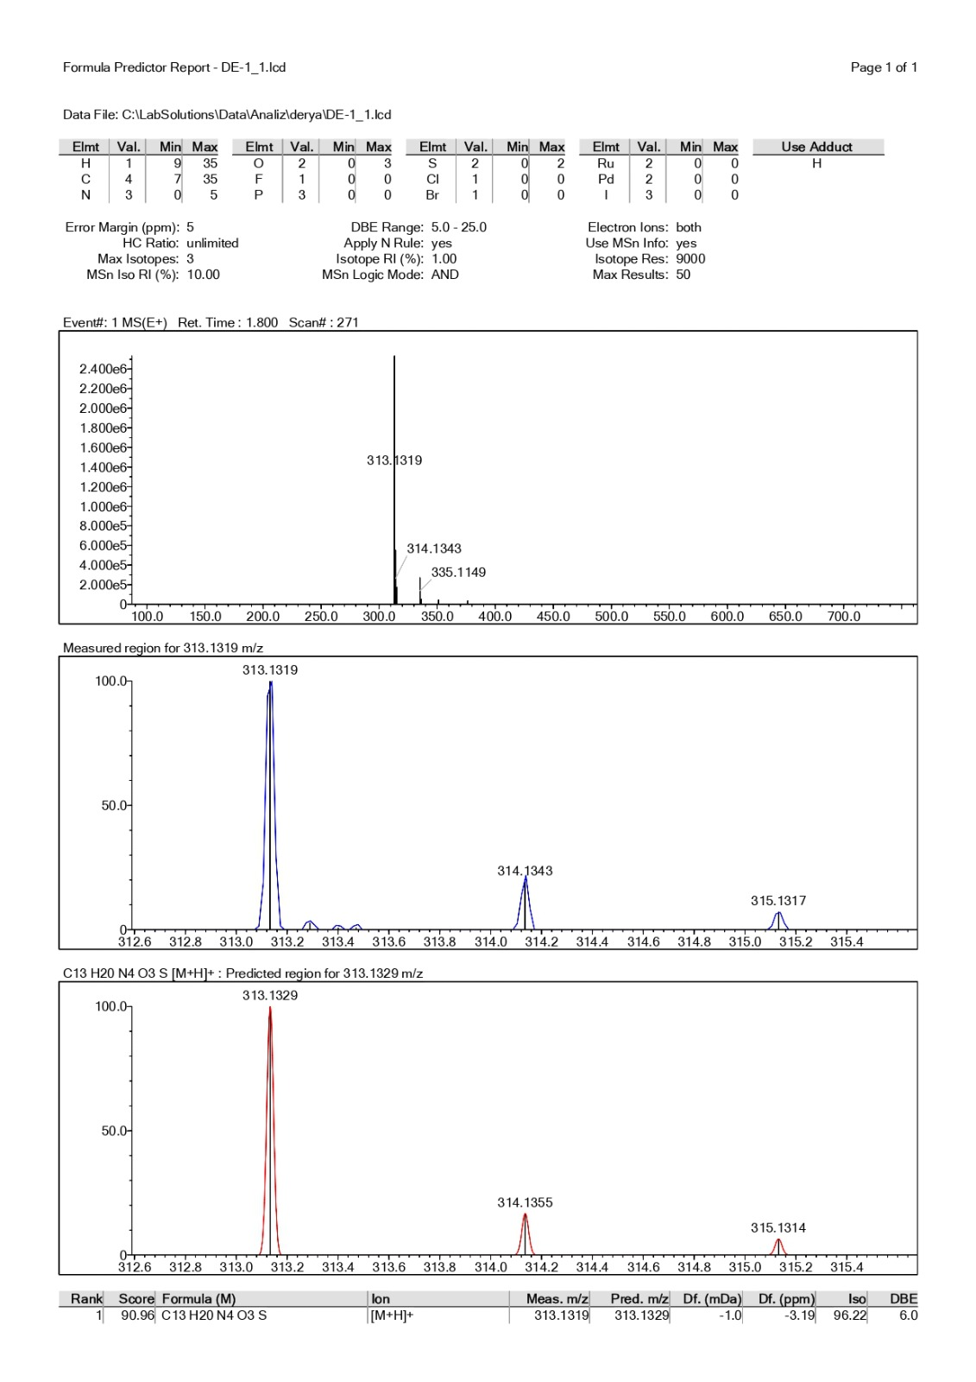

Figure S3. Compound 2a HRMS report
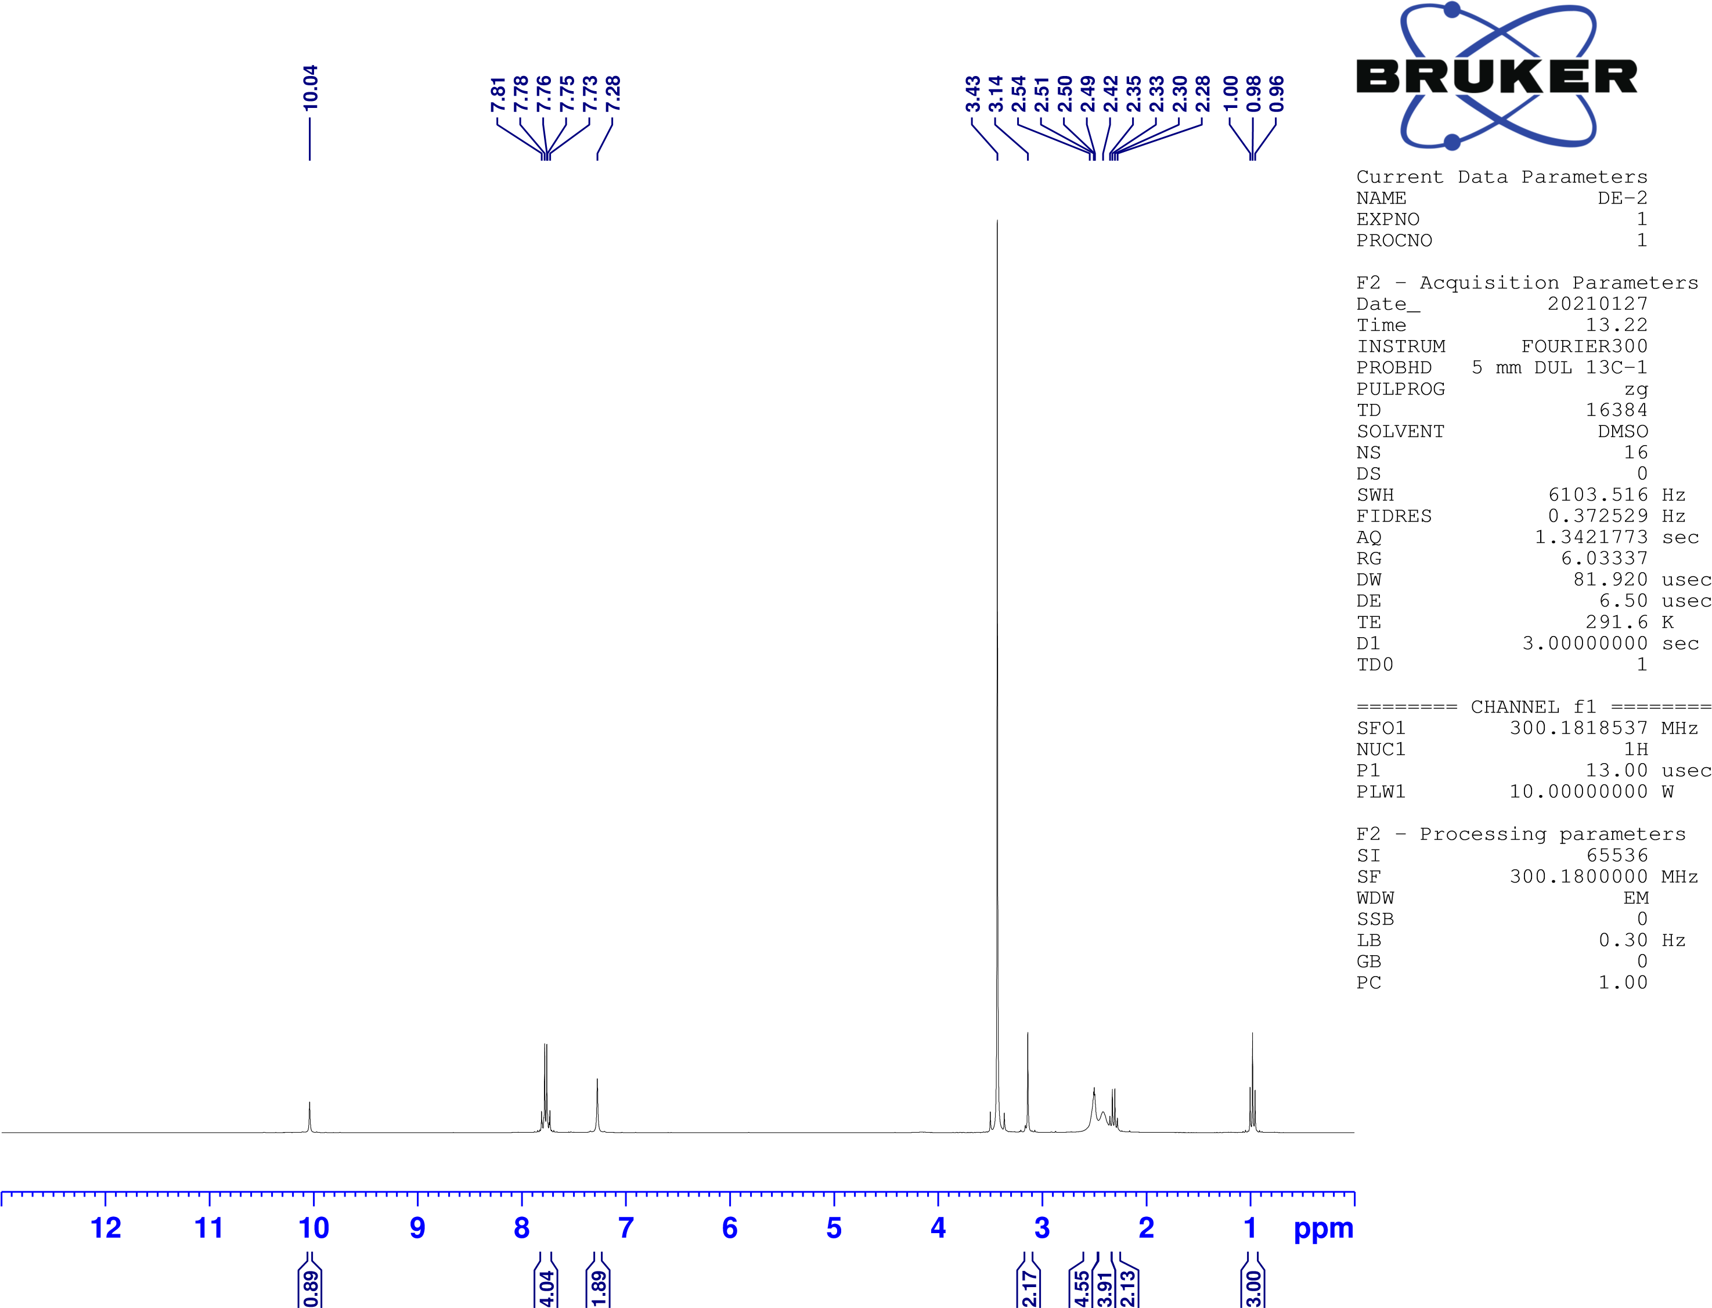

Figure S4. Compound 2b ¹H-NMR spectrum

Figure S5. Compound 2b ¹³C-NMR spectrum

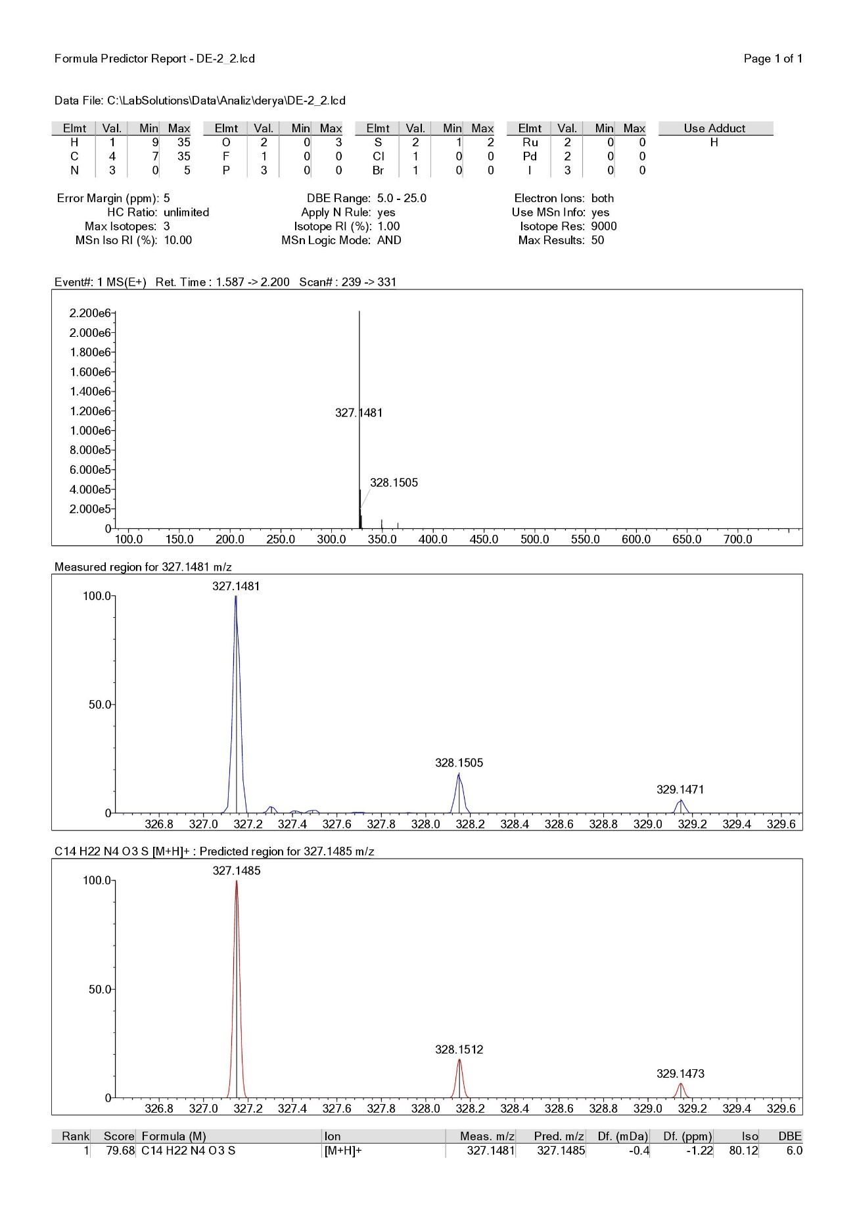

Figure S6. Compound 2b HRMS report
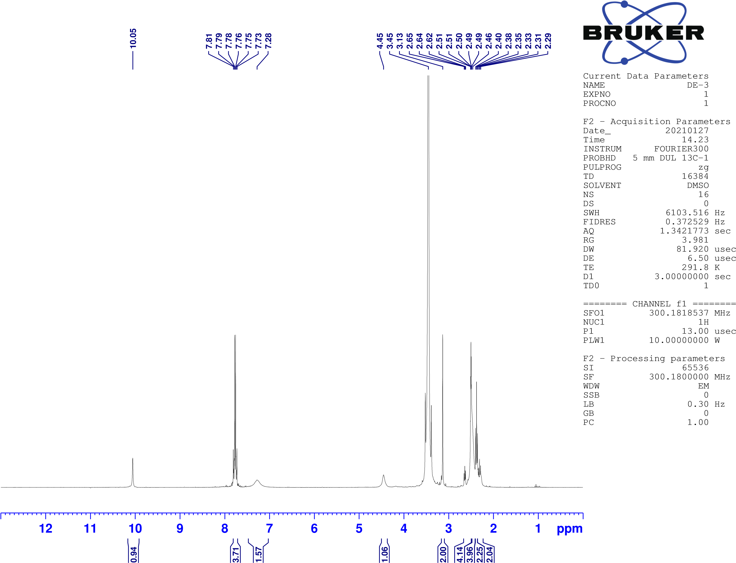

Figure S7. Compound 2c ¹H-NMR spectrum

Figure S8. Compound 2c ¹³C-NMR spectrum
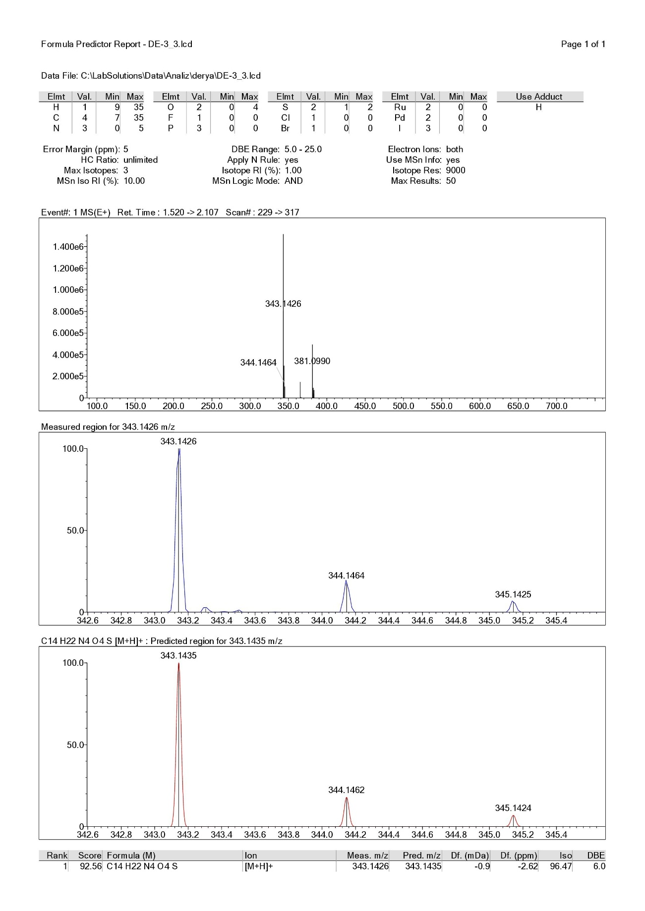

Figure S9. Compound 2c HRMS report

Figure S10. Compound 2d ¹H-NMR spectrum

Figure S11. Compound 2d ¹³C-NMR spectrum
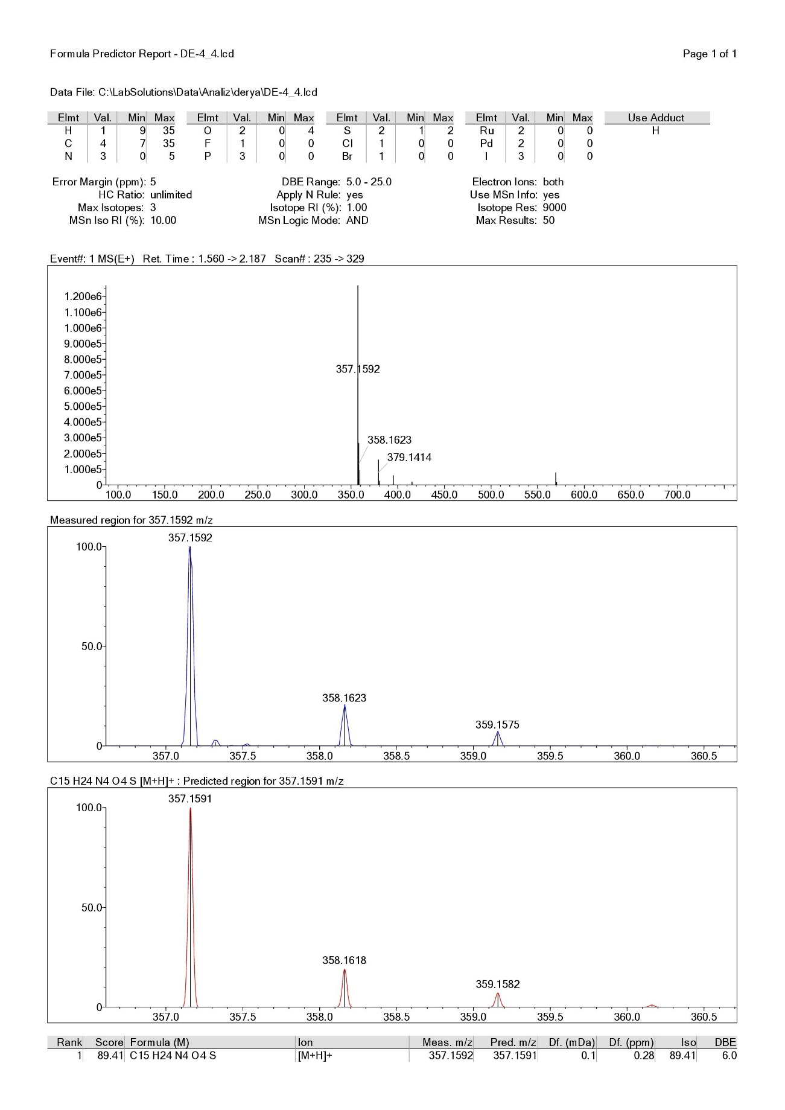

Figure S12. Compound 2d HRMS report

Figure S13. Compound 2e ¹H-NMR spectrum

Figure S14. Compound 2e ¹³C-NMR spectrum

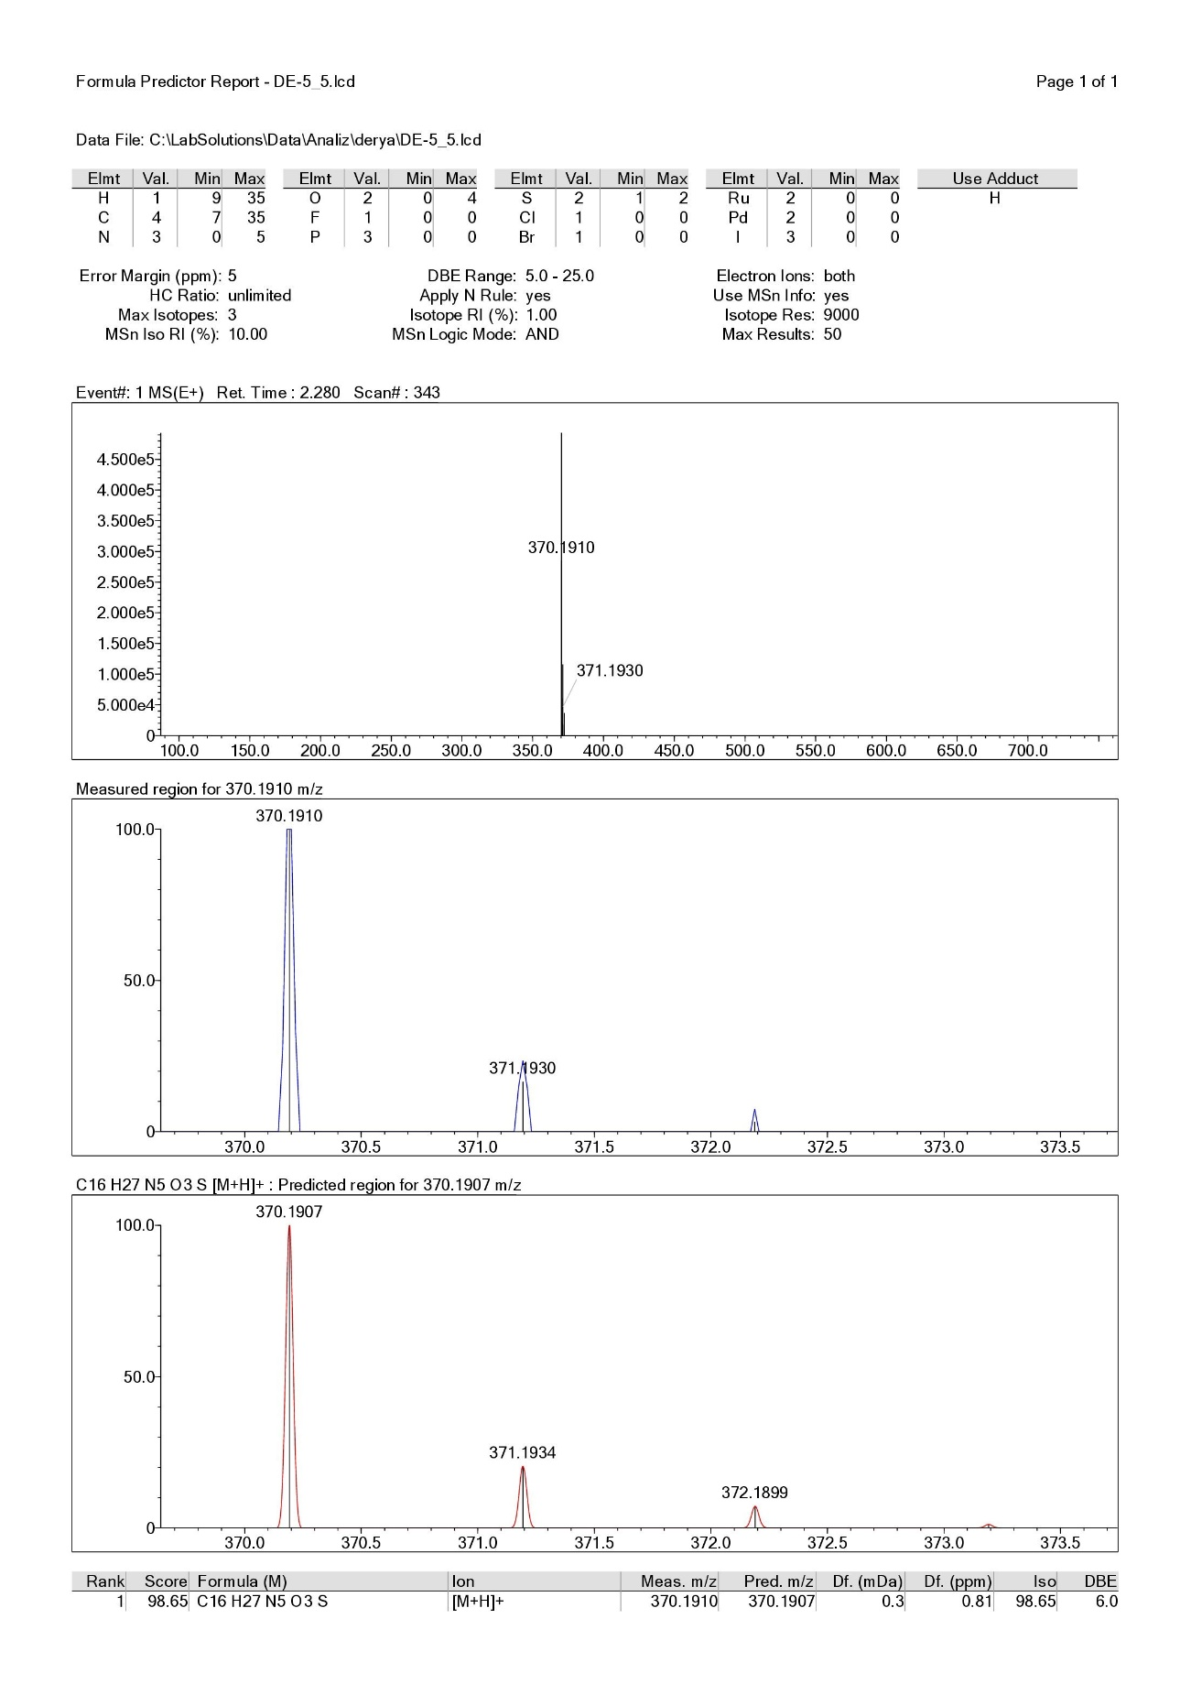

Figure S15. Compound 2e HRMS report

Figure S16. Compound 2f ¹H-NMR spectrum

Figure S17. Compound 2f ¹³C-NMR spectrum

Figure S18. Compound 2g ¹H-NMR spectrum

Figure S19. Compound 2g ¹³C-NMR spectrum

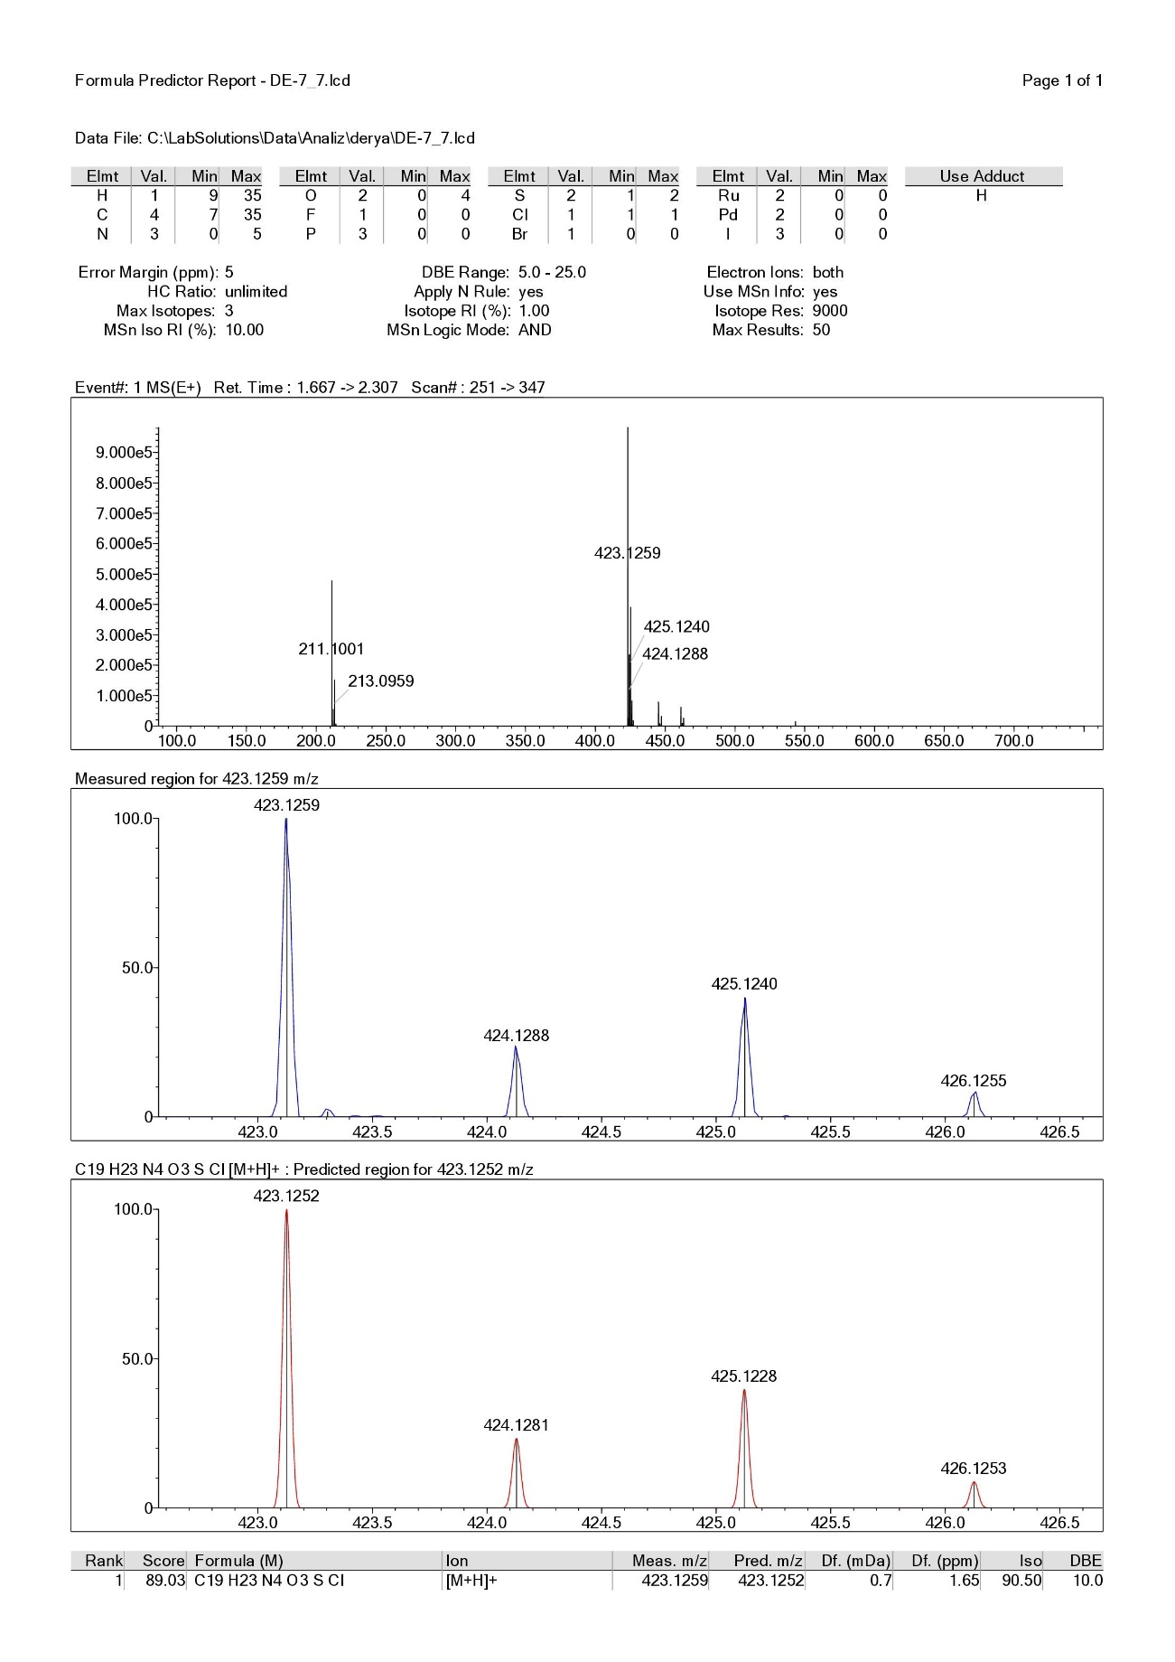

Figure S20. Compound 2g HRMS report

Figure S21. Compound 2h ¹H-NMR spectrum

Figure S22. Compound 2h ¹³C-NMR spectrum

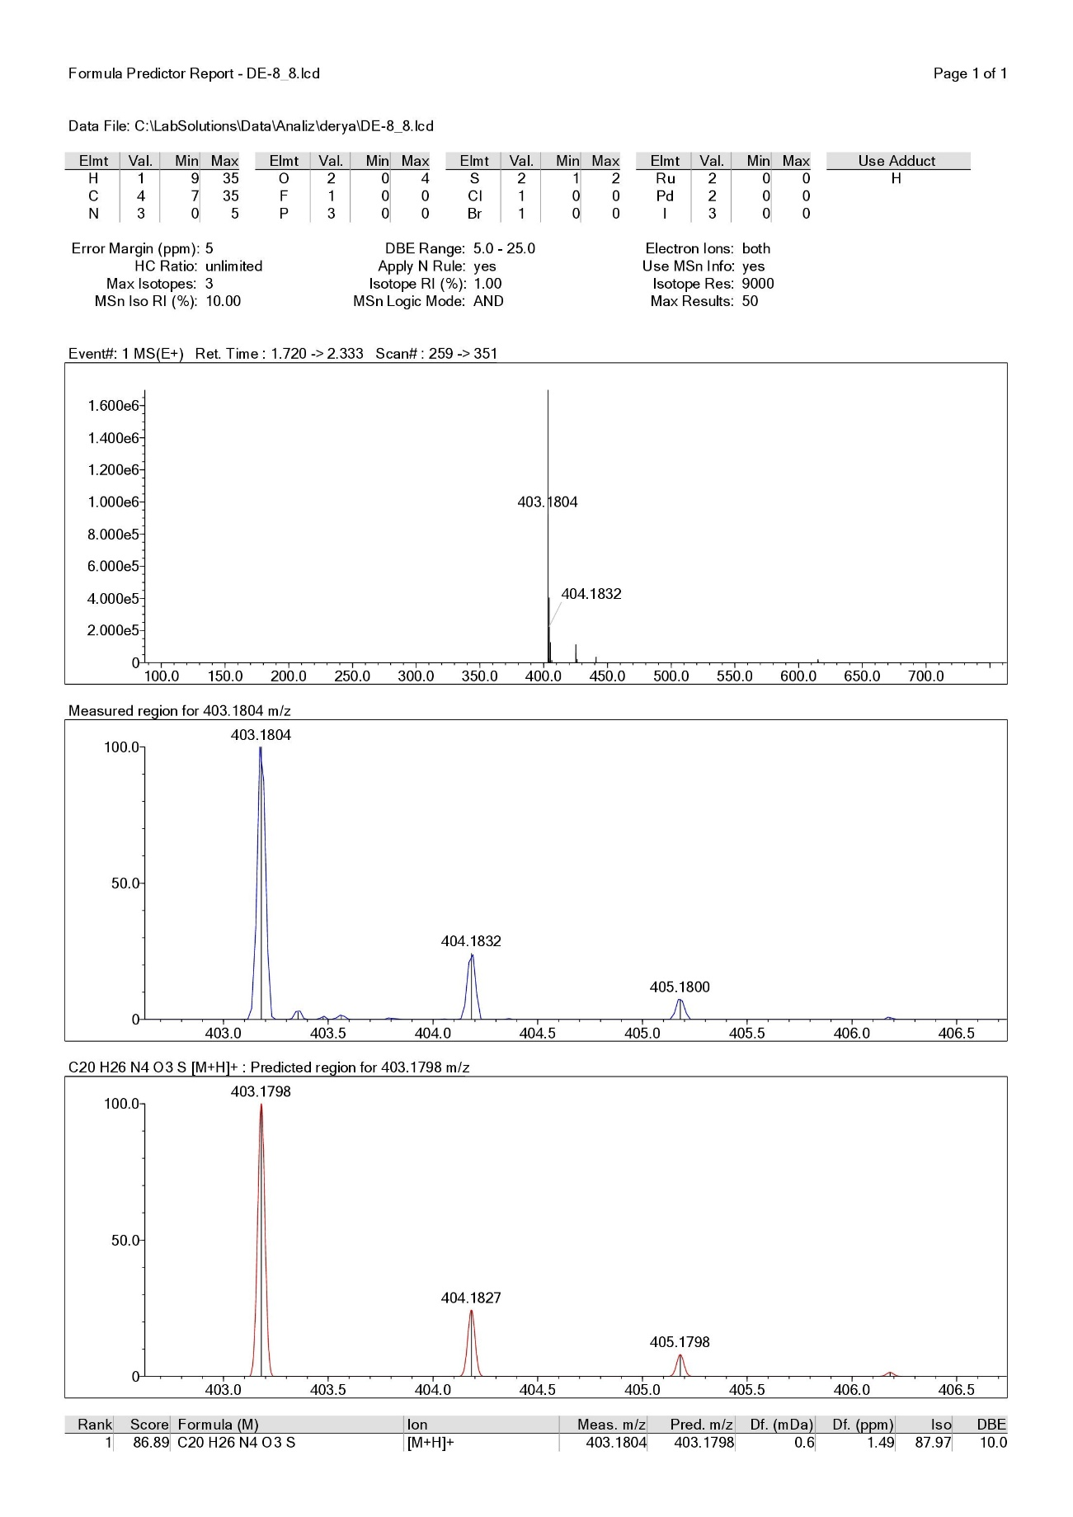

Figure S23. Compound 2h HRMS report

Figure S24. Compound 2i ¹H-NMR spectrum

Figure S25. Compound 2i ¹³C-NMR spectrum

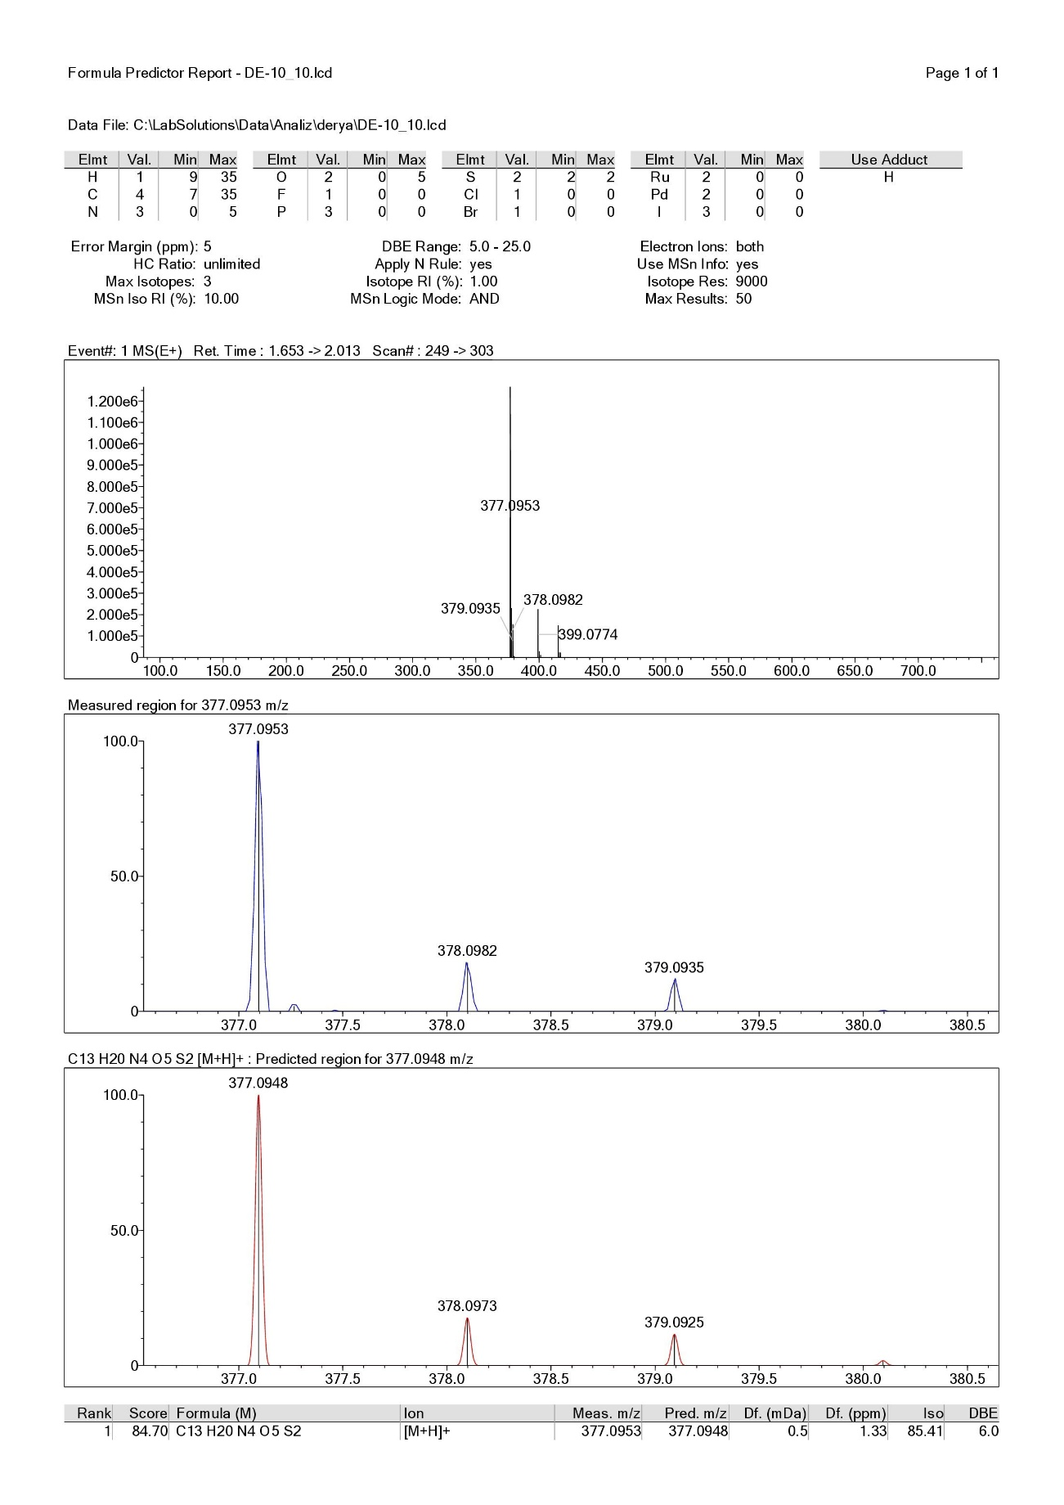

Figure S26. Compound 2i HRMS report

Figure S27. Compound 2j ¹H-NMR spectrum

Figure S28. Compound 2j ¹³C-NMR spectrum

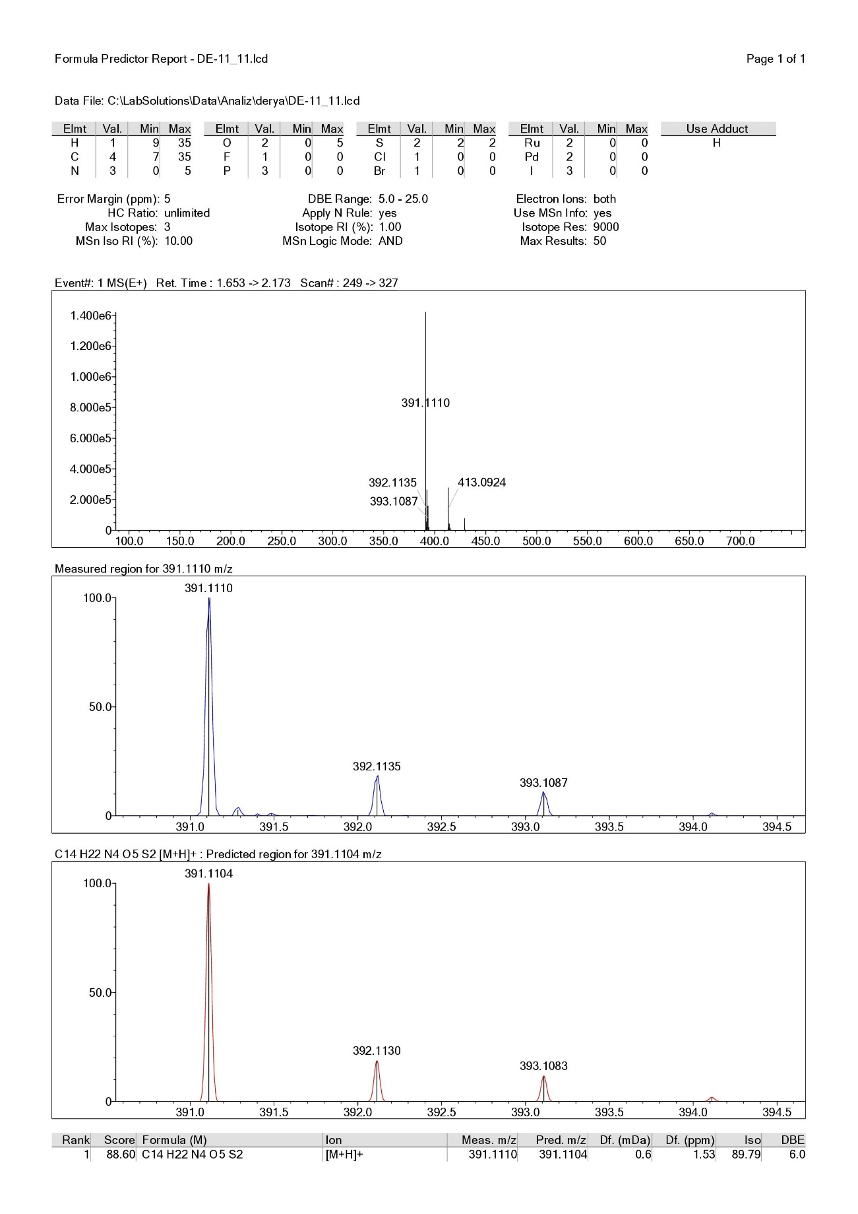

Figure S29. Compound 2j HRMS report

