Terpenoid compounds from the fruits of Solanum virginianum
Yan Liu, Shuang Liu, Zhen-Peng Xu, Si-Yi Wang, Yi-Kai Jiang, Wei Guan, Juan Pan, Hai-Xue Kuang*, and Bing-You Yang*
Yan Liu, Heilongjiang University of Chinese Medicine, Harbin, China, E-mail: lifeliuyan@163.com
Hai-Xue Kuang, Heilongjiang University of Chinese Medicine, Harbin, China, E-mail: hxkuang@yahoo.com
Bing-You Yang, Heilongjiang University of Chinese Medicine, Harbin, China, E-mail: ybywater@163.com
Key Laboratory of Basic and Application Research of Beiyao (Heilongjiang University of Chinese Medicine), Ministry of Education

Supplemenary Material
Table S1. ¹³C-NMR data of compounds 3-9 (CD₃OD)
Table S2. ¹³C-NMR data of compounds 10 (taraxerol) (CDCL₃)-11 (huzhangoside C) (Pyridine-d₅)
Figure S1. HR-ESI-MS spectrum of compound 1
Figure S2. ¹H-NMR spectrum of compound 1
Figure S3. ¹³C-NMR spectrum of compound 1
Figure S4. DEPT-135 spectrum of compound 1
Figure S5. HSQC spectrum of compound 1
Figure S6. ¹H-¹H COSY spectrum of compound 1
Figure S7. HMBC spectrum of compound 1
Figure S8. NOESY spectrum of compound 1
Figure S9. HR-ESI-MS spectrum of compound 2
Figure S10. ¹H-NMR spectrum of compound 2
Figure S11. ¹³C-NMR spectrum of compound 2
Figure S12. DEPT-135 spectrum of compound 2
Figure S13. HSQC spectrum of compound 2
Figure S14. ¹H-¹H COSY spectrum of compound 2
Figure S15. HMBC spectrum of compound 2
Figure S16. Chemical structures of compounds 3-11

Table S1. ¹³C-NMR data of compounds 3-9 (CD₃OD)
NO. | 3 | 4 | 5 | 6 | 7 | 8 | 9
1 | 40.7 | 37.3 | 37.0 | 42.4 | 37.1 | 40.7 | 169.6
2 | 46.4 | 48.1 | 49.9 | 50.7 | 48.3 | 46.5 | 119.3
3 | 65.3 | 202.4 | 63.8 | 201.2 | 202.0 | 65.3 | 151.4
4 | 45.6 | 125.4 | 48.0 | 127.2 | 126.2 | 45.7 | 135.1
5 | 77.8 | 170.1 | 78.7 | 167.3 | 165.8 | 77.8 | 131.9
6 | 78.9 | 52.4 | 119.1 | 80.0 | 56.8 | 78.9 | 21.3
7 | 133.0 | 26.8 | 200.7 | 131.5 | 129.0 | 131.2
8 | 134.7 | 37.8 | 101.4 | 135.3 | 138.1 | 136.1
9 | 78.8 | 75.5 | 212.9 | 77.3 | 77.6 | 69.6
10 | 21.8 | 19.9 | 26.6 | 21.2 | 21.2 | 24.2
11 | 27.6 | 29.1 | 26.7 | 24.7 | 27.5 | 27.5
12 | 26.2 | 27.6 | 30.0 | 23.4 | 28.0 | 26.2
13 | 27.5 | 25.0 | 32.5 | 19.5 | 23.7 | 27.1
1' | 102.6 | 102.1 | 98.6 | 102.8 | 103.0 |  | 49.3
2' | 75.3 | 75.2 | 75.3 | 75.2 | 75.2 |  | 42.8
3' | 78.2 | 78.2 | 78.6 | 78.1 | 77.8 |  | 73.9
4' | 71.8 | 71.9 | 71.7 | 71.7 | 71.4 |  | 42.8
5' | 78.0 | 77.9 | 77.8 | 78.0 | 75.2 |  | 87.6
6' | 62.8 | 63.0 | 62.9 | 62.8 | 64.7
7' |  |  |  |  |  |  | 77.1
8' |  |  |  |  |  |  | 83.2
9' |  |  |  |  |  |  | 19.7
10' |  |  |  |  |  |  | 16.3
1'' |  |  |  |  | 172.7 |  | 103.0
2'' |  |  |  |  | 20.8 |  | 75.1
3'' |  |  |  |  |  |  | 78.1
4'' |  |  |  |  |  |  | 71.6
5'' |  |  |  |  |  |  | 78.0
6'' |  |  |  |  |  |  | 62.8

Table S2. ¹³C-NMR data of compounds 10 (taraxerol) (CDCL₃)-11 (huzhangoside C) (Pyridine-d₅)
NO. | 10 | 11 | NO. | 10 | 11 | NO. | 11
1 | 37.9 | 38.9 | 23 | 28.1 | 28.1 | 4''' | 70.1
2 | 27.3 | 26.8 | 24 | 15.6 | 17.1 | 5''' | 65.2
3 | 79.2 | 88.5 | 25 | 15.6 | 15.6 | 1'''' | 95.5
4 | 39.1 | 39.5 | 26 | 30.1 | 17.4 | 2'''' | 73.7
5 | 55.7 | 56.0 | 27 | 26.0 | 26.0 | 3'''' | 78.6
6 | 18.9 | 18.4 | 28 | 30.0 | 176.4 | 4'''' | 70.7
7 | 35.3 | 33.0 | 29 | 33.5 | 33.0 | 5'''' | 77.9
8 | 38.9 | 39.8 | 30 | 21.5 | 23.6 | 6'''' | 69.0
9 | 48.9 | 47.9 | 1' |  | 106.0 | 1''''' | 104.7
10 | 37.8 | 36.9 | 2' |  | 76.9 | 2''''' | 75.2
11 | 17.6 | 23.6 | 3' |  | 79.7 | 3''''' | 76.4
12 | 35.9 | 122.7 | 4' |  | 71.4 | 4''''' | 78.1
13 | 37.7 | 144.0 | 5' |  | 66.9 | 5''''' | 77.0
14 | 158.2 | 42.0 | 1'' |  | 101.3 | 6''''' | 61.1
15 | 117.0 | 28.1 | 2'' |  | 71.9 | 1'''''' | 102.6
16 | 36.8 | 23.2 | 3'' |  | 81.1 | 2'''''' | 72.4
17 | 38.1 | 46.9 | 4'' |  | 72.7 | 3'''''' | 72.6
18 | 49.4 | 41.5 | 5'' |  | 69.8 | 4'''''' | 73.8
19 | 41.5 | 46.1 | 6'' |  | 18.5 | 5'''''' | 70.2
20 | 29.0 | 30.6 | 1''' |  | 104.5 | 6'''''' | 18.4
21 | 33.8 | 33.9 | 2''' |  | 72.6
22 | 33.2 | 32.4 | 3''' |  | 68.7

Figure S1. HR-ESI-MS spectrum of compound 1

Figure S2. ¹H-NMR spectrum of compound 1
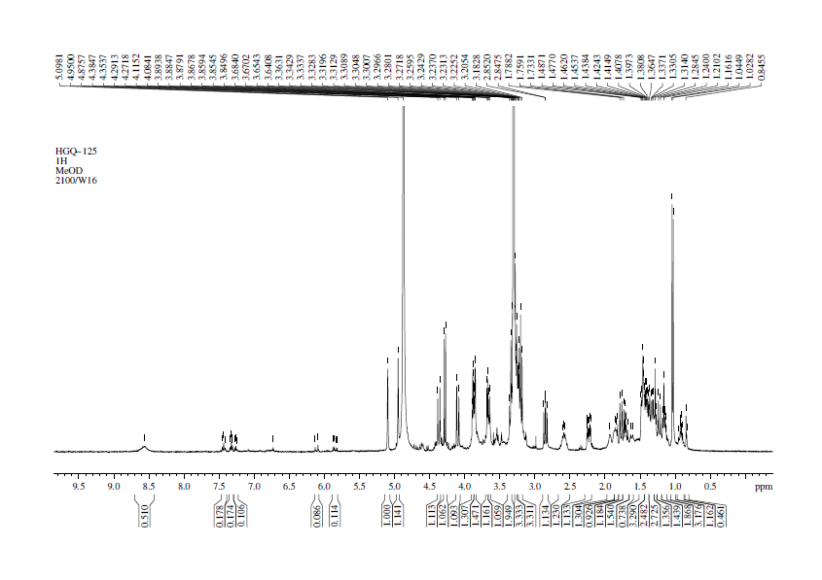

Figure S3. ¹³C-NMR spectrum of compound 1
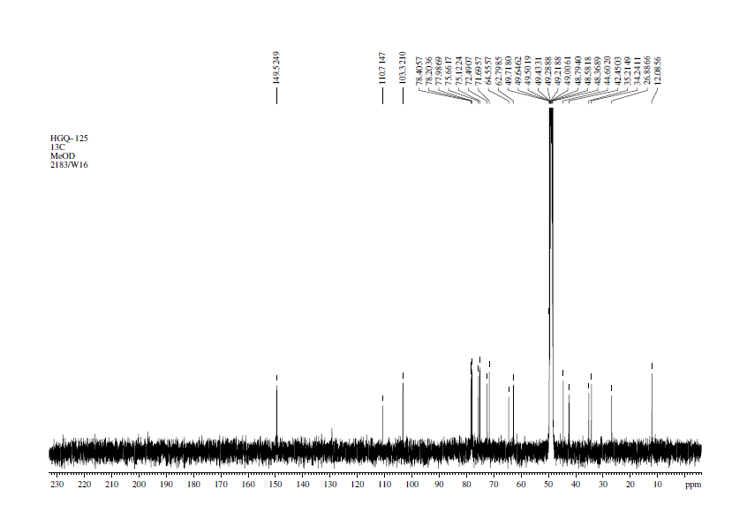

Figure S4. DEPT-135 spectrum of compound 1
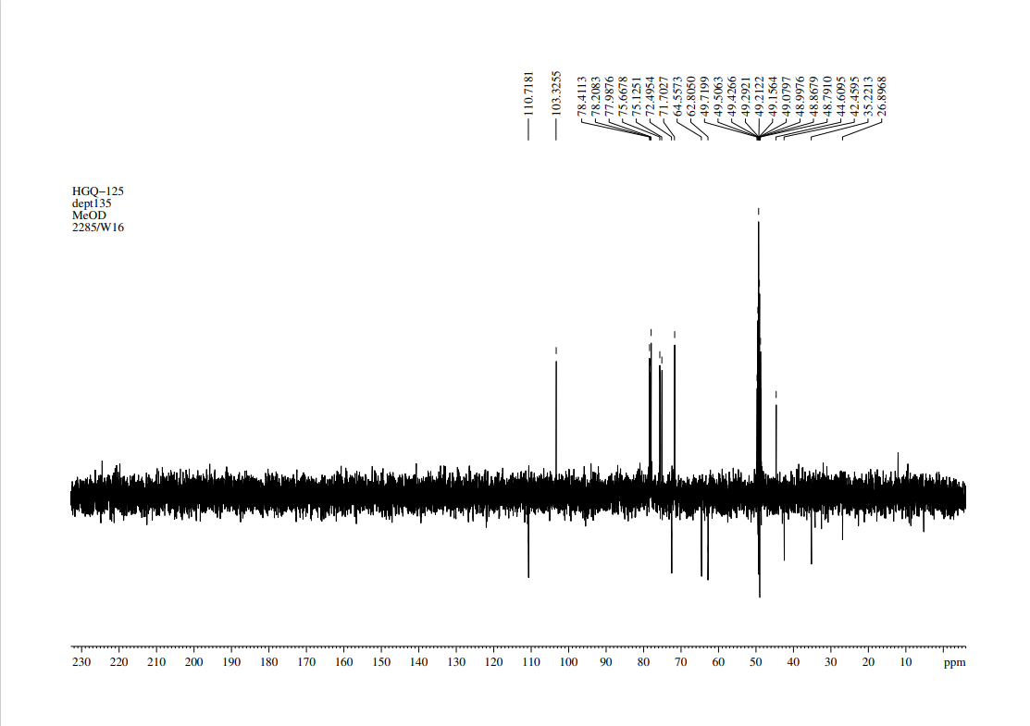

Figure S5. HSQC spectrum of compound 1
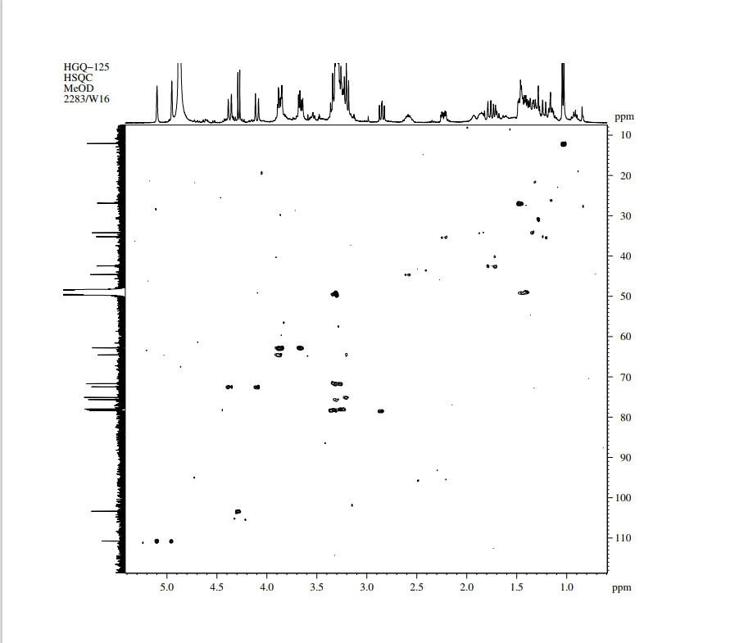

Figure S6. ¹H-¹H COSY spectrum of compound 1
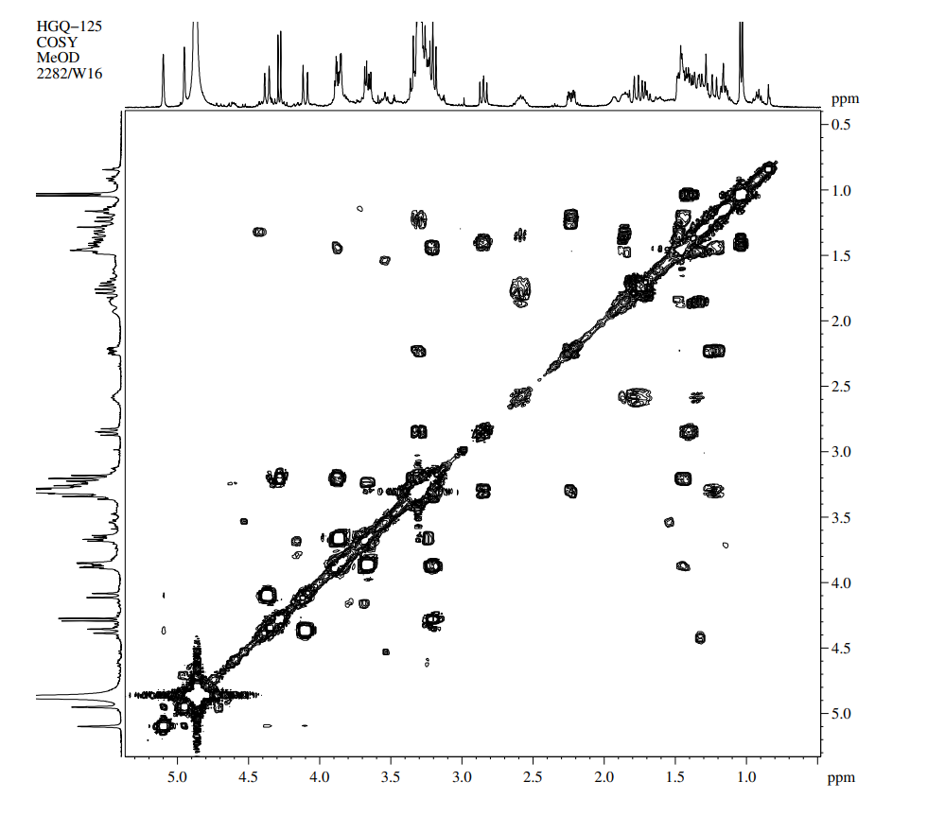

Figure S7. HMBC spectrum of compound 1
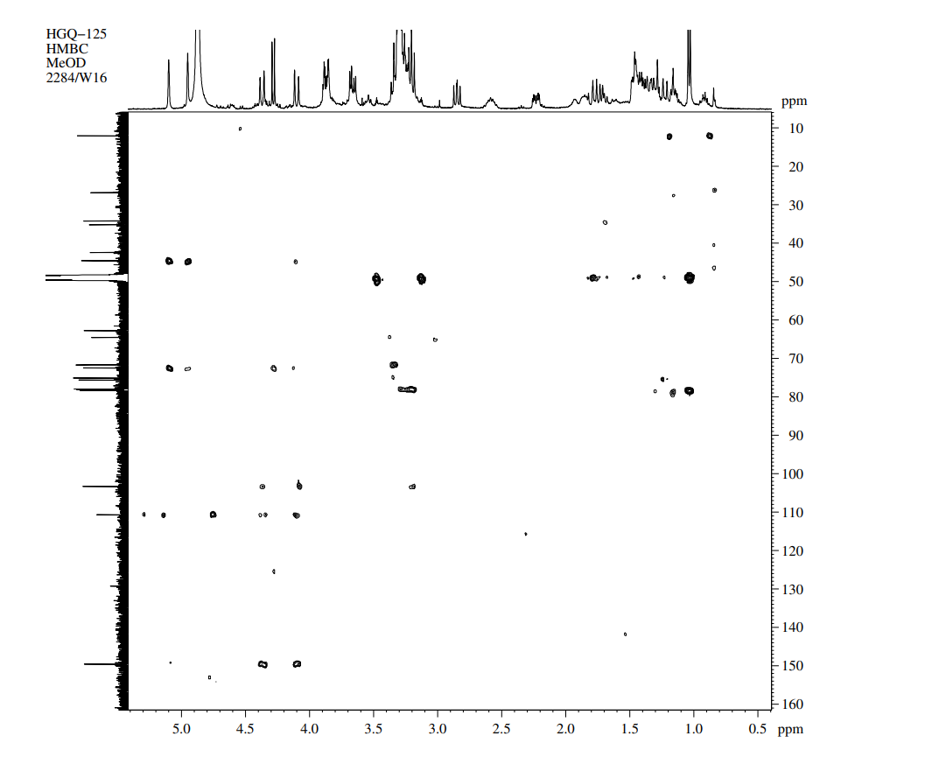

Figure S8. NOESY spectrum of compound 1
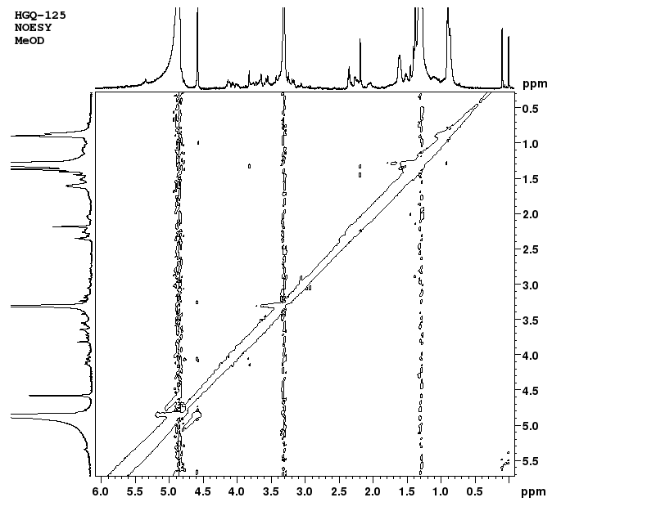

Figure S9. HR-ESI-MS spectrum of compound 2

Figure S10. ¹H-NMR spectrum of compound 2
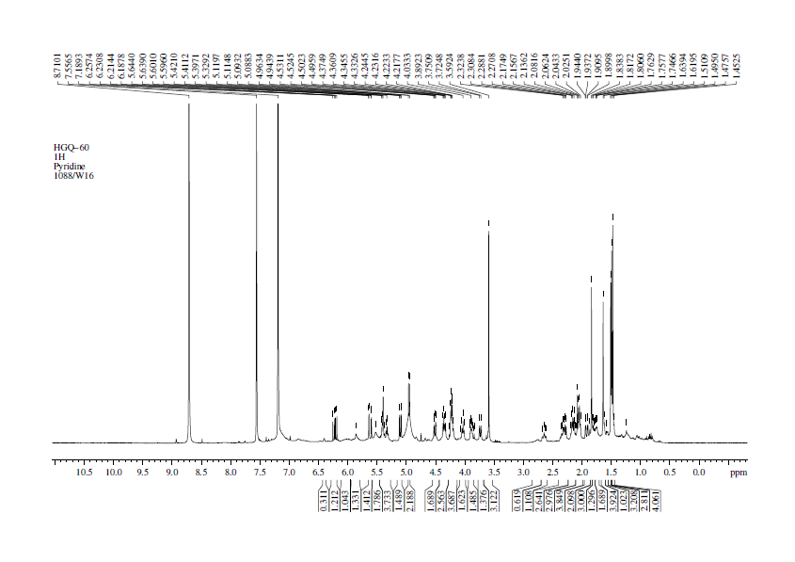

Figure S11. ¹³C-NMR spectrum of compound 2
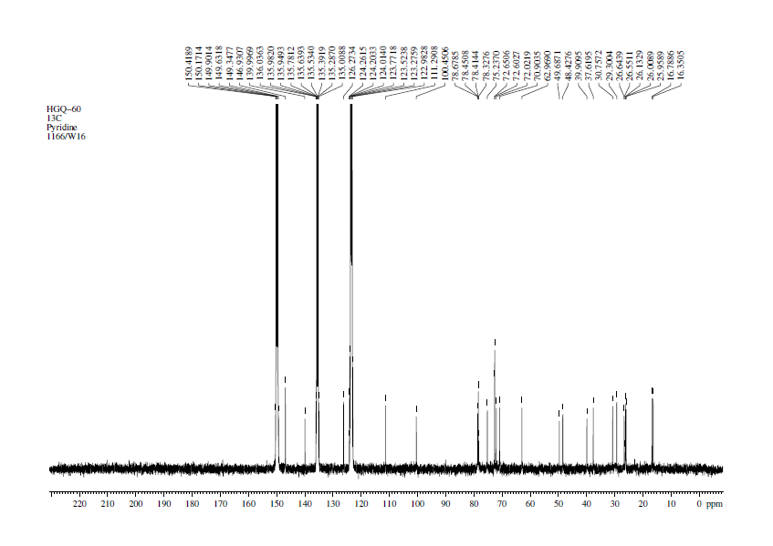

Figure S12. DEPT-135 spectrum of compound 2
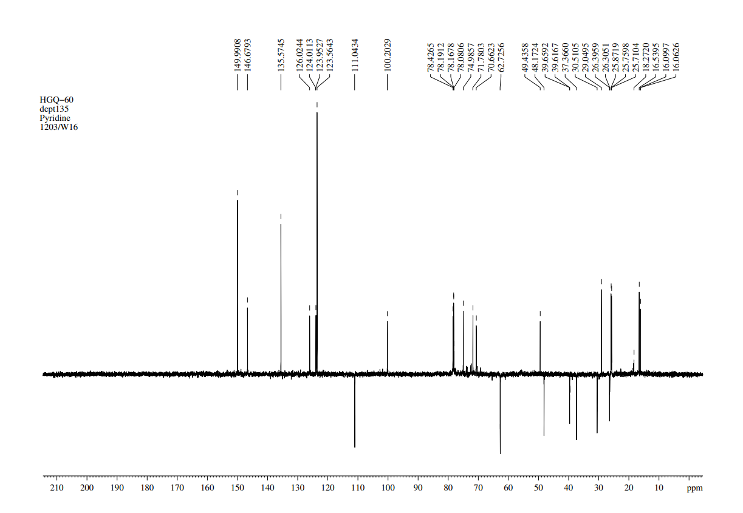

Figure S13. HSQC spectrum of compound 2
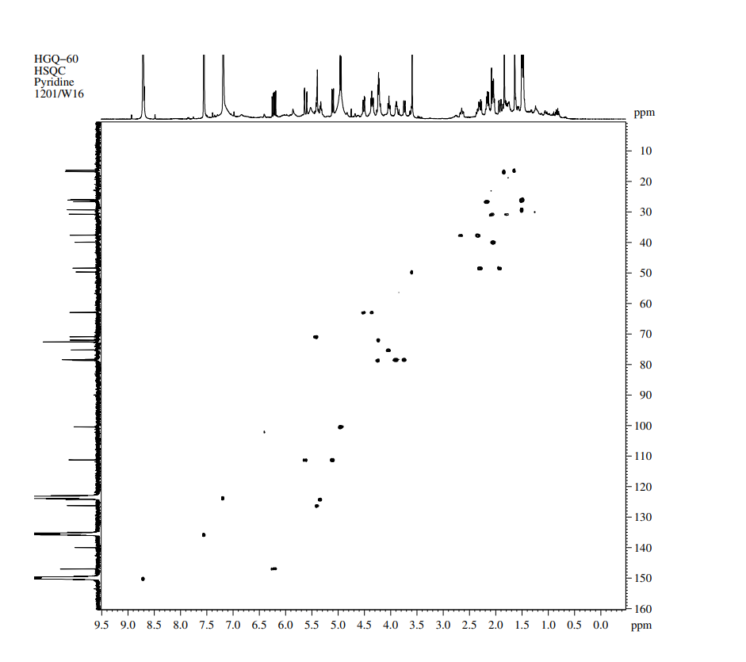

Figure S14. ¹H-¹H COSY spectrum of compound 2
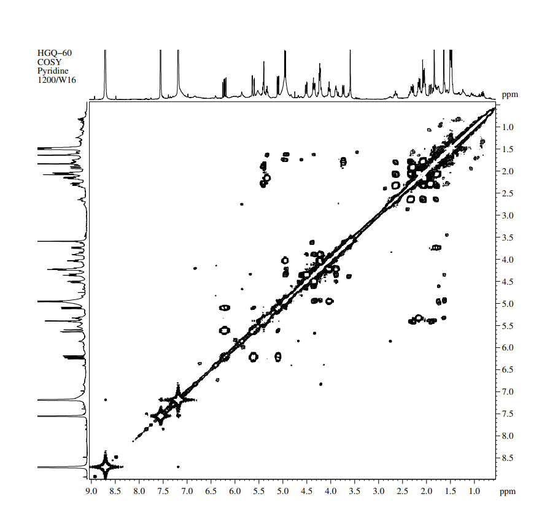

Figure S15. HMBC spectrum of compound 2
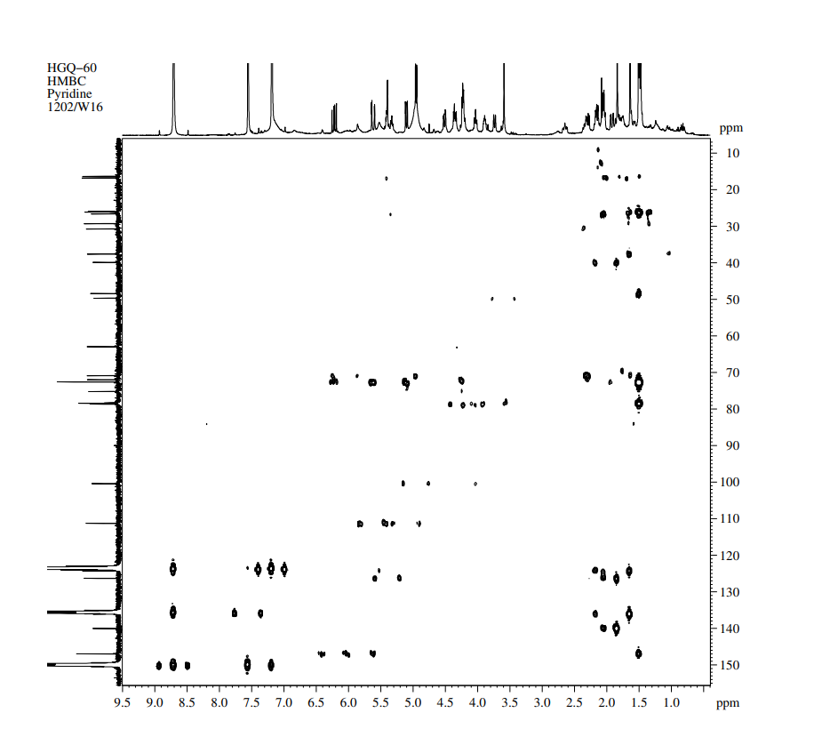

Figure S16. Chemical structures of compounds 3-11

