SUPPLEMENTARY MATERIAL

Isolation of compounds from the roots of Ambrosia artemisiifolia and their effects on human cancer cell lines

Elek Ferencz,^{1,2} Gabriella Spengler,³ István Zupkó,⁴ Martin Vollár,¹ Zoltán Péter Zomborszki,¹ Norbert Kúsz,¹ Judit Hohmann,^{1,5} Balázs Kovács,¹ Dezső Csupor,^{1,6,7} Eszter Laczkó-Zöld,⁸ Boglárka Csupor-Löffler^{1,6,*}

¹ Institute of Pharmacognosy, Faculty of Pharmacy, University of Szeged,
Eötvös u. 6, H-6720 Szeged, Hungary
² Department of Physical Chemistry, George Emil Palade University of Medicine, Pharmacy, Science, and Technology of Targu Mures, Gh. Marinescu 38, RO-540139 Tîrgu Mureș, Romania
³ Department of Medical Microbiology, Albert Szent-Györgyi Health Center and Albert Szent-Györgyi Medical School, University of Szeged, Semmelweis u. 6, H-6725 Szeged, Hungary.
⁴ Institute of Pharmacodynamics and Biopharmacy, Faculty of Pharmacy, University of Szeged,
Eötvös u. 6, H-6720 Szeged, Hungary
⁵ ELKH-USZ Biologically Active Natural Products Research Group, University of Szeged,
Eötvös u. 6, H-6720 Szeged, Hungary
⁶ Institute for Translational Medicine, Medical School, University of Pécs,
Szigeti út 12, H-7624 Pécs, Hungary
⁷ Institute of Clinical Pharmacy, Faculty of Pharmacy, University of Szeged,
Szikra u. 8, H-6725 Szeged, Hungary
⁸ Department of Pharmacognosy, George Emil Palade University of Medicine, Pharmacy, Science,
and Technology of Targu Mures, Gh. Marinescu 38, RO-540139 Tîrgu Mureș, Romania

Content
Fig. S1. ¹H NMR spectrum of compound 1. ……………………………………………………………………….……..……3
Fig. S2. ¹³C JMOD spectrum of compound 1. ……………………………………………………………..………..….……3
Fig. S3. ¹H-¹H COSY spectrum of compound 1. ……………………………………………………………..………………4
Fig. S4. HSQC spectrum of compound 1. ……………………………………………………………..……….…………4
Fig. S5. HMBC spectrum of compound 1. ……………………………………………………………..…………………5
Fig. S6. ¹H NMR spectrum of compound 2. ……………………………………………………………..…………….………5
Fig. S7. ¹H NMR spectrum of compound 3. ……………………………………………………………..……………….……6
Fig. S8. ¹H NMR spectrum of compound 4. ……………………………………………………………..……………….……6
Fig. S9. ¹H NMR spectrum of compound 5. ……………………………………………………………..……………….……7
Fig. S10. ¹³C JMOD spectrum of compound 5. ……………………………………………………………..……….….……7
Fig. S11. ¹H-¹H COSY spectrum of compound 5. ……………………………………………………………..………………8
Fig. S12. HSQC spectrum of compound 5. ……………………………………………………………..………………….……8
Fig. S13. HMBC spectrum of compound 5. ……………………………………………………………..………………………9
Fig. S14. NOESY spectrum of compound 5. ……………………………………………………………..………………..……9
Fig. S15. ¹H NMR spectrum of compound 6. ……………………………………………………………..…………….……10
Fig. S16. ¹³C JMOD spectrum of compound 6. .……………………………………………………………..………….…. …10
Fig. S17. Mass spectrum (APCI) of compound 6. ……………………………………………………………..………….……11
Fig. S18. Dose-effect curves of antiproliferative effects of compounds 3 and 4. ………………………………12

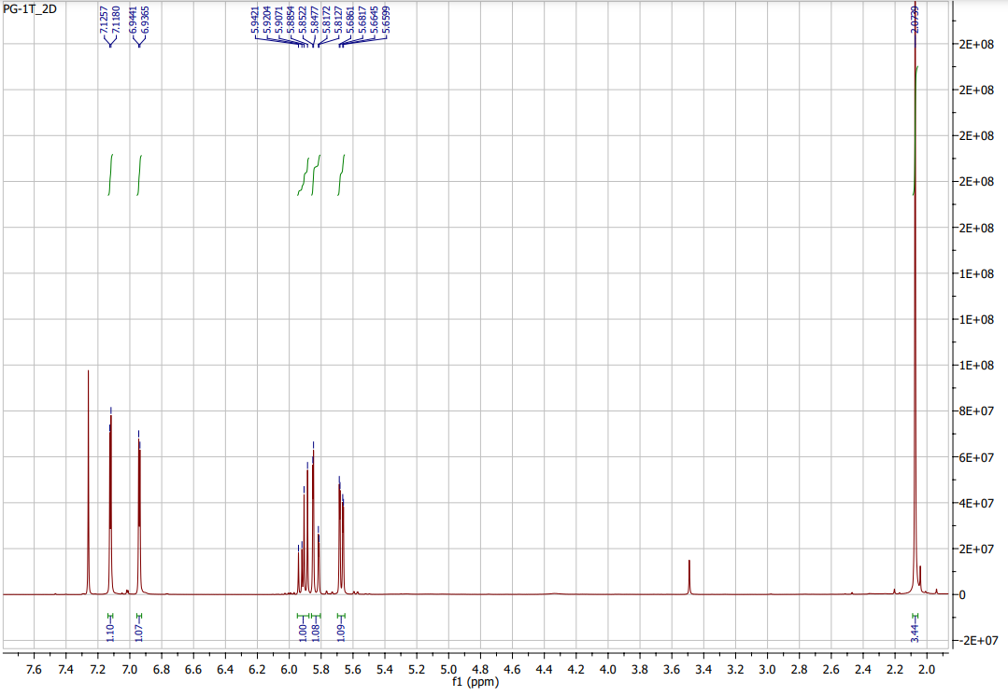
Fig. S1. ¹H NMR spectrum of compound 1.

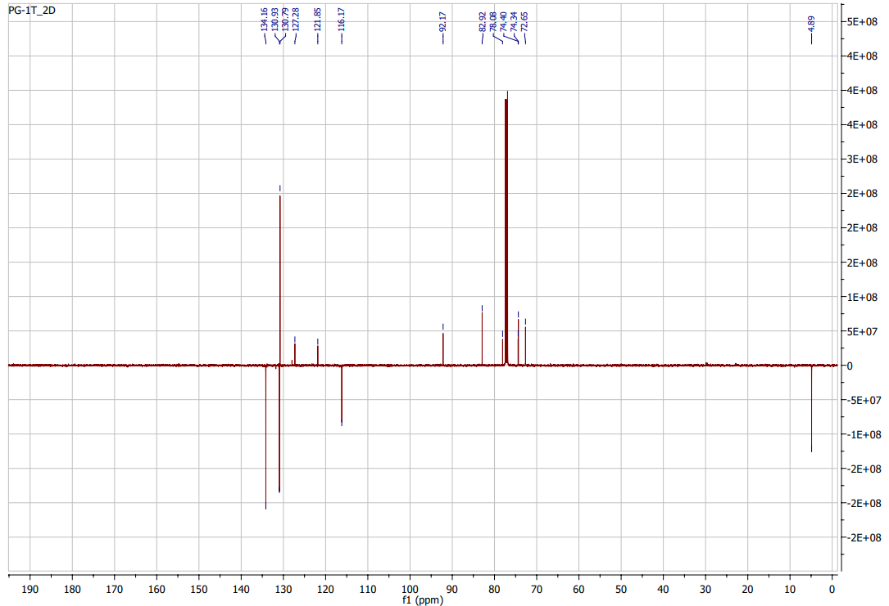
Fig. S2. ¹³C JMOD spectrum of compound 1.
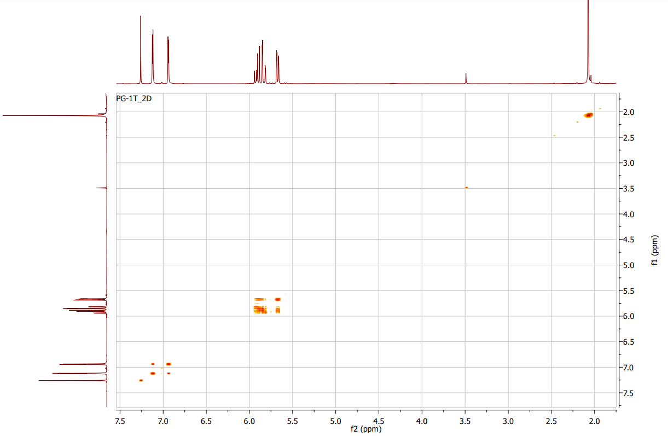
Fig. S3. ¹H-¹H COSY spectrum of compound 1.

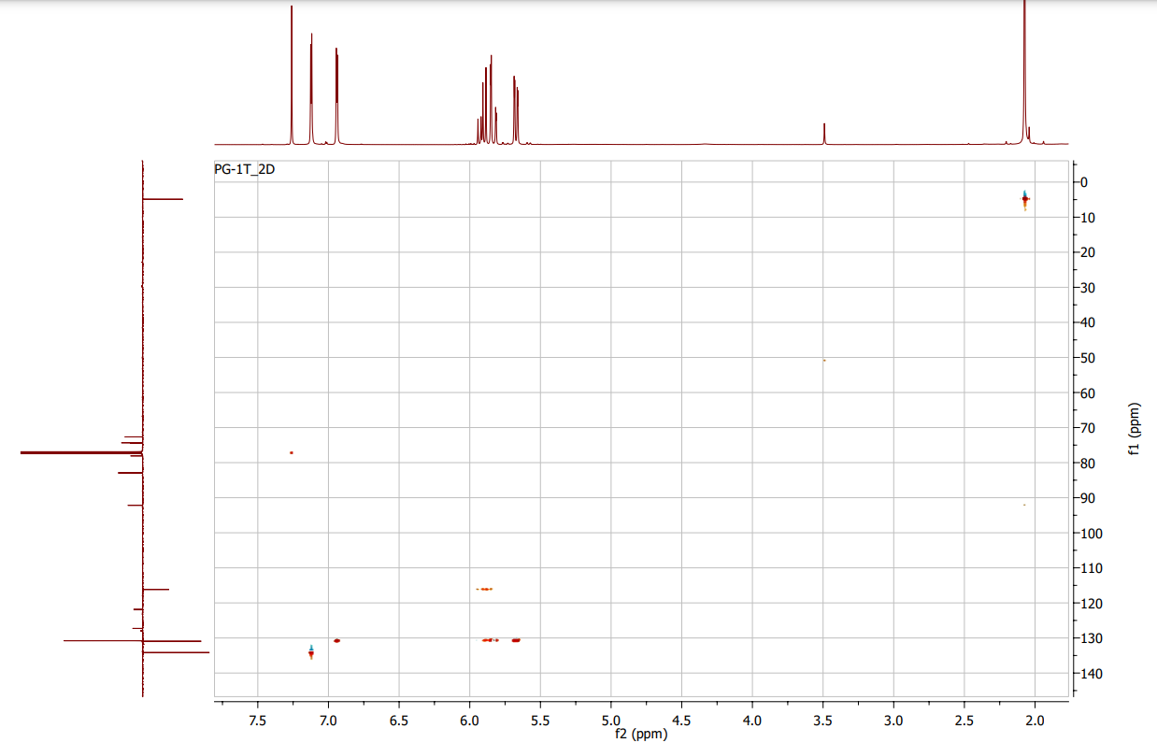
Fig. S4. HSQC spectrum of compound 1.

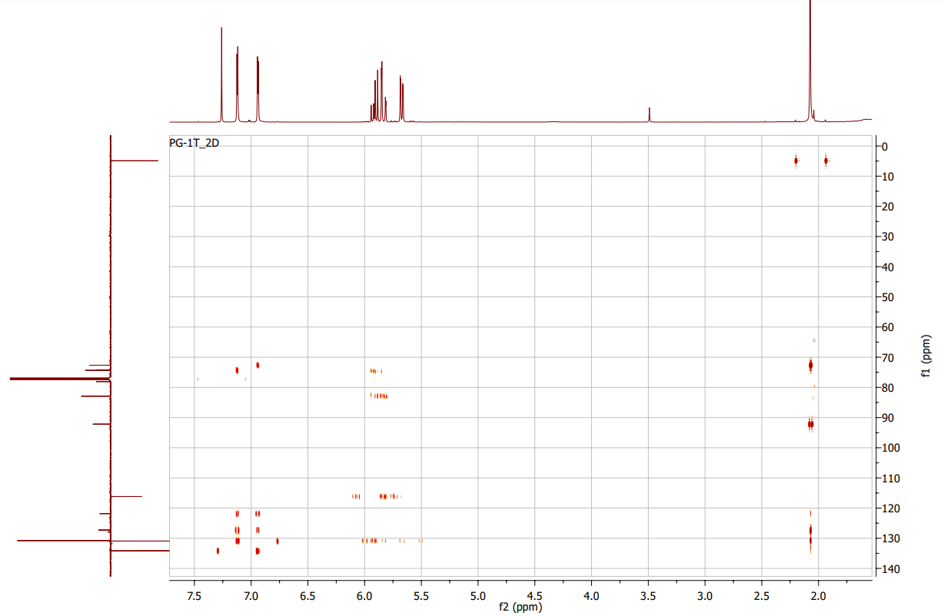
Fig. S5. HMBC spectrum of compound 1.

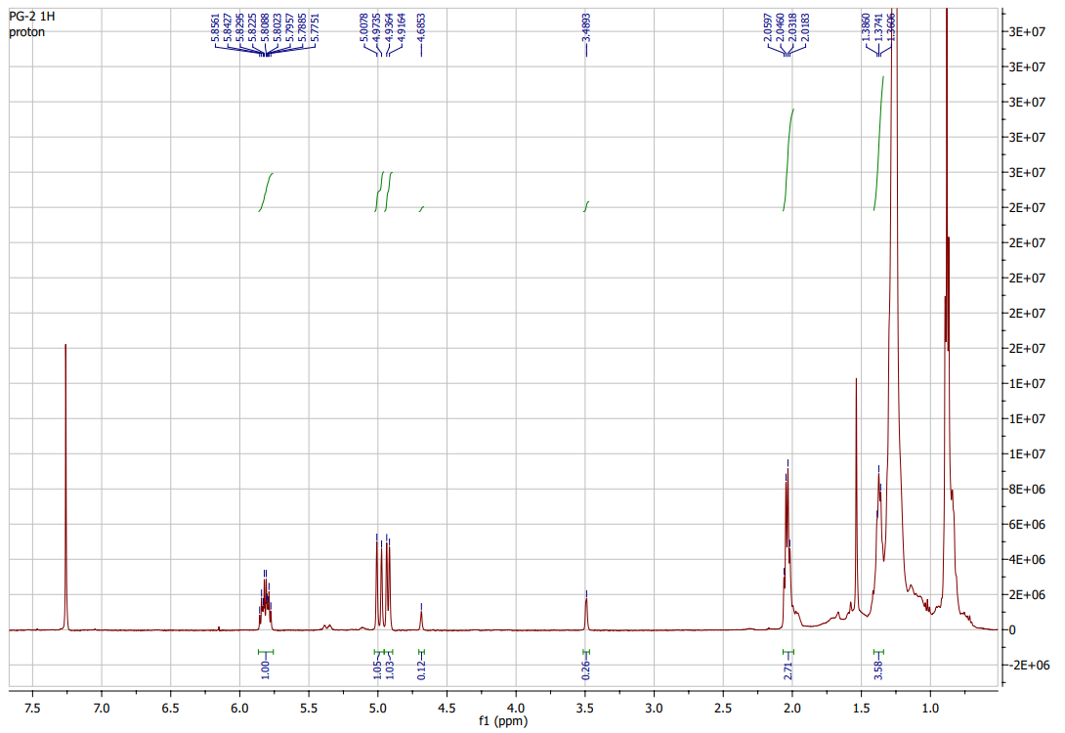
Fig. S6. ¹H NMR spectrum of compound 2.

Fig. S7. ¹H NMR spectrum of compound 3.

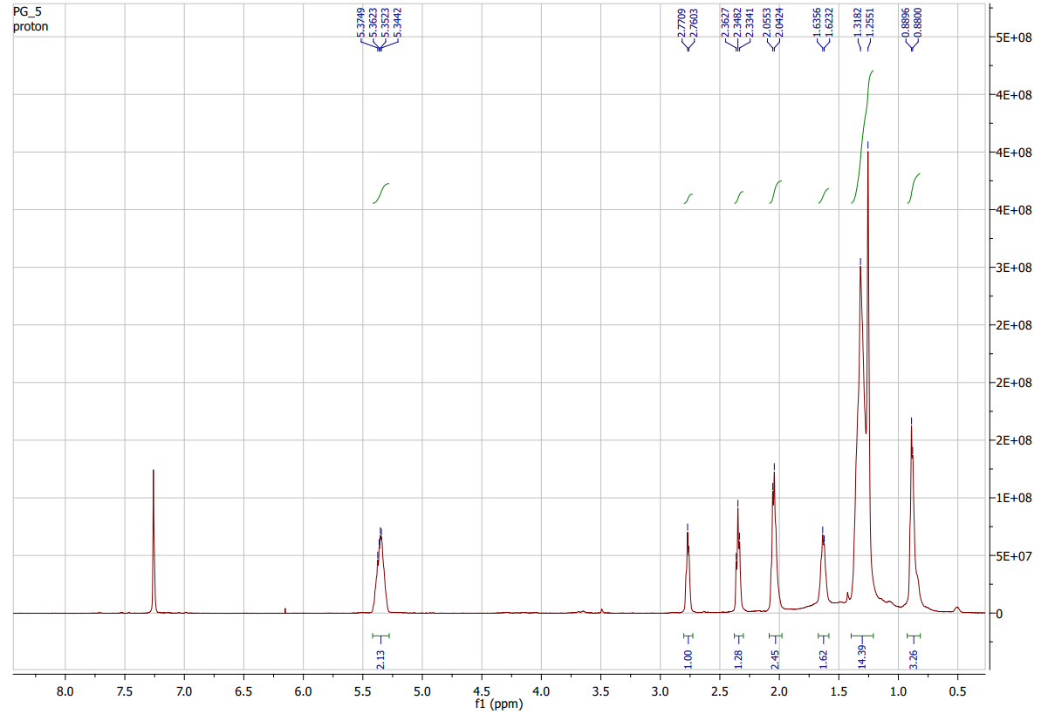
Fig. S8. ¹H NMR spectrum of compound 4.
Fig. S9. ¹H NMR spectrum of compound 5.

Fig. S10. ¹³C JMOD spectrum of compound 5.
Fig. S11. ¹H-¹H COSY spectrum of compound 5.

Fig. S12. HSQC spectrum of compound 5.
Fig. S13. HMBC spectrum of compound 5.

Fig. S14. NOESY spectrum of compound 5.
Fig. S15. ¹H NMR spectrum of compound 6.

Fig. S16. ¹³C JMOD spectrum of compound 6.
Fig. S17. Mass spectrum (APCI) of compound 6.

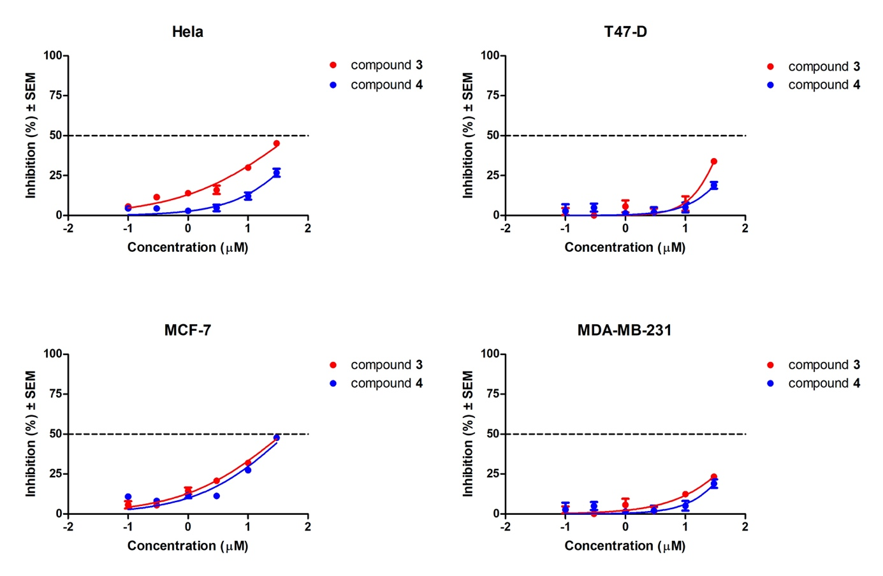
Fig. S18. Dose-effect curves of antiproliferative effects of compounds 3 and 4.

