Structure Elucidation of an Aspidofractinine-type Monoterpene Indole Alkaloid from Melodinus reticulatus
Adrien Jagora,¹ Sarah Szwarc,¹ Marc Litaudon,² Vincent Dumontet,² Jean-François Gallard,² Mehdi A. Beniddir¹ and Pierre Le Pogam¹
¹ Équipe “Chimie des substances naturelles” BioCIS, CNRS, Université Paris-Saclay, 5 rue J.- B. Clément, 92290 Châtenay-Malabry, France.
² Institut de Chimie des Substances Naturelles, CNRS, ICSN UPR 2301, Université Paris-Saclay, 91198, Gif-sur-Yvette, France.
Correspondence
Mehdi A. Beniddir, Équipe “Chimie des substances naturelles” BioCIS, CNRS, Université Paris-Saclay, 5 rue J.- B. Clément, 92290 Châtenay-Malabry, France.
Email: mehdi.beniddir@universite-paris-saclay.fr
Pierre Le Pogam, Équipe “Chimie des substances naturelles” BioCIS, CNRS, Université Paris-Saclay, 5 rue J.- B. Clément, 92290 Châtenay-Malabry, France.
Email: pierre.le-pogam-alluard@universite-paris-saclay.fr
Table of Contents
N° | Content | Page
S1 | Mass spectrum of 1 (retention time = 2.92 min) | S-3
S2 | ¹H NMR (CD₃OD, 600 MHz) spectrum of 1 | S-4
S3 | ¹³C NMR (CD₃OD, 150 MHz) spectrum of 1 | S-5
S4 | COSY NMR (CD₃OD, 600 MHz) spectrum of 1 | S-6
S5 | HSQC NMR (CD₃OD, 600/150 MHz) spectrum of 1 | S-7
S6 | HMBC NMR (CD₃OD, 600/150 MHz) spectrum of 1 | S-8
S7 | ROESY NMR (CD₃OD, 600 MHz) spectrum of 1 | S-9
S8 | Cartesian Coordinates of the lowest-energy conformers of the two epimer candidates of 1 | S-10

Figure S1. Mass spectrum of 1 (retention time = 2.92 min).

S2. ¹H NMR (CD₃OD, 600 MHz) spectrum of 1.
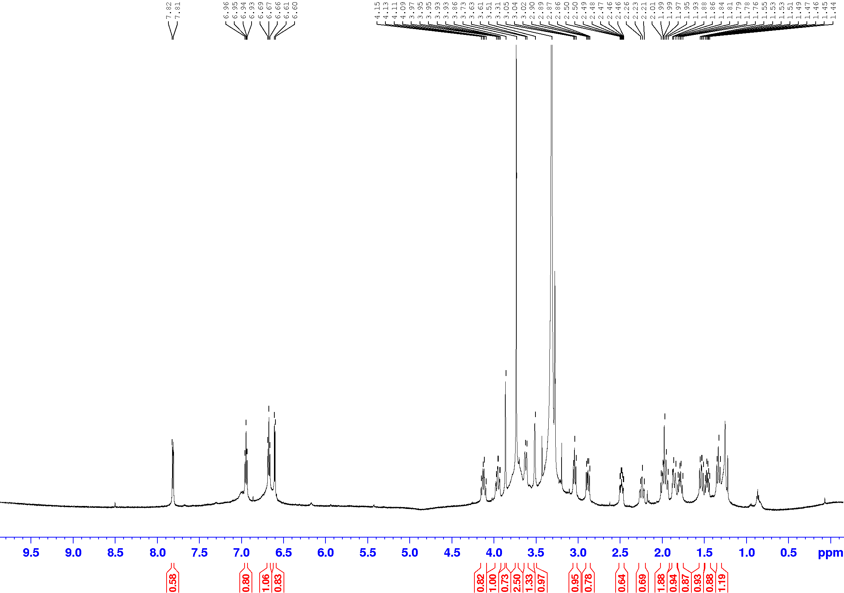

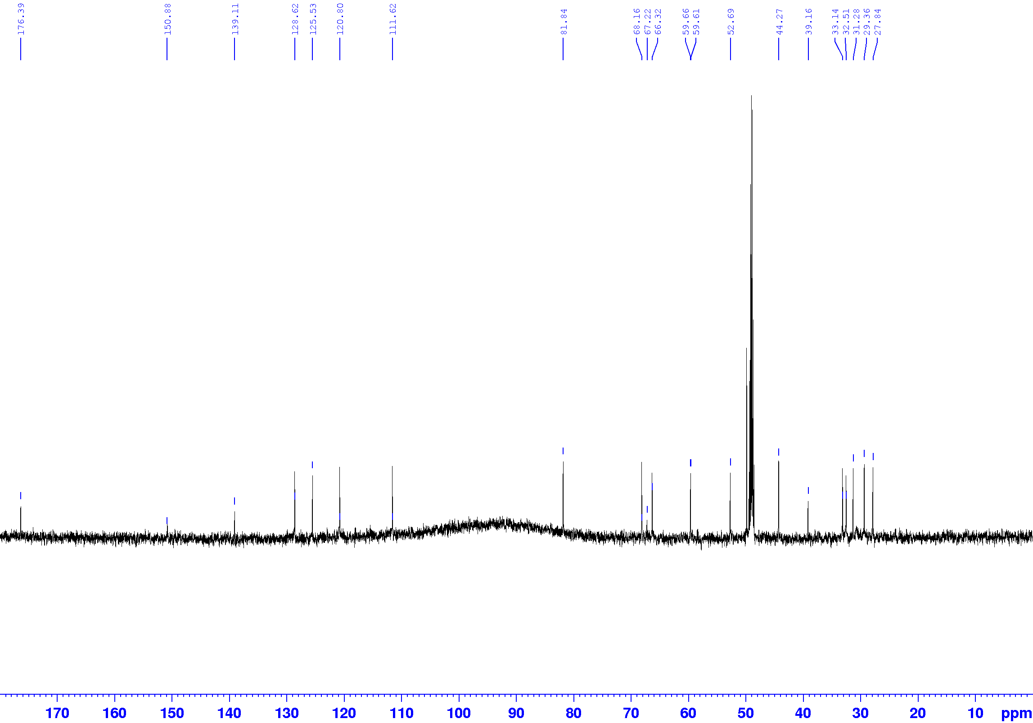
S3. ¹³C NMR (CD₃OD, 150 MHz) spectrum of 1.

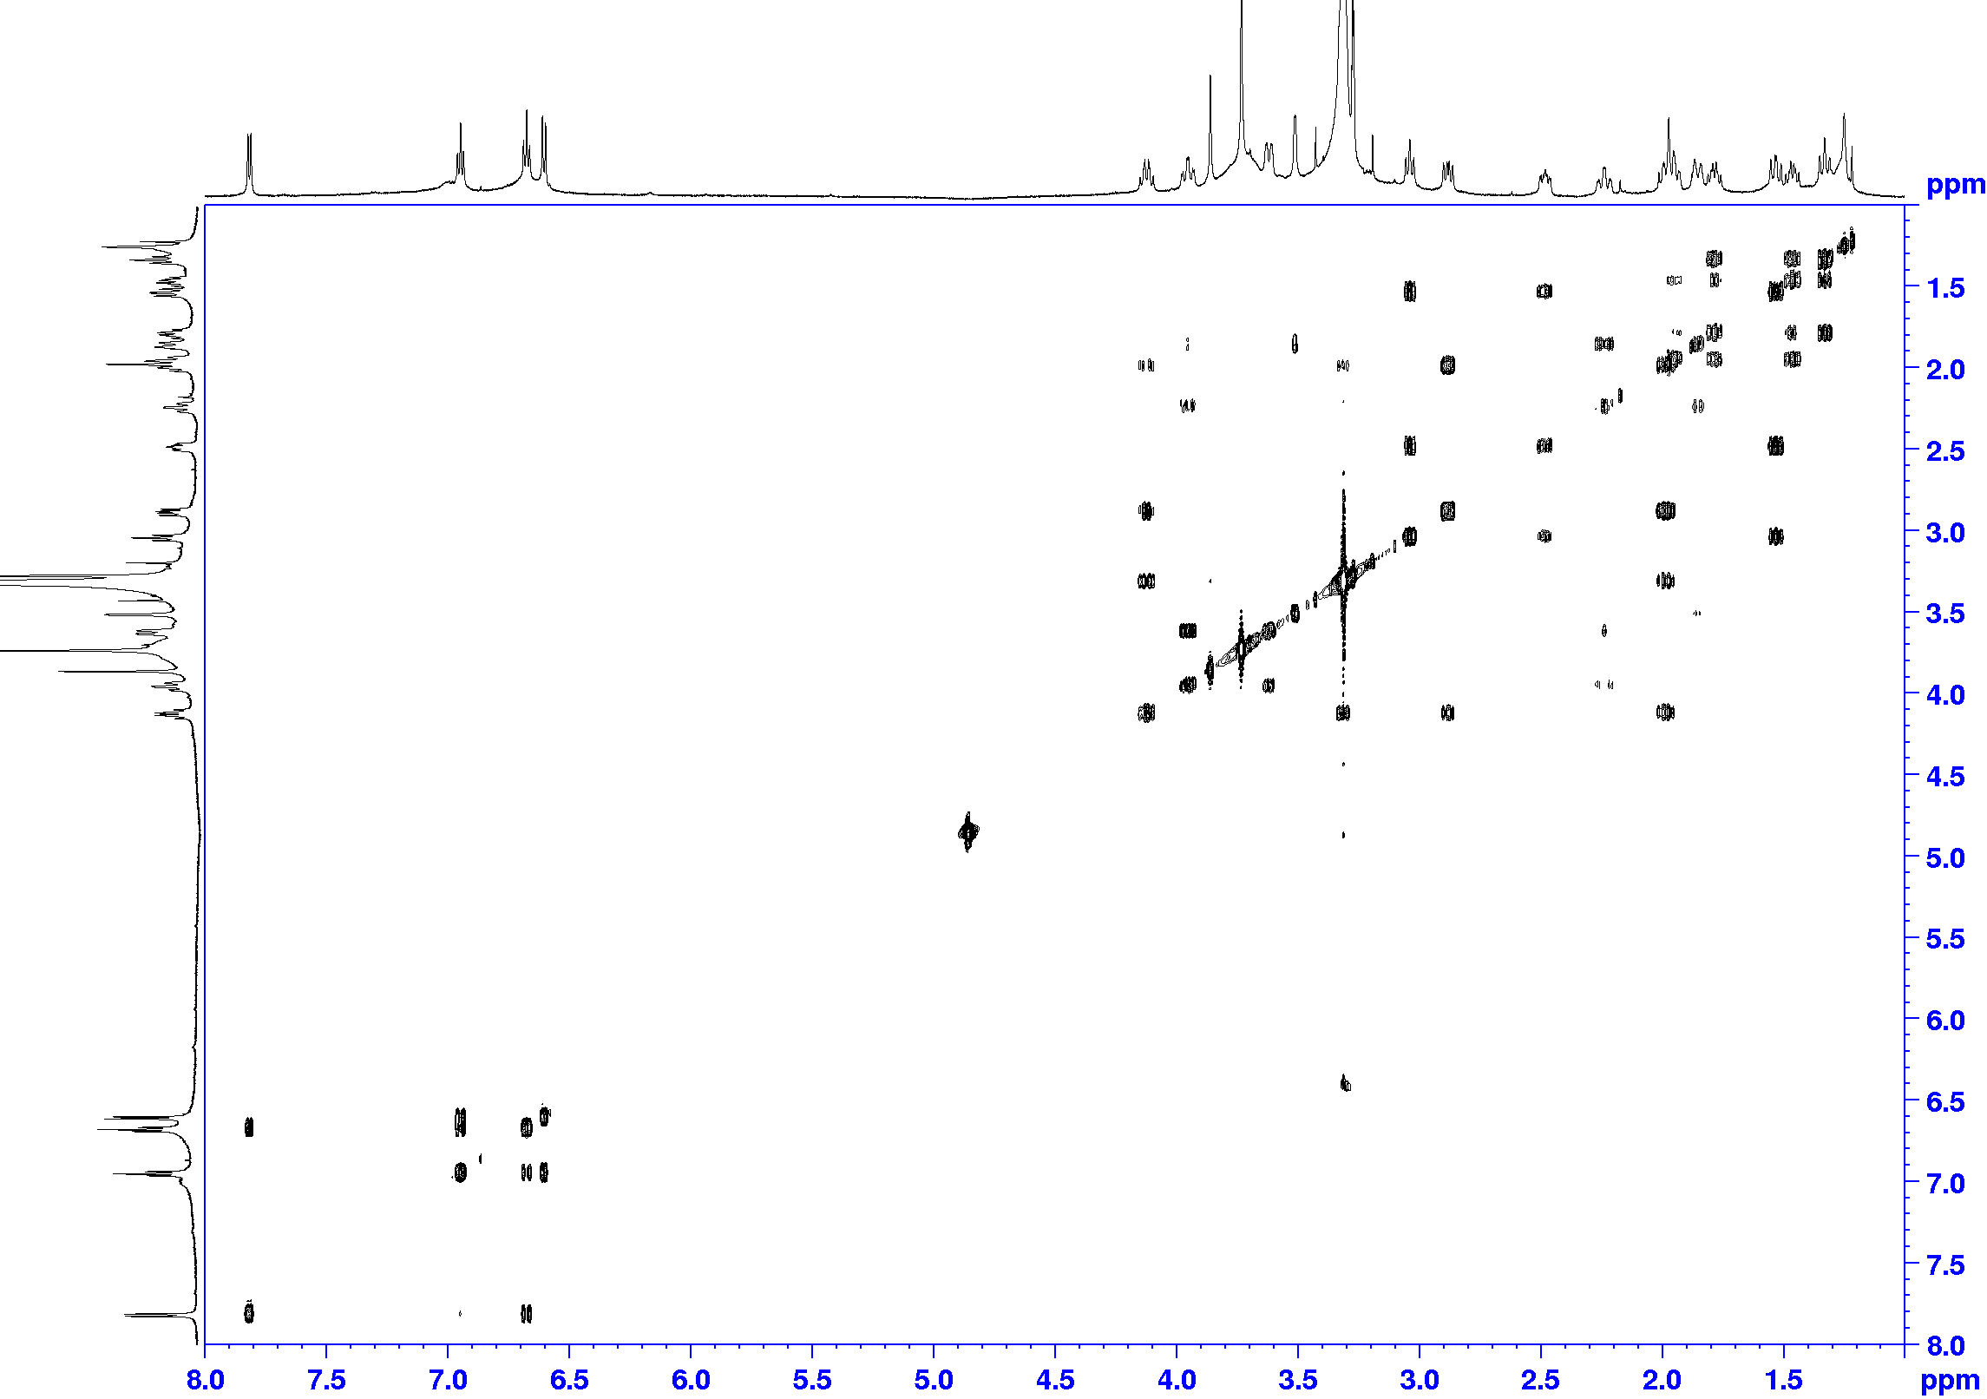
S4. COSY NMR (CD₃OD, 600 MHz) spectrum of 1.

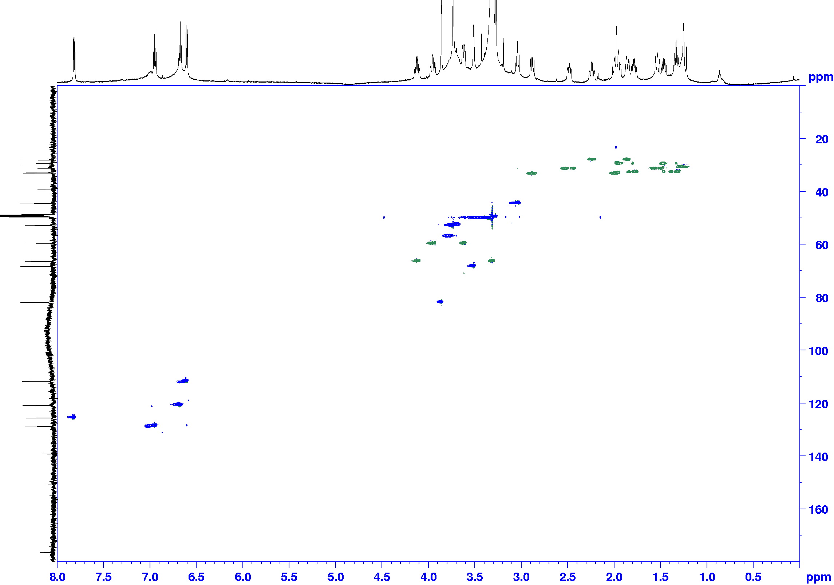
S5. HSQC NMR (CD₃OD, 600/150 MHz) spectrum of 1.

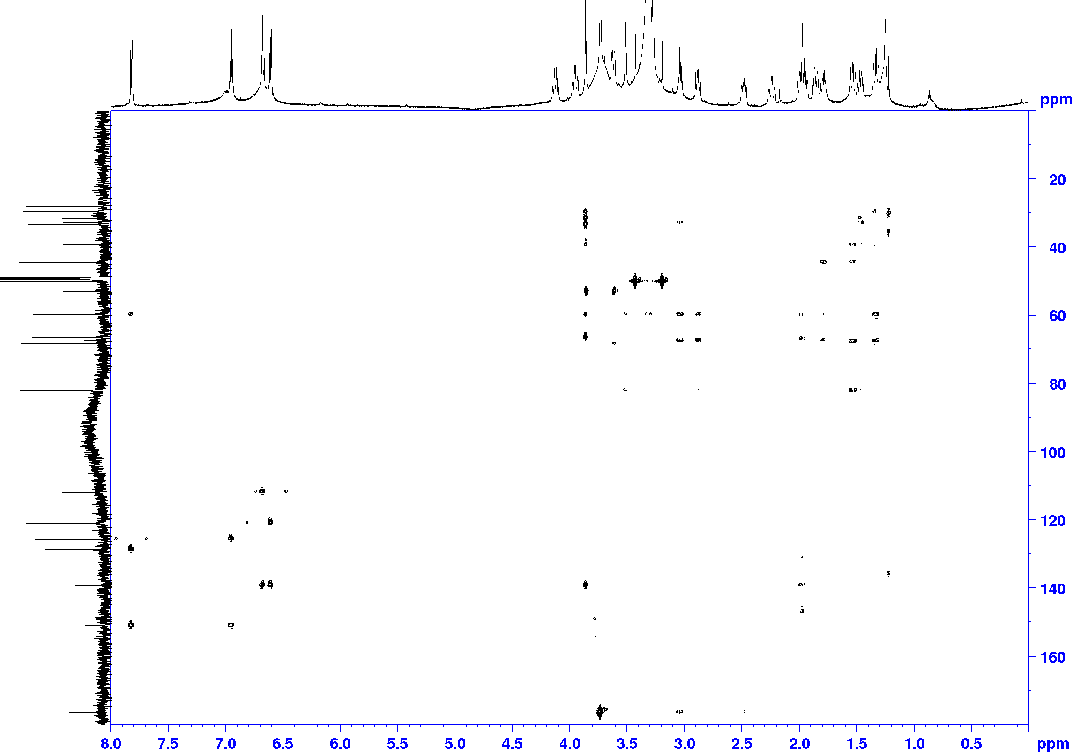
S6. HMBC NMR (CD₃OD, 600/150 MHz) spectrum of 1.

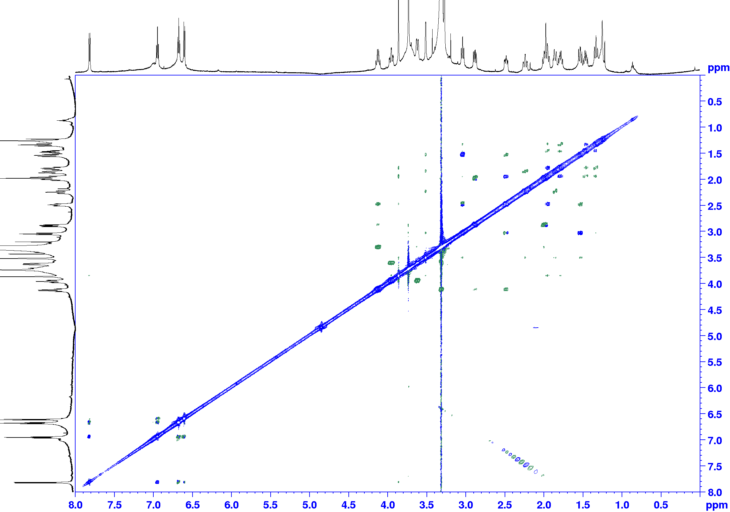
S7. ROESY NMR (CD₃OD, 600 MHz) spectrum of 1.

S8. Cartesian coordinates of the lowest-energy conformers of the two epimer candidates of 1.

Electronic energy (B3LYP): -1226.166964376543 Ha.
Lowest frequency: 41.1051 /cm.
Free enthalpy: -1225.791343 Ha.
Coordinates of the lowest energy conformer of 1 found at the B3LYP/6-31G* level
1 C -1.167406 -3.055602 -0.396417
2 C -2.295758 -3.871442 -0.225395
3 C -3.495701 -3.330474 0.242606
4 C -3.603523 -1.970054 0.559509
5 C -2.474839 -1.170521 0.397373
6 C -1.264067 -1.710311 -0.070062
7 N -2.338267 0.218468 0.627727
8 C -0.276429 -0.561928 -0.238355
9 C -0.897057 0.445561 0.801326
10 H -2.922043 0.601909 1.365578
11 C 1.220583 -0.741024 0.115017
12 C -0.399132 1.908791 0.667230
13 C 1.139486 1.843627 0.472452
14 C 1.714647 0.479590 0.958382
15 C -0.271459 -0.141039 -1.761787
16 C 1.192557 -0.056020 -2.194420
17 N 1.900123 -0.978778 -1.231986
18 C 3.390502 -0.773864 -1.171728
19 C 3.254746 0.536398 0.982951
20 C 3.829582 0.494804 -0.442587
21 O 3.717712 -0.582214 1.743446
22 H 4.687375 -0.561835 1.743800
23 C -1.094611 2.773637 -0.373805
24 O -0.668862 3.065126 -1.473339
25 O -2.270340 3.229728 0.105790
26 C -3.049710 4.017169 -0.810581
27 H -2.491072 4.901075 -1.128722
28 H -3.945160 4.305557 -0.259464
29 H -3.314615 3.425044 -1.690324
30 C -0.409164 0.007676 2.217985
31 C 1.115263 0.246273 2.367605
32 O 1.651926 -2.264165 -1.625472
33 H -0.225171 -3.435099 -0.780898
34 H -2.236601 -4.930067 -0.462873
35 H -4.364058 -3.972614 0.368638
36 H -4.539432 -1.555301 0.926047
37 H 1.434734 -1.660941 0.658096
38 H -0.630246 2.395430 1.622249
39 H 1.614716 2.643264 1.053560
40 H 1.366894 2.051835 -0.573218
41 H -0.793688 0.794451 -1.951169
42 H -0.767650- 0.928075 -2.328212
43 H 1.595638 0.958449 -2.134719
44 H 1.386124 -0.470811 -3.182946
45 H 3.738030 -0.814707 -2.206483
46 H 3.746202 -1.666527 -0.657180
47 H 3.562756 1.472242 1.477124
48 H 3.541124 1.398883 -0.991838
49 H 4.928009 0.507443 -0.398774
50 H -0.971869 0.573287 2.971505
51 H -0.652289 -1.048359 2.363828
52 H 1.320523 1.126012 2.991199
53 H 1.604232 -0.603667 2.847835

Electronic energy (B3LYP): -1226.1501104065426 Ha.
Lowest frequency: 27.9967 /cm.
Free enthalpy: -1225.7726 Ha.
Coordinates of the lowest energy conformer of the N-oxide epimer of 1 found at the B3LYP/6-31G* level
1 C -2.823010 -1.814400 -0.590550
2 C -4.217956 -1.882110 -0.457578
3 C -4.920581 -0.825207 0.123566
4 C -4.248288 0.298538 0.619263
5 C -2.862766 0.352859 0.499555
6 C -2.148408 -0.691064 -0.127687
7 N -2.004579 1.361874 1.021592
8 C -0.701922 -0.217380 -0.281415
9 C -0.657175 0.756057 0.947521
10 H -2.041049 2.236745 0.498436
11 C 0.482423 -1.180799 -0.135608
12 C 0.561906 1.687209 0.961576
13 C 1.841443 0.791473 0.795144
14 C 1.522502 -0.732000 0.900844
15 C -0.545317 0.275225 -1.766155
16 C 0.018091 -0.978410 -2.452727
17 N 1.157426 -1.302716 -1.517265
18 C 1.798442 -2.661689 -1.533251
19 C 2.807766 -1.586632 0.661213
20 C 2.535100 -2.871280 -0.179004
21 O 3.343840 -1.961688 1.935420
22 H 4.258765 -2.247684 1.792744
23 C 0.498126 2.866540 0.002019
24 O -0.514203 3.316832 -0.506776
25 O 1.707068 3.431517 -0.168924
26 C 1.741092 4.594919 -1.013245
27 H 1.408638 4.343118 -2.023430
28 H 2.782716 4.916279 -1.022029
29 H 1.096726 5.380778 -0.610446
30 C -0.498731 -0.126179 2.236878
31 C 0.827216 -0.938552 2.260891
32 O 2.147512 -0.388186 -1.756846
33 H -2.287787 -2.640480 -1.054213
34 H -4.751474 -2.760637 -0.809825
35 H -6.002030 -0.883682 0.215915
36 H -4.788586 1.103493 1.109506
37 H 0.132687 -2.187090 0.118605
38 H 0.586989 2.168136 1.950911
39 H 2.297754 0.971362 -0.173638
40 H 2.570074 1.036167 1.575594
41 H 0.195829 1.066080 -1.872465
42 H -1.492007 0.606944 -2.195851
43 H 0.450168 -0.810868 -3.438511
44 H -0.707810 -1.799177 -2.479024
45 H 1.034477 -3.434522 -1.687504
46 H 2.476569 -2.636193 -2.385396
47 H 3.522879 -0.967281 0.115621
48 H 1.961398 -3.557996 0.454310
49 H 3.495422 -3.363981 -0.371386
50 H -1.360516 -0.794431 2.308766
51 H -0.567121 0.552579 3.092965
52 H 1.491563 -0.601380 3.060651
53 H 0.632333 -2.000885 2.448918

