Supporting Information

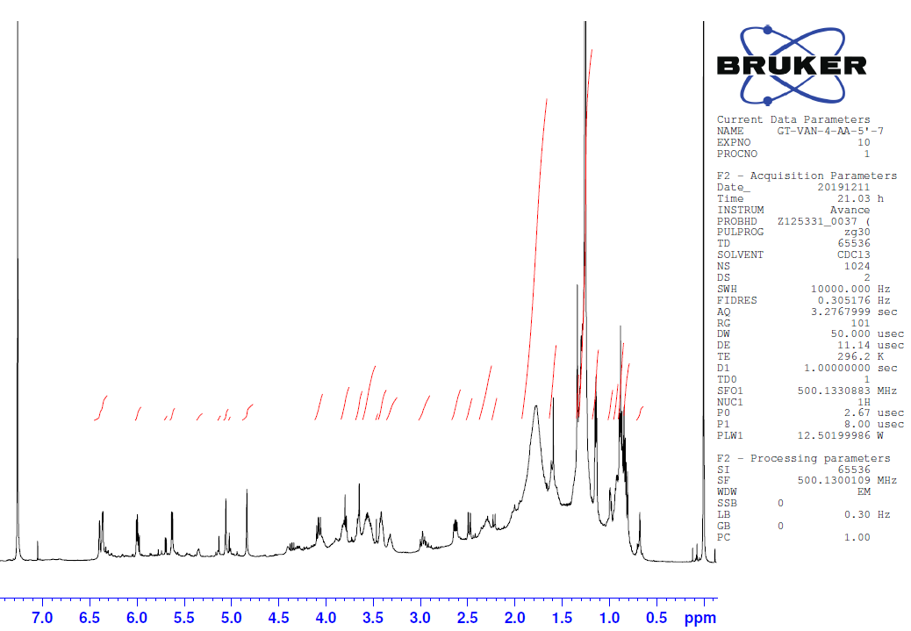
Figure S1. ¹H NMR spectrum of edremitine (1) (CDCl₃)

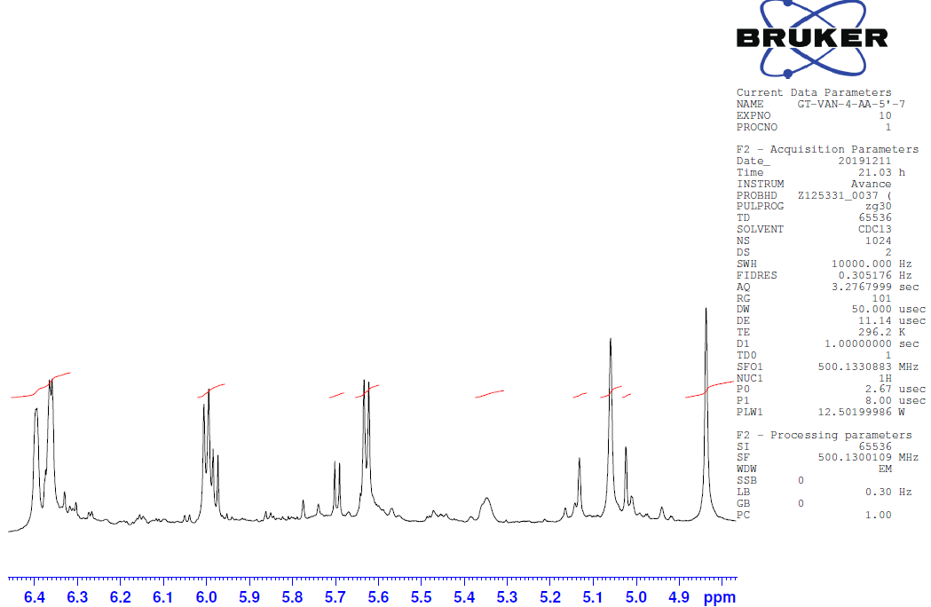
Figure S2. Alkene peak area at ¹H NMR spectrum of edremitine (1) (CDCl₃)

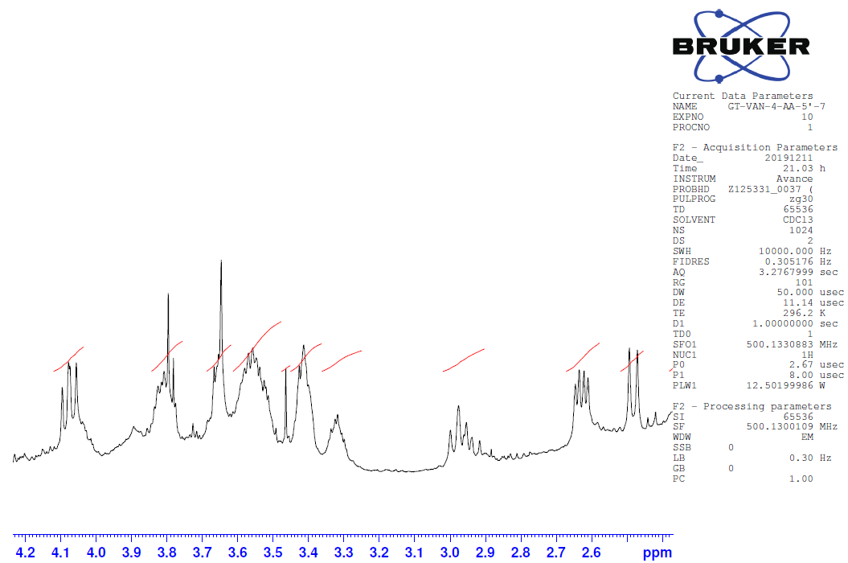
Figure S3. Aliphatic peak area at ¹H NMR spectrum of edremitine (1) (CDCl₃)
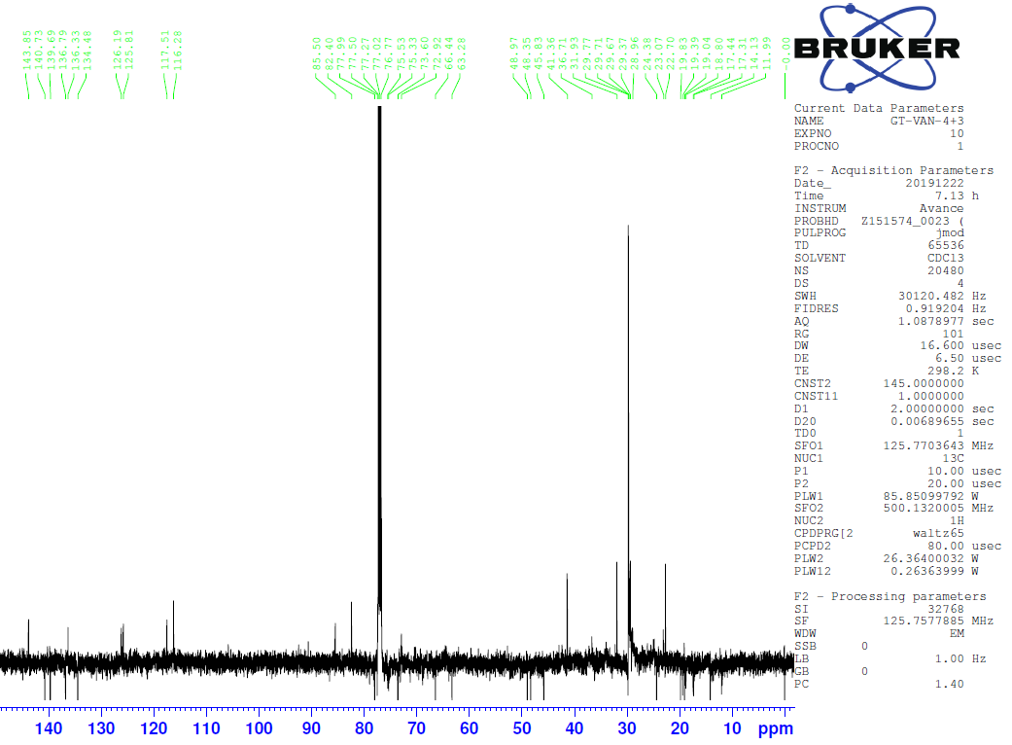
Figure S4. ¹³C NMR spectrum (APT) of edremitine (1) (CDCl₃)

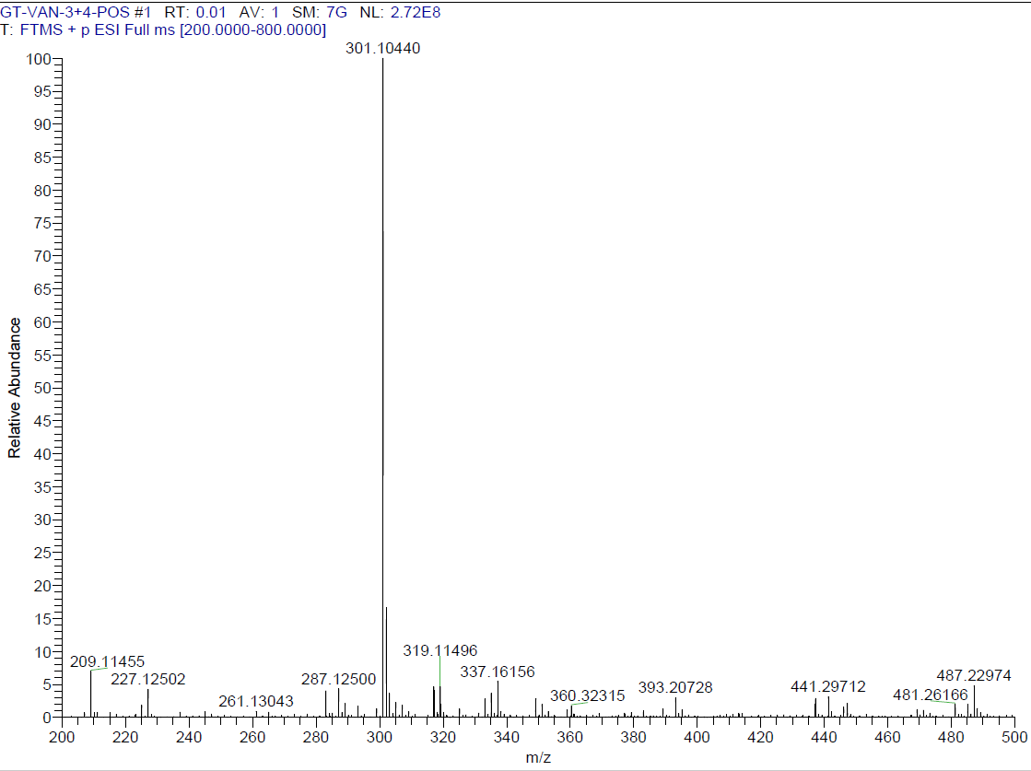
Figure S5. HRMS spectrum of edremitine (1)

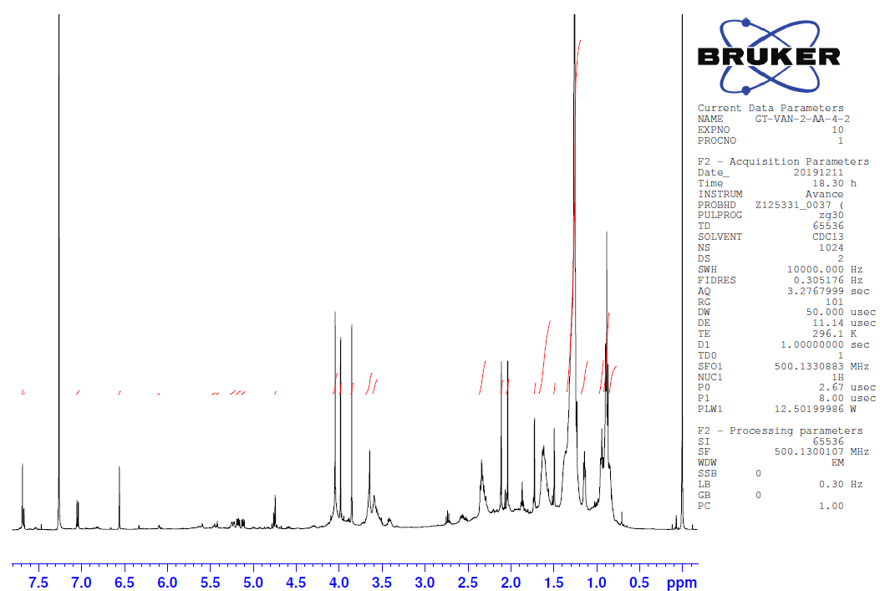
Figure S6. ¹H NMR spectrum of achillosine (2) (CDCl₃)

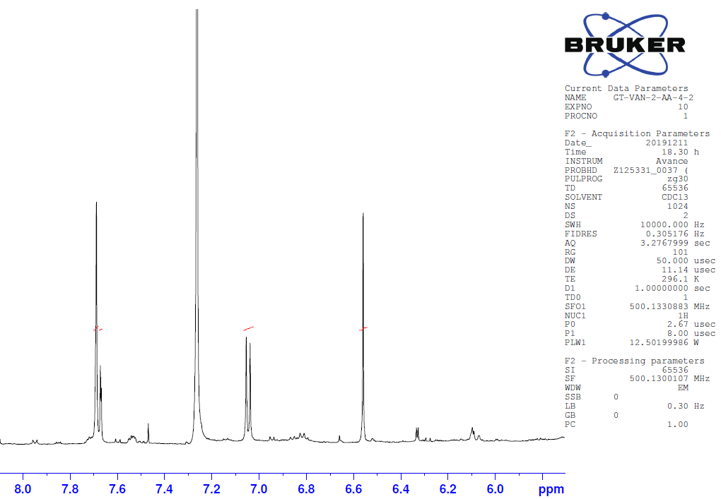
Figure S7. Aromatic peak area at ¹H NMR spectrum of achillosine (2) (CDCl₃)
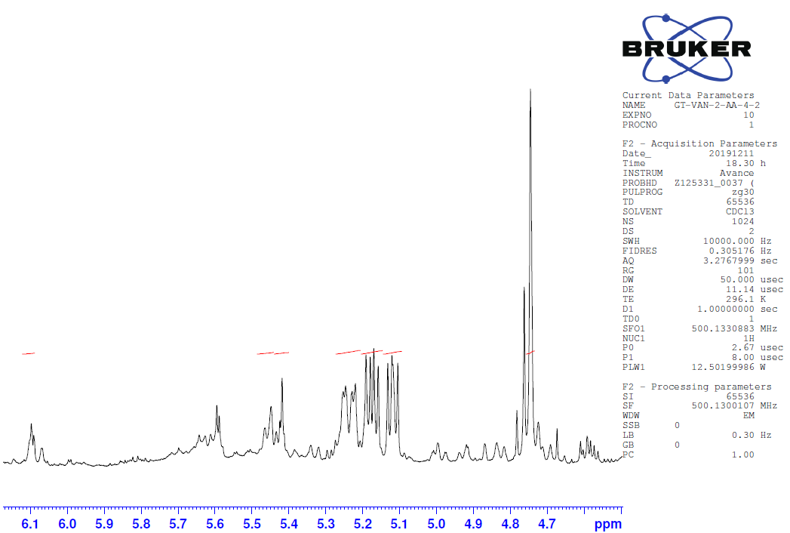
Figure S8. Aliphatic peak area at ¹H NMR spectrum of achillosine (2) (CDCl₃)
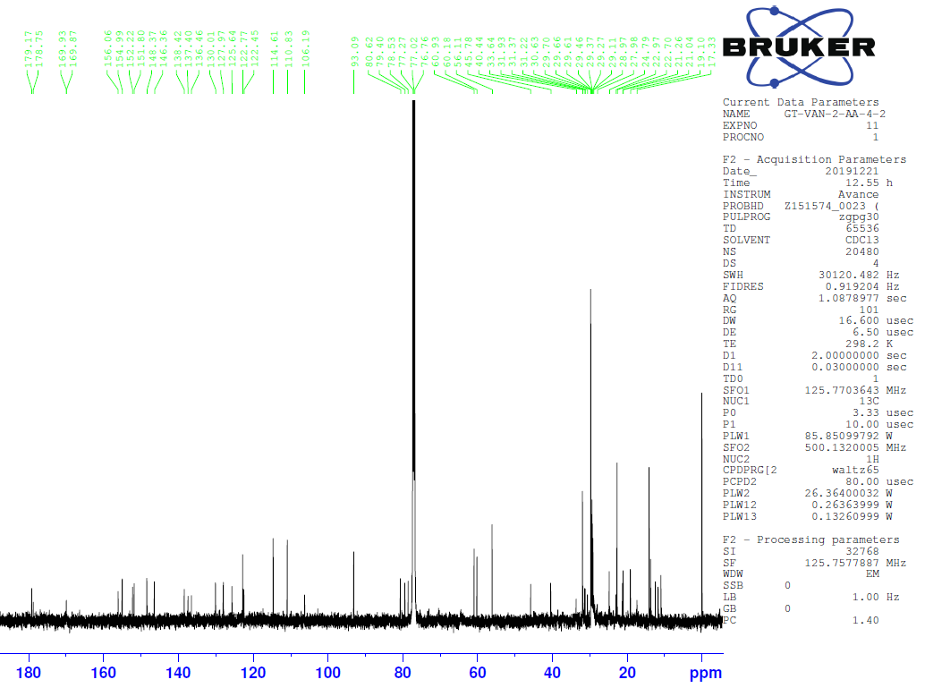
Figure S9. ¹³C NMR spectrum (APT) of achillosine (2) (CDCl₃)

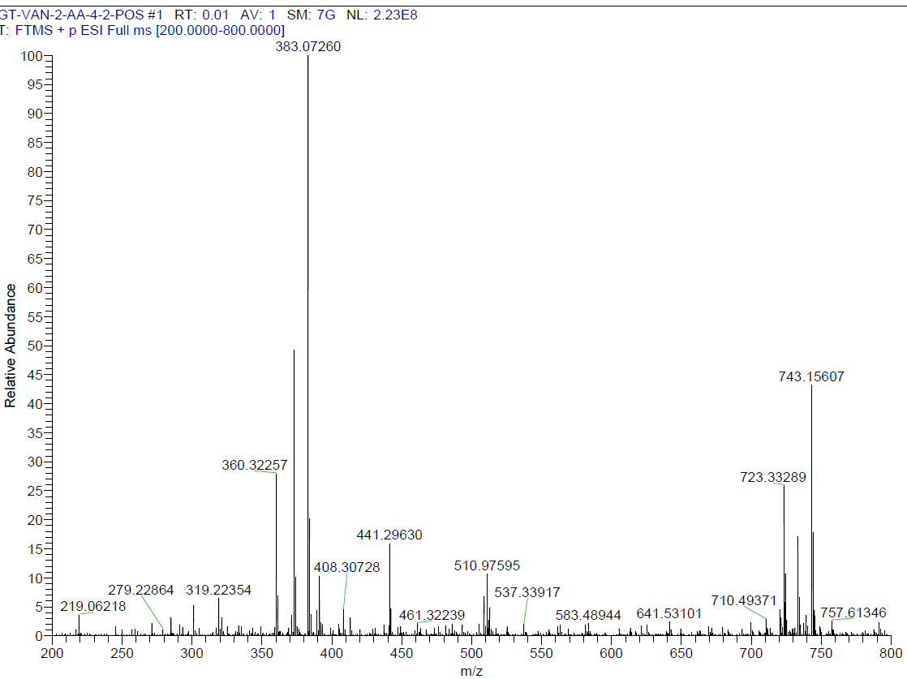
Figure S10. HRMS spectrum of achillosine (2)

