Supporting information

**Yaseen A. Al-Soud*, Sadeekah O. W. Saber, Sondos O. Alsawakhneh, Kafa’ A. S. Alhelal, Luay Abu-Qatouseh, Monther A. Khanfar and Raed A. Al-Qawasmeh\***

**Nitroimidazoles Part 10. Synthesis, crystal structure, molecular docking, and anticancer evaluation of some 4-nitroimidazole derivatives combined with piperazine moiety**

**\* Corresponding authors: Yaseen A. Al-Soud,** Department of Chemistry, Faculty of Science, Al al-Bayt University, Al-Mafraq, Jordan; e-mail: [alsoud@aabu.edu.jo](mailto:alsoud@aabu.edu.jo), and **Raed A. Al-Qawasmeh,** Department of Chemistry, College of Sciences, University of Sharjah, Sharjah 27272, UAE, and Department of Chemistry, The University of Jordan, Amman 11942, Jordan; e-mail: ralqawasmeh@sharjah.ac.ae

**Sadeekah O. W. Saber:** Faculty of Pharmacy, Jerash University, Jerash 26150, Jordan

**Sondos O. Alsawakhneh, Kafa’ A. S. Alhelal:** Department of Chemistry, Faculty of Science, Al al-Bayt University, Al-Mafraq, Jordan

**Luay Abu-Qatouseh:** Faculty of Pharmacy, University of Petra, Amman, Jordan

**Monther A. Khanfar,** Department of Chemistry, College of Sciences, University of Sharjah, Sharjah 27272, UAE, and Department of Chemistry, The University of Jordan, Amman 11942, Jordan.

**1a** / S1 (1H NMR)

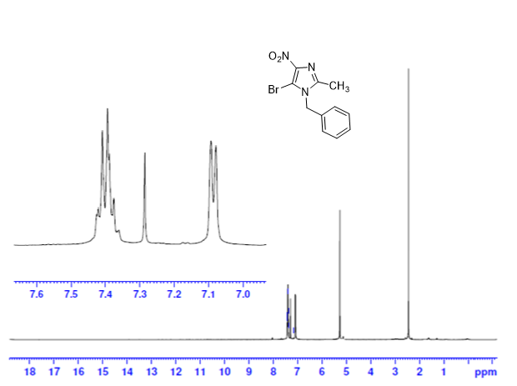

**1a** / S2 (13C NMR)

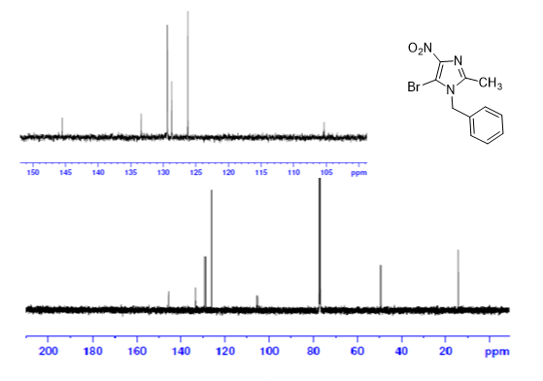

**1a** / S3 (DEPT–135)

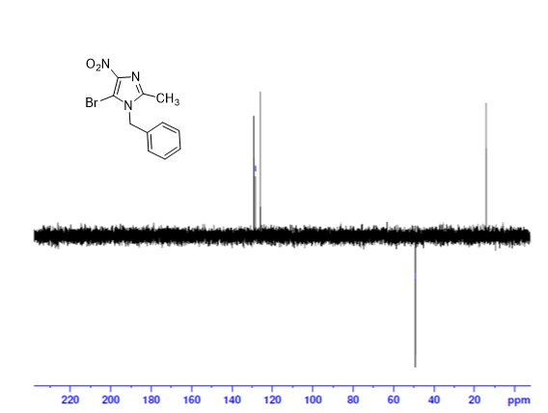

**1a** / S4 (Mass)

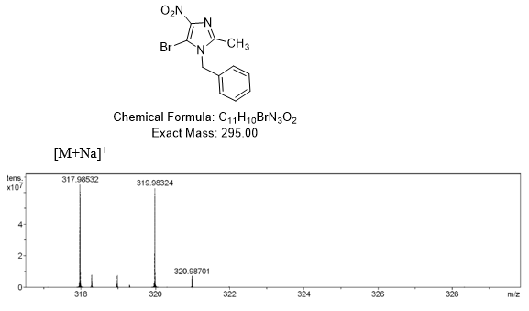

**2a** / S5 (1H NMR)

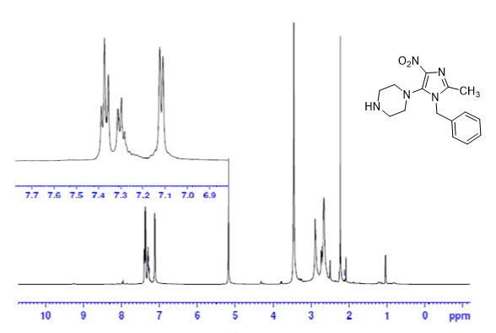

**2a** / S6 (13C NMR)

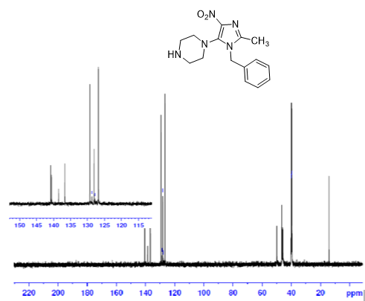

**2a** / S7 (DEPT–135)

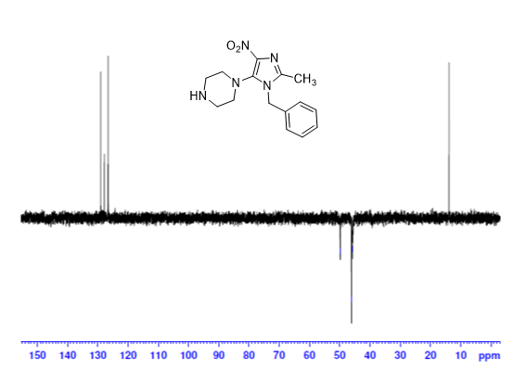

**2a** / S8 (HMQC spectrum)

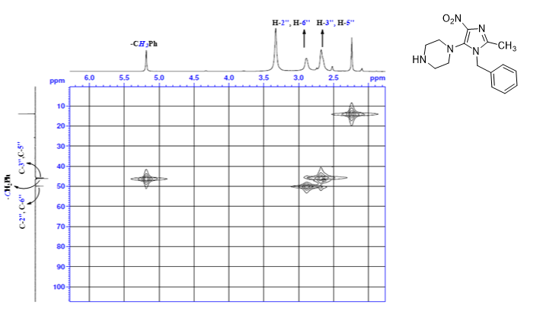

**2a** / S9 (HMBC spectrum)

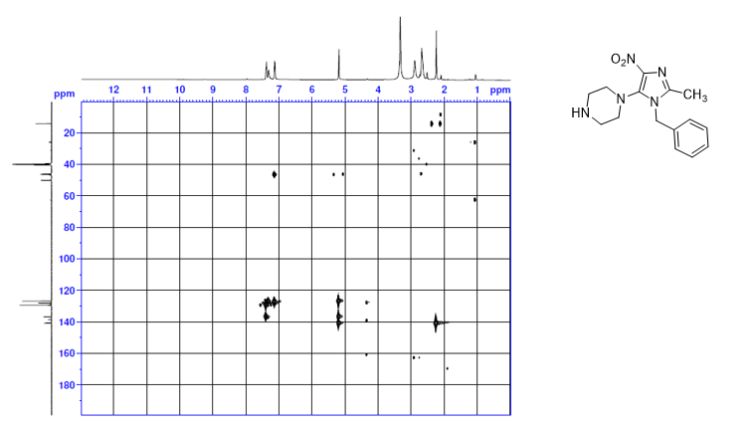

**2a** / S10 (Mass spectrum)



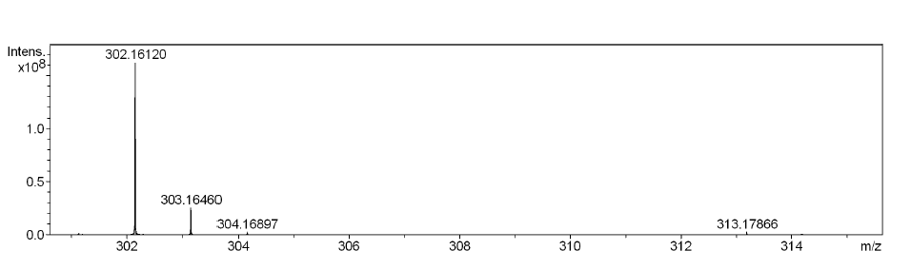

**3a** / S11 (1H NMR)

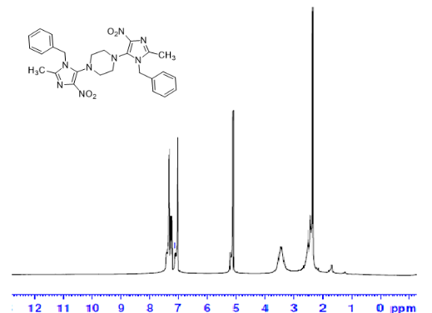

**3a** / S12 (13C NMR)

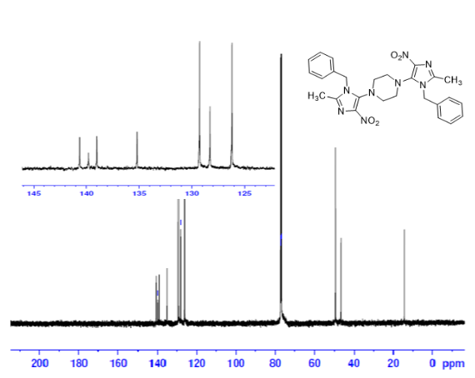

**3a** / S13 (DEPT–135)

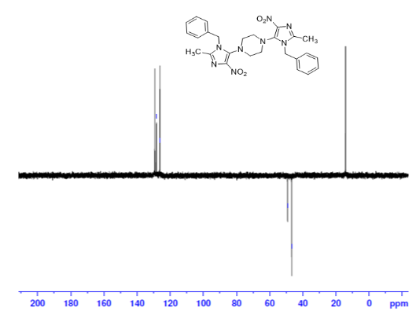

**3a** / S14 (Mass spectrum)

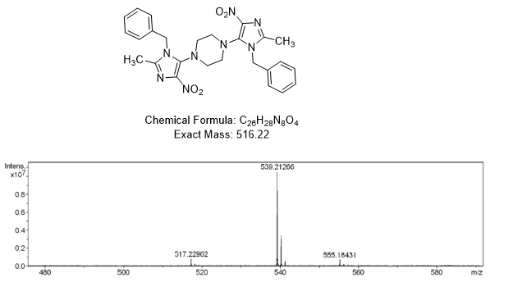

**4a** / S15 (1H NMR)

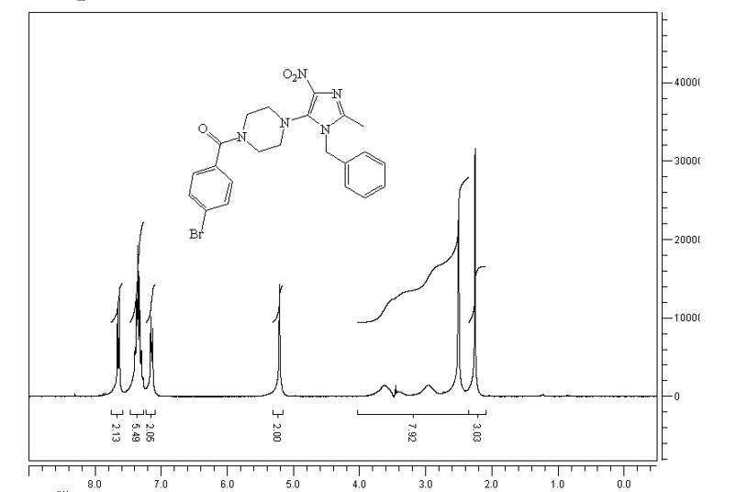

**4a** / S16 (13C NMR)

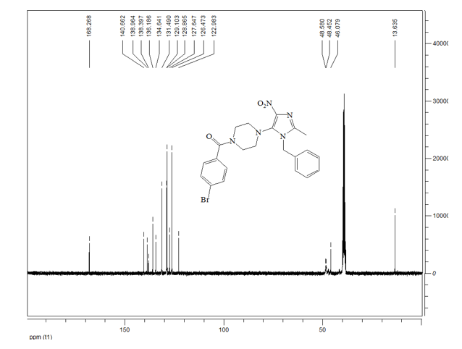

**4a** / S17 (DEPT–135)

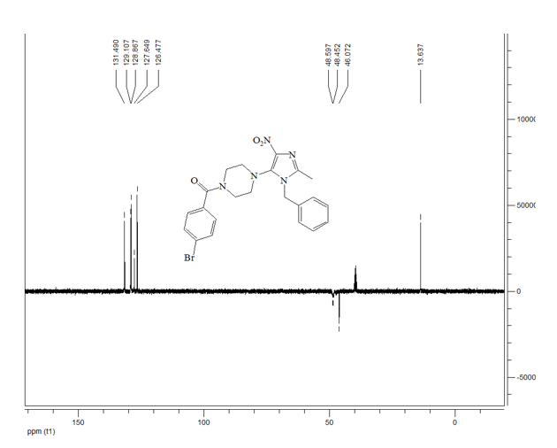

**4a** / S18 (Mass spectrum)

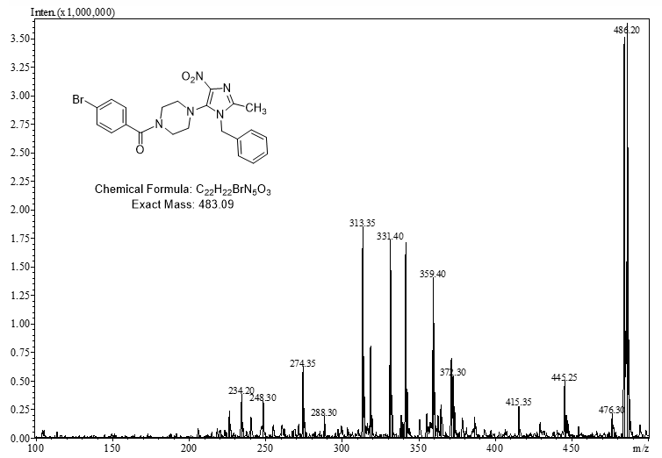

**4b** / S19 (1H NMR)

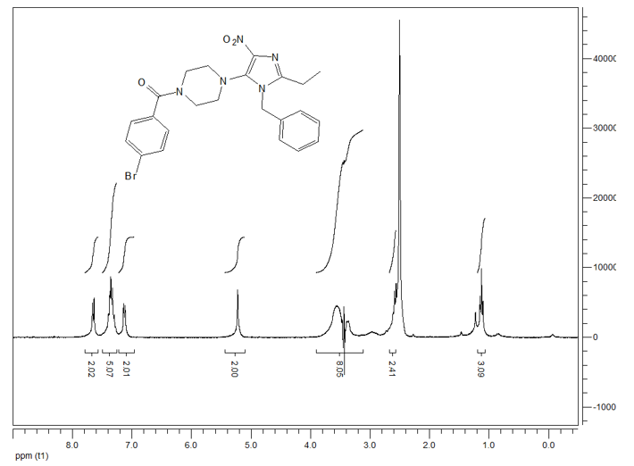

**4b** / S20 (13C NMR)

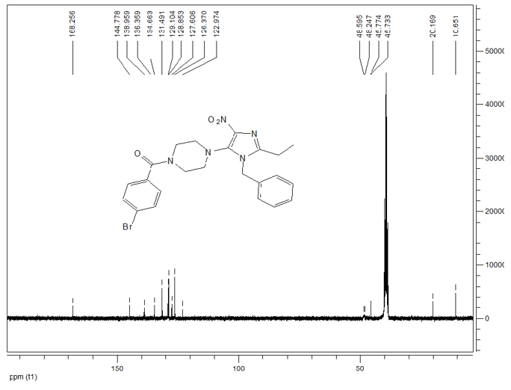

**4b** / S21 (DEPT–135)

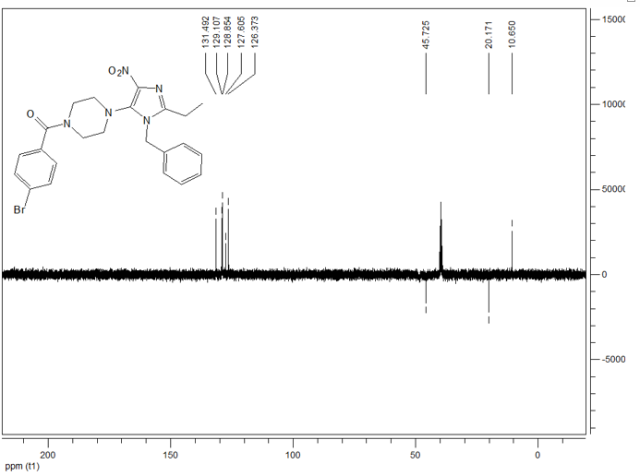

**4b** / S22 (Mass spectrum)

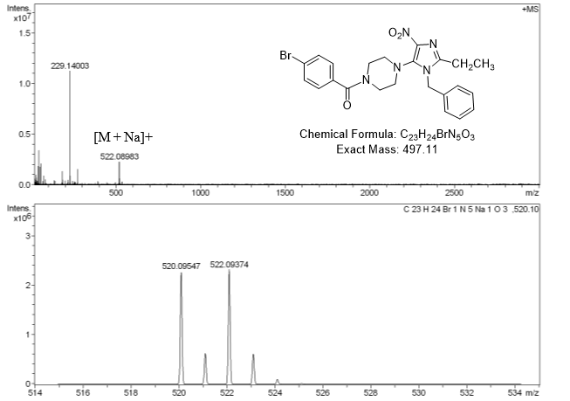

**5** / S23 (13C NMR)

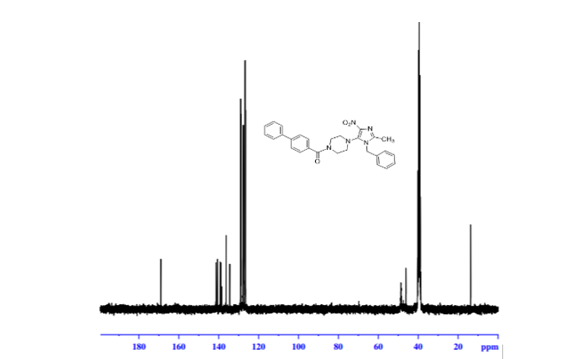

**5** / S24 (DEPT–135)

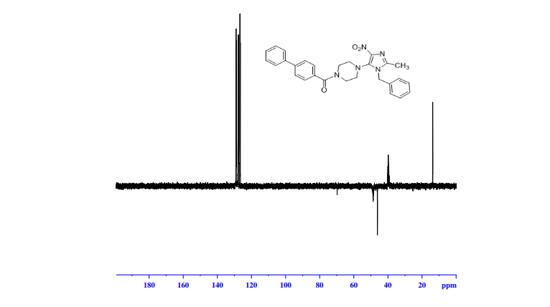

**6** / S25 (1H NMR)

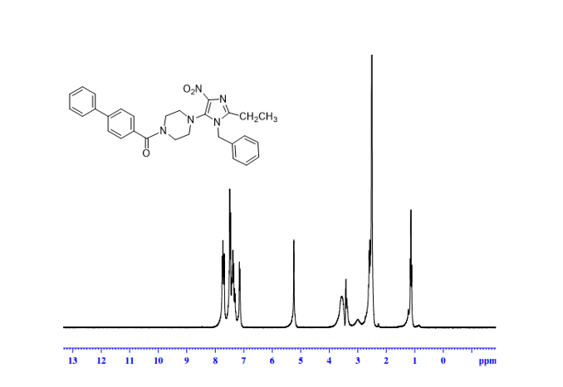

**6** / S26 (13C NMR)

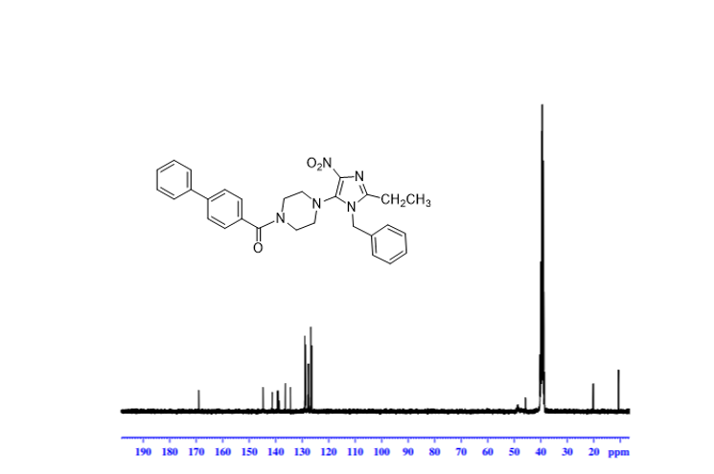

**6**/ S27 (Mass spectrum)

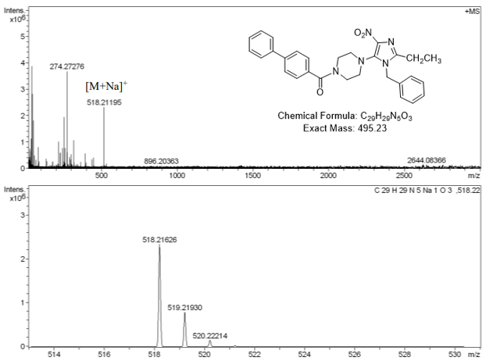

**11**/ S28 (1H NMR)

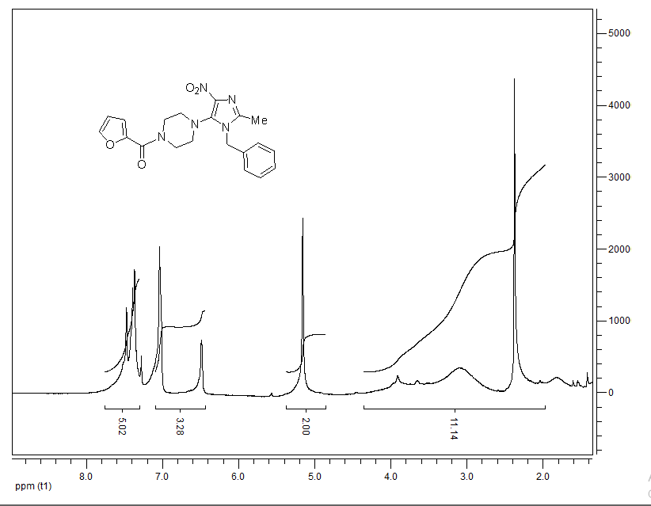

**12**/ S29 (**Bond Lengths for compound 3a**)

|  |  |  |  |  |  |  |
| --- | --- | --- | --- | --- | --- | --- |
| **Table: Bond Lengths for compound 3a.** | | | | | | |
| **Atom** | **Atom** | **Length/Å** |  | **Atom** | **Atom** | **Length/Å** |
| N001 | C007 | 1.371(3) |  | C007 | C008 | 1.375(3) |
| N001 | C009 | 1.372(3) |  | C009 | C00E | 1.488(3) |
| N001 | C00B | 1.477(3) |  | C00A | C00B | 1.515(3) |
| N002 | C008 | 1.364(3) |  | C00A | C00F | 1.376(3) |
| N002 | C009 | 1.320(3) |  | C00A | C00G | 1.376(4) |
| N003 | C007 | 1.398(3) |  | C7 | C81 | 1.502(3) |
| N003 | C7 | 1.470(3) |  | C8 | C71 | 1.502(3) |
| N003 | C8 | 1.472(3) |  | C00F | C00H | 1.388(4) |
| N004 | O005 | 1.223(2) |  | C00G | C00J | 1.382(4) |
| N004 | O006 | 1.228(2) |  | C00H | C00I | 1.379(4) |
| N004 | C008 | 1.437(3) |  | C00I | C00J | 1.372(4) |

**13**/ S30 (**Bond Angles for compound 3a**)

|  |  |  |  |  |  |  |  |  |
| --- | --- | --- | --- | --- | --- | --- | --- | --- |
| **Table: Bond Angles for compound 3a.** | | | | | | | | |
| **Atom** | **Atom** | **Atom** | **Angle/˚** |  | **Atom** | **Atom** | **Atom** | **Angle/˚** |
| C007 | N001 | C009 | 108.3(2) |  | C007 | C008 | N004 | 127.8(2) |
| C007 | N001 | C00B | 123.9(2) |  | N001 | C009 | C00E | 124.2(3) |
| C009 | N001 | C00B | 127.8(2) |  | N002 | C009 | N001 | 111.3(2) |
| C009 | N002 | C008 | 104.3(2) |  | N002 | C009 | C00E | 124.6(2) |
| C007 | N003 | C7 | 115.65(19) |  | C00F | C00A | C00B | 120.8(3) |
| C007 | N003 | C8 | 116.1(2) |  | C00F | C00A | C00G | 118.8(3) |
| C7 | N003 | C8 | 112.4(2) |  | C00G | C00A | C00B | 120.3(2) |
| O005 | N004 | O006 | 123.4(2) |  | N001 | C00B | C00A | 112.4(2) |
| O005 | N004 | C008 | 118.7(2) |  | N003 | C7 | C81 | 109.7(2) |
| O006 | N004 | C008 | 117.9(2) |  | N003 | C8 | C71 | 110.0(2) |
| N001 | C007 | N003 | 119.0(2) |  | C00A | C00F | C00H | 120.4(3) |
| N001 | C007 | C008 | 103.4(2) |  | C00A | C00G | C00J | 120.9(3) |
| C008 | C007 | N003 | 137.6(2) |  | C00I | C00H | C00F | 120.3(3) |
| N002 | C008 | N004 | 119.3(2) |  | C00J | C00I | C00H | 119.3(3) |
| N002 | C008 | C007 | 112.8(2) |  | C00I | C00J | C00G | 120.2(3) |