In vitro anticancer and antibacterial potentials of selected medicinal plants and isolation and characterization of a natural compound from Withania coagulans
Bassam Oud Aljohny¹, Yasir Anwar¹, Shahid Ali Khan²*

¹Department of Biological Sciences, Faculty of Science, King Abdulaziz University Jeddah, Kingdom of Saudi Arabia ¹yasirpcsir2006@gmail.com ¹boaljohny@kau.edu.sa
²Department of Chemistry, University of Swabi, Anbar 23561, Khyber Pakhtunkhwa, Pakistan ²shahidsawal007@gmail.com

Corresponding author Dr. Shahid Ali Khan*
Email: shahidsawal007@gmail.com Contact detail: 00923334246635
ORCID: 0000-0003-0132-8000
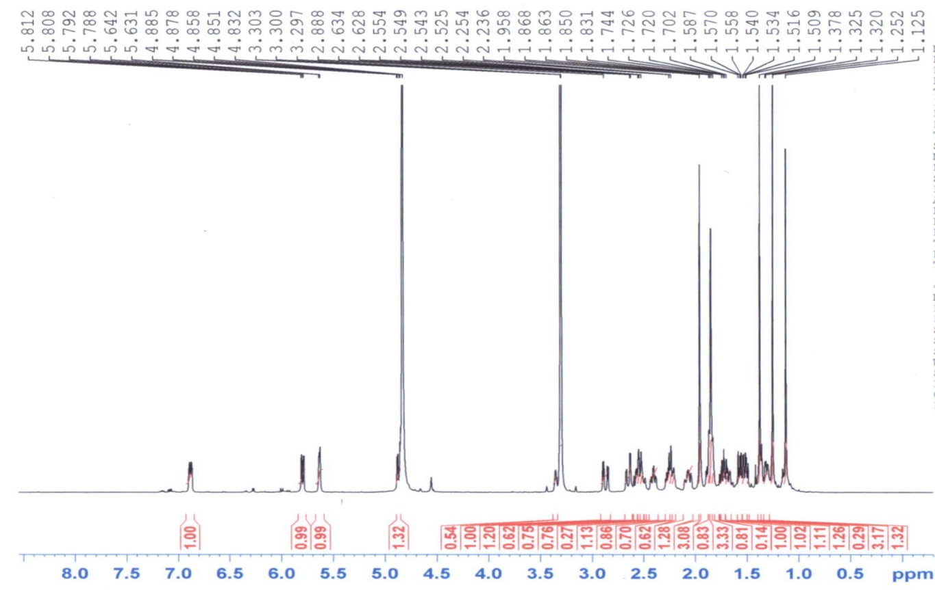
Figure-S1: ¹H-NMR spectrum of the isolated compound recorded in CD₃OD at 500 MHz.

Figure-S2: Broad Band NMR spectrum of the isolated compound recorded in CD₃OD at 500 MHz.

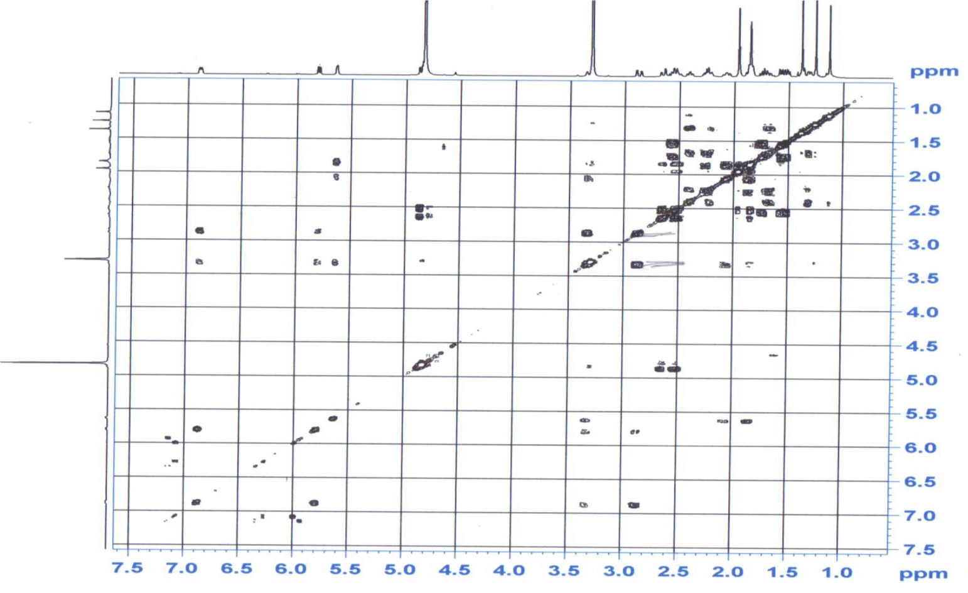
Figure-S3: Homonuclear COSY 45° spectrum of the isolated compound recorded in CD₃OD at 500 MHz.

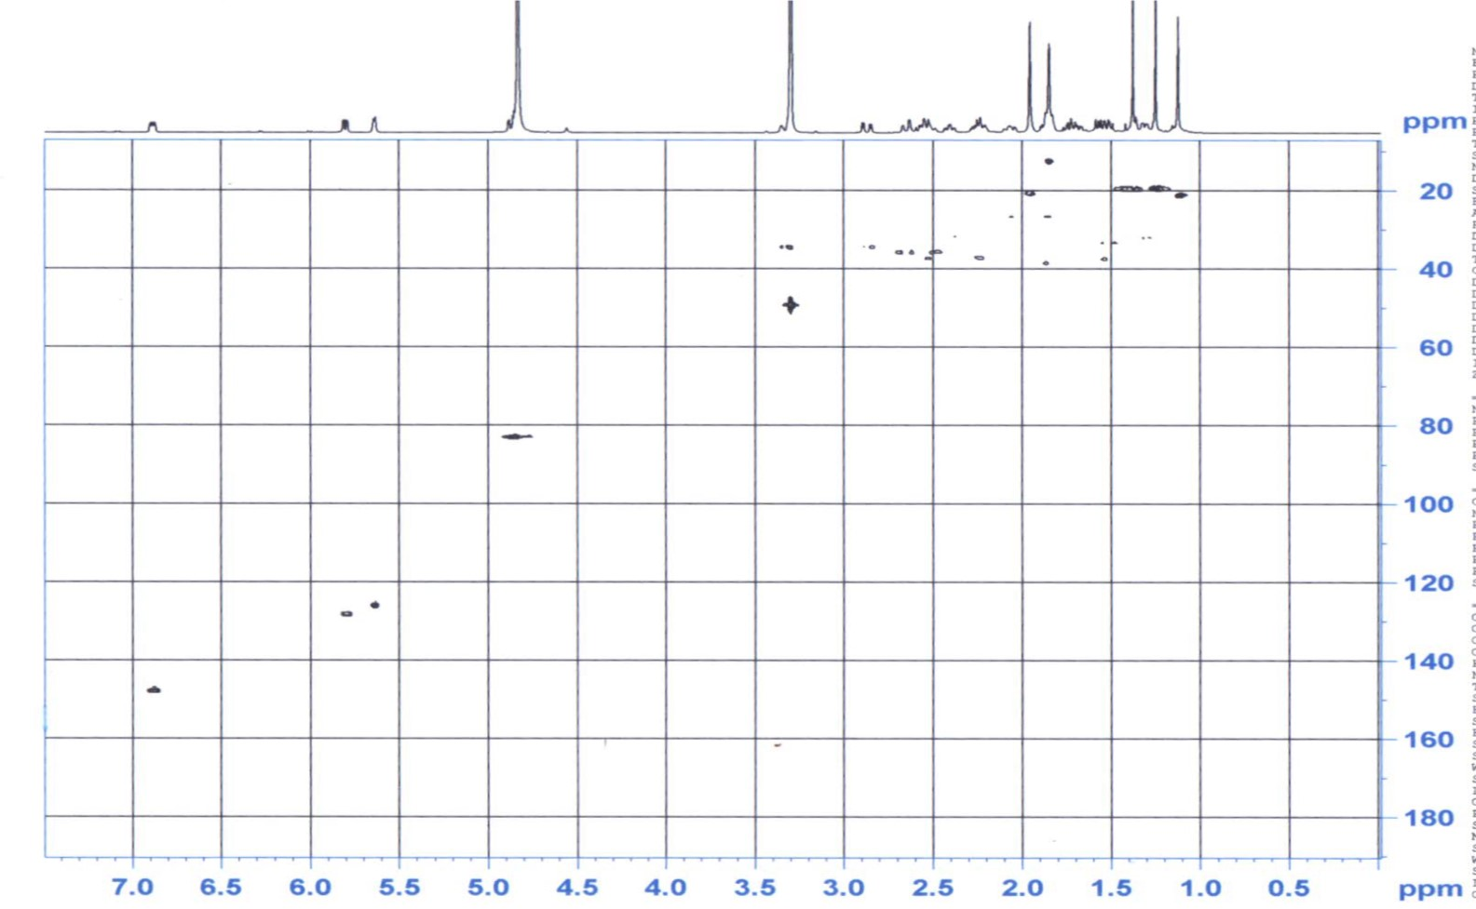
Figure-S4: Heteronuclear HSQC spectrum of the isolated compound recorded in CD₃OD at 500 MHz.

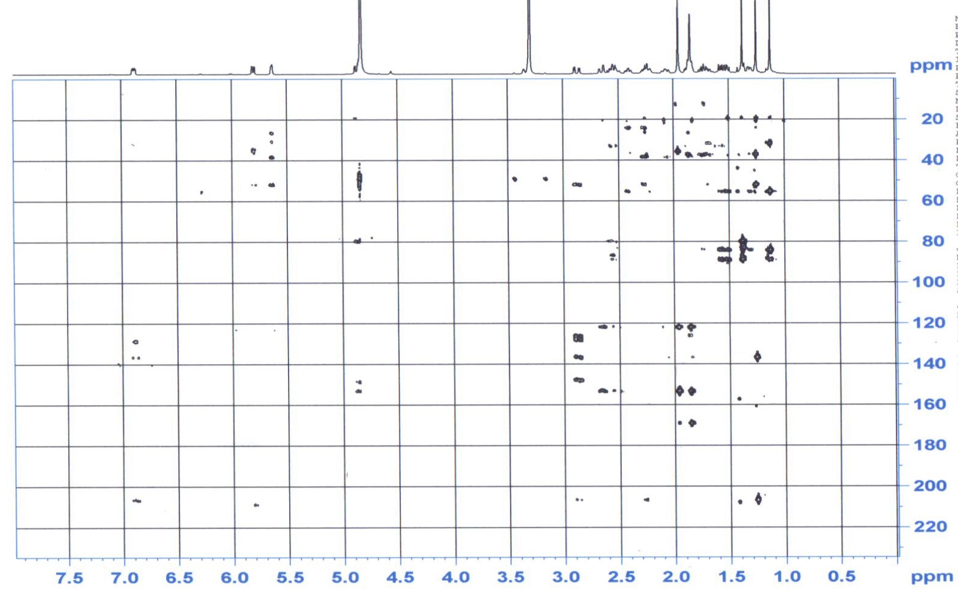
Figure-S5: Heteronuclear HMBC spectrum of the isolated compound recorded in CD₃OD at 500 MHz.

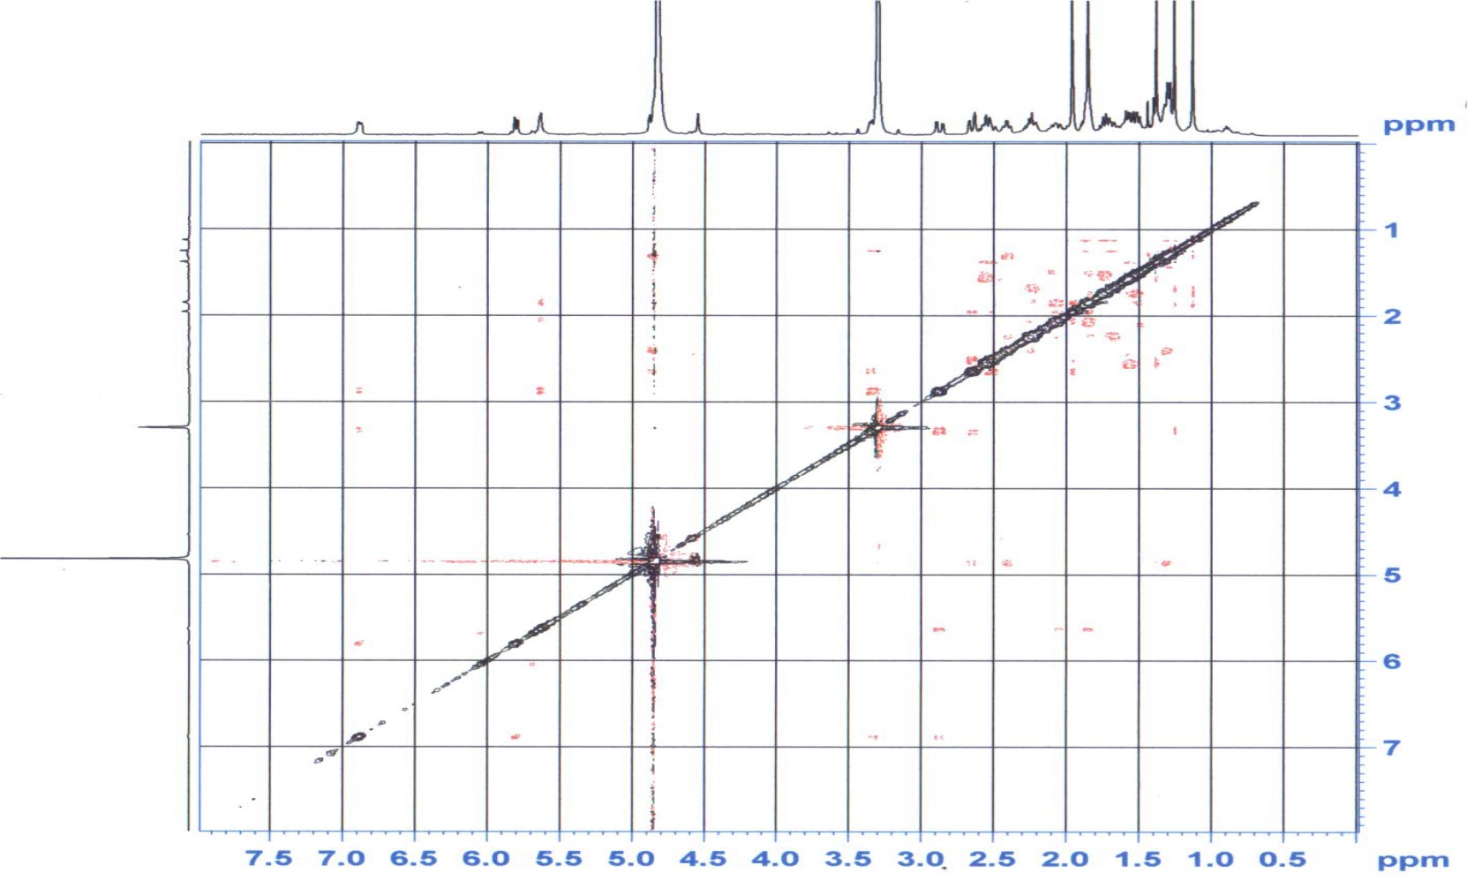
Figure-S6: Homonuclear NOSY spectrum of the isolated compound recorded in CD₃OD at 500 MHz.

