Supporting Information
Sesquiterpenoids from Tithonia diversifolia (Hemsl.) A. Gray induce apoptosis and inhibit the cell cycle progression of acute myeloid leukemia cells
Trinh Thi Thuy^{1,2}**, Nguyen Thi Thuy Linh ^{1,2}, Ba Thi Cham^{1,2}, Nguyen Thi Hoang Anh^{1,2}, Tran Duc Quan¹, Nguyen Thanh Tam^{1,2}, Le Thi Hong Nhung³, Do Thi Thao^{1,4}, Nguyen Phi Hung^{1,5}, Vu Dinh Hoang⁶, Sabrina Adorisio⁷, and Domenico V Delfino ^{7,8}*
¹Graduate University of Science and Technology, Vietnam Academy of Science and Technology, 18 Hoang Quoc Viet, Nghia Do, Cau Giay, Ha Noi, Viet Nam
²Institute of Chemistry, Vietnam Academy of Science and Technology, 18 Hoang Quoc Viet, Nghia Do, Cau Giay, Ha Noi, Viet Nam
³Hanoi University of Industry, 298 Cau Dien, North District Tu Liem, Ha Noi, Viet Nam
⁴Institute of Biotechnology, Vietnam Academy of Science and Technology, 18 Hoang Quoc Viet, Nghia Do, Cau Giay, Ha Noi, Viet Nam
⁵Institute of Natural Products Chemistry, Vietnam Academy Science and Technology, 18 Hoang Quoc Viet, Nghia Do, Cau Giay, Ha Noi, Viet Nam
⁶School of Chemical Engineering, Hanoi University of Science and Technology, 1 Dai Co Viet, Hai BBa Trung, Ha Noi, Viet Nam
⁷Foligno Nursing School, Department of Medicine and Surgery, University of Perugia, Piazzale Severi, S. Andrea delle Fratte, 06129 Perugia, Italy
⁸Department of Medicine and Surgery, University of Perugia, Piazzale Severi, S. Andrea delle Fratte, 06129 Perugia, Italy

* Email: domenico.delfino@unipg.it
** Email: thuy@ich.vast.vn
Dedication: Thanks Prof. Domenico V Delfino for his support for our researches during his time as president of Foligno Nursing School, University of Perugia.

Supporting Figures
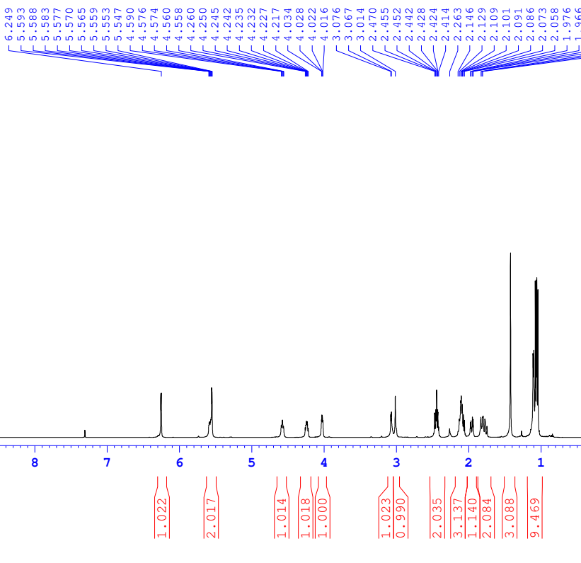
Supporting Figure 1: ¹H NMR spectrum of tagitinin A (1) in CDCl₃ (500 MHz)
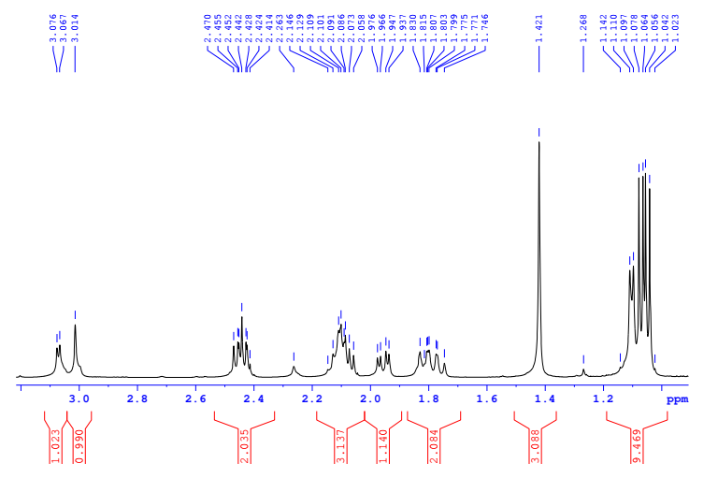 Supporting Figure 1A: ¹H NMR spectrum of tagitinin A (1) (from 3.08 to 1.0 ppm) in CDCl₃ (500 MHz)

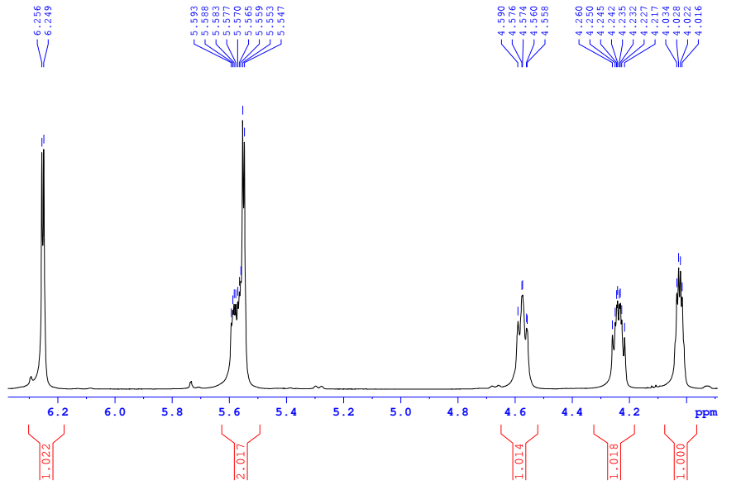
Supporting Figure 1B: ¹H NMR spectrum of tagitinin A (1) (from 6.3 to 4.0 ppm) in CDCl₃ (500 MHz)
A)
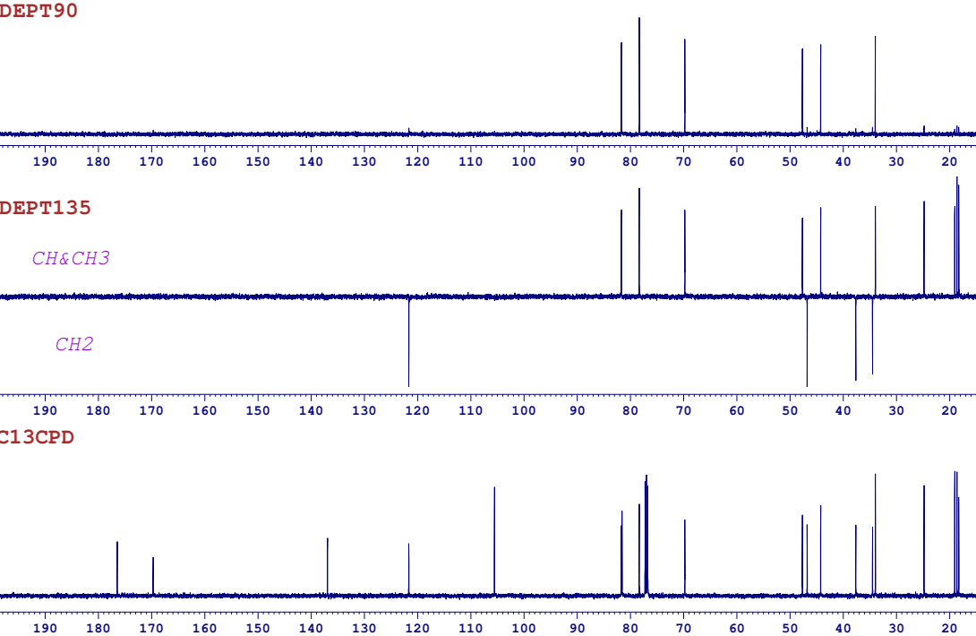
B)
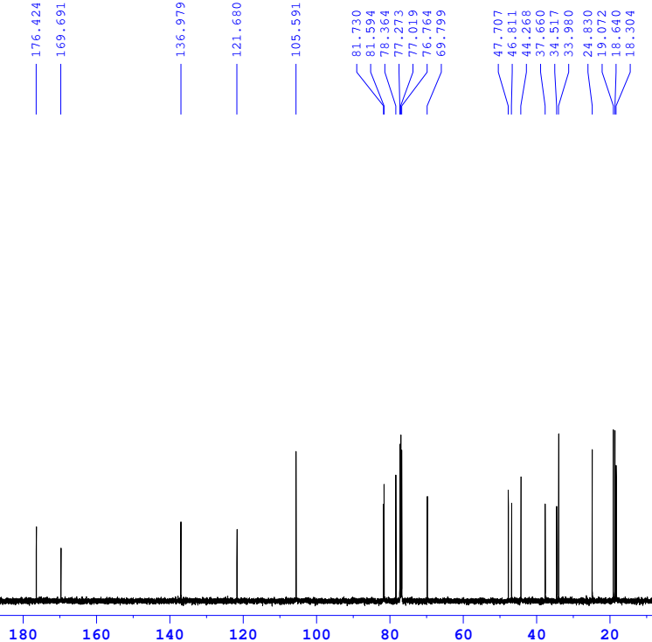
Supporting Figure 2: DEPT (A) and ¹³C NMR (B) spectra of tagitinin A (1) in CDCl₃ (125 MHz)

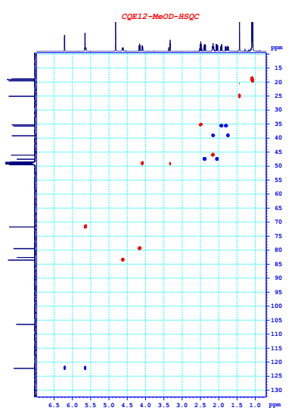
Supporting Figure 3: HSQC spectrum of tagitinin A (1) in CD₃OD

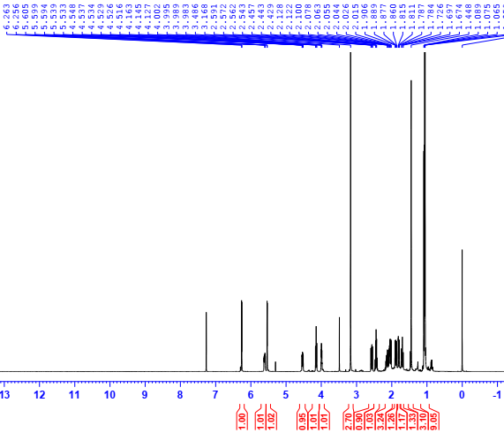

Supporting Figure 4: ¹H NMR spectrum of 1β-hydroxytirotundin 3-O-methyl ether (2) in CDCl₃ (500 MHz)

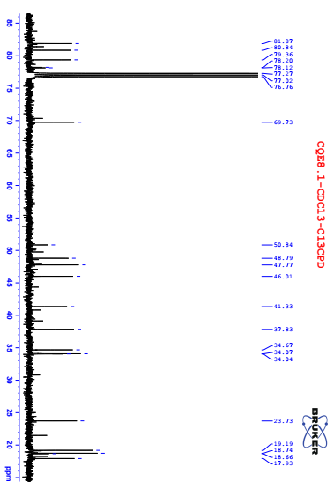
Supporting Figure 5: ¹³C NMR spectrum of 1β-hydroxytirotundin 3-O-methyl ether (2) in CDCl₃ (125 MHz)

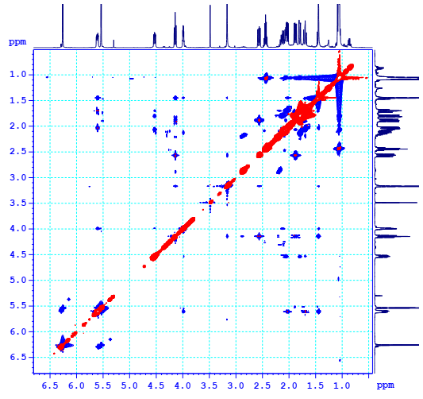
Supporting Figure 6: NOESY spectrum of 1β-hydroxytirotundin 3-O-methyl ether (2) in CDCl₃

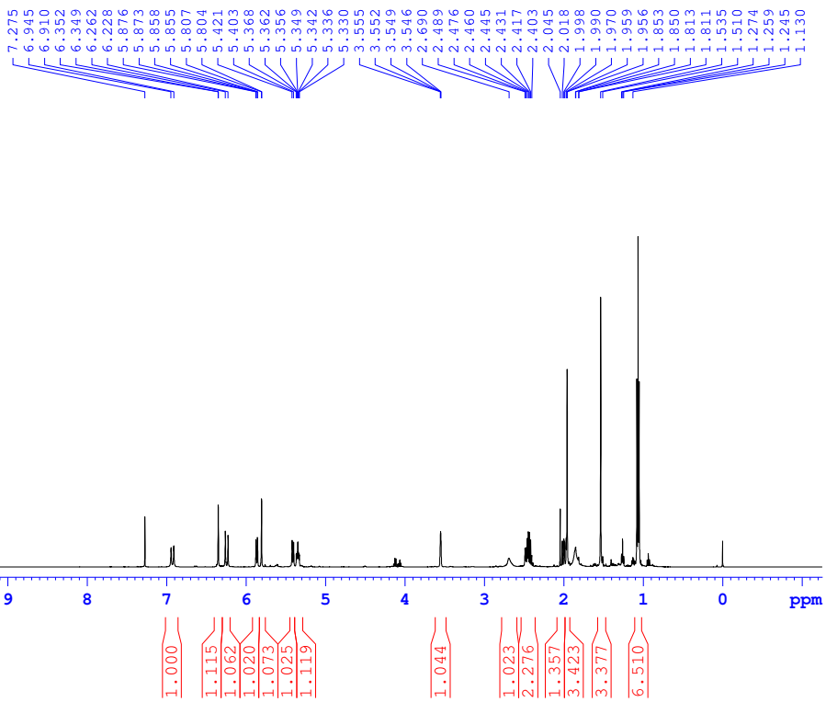

Supporting Figure 7: ¹H NMR spectrum of tagitinin C (3) in CDCl₃ (500 MHz)
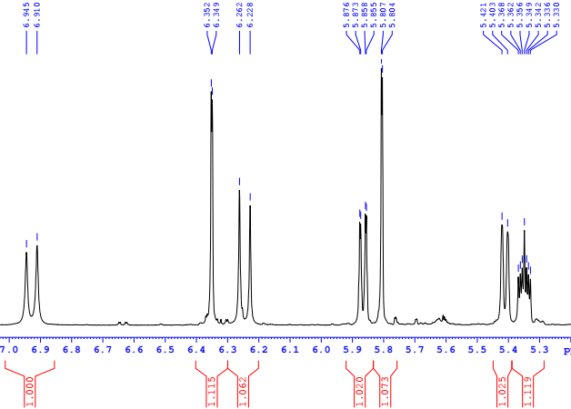

Supporting Figure 7A: ¹H NMR spectrum (region from 6.9 to 5.3 ppm) of tagitinin C (3) in CDCl₃

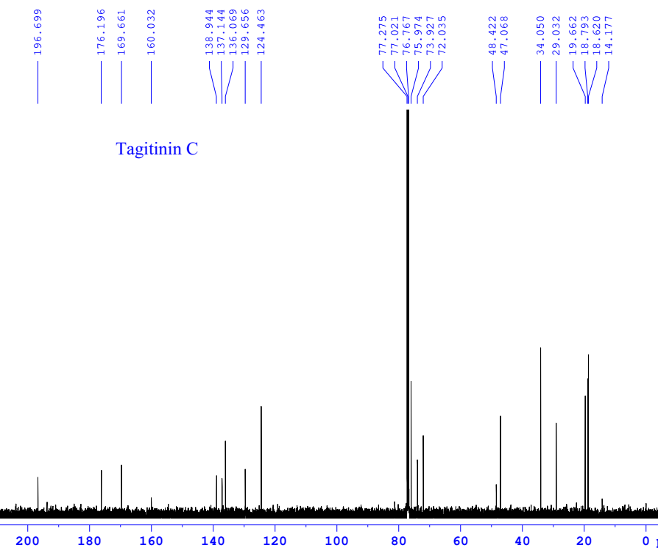
Supporting Figure 8: ¹³C NMR spectrum of tagitinin C (3) in CDCl₃ (125 MHz)

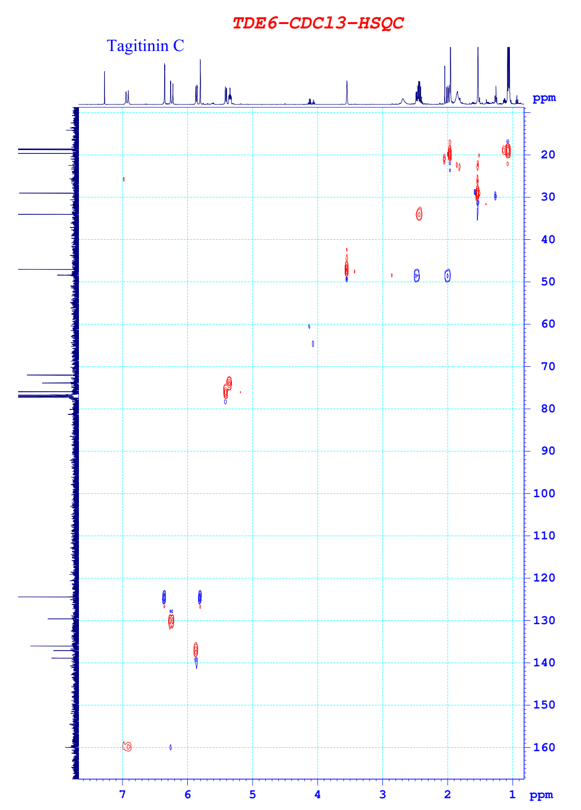
Supporting Figure 9: HSQC spectrum of tagitinin C (3) in CDCl₃

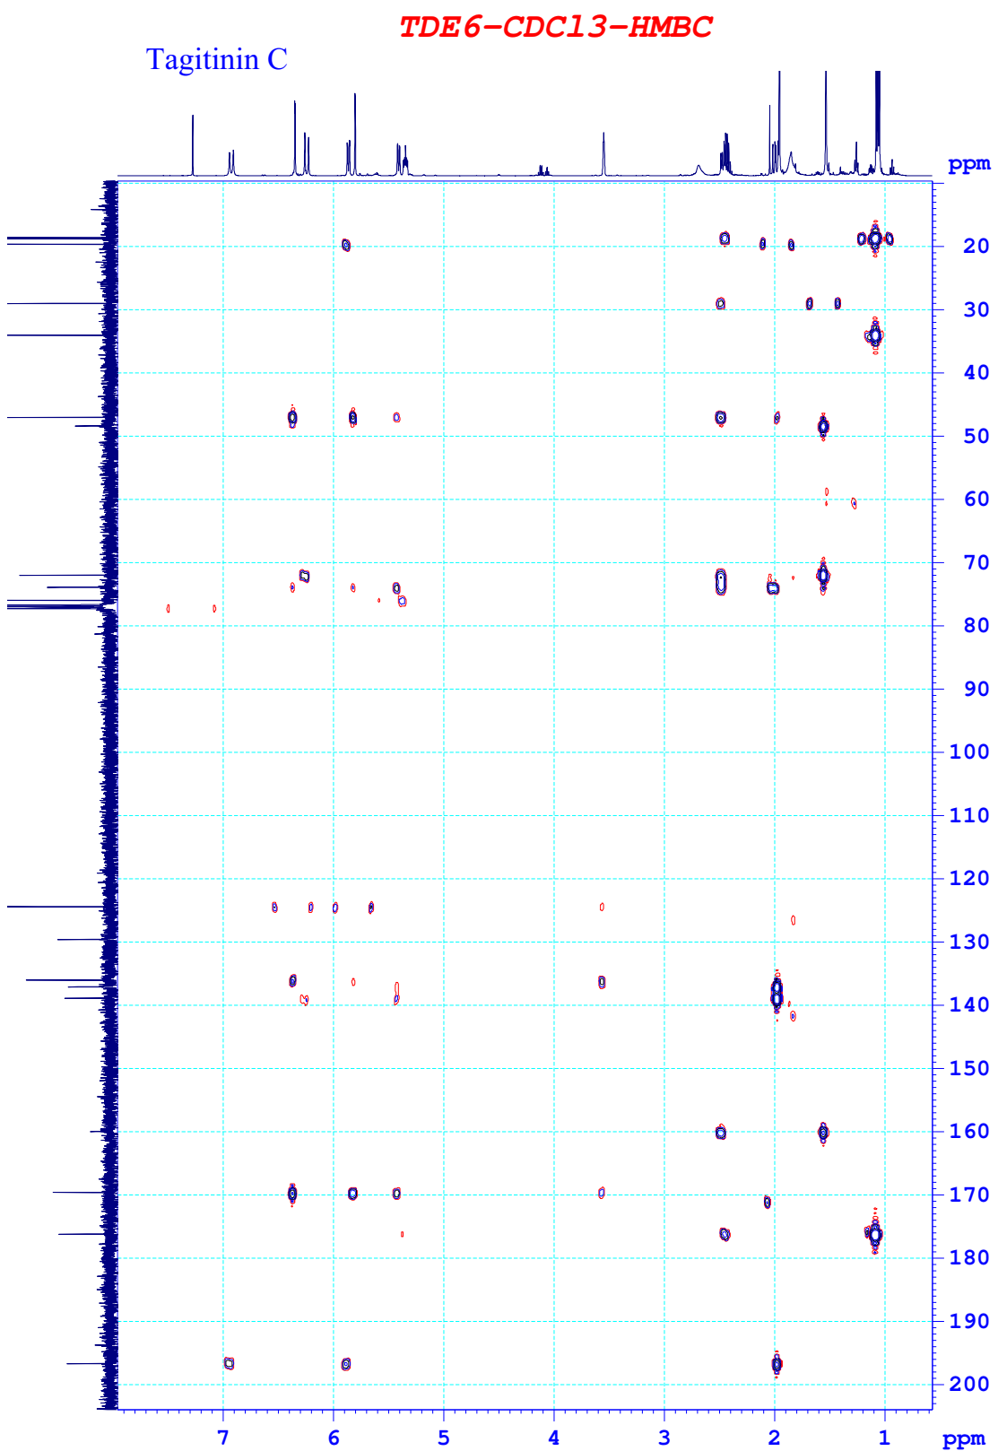
Supporting Figure 10: HMBC spectrum of tagitinin C (3) in CDCl₃
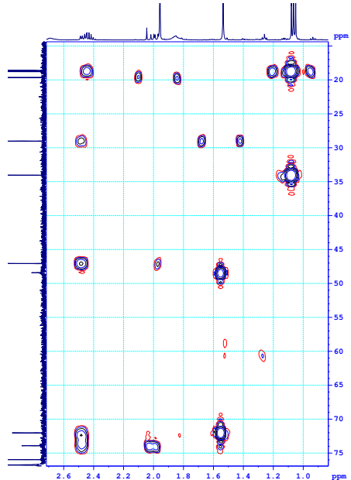
Supporting Figure 10A: HMBC spectrum (exspanse) of tagitinin C (3) in CDCl₃

