Elaeocarpus floribundus Bl. seeds as a new source of bioactive compounds with promising antioxidant and antimicrobial properties
Ayorinde V. Ogundele^{1, 2, 3}, Saikat Haldar⁴, Archana Yadav⁵ and Archana M. Das^{1,2*}
¹Natural Products Chemistry Group, Chemical Science and Technology Division,
CSIR-North East Institute of Science and Technology Jorhat-785006, Assam, India

² Academy of Scientific and Innovative Research (AcSIR), Ghaziabad-201002, India

³ Department of Chemistry, College of Pure and Applied Sciences, Kwara State
University, Malete, P. M. B. 1530, Ilorin-240243, Nigeria

⁴Medicinal, Aromatic and Economic Plants Group, Biological Sciences and
Technology Division, CSIR‐North East Institute of Science and Technology,
Jorhat-785006, Assam, India

⁵Biotechnology Group, Biological Science and Technology Division,
CSIR- North East Institute of Science and Technology, Jorhat-785006, Assam, India

*Corresponding author: archanads2@gmail.com

Supplementary data
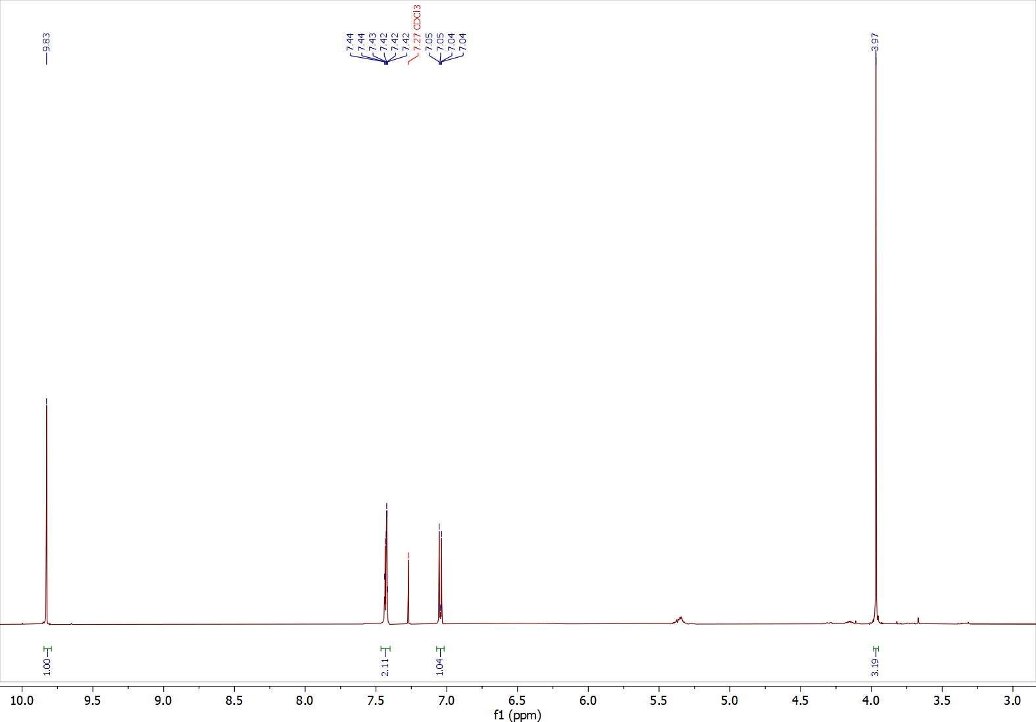
¹H-NMR spectrum of compound 1 (500 MHz, CDCl₃)
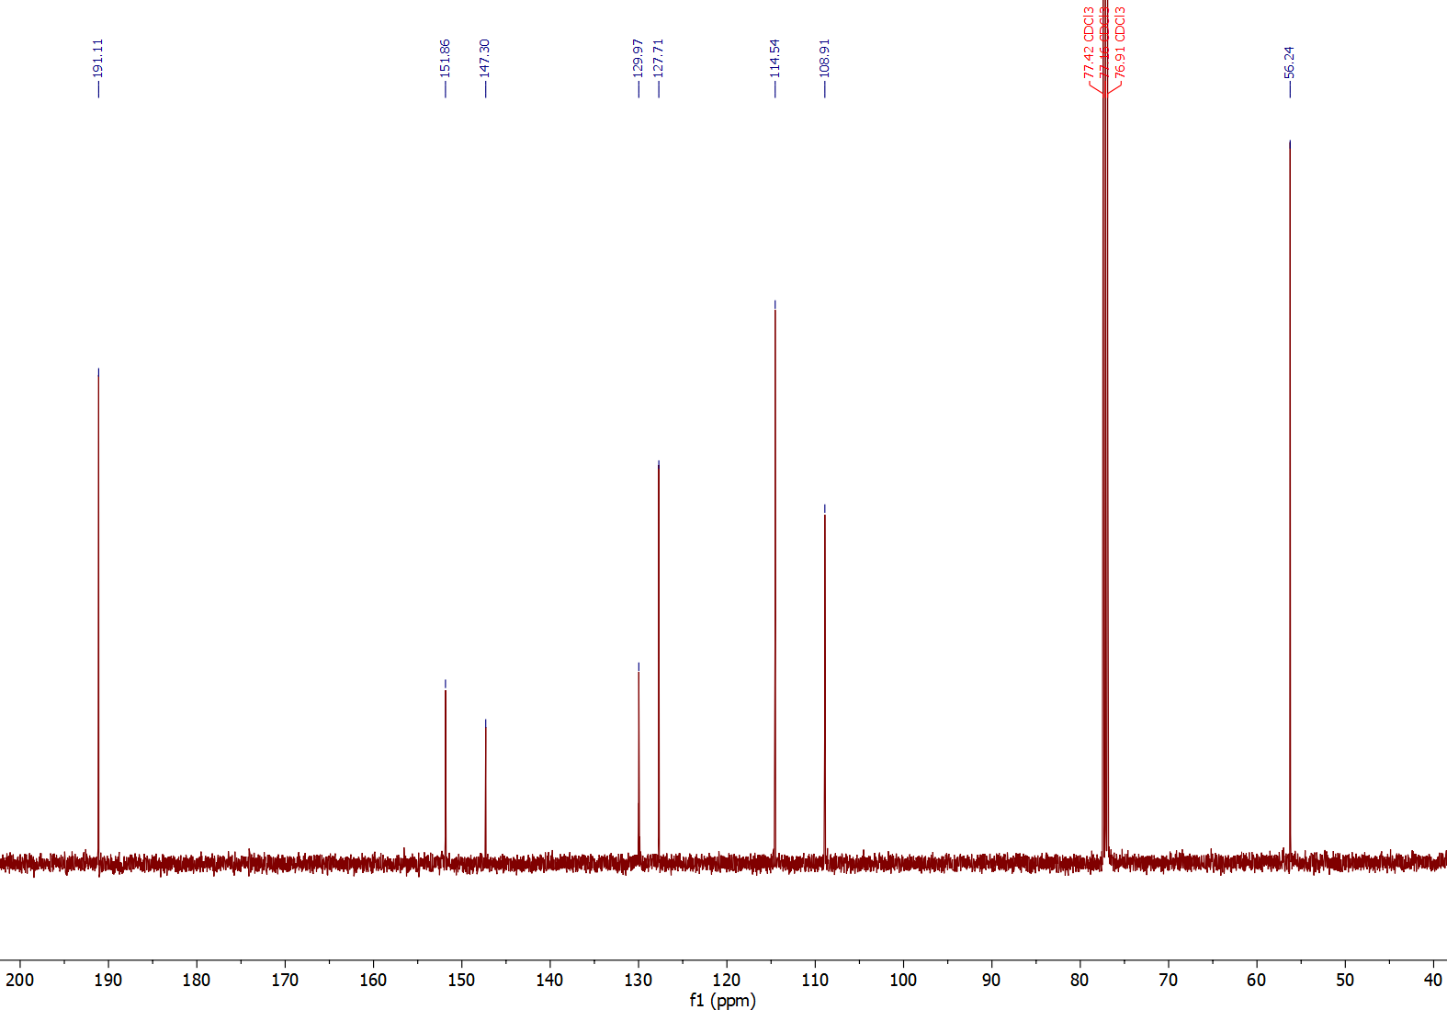
¹³C-NMR spectrum of compound 1 (125 MHz, CDCl₃)

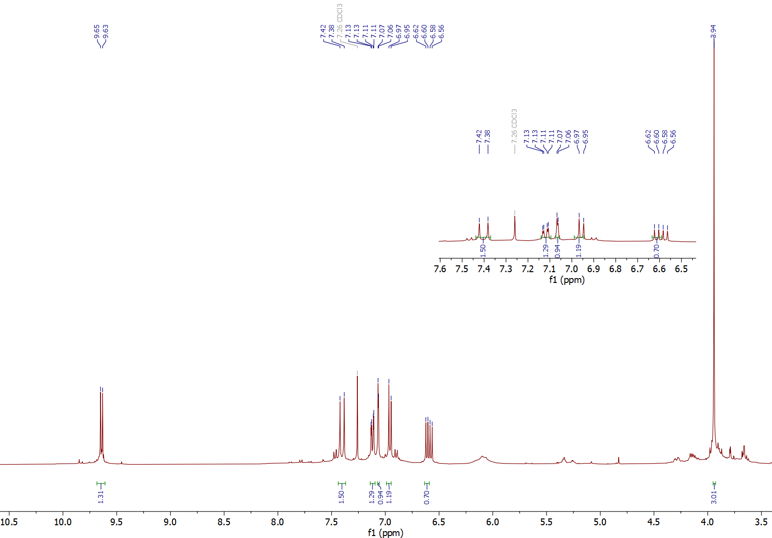
¹H-NMR spectrum of compound 2 (400 MHz, CDCl₃)

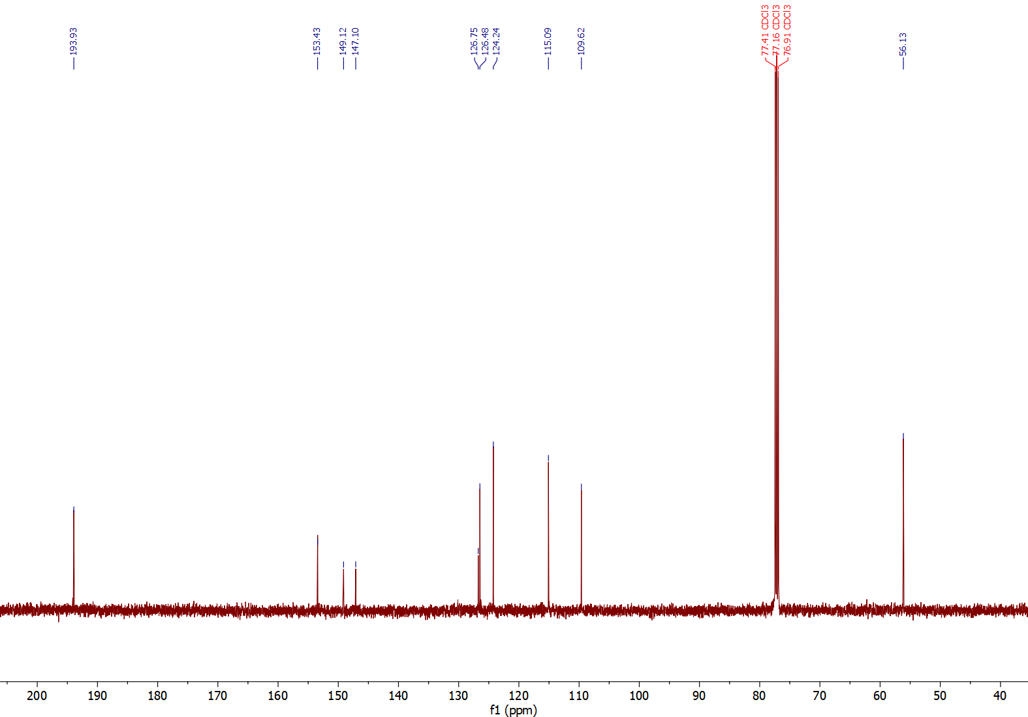
¹³C-NMR spectrum of compound 2 (125 MHz, CDCl₃)
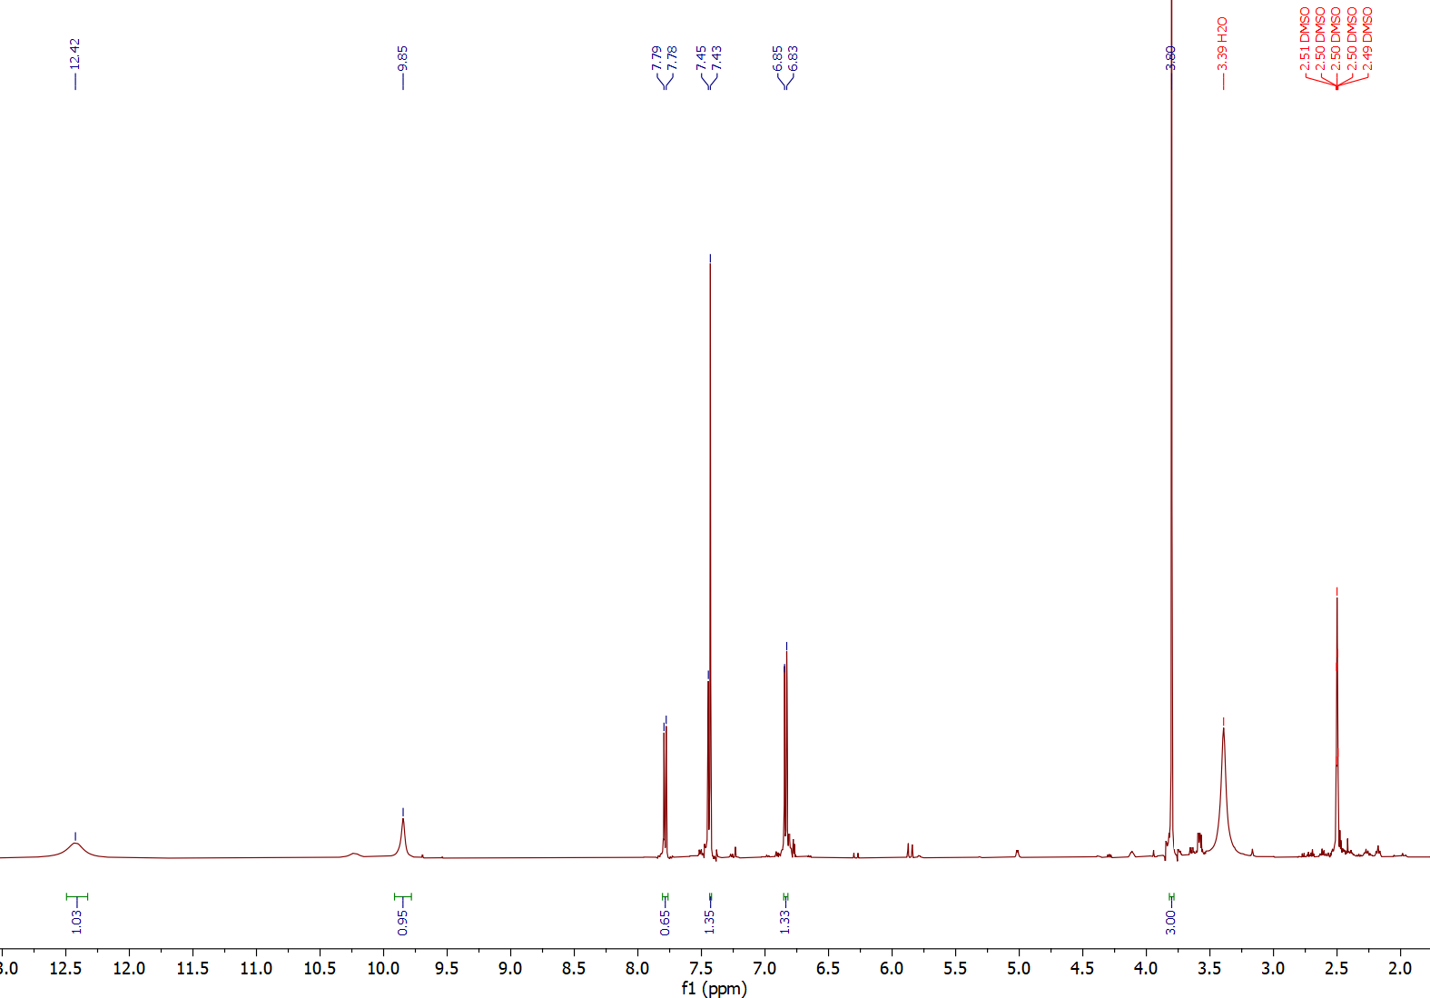
¹H-NMR spectrum of compound 3 (500 MHz, dmso-d₆)
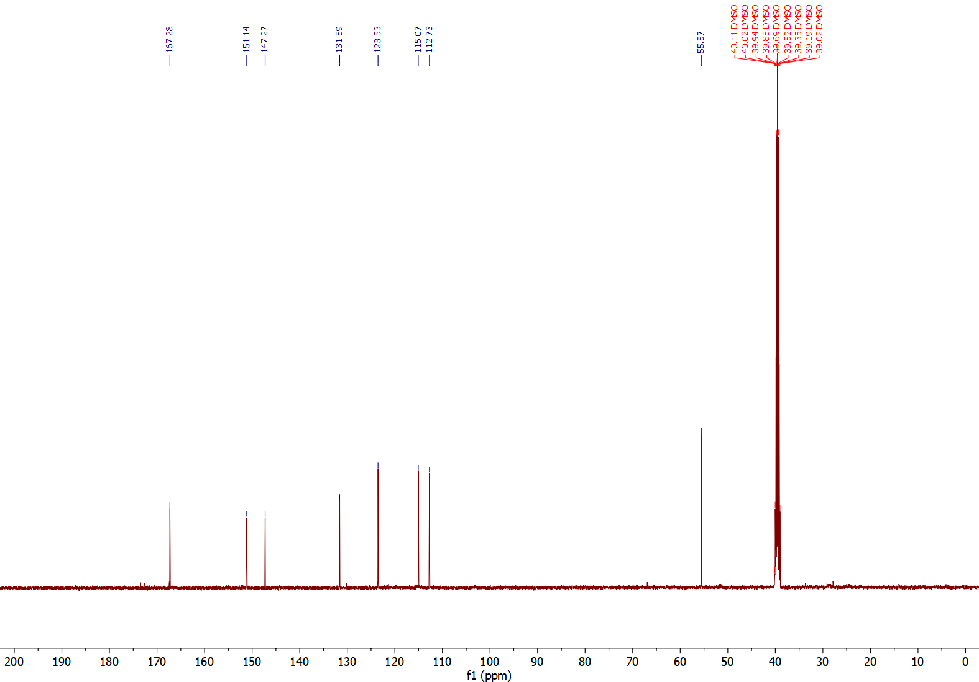
¹³C-NMR spectrum of compound 3 (125 MHz, dmso-d₆)
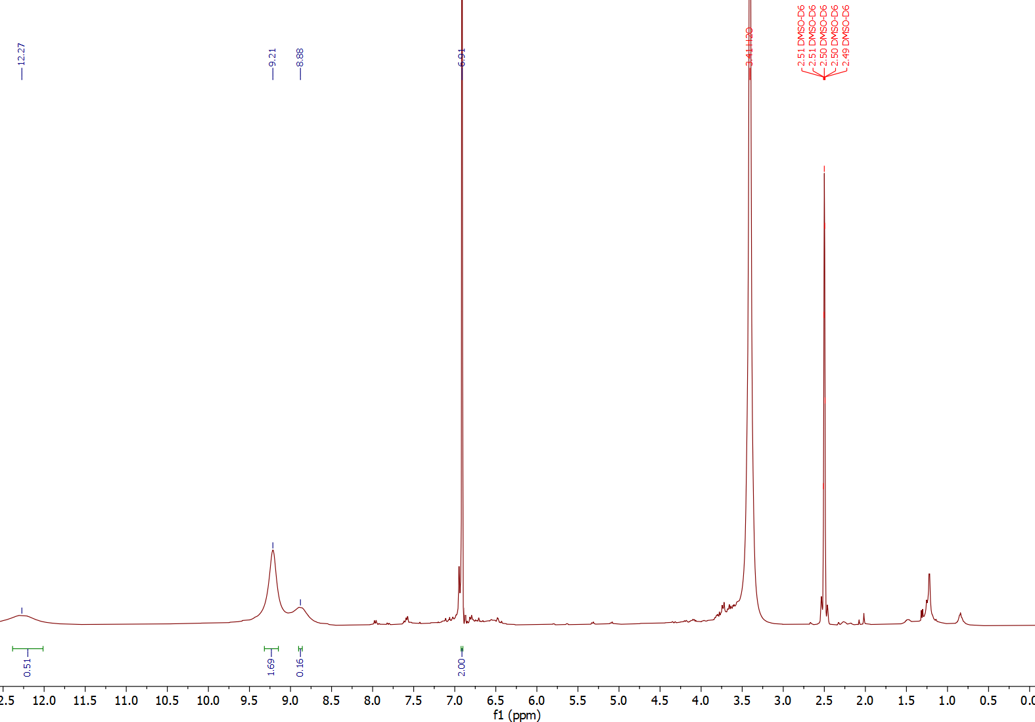
¹H-NMR spectrum of compound 4 (400 MHz, dmso-d₆)
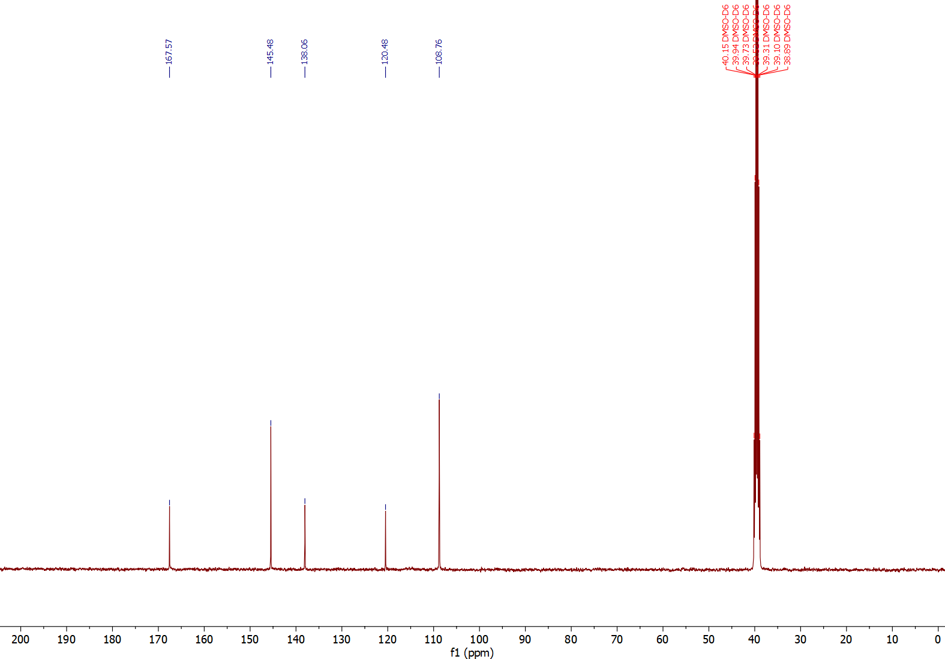
¹³C-NMR spectrum of compound 4 (100 MHz, dmso-d₆)
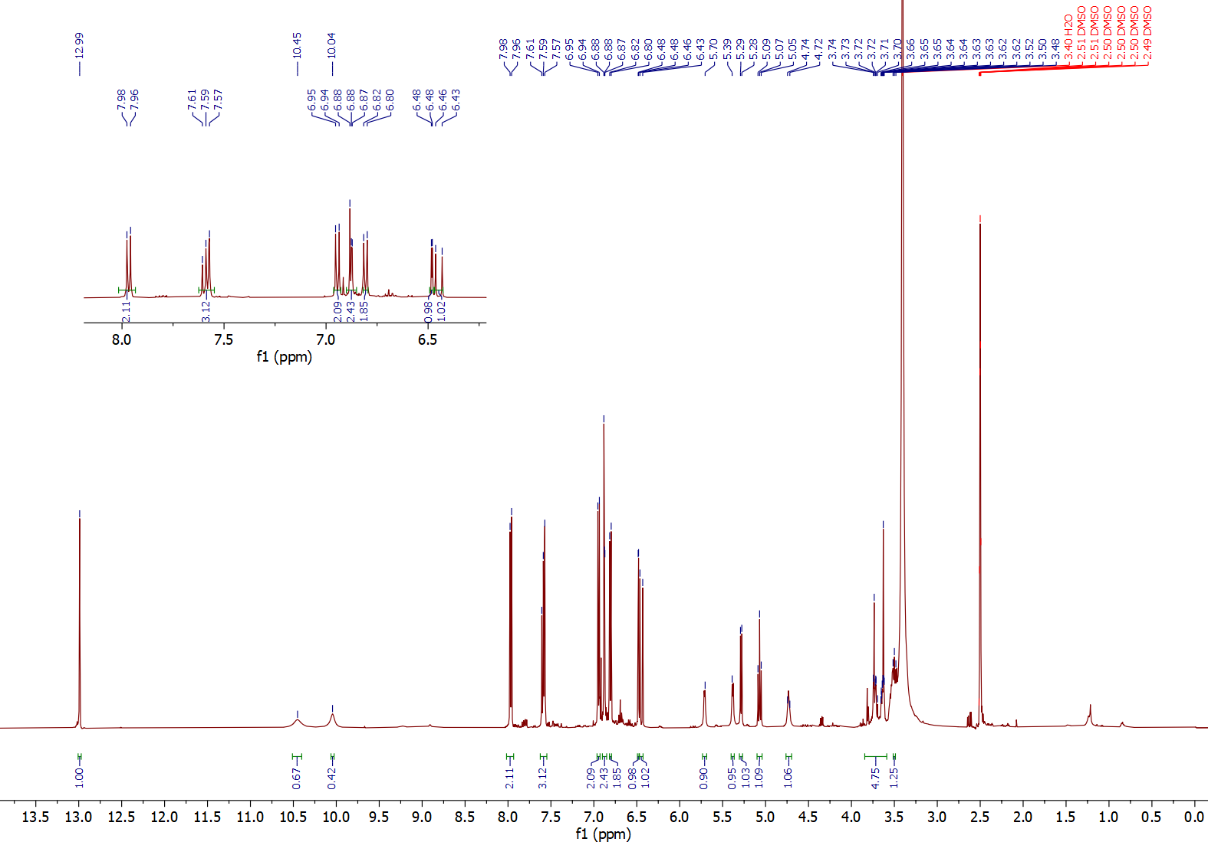
¹H-NMR spectrum of compound 5 (500 MHz, dmso-d₆)
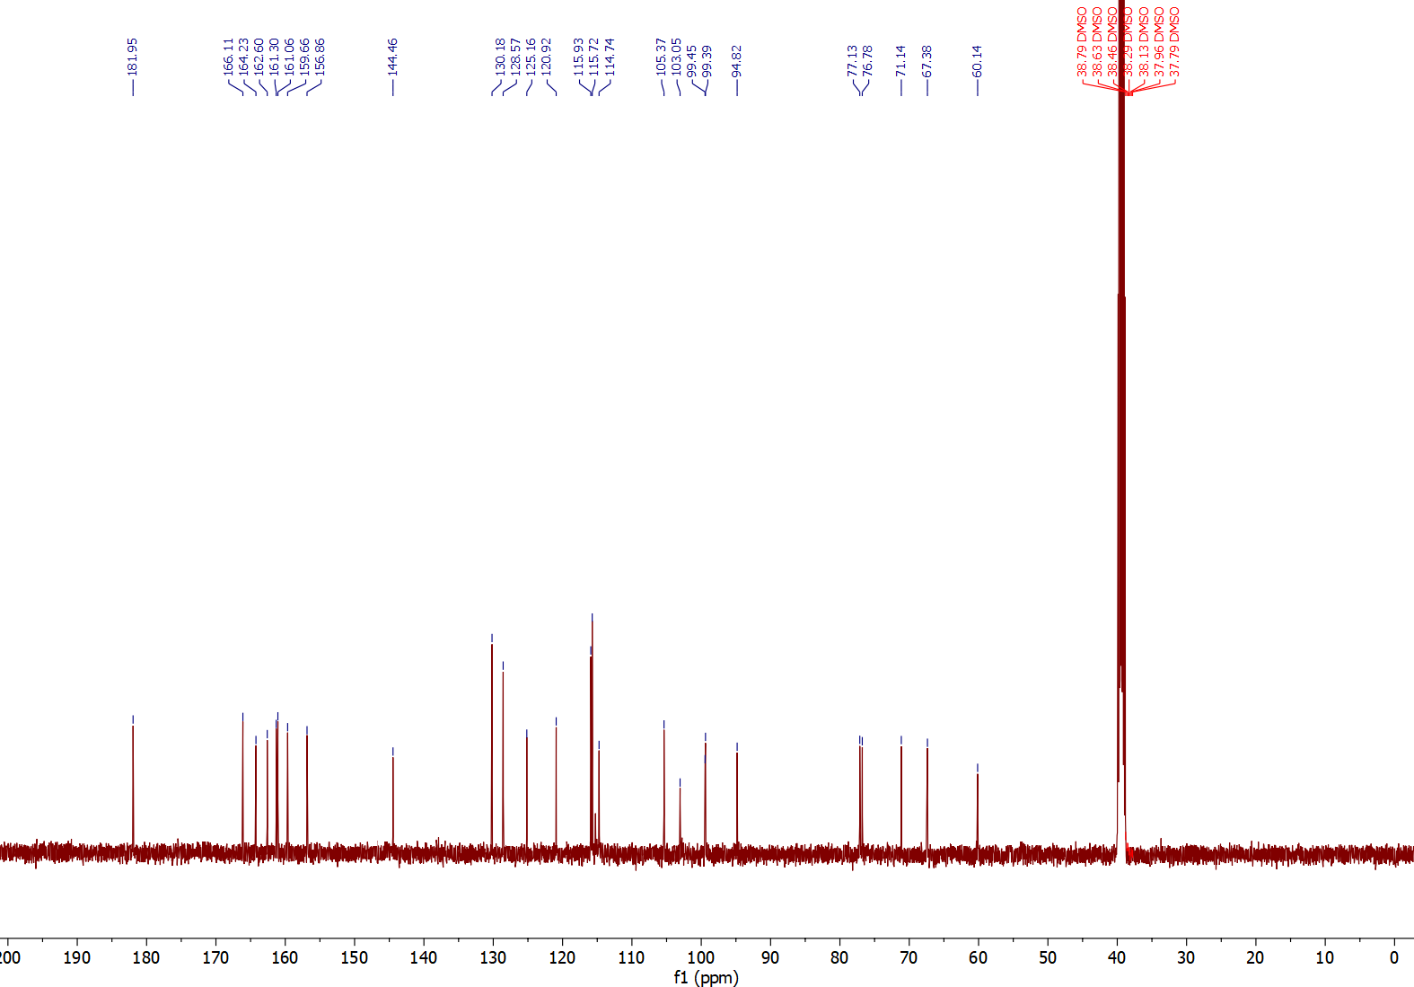
¹³C-NMR spectrum of compound 5 (125 MHz, dmso-d₆)

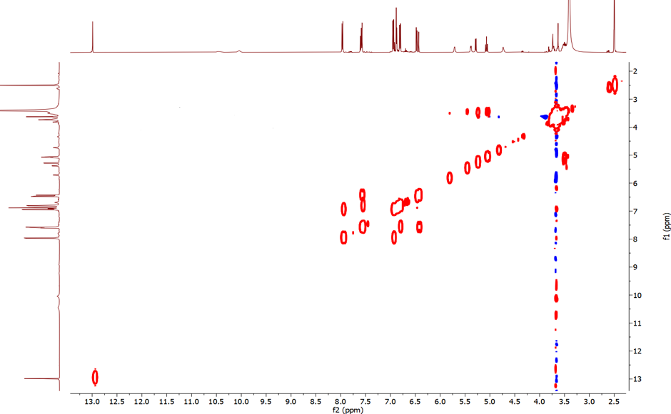
¹H-¹H COSY spectrum of compound 5 (500 MHz, dmso-d₆)

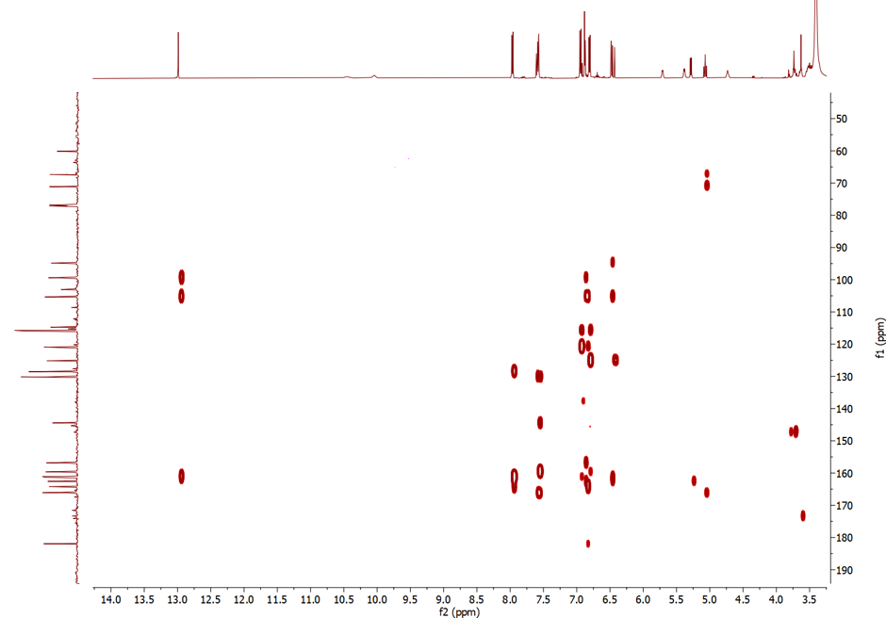
HMBC spectrum of compound 5 (500 MHz, dmso-d₆)
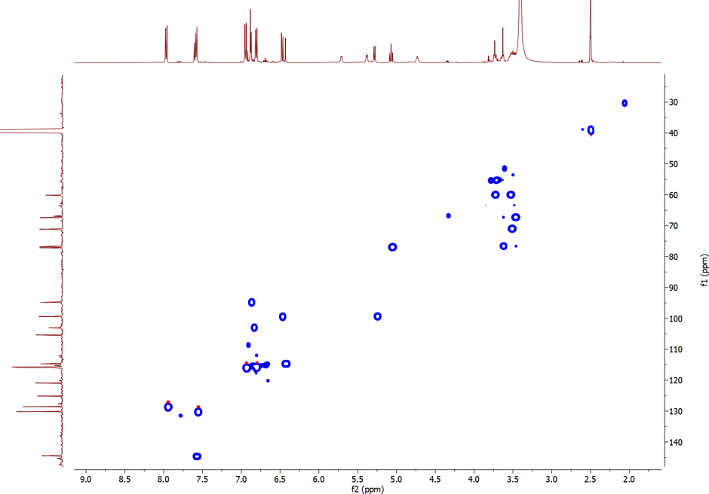
HSQC spectrum of compound 5 (500 MHz, dmso-d₆)
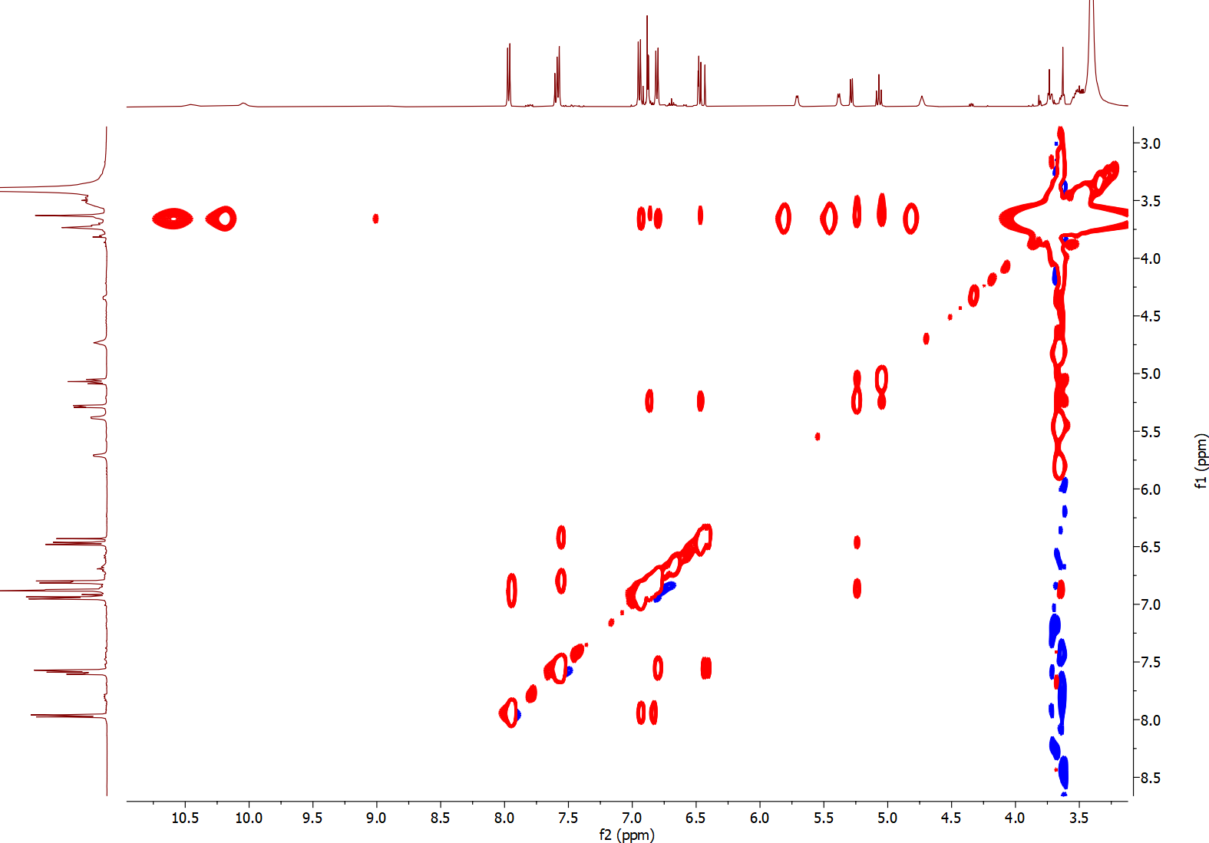
NOESY spectrum of compound 5 (500 MHz, dmso-d₆)
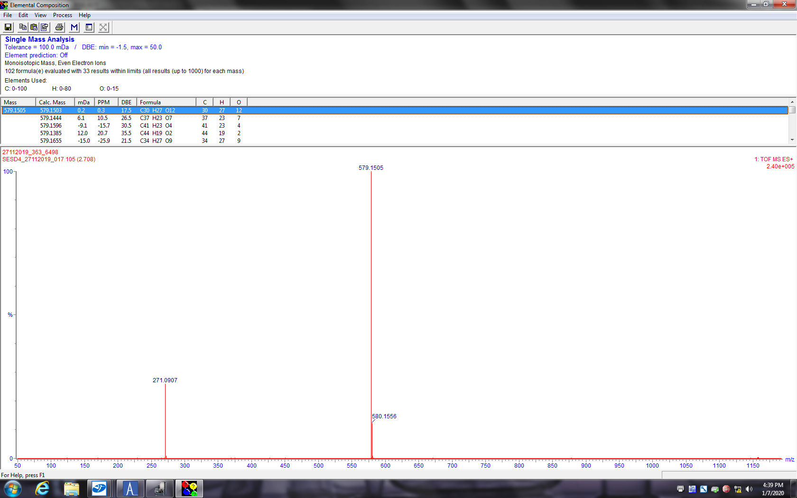
HR-ESI-MS of compound 5

