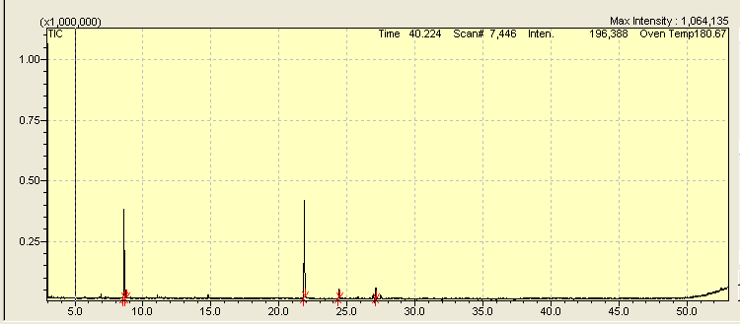
Figure: Analysis of the chemical constituents of the essential oil of O. gratissimum by Gas Chromatography System coupled to Mass Spectrometer (GC-MS)

