**SUPPLEMENTARY DATA**

**Enzyme inhibitory assessment of isolated constituents from *Plantago holosteum* Scop.**

F. Tugce Guragac Derelia, Yasin Gencb, Iclal Saracoglub, Esra Kupeli Akkola

a Department of Pharmacognosy, Faculty of Pharmacy, Gazi University, 06330, Etiler, Ankara, TURKEY

b Department of Pharmacognosy, Faculty of Pharmacy, Hacettepe University, 06100, Sihhiye, Ankara, TURKEY

**Abstract**

Plants of the *Plantago* genus are widely used in Turkish folk medicine especially for the treatment of wound, abscess and inflammation. The aqueous extract and five phenylethanoid glycosidesacteoside (**1**), arenarioside (**2**), echinacoside (**3**), isoacteoside (**4**) and leucosceptoside A (**5**) isolated from the aerial parts and roots of *Plantago holosteum* Scop. (Plantaginaceae) were tested for their possible inhibitory activity against hyaluronidase, elastase and collagenase, related to wound pathogenesis. Even though, the aqueous extract prepared from aerial parts (36.26 %) and roots (47.01 %), as well among the isolated compounds, acteoside (29.13 %), echinacoside (28.73 %) and isoacteoside (31.69 %) exerted a notable inhibition, arenarioside and leucosceptoside A were found inactive in the hyaluronidase enzyme inhibition test. Similar results were obtained from collagenase enzyme inhibition test. The aqueous extract prepared from aerial parts (31.09 %) and roots (35.17 %), echinacoside (25.13 %) and isoacteoside (23.85 %) exerted a notable inhibition in this test. However, none of the extracts and isolated compounds displayed elastase enzyme inhibitory activity. The experimental data demonstrated that *P. holosteum* displayed remarkable enzyme inhibitory activity against hyaluronidase and collagenase. This paper is the first report regarding to *in vitro* enzyme inhibitory activity of *P. holosteum*.

**Keywords:** Collagenase; Elastase; Hyaluronidase; Phenylethanoid glycosides; Plantaginaceae; *Plantago holosteum*.

**SUPPLEMENTARY DATA**

**CONTENT**

* 1H, 13C NMR, and DEPT spectra of **Acteoside (1)**
* 1H, 13C NMR and DEPT spectra of **Arenarioside (2)**
* 1H, and 13C NMR spectra of **Echinacoside (3)**
* 1H, 13C NMR, and DEPT spectra of **Isoacteoside (4)**
* 1H, 13C NMR, and DEPT spectra of **Leucosceptoside A (5)**
* NMR tables of Isolated Compounds **(Acteoside, Arenarioside, Echinacoside, Isoacteoside, Leucosceptoside A)**

**1H-NMR spectra of Acteoside**

**(A)**

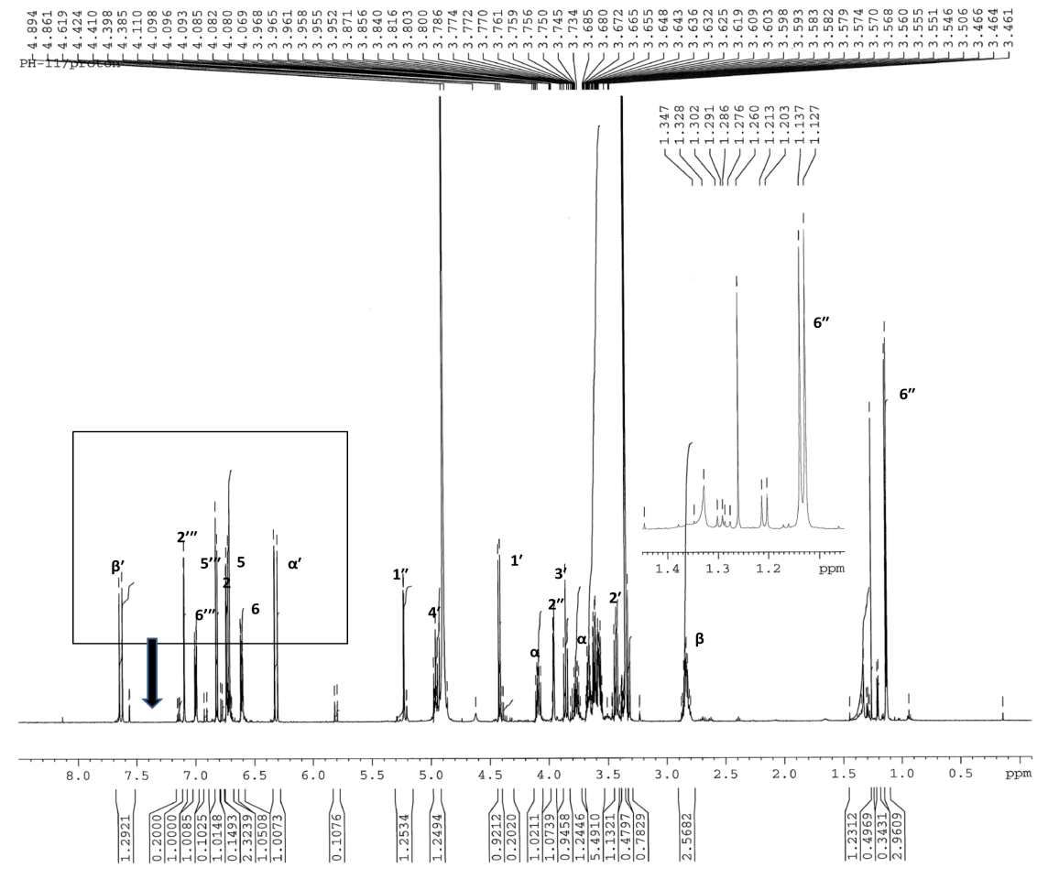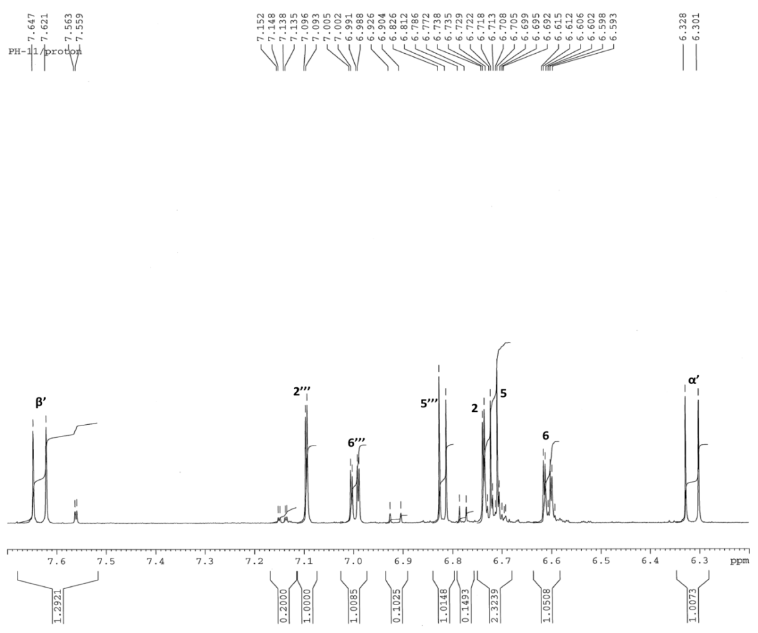

**13C-NMR spectrum of Acteoside**

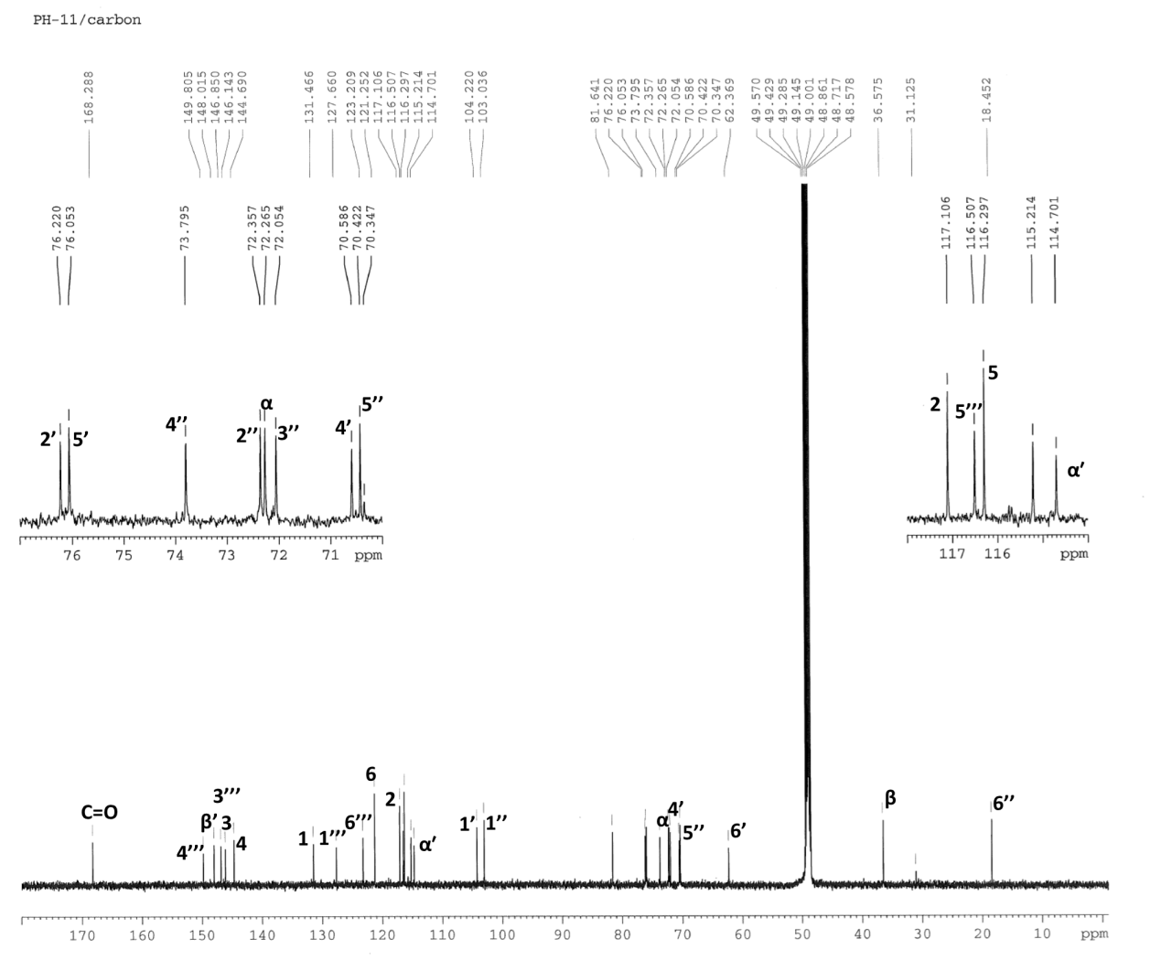

**DEPT-90 and DEPT-135 spectra of Acteoside**

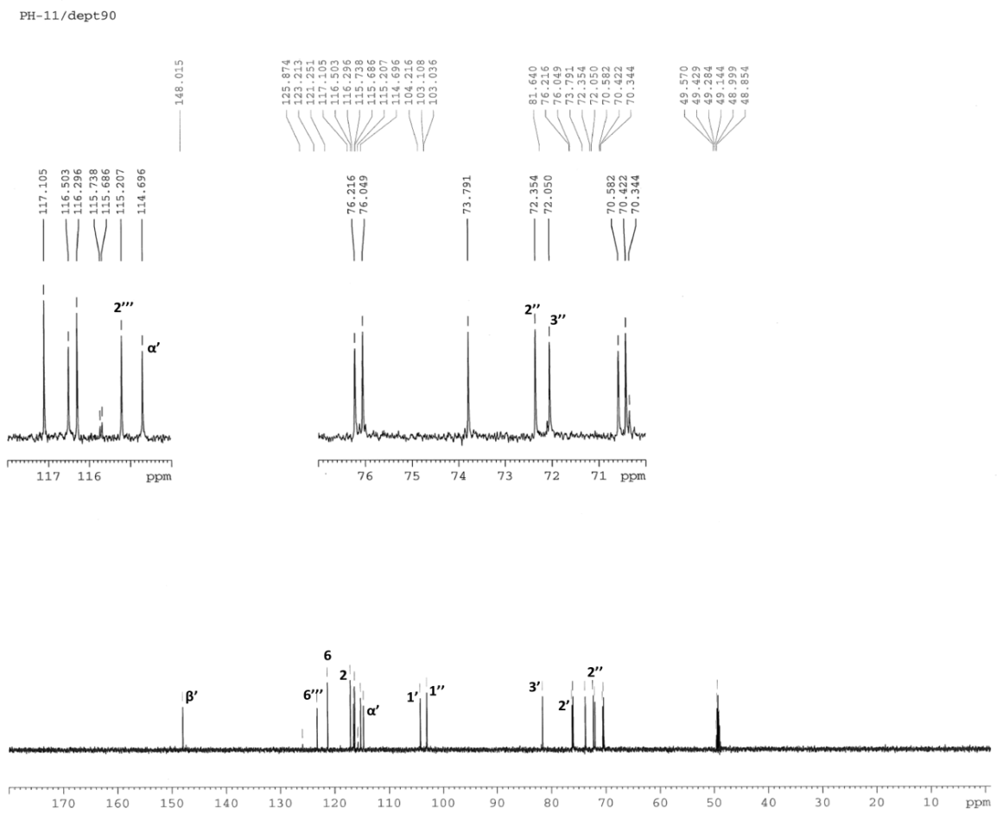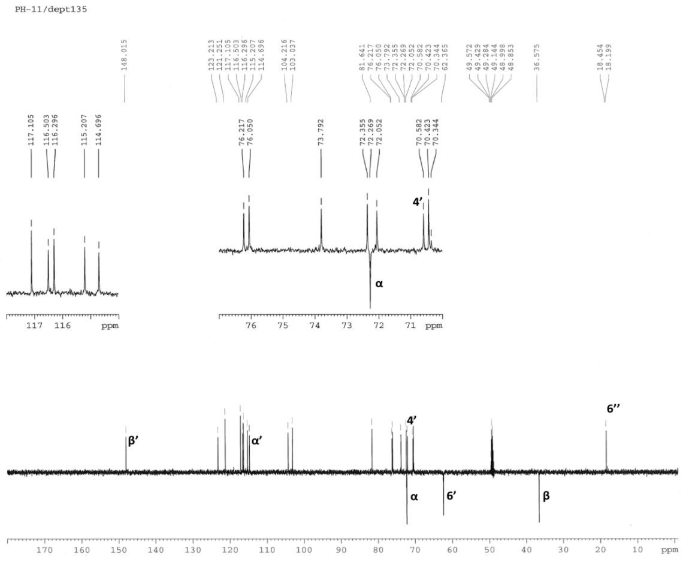

**1H-NMR spectra of Arenarioside**

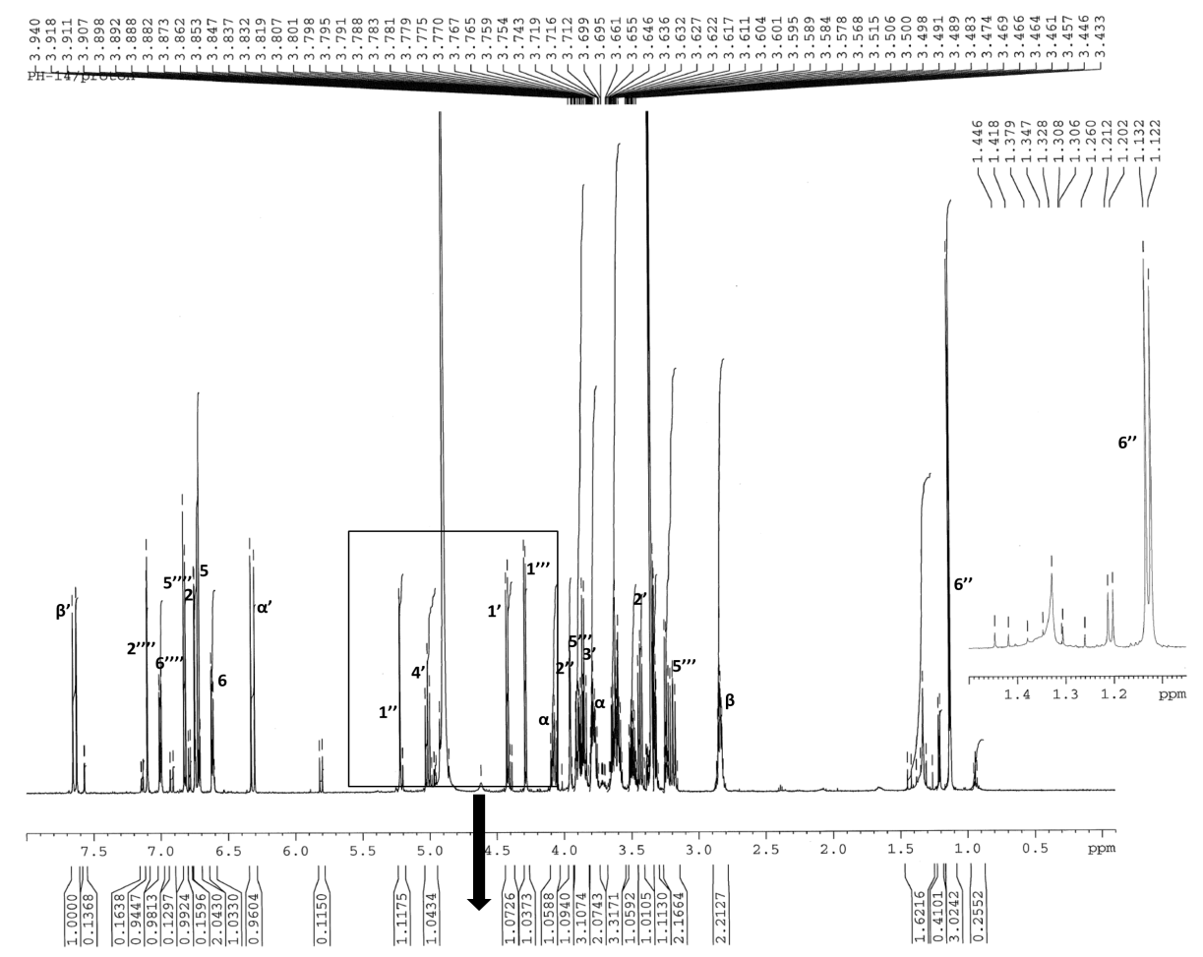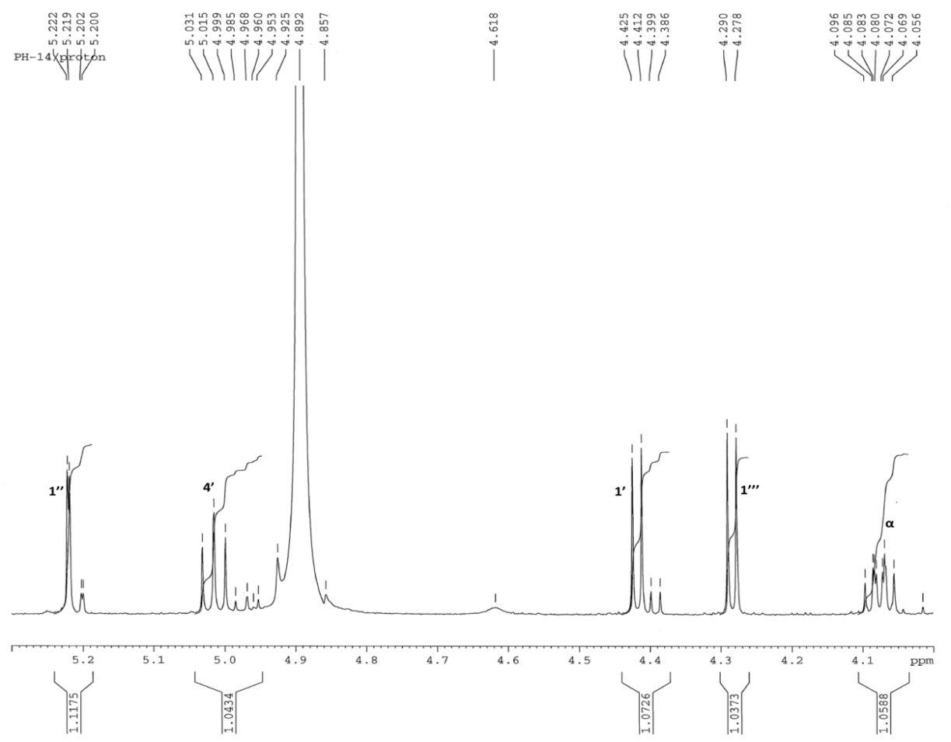

**13C-NMR spectrum of Arenarioside**

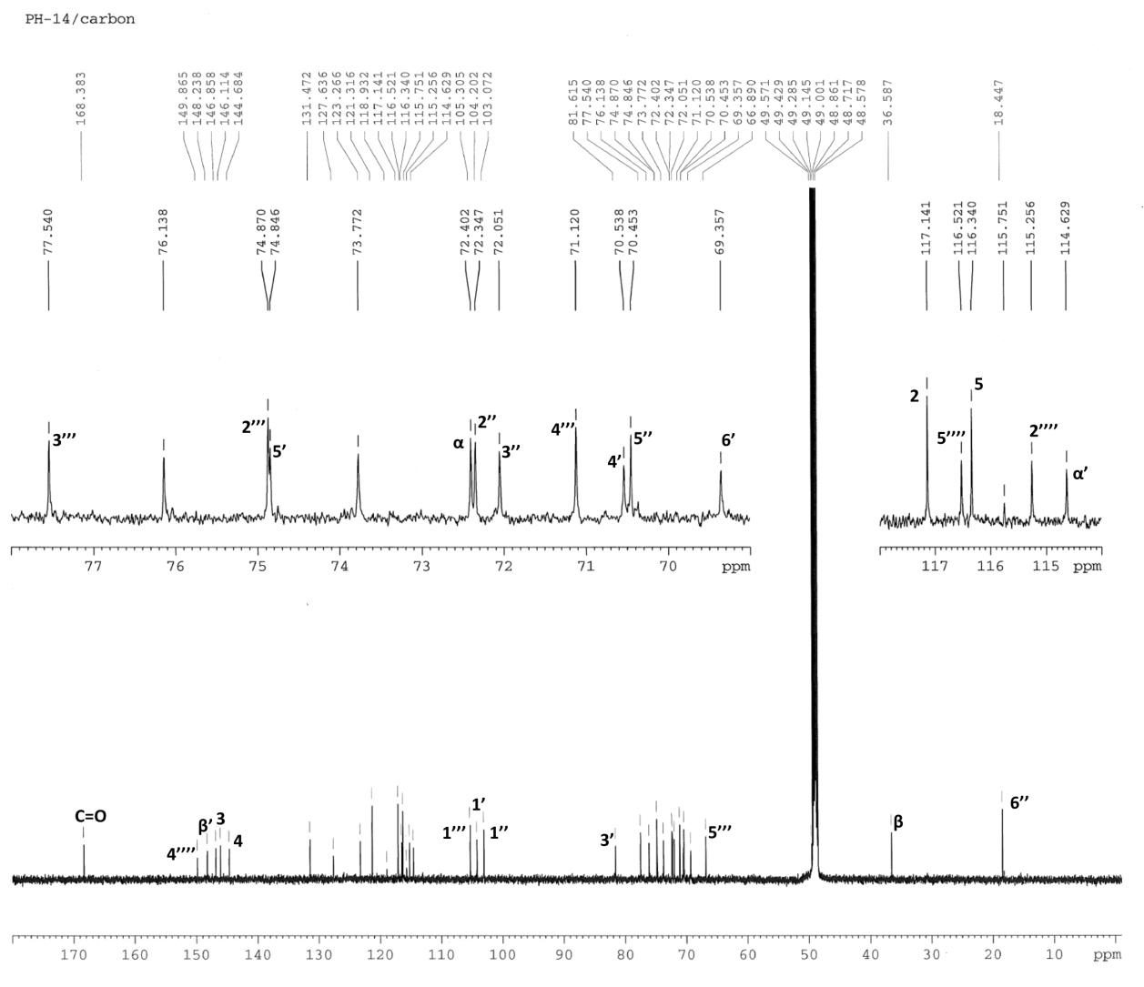

**DEPT-90 and DEPT-135 spectra of Arenarioside**

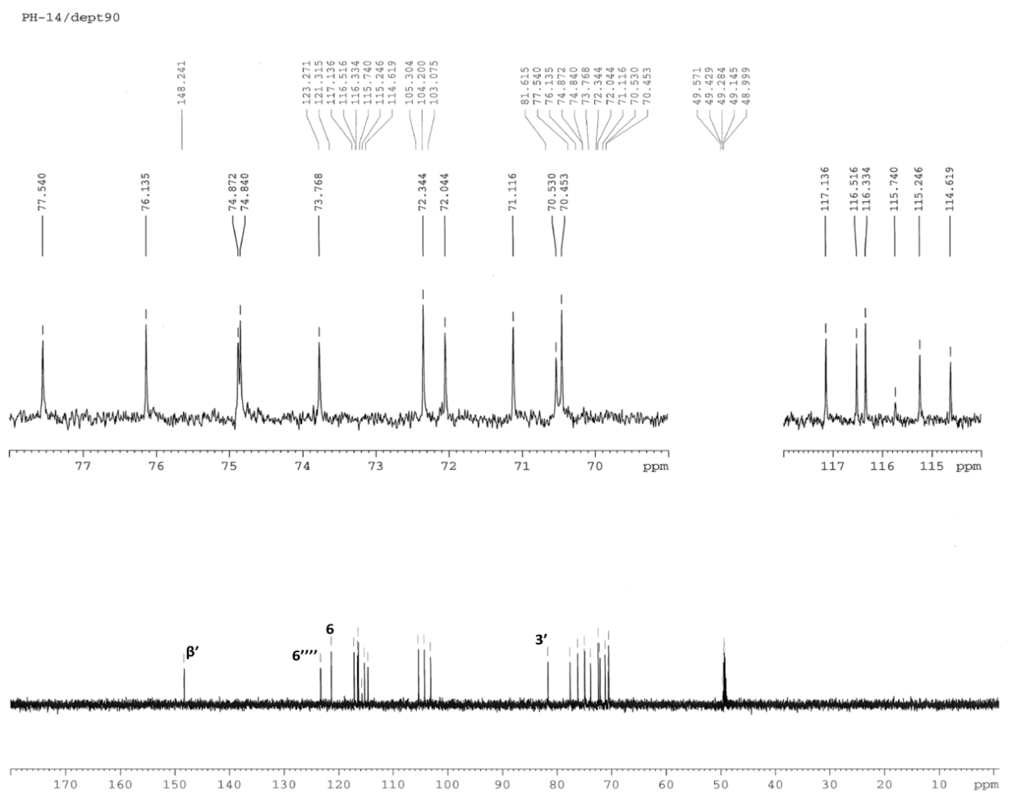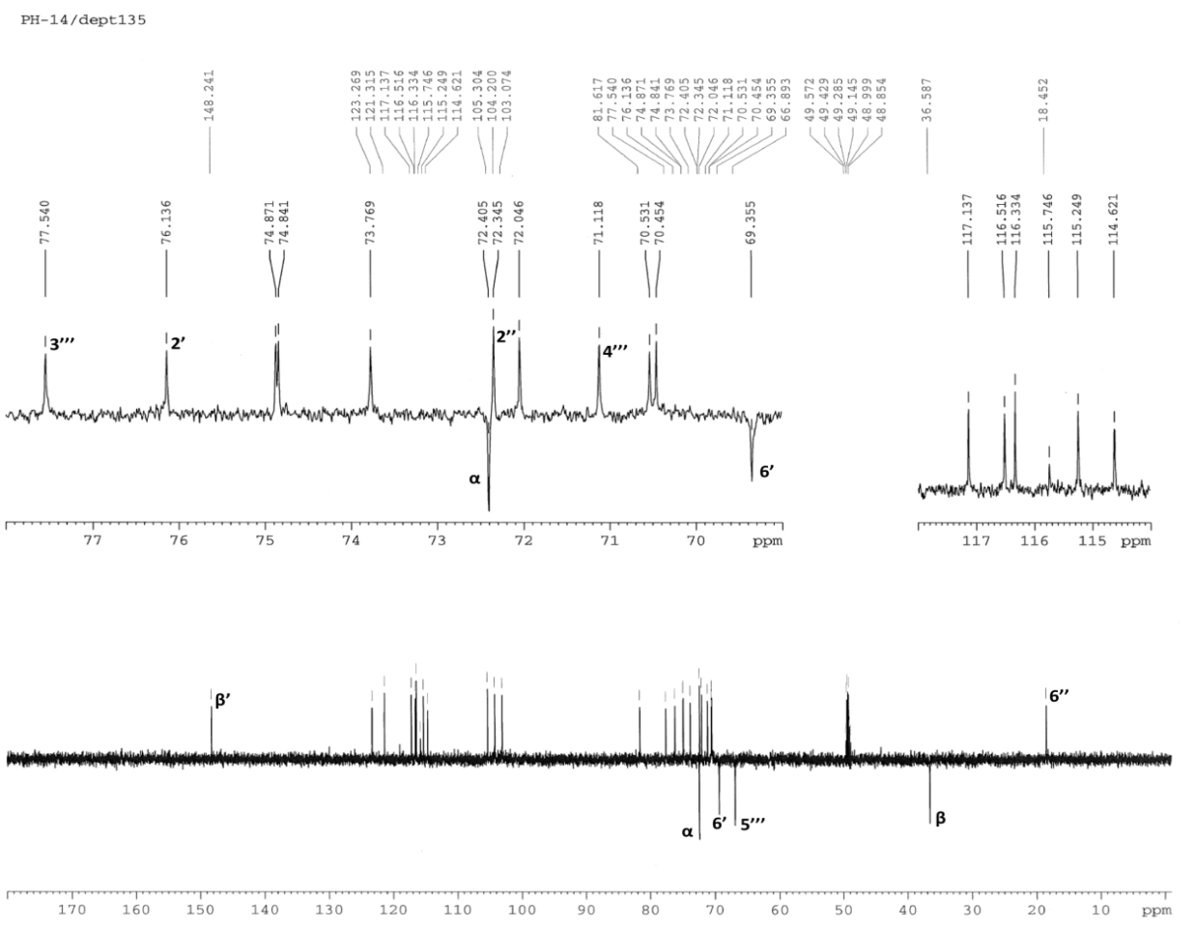

**1H-NMR spectra of Echinacoside**

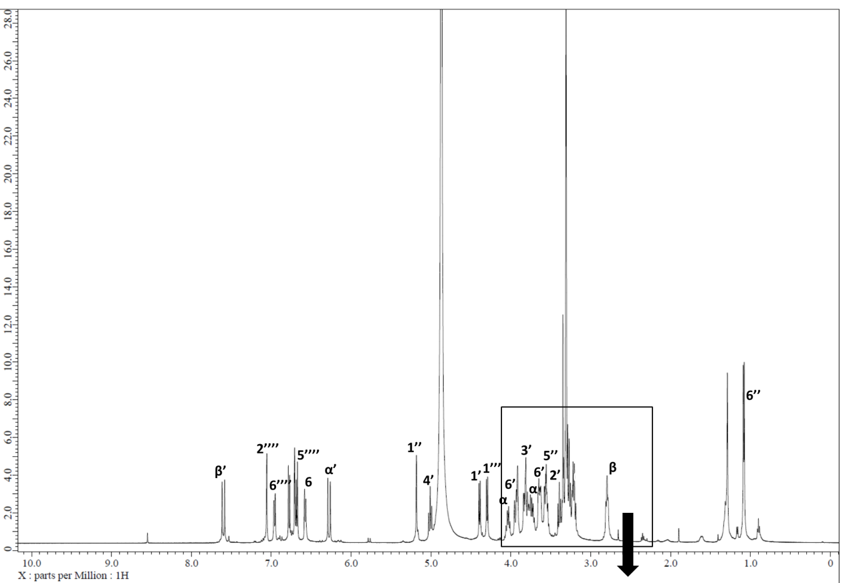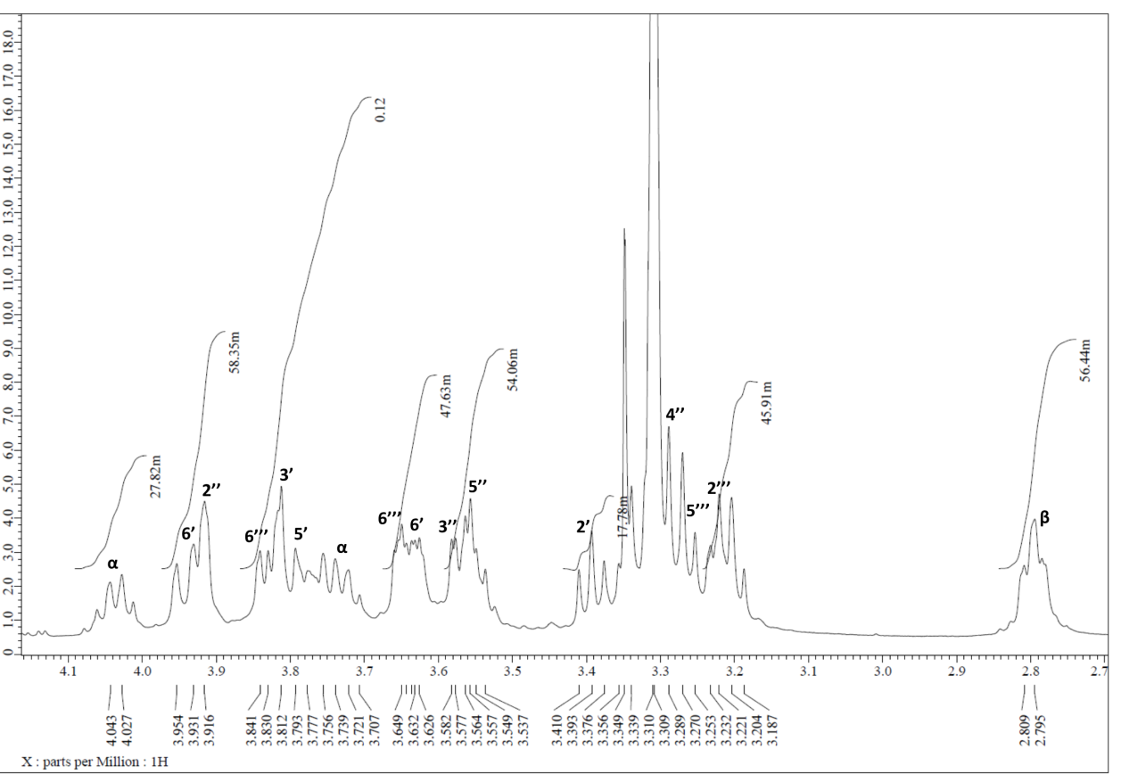

**13C-NMR spectra of Echinacoside**

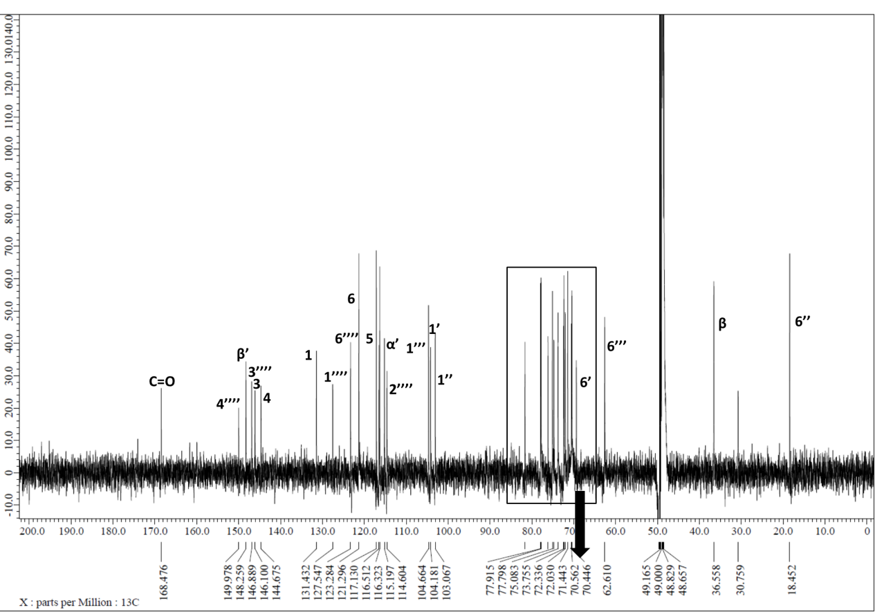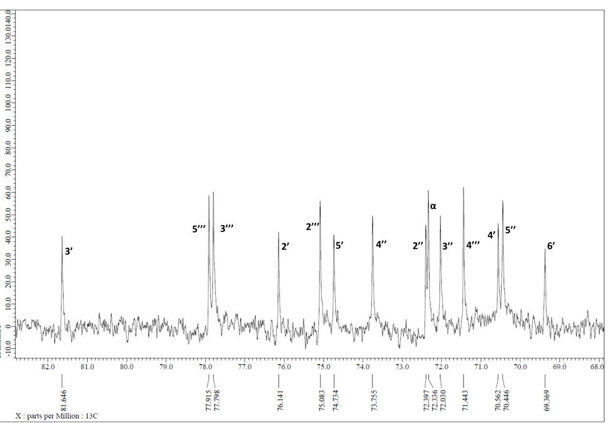

**1H-NMR spectra of Isoacteoside**

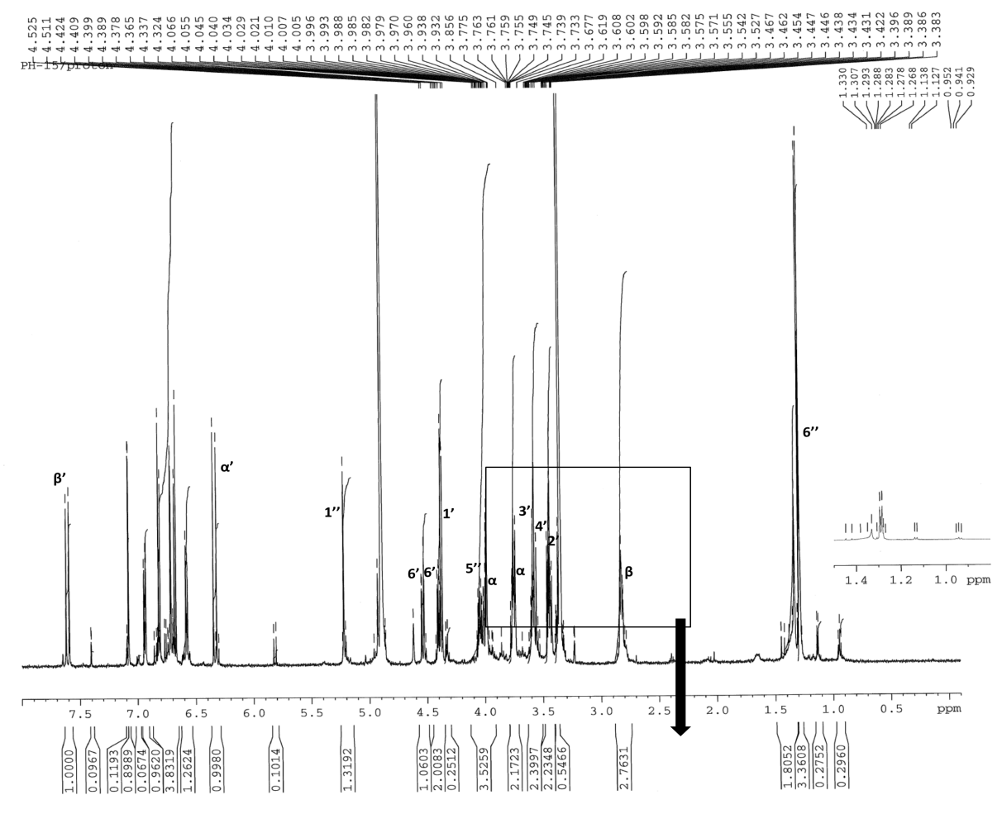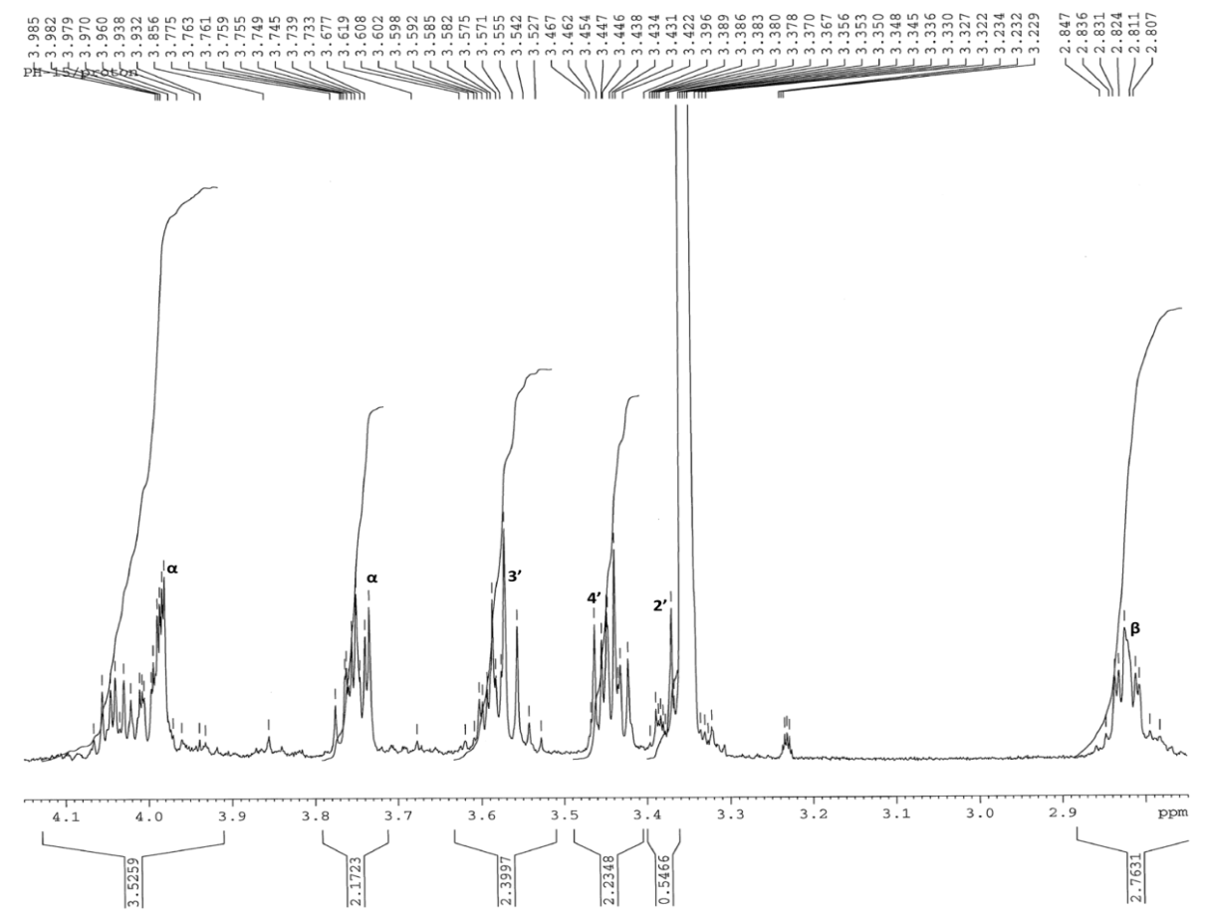

**13C-NMR spectrum of Isoacteoside**

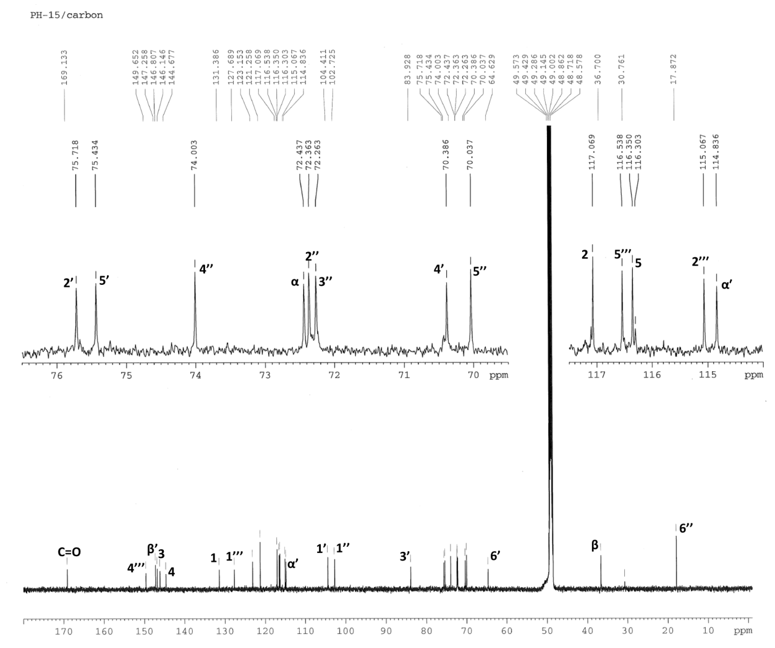

**DEPT-90 and DEPT-135 spectra of Isoacteoside**

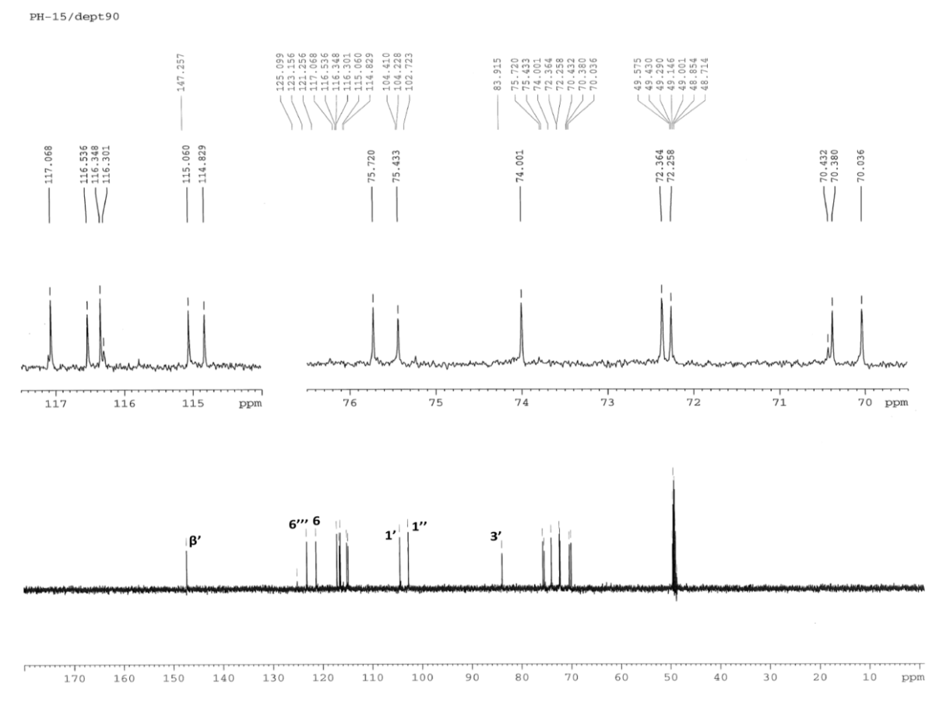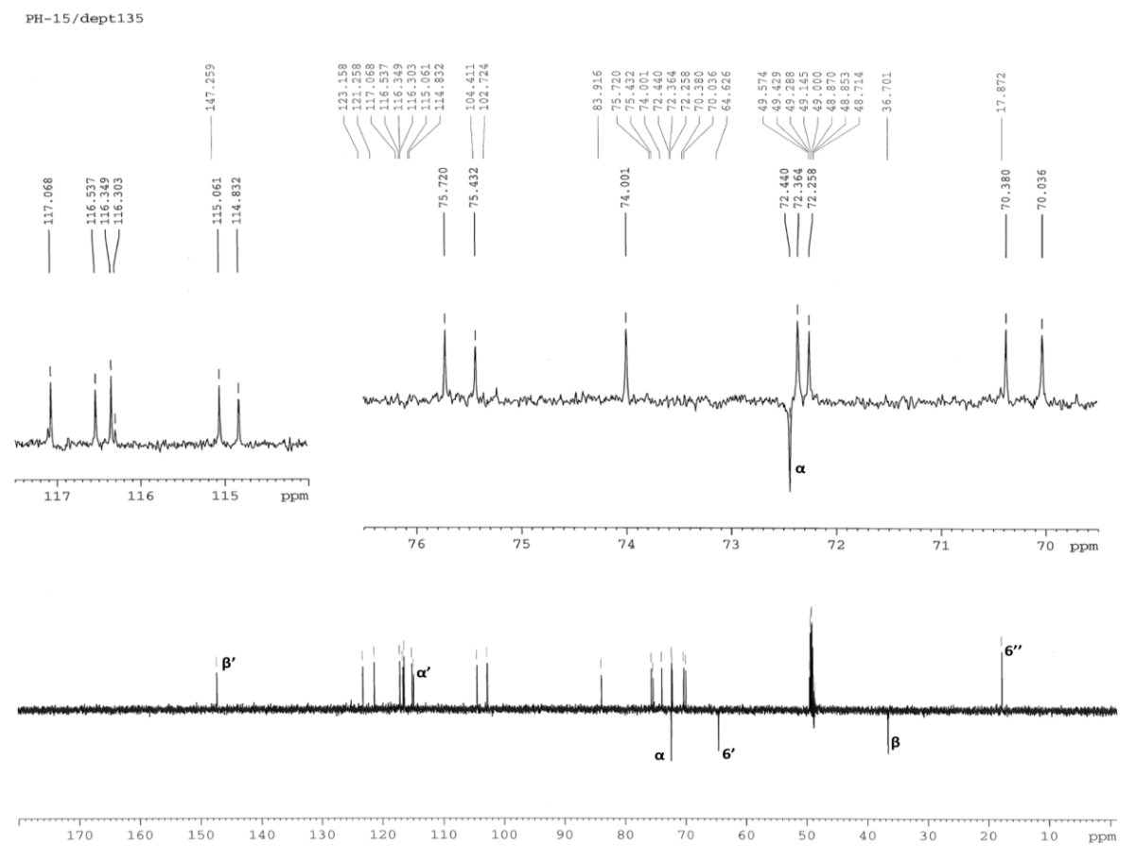

**1H-NMR spectra of Leucosceptoside A**

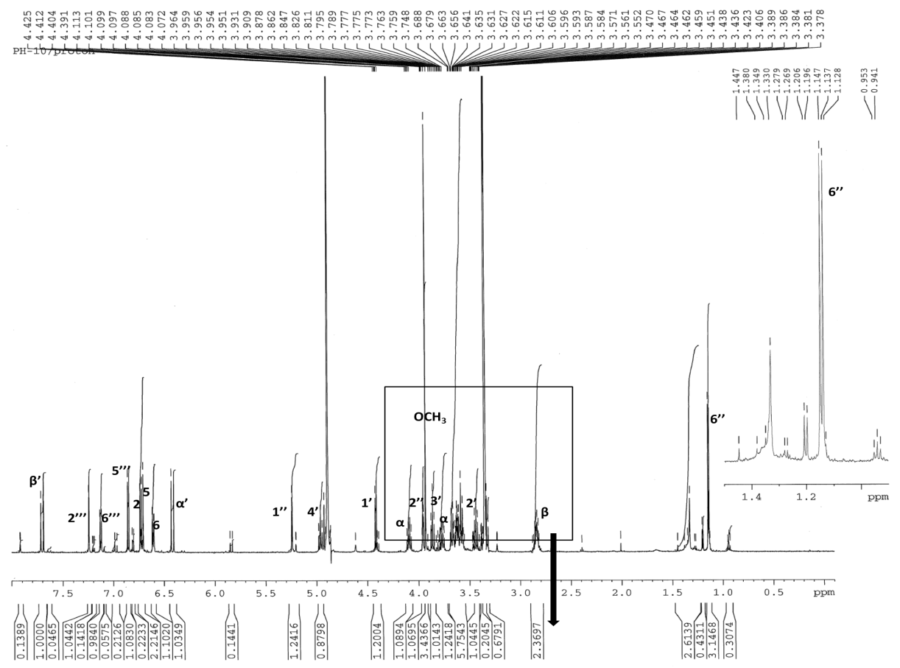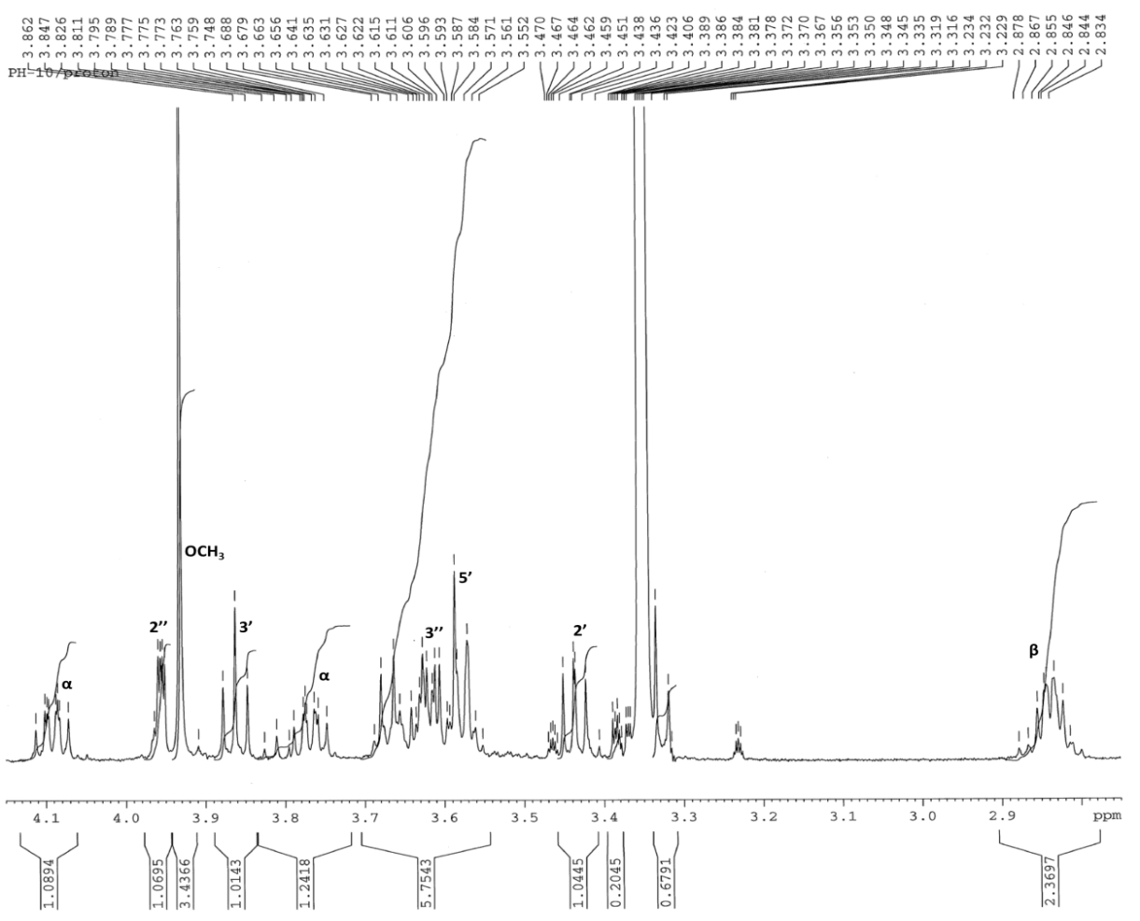

**13C-NMR spectrum of Leucosceptoside A**

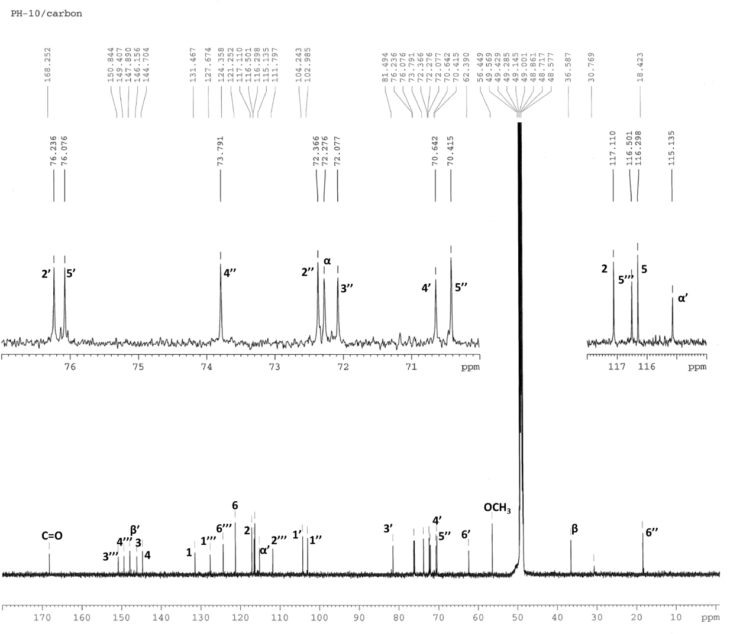

**DEPT-90 and DEPT-135 spectra of Leucosceptoside A**

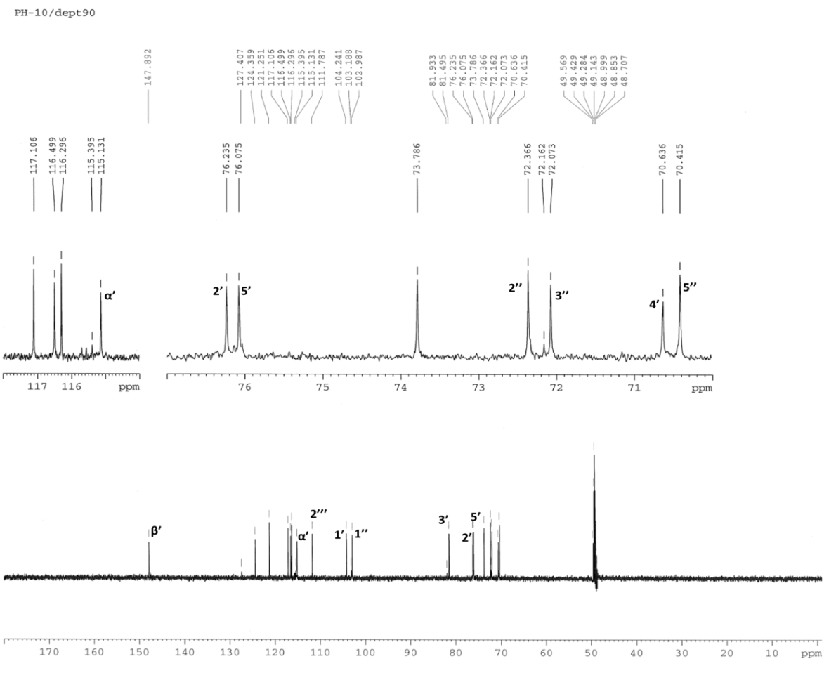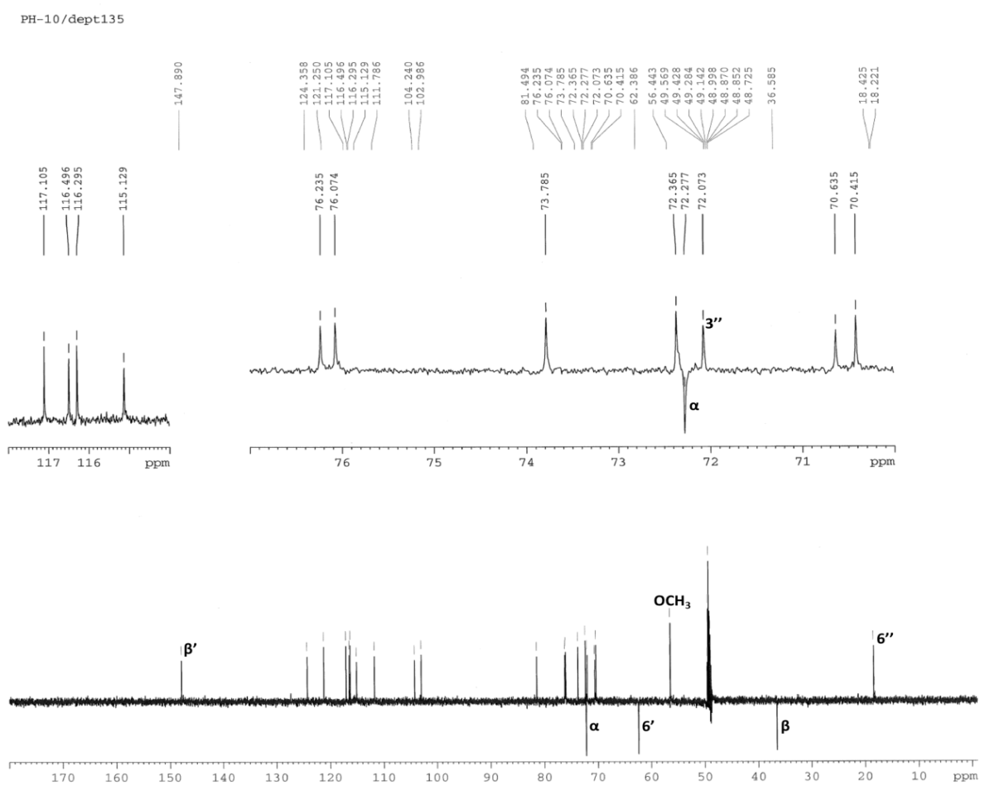

**Table 1**

**13C- and 1H- NMR data of acteoside** (CD3OD; 13C:150 MHz; 1H: 600 MHz)

|  |  |  |  |  |  |
| --- | --- | --- | --- | --- | --- |
| C/H Atom | DEPT | δC ppm | δH ppm | *J* (Hz) | HMBC (H→C) |
| Aglycone |  |  |  |  |  |
| 1 | C | 131.4 |  |  |  |
| 2 | CH | 117.1 | 6.73 d | (2.0) | C-3, C-4, C-6 |
| 3 | C | 146.1 |  |  |  |
| 4 | C | 144.6 |  |  |  |
| 5 | CH | 116.3 | 6.71 d | (8.0) | C-1, C-4, C-6 |
| 6 | CH | 121.2 | 6.61 dd | (8.0/2.0) | C-2, C-4 |
| *α* | CH2 | 72.2 | 4.09 m |  | C-1 |
|  |  |  | 3.77 m |  | C-1, C-1' |
| *β* | CH2 | 36.5 | 2.84 m |  | C-1, C-2, C-6 |
| Glucose |  |  |  |  |  |
| 1′ | CH | 104.2 | 4.41 d | (8.0) | C- *α* |
| 2′ | CH | 76.2 | 3.43 dd | (9.1/8.0) | C-3′ |
| 3′ | CH | 81.6 | 3.85 t | (9.2) | C-2', C-4′ |
| 4′ | CH | 70.6 | 4.96 t | (9.5) | C=O |
| 5′ | CH | 76.0 | 3.58 m |  |  |
| 6′ | CH2 | 62.3 | 3.66 gd | (13.1) |  |
|  |  |  | 3.56 dd | (12.0/6.5) |  |
| Rhamnose |  |  |  |  |  |
| 1'' | CH | 103.0 | 5.22 d | (1.7) | C-3′, C-4′ |
| 2'' | CH | 72.3 | 3.96 dd | (3.2/1.8) |  |
| 3'' | CH | 72.0 | 3.62 dd | (9.7/3.4) |  |
| 4'' | CH | 73.8 | 3.32 t | (9.5) |  |
| 5'' | CH | 70.4 | 3.59 m |  |  |
| 6'' | CH3 | 18.4 | 1.13 d | (6.2) | C-4′, C-4'' |
| Acyl |  |  |  |  |  |
| 1''' | C | 127.6 |  |  |  |
| 2''' | CH | 115.2 | 7.09 d | (2.0) | C-3''', C-4''', C-6''' |
| 3''' | C | 146.8 |  |  |  |
| 4''' | C | 149.8 |  |  |  |
| 5''' | CH | 116.5 | 6.82 d | (8.2) | C-3''', C-4''', C-6''' |
| 6''' | CH | 123.2 | 7.00 dd | (8.2/2.0) | C-3''', C-4''', C-5''' |
| *α*' | CH | 114.7 | 6.31 d | (16.0) | C-1''', C=O |
| *β'* | CH | 148.0 | 7.63 d | (16.0) | C-2''', C-6''', C=O |
| C=O | C | 168.3 |  |  |  |

The 13C and 1H assignments were based on HSQC, HMBC and COSY experiments

The 13C and 1H assignments were based on HSQC, HMBC and COSY experiments

The 13C and 1H assignments were based on HSQC, HMBC and COSY experiments

The 13C and 1H assignments were based on HSQC, HMBC and COSY experiments

The 13C and 1H assignments were based on HSQC, HMBC and COSY experiments

The 13C and 1H assignments were based on HSQC, HMBC and COSY experiments

The 13C and 1H assignments were based on HSQC, HMBC and COSY experiments

**Table 2**

**13C- and 1H- NMR data of arenarioside** (CD3OD; 13C:150 MHz; 1H: 600 MHz)

|  |  |  |  |  |  |
| --- | --- | --- | --- | --- | --- |
| C/H Atom | DEPT | δC ppm | δH ppm | *J* (Hz) | HMBC (H→C) |
| Aglycone |  |  |  |  |  |
| 1 | C | 131,4 |  |  |  |
| 2 | CH | 117,1 | 6,75 d | (2,0) | C-3, C-4, C-6 |
| 3 | C | 146,1 |  |  |  |
| 4 | C | 144,7 |  |  |  |
| 5 | CH | 116,3 | 6,72 d | (8,0) | C-1, C-4, C-6 |
| 6 | CH | 121,3 | 6,62 dd | (8,0/2,0) | C-2, C-4 |
| *α* | CH2 | 72,4 | 4,07 m |  | C-1 |
|  |  |  | 3,77 m |  | C-1, C-1’ |
| *β* | CH2 | 36,6 | 2,82 t | (7,6) | C-1, C-2, C-6 |
| Glucose |  |  |  |  |  |
| 1′ | CH | 104,2 | 4,42 d | (7,9) | C- *α* |
| 2′ | CH | 76,1 | 3,43 dd | (9,0/7,9) | C-3′ |
| 3′ | CH | 81,6 | 3,84 t | (9,2) | C-2’, C-4′ |
| 4′ | CH | 70,5 | 5,01 t | (9,8) | C=O |
| 5′ | CH | 74,8 | 3,78 m |  |  |
| 6′ | CH2 | 69,3 | 3,90 dd | (11,5/2,1) |  |
|  |  |  | 3,63 dd | (11,5/6,0) |  |
| Rhamnose |  |  |  |  |  |
| 1ʹʹ | CH | 103,1 | 5,21 d | (1,7) | C-3′, C-4′ |
| 2ʹʹ | CH | 72,3 | 3,95 dd | (3,2/1,8) |  |
| 3ʹʹ | CH | 72,1 | 3,61 dd | (9,5/3,2) |  |
| 4ʹʹ | CH | 73,7 | 3,33 t | (9,5) |  |
| 5ʹʹ | CH | 70,4 | 3,59 m |  |  |
| 6ʹʹ | CH3 | 18,4 | 1,13 d | (6,2) | C-4′, C-4’’ |
| Xylose |  |  |  |  |  |
| 1''' | CH | 105,3 | 4,28 d | (7,5) | C-6′, C-5''' |
| 2''' | CH | 74,9 | 3,23 dd | (9,0/7,5) |  |
| 3''' | CH | 77,5 | 3,34† |  |  |
| 4''' | CH | 71,1 | 3,49 m |  |  |
| 5''' | CH2 | 66,9 | 3,87 dd | (11,5/5,3) | C-1''', C-4''' |
|  |  |  | 3,19 dd | (11,5/10,2) |  |
| Acyl |  |  |  |  |  |
| 1ʹʹʹʹ | C | 127,6 |  |  |  |
| 2ʹʹʹʹ | CH | 115,2 | 7,10 d | (2,0) | C-3ʹʹʹʹ, C-4ʹʹʹʹ, C-6ʹʹʹʹ |
| 3ʹʹʹʹ | C | 146,8 |  |  |  |
| 4ʹʹʹʹ | C | 149,9 |  |  |  |
| 5ʹʹʹʹ | CH | 116,5 | 6,82 d | (8,1) | C-3ʹʹʹʹ, C-4ʹʹʹʹ, C-6ʹʹʹʹ |
| 6ʹʹʹʹ | CH | 123,3 | 7,00 dd | (8,3/2,1) | C-3ʹʹʹʹ, C-4ʹʹʹʹ, C-5ʹʹʹʹ |
| *α*' | CH | 114,6 | 6,31 d | (16,0) | C-1ʹʹʹʹ ,C=O |
| *β'* | CH | 148,2 | 7,64 d | (16,0) | C-2ʹʹʹʹ , C-6ʹʹʹʹ, C=O |
| C=O | C | 168,4 |  |  |  |

**Table 3**

**13C- and 1H- NMR data of echinacoside** (CD3OD; 13C:150 MHz; 1H: 600 MHz)

|  |  |  |  |  |  |
| --- | --- | --- | --- | --- | --- |
| C/H Atom | DEPT | δC ppm | δH ppm | *J* (Hz) | HMBC (H→C) |
| Aglycone |  |  |  |  |  |
| 1 | C | 131,4 |  |  |  |
| 2 | CH | 116,5 | 6,77 gs |  | C-3, C-4, C-6 |
| 3 | C | 146,1 |  |  |  |
| 4 | C | 144,6 |  |  |  |
| 5 | CH | 117,1 | 6,71 d | (8,0) | C-1, C-4, C-6 |
| 6 | CH | 121,3 | 6,57 gd | (8,0) | C-2, C-4 |
| *α* | CH2 | 72,4 | 4,03 m |  | C-1, C-*β* |
|  |  |  | 3,72 m |  | C-1, C-1’, C-*β* |
| *β* | CH2 | 36,5 | 2,80 t | (7,0) | C-1, C-2, C-6, C- *α* |
| Glucose |  |  |  |  |  |
| 1′ | CH | 104,1 | 4,39 d | (8,0) | C- *α* |
| 2′ | CH | 76,1 | 3,39 t | (8,5) | C-3′ |
| 3′ | CH | 81,6 | 3,81 t | (9,0) | C-2’, C-4′ |
| 4′ | CH | 70,5 | 5,01 t | (9,5) | C-1'', C-3′,C=O |
| 5′ | CH | 74,7 | 3,78 m |  |  |
| 6′ | CH2 | 69,4 | 3,93 gd | (11,5) |  |
|  |  |  | 3,62 dd | (11,5/6,0) |  |
| Rhamnose |  |  |  |  |  |
| 1ʹʹ | CH | 103,1 | 5,18 d | (1,7) | C-3′, C-4′ |
| 2ʹʹ | CH | 72,3 | 3,91† |  |  |
| 3ʹʹ | CH | 72,1 | 3,58 dd | (9,0/2,5) |  |
| 4ʹʹ | CH | 73,7 | 3,28 t | (9,5) |  |
| 5ʹʹ | CH | 70,4 | 3,56 m |  |  |
| 6ʹʹ | CH3 | 18,4 | 1,08 d | (6,0) | C-4′, C-4ʹʹ |
| Glucose |  |  |  |  |  |
| 1''' | CH | 104,6 | 4,30 d | (7,5) | C-6′ |
| 2''' | CH | 75,1 | 3,22 t | (8,5) |  |
| 3''' | CH | 77,8 | 3,35† |  |  |
| 4''' | CH | 71,4 | 3,27 dd | (9,5/8,5) |  |
| 5''' | CH | 77,9 | 3,24† |  | C-1''', C-4''' |
| 6''' | CH2 | 62,6 | 3,83 gd | (12,5) |  |
|  |  |  | 3,64 dd | (11,5/6,0) |  |
| Acyl |  |  |  |  |  |
| 1ʹʹʹʹ | C | 127,5 |  |  |  |
| 2ʹʹʹʹ | CH | 115,2 | 7,06 gs |  | C-3ʹʹʹʹ, C-4ʹʹʹʹ, C-6ʹʹʹʹ |
| 3ʹʹʹʹ | C | 146,9 |  |  |  |
| 4ʹʹʹʹ | C | 149,9 |  |  |  |
| 5ʹʹʹʹ | CH | 116,3 | 6,68 d | (8,0) | C-3ʹʹʹʹ, C-4ʹʹʹʹ, C-6ʹʹʹʹ |
| 6ʹʹʹʹ | CH | 123,3 | 6,95 gd | (8,5) | C-3ʹʹʹʹ, C-4ʹʹʹʹ, C-5ʹʹʹʹ |
| *α*' | CH | 114,6 | 6,28 d | (16,0) | C-1ʹʹʹʹ ,C=O |
| *β'* | CH | 148,2 | 7,60 d | (16,0) | C-2ʹʹʹʹ , C-6ʹʹʹʹ, C=O |
| C=O | C | 168,4 |  |  |  |

**Table 4**

**13C- and 1H- NMR data of isoacteoside** (CD3OD; 13C:150 MHz; 1H: 600 MHz)

|  |  |  |  |  |  |
| --- | --- | --- | --- | --- | --- |
| C/H Atom | DEPT | δC ppm | δH ppm | *J* (Hz) | HMBC (H→C) |
| Aglycone |  |  |  |  |  |
| 1 | C | 131.4 |  |  |  |
| 2 | CH | 117.1 | 6.71 d | (1.9) | C-3, C-4, C-6 |
| 3 | C | 146.1 |  |  |  |
| 4 | C | 144.7 |  |  |  |
| 5 | CH | 116.3 | 6.67 d | (8.0) | C-1, C-4, C-6 |
| 6 | CH | 121.2 | 6.58 dd | (8.0/1.9) | C-2, C-4 |
| *α* | CH2 | 72.4 | 3.98 m |  | C-1 |
|  |  |  | 3.74 m |  | C-1, C-1' |
| *β* | CH2 | 36.7 | 2.82 t | (7.6) | C-1, C-2, C-6 |
| Glucose |  |  |  |  |  |
| 1′ | CH | 104.4 | 4.37 d | (8.0) | C- *α* |
| 2′ | CH | 75.7 | 3.38 dd | (9.4/7.6) | C-3′ |
| 3′ | CH | 83.9 | 3.56 t | (8.9) | C-2', C-4′ |
| 4′ | CH | 70.4 | 3.45 dd | (10.0/8.0) |  |
| 5′ | CH | 75.4 | 3.58 m |  |  |
| 6′ | CH2 | 64.6 | 4.53 dd | (11.8/2.0) |  |
|  |  |  | 4.38 dd | (11.9/6.0) |  |
| Rhamnose |  |  |  |  |  |
| 1'' | CH | 102.7 | 5.21 d | (1.5) | C-3′, C-4′ |
| 2'' | CH | 72.4 | 3.98 dd | (3.4/1.8) |  |
| 3'' | CH | 72.3 | 3.74 dd | (9.5/3.3) |  |
| 4'' | CH | 74.0 | 3.44 t | (8.8) |  |
| 5'' | CH | 70.0 | 4.04 m |  |  |
| 6'' | CH3 | 17.9 | 1.28 d | (6.2) | C-4′, C-4'' |
| Acyl |  |  |  |  |  |
| 1''' | C | 127.7 |  |  |  |
| 2''' | CH | 115.1 | 7.07 d | (2.0) | C-3''', C-4''', C-6''' |
| 3''' | C | 146.8 |  |  |  |
| 4''' | C | 149.6 |  |  |  |
| 5''' | CH | 116.5 | 6.80 d | (8.1) | C-3''', C-4''', C-6''' |
| 6''' | CH | 123.1 | 6.93 dd | (8.1/2.0) | C-3''', C-4''', C-5''' |
| *α*' | CH | 114.8 | 6.33 d | (16.0) | C-1''', C=O |
| *β'* | CH | 147.2 | 7.60 d | (16.0) | C-2''', C-6''', C=O |
| C=O | C | 169.1 |  |  |  |

**Table 5**

**13C- and 1H- NMR data of leucosceptoside A** (CD3OD; 13C:150 MHz; 1H: 600 MHz)

|  |  |  |  |  |  |
| --- | --- | --- | --- | --- | --- |
| C/H Atom | DEPT | δC ppm | δH ppm | *J* (Hz) | HMBC (H→C) |
| Aglycone |  |  |  |  |  |
| 1 | C | 131,4 |  |  |  |
| 2 | CH | 117,1 | 6,73 d | (2,0) | C-3, C-4, C-6 |
| 3 | C | 146,1 |  |  |  |
| 4 | C | 144,7 |  |  |  |
| 5 | CH | 116,3 | 6,71 d | (8,0) | C-1, C-4, C-6 |
| 6 | CH | 121,2 | 6,61 dd | (8,0/2,0) | C-2, C-4 |
| *α* | CH2 | 72,2 | 4,09 m |  | C-1 |
|  |  |  | 3,77 m |  | C-1, C-1' |
| *β* | CH2 | 36,5 | 2,84 m |  | C-1, C-2, C-6 |
| Glucose |  |  |  |  |  |
| 1′ | CH | 104,2 | 4,42 d | (7,8) | C- *α* |
| 2′ | CH | 76,2 | 3,43 dd | (9,1/7,9) | C-3′ |
| 3′ | CH | 81,5 | 3,86 t | (9,2) | C-2', C-4′ |
| 4′ | CH | 70,6 | 4,96 t | (9,4) | C=O |
| 5′ | CH | 76,1 | 3,58 m |  |  |
| 6′ | CH2 | 62,4 | 3,67 gd | (10,0) |  |
|  |  |  | 3,58 dd | (12,0/5,5) |  |
| Rhamnose |  |  |  |  |  |
| 1'' | CH | 102,9 | 5,24 d | (1,6) | C-3′, C-4′ |
| 2'' | CH | 72,3 | 3,95 dd | (3,2/1,7) |  |
| 3'' | CH | 72,1 | 3,62 dd | (9,4/3,2) |  |
| 4'' | CH | 73,8 | 3,33 t | (9,5) |  |
| 5'' | CH | 70,4 | 3,63† |  |  |
| 6'' | CH3 | 18,4 | 1,13 d | (6,2) | C-4′, C-4'' |
| Acyl |  |  |  |  |  |
| 1''' | C | 127,6 |  |  |  |
| 2''' | CH | 111,8 | 7,24 d | (1,8) | C-3''', C-4''', C-6''' |
| 3''' | C | 149,4 |  |  |  |
| 4''' | C | 150,8 |  |  |  |
| 5''' | CH | 116,5 | 6,85 d | (8,1) | C-3''', C-4''', C-6''' |
| 6''' | CH | 124,3 | 7,13 dd | (8,3/1,8) | C-3''', C-4''', C-5''' |
| *α*' | CH | 115,1 | 6,41 d | (16,0) | C-1''', C=O |
| *β'* | CH | 147,9 | 7,70 d | (16,0) | C-2''', C-6''', C=O |
| C=O | C | 168,2 |  |  |  |
| OCH3 | CH3 | 56,4 | 3,93 s |  | C-3''' |

**(A)**