A new ursane-type triterpene oxoglucopyranoside from Crossopteryx febrifuga

Modjinan Kayangar¹, Raymond Nono Ngansop¹, Jonas Kühlborn², Roland Tchuenguem³ Beaudelaire K. Ponou¹, Kristina Jenett-Siems⁴, Rémy B. Teponno¹, Jean P Dzoyem³ Till Opatz², Matthias F. Melzig⁴ Léon A. Tapondjou^{1,}*
¹ Department of Chemistry, Faculty of Science, University of Dschang, P.O. Box 67, Dschang, Cameroon
² Johannes Gutenberg University Mainz, Institute of Organic Chemistry, Duesbergweg 10-14, D–55128 Mainz, Germany
³ Department of Biochemistry, Faculty of Science, University of Dschang, P.O. Box 67, Dschang, Cameroon
⁴Institut für Pharmazie (Pharmazeutische Biologie), Freie Universität Berlin, Königin-Luise-Str. 2-4, D-14195 Berlin, Germany

Léon Azefack Tapondjou, Department of Chemistry, Faculty of Science, University of Dschang, Box 67, Dschang, Cameroon; Tel: +237-675004826; E-mail: tapondjou2001@yahoo.fr
Z. Naturforsch. 2019, 64b, XXXX–XXXX; received

Fig. S1 HRESIMS of spectrum of compound 1
Fig. S2 ¹H NMR spectrum of compound 1
Fig. S3 ¹H-¹H COSY spectrum of compound 1
Fig. S4 HSQC spectrum of compound 1
Fig. S5 HMBC spectrum of compound 1
Fig. S5 Fluxogram of the isolation of compounds from Crossopteryx februfuga

Fig. S1 HRESIMS of spectrum of compound 1

Fig. S2 ¹H NMR spectrum of compound 1

Fig. S3 ¹H-¹H COSY spectrum of compound 1

Fig. S4 HSQC spectrum of compound 1
Fig. S5 HMBC spectrum of compound 1

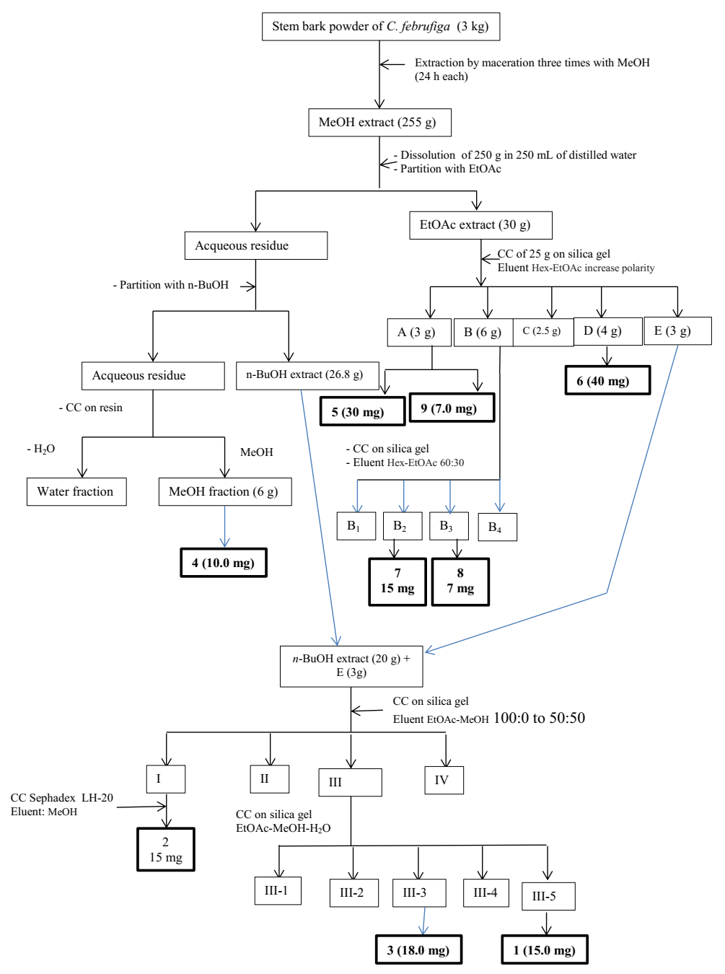
Figure S6: Fluxogram of the isolation of compounds from Crossopteryx febrifuga

