Contents:
Figures
Figure S1. Representative GC×GC chromatogram of a hexane body wash of E. neotenicus neotenic queen.
Figure S2. ¹H NMR spectrum of (2R,3R)-epoxyfarnesol.
Figure S3. ¹H NMR spectrum of (3R,6E)-nerolidol.

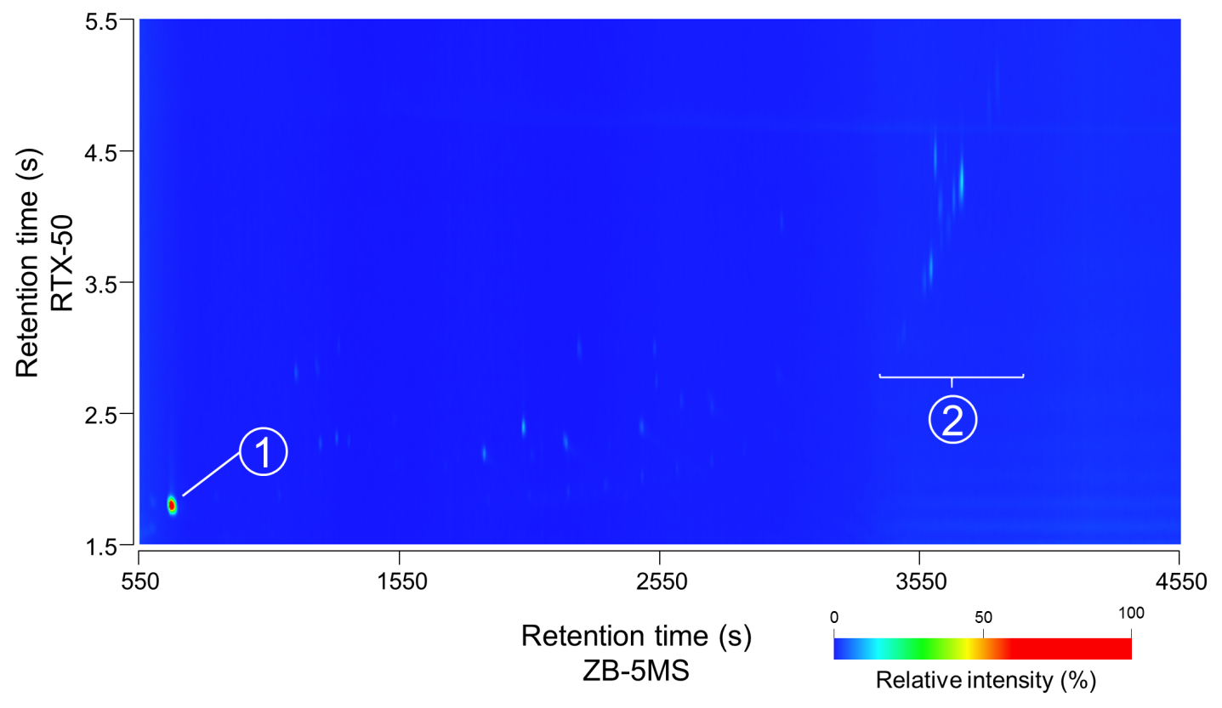
Figure S1: Representative GC×GC chromatogram of a hexane body wash of E. neotenicus neotenic queen. The figure shows a 2D view on a chromatogram spanning from the low molecular weight fraction, including the dominant analyte (3R,6E)-nerolidol (1), to the high molecular weight fraction, containing the cuticular hydrocarbons (2) with 35‒41 carbons. The temperature program allowing elution of both, (3R,6E)-nerolidol and cuticular hydrocarbons, was set as follows. Primary column: 150 °C (1 min) to 315 °C at 3 °C/min, 315 °C to 325 °C (20 min) at 10 °C/min).

Figure S2. ¹H NMR spectrum of (2R,3R)-epoxyfarnesol.

Figure S3. ¹H NMR spectrum of (3R,6E)-nerolidol.

