Supporting Information

Title: Curviflorside and curviflorin, new naphthalene glycoside and flavanol from Plicosepalus curviflorus

Nawal M. Al Musayeib^{1,*}, Sabrin R. M. Ibrahim^{2, 3,*}, Musarat Amina¹, Gadah A. Al Hamoud¹ and Gamal A. Mohamed^{4, 5}

¹Department of Pharmacognosy, College of Pharmacy, King Saud University, Riyadh 11451, Saudi Arabia
²Department of Pharmacognosy and Pharmaceutical Chemistry, College of Pharmacy, Taibah University, Al-Madinah Al-Munawarah 30078, Saudi Arabia
³Department of Pharmacognosy, Faculty of Pharmacy, Assiut University, Assiut 71526, Egypt
⁴Department of Natural Products and Alternative Medicine, Faculty of Pharmacy, King Abdulaziz University, Jeddah 21589, Saudi Arabia
⁵Department of Pharmacognosy, Faculty of pharmacy, Al-Azhar University, Assiut Branch, Assiut 71524, Egypt

* Corresponding author: Sabrin R.M. Ibrahim, Department of Pharmacognosy and Pharmaceutical Chemistry, College of Pharmacy, Taibah University, Al Madinah Al Munawwarah 30078, Saudi Arabia, E-mail: sabrinshaur@gmail.com; sribrahim@taibahu.edu.sa. Phone: +966 581183034.

* Nawal M. Al Musayeib, Department of Pharmacognosy, College of Pharmacy, King Saud University, Riyadh 11451, Saudi Arabia, E-mail: nawal.pharmacy@gmail.com; nalmusayeib@ksu.edu.sa. Phone: +966 598566807.

Table of Contents
 | Page
Figure S1. ¹H NMR spectrum of compound 1 (700 MHz, DMSO-d₆). | 3
Figure S2. ¹³C NMR spectrum of compound 1 (175 MHz, DMSO-d₆). | 3
Figure S3. DEPT ¹³C NMR spectrum of compound 1. | 4
Figure S4. ¹H-¹H COSY spectrum of compound 1. | 4
Figure S5. HSQC spectrum of compound 1. | 5
Figure S6. HMBC spectrum of compound 1. | 5
Figure S7. ¹H NMR spectrum of compound 2 (700 MHz, DMSO-d₆). | 6
Figure S8. ¹H-¹H COSY spectrum of compound 2. | 6
Figure S9. HSQC spectrum of compound 2. | 7
Figure S10. HMBC spectrum of compound 2. | 7
Figure S11. ¹H NMR spectrum of compound 3 (700 MHz, DMSO-d₆). | 8
Figure S12. ¹³C NMR spectrum of compound 3 (175 MHz, DMSO-d₆). | 8
Figure S13. DEPT ¹³C NMR spectrum of compound 3. | 9
Figure S14. ¹H-¹H COSY spectrum of compound 3. | 9
Figure S15. HSQC spectrum of compound 3. | 10
Figure S16. HMBC spectrum of compound 3. | 10
Figure S17. HRESIMS spectrum of compound 3 | 11
Figure S18. ¹H NMR spectrum of compound 4 (700 MHz, DMSO-d₆). | 11
Figure S19. ¹³C NMR spectrum of compound 4 (175 MHz, DMSO-d₆). | 12
Figure S20. DEPT ¹³C NMR spectrum of compound 4. | 12
Figure S21. ¹H-¹H COSY spectrum of compound 4. | 13
Figure S22. HSQC spectrum of compound 4. | 13
Figure S23. HMBC spectrum of compound 4. | 14
Figure S24. HRESIMS spectrum of compound 4. | 14
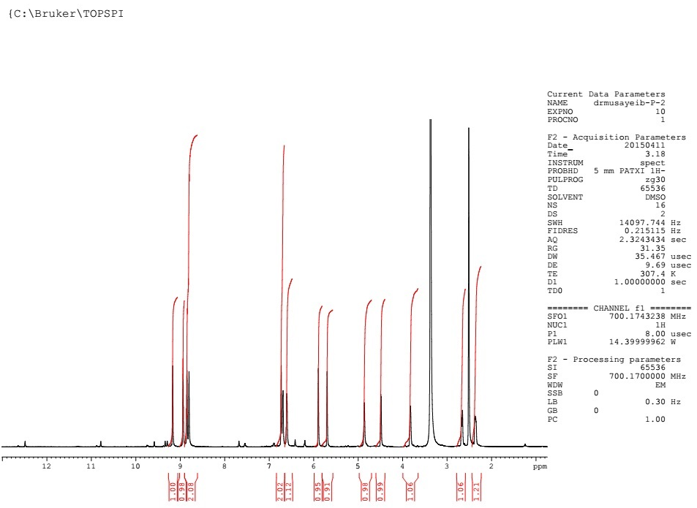
Figure S1. ¹H NMR spectrum of compound 1 (700 MHz, DMSO-d₆).

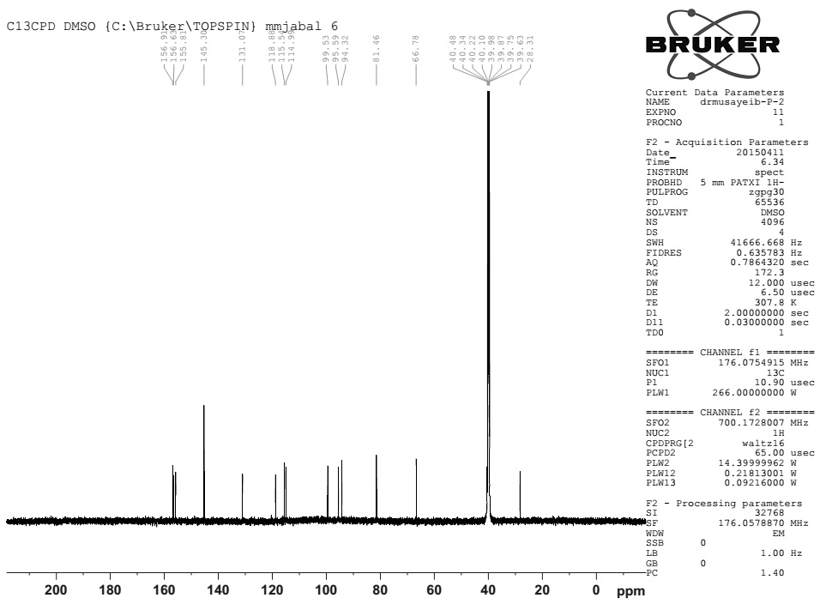
Figure S2. ¹³C NMR spectrum of compound 1 (175 MHz, DMSO-d₆).
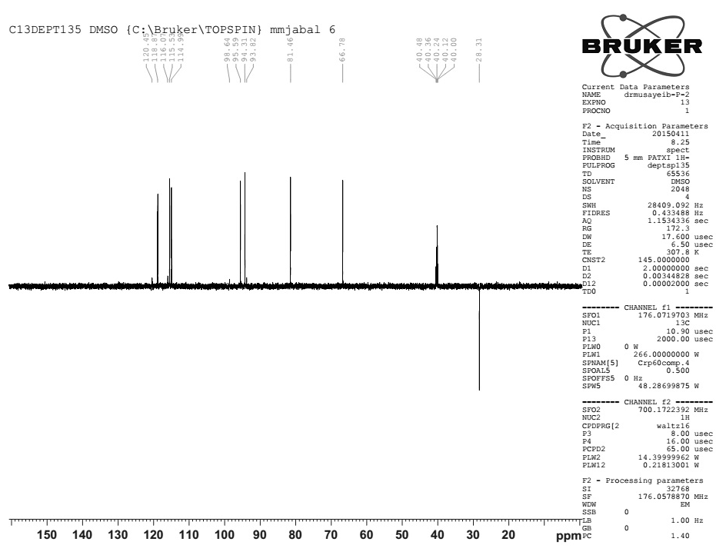
Figure S3. DEPT ¹³C NMR spectrum of compound 1.

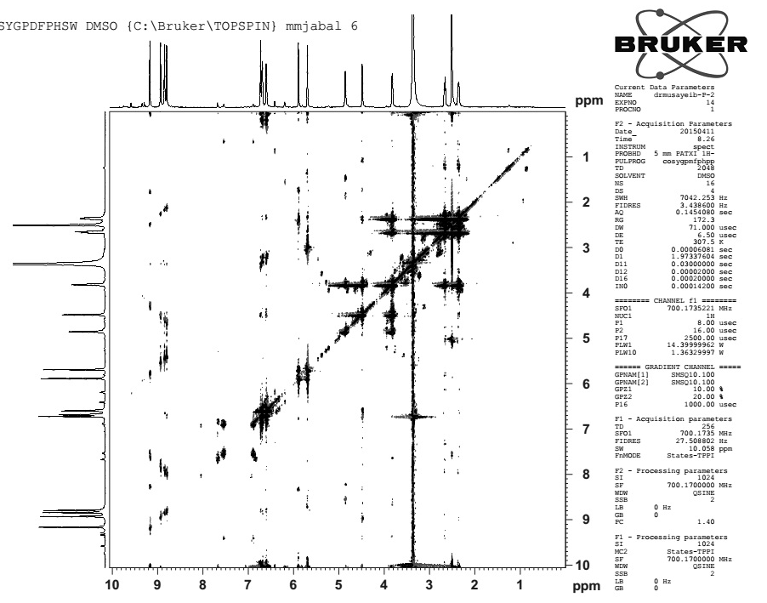
Figure S4. ¹H-¹H COSY spectrum of compound 1.
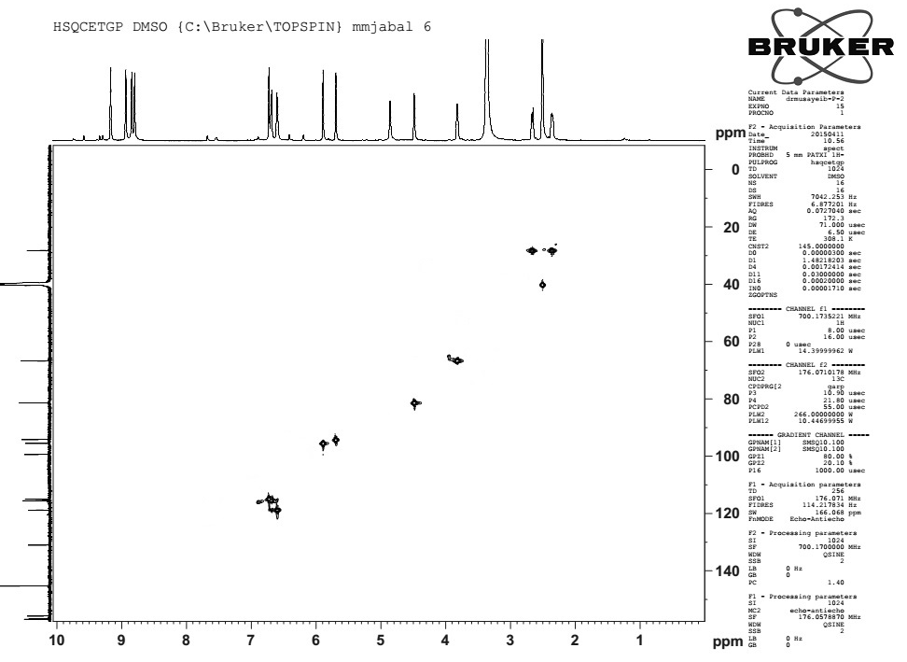
Figure S5. HSQC spectrum of compound 1.

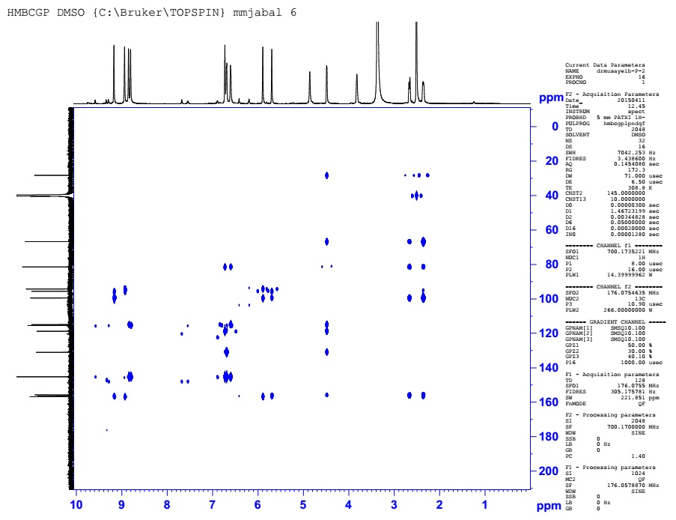
Figure S6. HMBC spectrum of compound 1.
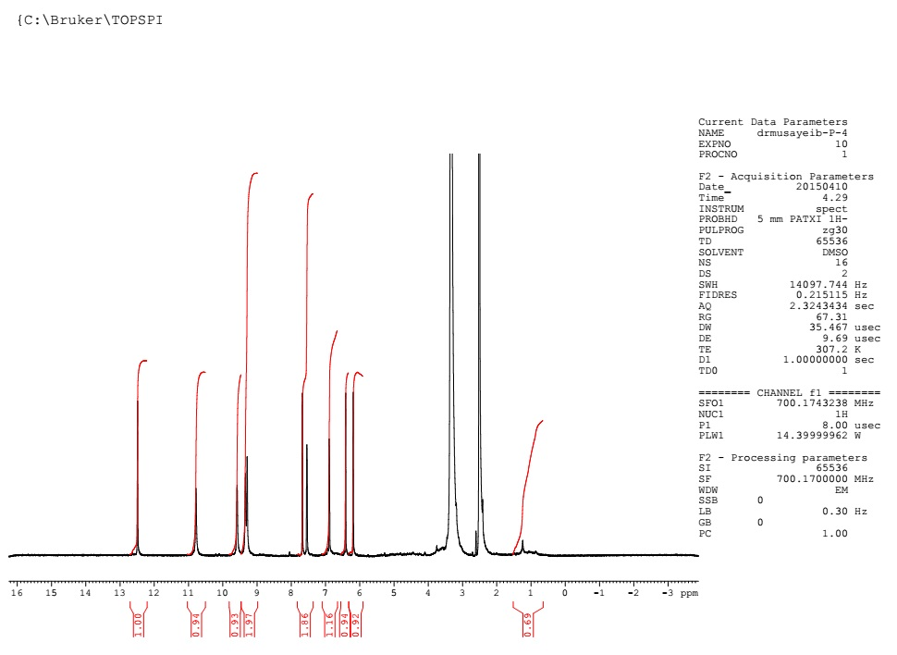
Figure S7. ¹H NMR spectrum of compound 2 (700 MHz, DMSO-d₆).

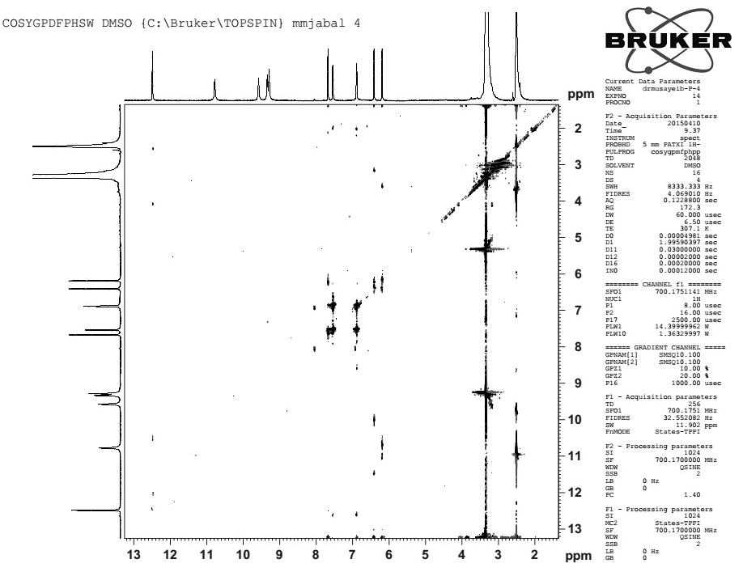
Figure S8. ¹H-¹H COSY spectrum of compound 2.
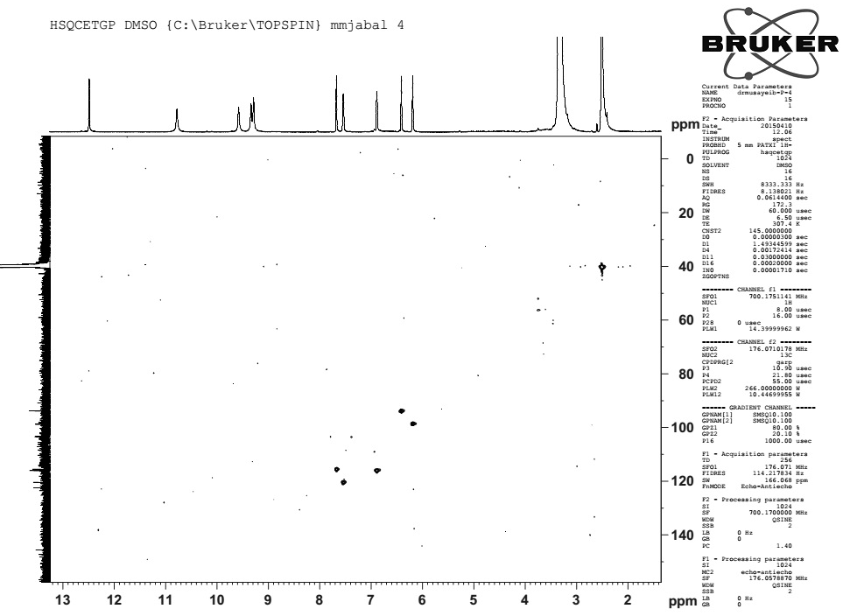
Figure S9. HSQC spectrum of compound 2.

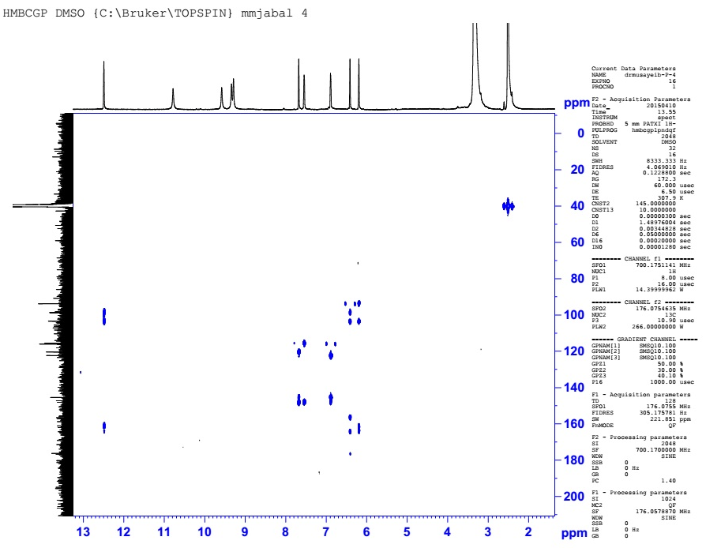
Figure S10. HMBC spectrum of compound 2.

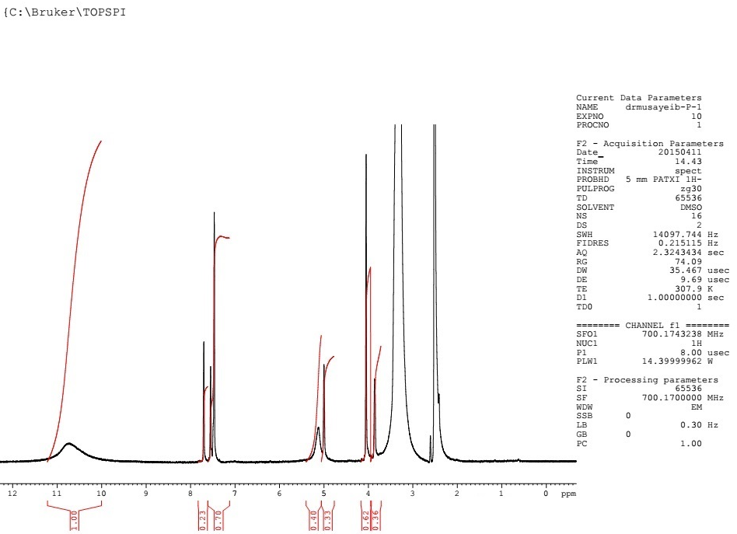
Figure S11. ¹H NMR spectrum of compound 3 (700 MHz, DMSO-d₆).

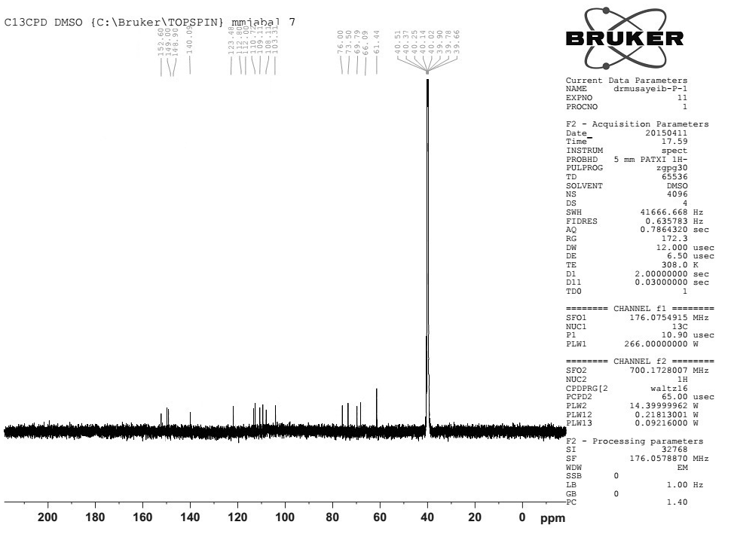
Figure S12. ¹³C NMR spectrum of compound 3 (175 MHz, DMSO-d₆).

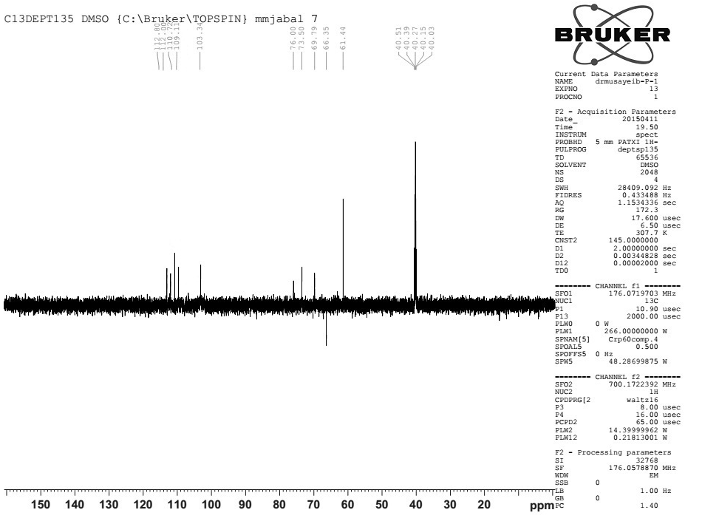

Figure S13. DEPT ¹³C NMR spectrum of compound 3.

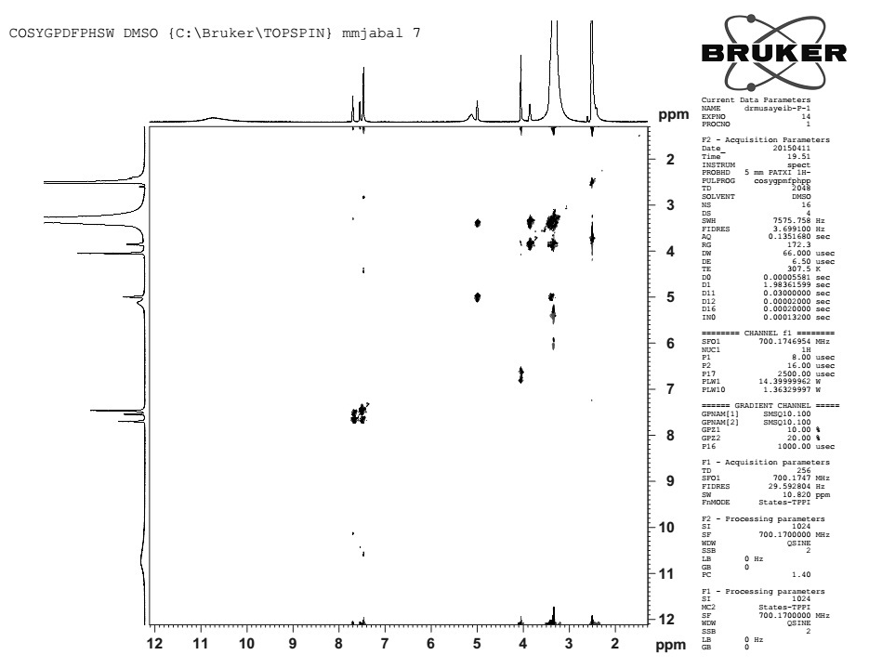
Figure S14. ¹H-¹H COSY spectrum of compound 3.
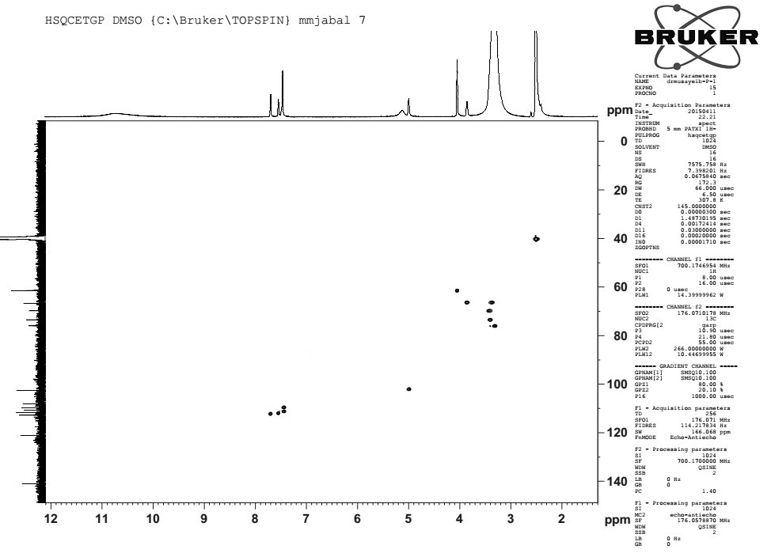
Figure S15. HSQC spectrum of compound 3.

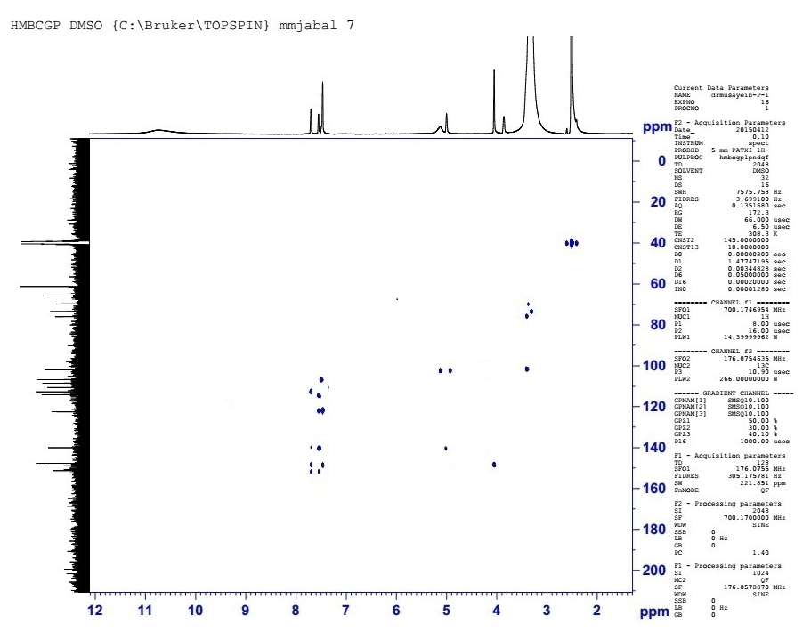
Figure S16. HMBC spectrum of compound 3.
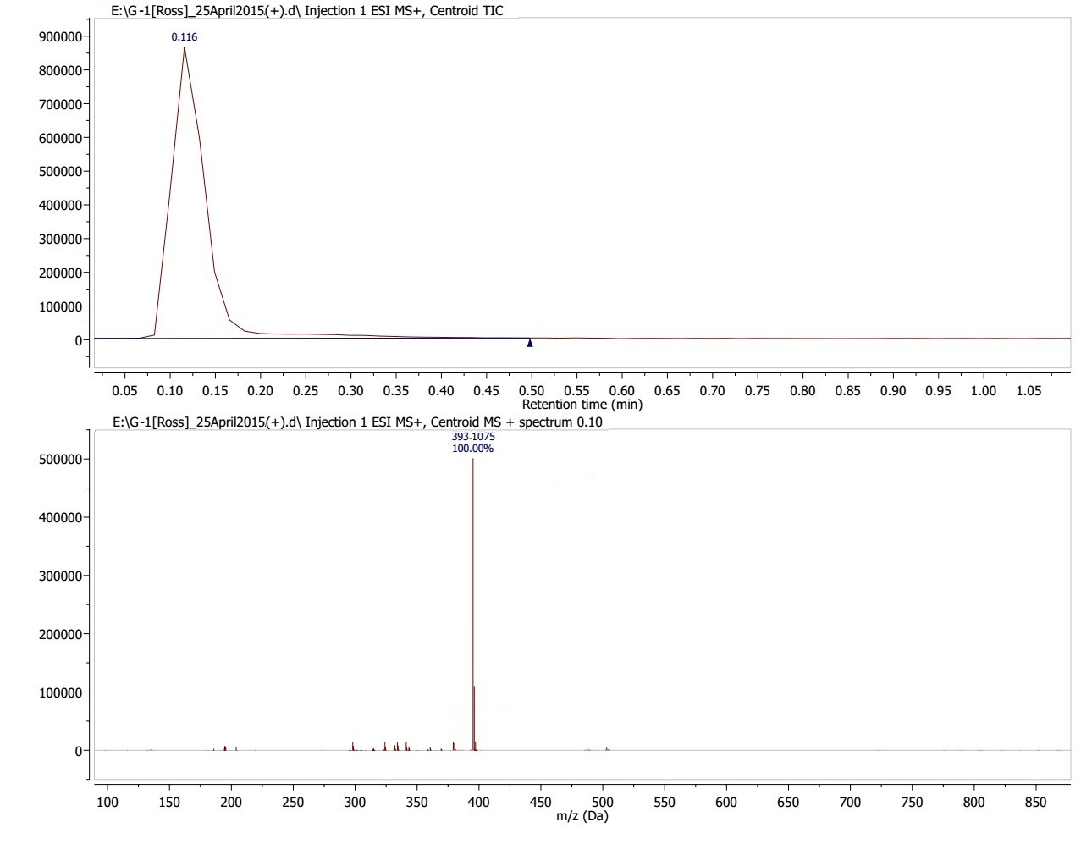
Figure S17. HRESIMS spectrum of compounds 3

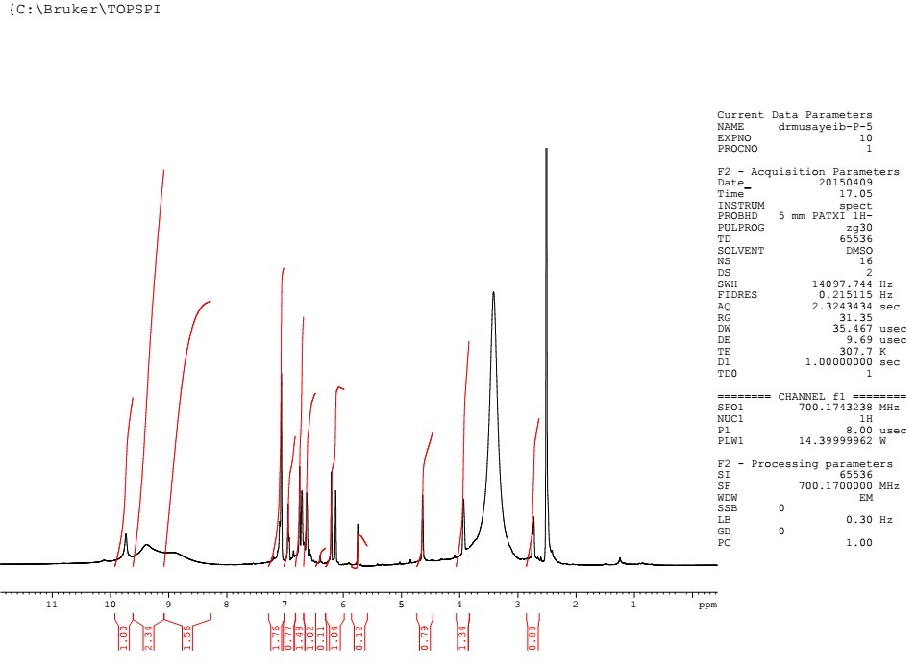
Figure S18. ¹H NMR spectrum of compound 4 (700 MHz, DMSO-d₆).

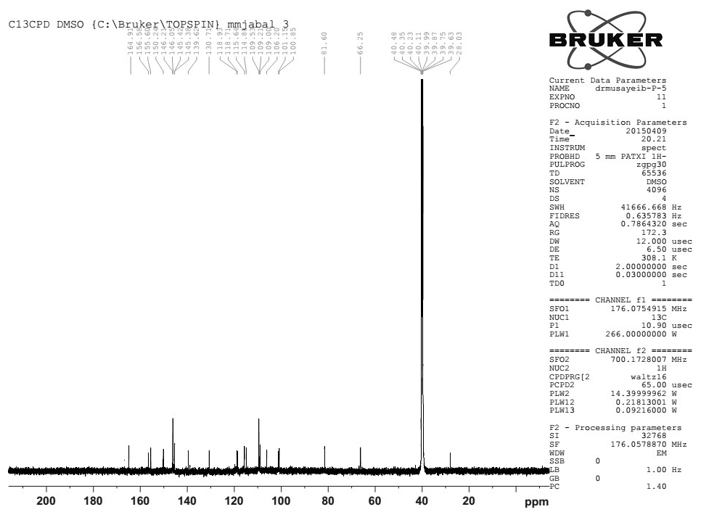
Figure S19. ¹³C NMR spectrum of compound 4 (175 MHz, DMSO-d₆).

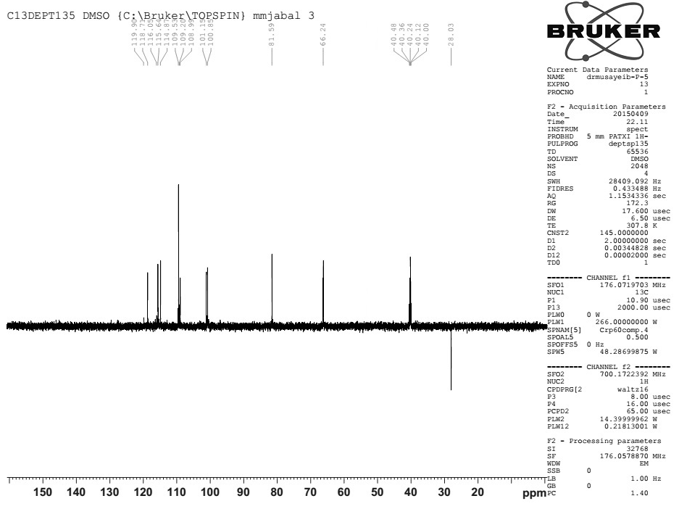
Figure S20. DEPT ¹³C NMR spectrum of compound 4.

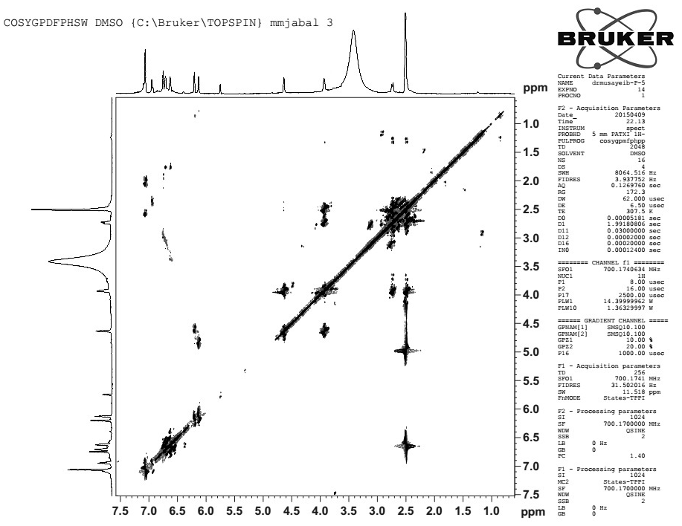
Figure S21. ¹H-¹H COSY spectrum of compound 4.

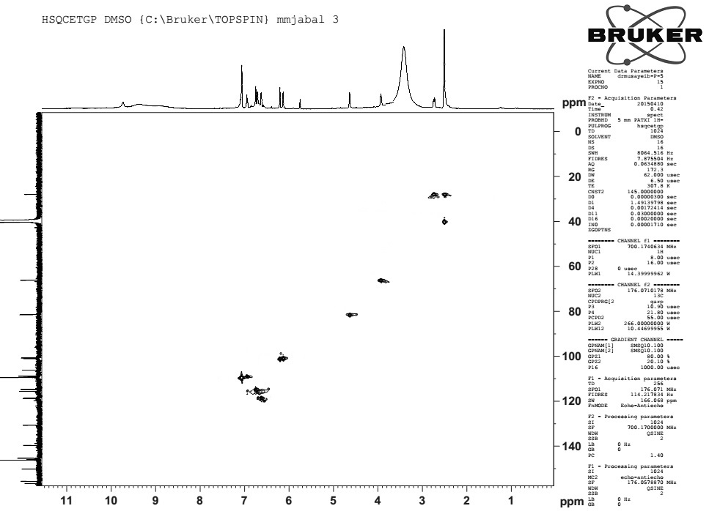
Figure S22. HSQC spectrum of compound 4.

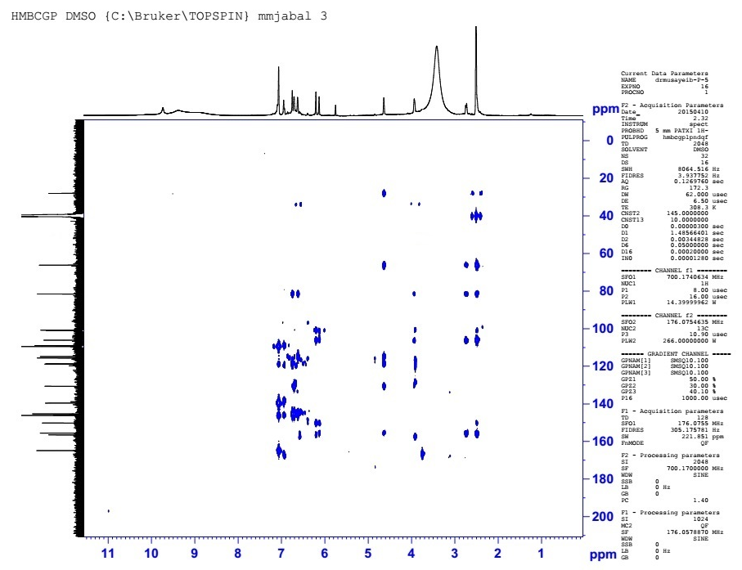
Figure S23. HMBC spectrum of compound 4.
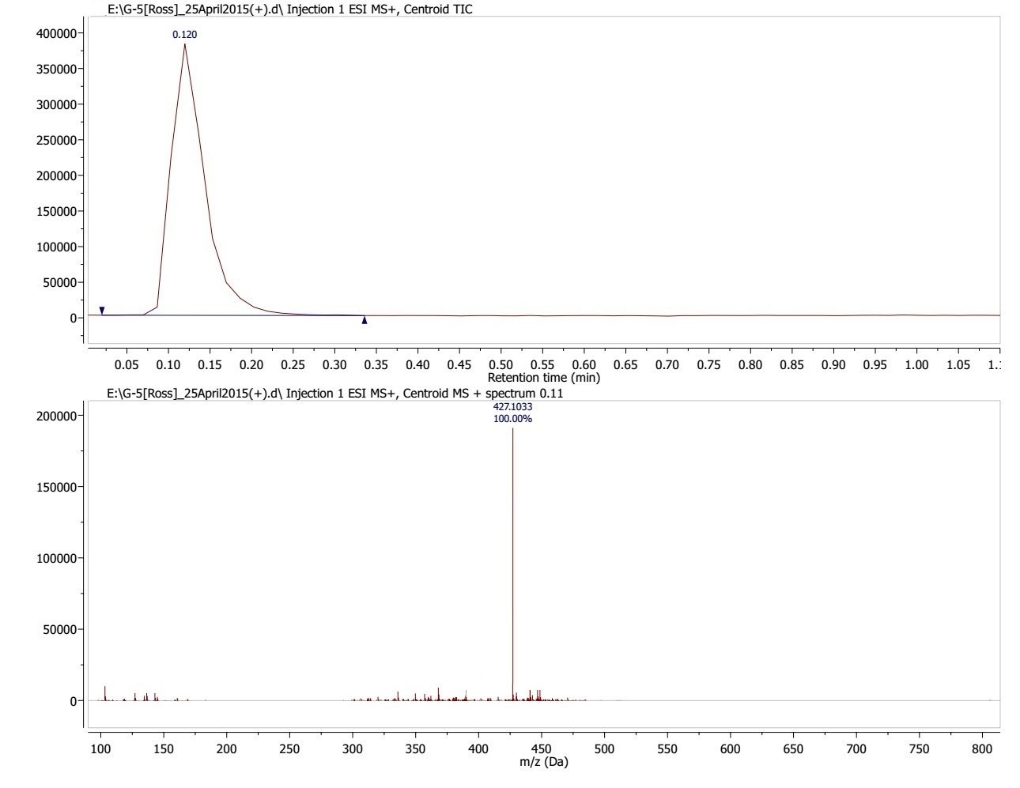
Figure S24. HRESIMS spectrum of compound 4

