Supplementary Material

Title: Aspernolides L and M, New Butyrolactones from the Endophytic Fungus Aspergillus versicolor

Sabrin R. M. Ibrahim^{1, 2*}, Gamal A. Mohamed^{3, 4} and Samir A. Ross ⁵

¹ Department of Pharmacognosy and Pharmaceutical Chemistry, College of Pharmacy, Taibah University, Al Madinah Al Munawwarah 30078, Saudi Arabia
² Department of Pharmacognosy, Faculty of Pharmacy, Assiut University, Assiut 71526, Egypt
³ Department of Natural Products and Alternative Medicine, Faculty of Pharmacy, King Abdulaziz University, Jeddah 21589, Saudi Arabia
⁴ Department of Pharmacognosy, Faculty of Pharmacy, Al-Azhar University, Assiut Branch, Assiut 71524, Egypt
⁵ National Center for Natural Products Research, Department of Pharmacognosy, School of Pharmacy, The University of Mississippi, Mississippi 38677, USA

* Corresponding author: Sabrin R.M. Ibrahim, Department of Pharmacognosy and Pharmaceutical Chemistry, College of Pharmacy, Taibah University, Al Madinah Al Munawwarah 30078, Saudi Arabia, E-mail: sabrinshaur@gmail.com; sribrahim@taibahu.edu.sa. Phone: +966 581183034.

 | Table of contents | Page
S1: | ¹H NMR spectrum of compound 1 (DMSO-d₆, 500 MHz) | 3
S2: | ¹³C NMR spectrum of compound 1 (DMSO-d₆, 125 MHz) | 3
S3: | ¹H NMR spectrum of compound 2 (DMSO-d₆, 500 MHz) | 4
S4: | ¹³C NMR spectrum of compound 2 (DMSO-d₆, 125 MHz) | 4
S5: | HSQC spectrum of compound 2 | 5
S6: | HMBC spectrum of compound 2 | 5
S7: | ¹H NMR spectrum of compound 3 (DMSO-d₆, 500 MHz) | 6
S8: | ¹³C NMR spectrum of compound 3 (DMSO-d₆, 125 MHz) | 6
S9: | ¹H NMR spectrum of compound 4 (DMSO-d₆, 500 MHz) | 7
S10: | ¹³C NMR spectrum of compound 4 (DMSO-d₆, 125 MHz) | 7
S11: | HSQC spectrum of compound 4 | 8
S12: | HMBC spectrum of compound 4 | 8
S13: | ¹H NMR spectrum of compound 5 (DMSO-d₆, 500 MHz) | 9
S14: | ¹³C NMR spectrum of compound 5 (DMSO-d₆, 125 MHz) | 9
S15: | ¹H NMR spectrum of compound 6 (DMSO-d₆, 500 MHz) | 10
S16: | ¹³C NMR spectrum of compound 6 (DMSO-d₆, 125 MHz) | 10

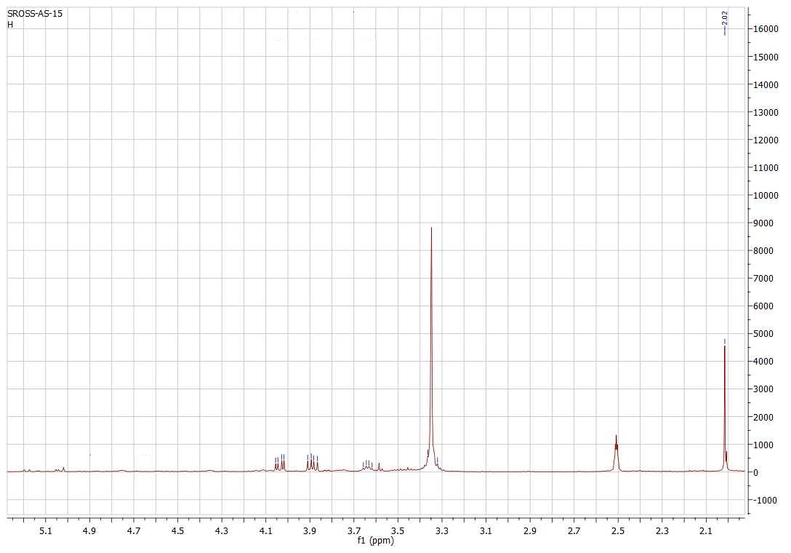

S1:¹H NMR spectrum of compound 1 (DMSO-d₆, 500 MHz)

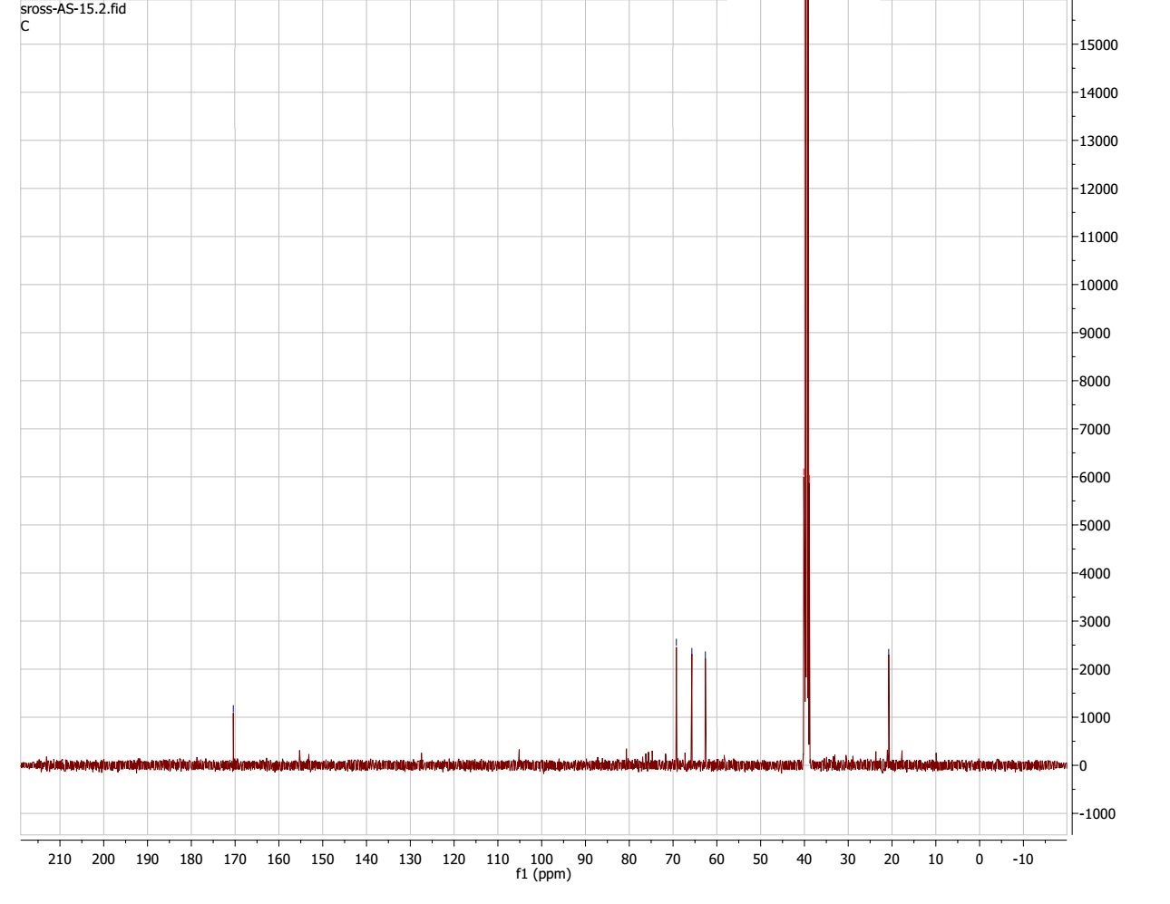

S2: ¹³C NMR spectrum of compound 1 (DMSO-d₆, 125 MHz)

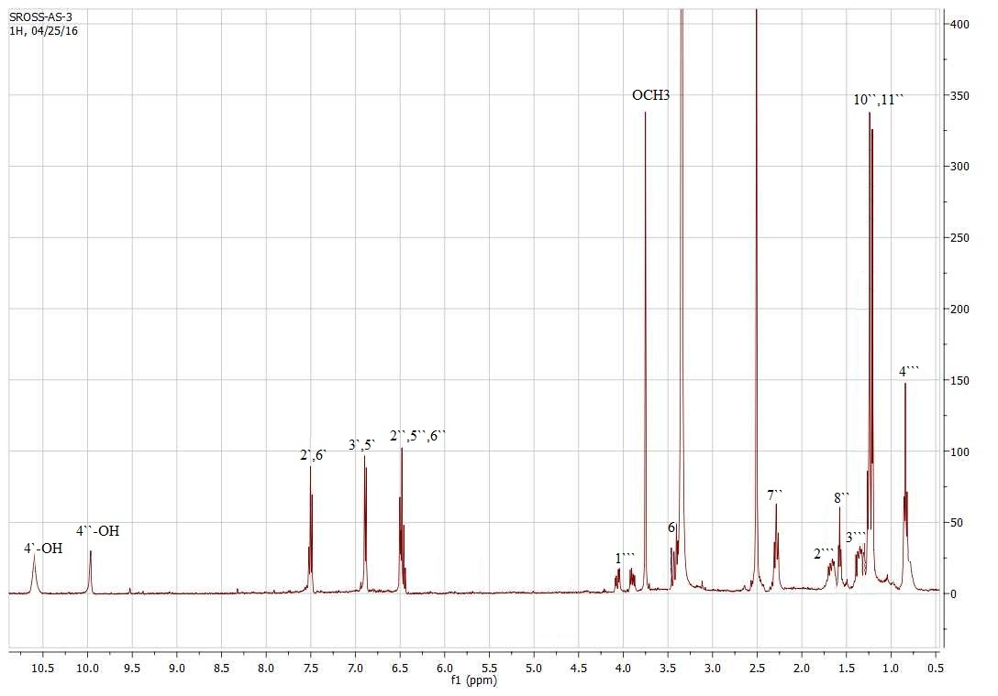

S3: ¹H NMR spectrum of compound 2 (DMSO-d₆, 500 MHz)

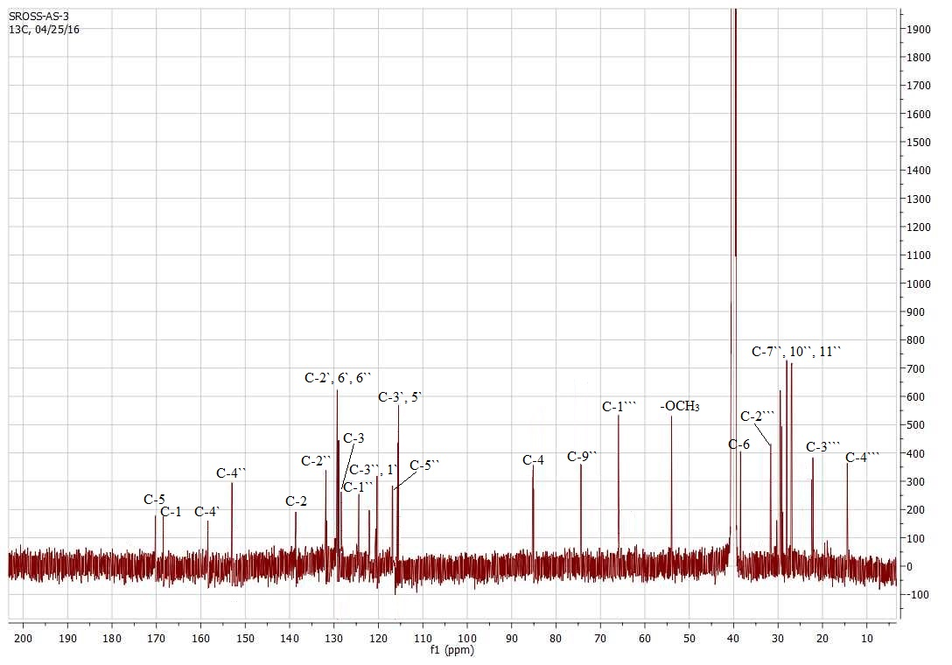

S4: ¹³C NMR spectrum of compound 2 (DMSO-d₆, 125 MHz)

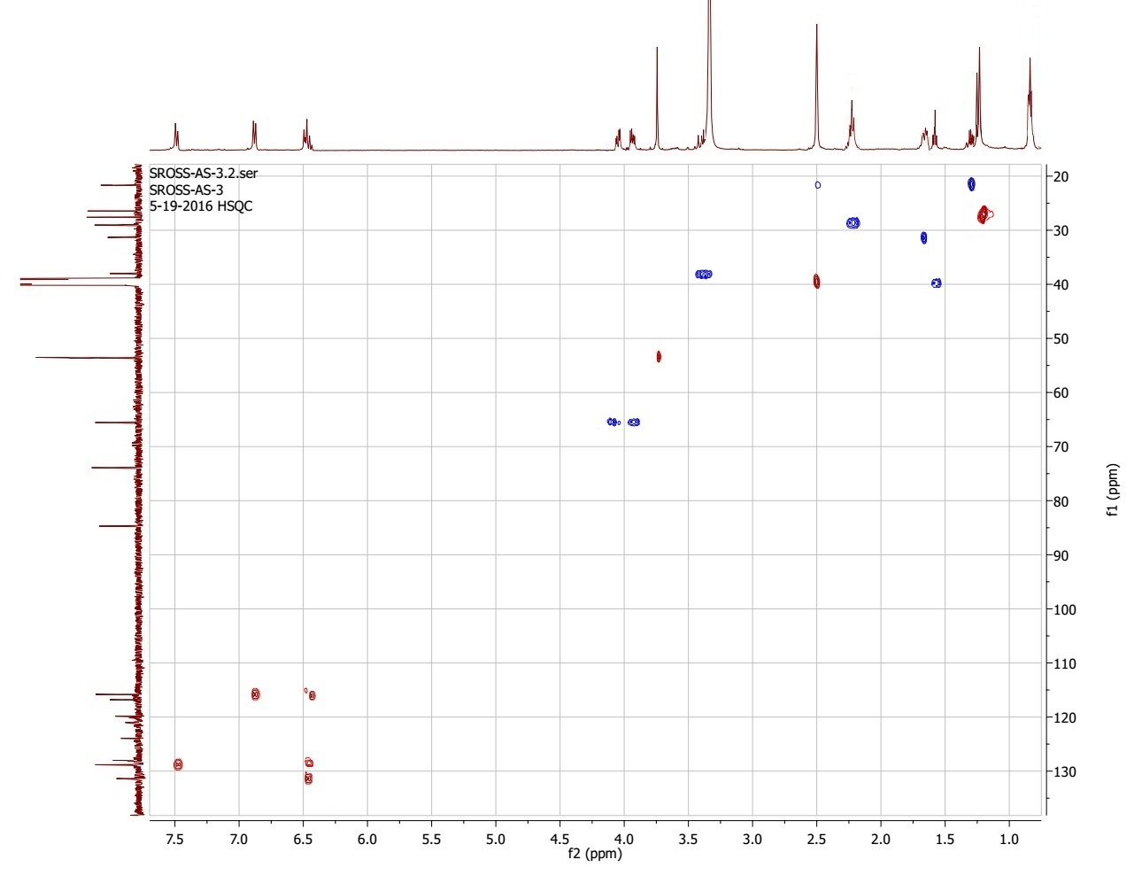

S5: HSQC spectrum of compound 2

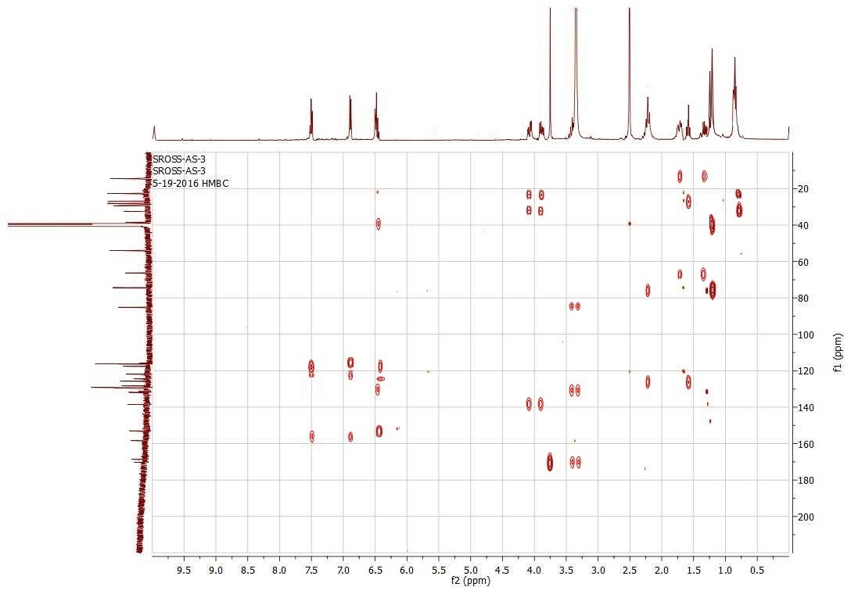

S6: HMBC spectrum of compound 2

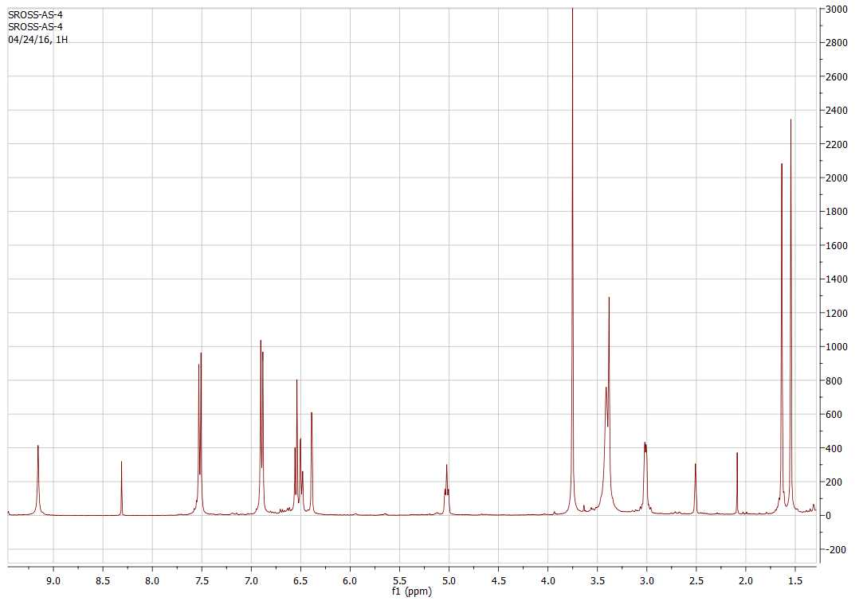

S7: ¹H NMR spectrum of compound 3 (DMSO-d₆, 500 MHz)

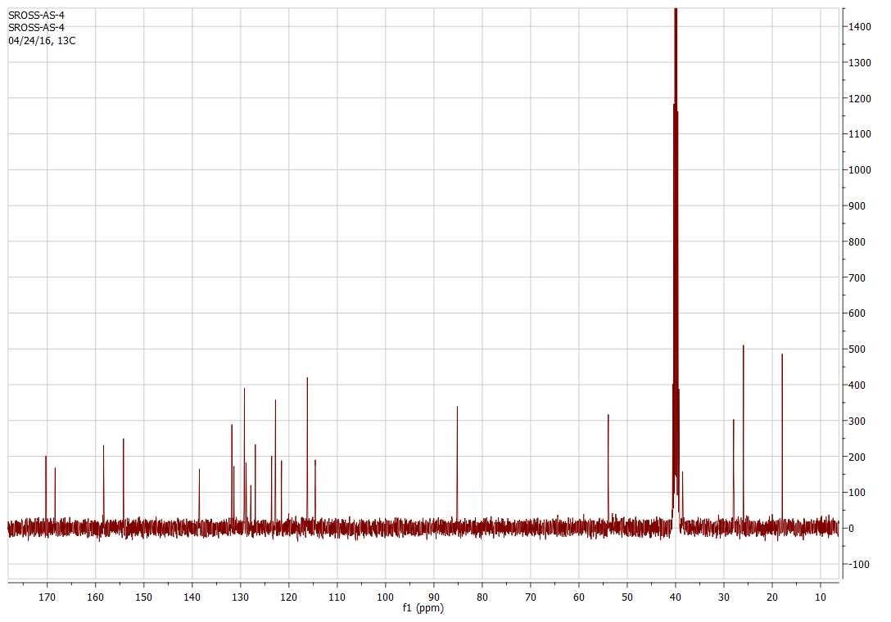

S8: ¹³C NMR spectrum of compound 3 (DMSO-d₆, 125 MHz)

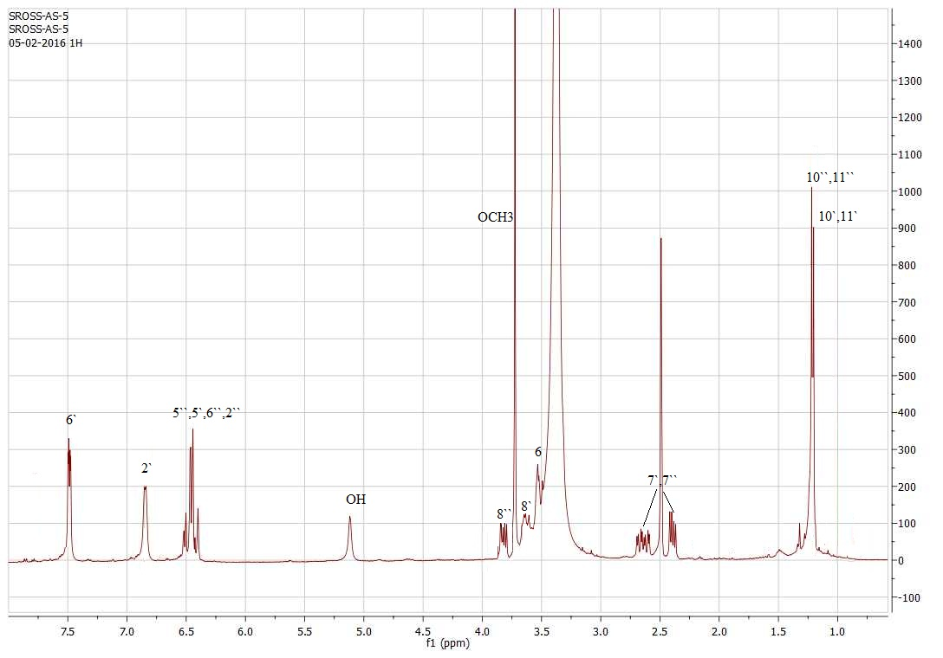

S9: ¹H NMR spectrum of compound 4 (DMSO-d₆, 500 MHz)

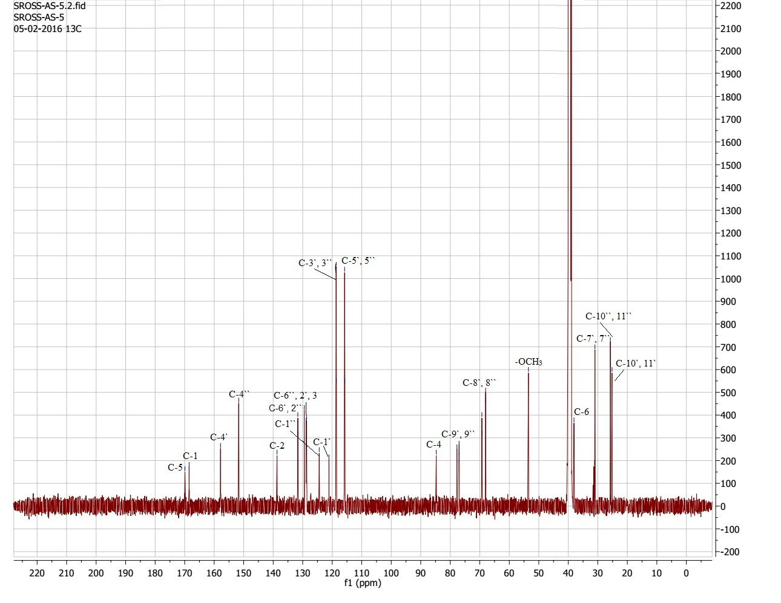

S10: ¹³C NMR spectrum of compound 4 (DMSO-d₆, 125 MHz)

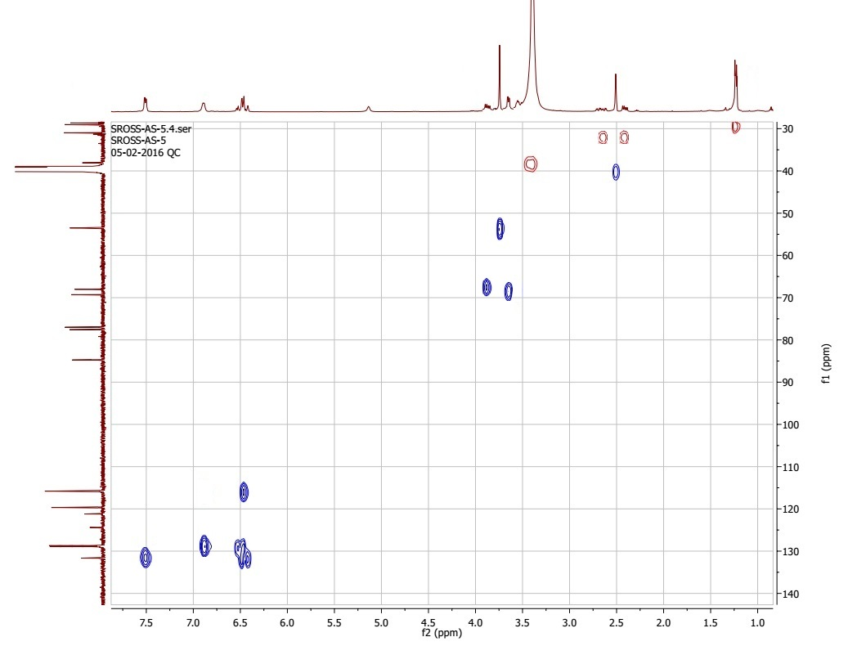

S11: HSQC spectrum of compound 4

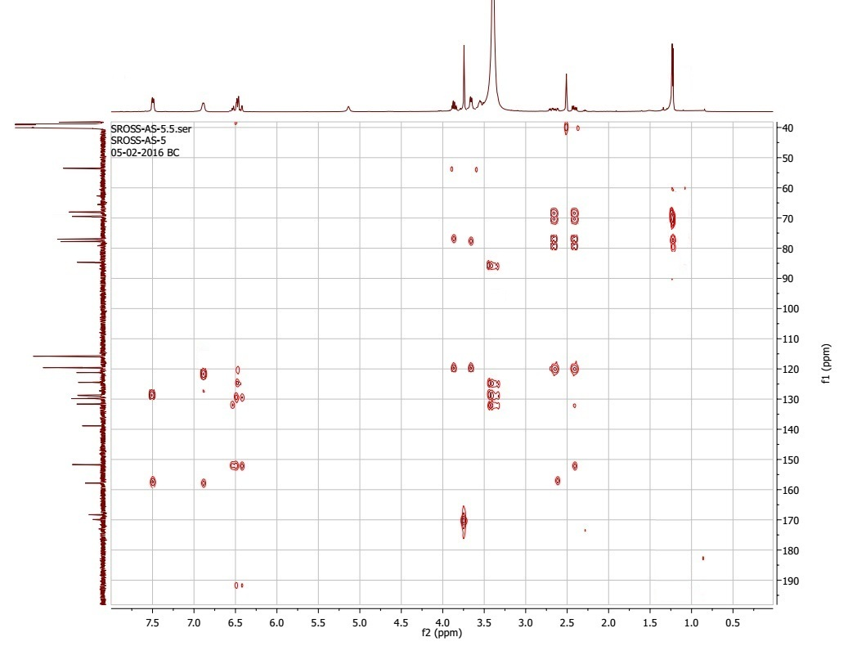

S12: HMBC spectrum of compound 4

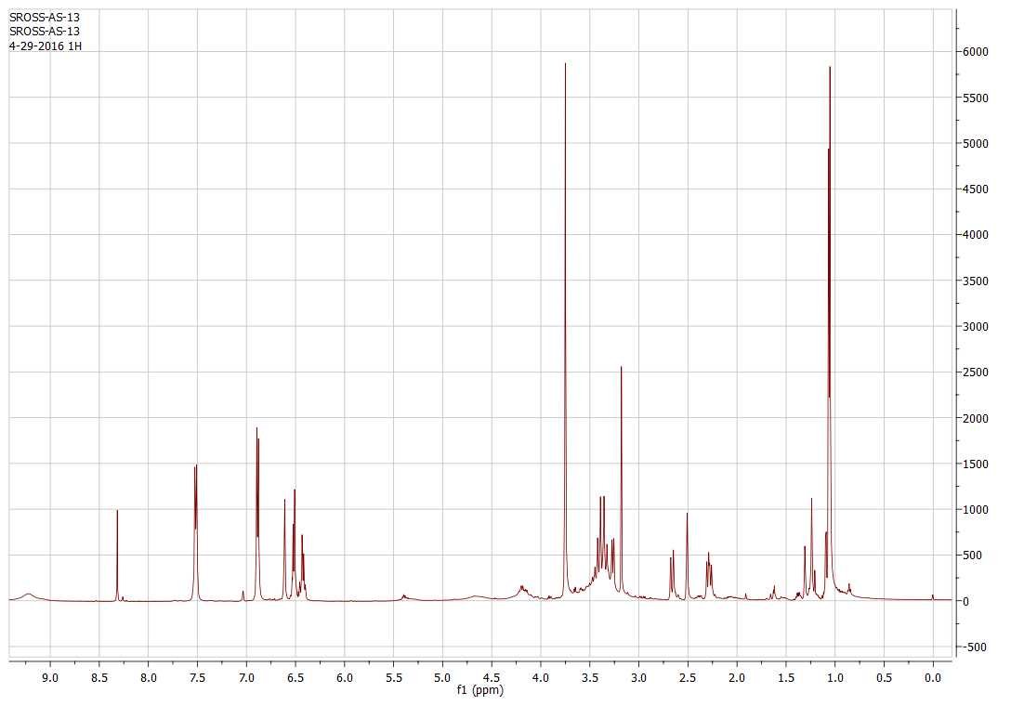

S13: ¹H NMR spectrum of compound 5 (DMSO-d₆, 500 MHz)

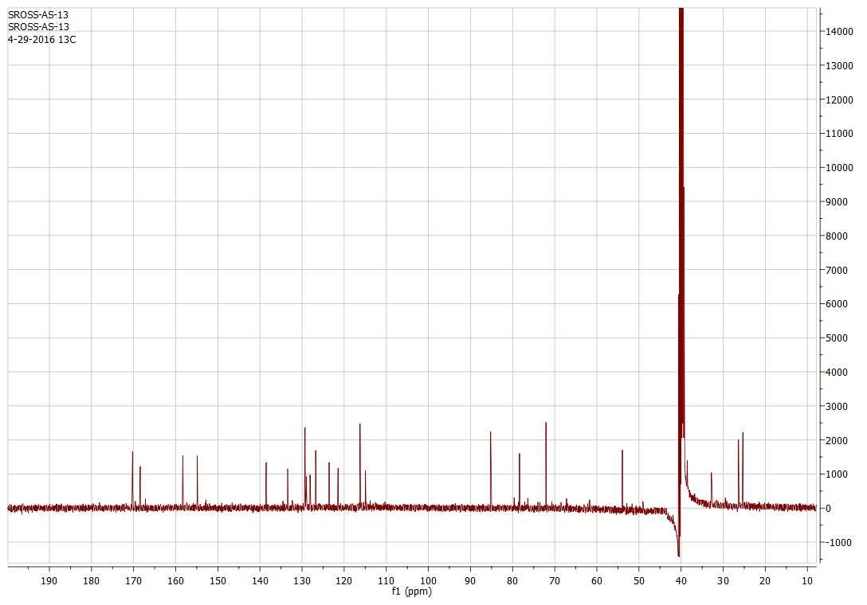

S14: ¹³C NMR spectrum of compound 5 (DMSO-d₆, 125 MHz)

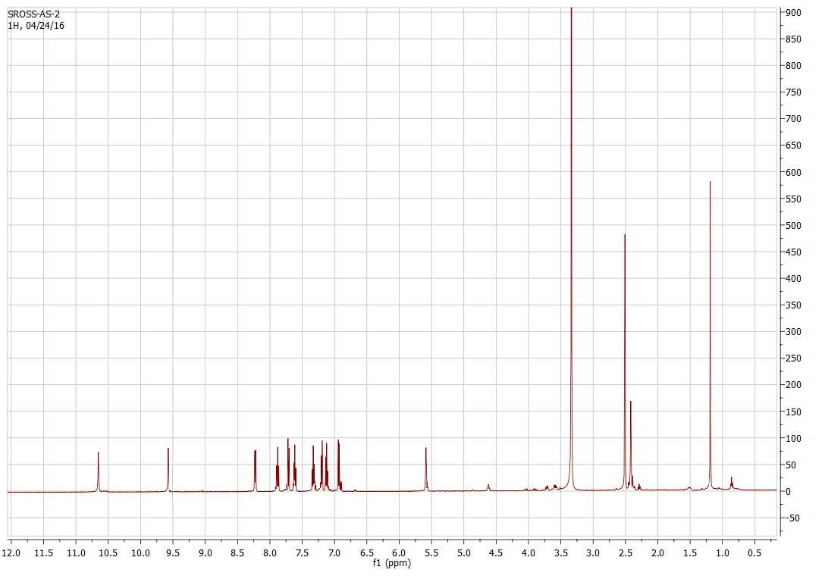

S15: ¹H NMR spectrum of compound 6 (DMSO-d₆, 500 MHz)

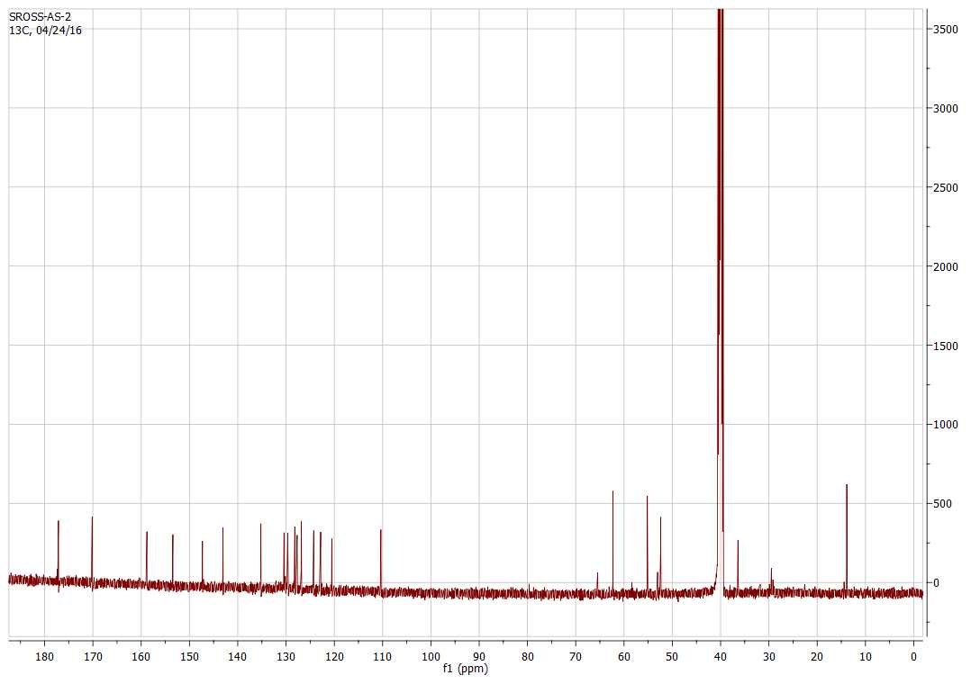

S16: ¹³C NMR spectrum of compound 6 (DMSO-d₆, 125 MHz)

