Supplementary Material

Volatile oil profile of some Lamiaceous plants growing in Saudi Arabia and their biological activities

Sabrin R. M. Ibrahim^{1,*}, Hossam M. Abdallah^{2,3}, Gamal A. Mohamed^{2,4}, Mohamed A. Farag³, Khalid Z. Alshali⁵, Emad Alsherif^{6,7} and Samir A. Ross⁸

¹Department of Pharmacognosy and Pharmaceutical Chemistry, College of Pharmacy, Taibah University, Al Madinah Al Munawwarah 30078, Saudi Arabia.
²Department of Natural Products and Alternative Medicine, Faculty of Pharmacy, King Abdulaziz University, Jeddah, Saudi Arabia.
³Department of Pharmacognosy, Faculty of Pharmacy, Cairo University, Cairo, Egypt.
⁴Department of Pharmacognosy, Faculty of Pharmacy, Al-Azhar University, Assiut Branch, Assiut, Egypt.
⁵Department of Medicine, Faculty of Medicine, King Abdulaziz University, Jeddah, Saudi Arabia.
⁶Department of Botany, Faculty of Science, Beni Suef University, Beni Suef 62111, Egypt.
⁷Department of Biology, Faculty of Science & Arts, Khulais, King Abdulaziz University, Jeddah, Saudi Arabia.
⁸National Center for Natural Products Research, Department of Pharmacognosy, School of Pharmacy, University of Mississippi, University, MS 38677, USA

*E-mail address: sabrinshaur@gmail.com; sribrahim@taibahu.edu.sa

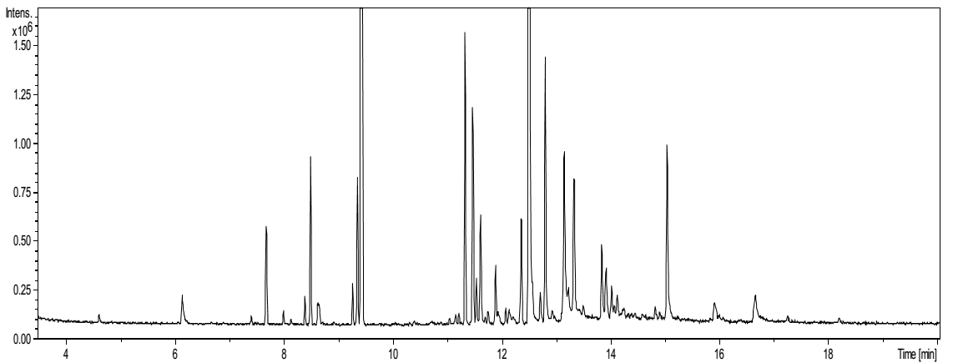
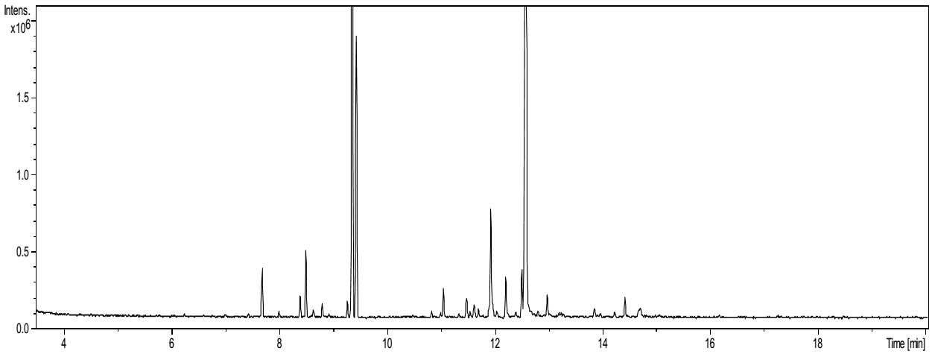
Fig 1S: GC chromatograms of essential oils from Mentha longifolia L. (top) and Mentha microphylla K.Koch (bottom).

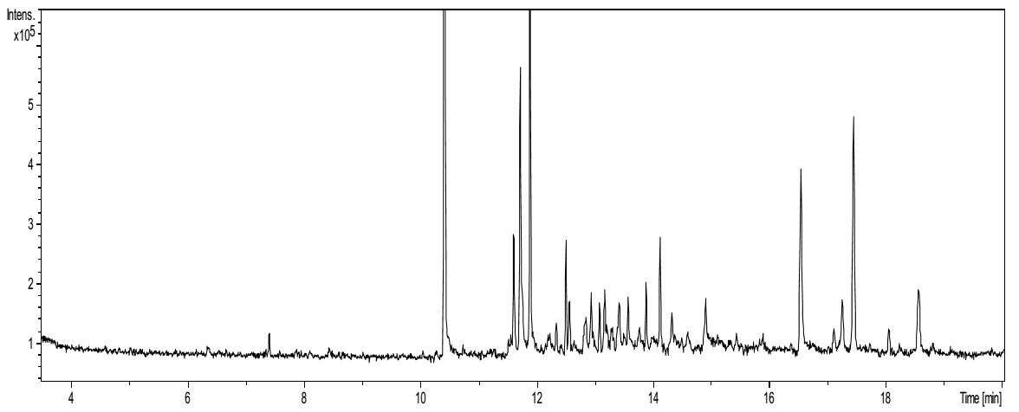
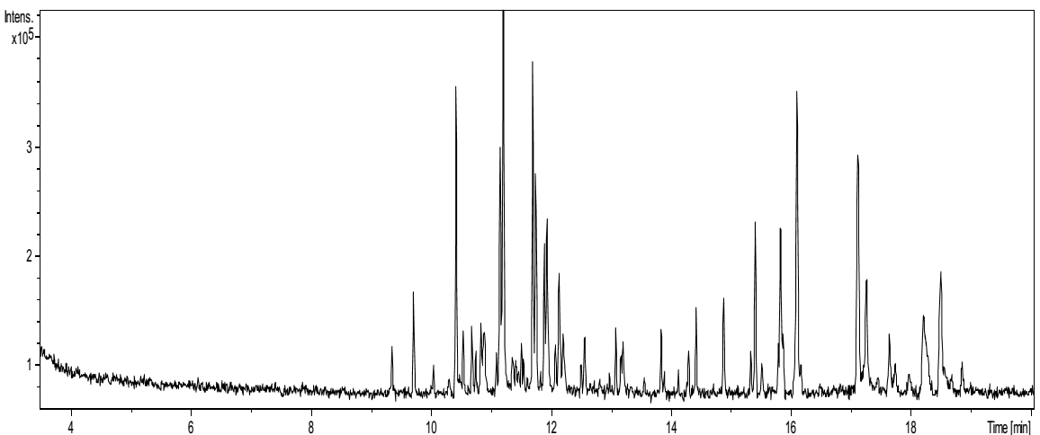
Fig 2S: GC chromatogram of essential oils from Mentha australis R.Br. (top) and Teucrium polium L. (bottom).

