Synthesis and structure characterization of three new mixed ligand alkaline-earth metal picrates

Dedicated to Professor Christian Näther on the occasion of his 60th birthday

Neha U. Parsekar, Kedar U. Narvekar, Bikshandarkoil R. Srinivasan*
School of Chemical Sciences, Goa University, Goa 403206, India *Email: srini@unigoa.ac.in

Supplementary material for ONLINE version

Table S1: Geometric parameters (Å, º) of the picrate anion and nicotinamide in 1-3.

[Ba(H₂O)(nic)₂(pic)₂] 1
C1-O2 | 1.234(2) |  | N4-C10 | 1.442(2)
C1-N1 | 1.329(2) |  | O3-C7 | 1.245(2)
C1-C2 | 1.492(2) |  | N3-O5 | 1.232(2)
N2-C5 | 1.327(2) |  | N3-C8 | 1.449(2)
N2-C6 | 1.337(2) |  | N5-O9 | 1.219(2)
C2-C6 | 1.382(2) |  | N5-O8 | 1.220(2)
C2-C3 | 1.386(2) |  | N5-C12 | 1.461(2)
O4-N3 | 1.2279(19) |  | C7-C12 | 1.452(2)
C4-C3 | 1.368(3) |  | C7-C8 | 1.453(2)
C4-C5 | 1.377(3) |  | C8-C9 | 1.376(2)
N4-O6 | 1.224(2) |  | C9-C10 | 1.378(3)
N4-O7 | 1.229(2) |  | C10-C11 | 1.391(3)
 |  |  | C11-C12 | 1.365(2)
O2-C1-N1 | 122.65(16) |  | O9-N5-C12 | 119.01(18)
O2-C1-C2 | 119.38(16) |  | O8-N5-C12 | 117.28(18)
N1-C1-C2 | 117.96(15) |  | N2-C6-C2 | 123.52(15)
C5-N2-C6 | 117.21(15) |  | O3-C7-C12 | 122.55(16)
C6-C2-C3 | 117.86(15) |  | O3-C7-C8 | 126.17(16)
C6-C2-C1 | 123.07(15) |  | C12-C7-C8 | 111.18(14)
C3-C2-C1 | 119.05(15) |  | C9-C8-N3 | 115.95(16)
C3-C4-C5 | 118.89(18) |  | C9-C8-C7 | 124.27(16)
O6-N4-O7 | 122.87(17) |  | N3-C8-C7 | 119.77(15)
O6-N4-C10 | 118.91(17) |  | C8-C9-C10 | 119.42(16)
O7-N4-C10 | 118.22(17) |  | C9-C10-C11 | 121.16(16)
C4-C3-C2 | 119.08(17) |  | C9-C10-N4 | 119.61(16)
O4-N3-O5 | 121.99(15) |  | C11-C10-N4 | 119.23(16)
O4-N3-C8 | 119.63(15) |  | C12-C11-C10 | 118.76(16)
O5-N3-C8 | 118.38(15) |  | C11-C12-C7 | 125.13(16)
N2-C5-C4 | 123.41(17) |  | C11-C12-N5 | 116.21(16)
O9-N5-O(8) | 123.70(19) |  | C7-C12-N5 | 118.55(15)
[Ca(H₂O)₂(nic)₂(pic)₂] 2
N1-C6 | 1.330(3) |  | N3-O4 | 1.233(2)
N1-C5 | 1.335(3) |  | N3-C8 | 1.450(3)
C1-O2 | 1.231(3) |  | C2-C6 | 1.388(3)
C1-N2 | 1.319(3) |  | N4-O6 | 1.223(3)
C1-C2 | 1.490(3) |  | N4-O7 | 1.231(3)
C12-C11 | 1.364(3) |  | N4-C10 | 1.452(3)
C12-C7 | 1.452(3) |  | C4-C5 | 1.369(3)
C12-N5 | 1.458(3) |  | N5-O9 | 1.216(3)
O3-C7 | 1.247(2) |  | N5-O8 | 1.227(3)
C3-C4 | 1.379(3) |  | C7-C8 | 1.452(3)
C3-C2 | 1.382(3) |  | C11-C10 | 1.376(4)
N3-O5 | 1.222(2) |  | C9-C10 | 1.375(3)
 |  |  | C9-C8 | 1.381(3)
C6-N1-C5 | 117.11(19) |  | C5-C4-C3 | 118.1(2)
O2-C1-N2 | 121.5(2) |  | O9-N5-O8 | 123.7(2)
O2-C1-C2 | 119.00(19) |  | O9-N5-C12 | 118.8(2)
N2-C1-C2 | 119.47(19) |  | O8-N5-C12 | 117.5(2)
C11-C12-C7 | 124.2(2) |  | N1-C5-C4 | 124.1(2)
C11-C12-N5 | 116.0(2) |  | N1-C6-C2 | 123.4(2)
C7-C12-N5 | 119.77(19) |  | O3-C7-C8 | 125.26(19)
C4-C3-C2 | 119.4(2) |  | O3-C7-C12 | 123.2(2)
O5-N3-O4 | 121.04(19) |  | C8-C7-C12 | 111.59(18)
O5-N3-C8 | 118.82(18) |  | C12-C11-C10 | 119.5(2)
O4-N3-C8 | 120.14(18) |  | C10-C9-C8 | 118.9(2)
C3-C2-C6 | 117.8(2) |  | C9-C8-N3 | 115.3(2)
C3-C2-C1 | 118.65(18) |  | C9-C8-C7 | 124.1(2)
C6-C2-C1 | 123.48(19) |  | N3-C8-C7 | 120.50(18)
O6-N4-O7 | 123.6(2) |  | C9-C10-C11 | 121.6(2)
O6-N4-C10 | 118.4(2) |  | C9-C10-N4 | 119.2(2)
O7-N4-C10 | 118.0(3) |  | C11-C10-N4 | 119.2(2)
[Sr(H₂O)₂(nic)₂(pic)₂] 3
N1-C6 | 1.334(4) |  | N4-C10 | 1.459(4)
N1-C5 | 1.345(5) |  | O3-C7 | 1.246(4)
C1-O2 | 1.234(4) |  | N3-O5 | 1.216(4)
C1-N2 | 1.324(5) |  | N3-C8 | 1.456(4)
C1-C2 | 1.491(5) |  | N5-O9 | 1.213(5)
C2-C3 | 1.385(4) |  | N5-O8 | 1.226(4)
C2-C6 | 1.394(5) |  | N5-C12 | 1.462(5)
O4-N3 | 1.234(3) |  | C7-C8 | 1.450(5)
C4-C5 | 1.368(5) |  | C7-C12 | 1.457(4)
C4-C3 | 1.387(5) |  | C8-C9 | 1.383(4)
N4-O6 | 1.219(5) |  | C9-C10 | 1.375(5)
N4-O7 | 1.226(5) |  | C10-C11 | 1.378(5)
 |  |  | C11-C12 | 1.363(5)
C6-N1-C5 | 117.5(3) |  | O9-N5-C12 | 119.0(3)
O2-C1-N2 | 121.7(3) |  | O8-N5-C12 | 117.7(4)
O2-C1-C2 | 118.7(3) |  | O3-C7-C8 | 125.5(3)
N2-C1-C2 | 119.5(3) |  | O3-C7-C12 | 122.7(3)
C3-C2-C6 | 117.8(3) |  | C8-C7-C12 | 111.8(3)
C3-C2-C1 | 118.5(3) |  | N1-C6-C2 | 123.1(3)
C6-C2-C1 | 123.7(3) |  | C9-C8-C7 | 124.0(3)
C5-C4-C3 | 117.8(3) |  | C9-C8-N3 | 114.8(3)
O6-N4-O7 | 123.6(4) |  | C7-C8-N3 | 121.1(3)
O6-N4-C10 | 118.7(4) |  | C10-C9-C8 | 118.8(4)
O7-N4-C10 | 117.7(4) |  | C9-C10-C11 | 121.9(3)
C2-C3-C4 | 119.9(3) |  | C9-C10-N4 | 119.1(4)
O5-N3-O4 | 121.1(3) |  | C11-C10-N4 | 119.0(3)
O5-N3-C8 | 119.1(3) |  | C12-C11-C10 | 119.3(3)
O4-N3-C8 | 119.8(3) |  | C11-C12-C7 | 124.1(3)
N1-C5-C4 | 123.9(3) |  | C11-C12-N5 | 116.5(3)
O9-N5-O8 | 123.2(4) |  | C7-C12-N5 | 119.4(3)

Table S2: Hydrogen bonding geometries (Å, °) for 1-3.

D-HꞏꞏꞏA | d(D-H) | d(HꞏꞏꞏA) | <DHA | d(DꞏꞏꞏA) | Symmetry code
[Ba(H₂O)(nic)₂(pic)₂] 1
N1-H1AꞏꞏꞏO3 | 0.86 | 2.574 | 160.25 | 3.396 | -x+1, y, -z+3/2
N1-H1AꞏꞏꞏO9 | 0.86 | 2.273 | 130.13 | 2.903 | -x+1, y, -z+3/2
N1-H1BꞏꞏꞏO5 | 0.86 | 2.32 | 164.14 | 3.156 | -x+1/2, y-1/2, -z+3/2
O1-H1CꞏꞏꞏO7 | 0.93 | 2.307 | 135.43 | 3.04 | -x+1/2, -y+1/2, -z+1
O1-H1DꞏꞏꞏO7 | 0.93 | 2.307 | 135.43 | 3.04 | x+1/2, -y+1/2, z+1/2
C4-H4ꞏꞏꞏO8 | 0.93 | 2.536 | 161.5 | 3.431 | x-1/2, y+1/2, z
C5-H5ꞏꞏꞏO4 | 0.93 | 2.537 | 134.77 | 3.259 | x-1/2, y-1/2, z
C5-H5ꞏꞏꞏO6 | 0.93 | 2.634 | 116.78 | 3.163 | -x, -y+1, -z+1
C6-H6ꞏꞏꞏO2 | 0.93 | 2.622 | 126.72 | 3.264 | -x+1/2, y-1/2, -z+3/2
[Ca(H₂O)₂(nic)₂(pic)₂] 2
O1-H1BꞏꞏꞏO7 | 0.793 | 2.534 | 137.1 | 3.161 | x+1/2, -y+3/2, z+1/2
O1-H1BꞏꞏꞏO9 | 0.793 | 2.595 | 144.5 | 3.273 | -x+1, -y+1, -z+1
O1-H1AꞏꞏꞏN1 | 0.814 | 1.988 | 164.27 | 2.78 | -x+1, y+1, -z+3/2
N2-H2AꞏꞏꞏO3 | 0.86 | 2.417 | 149.42 | 3.188 | -x+1, y, -z+3/2
N2-H2AꞏꞏꞏO9 | 0.86 | 2.202 | 137.97 | 2.898 | -x+1, y, -z+3/2
N2-H2BꞏꞏꞏO5 | 0.86 | 2.619 | 145.85 | 3.366 | -x+1, y-1, -z+3/2
C6-H6ꞏꞏꞏO4 | 0.93 | 2.658 | 137.5 | 3.402 | -x+1, y-1, -z+3/2
[Sr(H₂O)₂(nic)₂(pic)₂] 3
O1-H1AꞏꞏꞏO7 | 0.93 | 2.324 | 138 | 3.078 | x-1/2, -y+1/2, z-1/2
O1-H1AꞏꞏꞏO9 | 0.93 | 2.565 | 139.41 | 3.327 | -x+1, -y+1, -z+1
O1-H1BꞏꞏꞏN1 | 0.93 | 2.003 | 141.12 | 2.788 | -x+1, y-1, -z+1/2
N2-H2AꞏꞏꞏO3 | 0.86 | 2.664 | 145.96 | 3.411 | -x+1, y, -z+1/2
N2-H2AꞏꞏꞏO9 | 0.86 | 2.270 | 144.55 | 3.012 | -x+1, y, -z+1/2
N2-H2BꞏꞏꞏO5 | 0.86 | 2.544 | 148.41 | 3.308 | -x+1, y+1, -z+1/2
C6-H6ꞏꞏꞏO4 | 0.93 | 2.676 | 141.11 | 3.449 | -x+1, y+1, -z+1/2

Table S3: Analysis of short ring-π - π interactions with Cg∙∙∙Cg distances < 6.0 Å , α < 20.0º and β < 60.0º in 1-3.
Cg(I) | Res(I) | Cg(J) | [ARU(J)] | Cg∙∙∙Cg | α | β | γ | CgI_Perp | Cg J_Perp | Slippage
[Ba(H₂O)(nic)₂(pic)₂] 1
Cg(1) | [1] -> | Cg(1) | [2555.01] | 4.8301(2) | 46 | 42.9 | 42.9 | 3.5406 | 3.5406
Cg(1) | [1] -> | Cg(2) | [6545.01] | 4.8301(2) | 46 | 42.9 | 42.9 | 3.5406 | 3.5406
Cg(1) | [1] -> | Cg(3) | [3556.01] | 5.1921(2) | 56 | 20.1 | 76.3 | 1.2271 | 4.8757
Cg(1) | [1] -> | Cg(3) | [5445.01] | 5.5792(2) | 56 | 32.4 | 31.7 | 4.7454 | 4.7115
Cg(1) | [1] -> | Cg(3) | [8444.01] | 5.8395(2) | 12 | 46.9 | 53.6 | 3.4650 | 3.9869 | 4.267
Cg(2) | [1] -> | Cg(1) | [6555.01] | 4.8301(2) | 46 | 42.9 | 42.9 | 3.5406 | 3.5406
Cg(2) | [1] -> | Cg(2) | [2655.01] | 4.8301(2) | 46 | 42.9 | 42.9 | 3.5406 | 3.5406
Cg(2) | [1] -> | Cg(3) | [1555.01] | 5.5792(2) | 56 | 32.4 | 31.7 | 4.7454 | 4.7115
Cg(2) | [1] -> | Cg(3) | [4554.01] | 5.8395(2) | 12 | 46.9 | 53.6 | 3.4650 | 3.9869 | 4.267
Cg(2) | [1] -> | Cg(3) | [7556.01] | 5.1921(2) | 56 | 20.1 | 76.3 | 1.2271 | 4.8757
Cg(3) | [1] -> | Cg(1) | [5555.01] | 5.5792(2) | 56 | 31.7 | 32.4 | 4.7115 | 4.7454
Cg(3) | [1] -> | Cg(1) | [8545.01] | 5.8395(2) | 12 | 53.6 | 46.9 | 3.9869 | 3.4650 | 4.700
Cg(3) | [1] -> | Cg(2) | [1555.01] | 5.5792(2) | 56 | 31.7 | 32.4 | 4.7115 | 4.7454
Cg(3) | [1] -> | Cg(2) | [4555.01] | 5.8395(2) | 12 | 53.6 | 46.9 | 3.9869 | 3.4650 | 4.700
Cg(3) | [1] -> | Cg(3) | [3556.01] | 5.9138(2) | 0 | 51.9 | 51.9 | 3.6528 | 3.6528 | 4.651
Cg(3) | [1] -> | Cg(3) | [7556.01] | 4.5669(2) | 0 | 39.6 | 39.6 | 3.5182 | 3.5182 | 2.912
Where, Cg(1) = Cg(2) = nicotinamide (C2, C3, C4, C5, N2, C6) & Cg(3) = picrate (C7, C8, C9, C10, C11, C12)
[Ca(H₂O)₂(nic)₂(pic)₂] 2
Cg(1) | [1] -> | Cg(2) | [1545.01] | 5.2823(3) | 4 | 56.0 | 57.6 | 2.8276 | 2.9551 | 4.378
Cg(1) | [1] -> | Cg(2) | [4554.01] | 3.5476(2) | 3 | 15.9 | 19.1 | 3.3521 | 3.4119 | 0.972
Cg(2) | [1] -> | Cg(1) | [1565.01] | 5.2823(3) | 4 | 57.6 | 56.0 | 2.9551 | 2.8276 | 4.462
Cg(2) | [1] -> | Cg(1) | [4555.01] | 3.5476(2) | 3 | 19.1 | 15.9 | 3.4119 | 3.3521 | 1.161
Cg(2) | [1] -> | Cg(2) | [7557.01] | 5.0824(3) | 0 | 47.1 | 47.1 | 3.4579 | 3.4579 | 3.725
Where, Cg(1) = nicotinamide (C2, C3, C4, C5, N1, C6) & Cg(2) = picrate (C7, C8, C9, C10, C11, C12)
[Sr(H₂O)₂(nic)₂(pic)₂] 3
Cg(1) | [1] -> | Cg(1) | [2556.01] | 5.9676(7) | 3 | 55.0 | 55.0 | 3.4215 | 3.4215 | 4.889
Cg(1) | [1] -> | Cg(2) | [1545.01] | 5.3705(6) | 4 | 57.9 | 56.9 | 2.9315 | 2.8562 | 4.548
Cg(1) | [1] -> | Cg(2) | [4554.01] | 3.5435(4) | 4 | 14.7 | 19.0 | 3.3514 | 3.4272 | 0.900
Cg(2) | [1] -> | Cg(1) | [1565.01] | 5.3705(6) | 4 | 57.9 | 56.9 | 2.8562 | 2.9315 | 4.500
Cg(2) | [1] -> | Cg(1) | [4555.01] | 3.5435(4) | 4 | 19.0 | 14.7 | 3.4272 | 3.3514 | 1.151
Cg(2) | [1] -> | Cg(2) | [7557.01] | 4.9079(6) | 0 | 45.4 | 45.4 | 3.4487 | 3.4487 | 3.492
Where, Cg(1) = nicotinamide (C2, C3, C4, C5, N1, C6) & Cg(2) = picrate (C7, C8, C9, C10, C11, C12)
- Cg(I) = Plane number I (= ring number in () above)
The Cg(I) refer to the ring centre-of-gravity numbers given in () in the ring-analysis above
- α = Dihedral Angle between Planes I and J (º)
- β = Angle Cg(I)-->Cg(J) or Cg(I)-->Me vector and normal to plane I (º)
- γ = Angle Cg(I)-->Cg(J) vector and normal to plane J (º)
- Cg∙∙∙Cg = Distance between ring Centroids (Å)
- CgI_Perp = Perpendicular distance of Cg(I) on ring J (Å)
- CgJ_Perp = Perpendicular distance of Cg(J) on ring I (Å)
- Slippage = Distance between Cg(I) and perpendicular projection of Cg(J) on ring I (Ang).

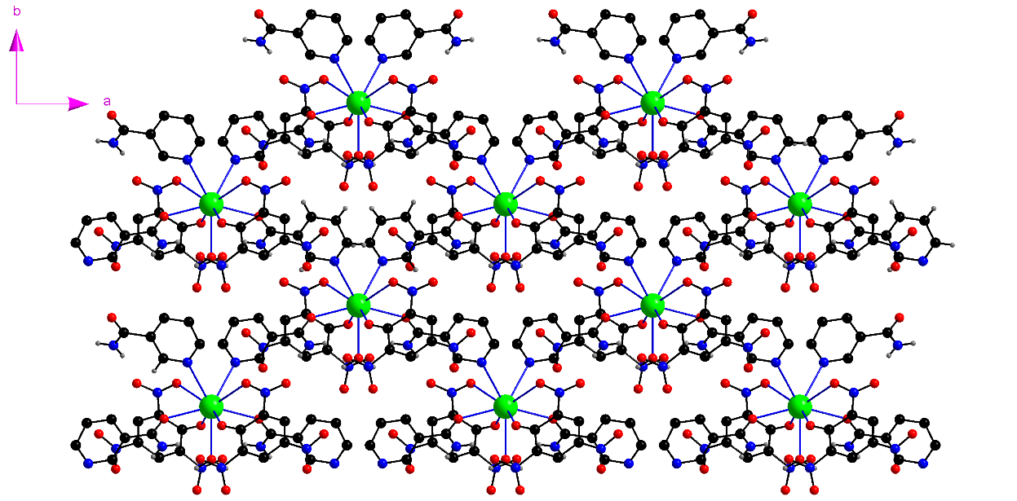
Fig. S1: The two dimensional connectivity in 1 showing all the terminal and bridging ligands around Ba.

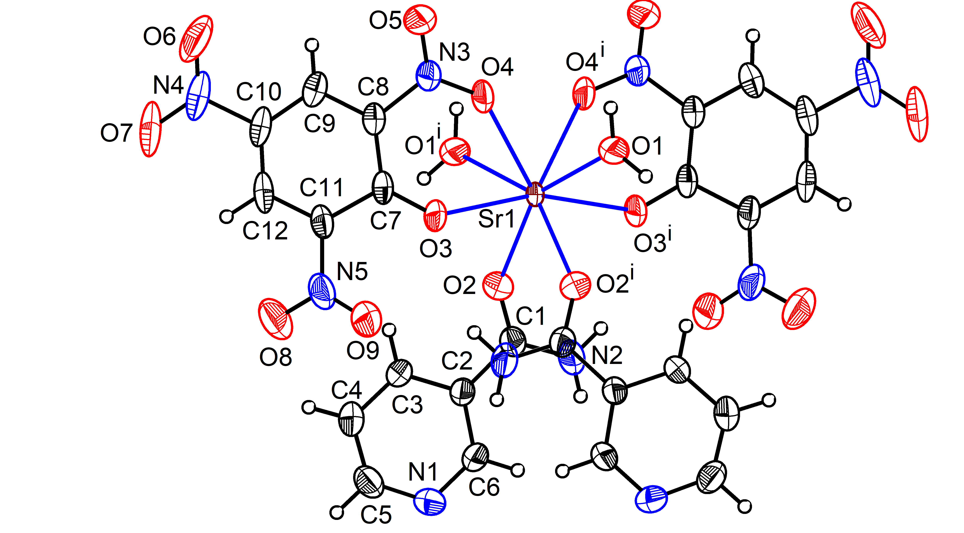
Fig. S2: Crystal structure of 3 showing eight-fold coordination around Sr. Displacement ellipsoids are drawn at 50% probability level for all non-hydrogen atoms. Symmetry code: (i) -x+1, y, -z+3/2.

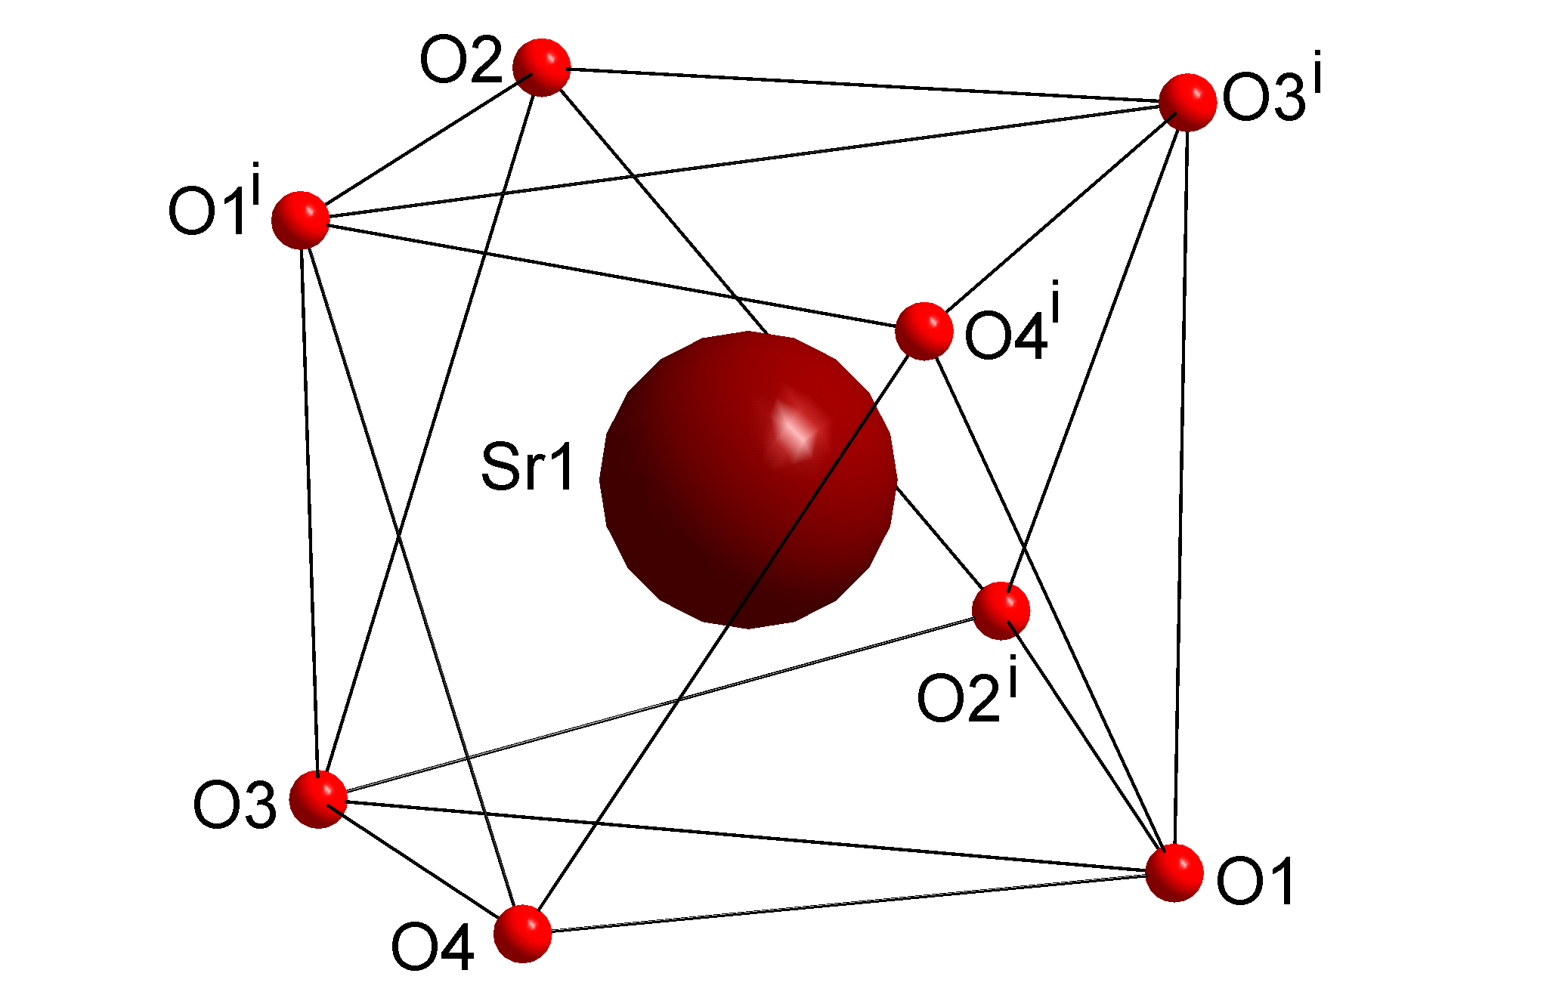
Fig. S3: The distorted square-antiprismatic {SrO₈} polyhedron in 3.

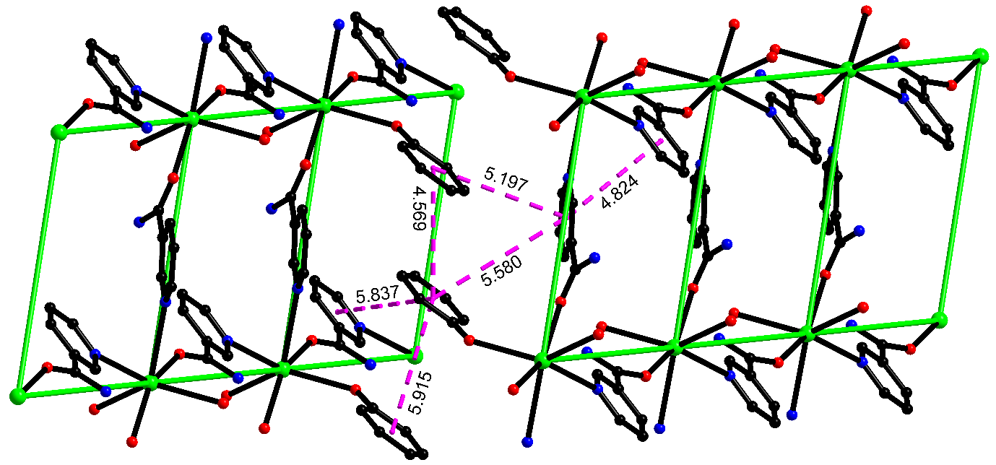
Fig. S4: π∙∙∙π stacking interactions in adjacent layers of [Ba(H₂O)(nic)₂(pic)₂] 1.

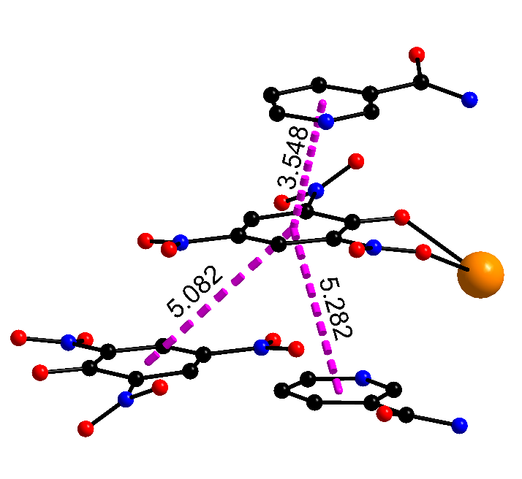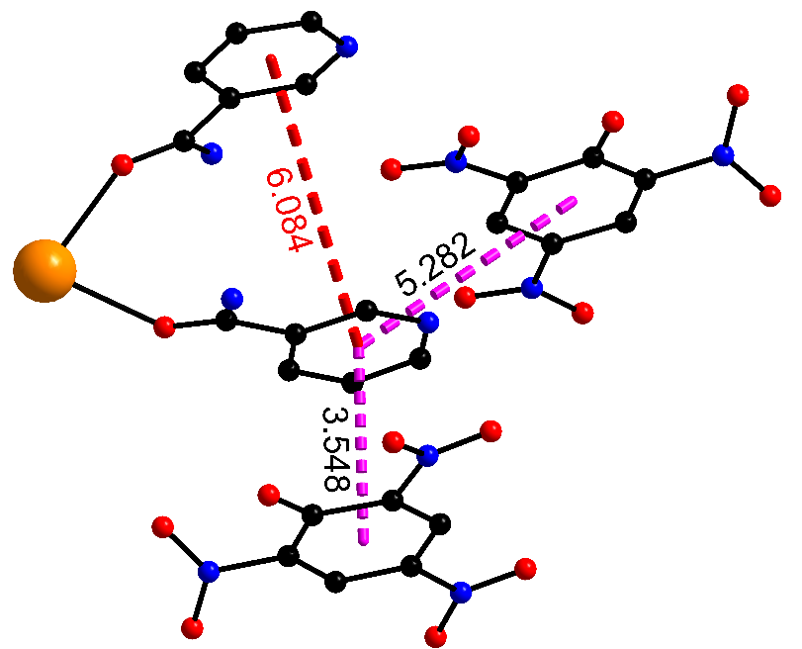

Fig. S5: π∙∙∙π stacking interactions in [Ca(H₂O)₂(nic)₂(pic)₂] 2.

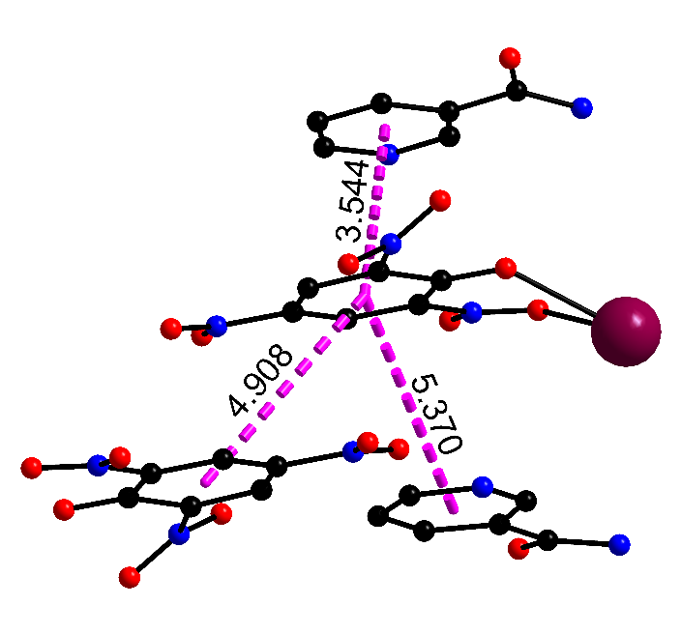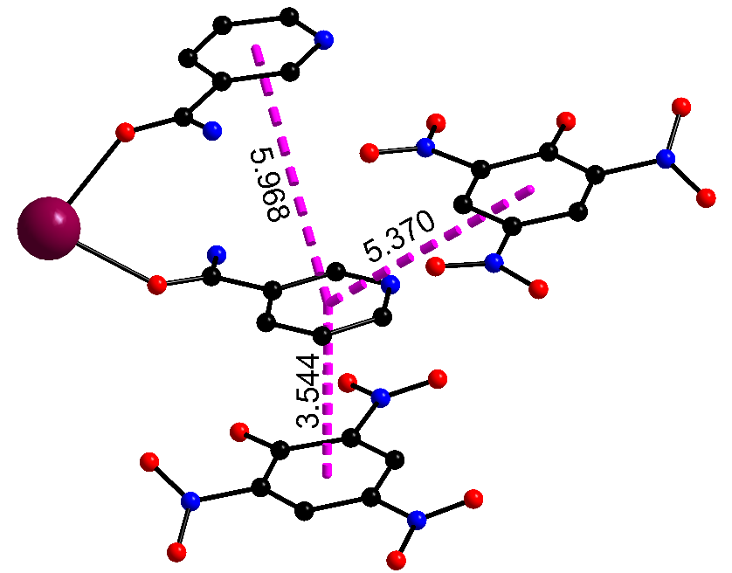
Fig. S6: π∙∙∙π stacking interactions in [Sr(H₂O)₂(nic)₂(pic)₂] 3.
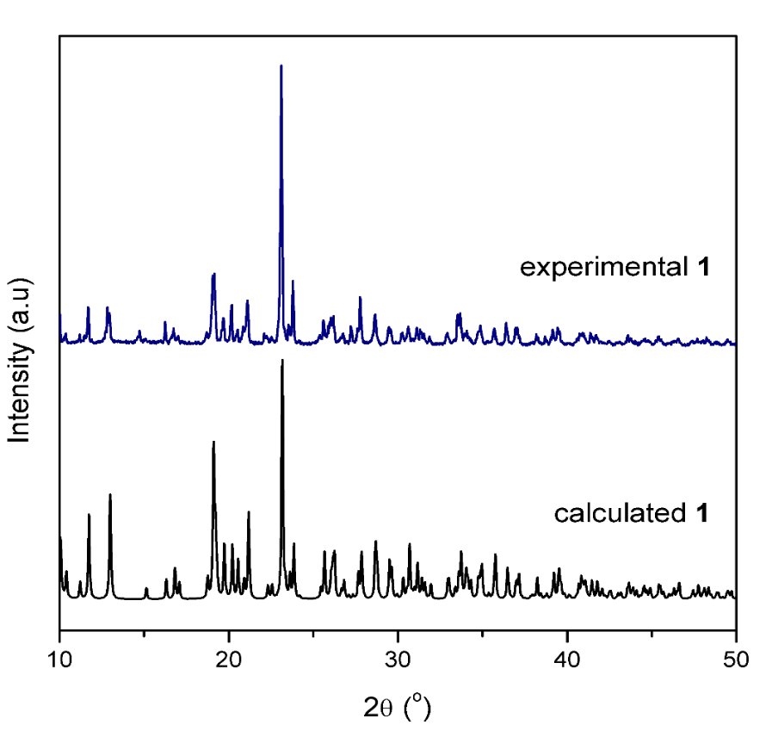
Fig. S7: Experimental and calculated powder pattern of 1.

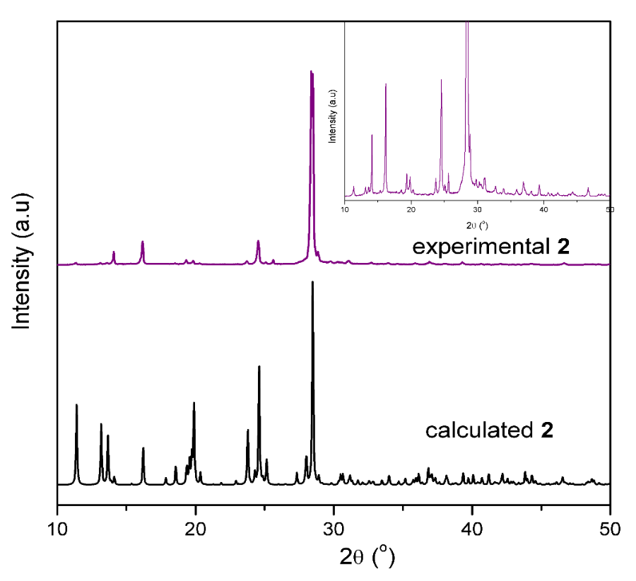

Fig. S8: Experimental and calculated powder pattern of 2.

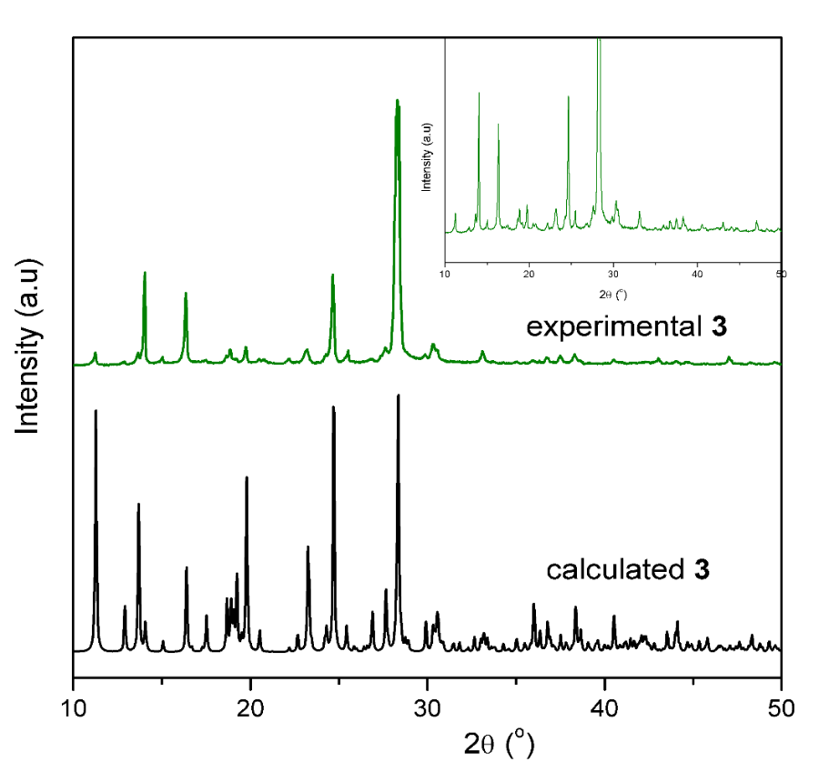
Fig. S9: Experimental and calculated powder pattern of 3.

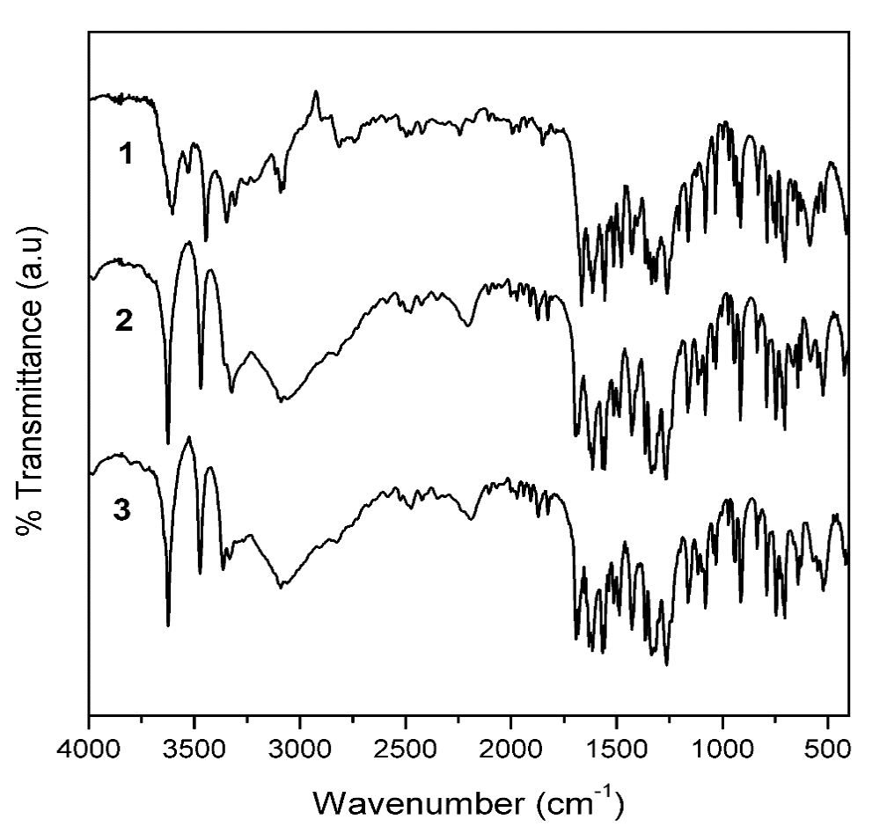
Fig. S10: Infrared spectra of 1-3.

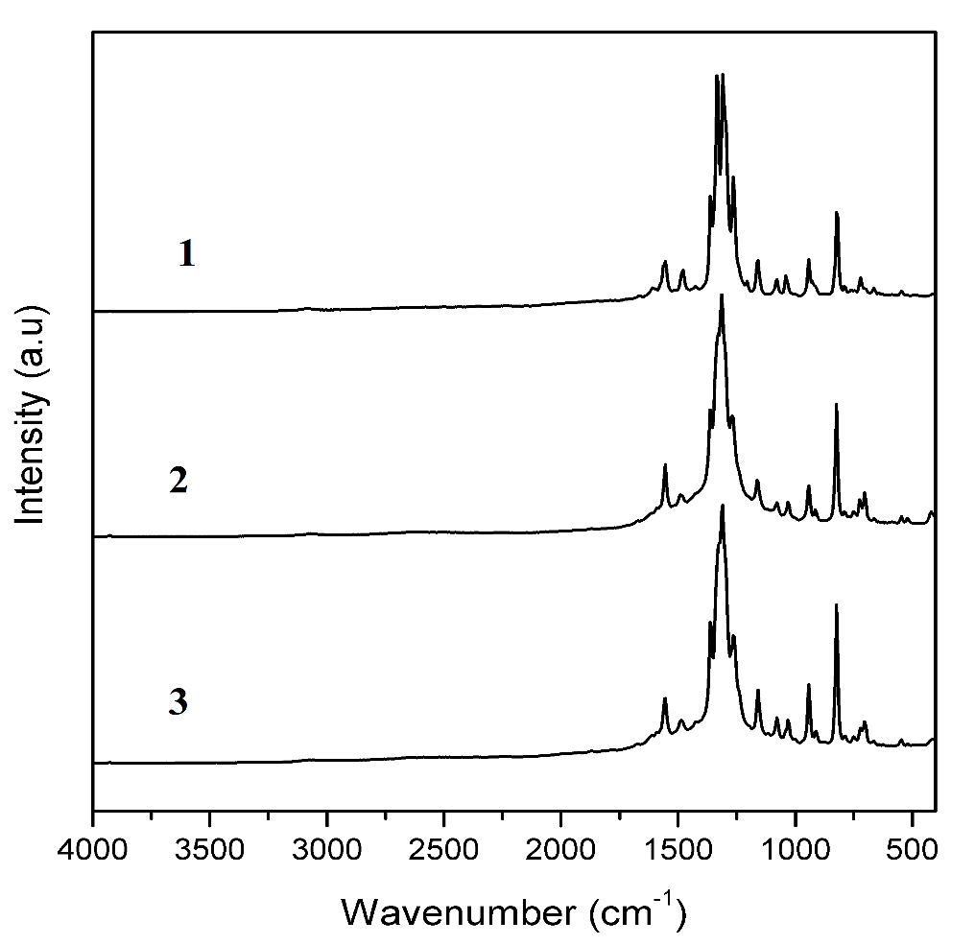
Fig. S11: Raman spectra of 1-3.

