Supporting Information

Chalcogenative Spirocyclization of N-Aryl Propiolamides with Diselenides/Disulfides Promoted by Selectfluor
Jinwei Yuan,^{a,}* Guangchao Huang,ª Lili Wang,ª Xinyuan Wang,ª Liangru Yang,^{a,}* Yongmei Xiao,ª Pu Maoª, Shouren Zhang,^{b,}* Lingbo Qu^{c}
ª School of Chemistry & Chemical Engineering, Henan University of Technology, Zhengzhou 450001, P. R. China
^{b} Henan Key Laboratory of Nanocomposites and Applications; Institute of Nanostructured Functional Materials, Huanghe Science and Technology College, Zhengzhou 450006, P. R. China
^{c} College of Chemistry, Zhengzhou University, Zhengzhou 450001, P. R. China
*Corresponding authors:
E-mail: yuanjinweigs@126.com (Jin-Wei Yuan)

Contents
1. General experimental information 1
2. Optimization of reaction conditions 2
3. Synthesis and characterization of the desired products 3
4. Copies of spectra of products 15
5. Intermolecular competition experiment 54

1. General experimental information
All chemicals were commercially available and used as received without further purification. Column chromatography was performed using 300-400 mesh silica. Nuclear magnetic resonance spectra were recorded on Bruker Avance 400 MHz spectrometer. ¹H NMR spectra were recorded in ppm from tetramethylsilane. Data were reported as follows: chemical shift, multiplicity (s = singlet, d = doublet, t = triplet, m = multiplet and br = broad), coupling constant in Hz and integration. ¹³C NMR spectra were recorded in ppm from tetramethylsilane. ¹⁹F NMR spectra were recorded in ppm with fluorobenzene as external standard. High resolution mass spectra (HR MS) were obtained on Thermo Scientific LTQ Orbitrap XL instrument using the ESI technique. IR spectra were recorded on WQF-510 Fourier transform infrared spectrophotometer. Melting points were determined on an XT4A microscopic apparatus and are uncorrected.

2. Optimization of reaction conditions
Table S1 Screening the amount of 1a and 2aª
Entry | The molar amount of  1a and 2a | Yields (%)^{b}
1 | 1:0.3 | 41
2 | 1:0.5 | 69
3 | 1:1.0 | 80
4 | 1:1.5 | 80

^{[a]} Reaction conditions: N-(4-methoxyphenyl)-N-methyl-3-phenylpropiolamide 1a (0.2 mmol, 53.0 mg), diphenyl diselenide 2a, Selectfluor agent (0.2 mmol, 66.0 mg), in CH₃CN (2.0 mL) at 40 ºC for 1.5 h.
^{[b]} Isolated yield.

3. Synthesis and characterization of the desired products
General experimental procedure for the synthesis of 3-arylselenenyl azaspiro[4,5]trienones (3)
N-Aryl alkynamides 1 (0.2 mmol), diaryldiselenide 2 (0.2 mmol), Selectfluor agent (0.2 mmol, 70.8 mg), and acetonitrile (2.0 mL) were added to a 10 mL reaction tube. The mixture was stirred at 40 ºC for 1.5 h. After completion of the reaction, the solvent was distilled under vacuum. Then, the resulting mixture was dissolved with ethyl acetate (15 mL), washed with saturated sodium chloride solution (10 mL × 2). The organic phase was dried over anhydrous Na₂SO₄ and concentrated under vacuum. The residue was purified by silica gel column chromatography to give 3-arylselenenyl azaspiro[4,5]trienones 3 using ethyl acetate/dichloromethane as eluant.
4-(3,4-Dimethylphenyl)-1-methyl-3-(phenylselanyl)-1-azaspiro[4.5]deca-3,6,9-triene-2,8-dione (3c)
Orange crystal; yield: 73.9 mg (85%); m.p. 131-132 ºC. − IR (KBr): ν = 2922, 1687, 1660, 1623, 1384, 863 cm⁻¹. − ¹H NMR (400 MHz, CDCl₃): δ = 7.38 (d, J_{H-H} = 7.6 Hz, 2H), 7.18-7.09 (m, 3H), 6.95 (d, J_{H-H} = 7.8 Hz, 1H), 6.87 (d, J_{H-H} = 7.9 Hz, 1H), 6.83 (s, 1H), 6.50 (d, J_{H-H} = 10.0 Hz, 2H), 6.43 (d, J_{H-H} = 10.0 Hz, 2H), 2.88 (s, 3H), 2.17 (s, 3H), 2.11 (s, 3H). − ¹³C NMR (100 MHz, CDCl₃): δ = 184.1 (C=O), 168.9 (C=O), 154.6, 145.3 (CH), 138.3, 136.3, 133.6 (CH), 132.9 (CH), 129.4 (CH), 129.3 (CH), 129.1, 128.8 (CH), 128.6, 127.6 (CH), 127.4, 125.2 (CH), 68.9, 26.3 (CH₃), 19.7 (CH₃), 19.6 (CH₃). − HR MS ((+)ESI): m/z = 436.0806 (calcd. 436.0810 for C₂₄H₂₂NO₂Se [M + H]⁺).
4-(4-Methoxyphenyl)-1-methyl-3-(phenylselanyl)-1-azaspiro[4.5]deca-3,6,9-triene-2,8-dione (3d)
Pale yellow crystal; yield: 75.2 mg (86%); m.p. 173-174 ºC. − IR (KBr): ν = 2954, 1693, 1667, 1625, 1606, 1508, 1359, 1258, 1180, 877 cm⁻¹. − ¹H NMR (400 MHz, CDCl₃): δ = 7.34 (d, J_{H-H} = 6.9 Hz, 2H), 7.13-7.07 (m, 5H), 6.68 (d, J_{H-H} = 8.7 Hz, 2H), 6.48 (d, J_{H-H} = 10.2 Hz, 2H), 6.41 (d, J_{H-H} = 10.2 Hz, 2H), 3.70 (s, 3H), 2.84 (s, 3H). − ¹³C NMR (100 MHz, CDCl₃): δ = 184.0 (C=O), 168.9 (C=O), 160.4, 154.4, 145.4 (CH), 133.3 (CH), 132.9 (CH), 129.5 (CH), 129.0 (CH), 128.4, 127.7 (CH), 123.5, 113.6 (CH), 68.8, 55.2 (CH₃), 26.3 (CH₃). − HR MS ((+)ESI): m/z = 438.0596 (calcd. 438.0603 for C₂₃H₂₀NO₃Se [M + H]⁺).
4-(4-Fluorophenyl)-1-methyl-3-(phenylselanyl)-1-azaspiro[4.5] deca-3,6,9-triene-2,8-dione (3e)²
Pale yellow crystal; yield: 60.3 mg (71%); m.p. 140-141 ºC. − IR (KBr): ν = 2919, 1688, 1665, 1626, 1500, 1386, 1231, 876 cm⁻¹. − ¹H NMR (400 MHz, CDCl₃): δ = 7.29 (d, J_{H-H} = 7.7 Hz, 2H), 7.11 (t, J_{H-H} = 7.1 Hz, 1H), 7.06-7.7.02 (m, 4H), 6.78 (t, J_{H-H} = 8.6 Hz, 2H), 6.49 (d, J_{H-H} = 10.0 Hz, 2H), 6.38 (d, J_{H-H} = 10.0 Hz, 2H), 2.85 (s, 3H). − ¹³C NMR (100 MHz, CDCl₃): δ = 183.7 (C=O), 168.5 (C=O), 162.9 (d, J_{P-C} = 248.7 Hz), 152.4, 144.9, 133.5 (d, J_{P-C} = 72.8 Hz), 130.6, 130.1, 130.0, 129.0, 127.9, 127.1, 126.9 (d, J_{P-C} = 30.6 Hz), 115.2 (d, J_{P-C} = 21.7 Hz), 69.1, 26.4 (CH₃). − ¹⁹F NMR (376 MHz, CDCl₃): δ = -110.8. − HR MS ((+)ESI): m/z = 426.0396 (calcd. 426.0403 for C₂₂H₁₇FNO₂Se [M + H]⁺).
4-(4-Chlorophenyl)-1-methyl-3-(phenylselanyl)-1-azaspiro[4.5] deca-3,6,9-triene-2,8-dione (3f)²
Pale yellow crystal; yield: 67.0 mg (76%); m.p. 164-165 ºC. − IR (KBr): ν = 1688, 1665, 1387, 986 cm⁻¹. − ¹H NMR (400 MHz, CDCl₃): δ = 7.32 (d, J_{H-H} = 7.0 Hz, 2H), 7.18-7.15 (m, 1H), 7.10-7.06 (m, 4H), 7.00 (dd, J_{H-H} = 8.8, 2.2 Hz, 2H), 6.52 (d, J_{H-H} = 10.3 Hz, 2H), 6.42 (d, J_{H-H} = 10.3 Hz, 2H), 2.89 (s, 3H). − ¹³C NMR (100 MHz, CDCl₃): δ = 183.7 (C=O), 168.5 (C=O), 151.9, 144.8 (CH), 135.3, 134.0 (CH), 133.2 (CH), 131.0, 129.5, 129.4 (CH), 129.0 (CH), 128.3 (CH), 128.0 (CH), 126.5, 69.1, 26.4 (CH₃). − HR MS ((+)ESI): m/z = 442.0100 (calcd. 442.0108 for C₂₂H₁₇ClNO₂Se [M + H]⁺).
4-(4-Bromophenyl)-1-methyl-3-(phenylselanyl)-1-azaspiro[4.5] deca-3,6,9-triene-2,8-dione (3g)²
Pale yeloow crystal; yield: 74.7 mg (77%); m.p. 159-160 ºC. − IR (KBr): ν = 2920, 1691, 1666, 1626, 1480, 1418, 1386, 1062, 872 cm⁻¹. − ¹H NMR (400 MHz, CDCl₃): δ = 7.33 (dd, J_{H-H} = 7.9, 0.9 Hz, 2H), 7.27-7.24 (m, 2H), 7.20-7.16 (m, 1H), 7.09 (t, J_{H-H} = 7.6 Hz, 2H), 6.91 (d, J_{H-H} = 8.6 Hz, 2H), 6.49 (d, J_{H-H} = 10.2 Hz, 2H), 6.42 (d, J_{H-H} = 10.2 Hz, 2H), 2.90 (s, 3H). − ¹³C NMR (100 MHz, CDCl₃): δ = 183.7 (C=O), 168.5 (C=O), 151.7, 144.7 (CH), 134.2, 133.2, 131.3, 131.2, 129.9, 129.6, 129.0, 128.1, 126.4, 123.7, 69.0, 26.4 (CH₃). − HR MS ((+)ESI): m/z = 485.9595 (calcd. 485.9602 for C₂₂H₁₇BrNO₂Se [M + H]⁺).
4-(4-iodophenyl)-1-methyl-3-(phenylselanyl)-1-azaspiro[4.5]deca-3,6,9-triene-2,8-dione (3h)²
Colorless crystal; yield: 87.4 mg (82%); m.p. 136-137 ºC. − IR (KBr): ν = 2924, 1688, 1621, 1384, 873 cm⁻¹. − ¹H NMR (400 MHz, CDCl₃): δ = 7.45 (d, J_{H-H} = 8.4 Hz, 2H), 7.32 (d, J_{H-H} = 7.2 Hz, 2H), 7.19 (t, J_{H-H} = 7.4 Hz, 1H), 7.08 (t, J_{H-H} = 7.4 Hz, 2H), 6.77 (d, J_{H-H} = 8.4 Hz, 2H), 6.49 (d, J_{H-H} = 10.1 Hz, 2H), 6.41 (d, J_{H-H} = 10.1 Hz, 2H), 2.89 (s, 3H). − ¹³C NMR (100 MHz, CDCl₃): δ = 183.7 (C=O), 168.5 (C=O), 151.8, 144.7 (CH), 137.2 (CH), 134.2 (CH), 133.2 (CH), 131.1, 130.4, 129.6 (CH), 129.1 (CH), 128.1 (CH), 126.4, 95.7, 69.0, 26.4 (CH₃). − HR MS ((+)ESI): m/z = 533.9459 (calcd. 533.9464 for C₂₂H₁₇INO₂Se [M + H]⁺).
1-Methyl-4-(4-nitrophenyl)-3-(phenylselanyl)-1-azaspiro[4.5]deca-3,6,9-triene-2,8-dione (3i)²
Pale yellow crystal; yield: 50.6 mg (56%); m.p. 189-190 ºC. − IR (KBr): ν = 1690, 1666, 1514, 1388, 1345, 987, 741 cm⁻¹. − ¹H NMR (400 MHz, CDCl₃): δ = 7.92 (d, J_{H-H} = 8.5 Hz, 2H), 7.30 (d, J_{H-H} = 7.8 Hz, 2H), 7.17 (d, J_{H-H} = 8.6 Hz, 2H), 7.12 (t, J_{H-H} = 7.7 Hz, 1H), 7.02 (t, J_{H-H} = 7.5 Hz, 2H), 6.55 (d, J_{H-H} = 10.1 Hz, 2H), 6.44 (d, J_{H-H} = 10.1 Hz, 2H), 2.94 (s, 3H). − ¹³C NMR (100 MHz, CDCl₃): δ = 183.4 (C=O), 168.2 (C=O), 148.8, 147.6, 144.3 (CH), 137.4, 134.7 (CH), 133.6, 133.4 (CH), 129.2 (CH), 129.1 (CH), 128.4 (CH), 125.5, 123.1 (CH), 69.2, 26.5 (CH₃). − HR MS ((+)ESI): m/z = 453.0343 (calcd. 453.0348 for C₂₂H₁₇N₂O₄Se [M + H]⁺).
1-Methyl-4-(naphthalen-1-yl)-3-(phenylselanyl)-1-azaspiro[4.5] deca-3,6,9-triene-2,8-dione (3j)
Brown crystal; yield: 74.0 mg (81%); m.p. 186-187 ºC (lit.¹ 127.2-129.8 ºC). − IR (KBr): ν = 1685, 1666, 1623, 1378, 857 cm⁻¹. − ¹H NMR (400 MHz, CDCl₃): δ = 7.69-7.67 (m, 1H), 7.58-7.55 (m, 2H), 7.44-7.41 (m, 2H), 7.09 (t, J_{H-H} = 7.4 Hz, 1H), 6.94 (d, J_{H-H} = 7.0 Hz, 2H), 6.90-6.85 (m, 2H), 6.71-6.67 (m, 3H), 6.50 (dd, J_{H-H} = 10.0 Hz, J_{H-H} = 1.6 Hz, 2H), 5.97 (dd, J_{H-H} = 10.0 Hz, J_{H-H} = 1.6 Hz, 1H), 2.97 (s, 3H). − ¹³C NMR (100 MHz, CDCl₃): δ = 183.8 (C=O), 168.8 (C=O), 149.0, 144.8 (CH), 144.7 (CH), 135.0 (CH), 133.5 (CH), 133.2, 132.6 (CH), 130.2, 129.4 (CH), 128.7 (CH), 128.0 (CH), 127.5, 126.6 (CH), 126.0 (CH), 125.0 (CH), 124.1 (CH), 123.9, 70.8, 26.8 (CH₃). − HR MS ((+)ESI): m/z = 458.0648 (calcd. 458.0654 for C₂₆H₂₀NO₂Se [M + H]⁺).
4-Ethyl-1-methyl-3-(phenylselanyl)-1-azaspiro[4.5]deca-3,6,9-triene-2,8-dione (3k)²
Pale yellow crystal; yield: 56.0 mg (78%); m.p. 86-87 ºC. − IR (KBr): ν = 2920, 1712, 1698, 1658, 1624, 1417, 1364, 1013, 853 cm⁻¹. − ¹H NMR (400 MHz, CDCl₃): δ = 7.54-7.51 (m, 2H), 7.26-7.25 (m, 3H), 6.54 (d, J_{H-H} = 10.1 Hz, 2H), 6.39 (d, J_{H-H} = 10.1 Hz, 2H), 2.85 (s, 3H), 2.20 (q, J_{H-H} = 7.6 Hz, 2H), 1.00 (t, J_{H-H} = 7.6 Hz, 3H). − ¹³C NMR (100 MHz, CDCl₃): δ = 184.1 (C=O), 169.0 (C=O), 161.3 (CH), 145.3 (CH), 133.1 (CH), 132.8 (CH), 129.3 (CH), 128.4, 127.8, 127.7 (CH), 69.2, 26.6 (CH₃), 20.9 (CH₂), 14.1 (CH₃). − HR MS ((+)ESI): m/z = 360.0490 (calcd. 360.0497 for C₁₈H₁₈NO₂Se [M + H]⁺).
1-Methyl-4-phenyl-3-(phenylselanyl)quinolin-2(1H)-one (3l)³
Pale yellow crystal; yield: 32.8 mg (42%); m.p. 160-163 ºC. − IR (KBr): ν = 2971, 1637, 1598, 1575, 1438, 1045, 735 cm⁻¹. − ¹H NMR (400 MHz, CDCl₃): δ = 7.53 (t, J_{H-H} = 7.1 Hz, 1H), 7.39-7.35 (m, 4H), 7.27-7.23 (m, 2H), 7.15-7.04 (m, 7H), 3.79 (s, 3H). − ¹³C NMR (100 MHz, CDCl₃): δ = 160.5, 155.0, 139.9, 138.0, 132.2 (CH), 131.7, 130.9 (CH), 128.8 (CH), 128.7 (CH), 128.2 (CH), 128.1 (CH), 126.7 (CH), 126.2, 122.0 (CH), 121.5, 114.2 (CH), 30.9 (CH₃). − HR MS ((+)ESI): m/z = 414.0362 (calcd. 414.0368 for C₂₂H₁₇NOSeNa [M + Na]⁺).
1-Methyl-4-phenyl-3-(o-tolylselanyl)-1-azaspiro[4.5]deca-3,6,9-triene-2,8-dione (3m)
Pale yellow crystal; yield: 69.9 mg (83%); m.p. 104-106 ºC. − IR (KBr): ν = 2923, 1693, 1666, 1627, 1368, 1275, 1034, 872 cm⁻¹. − ¹H NMR (400 MHz, CDCl₃): δ = 7.31 (dd, J_{H-H} = 7.8, 1.0 Hz, 1H), 7.21-7.17 (m, 1H), 7.14-7.10 (m, 2H), 7.05-7.03 (m, 3H), 6.99 (d, J_{H-H} = 6.4 Hz, 1H), 6.91 (td, J_{H-H} = 7.5 Hz, J_{H-H} = 1.3 Hz, 1H), 6.52 (d, J_{H-H} = 10.2 Hz, 2H), 6.41 (d, J_{H-H} = 10.2 Hz, 2H), 2.89 (s, 3H), 2.29 (s, 3H). − ¹³C NMR (100 MHz, CDCl₃): δ = 184.0 (C=O), 168.7 (C=O), 153.6, 145.1 (CH), 140.3, 134.5 (CH), 133.0 (CH), 130.9, 130.0 (CH), 129.8, 129.2 (CH), 128.4 (CH), 128.0 (CH), 127.9, 127.8 (CH), 126.4 (CH), 69.2, 26.4 (CH₃), 22.6 (CH₃). − HR MS ((+)ESI): m/z = 444.0468 (calcd. 444.0473 for C₂₃H₁₉NO₂SeNa [M + H]⁺).
1-Methyl-4-phenyl-3-(m-tolylselanyl)-1-azaspiro[4.5]deca-3,6,9-triene-2,8-dione (3n)
Colorless acicular crystal; yield: 71.6 mg (85%); m.p. 163-164 ºC. − IR (KBr): ν = 2920, 1702, 1687, 1668, 1628, 1362, 868 cm⁻¹. − ¹H NMR (400 MHz, CDCl₃): δ = 7.25-7.21 (m, 1H), 7.18-7.13 (m, 4H), 7.08-7.05 (m, 2H), 6.99 (t, J_{H-H} = 7.4 Hz, 1H), 6.95 (d, J_{H-H} = 7.6 Hz, 1H), 6.50 (d, J_{H-H} = 10.2 Hz, 2H), 6.42 (d, J_{H-H} = 10.2 Hz, 2H), 2.90 (s, 3H), 2.18 (s, 3H). − ¹³C NMR (100 MHz, CDCl₃): δ = 184.0 (C=O), 168.9 (C=O), 153.4, 145.1 (CH), 138.6, 134.8 (CH), 133.0 (CH), 131.1, 131.0 (CH), 130.3, 129.2 (CH), 128.8 (CH), 128.7 (CH), 128.0 (CH), 127.9 (CH), 126.5, 69.1, 26.4 (CH₃), 21.1 (CH₃). − HR MS ((+)ESI): m/z = 422.0647 (calcd. 422.0654 for C₂₃H₂₀NO₂Se [M + H]⁺).
1-Methyl-4-phenyl-3-(p-tolylselanyl)-1-azaspiro[4.5]deca-3,6,9-triene-2,8-dione (3o)
Pale yellow acicular crystal; yield: 73.2 mg (87%); m.p. 163-164 ºC (lit.¹ 152.2-157.8 ºC). − IR (KBr): ν = 2921, 1702, 1667, 1628, 1362, 1362, 1035, 869 cm⁻¹. − ¹H NMR (400 MHz, CDCl₃): δ = 7.29-7.24 (m, 3H), 7.19 (t, J_{H-H} = 7.2 Hz, 2H), 7.09-7.06 (m, 2H), 6.91 (d, J_{H-H} = 7.9 Hz, 2H), 6.49 (d, J_{H-H} = 10.2 Hz, 2H), 6.42 (d, J_{H-H} = 10.2 Hz, 2H), 2.89 (s, 3H), 2.25 (s, 3H). − ¹³C NMR (100 MHz, CDCl₃): δ = 184.0 (C=O), 153.4 (C=O), 145.1 (CH), 138.1, 134.4 (CH), 133.0 (CH), 131.2, 130.5, 129.8 (CH), 129.2 (CH), 128.1 (CH), 128.0 (CH), 123.1, 69.0, 26.3 (CH₃), 21.1 (CH₃). − HR MS ((+)ESI): m/z = 444.0468 (calcd. 444.0473 for C₂₃H₁₉NO₂SeNa [M + Na]⁺).
3-((3,4-Dimethylphenyl)selanyl)-1-methyl-4-phenyl-1-azaspiro[4.5] deca-3,6,9-triene-2,8-dione (3p)
Colorless acicular crystal; yield: 78.3 mg (90%); m.p. 127-128 ºC. − IR (KBr): ν = 2917, 1702, 1688, 1665, 1625, 1363, 985, 870 cm⁻¹. − ¹H NMR (400 MHz, CDCl₃): δ = 7.23-7.20 (m, 1H), 7.17-7.12 (m, 3H), 7.10 (s, 1H), 7.04 (dd, J_{H-H} = 8.5 Hz, J_{H-H} = 1.4 Hz, 2H), 6.86 (d, J_{H-H} = 7.8 Hz, 1H), 6.49 (d, J_{H-H} = 10.2 Hz, 2H), 6.41 (d, J_{H-H} = 10.2 Hz, 2H), 2.89 (s, 3H), 2.14 (s, 3H), 2.08 (s, 3H) . − ¹³C NMR (100 MHz, CDCl₃): δ = 184.0 (C=O), 168.9 (C=O), 152.7, 145.2, 137.2, 136.8, 135.8, 133.0, 132.0, 131.1, 130.7, 130.2, 129.0, 128.0, 127.9, 122.9, 69.1, 26.4 (CH₃), 19.5 (CH₃), 19.4 (CH₃) . − HR MS ((+)ESI): m/z = 458.0621 (calcd. 458.0629 for C₂₄H₂₁NO₂SeNa [M + Na]⁺).
3-((3-Methoxyphenyl)selanyl)-1-methyl-4-phenyl-1-azaspiro[4.5] deca-3,6,9-triene-2,8-dione (3q)
Colorless crysta; yield: 81.3 mg (93%); m.p. 141-142 ºC. − IR (KBr): ν = 2923, 2852, 1698, 1668, 1628, 1585, 1477, 1366, 1231, 1027, 872 cm⁻¹. − ¹H NMR (400 MHz, CDCl₃): δ = 7.23-7.21 (m, 1H), 7.16 (t, J_{H-H} = 7.7 Hz, 2H), 7.10 (d, J_{H-H} = 7.0 Hz, 2H), 7.01 (t, J_{H-H} = 7.8 Hz, 1H), 6.94 (d, J_{H-H} = 7.7 Hz, 1H), 6.87 (t, J_{H-H} = 1.6 Hz, 1H), 6.69-6.66 (m, 1H), 6.53 (d, J_{H-H} = 10.1 Hz, 2H), 6.41 (d, J_{H-H} = 10.1 Hz, 2H), 3.67 (s, 3H), 2.89 (s, 3H) . − ¹³C NMR (100 MHz, CDCl₃): δ = 183.9 (C=O), 168.7 (C=O), 159.4, 154.4, 145.0 (CH), 133.0 (CH), 131.1, 129.9, 129.7 (CH), 129.3 (CH), 128.1 (CH), 128.0 (CH), 125.8 (CH), 119.0 (CH), 113.7 (CH), 69.1, 55.1 (CH₃), 26.4 (CH₃). − HR MS ((+)ESI): m/z = 438.0597 (calcd. 438.0603 for C₂₃H₂₀NO₃Se [M + H]⁺).
3-((4-Methoxyphenyl)selanyl)-1-methyl-4-phenyl-1-azaspiro[4.5] deca-3,6,9-triene-2,8-dione (3r)³
Colorless crystal; yield: 83.0 mg (95%); m.p. 141-142 ºC. − IR (KBr): ν = 2833, 1684, 1669, 1489, 1364, 1249, 1029, 869 cm⁻¹. − ¹H NMR (400 MHz, CDCl₃): δ = 7.33 (d, J_{H-H} = 8.8 Hz, 1H), 7.25 (t, J_{H-H} = 7.4 Hz, 1H), 7.18 (t, J_{H-H} = 7.4 Hz, 2H), 6.62 (d, J_{H-H} = 8.8 Hz, 2H), 6.48 (d, J_{H-H} = 10.2 Hz, 2H), 6.40 (d, J_{H-H} = 10.2 Hz, 2H), 3.73 (s, 3H), 2.88 (s, 3H) . − ¹³C NMR (100 MHz, CDCl₃): δ = 184.0 (C=O), 168.9 (C=O), 159.8, 152.6, 145.1 (CH), 136.7 (CH), 133.0 (CH), 131.1, 130.8, 129.2 (CH), 128.1 (CH), 116.4, 114.6 (CH), 69.0, 55.2 (CH₃), 26.4 (CH₃). − HR MS ((+)ESI): m/z = 438.0597 (calcd. 438.0603 for C₂₃H₂₀NO₃Se [M + H]⁺).
3-((4-Fluorophenyl)selanyl)-1-methyl-4-phenyl-1-azaspiro[4.5] deca-3,6,9-triene-2,8-dione (3s)
Pale yellow acicular crystal; yield: 69.7 mg (82%); m.p. 134-135 ºC. − IR (KBr): ν = 2925, 1703, 1669, 1630, 1481, 1364, 1217, 827 cm⁻¹. − ¹H NMR (400 MHz, CDCl₃): δ = 7.38-7.35 (m, 2H), 7.26 (t, J_{H-H} = 6.3 Hz, 1H), 7.21-7.17 (m, 2H), 7.06-7.04 (m, 2H), 6.78 (t, J_{H-H} = 8.7 Hz, 2H), 6.50 (d, J_{H-H} = 10.2 Hz, 2H), 6.41 (d, J_{H-H} = 10.2 Hz, 2H), 2.89 (s, 3H). − ¹³C NMR (100 MHz, CDCl₃): δ = 183.9 (C=O), 168.7 (C=O), 163.9, 161.5, 153.4, 144.8 (CH), 136.7 (d, J_{F-C} = 8.1 Hz, CH), 133.1 (CH), 131.0, 130.3, 129.4 (CH), 128.1 (d, J_{F-C} = 17.8 Hz, CH), 121.1 (d, J_{F-C} = 3.5 Hz), 116.1 (d, J_{F-C} = 21.5 Hz, CH), 69.1, 26.4 (CH₃). − ¹⁹F NMR (376 MHz, CDCl₃): δ = -112.8. − HR MS ((+)ESI): m/z = 426.0398 (calcd. 426.0403 for C₂₂H₁₇FNO₂Se [M + H]⁺).
3-((4-Chlorophenyl)selanyl)-1-methyl-4-phenyl-1-azaspiro[4.5] deca-3,6,9-triene-2,8-dione (3t)
Colorless acicular crystal; yield: 73.2 mg (83%); m.p. 189-190 ºC (lit.¹ 187.4-188.4 ºC). − IR (KBr): ν = 2922, 2851, 1700, 1668, 1629, 1467, 1412, 1364, 1083, 1003, 818 cm⁻¹. − ¹H NMR (400 MHz, CDCl₃): δ = 7.32-7.27 (m, 3H), 7.21 (t, J_{H-H} = 7.2 Hz, 2H), 7.08-7.05 (m, 4H), 6.49 (d, J_{H-H} = 10.3 Hz, 2H), 6.43 (d, J_{H-H} = 10.3 Hz, 2H), 2.90 (s, 3H). − ¹³C NMR (100 MHz, CDCl₃): δ = 183.8 (C=O), 168.6 (C=O), 154.0, 144.7 (CH), 135.5 (CH), 134.5, 133.2 (CH), 131.0, 130.0, 129.5 (CH), 129.1 (CH), 128.3 (CH), 128.0 (CH), 124.9, 69.1, 26.4 (CH₃). − HR MS ((+)ESI): m/z = 442.0100 (calcd. 442.0108 for C₂₂H₁₇ClNO₂Se [M + H]⁺).
3-((4-Aromophenyl)selanyl)-1-methyl-4-phenyl-1-azaspiro[4.5] deca-3,6,9-triene-2,8-dione (3u)³
Colorless acicular crysta; yield: 79.5 mg (82%); m.p.197-198 ºC. − IR (KBr): ν = 2922, 1700, 1668, 1629, 1411, 1362, 1060, 999, 810 cm⁻¹. − ¹H NMR (400 MHz, CDCl₃): δ = 7.32-7.28 (m, 2H), 7.24-7.19 (m, 5H), 7.07-7.05 (m, 2H), 6.49 (d, J_{H-H} = 10.3 Hz, 2H), 6.43 (d, J_{H-H} = 10.3 Hz, 2H), 2.90 (s, 3H). − ¹³C NMR (100 MHz, CDCl₃): δ = 183.8 (C=O), 168.6 (C=O), 154.1, 144.7 (CH), 135.7 (CH), 133.2 (CH), 132.1 (CH), 131.0, 129.9, 129.5 (CH), 128.3 (CH), 128.0 (CH), 125.6, 122.6, 69.1, 26.4 (CH₃). − HR MS ((+)ESI): m/z = calcd for C₂₂H₁₇BrNO₂Se [M + H]⁺ 485.9602, found 485.9595.
3-((4-Iodophenyl)selanyl)-1-methyl-4-phenyl-1-azaspiro[4.5]deca-3,6,9-triene-2,8-dione (3v)
Colorless crystal; yield: 80.0 mg (75%); m.p. 207-208 ºC. − IR (KBr): ν = 2987, 1701, 1684, 1668, 1629, 1466, 1367, 1061, 810 cm⁻¹. − ¹H NMR (400 MHz, CDCl₃): δ = 7.40 (d, J_{H-H} = 8.3 Hz, 2H), 7.32-7.28 (m, 1H), 7.21 (t, J_{H-H} = 7.8 Hz, 2H), 7.09 (d, J_{H-H} = 8.3 Hz, 2H), 7.05 (d, J_{H-H} = 7.2 Hz, 2H), 6.49 (d, J_{H-H} = 10.3 Hz, 2H), 6.43 (d, J_{H-H} = 10.3 Hz, 2H), 2.90 (s, 3H). − ¹³C NMR (100 MHz, CDCl₃): δ = 183.8 (C=O), 168.5 (C=O), 154.2, 144.7 (CH), 138.0 (CH), 135.8 (CH), 133.2 (CH), 130.9, 129.8, 129.5 (CH), 128.3 (CH), 128.0 (CH), 126.6, 94.2, 69.1, 26.4 (CH₃). − HR MS ((+)ESI): m/z = 533.9459 (calcd. 533.9464 for C₂₂H₁₇INO₂Se [M + H]⁺).
1-Methyl-3-((4-nitrophenyl)selanyl)-4-phenyl-1-azaspiro[4.5]deca-3,6,9-triene-2,8-dione (3w)⁴
Colorless crystal; yield: 56.9 mg (63%); m.p. 152-153 ºC. − IR (KBr): ν = 2921, 1698, 1668, 1627, 1595, 1572, 1508, 1361, 1341,1274, 1059 cm⁻¹. − ¹H NMR (400 MHz, CDCl₃): δ = 7.98 (d, J_{H-H} = 8.8 Hz, 2H), 7.49 (d, J_{H-H} = 8.8 Hz, 2H), 7.34-7.31 (m, 1H), 7.27-7.24 (m, 3H), 7.15 (d, J_{H-H} = 7.2 Hz, 2H), 6.54 (d, J_{H-H} = 10.3 Hz, 2H), 6.49 (d, J_{H-H} = 10.3 Hz, 2H), 2.93 (s, 3H). − ¹³C NMR (100 MHz, CDCl₃): δ = 183.7 (C=O), 168.0 (C=O), 156.7, 147.0, 144.3 (CH), 137.4, 133.5 (CH), 132.6 (CH), 130.9, 130.1 (CH), 128.5 (CH), 128.4, 127.8 (CH), 123.8 (CH), 69.2, 26.5 (CH₃). − HR MS ((+)ESI): m/z = 475.0169 (calcd. 475.0167 for C₂₂H₁₆N₂O₄SeNa [M + Na]⁺).
3-((4-Acetylphenyl)selanyl)-1-methyl-4-phenyl-1-azaspiro[4.5] deca-3,6,9-triene-2,8-dione (3x)
Pale yellow crystal; yield: 56.6 mg (63%); m.p. 171-172 ºC. − IR (KBr): ν = 1699, 1674, 1663, 1625, 1582, 1394, 1358, 1264, 726 cm⁻¹. − ¹H NMR (400 MHz, CDCl₃): δ = 7.70 (d, J_{H-H} = 8.4 Hz, 2H), 7.42 (d, J_{H-H} = 8.4 Hz, 2H), 7.30-7.28 (m, 1H), 7.27-7.20 (m, 2H), 7.15 (d, J_{H-H} = 7.2 Hz, 2H), 6.56 (d, J_{H-H} = 10.3 Hz, 2H), 6.47 (d, J_{H-H} = 10.3 Hz, 2H), 2.91 (s, 3H), 2.53 (s, 3H). − ¹³C NMR (100 MHz, CDCl₃): δ = 183.8 (C=O), 168.3 (C=O), 156.1, 144.6 (CH), 135.9, 134.7, 133.2 (CH), 132.3 (CH), 131.0, 129.7 (CH), 128.9, 128.7 (CH), 128.3 (CH), 127.9 (CH), 69.1, 26.5 (CH₃), 26.4 (CH₃). − HR MS ((+)ESI): m/z = 450.0595 (calcd. 450.0603 for C₂₄H₂₀NO₃Se [M + H]⁺).
4-((1-Methyl-2,8-dioxo-4-phenyl-1-azaspiro[4.5]deca-3,6,9-trien-3-yl)selanyl)benzonitrile (3y)
Colorless crystal; yield: 37.2 mg (43%); m.p. 143-144 ºC (lit.³ 158-160 ºC). − IR (KBr): ν = 2923, 2223, 1707, 1668, 1627, 1584, 1480, 1384, 1366, 869 cm⁻¹. − ¹H NMR (400 MHz, CDCl₃): δ = 7.44 (J_{H-H} = 8.5 Hz, 2H), 7.39 (J_{H-H} = 8.5 Hz, 2H), 7.35-7.31 (m, 1H), 7.27-7.23 (m, 2H), 7.14-7.12 (m, 2H), 6.53 (d, J_{H-H} = 10.4 Hz, 2H), 6.48 (d, J_{H-H} = 10.4 Hz, 2H), 2.92 (s, 3H). − ¹³C NMR (100 MHz, CDCl₃): δ = 183.6 (C=O), 168.1 (C=O), 156.4, 144.3 (CH), 134.7, 133.4 (CH), 132.9 (CH), 132.2 (CH), 130.9, 130.0 (CH), 128.6, 128.5 (CH), 127.8 (CH), 118.3, 111.1, 69.1, 26.5 (CH₃). − HR MS ((+)ESI): m/z = 433.0444 (calcd. 433.0450 for C₂₃H₁₇N₂O₂Se [M + H]⁺).
1-Methyl-4-phenyl-3-((4-(trifluoromethoxy)phenyl)selanyl)-1-azaspiro[4.5]deca-3,6,9-triene-2,8-dione (3z)
Colorless crystal; yield: 56.9 mg (58%); m.p. 145-146 ºC. − IR (KBr): ν = 2925, 1700, 1685, 1670, 1483, 1367, 1268, 1213, 1166, 736 cm⁻¹. − ¹H NMR (400 MHz, CDCl₃): δ = 7.37 (d, J_{H-H} = 8.7 Hz, 2H), 7.24 (t, J_{H-H} = 7.4 Hz, 1H), 7.16 (t, J_{H-H} = 7.2 Hz, 2H), 7.03 (d, J_{H-H} = 7.2 Hz, 2H), 6.91 (d, J_{H-H} = 8.0 Hz, 2H), 6.51 (d, J_{H-H} = 10.2 Hz, 2H), 6.42 (d, J_{H-H} = 10.2 Hz, 2H), 2.91 (s, 3H). − ¹³C NMR (100 MHz, CDCl₃): δ = 183.8 (C=O), 168.6 (C=O), 153.6, 149.0, 144.7 (CH), 135.8 (CH), 133.2 (CH), 130.8, 130.0, 129.4 (CH), 128.2 (CH), 127.9 (CH), 124.7, 121.5, 121.3 (CH), 119.0, 69.2, 26.4 (CH₃). − ¹⁹F NMR (376 MHz, CDCl₃): δ = -57.7. − HR MS ((+)ESI): m/z = 514.0143 (calcd. 514.0140 for C₂₃H₁₆F₃NO₃SeNa [M + Na]⁺).
1-Methyl-4-phenyl-3-(pyridin-3-ylselanyl)-1-azaspiro[4.5]deca-3,6,9-triene-2,8-dione (3ap)
Pale yellow crystal; yield: 39.2 mg (48%); m.p. 155-156 ºC. − IR (KBr): ν = 2921, 1697, 1667, 1627, 1569, 1557, 1415, 1361, 871 cm⁻¹. − ¹H NMR (400 MHz, CDCl₃): δ = 8.34-8.33 (m, 1H), 7.40 (td, J_{H-H} = 7.6 Hz, J_{H-H} = 1.9 Hz, 1H), 7.29-7.23 (m, 6H), 7.04-7.01 (m, 1H), 6.63 (d, J_{H-H} = 10.1 Hz, 2H), 6.48 (d, J_{H-H} = 10.1 Hz, 2H), 2.92 (s, 3H). − ¹³C NMR (100 MHz, CDCl₃): δ = 184.0 (C=O), 168.5 (C=O), 157.1, 153.3, 150.2 (CH), 145.1 (CH), 136.4 (CH), 133.1 (CH), 131.5, 129.7 (CH), 128.6, 128.3 (CH), 127.9 (CH), 126.4 (CH), 121.4 (CH), 69.0, 26.4 (CH₃). − HR MS ((+)ESI): m/z = 409.0441 (calcd. 409.0450 for C₂₁H₁₇N₂O₂Se [M + H]⁺).
1-Methyl-4-phenyl-3-(thiophen-2-ylselanyl)-1-azaspiro[4.5]deca-3,6,9-triene-2,8-dione (3aq)
Plae yellow crystal; yield: 29.7 mg (36%); m.p. 165-166 ºC. − IR (KBr): ν = 2922, 1687, 1665, 1626, 1267, 1215, 870 cm⁻¹. − ¹H NMR (400 MHz, CDCl₃): δ = 7.30-7.26 (m, 2H), 7.24-7.20 (m, 2H), 7.08 (d, J_{H-H} = 7.0 Hz, 2H), 7.04 (dd, J_{H-H} = 3.5 Hz, J_{H-H} = 1.0 Hz, 1H), 6.77 (dd, J_{H-H} = 5.3 Hz, J_{H-H} = 3.6 Hz, 1H), 6.48 (d, J_{H-H} = 10.2 Hz, 2H), 6.40 (d, J_{H-H} = 10.2 Hz, 2H), 2.89 (s, 3H). − ¹³C NMR (100 MHz, CDCl₃): δ = 183.9 (C=O), 168.4 (C=O), 153.8, 144.7 (CH), 137.4 (CH), 133.1 (CH), 131.8 (CH), 130.8, 130.5, 129.3 (CH), 128.2 (CH), 128.0 (CH), 127.7 (CH), 119.4, 69.1, 26.4 (CH₃), 22.6 (CH₃). − HR MS ((+)ESI): m/z = 414.0054 (calcd. 414.0061 for C₂₀H₁₆NO₂SSe [M + H]⁺).
3-(Benzylselanyl)-1-methyl-4-phenyl-1-azaspiro[4.5]deca-3,6,9-triene-2,8-dione (3ar)
Pale yellow acicular crystal; yield: 73.2 mg (87%); m.p. 146-147 ºC. − IR (KBr): ν = 2926, 1693, 1666, 1626, 1367, 1061, 874 cm⁻¹. − ¹H NMR (400 MHz, CDCl₃): δ = 7.33-7.29 (m, 1H), 7.26-7.17 (m, 7H), 6.94 (d, J_{H-H} = 7.1 Hz, 2H), 6.40 (d, J_{H-H} = 10.2 Hz, 2H), 6.31 (d, J_{H-H} = 10.2 Hz, 2H), 4.27 (s, 2H), 2.90 (s, 3H). − ¹³C NMR (100 MHz, CDCl₃): δ = 184.0 (C=O), 169.1 (C=O), 154.8, 145.0 (CH), 138.4, 132.9 (CH), 131.6, 129.6 (CH), 129.2 (CH), 128.6, 128.3 (CH), 128.2 (CH), 128.0 (CH), 127.0 (CH), 68.7, 29.2 (CH₂), 26.3 (CH₃). − HR MS ((+)ESI): m/z = 422.0646 (calcd. 422.0654 for C₂₃H₂₀NO₂Se [M + H]⁺).
General experimental procedure for the synthesis of 3-arylthio azaspiro[4,5]trienones (5)
N-(4-Methoxyphenyl)-N-methyl-3-phenylpropiolamide 1a (0.2 mmol, 53.0 mg), diaryldisulfides 4 (0.2 mmol), Selectfluor agent (0.2 mmol, 70.8 mg), and acetonitrile (2.0 mL) were added to a 10 mL reaction tube. The mixture was stirred at 40 ºC for 1.5 h. After completion of the reaction, the solvent was distilled under vacuum. Then, the resulting mixture was dissolved with ethyl acetate (15 mL), washed with saturated sodium chloride solution (10 mL × 2). The organic phase was dried over anhydrous Na₂SO₄ and concentrated under vacuum. The residue was purified by silica gel column chromatography to give 3-arylthio azaspiro[4,5]trienones 5 using ethyl acetate/dichloromethane as eluant.
3-((4-Methoxyphenyl)thio)-1-methyl-4-phenyl-1-azaspiro[4.5] deca-3,6,9-triene-2,8-dione (5c)
Colorless crystal; yield: 37.3 mg (48%); m.p. 162-163 ºC (lit.⁵ 156.3-157.6 ºC). − IR (KBr): ν = 2923, 1688, 1667, 1470, 1363, 1285, 1242, 1169, 1033 cm⁻¹; − ¹H NMR (400 MHz, CDCl₃): δ = 7.27-7.20 (m, 5H), 7.15 (d, J_{H-H} = 6.9 Hz, 2H), 6.68 (d, J_{H-H} = 8.7 Hz, 2H), 6.50 (d, J_{H-H} = 10.2 Hz, 2H), 6.43 (d, J_{H-H} = 10.2 Hz, 2H), 3.73 (s, 3H), 2.86 (s, 3H); − ¹³C NMR (100 MHz, CDCl₃): δ = 184.0, 167.8, 159.7, 150.2, 145.3 (CH), 134.5 (CH), 133.5, 133.0 (CH), 130.6, 129.3 (CH), 128.3 (CH), 128.1 (CH), 121.0, 114.4 (CH), 67.6, 55.2 (CH₃), 26.3 (CH₃); − HR MS ((+)ESI): m/z = 390.1152 (calcd. 390.1158 for C₂₃H₂₀NO₃S [M + H]⁺).
3-((2-Fluorophenyl)thio)-1-methyl-4-phenyl-1-azaspiro[4.5]deca-3,6,9-triene-2,8-dione (5d)
Pale yellow crystal; yield: 45.2 mg (60%); m.p. 147-148 ºC (lit.⁶ 155.2-156.7 ºC). − IR (KBr): ν = 2923, 1694, 1664, 1473, 1386, 1373, 1223, 874 cm⁻¹. − ¹H NMR (400 MHz, CDCl₃): δ = 7.35 (td, J_{H-H} = 7.5 Hz, J_{F-H} = 1.6 Hz, 1H), 7.27-7.19 (m, 5H), 7.18-7.14 (m, 1H), 6.97 (td, J_{H-H} = 7.6 Hz, J_{F-H} = 1.2 Hz, 1H), 6.53 (d, J_{H-H} = 10.2 Hz, 2H), 6.45 (d, J_{H-H} = 10.2 Hz, 2H), 2.87 (s, 3H). − ¹³C NMR (100 MHz, CDCl₃): δ = 183.9 (C=O), 167.3 (C=O), 162.7, 160.3, 150.2, 145.1 (CH), 134.0 (CH), 133.1 (CH), 131.0 (d, J_{F-C} = 1.6 Hz), 130.4, 130.2 (d, J_{F-C} = 7.9 Hz, CH), 129.5 (CH), 128.2 (CH), 128.0 (CH), 124.4 (d, J_{F-C} = 3.6 Hz, CH), 117.8 (d, J_{F-C} = 17.4 Hz), 115.8 (d, J_{F-C} = 21.9 Hz, CH), 67.7, 26.2 (CH₃). − ¹⁹F NMR (376 MHz, CDCl₃): δ = -107.5. − HR MS ((+)ESI): m/z = 378.0950 (calcd. 378.0959 for C₂₂H₁₇FNO₂S [M + H]⁺).
3-((4-Chlorophenyl)thio)-1-methyl-4-phenyl-1-azaspiro[4.5]deca-3,6,9-triene-2,8-dione (5e)
Pale yellow acicular crystal; yield: 44.0 mg (56%); m.p. 182-183 ºC (lit.⁵ 180.7-181.3 ºC). − IR (KBr): ν = 2921, 1705, 1671, 1632, 1470, 1413, 1368, 1089, 1001, 869 cm⁻¹. − ¹H NMR (400 MHz, CDCl₃): δ = 7.34-7.30 (m, 1H), 7.28-23 (m, 3H), 7.21-7.18 (m, 3H), 7.14 (d, J_{H-H} = 8.6 Hz, 2H), 6.53 (d, J_{H-H} = 10.3 Hz, 2H), 6.46 (d, J_{H-H} = 10.3 Hz, 2H), 2.88 (s, 3H). − ¹³C NMR (100 MHz, CDCl₃): δ = 183.8, 167.4, 152.9, 144.8 (CH), 133.8, 133.2 (CH), 132.5 (CH), 131.8, 130.4, 130.0, 129.8 (CH), 129.0 (CH), 128.4 (CH), 128.1 (CH), 67.7, 26.3 (CH₃). − HR MS ((+)ESI) m/z = 394.0657 (calcd. 394.0663 for C₂₂H₁₇ClNO₂S [M + H]⁺).
1-Methyl-3-((2-nitrophenyl)thio)-4-phenyl-1-azaspiro[4.5]deca-3,6,9-triene-2,8-dione (5f)
Pale yellow crystal; yield: 36.3 mg (45%); m.p. 175-177 ºC. − IR (KBr): ν = 2920, 1704, 1666, 1626, 1513, 1371, 1337, 1304, 731 cm⁻¹. − ¹H NMR (400 MHz, CDCl₃): δ = 8.19 (dd, J_{H-H} = 8.2 Hz, J_{H-H} = 1.3 Hz, 1H), 7.50 (td, J_{H-H} = 7.6, 0.7 Hz, 1H), 7.41-7.37 (m, 1H), 7.36-7.31 (m, 5H), 7.26-7.24 (m, 1H), 6.60 (d, J_{H-H} = 10.3 Hz, 2H), 6.54 (d, J_{H-H} = 10.3 Hz, 2H), 2.92 (s, 3H). − ¹³C NMR (100 MHz, CDCl₃): δ = 183.7 (C=O), 166.9 (C=O), 159.1, 146.7, 144.3 (CH), 133.6 (CH), 133.5 (CH), 133.1, 130.5 (CH), 130.2, 130.0, 129.1 (CH), 128.7 (CH), 127.8 (CH), 126.5 (CH), 126.1 (CH), 68.0, 26.4 (CH₃). − ¹⁹F NMR (376 MHz, CDCl₃): δ = -107.5. − HR MS ((+)ESI): m/z = 405.0898 (calcd. 405.0904 for C₂₂H₁₇N₂O₄S [M + H]⁺).
1-Methyl-3-((3-nitrophenyl)thio)-4-phenyl-1-azaspiro[4.5]deca-3,6,9-triene-2,8-dione (5g)
Pale yellow acicular crystal; yield: 37.2 mg (46%); m.p. 227-228 ºC (lit.⁶ 156.3-159.2 ºC). − IR (KBr): ν = 2919, 1697, 1672, 1515, 1368, 1343, 869, 733 cm⁻¹. − ¹H NMR (400 MHz, CDCl₃): δ = 8.02-7.99 (m, 2H), 7.64 (d, J_{H-H} = 7.8 Hz, 1H), 7.38 (t, J_{H-H} = 8.0 Hz, 1H), 7.34-7.22 (m, 5H), 6.57 (d, J_{H-H} = 10.2 Hz, 2H), 6.51 (d, J_{H-H} = 10.2 Hz, 2H), 2.91 (s, 3H). − ¹³C NMR (100 MHz, CDCl₃): δ = 183.6 (C=O), 167.0 (C=O), 154.4, 148.2, 144.4 (CH), 136.2 (CH), 134.4, 133.5 (CH), 130.5, 130.2, 130.1 (CH), 129.6 (CH), 128.5 (CH), 127.9 (CH), 125.1 (CH), 122.2 (CH), 67.9, 26.4 (CH₃). − ¹⁹F NMR (376 MHz, CDCl₃): δ = -107.5. − HR MS ((+)ESI): m/z = 405.0897 (calcd. 405.0904 for C₂₂H₁₇N₂O₄S [M + H]⁺).
1-Methyl-4-phenyl-3-(phenyltellanyl)-1-azaspiro[4.5]deca-3,6,9-triene-2,8-dione (5h)
Pale yellow powder; yield: 68.5 mg (75%); m.p. 136-137 ºC (lit.¹ 135.1-135.9 ºC). − IR (KBr): ν = 2920, 1682, 1667, 1628, 1434, 1356, 868, 741 cm⁻¹. − ¹H NMR (400 MHz, CDCl₃): δ = 7.55 (dd, J_{H-H} = 7.8, 1.0 Hz, 2H), 7.19-7.13 (m, 2H), 7.11-7.07 (m, 2H), 7.01-6.96 (m, 4H), 6.49 (d, J_{H-H} = 10.2 Hz, 2H), 6.38 (d, J_{H-H} = 10.2 Hz, 2H), 2.90 (s, 3H). − ¹³C NMR (100 MHz, CDCl₃): δ = 184.0 (C=O), 170.9 (C=O), 158.0, 145.1 (CH), 139.7 (CH), 132.9 (CH), 132.0, 129.2 (CH), 129.0 (CH), 128.3 (CH), 128.0 (CH), 127.8 (CH), 118.2, 110.9, 71.1, 26.6 (CH₃). − ¹⁹F NMR (376 MHz, CDCl₃): δ = -107.5. − HR MS ((+)ESI): m/z = 458.0388 (calcd. 458.0394 for C₂₂H₁₈NO₂Te [M + H]⁺).

References
- Recchi A. M. S., Rosa P. H. P., Back D. F., Zeni G. Org. Biomol. Chem. 2020, 18, 3544-3551.
- Hua J., Fang Z., Bian M., Ma T., Yang M., Xu J., Liu C. K., He W., Zhu N., Yang Z., Guo K. ChemSusChem 2020, 13, 2053-2059.
- Sahoo H., Grandhi G. S., Ramakrishna I., Baidya M. Org. Biomol. Chem. 2019, 17, 10163-10166.
- Sahoo H., Mandal A., Dana S., Baidya M. Adv. Synth. Catal. 2018, 360, 1099-1103.
- Wei W., Cui H., Yang D., Yue H., He C., Zhang Y., Wang H. Green Chem. 2017, 19, 5608-5613.
- Qian P. C., Liu Y., Song R. J., Xiang J. N., Li J. H. Synlett 2015, 26, 1213-1216.

4. Copies of spectra of products
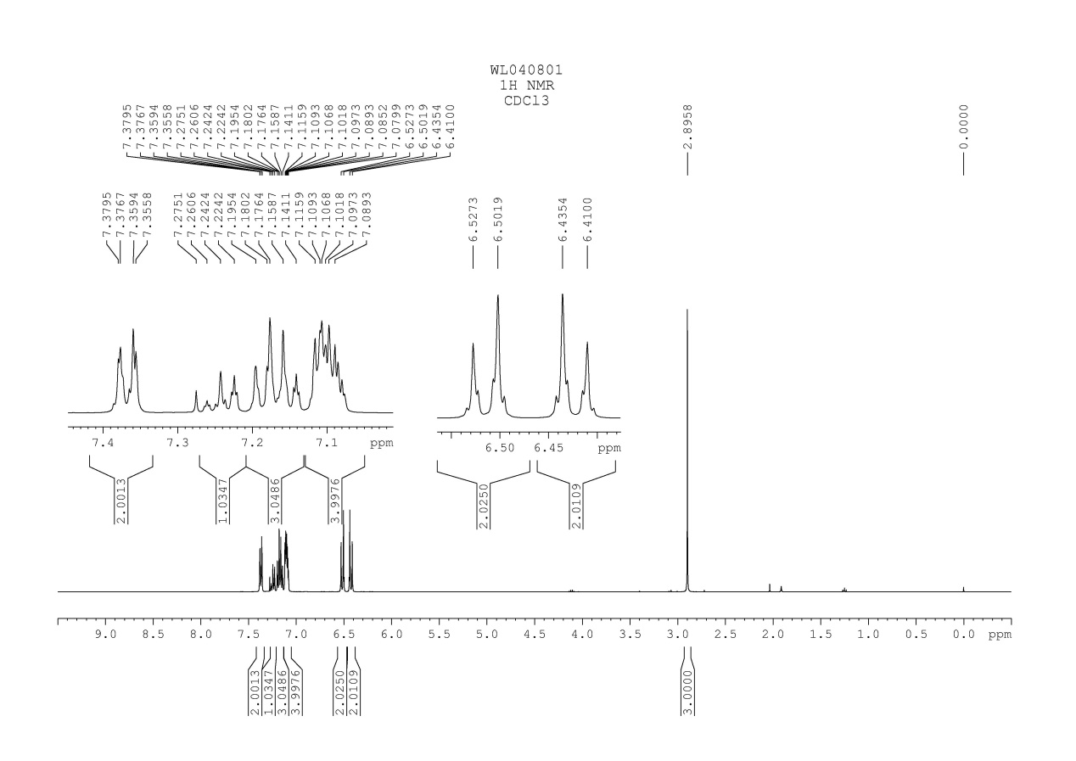
Fig. 1 ¹H NMR spectrum of compound 3ª
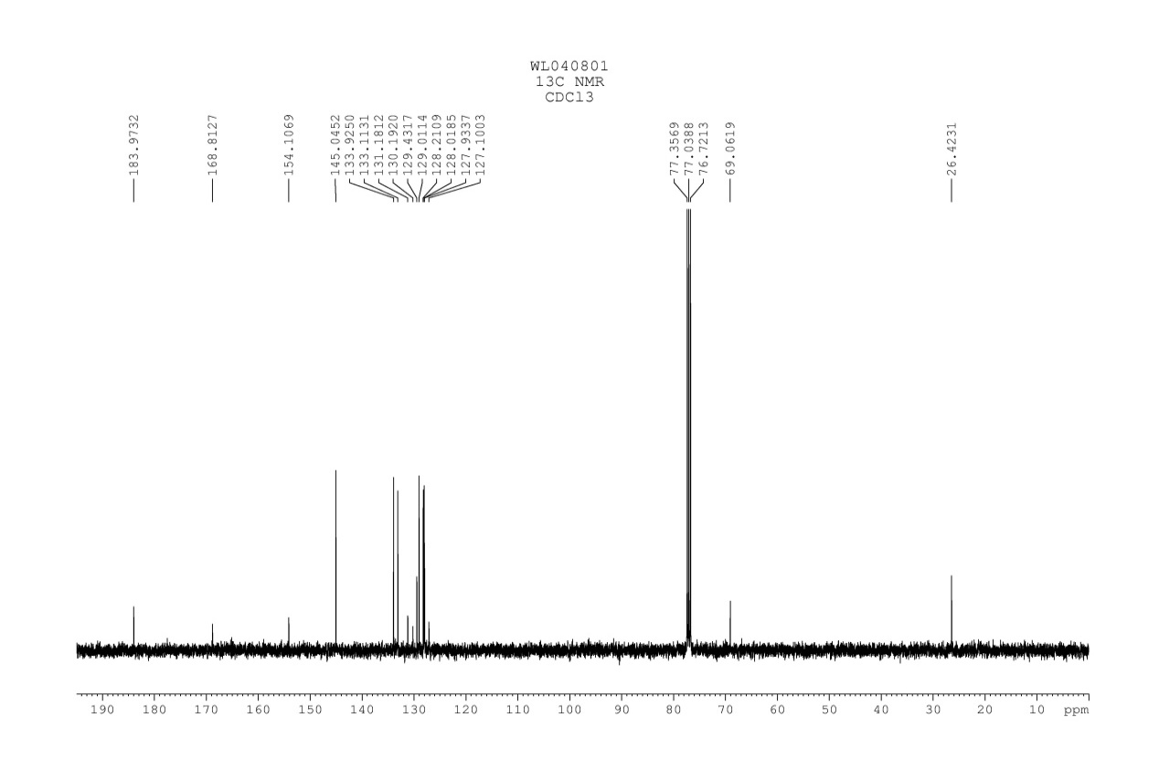
Fig. 2 ¹³C NMR spectrum of compound 3a
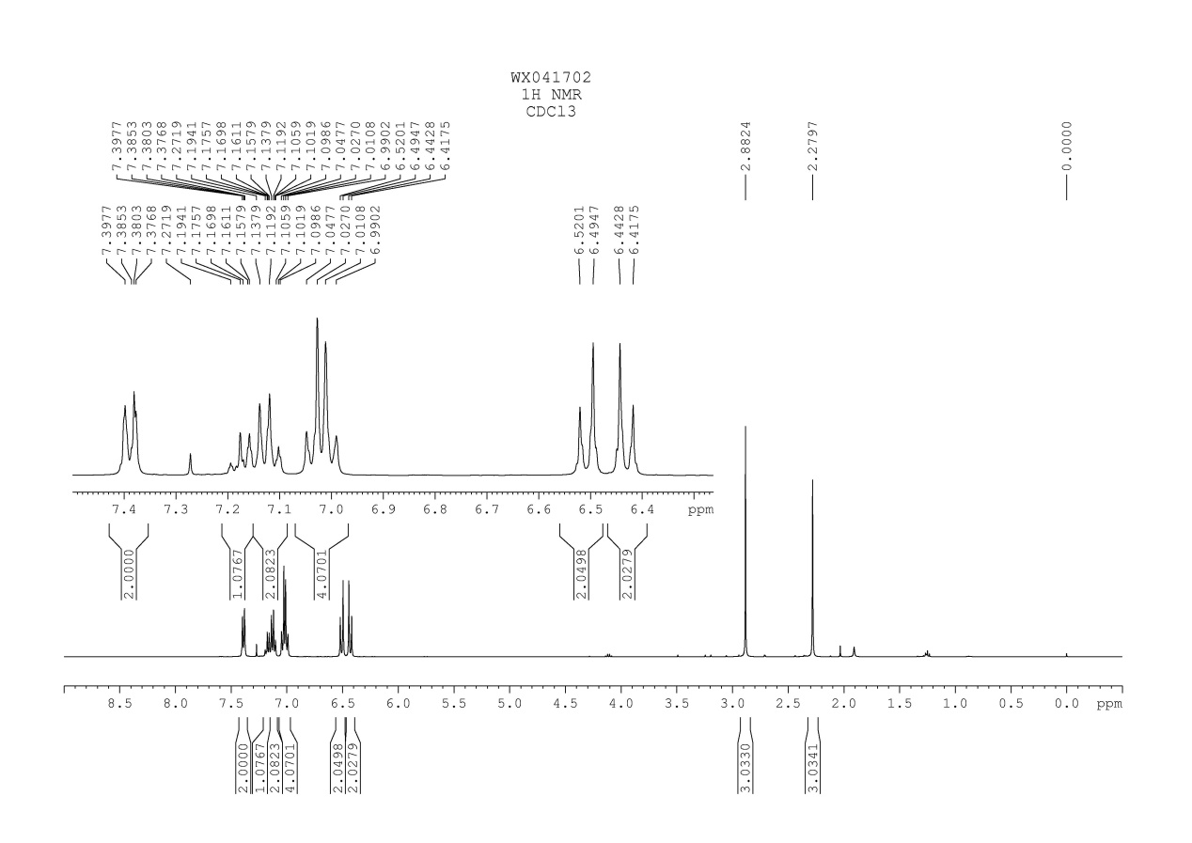
Fig. 3 ¹H NMR spectrum of compound 3b

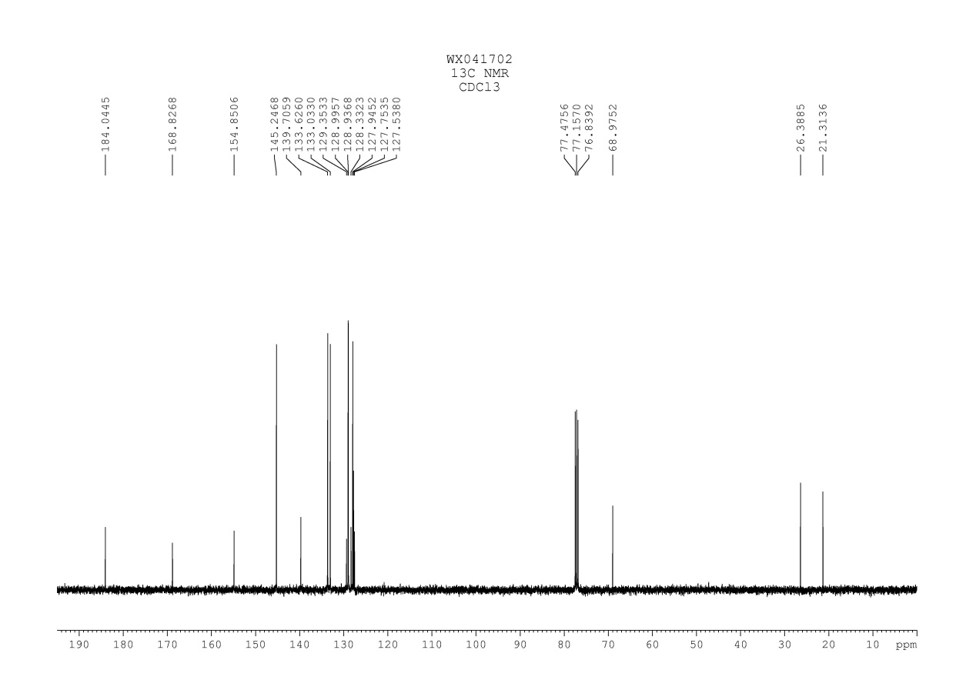
Fig. 4 ¹³C NMR spectrum of compound 3b

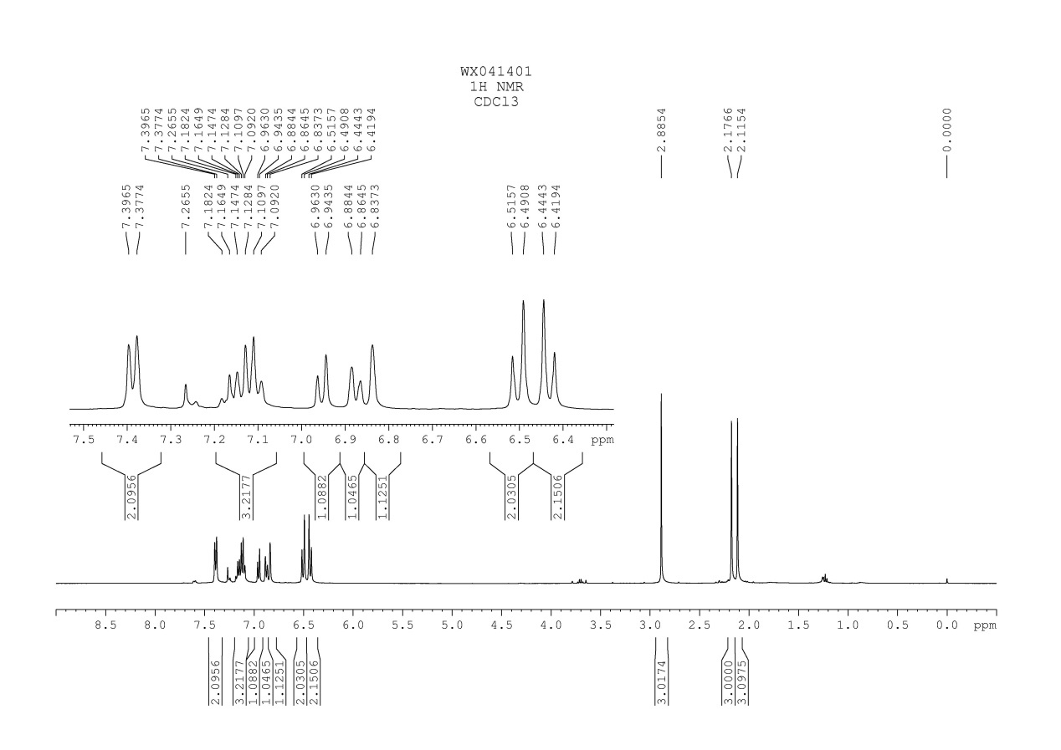
Fig. 5 ¹H NMR spectrum of compound 3c

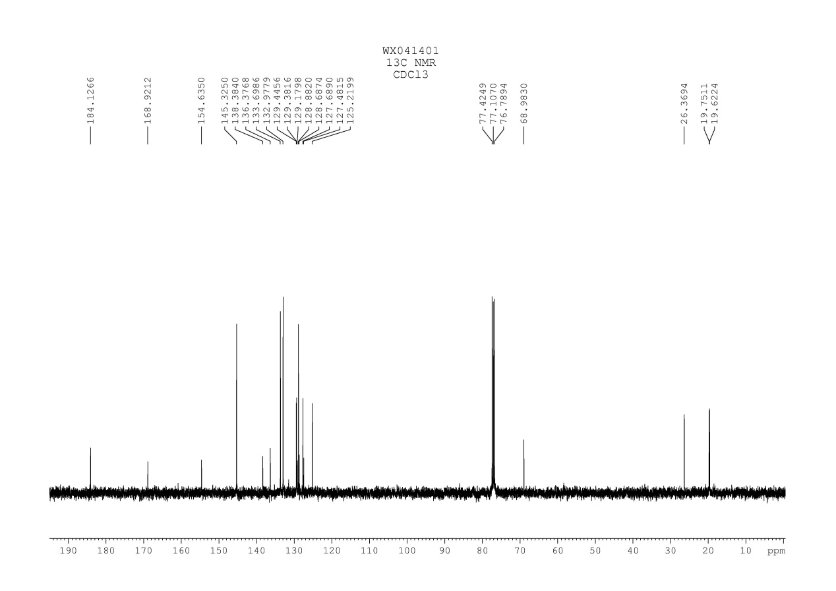
Fig. 6 ¹³C NMR spectrum of compound 3c

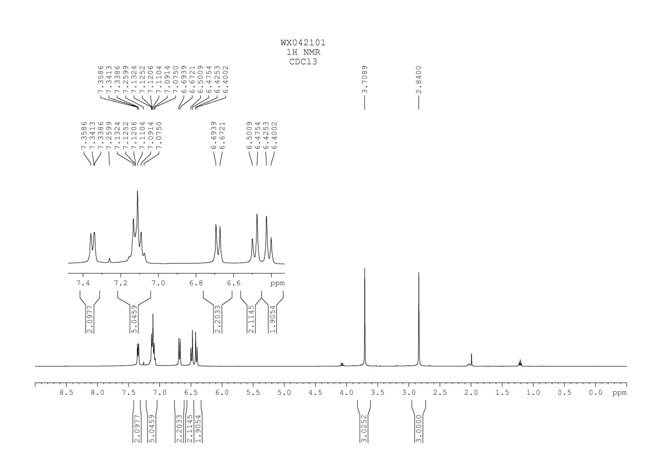
Fig. 7 ¹H NMR spectrum of compound 3d

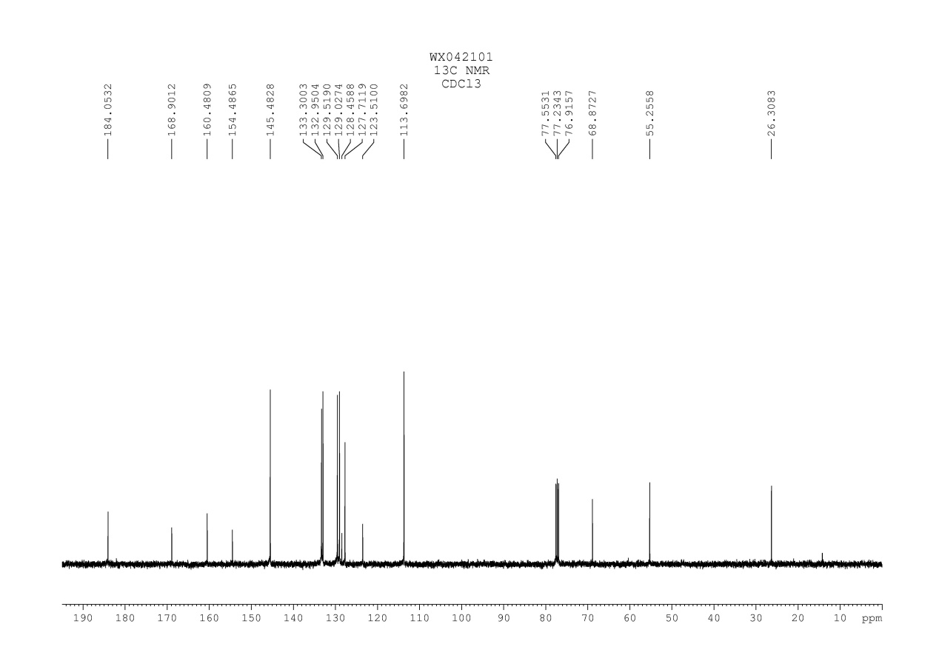
Fig. 8 ¹³C NMR spectrum of compound 3d

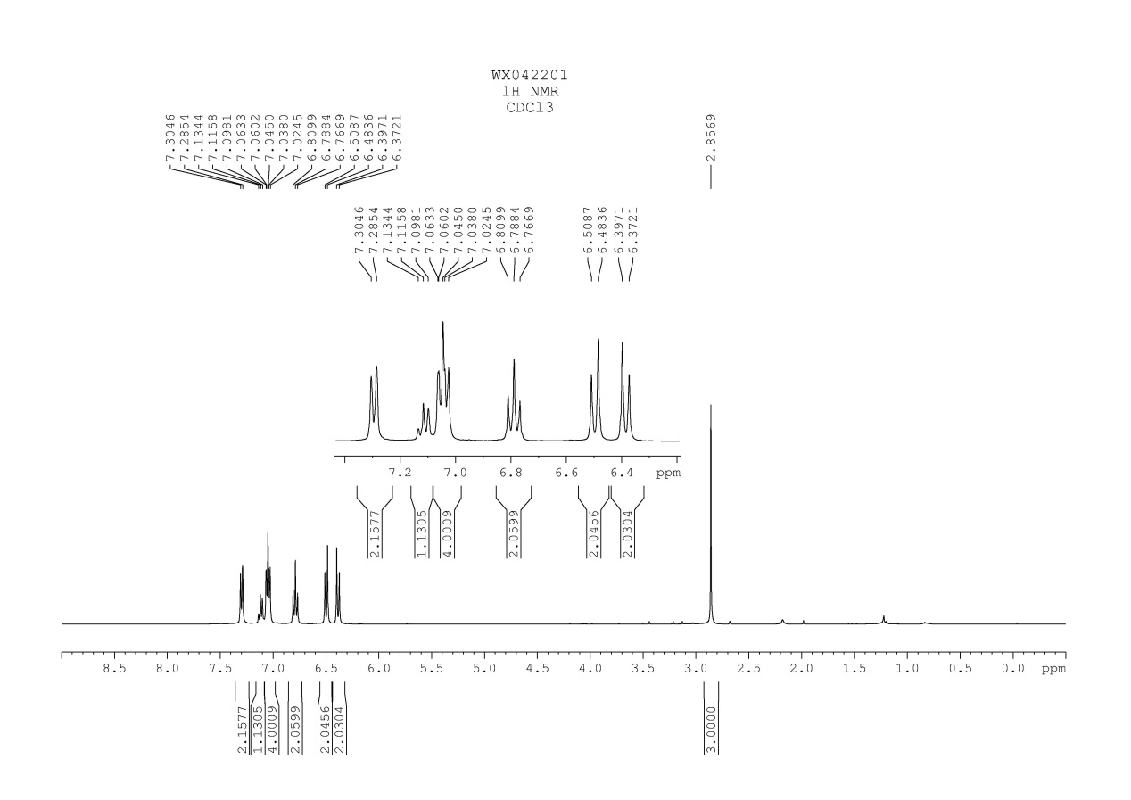
Fig. 9 ¹H NMR spectrum of compound 3e

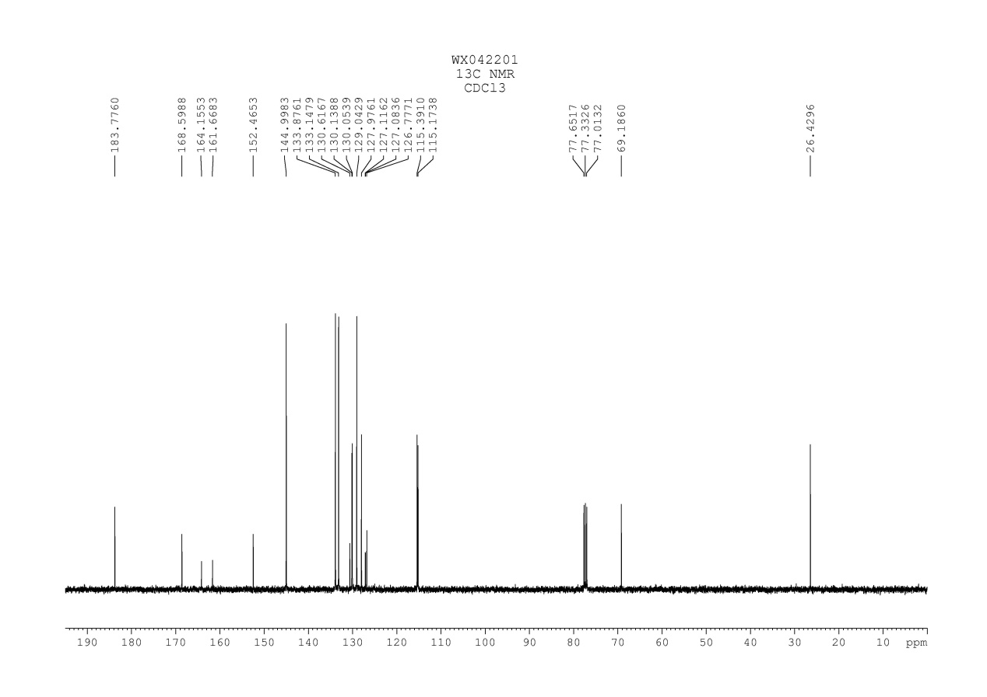
Fig. 10 ¹³C NMR spectrum of compound 3e

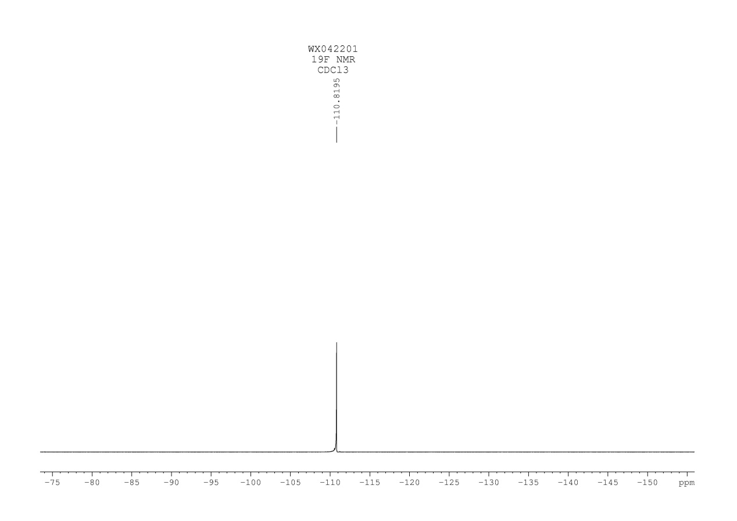
Fig. 11 ¹⁹F NMR spectrum of compound 3e

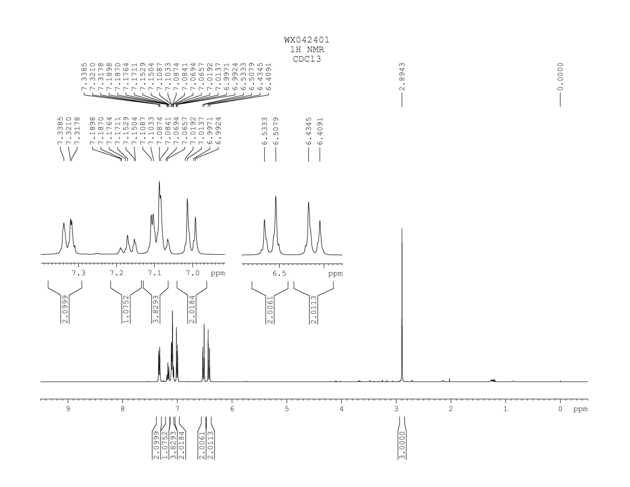
Fig. 12 ¹H NMR spectrum of compound 3f
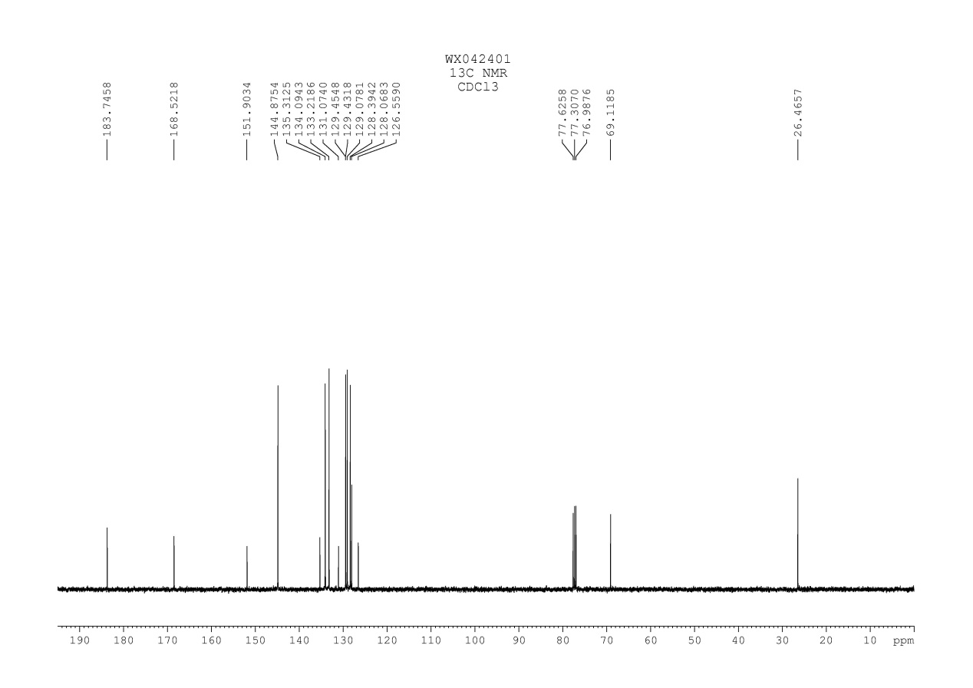
Fig. 13 ¹³C NMR spectrum of compound 3f

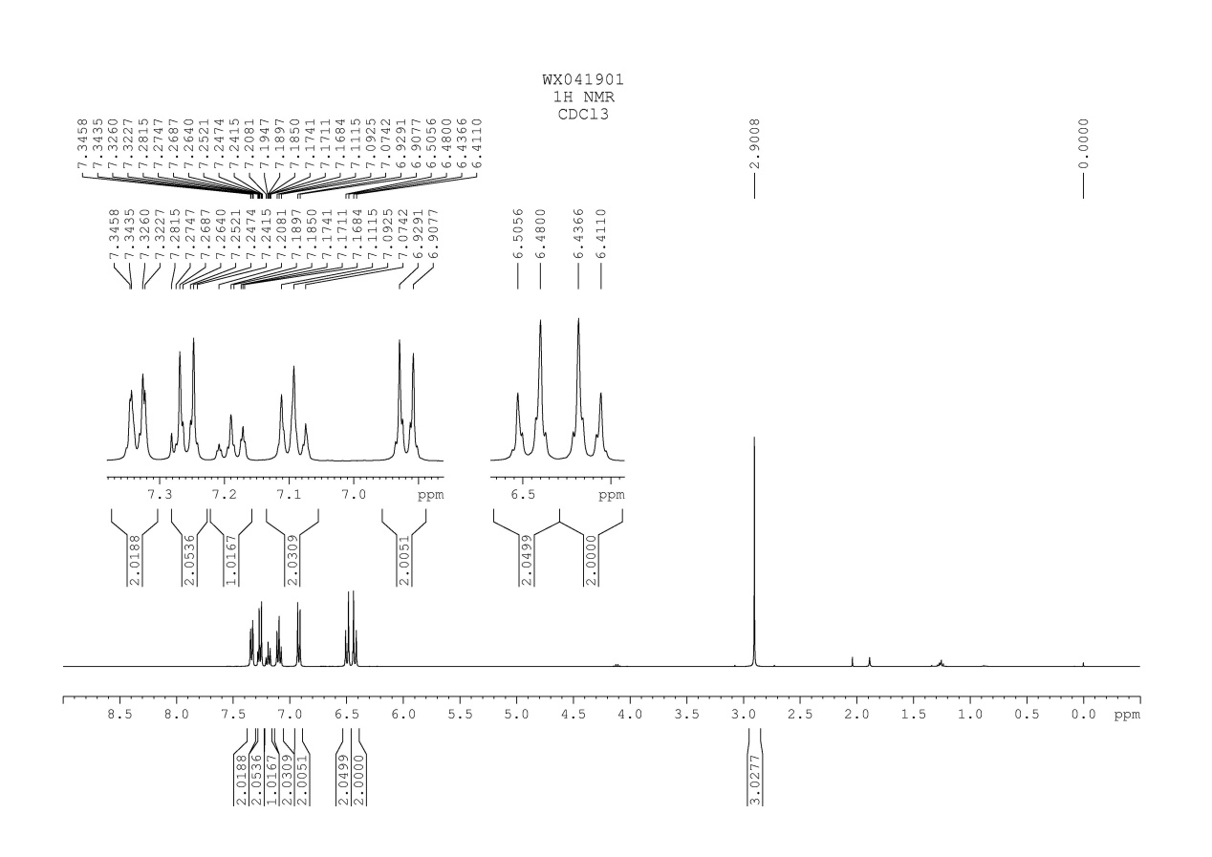
Fig. 14 ¹H NMR spectrum of compound 3g

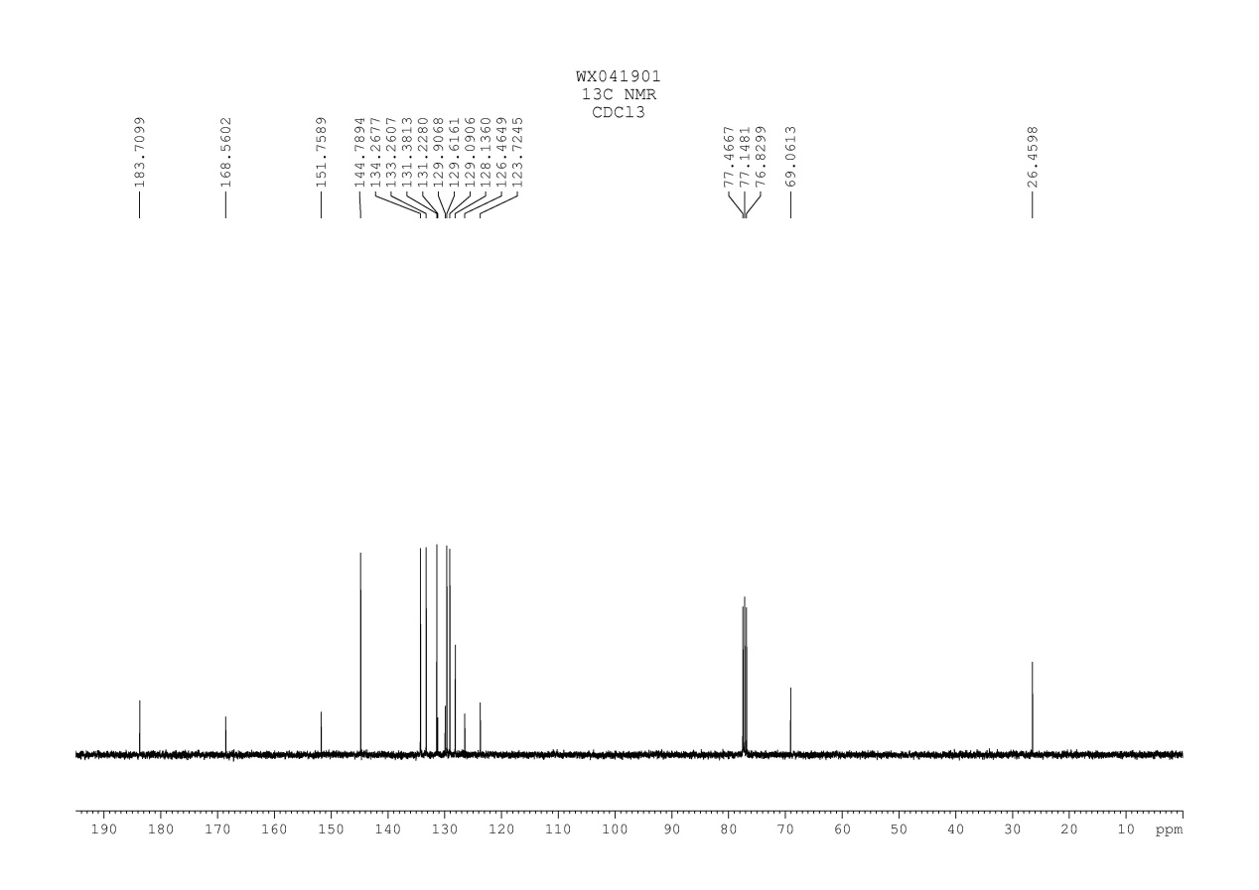
Fig. 15 ¹³C NMR spectrum of compound 3g

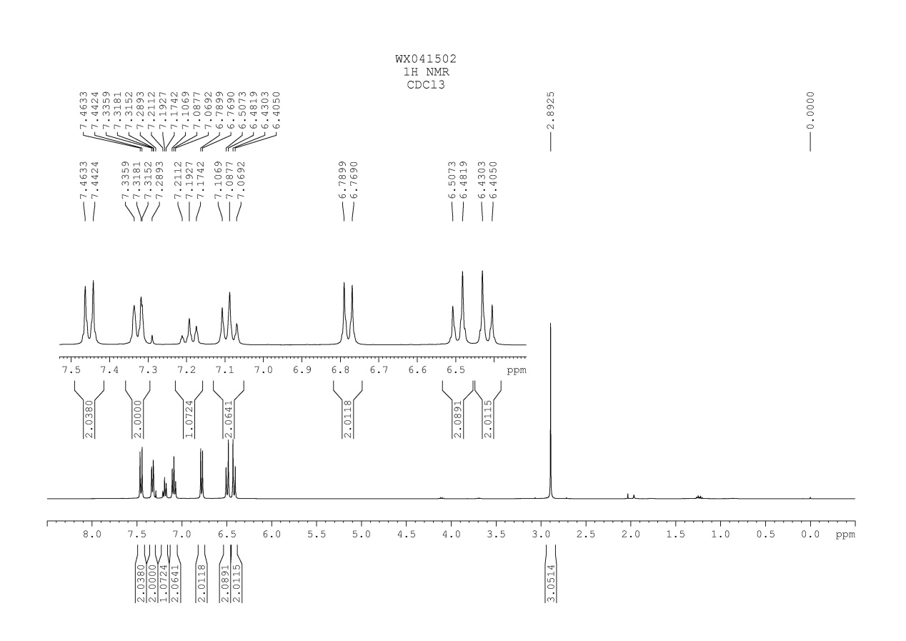
Fig. 16 ¹H NMR spectrum of compound 3h

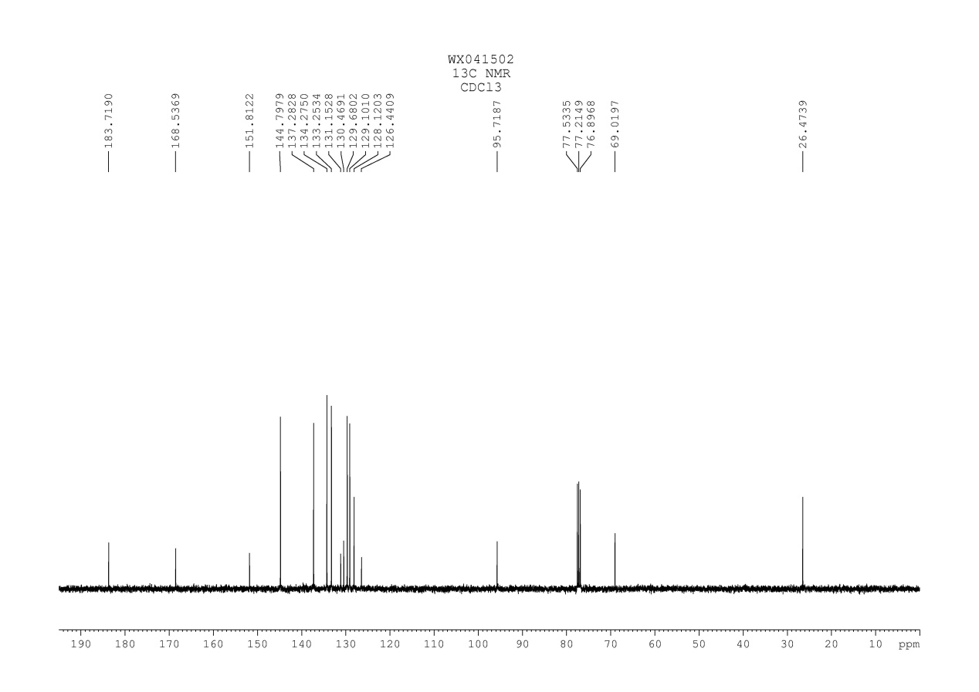
Fig. 17 ¹³C NMR spectrum of compound 3h

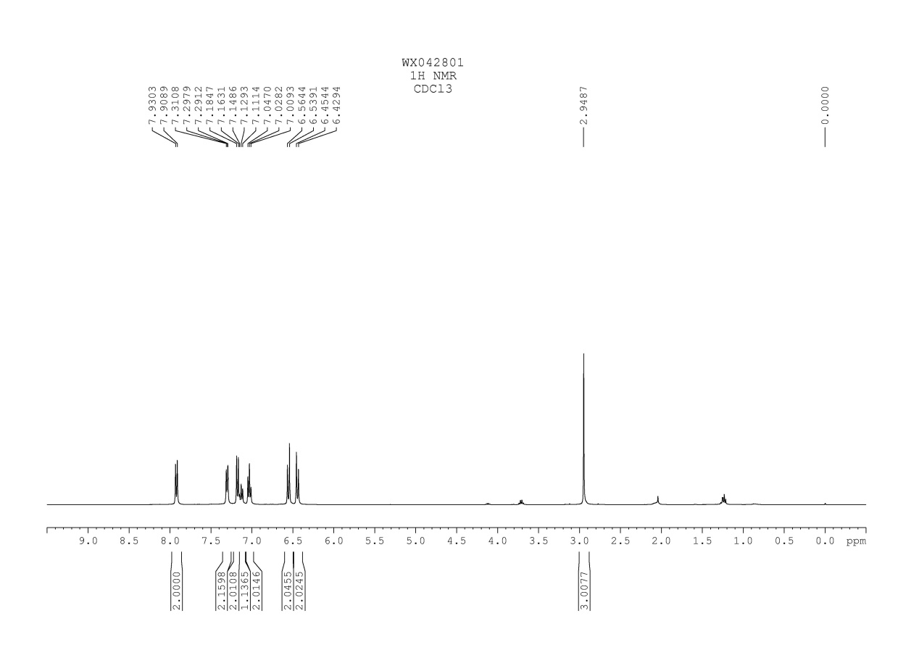
Fig. 18 ¹H NMR spectrum of compound 3i

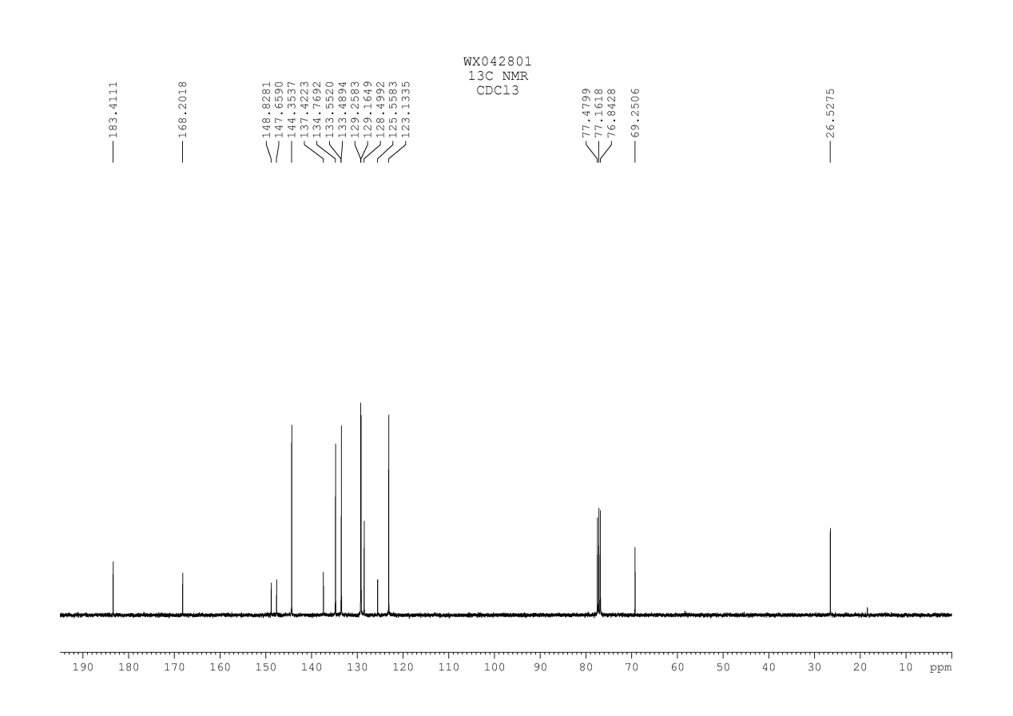
Fig. 19 ¹³C NMR spectrum of compound 3i

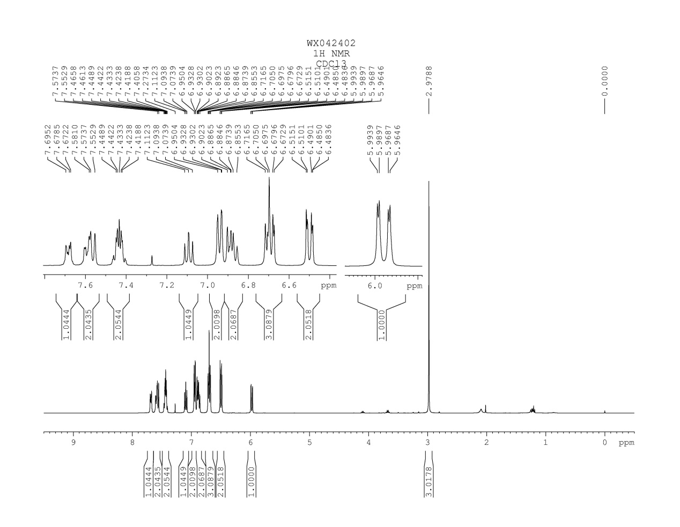
Fig. 20 ¹H NMR spectrum of compound 3j
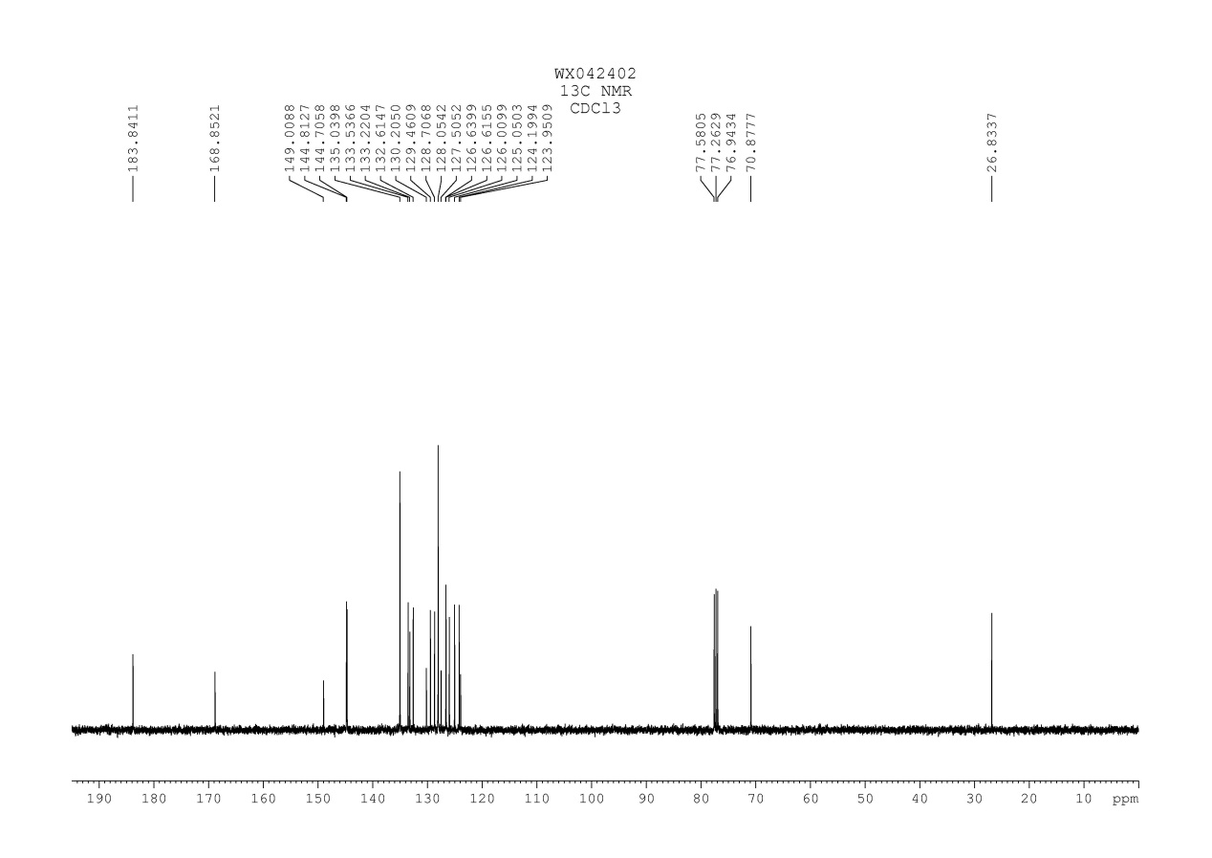
Fig. 21 ¹³C NMR spectrum of compound 3j

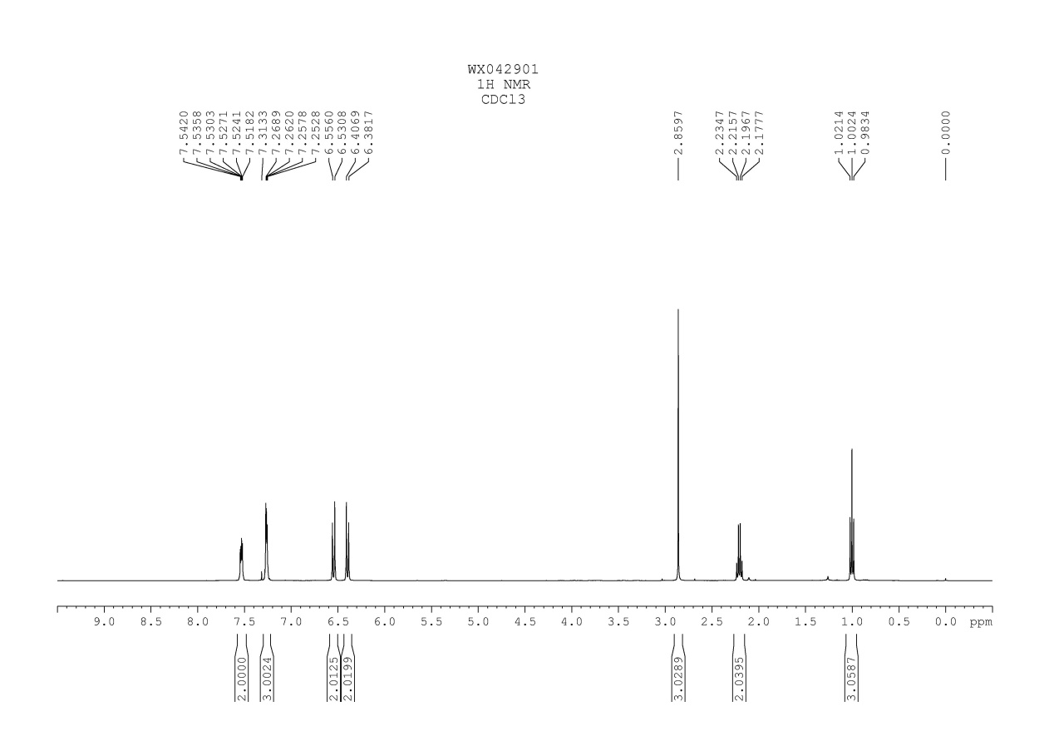
Fig. 22 ¹H NMR spectrum of compound 3k

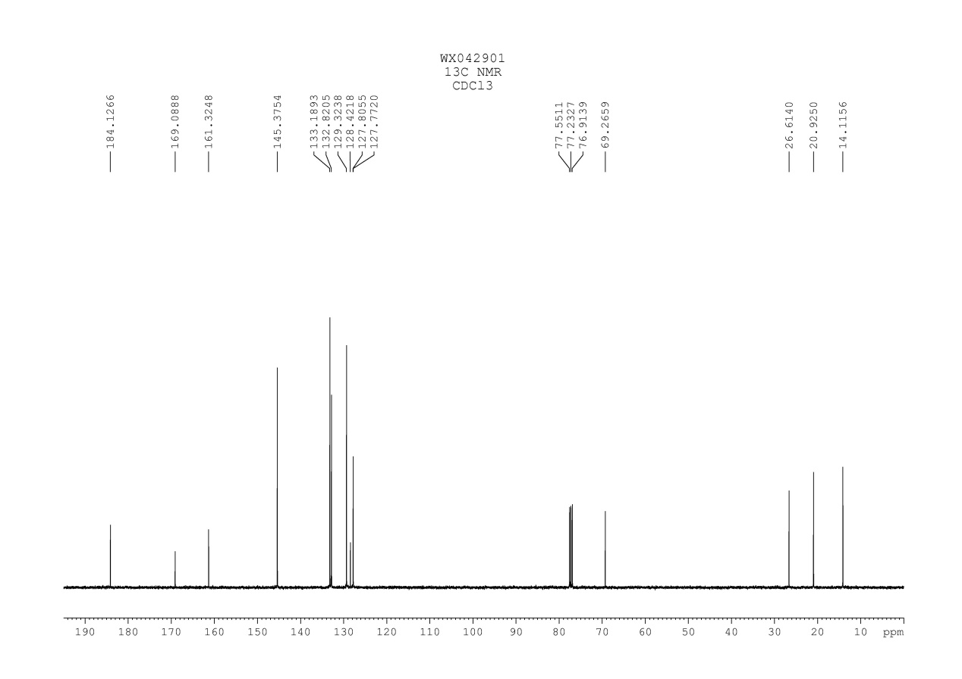
Fig. 23 ¹³C NMR spectrum of compound 3k

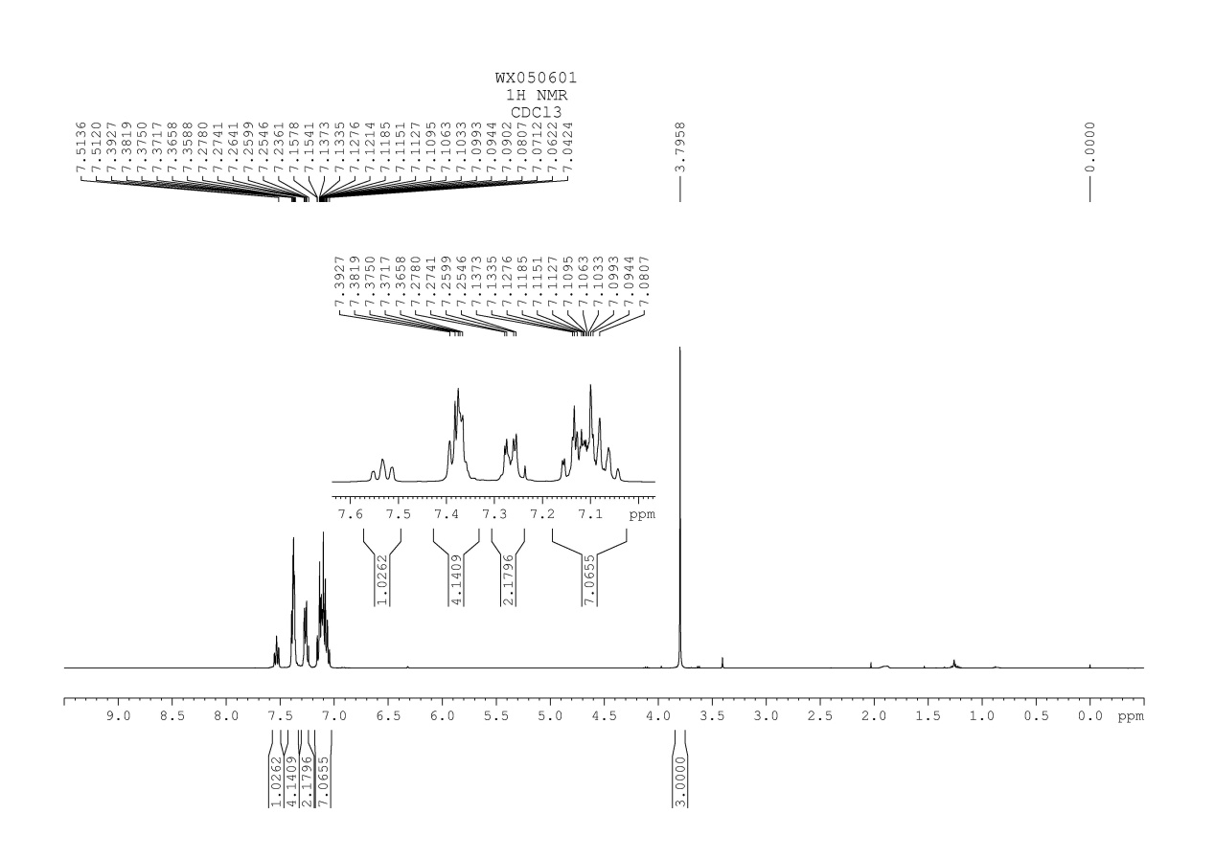
Fig. 24 ¹H NMR spectrum of compound 3l

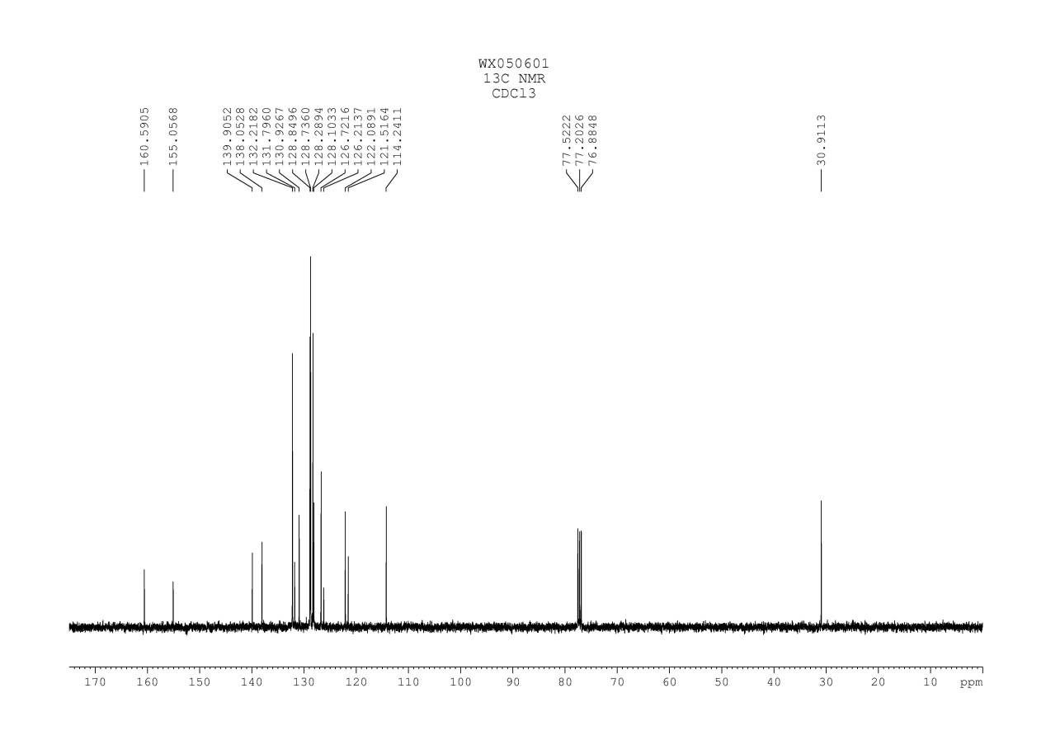
Fig. 25 ¹³C NMR spectrum of compound 3l

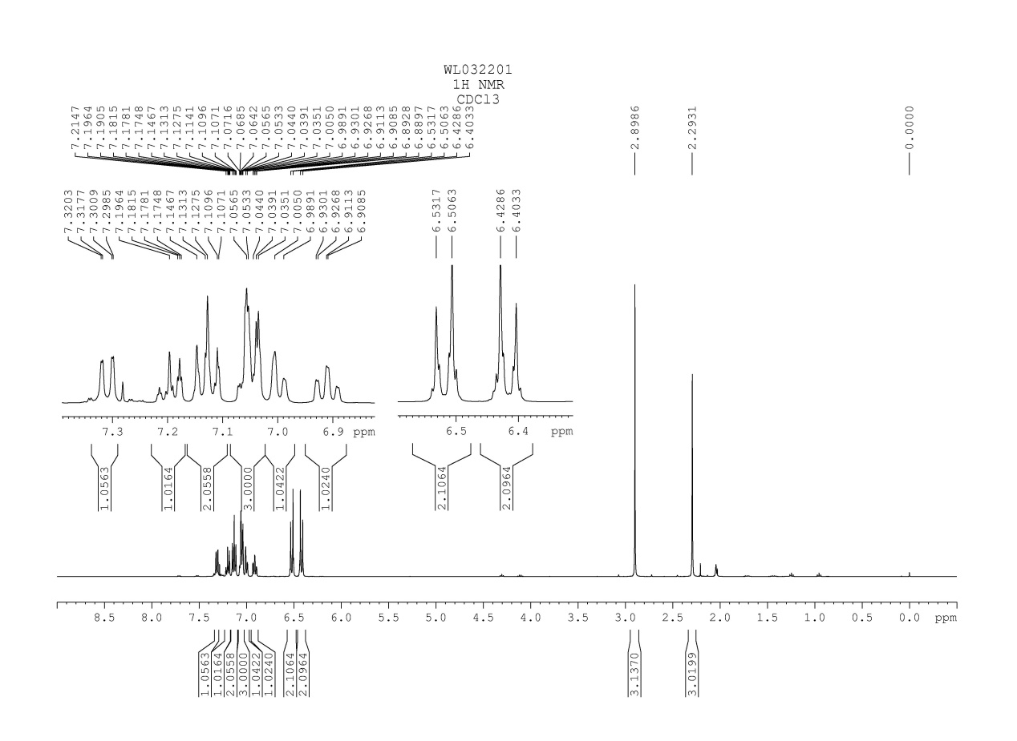
Fig. 26 ¹H NMR spectrum of compound 3m

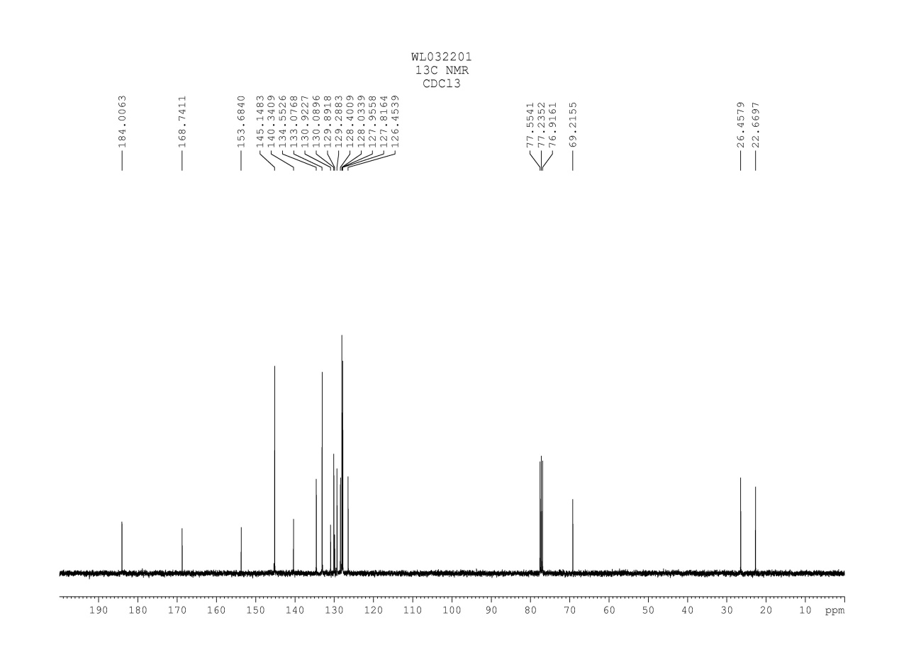
Fig. 27 ¹³C NMR spectrum of compound 3m
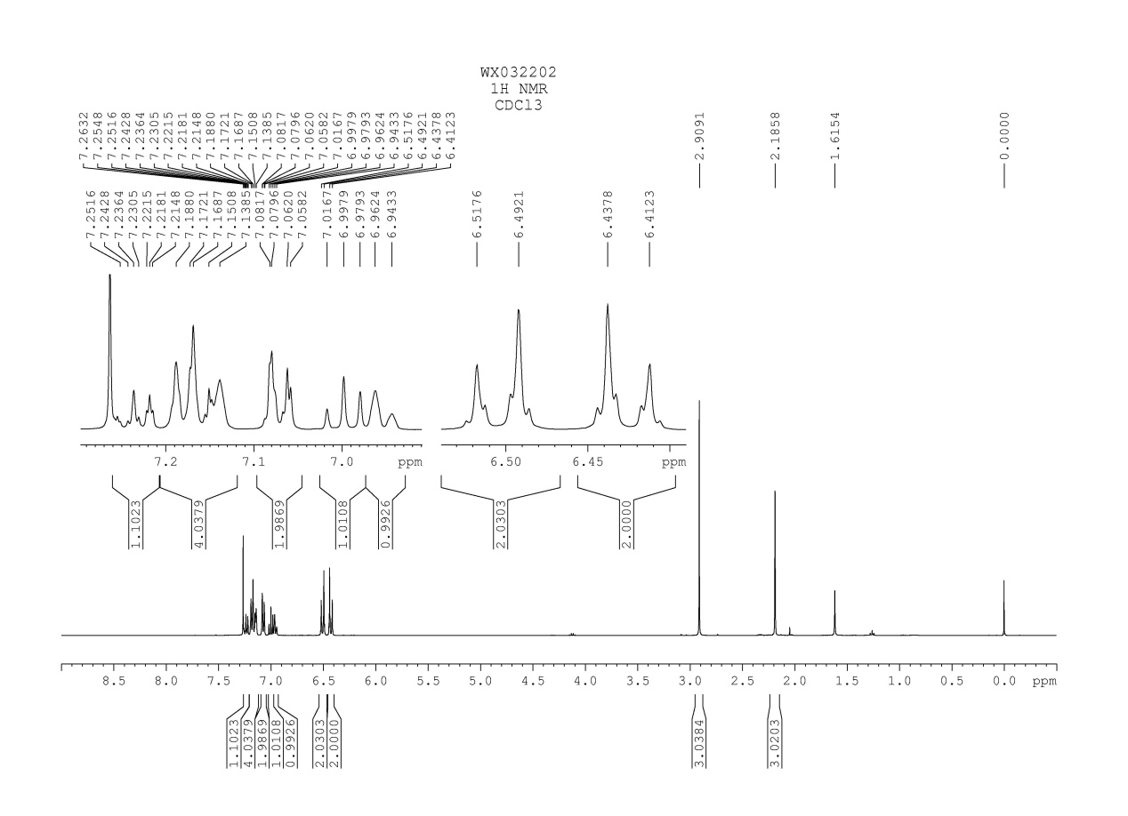
Fig. 28 ¹H NMR spectrum of compound 3n

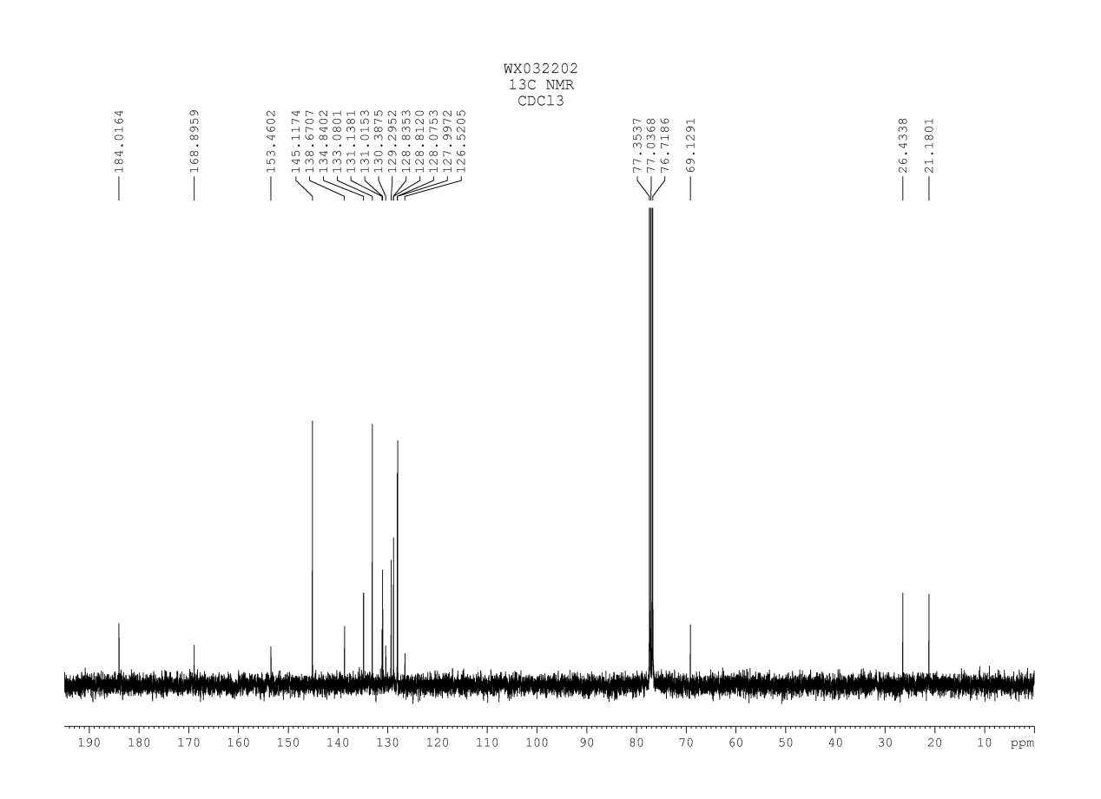
Fig. 29 ¹³C NMR spectrum of compound 3n
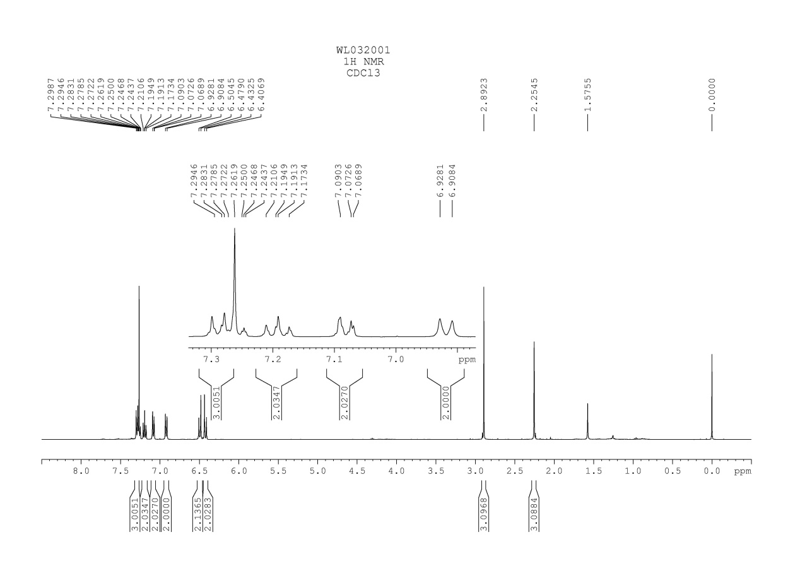
Fig. 30 ¹H NMR spectrum of compound 3o

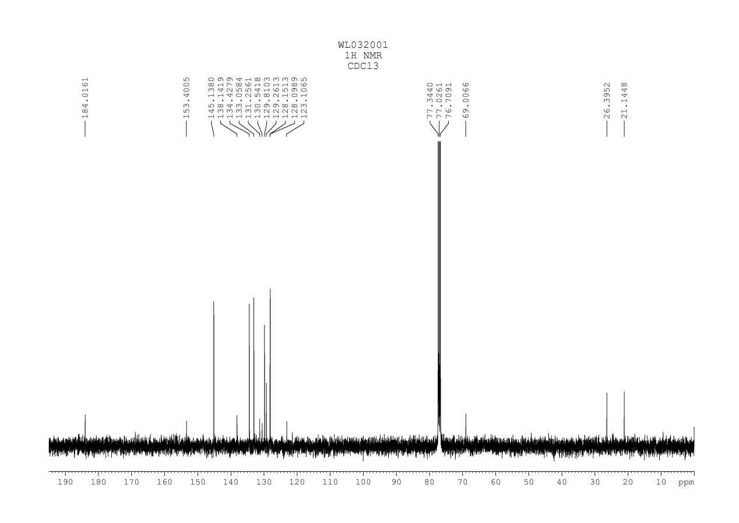
Fig. 31 ¹³C NMR spectrum of compound 3o

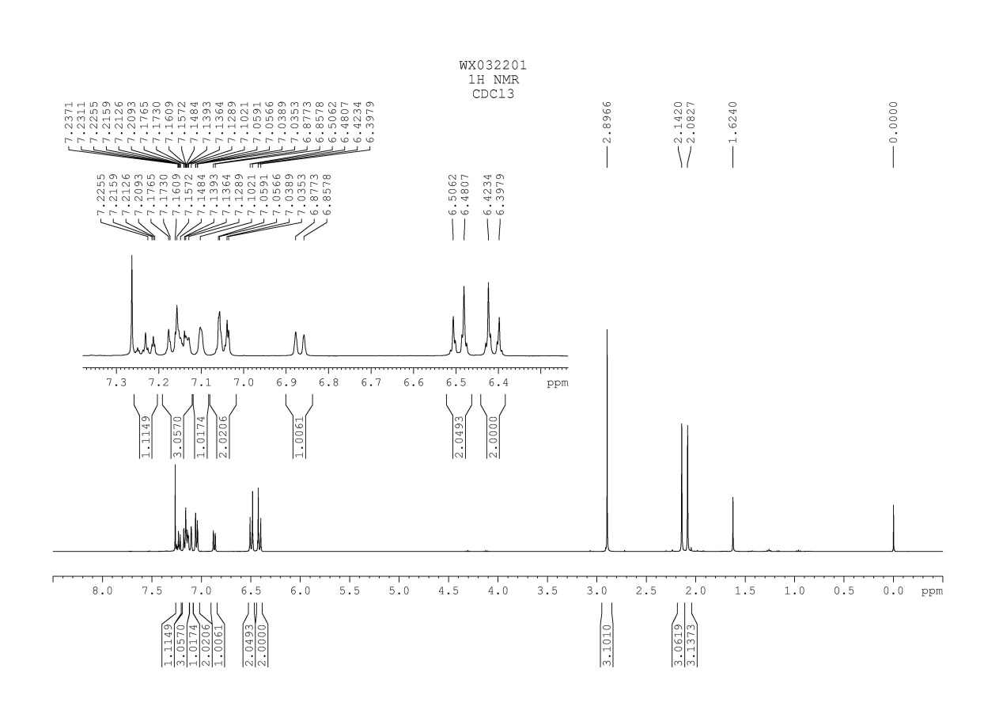
Fig. 32 ¹H NMR spectrum of compound 3p

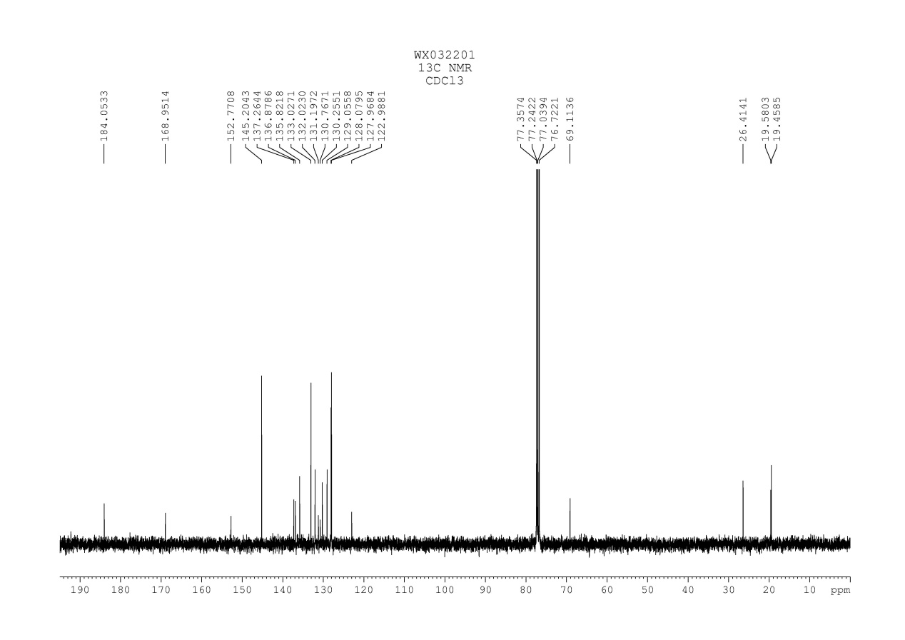
Fig. 33 ¹³C NMR spectrum of compound 3p

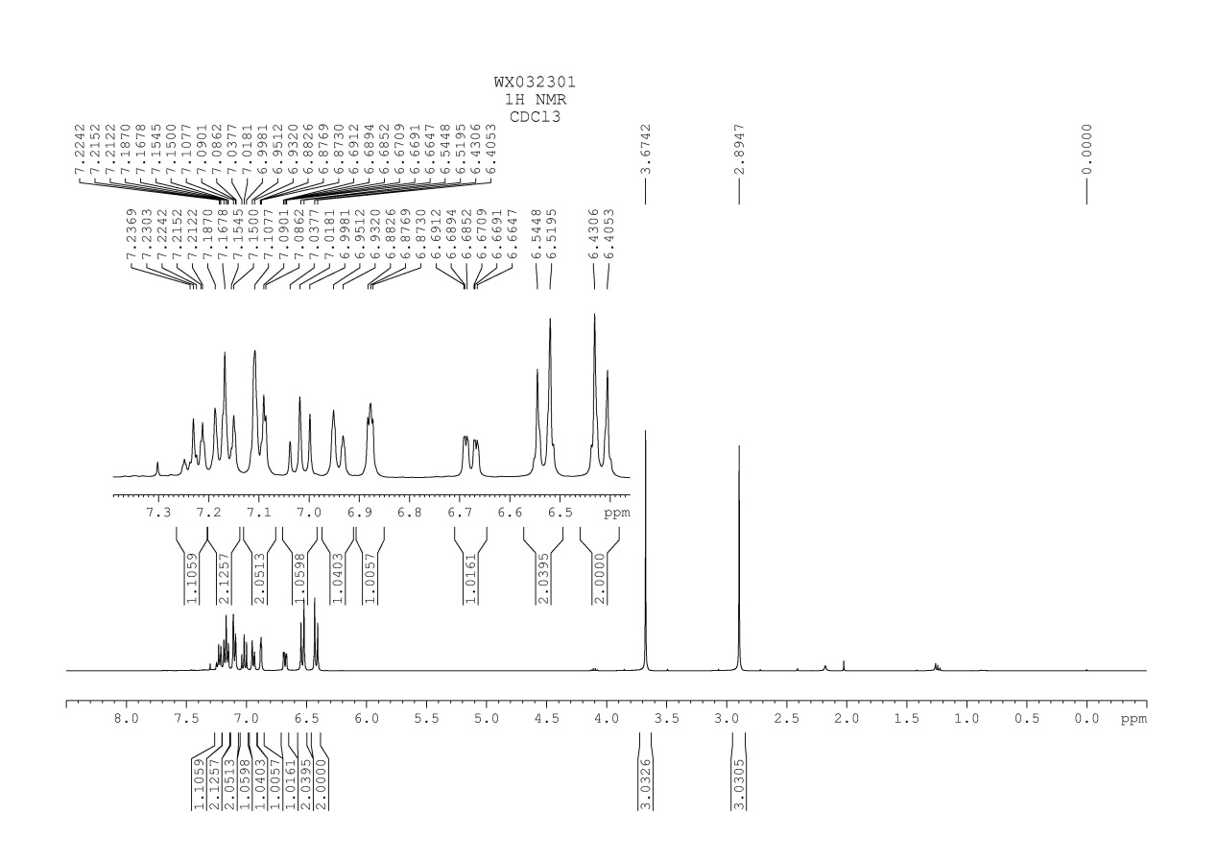
Fig. 34 ¹H NMR spectrum of compound 3q

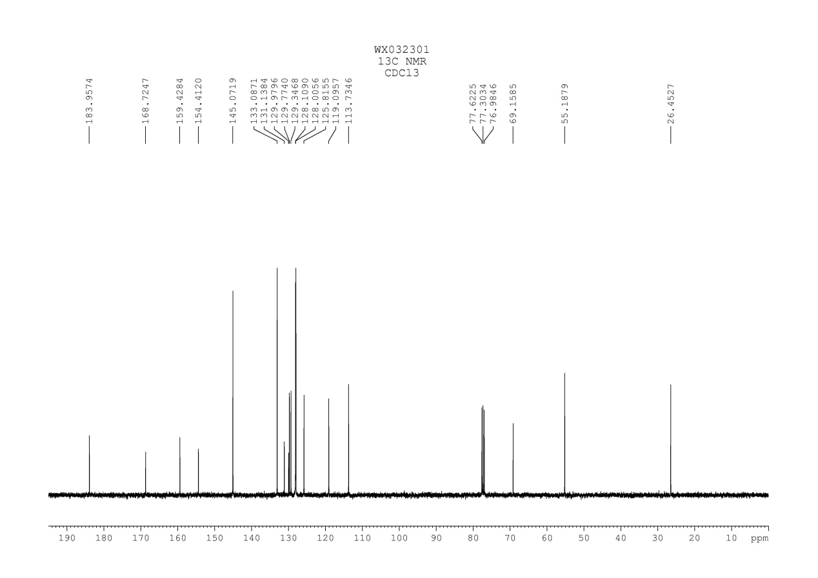
Fig. 35 ¹³C NMR spectrum of compound 3q

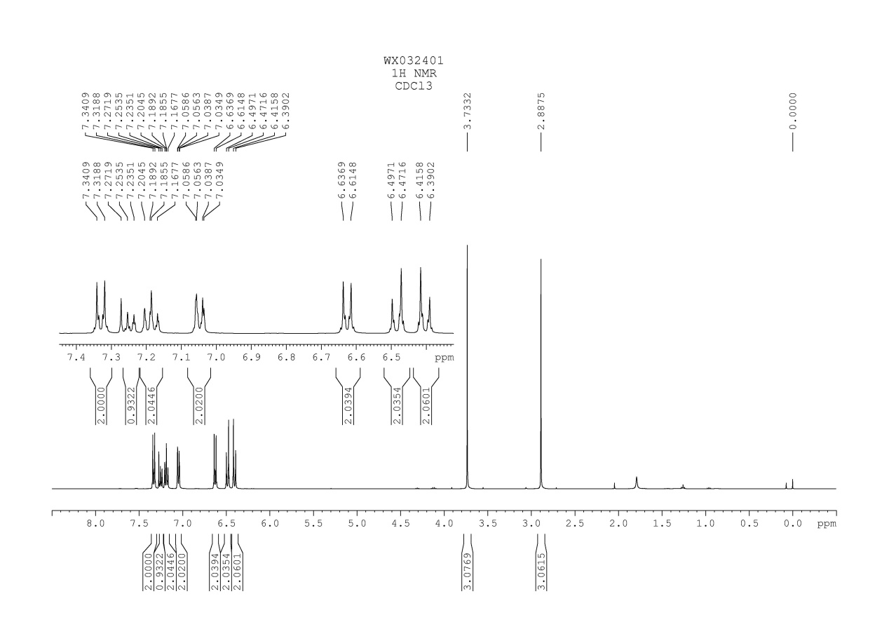
Fig. 36 ¹H NMR spectrum of compound 3r

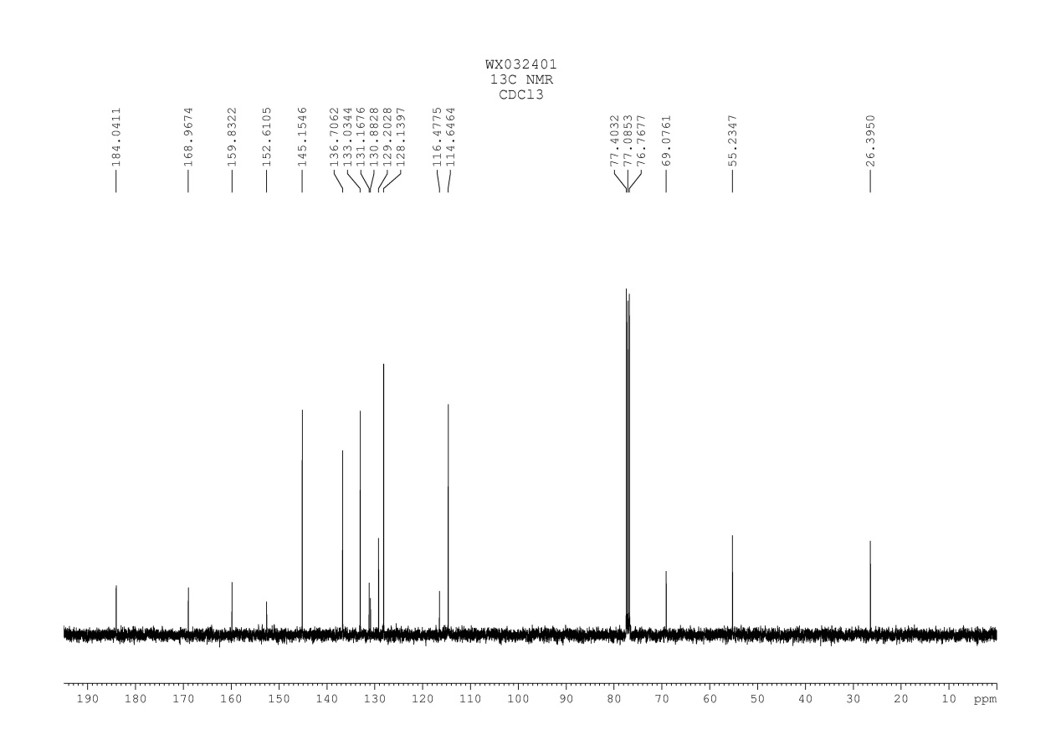
Fig. 37 ¹³C NMR spectrum of compound 3r

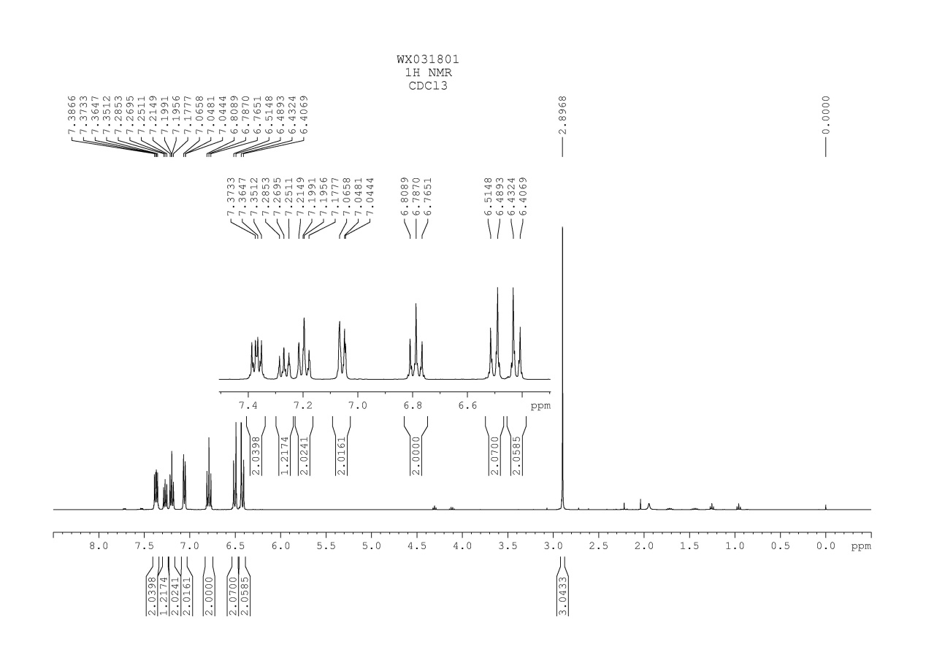
Fig. 38 ¹H NMR spectrum of compound 3s

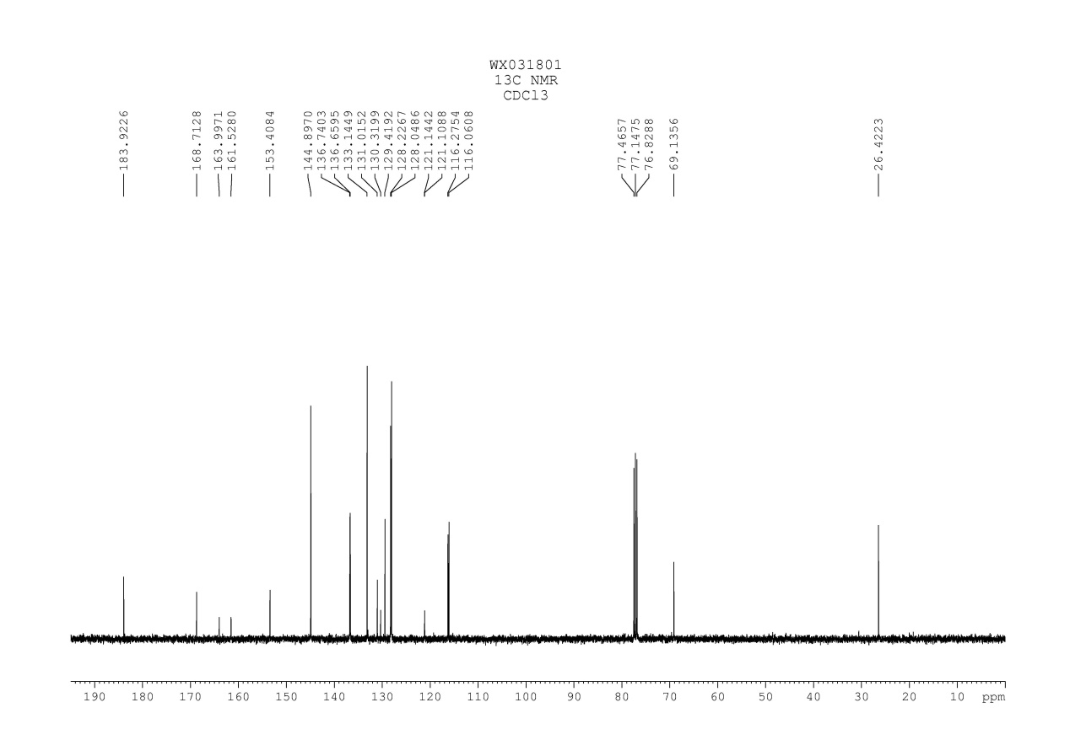
Fig. 39 ¹³C NMR spectrum of compound 3s

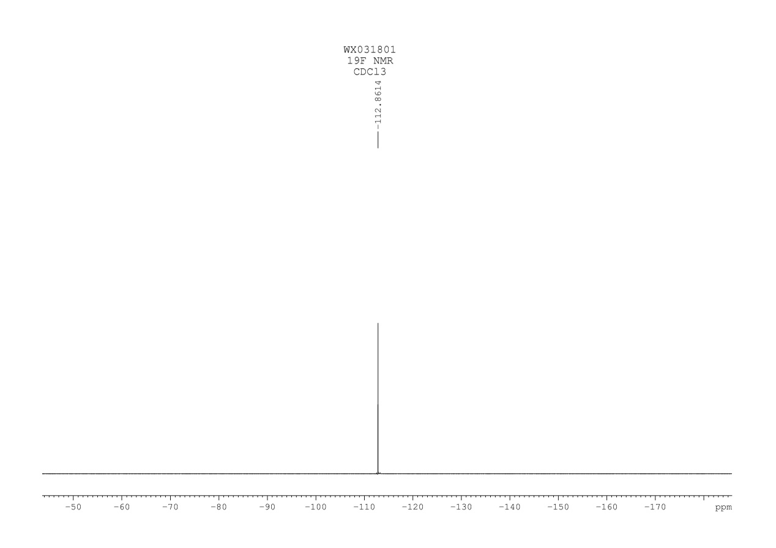
Fig. 40 ¹⁹F NMR spectrum of compound 3s

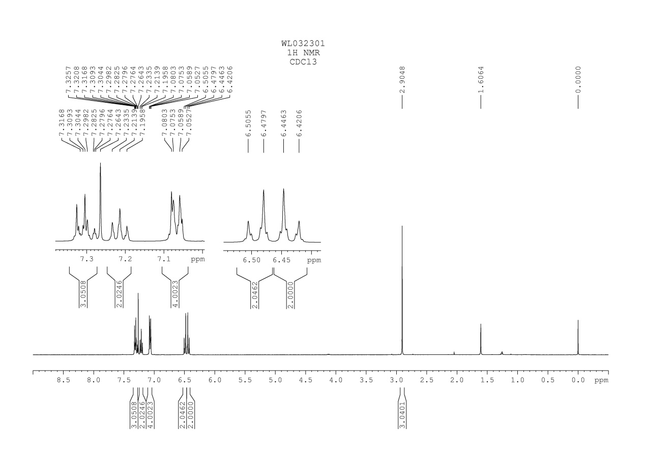
Fig. 41 ¹H NMR spectrum of compound 3t

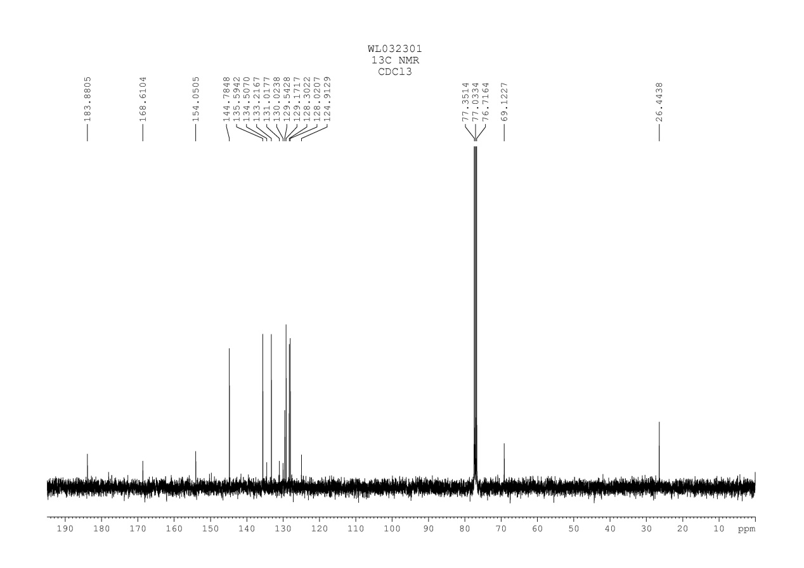
Fig. 42 ¹³C NMR spectrum of compound 3t

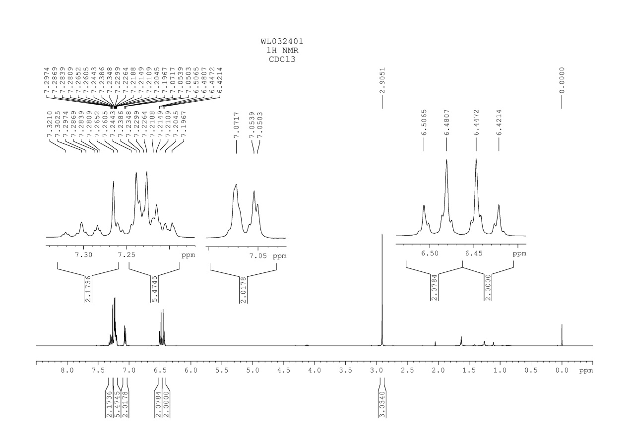
Fig. 43 ¹H NMR spectrum of compound 3u

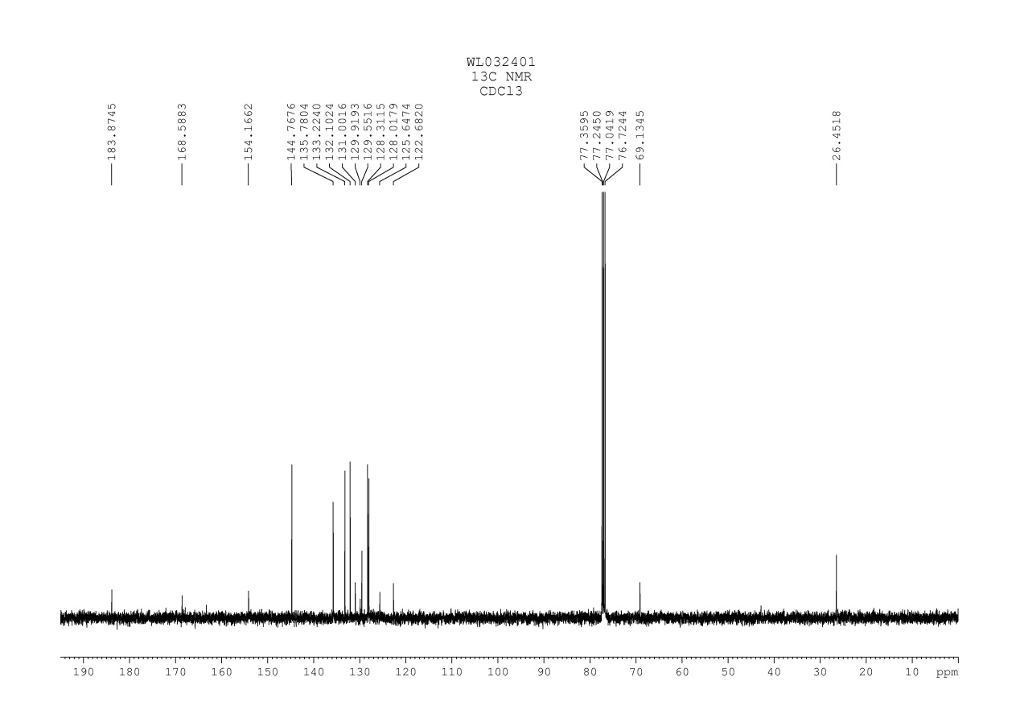
Fig. 44 ¹³C NMR spectrum of compound 3u

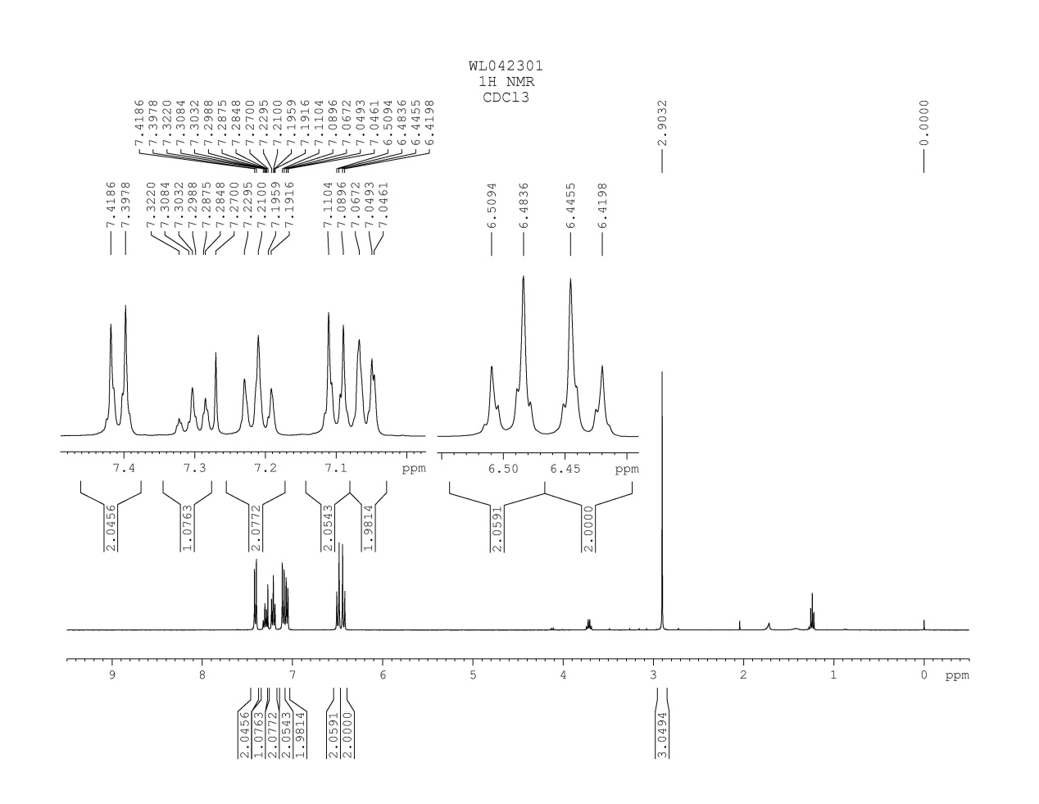
Fig. 45 ¹H NMR spectrum of compound 3v
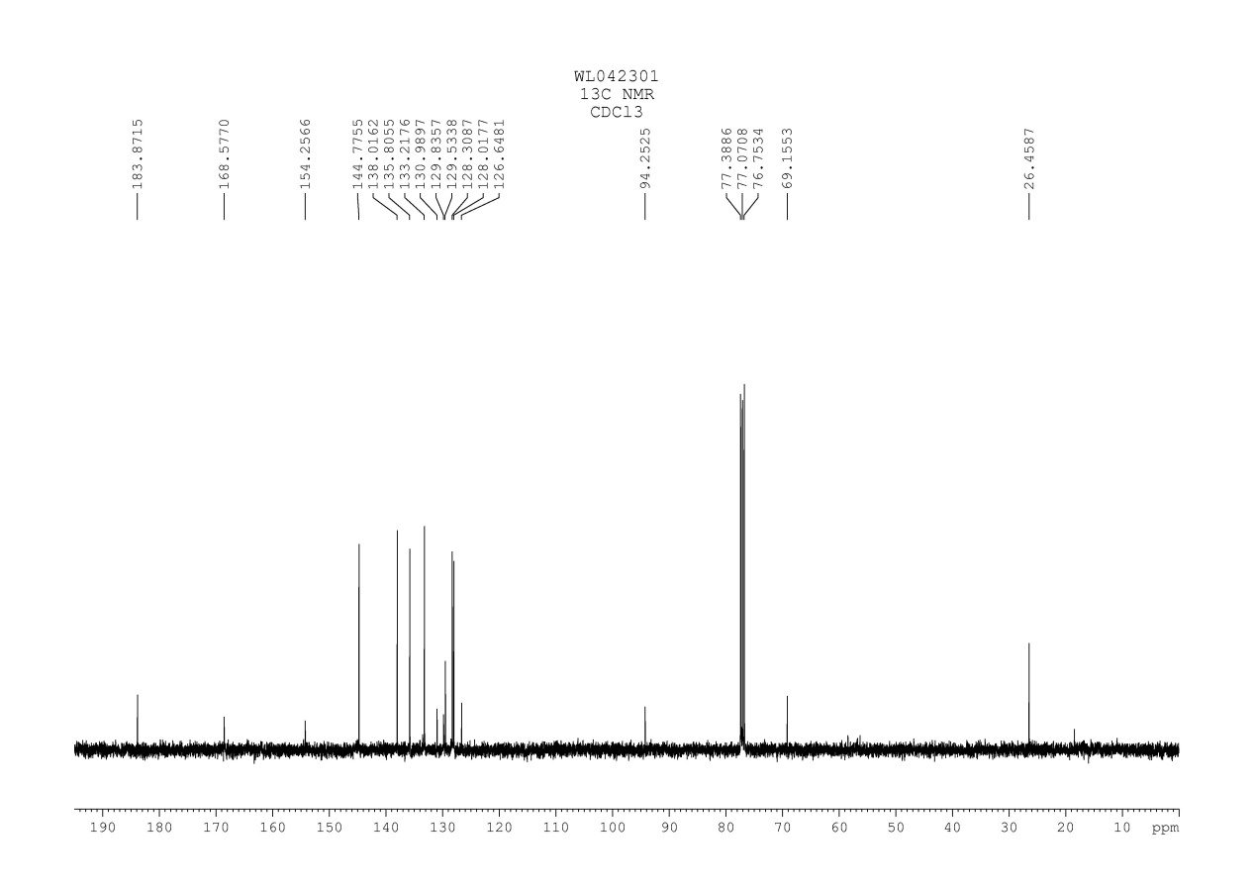
Fig. 46 ¹³C NMR spectrum of compound 3v

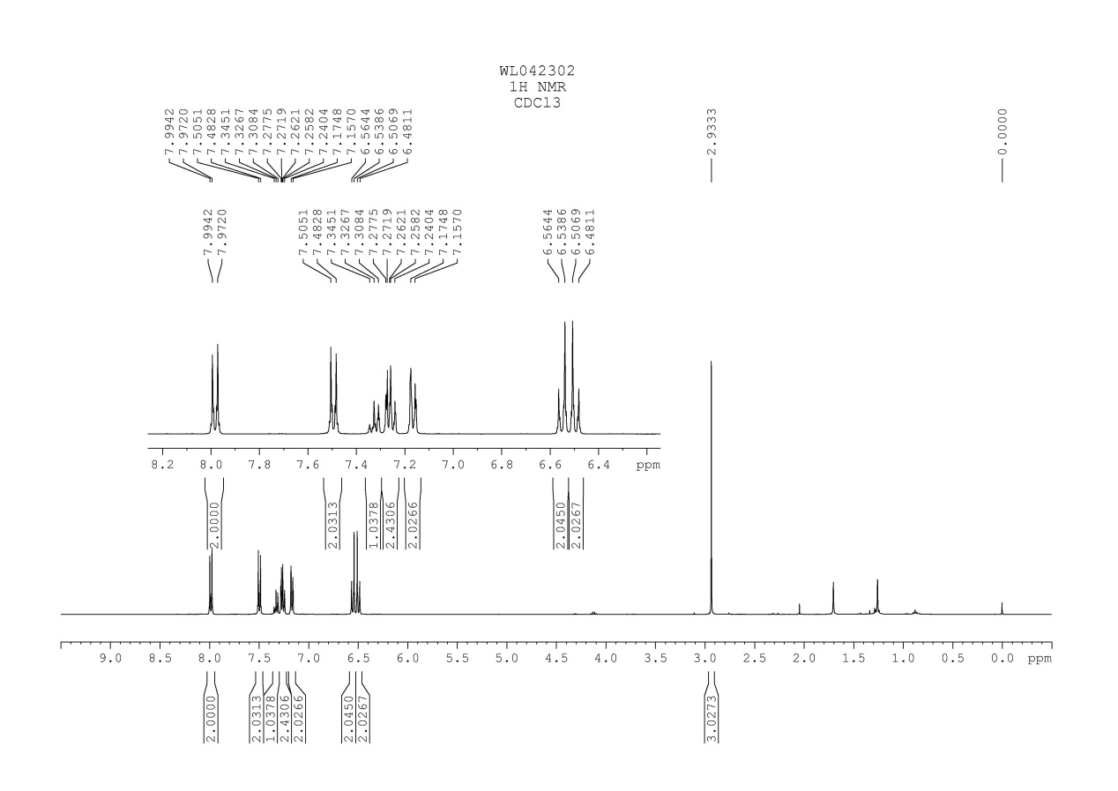
Fig. 47 ¹H NMR spectrum of compound 3w

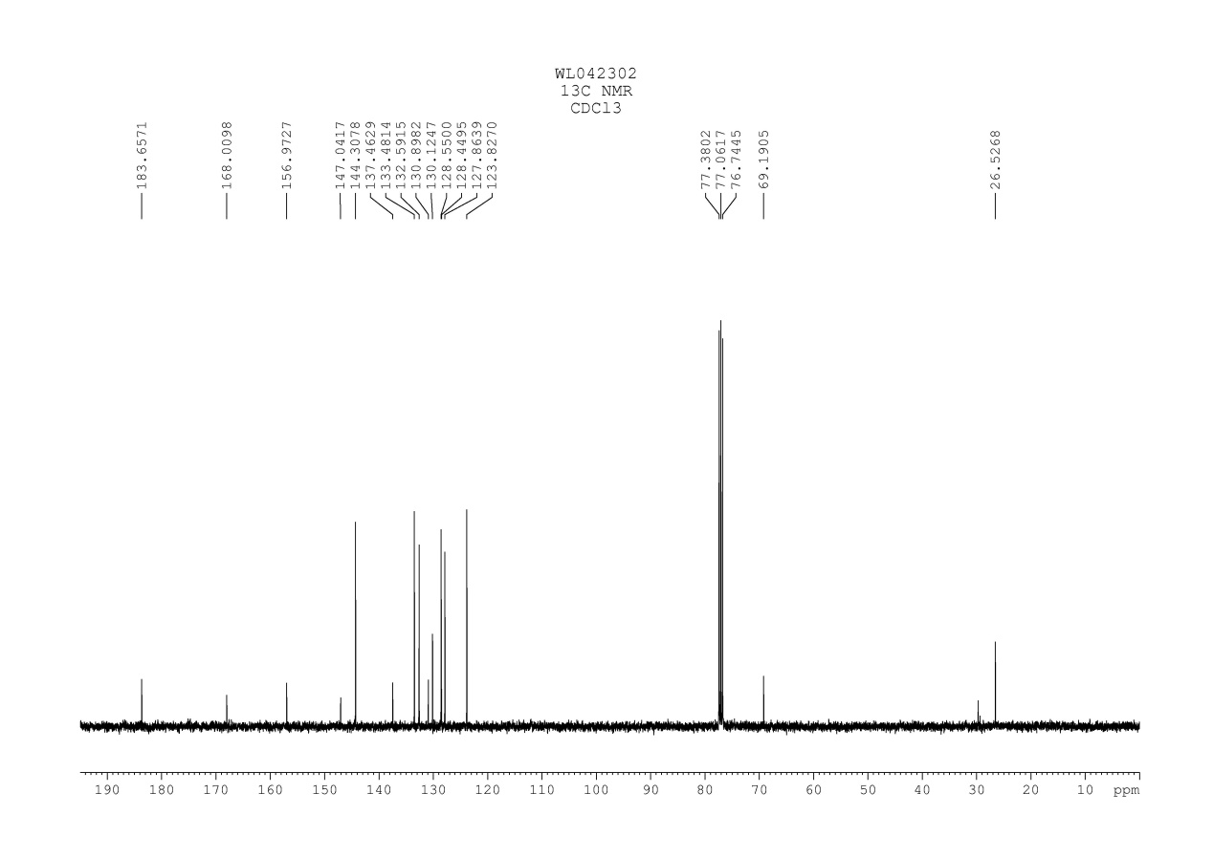
Fig. 48 ¹³C NMR spectrum of compound 3w

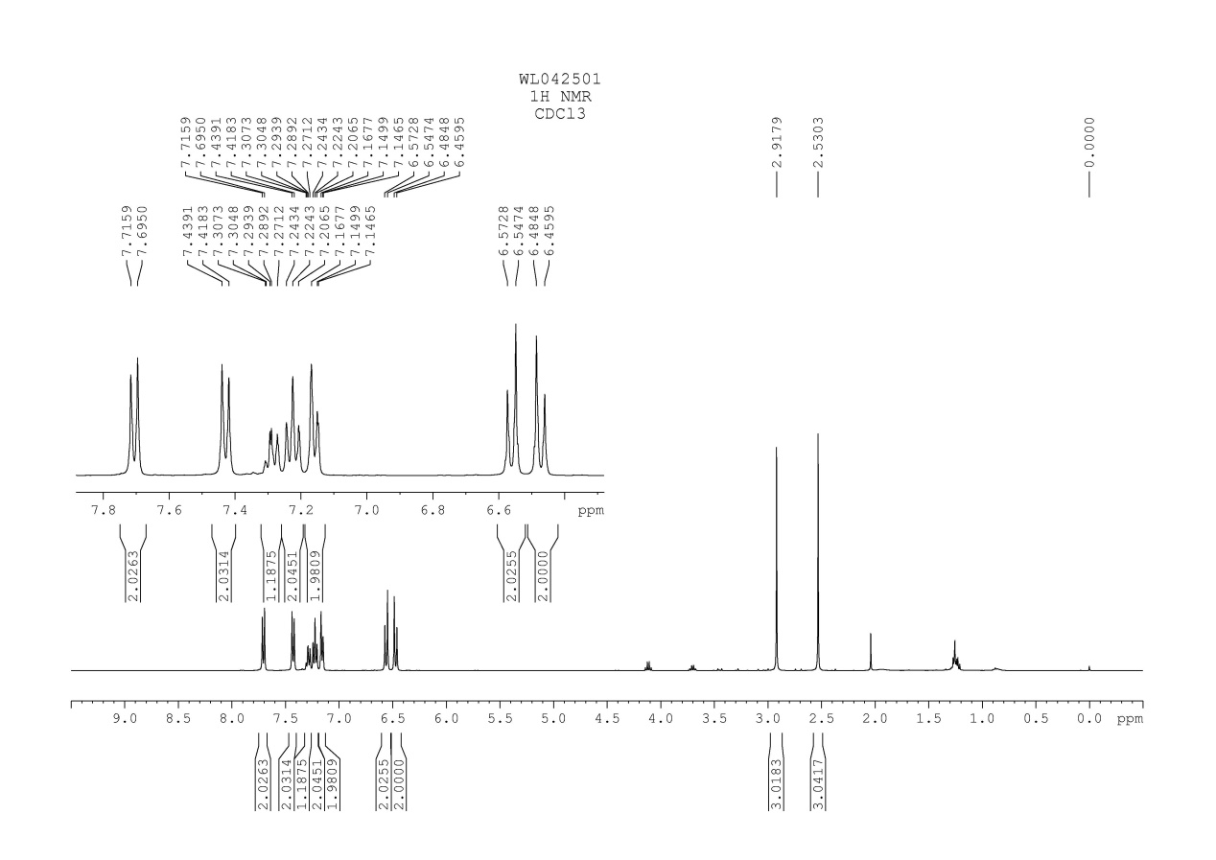
Fig. 49 ¹H NMR spectrum of compound 3x

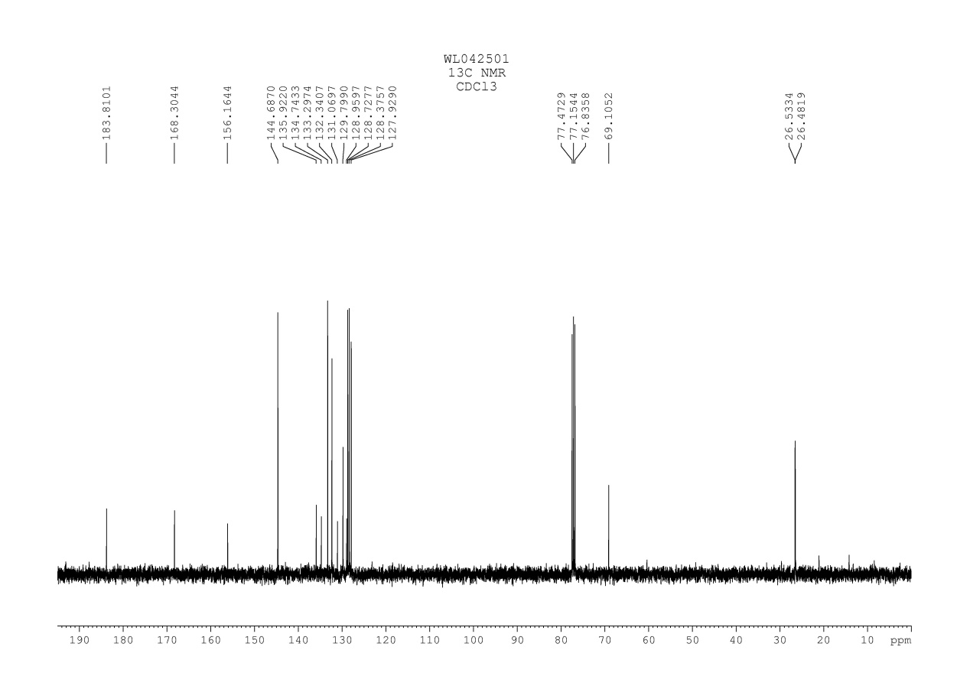
Fig. 50 ¹³C NMR spectrum of compound 3x

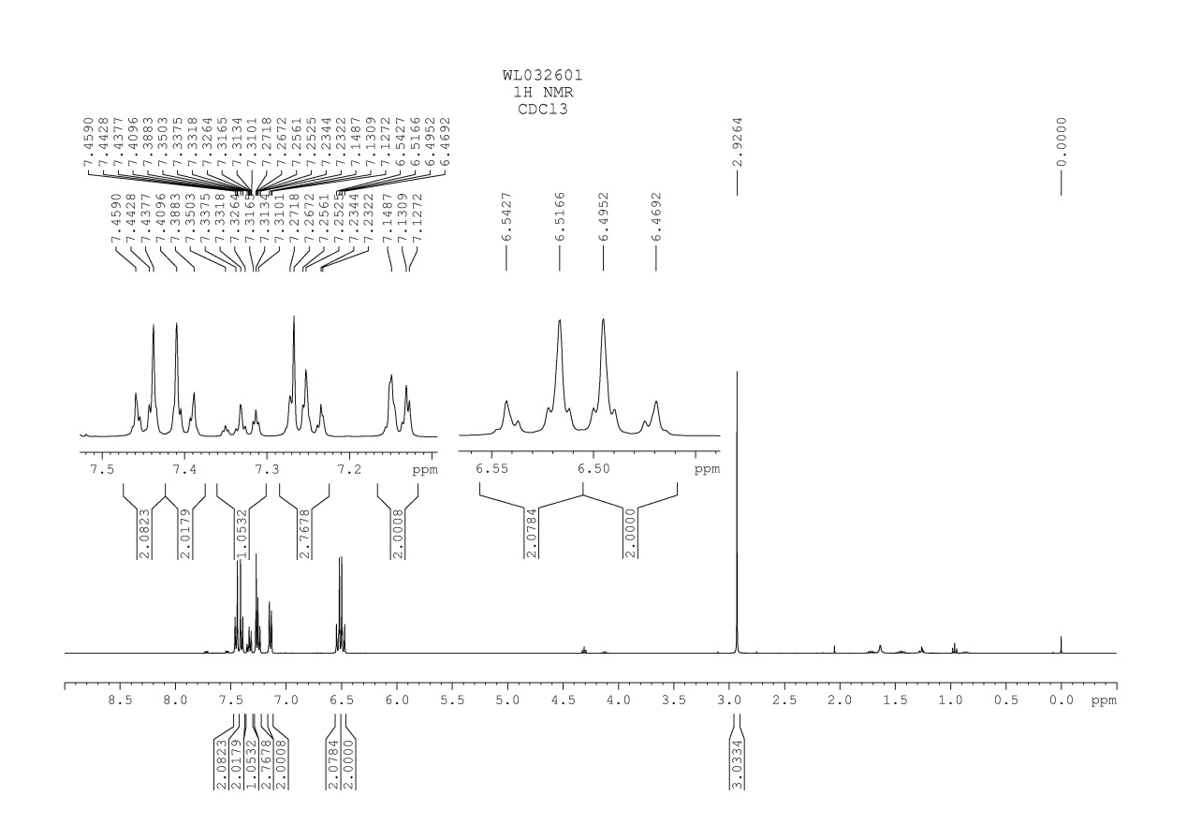
Fig. 51 ¹H NMR spectrum of compound 3y

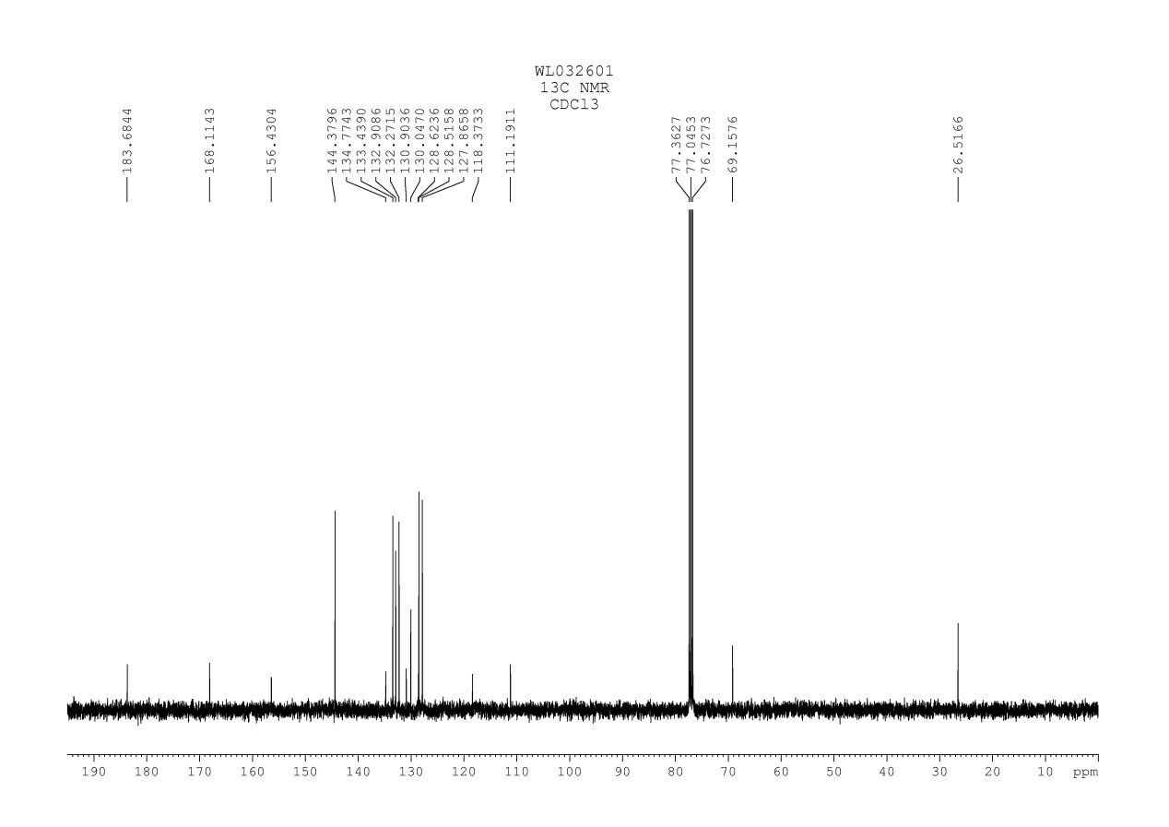
Fig. 52 ¹³C NMR spectrum of compound 3y

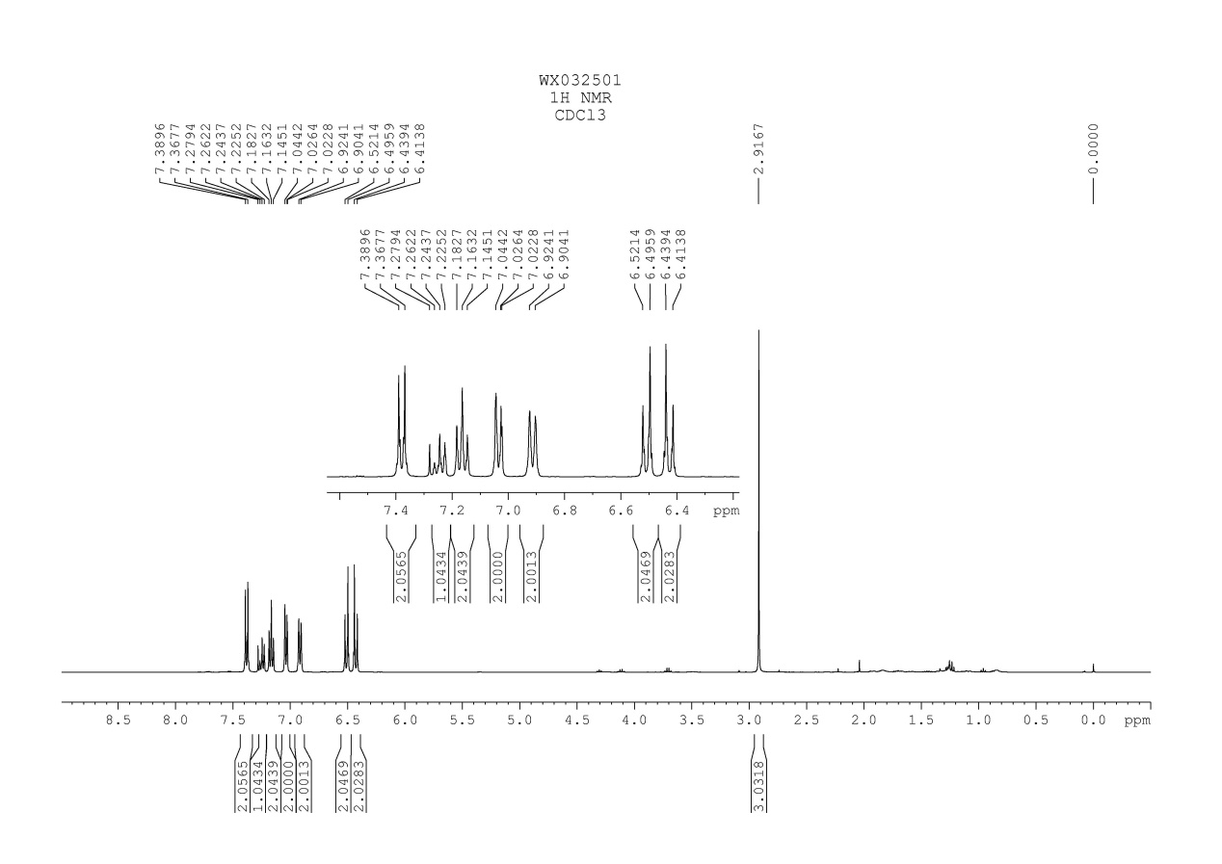
Fig. 53 ¹H NMR spectrum of compound 3z

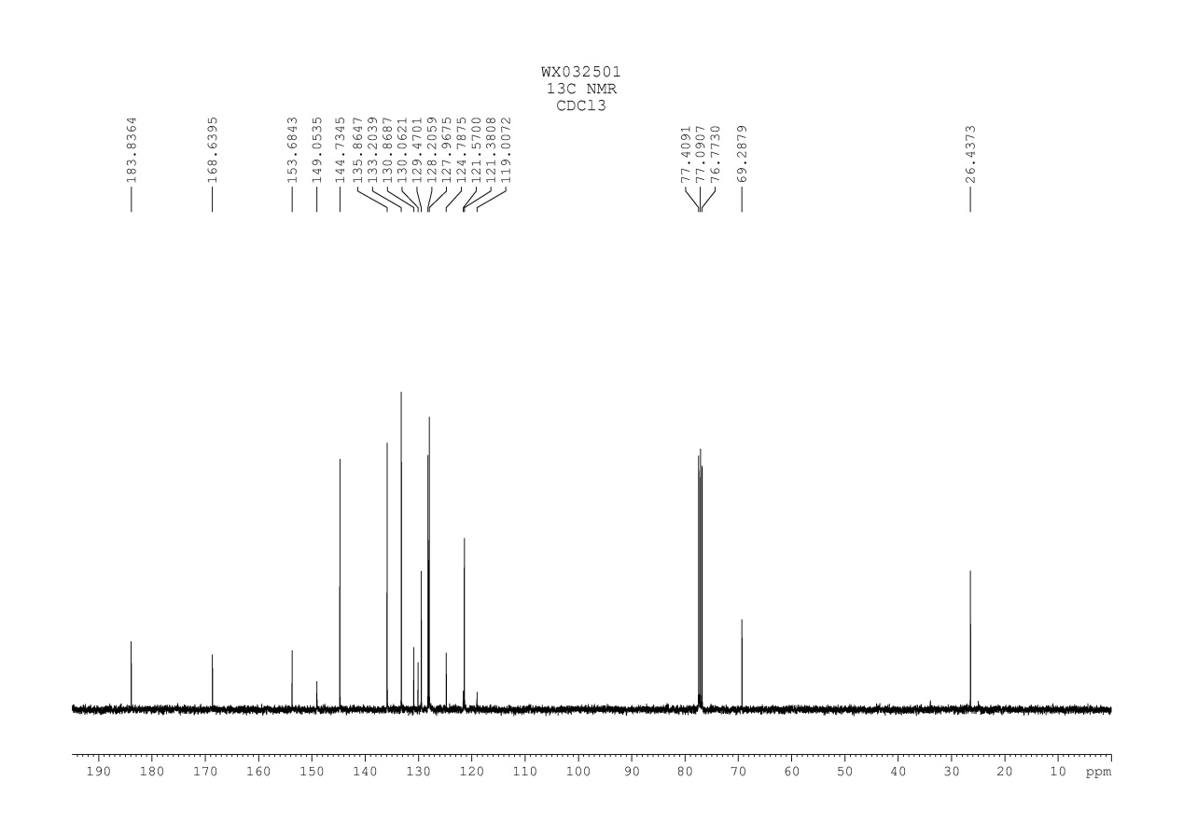
Fig. 54 ¹³C NMR spectrum of compound 3z

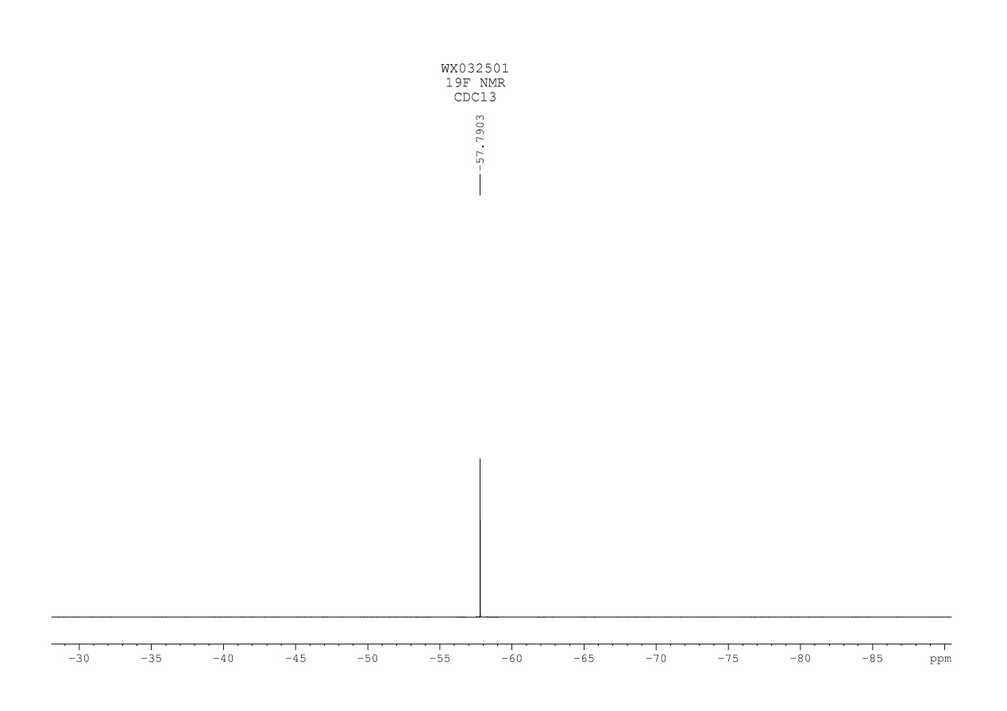
Fig. 55 ¹⁹F NMR spectrum of compound 3z

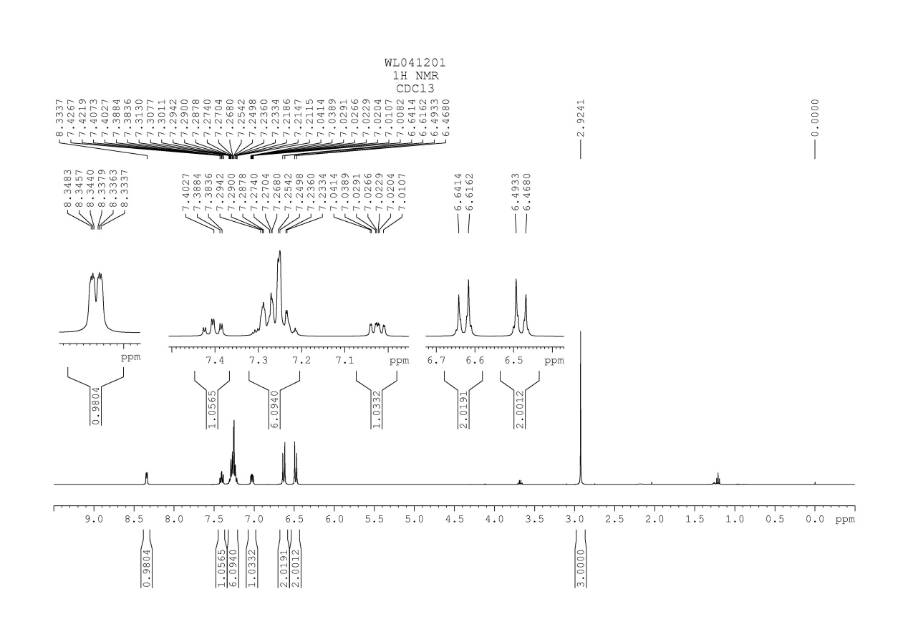
Fig. 56 ¹H NMR spectrum of compound 3ap

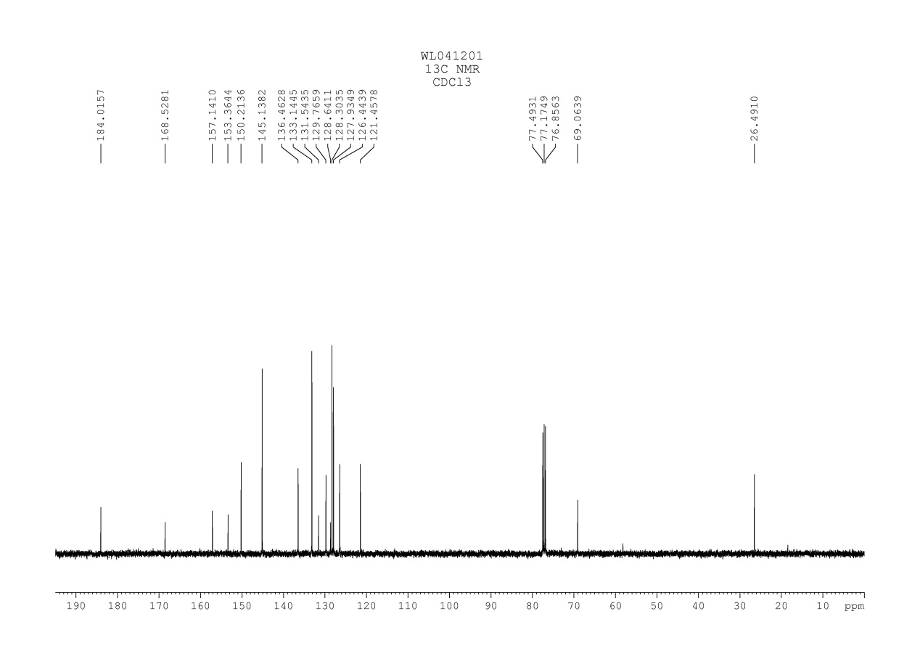
Fig. 57 ¹³C NMR spectrum of compound 3ap

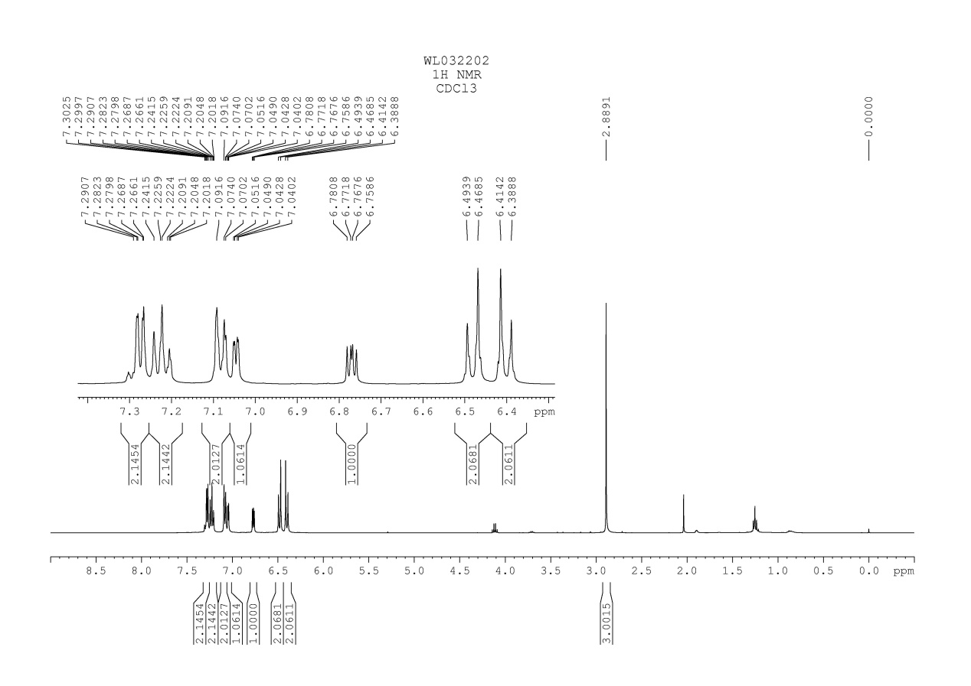
Fig. 58 ¹H NMR spectrum of compound 3aq

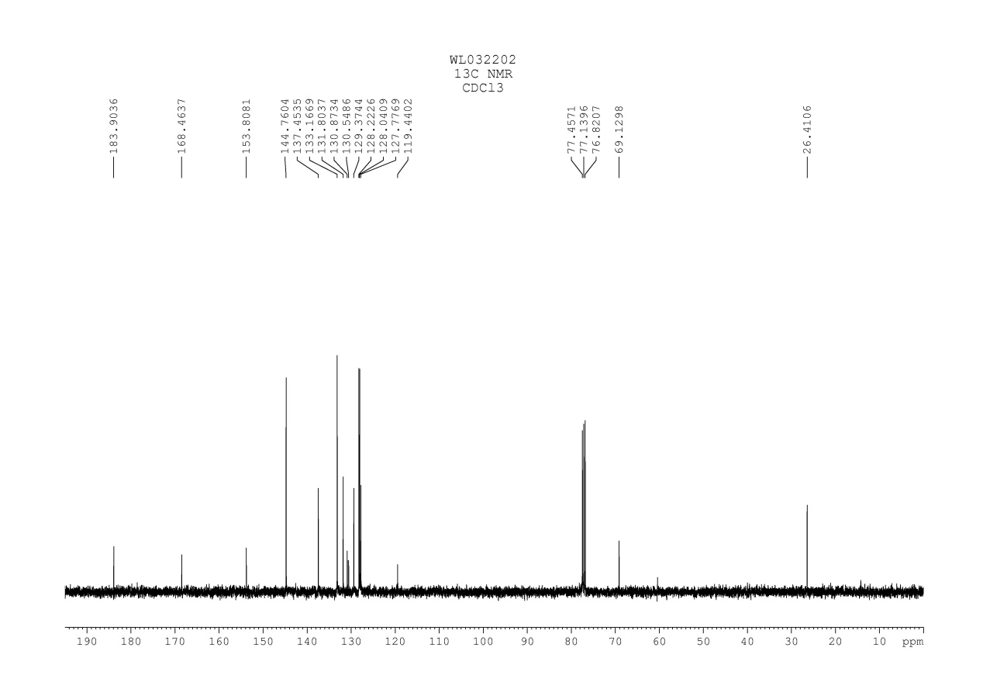
Fig. 59 ¹³C NMR spectrum of compound 3aq

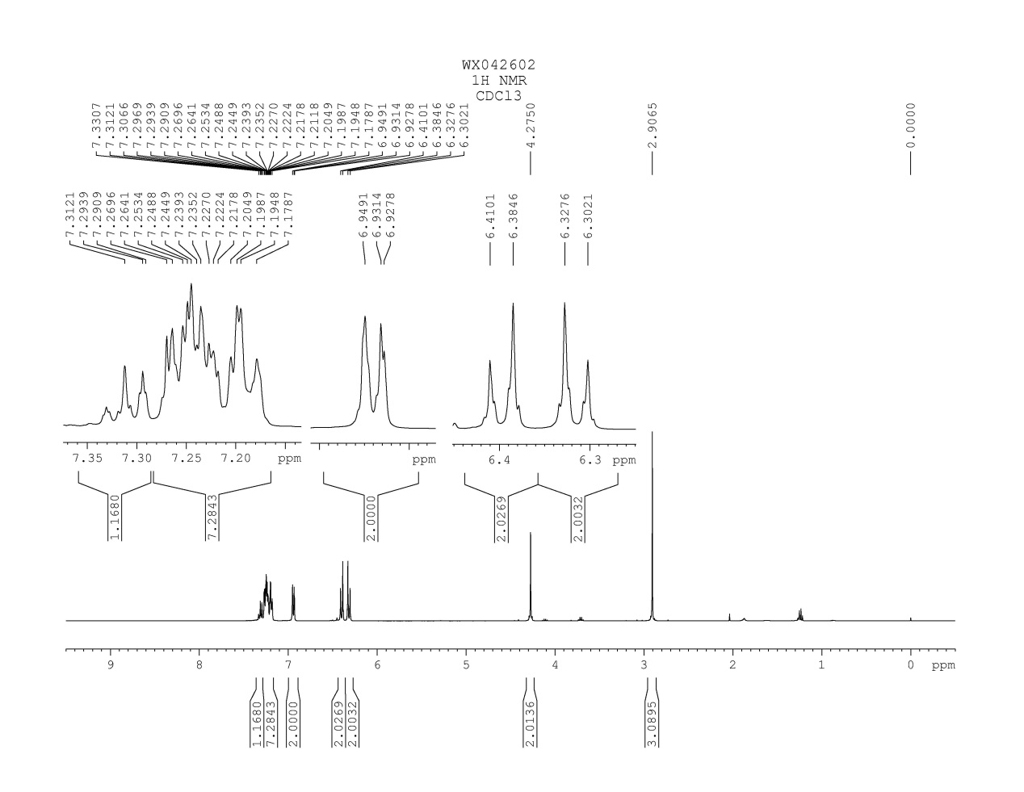
Fig. 60 ¹H NMR spectrum of compound 3ar
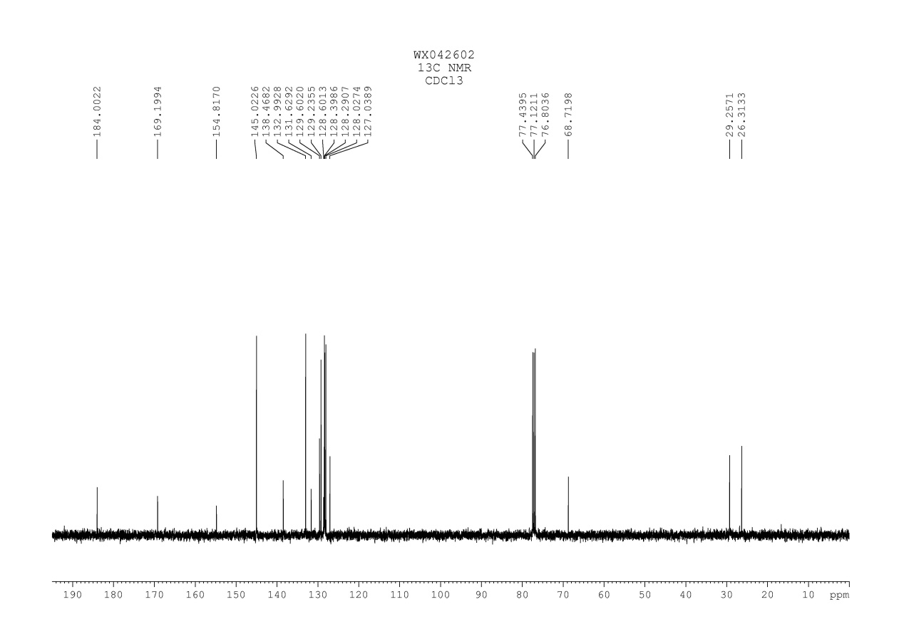
Fig. 61 ¹³C NMR spectrum of compound 3ar

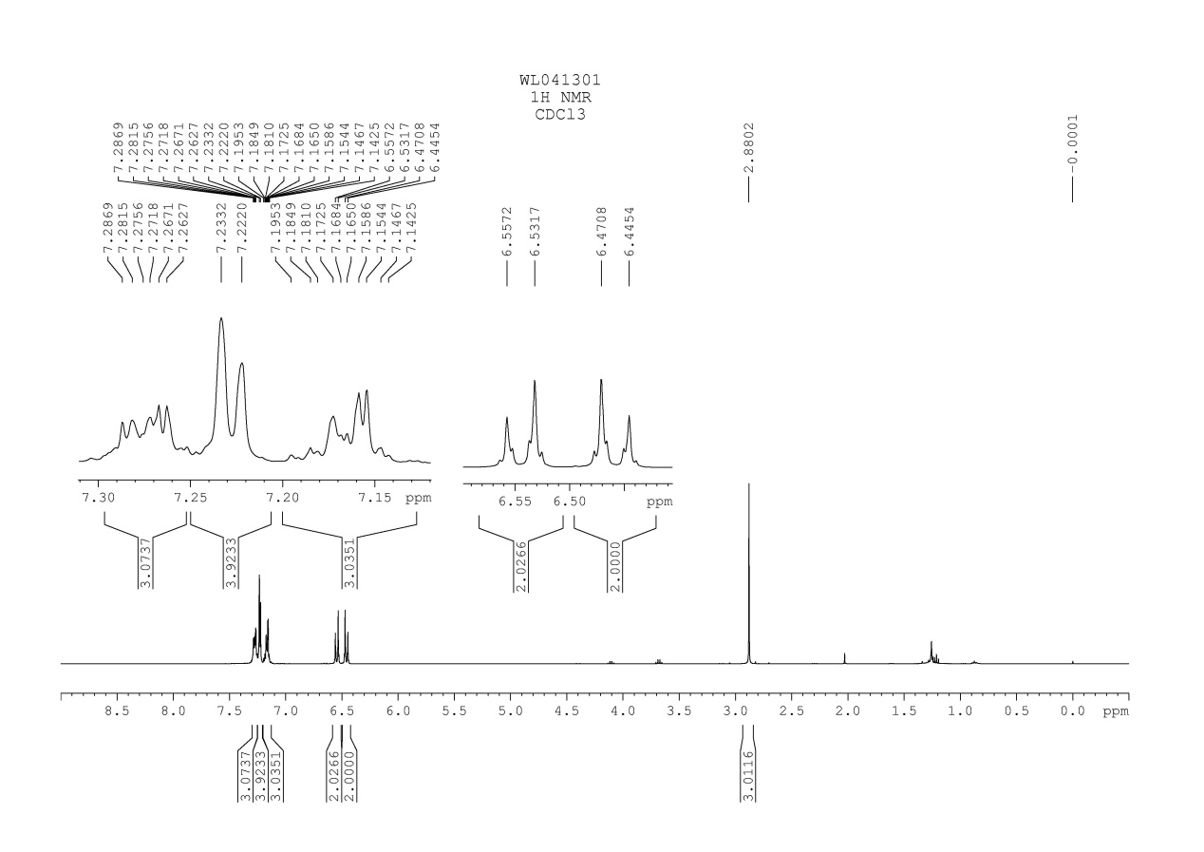
Fig. 62 ¹H NMR spectrum of compound 5a

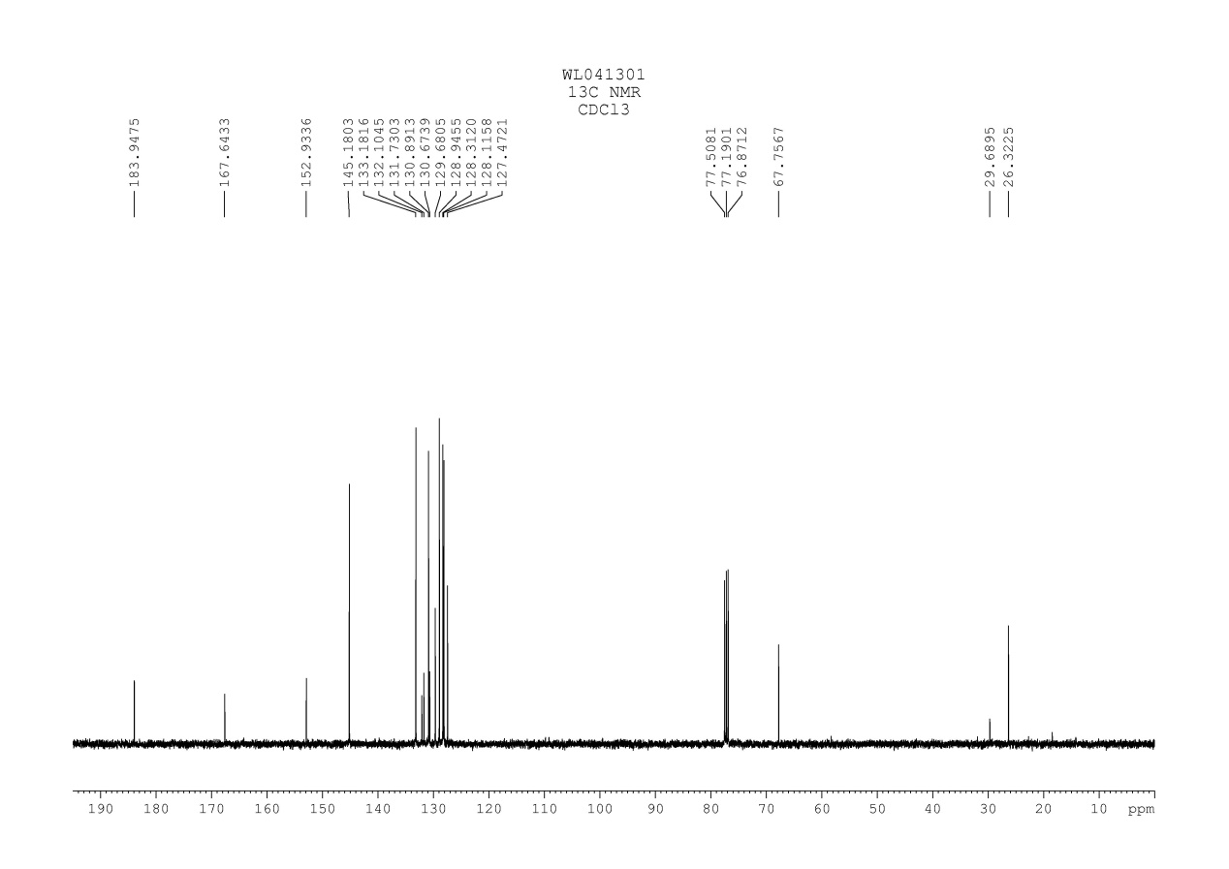
Fig. 63 ¹³C NMR spectrum of compound 5a

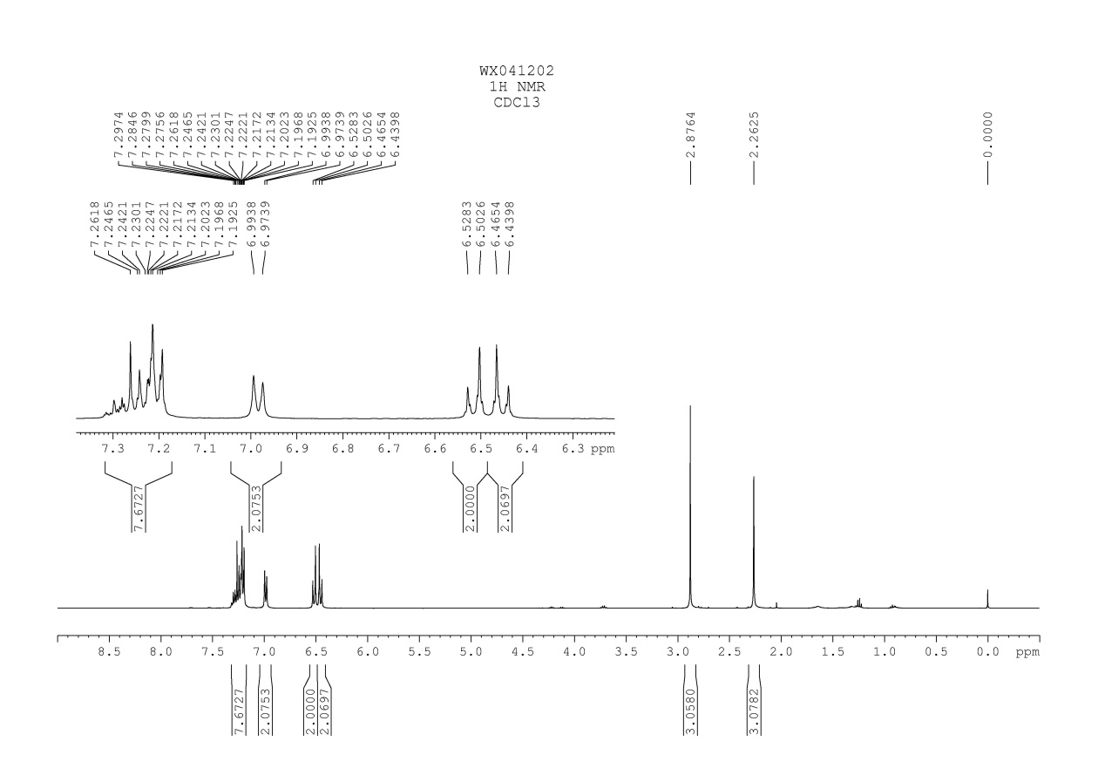
Fig. 64 ¹H NMR spectrum of compound 5b

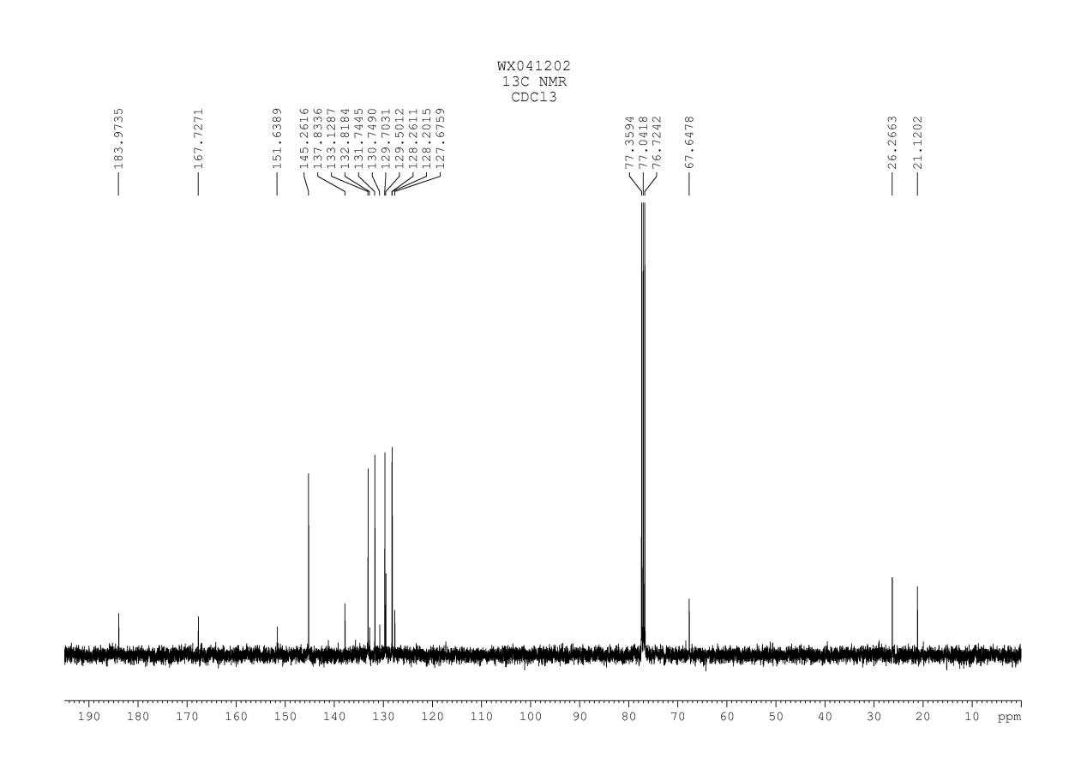
Fig. 65 ¹³C NMR spectrum of compound 5b

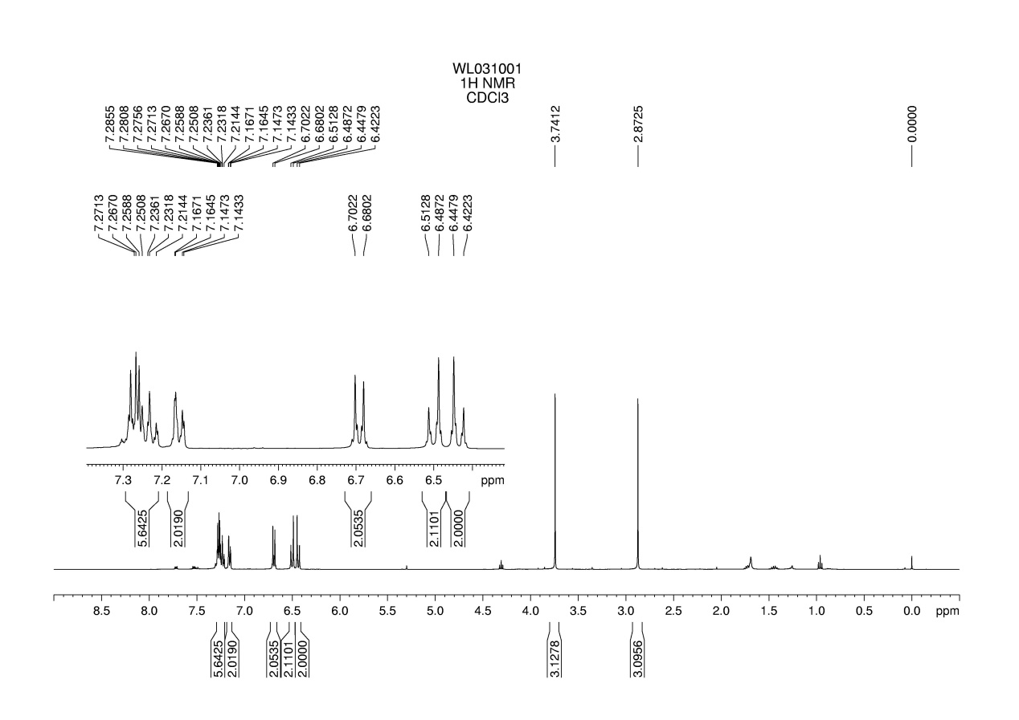
Fig. 66 ¹H NMR spectrum of compound 5c

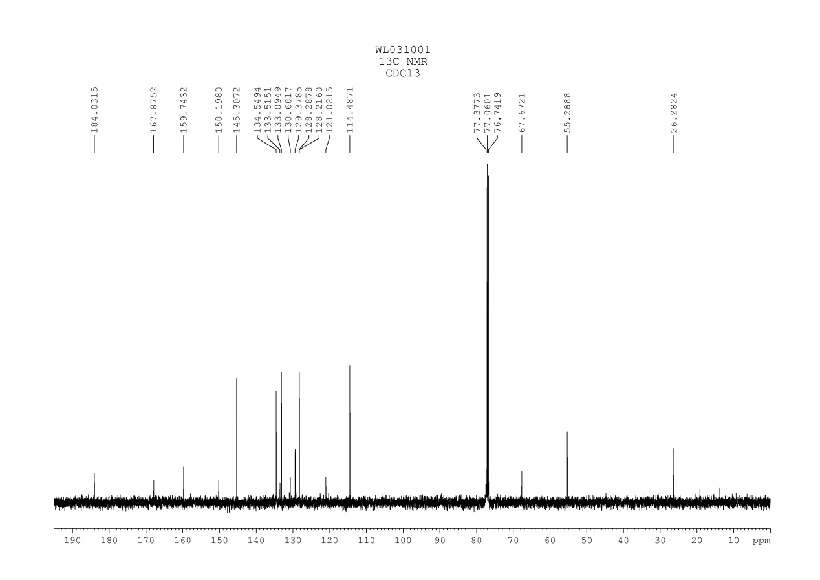
Fig. 67 ¹³C NMR spectrum of compound 5c

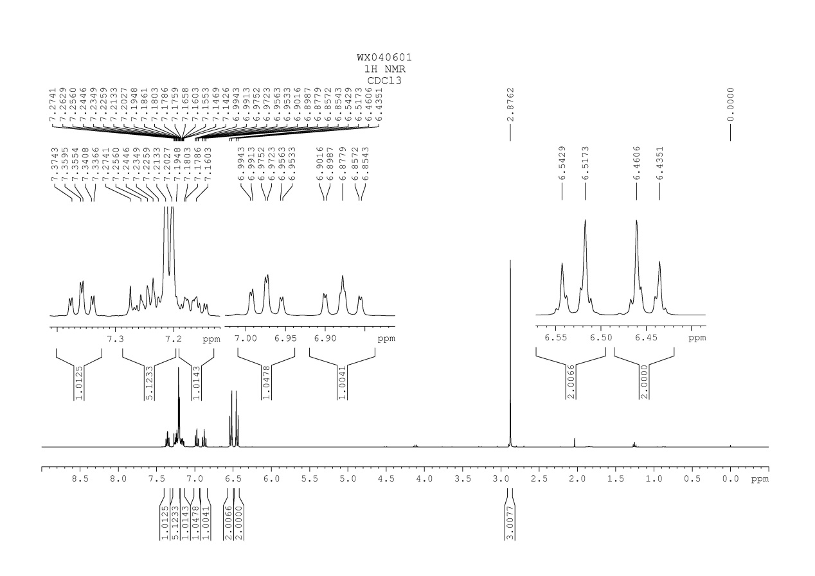
Fig. 68 ¹H NMR spectrum of compound 5d

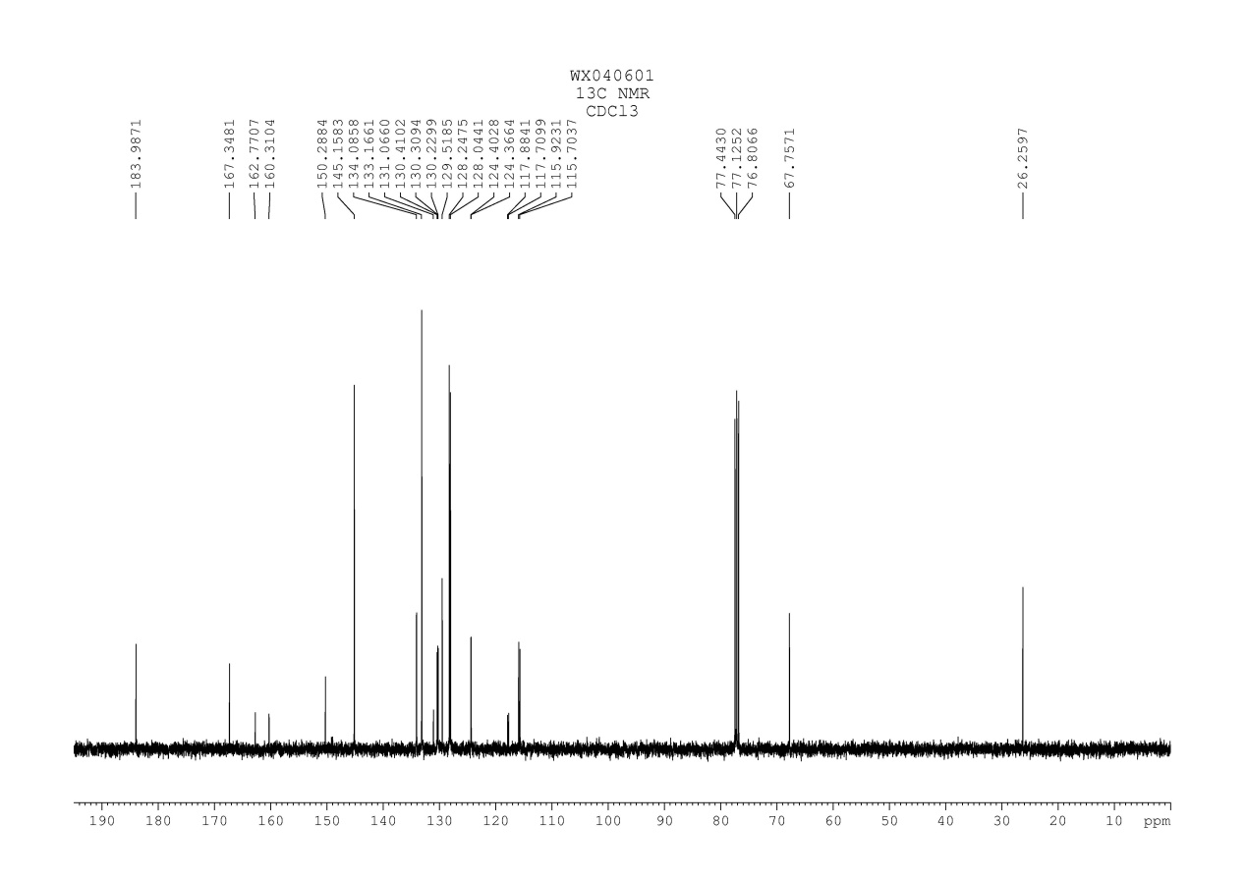
Fig. 69 ¹³C NMR spectrum of compound 5d

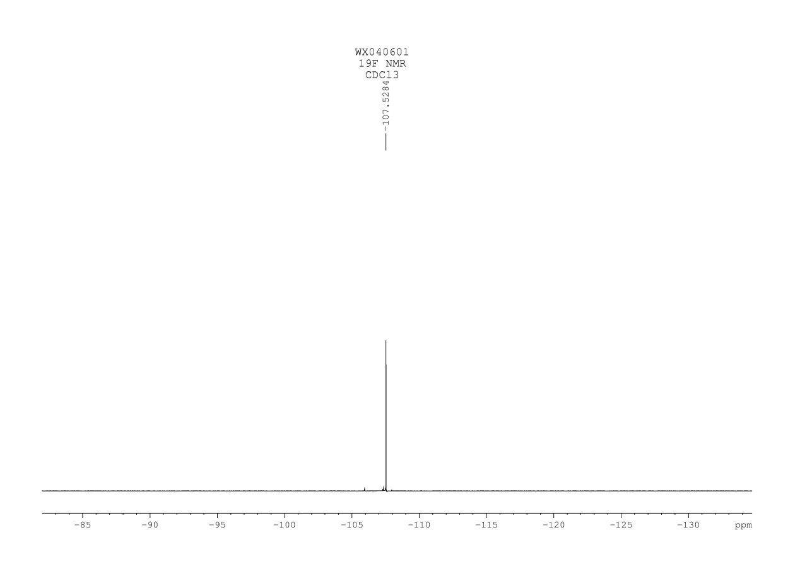
Fig. 70 ¹⁹F NMR spectrum of compound 5d

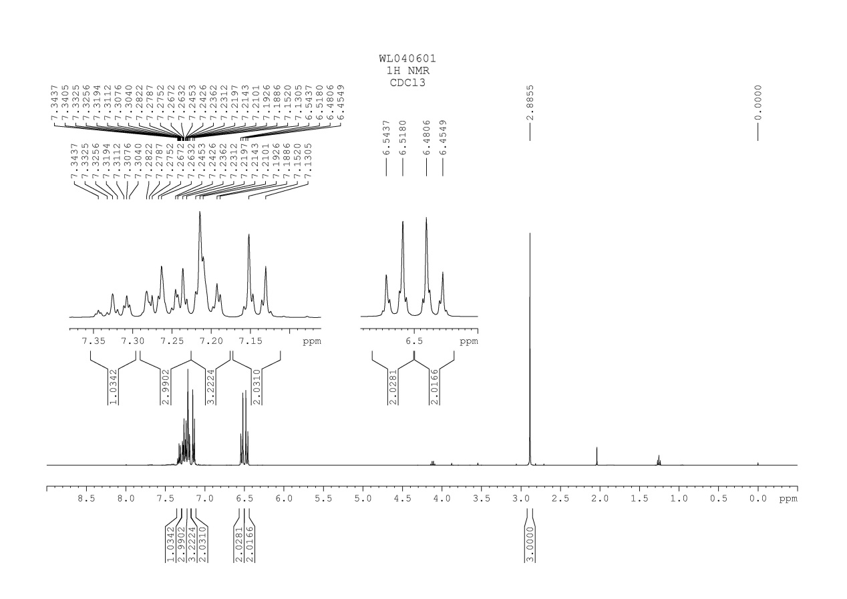
Fig. 71 ¹H NMR spectrum of compound 5e

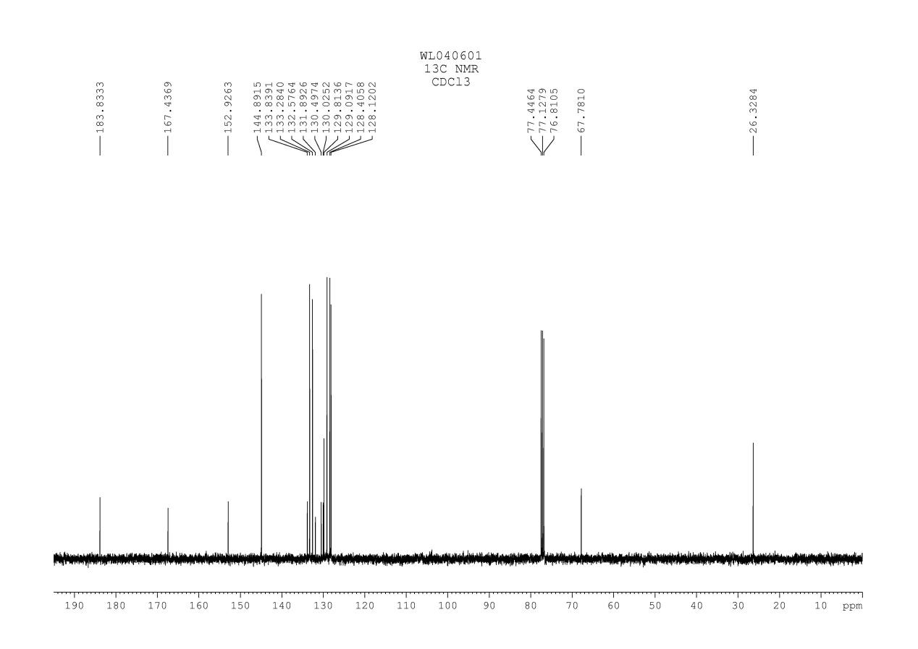
Fig. 72 ¹³C NMR spectrum of compound 5e

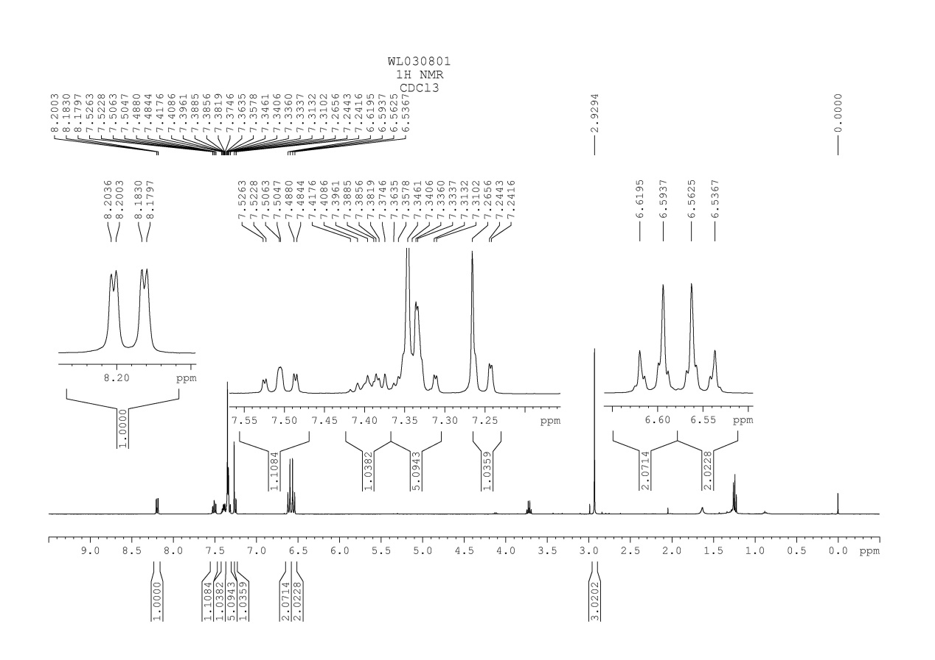
Fig. 73 ¹H NMR spectrum of compound 5f

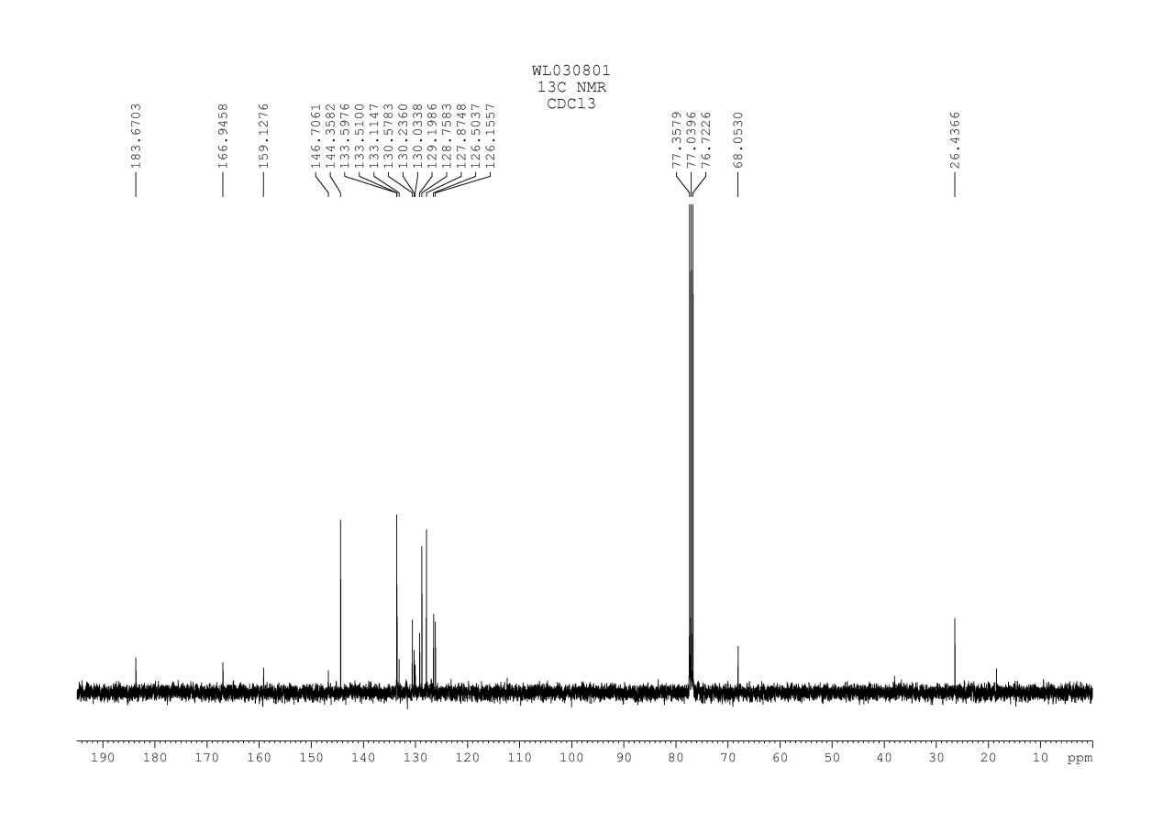
Fig. 74 ¹³C NMR spectrum of compound 5f

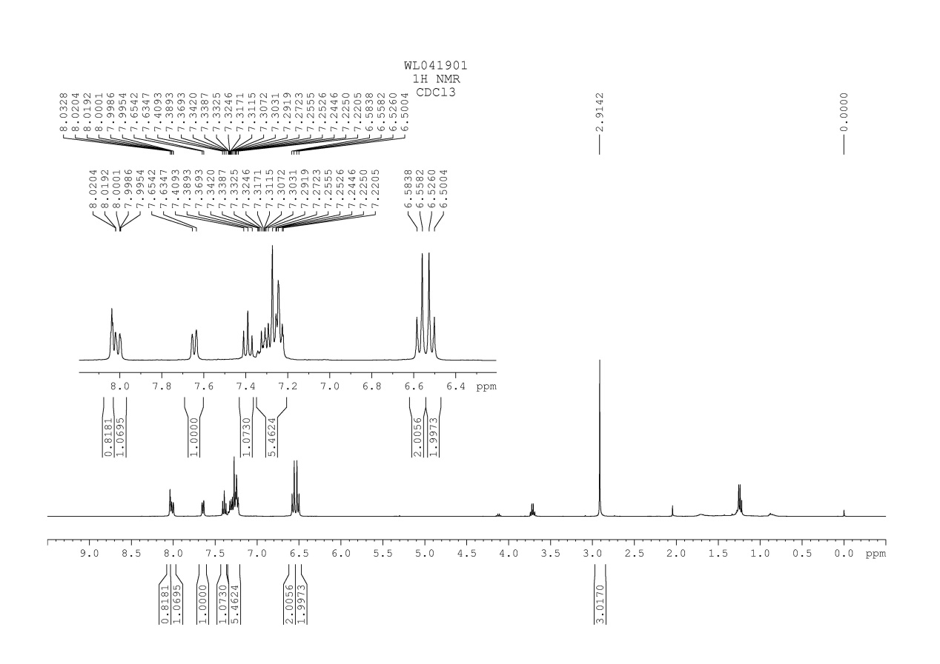
Fig. 75 ¹H NMR spectrum of compound 5g

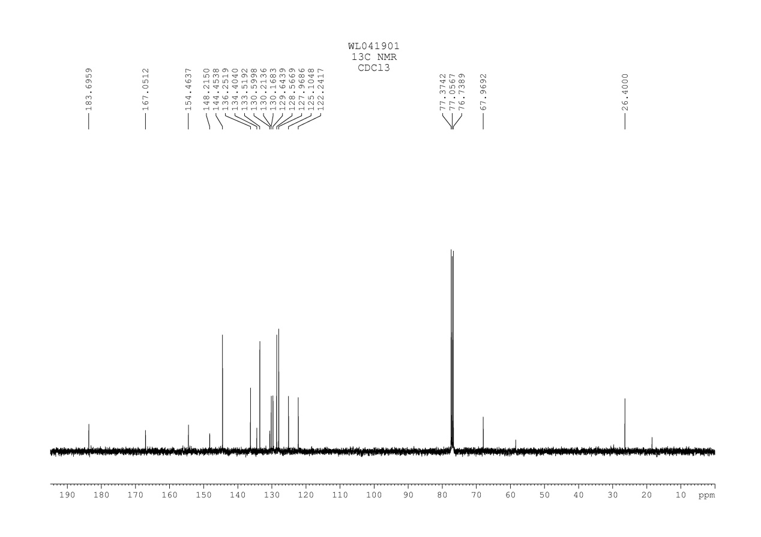
Fig. 76 ¹³C NMR spectrum of compound 5g

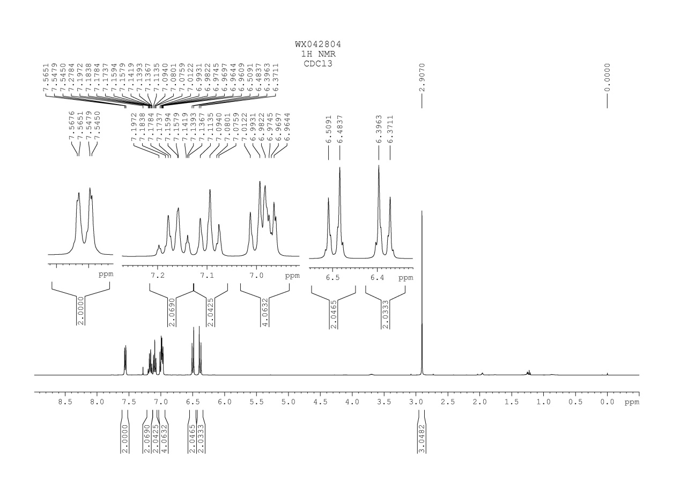
Fig. 77 ¹H NMR spectrum of compound 5h

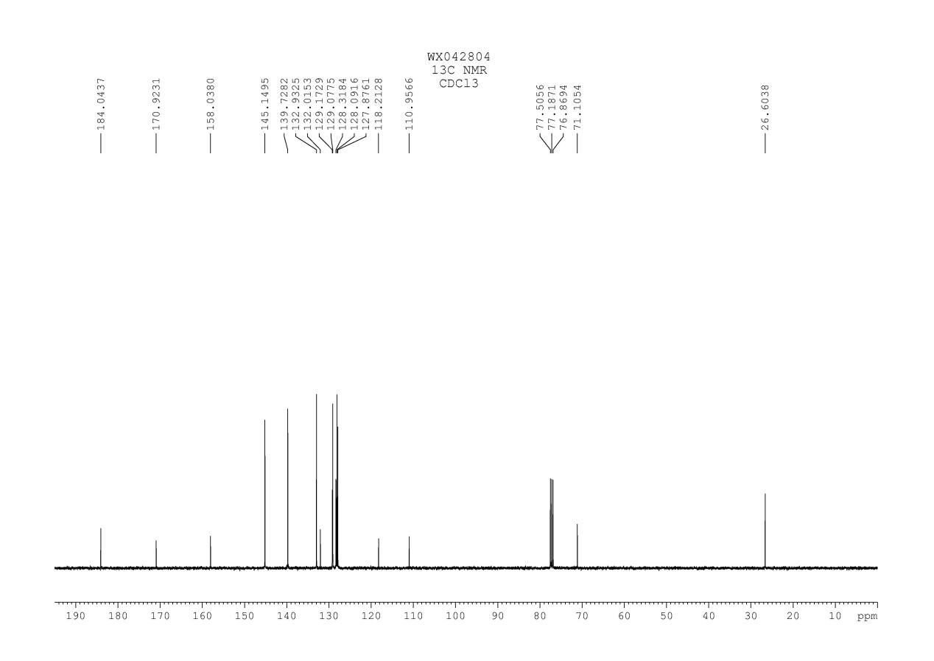
Fig. 78 ¹³C NMR spectrum of compound 5h

5. Intermolecular competition experiment
N-(4-Methoxyphenyl)-N-methyl-3-phenylpropiolamide 1a (0.2 mmol, 53.0 mg), diphenyl diselenide 2a (0.1 mmol, 31.4 mg), diphenyl disulfides 4a (0.1 mmol, 21.8 mg), Selectfluor agent (0.2 mmol, 70.8 mg), and acetonitrile (2.0 mL) were added to a 10 mL reaction tube. The mixture was stirred at 40 ºC for 1.5 h. After completion of the reaction, the solvent was distilled under vacuum. Then, the resulting mixture was dissolved with ethyl acetate (15 mL).
The yields of 3a and 5a were analyzed by HPLC.
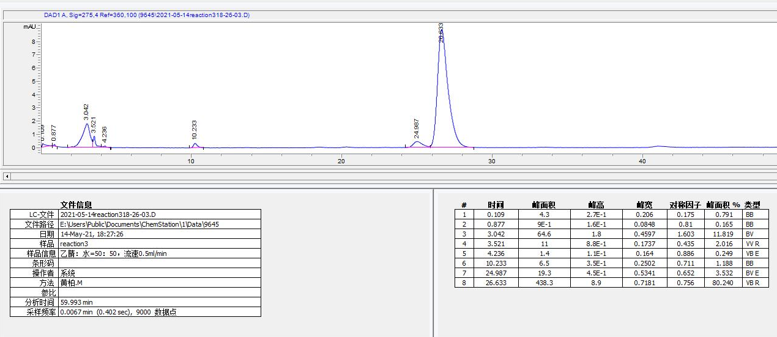
3a
5a

