**Supporting Information**

**[Msim]CuCl3: as an efficient catalystfor the preparation of   
5-amino-1H-pyrazole-4-carbonitriles by anomeric based oxidation**

Ardeshir Khazaei,a,* Ahmad Reza Moosavi-Zare,b,* Hadis Goudarzi,a Mahsa Tavasolia

*aFaculty of Chemistry, Bu-Ali Sina University, Hamedan, 6517838683, Iran.*

*bDepartment of Chemical Engineering, Hamedan University of Technology, Hamedan, 65155, Iran.*

*\*Corresponding author: E-mail addresses:* [*Khazaei_1326@yahoo.com*](mailto:Khazaei_1326@yahoo.com)*;* [*moosavizare@yahoo.com*](mailto:moosavizare@yahoo.com)*.*

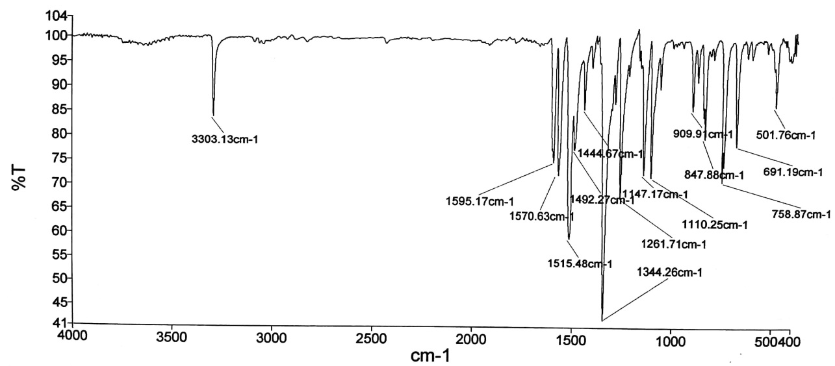

**Figure S1**. The IR spectrum of compound (1).

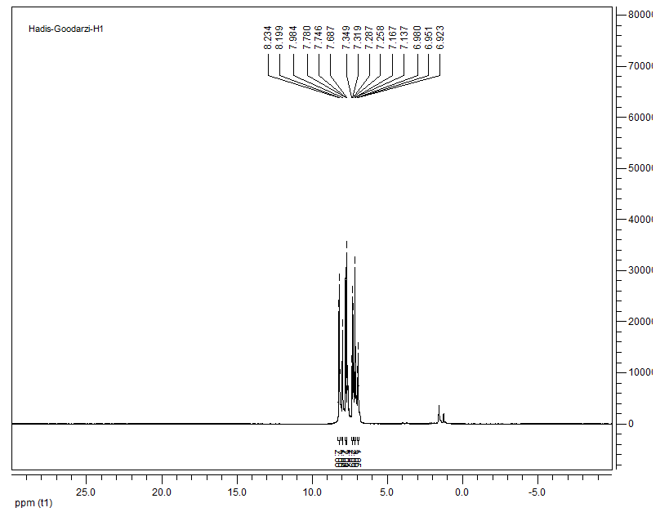



**Figure S2**. The 1HNMR spectrum of compound (1).

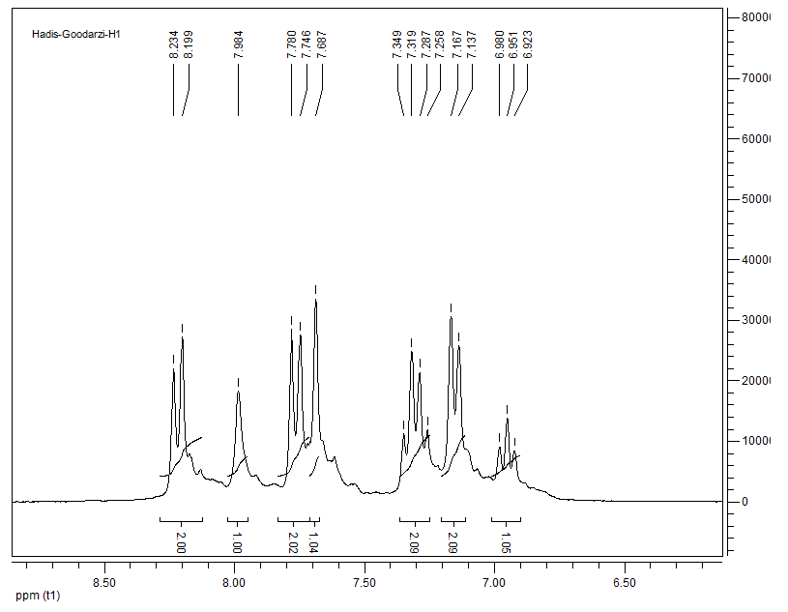

**Figure S3**. The expansion of 1HNMR spectrum for compound (1).

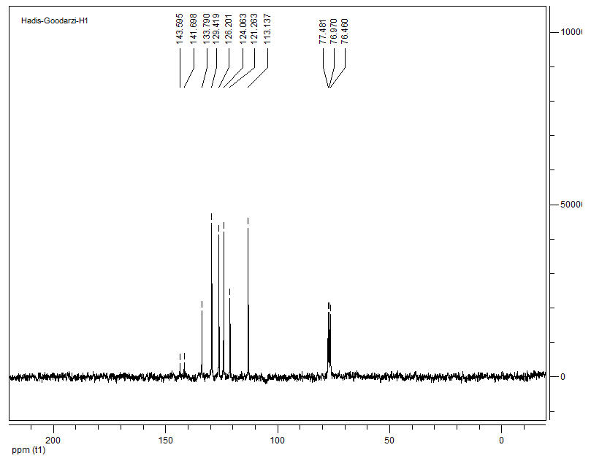

**Figure S4**. The 13CNMR spectrum of compound (1).

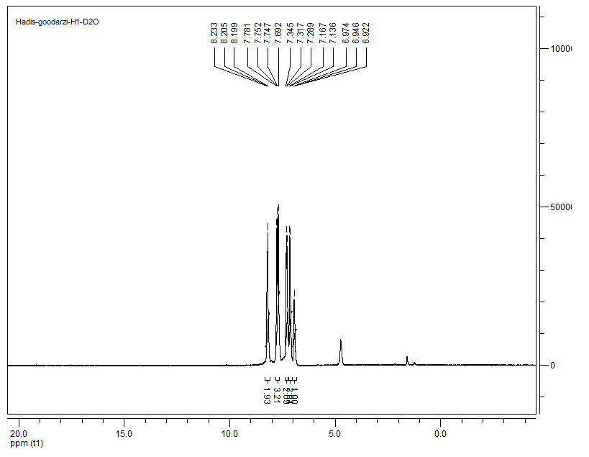

**Figure S5**. The 1HNMR spectrum of compound (1) in D2O.

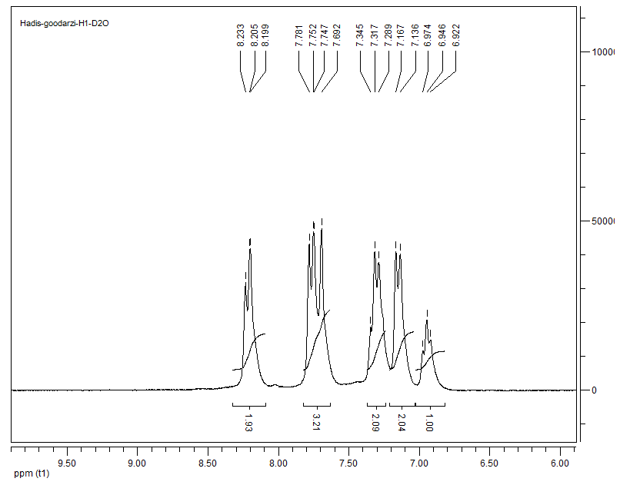

**Figure S6**. The expansion of 1HNMR spectrum for compound (1) in D2O.

|  |
| --- |
|  |
|  |
| **Brown solid: m.p.= 162-164˚C ; IR (KBr) = υ 1110, 1147, 1261, 1344, 1444, 1595, 3303 cm-1.**  **1H NMR (250 MHz, CDCl3): δ (ppm) 6.95 (1H, t, *J* = 7.25 Hz), 7.14 (2H, d, *J* = 7.50 Hz), 7.29 (2H, q, *J* = 7.50 Hz), 7.68 (1H, s), 7.76 (2H, d, *J* = 8.50 Hz), 7.98 (1H, s), 8.21 (2H, d, *J* = 8.75 Hz). 13C NMR (62.5 MHz, CDCl3): δ (ppm) 113.1, 121.2, 124.0, 126.2, 129.4, 133.7, 141.6, 143.5.** |

**Table S1.** The spectral data of compound (1).

****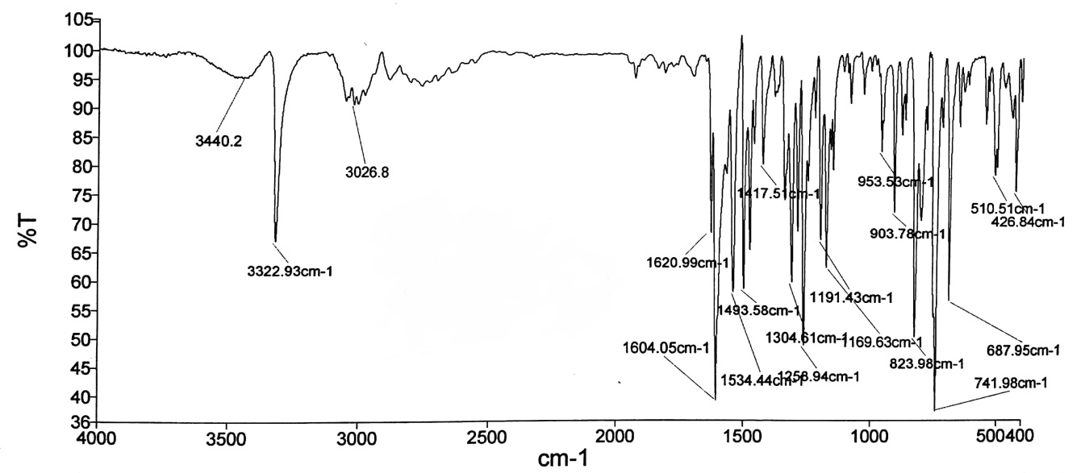

**Figure S7**. The IR spectrum of compound (13).

****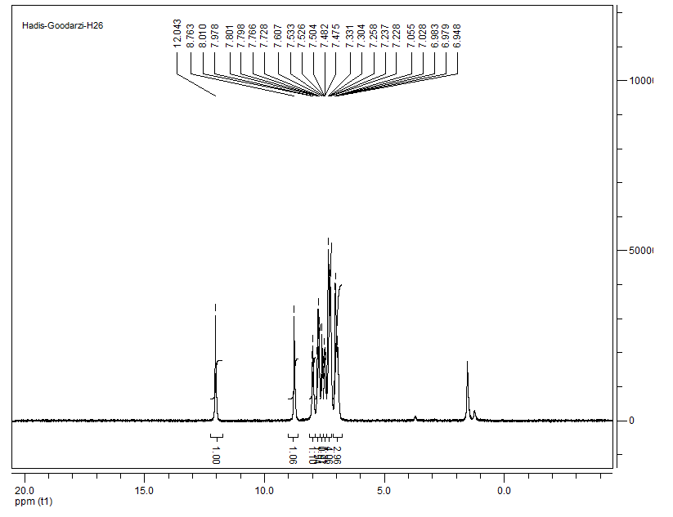

**Figure S8**. The 1HNMR spectrum of compound (13).

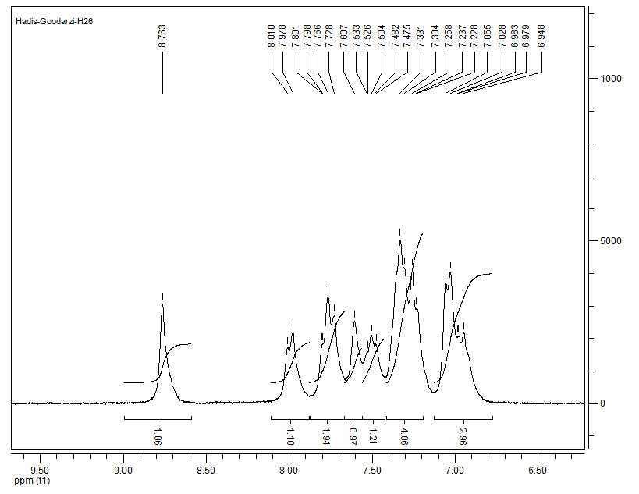

**Figure S9**. The expansion of 1HNMR spectrum for compound (13).

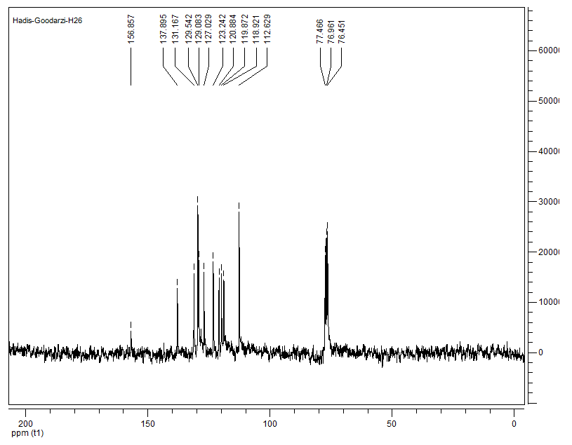

**Figure S10**. The 13CNMR spectrum of compound (13).

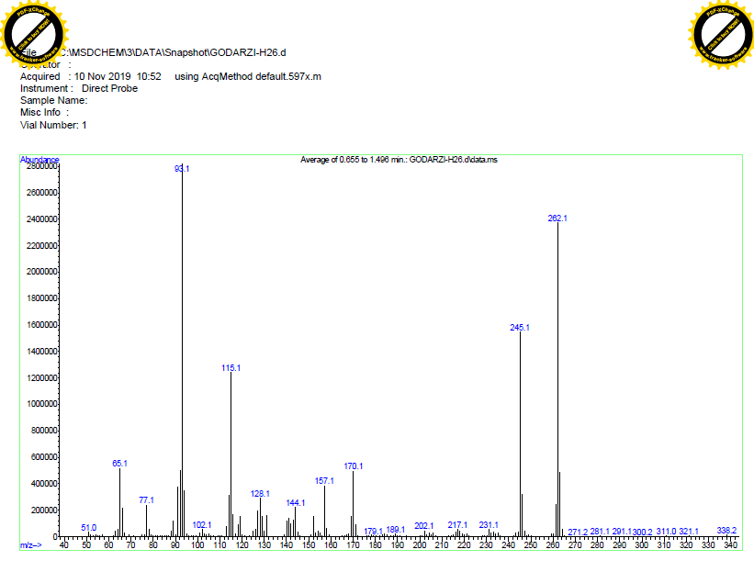

**Figure S11**. The mass spectrum of compound (13).

|  |
| --- |
|  |
|  |
| **Cream solid: m.p.= 212-216˚C ; IR (KBr) = υ 1169, 1258, 1304, 1534, 1604, 3026, 3322, 3440 cm-1.**  **1H NMR (250 MHz, CDCl3): δ (ppm) 6.94-7.05 (3H, m), 7.22-7.33 (4H, m), 7.47-7.53 (1H, m), 7.60 (1H, s), 7.72-7.80 (2H, m), 7.98 (1H, d, *J* = 8 Hz), 8.76 (1H, s), 12.04 (1H, s). 13C NMR (62.5 MHz, CDCl3): δ (ppm) 112.6, 118.9, 119.8, 120.8, 123.2, 127.0, 129.0, 129.5, 131.1, 137.8, 156.8. MS: m/z = 326.1 [M]+.** |

**Table S2.** The spectral data of compound (13).

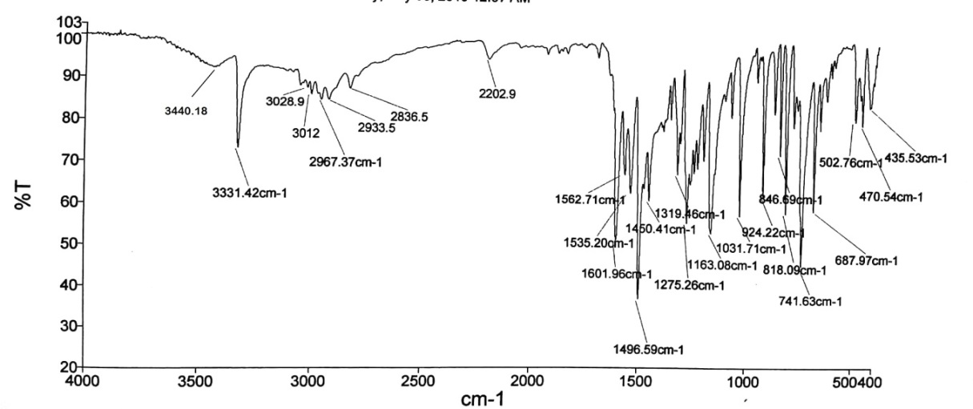

**Figure S12**. The IR spectrum of compound (14).

****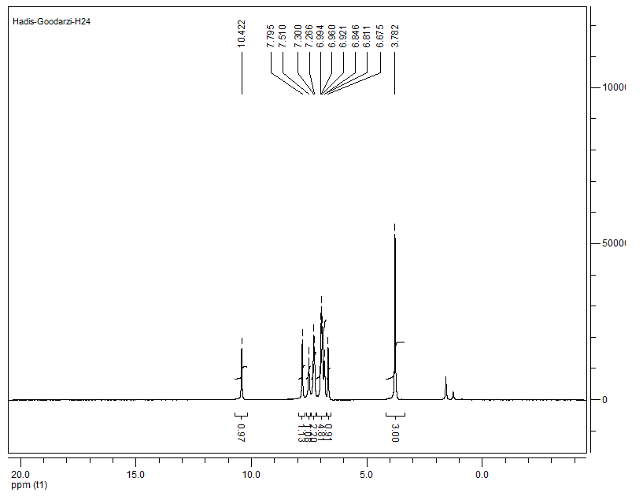

**Figure S13**. The 1HNMR spectrum of compound (14).

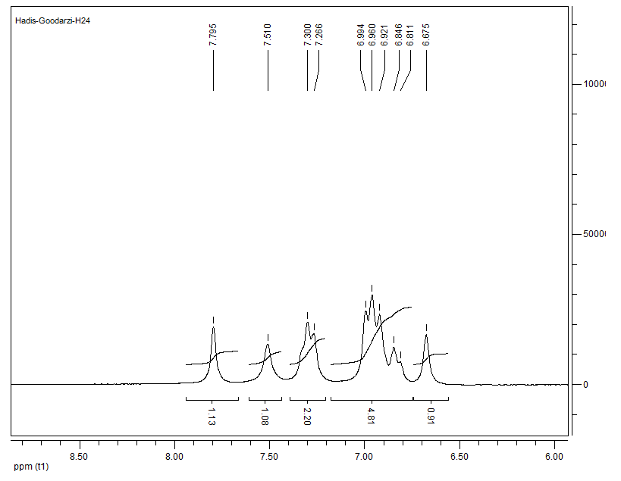

**Figure S14**. The expansion of 1HNMR spectrum for compound (14).

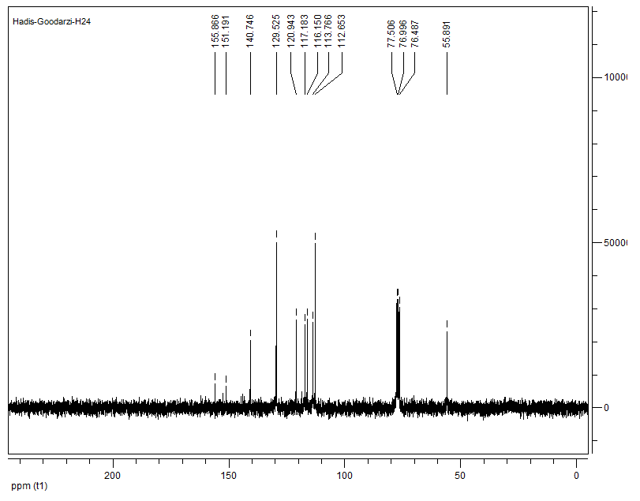

**Figure S15**. The 13CNMR spectrum of compound (14).

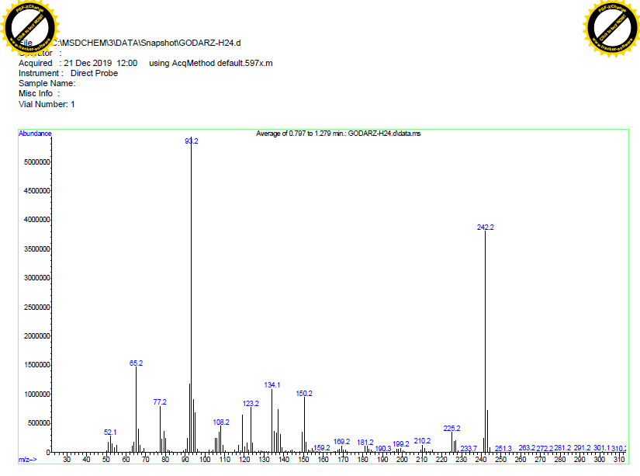

**Figure S16**. The mass spectrum of compound (14).

|  |
| --- |
|  |
|  |
| **Cream solid: m.p.= 140-143˚C ; IR (KBr) = υ 1031, 1163, 1275, 1319, 1496, 1535, 1601, 2202, 2967, 3012, 3331, 3440 cm-1.**  **1H NMR (250 MHz, CDCl3): δ (ppm) 3.78 (3H, s), 6.67 (1H, s), 6.81-6.99 (5H, m), 7.28 (2H, d, *J* = 8.5 Hz), 7.51 (1H, s), 7.79 (1H, s), 10.42 (1H, s). 13C NMR (62.5 MHz, CDCl3): δ (ppm) 55.8, 112.6, 113.7, 116.1, 117.1, 120.9, 129.5, 140.7, 151.1, 155.8. MS: m/z = 306.11 [M]+.** |

**Table S3.** The spectral data of compound (14).