**Supplementary Materials**

For paper: Electrical conductivity of zirconium tetrachloride solutions in molten sodium, potassium and cesium chlorides

Salyulev A.B., Potapov A.M.

**Table 1S**

Specific conductivity of MCl - ZrCl4 mixtures (M = Na, K, Cs). Initial data.

The points marked in bold lie below the liquidus line.

| *t*, 0C | , S/cm | *t*, 0C | , S/cm | *t*, 0C | , S/cm | *t*, 0C | , S/cm |
| --- | --- | --- | --- | --- | --- | --- | --- |
| NaCl - 10.5 mol.% ZrCl4 | | | | | | | |
| 797 | 2.2306 | 791 | 2.2189 | **757** | **2.0200** | **710.5** | **0.9902** |
| 802 | 2.2368 | 787.5 | 2.2134 | **756** | **1.8854** | **706** | **0.9567** |
| 805 | 2.2440 | 785 | 2.2083 | **754** | **1.7575** | **702.5** | **0.9355** |
| 808 | 2.2508 | 783 | 2.2043 | **751** | **1.6292** | **697** | **0.9016** |
| 810 | 2.2550 | 780 | 2.1988 | **748** | **1.5388** | **694** | **0.8835** |
| 811 | 2.2571 | 777 | 2.1934 | **745** | **1.4471** | **688** | **0.8451** |
| 810 | 2.2534 | 774 | 2.1879 | **740** | **1.3458** | **683** | **0.8208** |
| 808 | 2.2503 | 771 | 2.1801 | **736** | **1.2768** | **678** | **0.7762** |
| 805 | 2.2451 | 768 | 2.1742 | **732** | **1.2153** | **674** | **0.7401** |
| 802 | 2.2394 | 765 | 2.1684 | **728** | **1.1636** | **671** | **0.7306** |
| 797 | 2.2306 | 762 | 2.1583 | **722** | **1.0959** | **666** | **0.6887** |
| 794 | 2.2250 | **760** | **2.1487** | **717** | **1.0452** | **661** | **0.6674** |
| NaCl - 20.5 mol.% ZrCl4 | | | | | | | |
| 668.5 | 1.3875 | 657 | 1.3726 | **646** | **1.3620** | **621** | **1.2420** |
| 668 | 1.3840 | 654.5 | 1.3719 | **645** | **1.3486** | **613** | **1.2107** |
| 667 | 1.3810 | 653 | 1.3711 | **641** | **1.3186** | **600** | **1.1699** |
| 665 | 1.3775 | 651 | 1.3703 | **638.5** | **1.3088** | **570** | **1.0765** |
| 662 | 1.3750 | 649 | 1.3693 | **634.5** | **1.2948** | **550** | **1.0115** |
| 659 | 1.3734 | 646.5 | 1.3668 | **631** | **1.2813** |  |  |
| NaCl - 25.5 mol.% ZrCl4 | | | | | | | |
| 643 | 1.3320 | 610 | 1.2625 | 582 | 1.2070 | **552** | **1.1220** |
| 630.5 | 1.3008 | 608 | 1.2584 | 579 | 1.2010 | **550** | **1.1170** |
| 629 | 1.2985 | 606 | 1.2542 | 577 | 1.1970 | **548** | **1.1110** |
| 629.5 | 1.2973 | 604 | 1.2487 | 574 | 1.1911 | **542** | **0.9788** |
| 627 | 1.2959 | 600 | 1.2428 | 572 | 1.1873 | **540** | **0.8299** |
| 627 | 1.2929 | 598 | 1.2387 | 569.5 | 1.1816 | **535** | **0.5425** |
| 625 | 1.2895 | 596 | 1.2346 | **567** | **1.1741** | **532** | **0.5517** |
| 623 | 1.2878 | 594 | 1.2307 | **564** | **1.1640** | **520** | **0.3720** |
| 622 | 1.2839 | 592 | 1.2268 | **562** | **1.1554** | **514** | **0.3063** |
| 618.5 | 1.2780 | 589 | 1.2211 | **559** | **1.1437** |  |  |
| 616.5 | 1.2741 | 587 | 1.2171 | **557** | **1.1371** |  |  |
| 614 | 1.2694 | 585 | 1.2128 | **554** | **1.1278** |  |  |
| KCl - 10.0 mol.% ZrCl4 | | | | | | | |
| 790 | 1.5880 | 804 | 1.6155 | 768 | 1.5453 | **723.5** | **1.0874** |
| 795.5 | 1.5984 | 801 | 1.6098 | 765 | 1.5388 | **719** | **0.9784** |
| 798.5 | 1.6070 | 797.5 | 1.6047 | 762.5 | 1.5334 | **713.5** | **0.8813** |
| 804 | 1.6163 | 796 | 1.6009 | 759 | 1.5251 | **710** | **0.8189** |
| 808.5 | 1.6247 | 792.5 | 1.5939 | 755 | 1.5172 | **703** | **0.7464** |
| 813 | 1.6338 | 790 | 1.5882 | 751.5 | 1.5085 | **696.5** | **0.6773** |
| 817.5 | 1.6432 | 786.5 | 1.5832 | 748 | 1.5008 | **692.5** | **0.6440** |
| 822.5 | 1.6504 | 784.5 | 1.5775 | 744.5 | 1.4918 | **688.5** | **0.6019** |
| 818.5 | 1.6429 | 781 | 1.5726 | 740.5 | 1.4835 | **683.5** | **0.5735** |
| 815.5 | 1.6366 | 778 | 1.5665 | 737 | 1.4749 | **678** | **0.5449** |
| 813 | 1.6306 | 775.5 | 1.5623 | 732.5 | 1.4654 | **674** | **0.5209** |
| 809.5 | 1.6255 | 774 | 1.5564 | 729.5 | 1.4568 | **669.5** | **0.4985** |
| 806.5 | 1.6198 | 770.5 | 1.5489 | **725.5** | **1.2922** | **662** | **0.4711** |
| KCl - 20.0 mol.% ZrCl4 | | | | | | | |
| 784 | 1.1951 | 772.5 | 1.1793 | 707.5 | 1.0717 | 641 | 0.9476 |
| 788 | 1.2003 | 769 | 1.1738 | 703 | 1.0650 | 638 | 0.9387 |
| 792.5 | 1.2074 | 764.5 | 1.1678 | 701 | 1.0617 | **633** | **0.8940** |
| 795.5 | 1.2136 | 761 | 1.1622 | 695.5 | 1.0511 | **631** | **0.8736** |
| 799.5 | 1.2190 | 757.5 | 1.1566 | 691.5 | 1.0439 | **623** | **0.8292** |
| 804 | 1.2257 | 753.5 | 1.1503 | 687 | 1.0360 | **617** | **0.7935** |
| 809.5 | 1.2335 | 750 | 1.1453 | 683.5 | 1.0290 | **611** | **0.7642** |
| 810 | 1.2342 | 746.5 | 1.1394 | 680 | 1.0230 | **605** | **0.4671** |
| 808.5 | 1.2308 | 742 | 1.1321 | 676 | 1.0158 | **604.5** | **0.3384** |
| 803 | 1.2235 | 739 | 1.1268 | 672.5 | 1.0093 | **603** | **0.2918** |
| 800 | 1.2178 | 735 | 1.1204 | 669 | 1.0030 | **603.5** | **0.2463** |
| 795.5 | 1.2126 | 732 | 1.1143 | 664 | 0.9940 | **602** | **0.2086** |
| 791.5 | 1.2068 | 728 | 1.1076 | 661 | 0.9871 | **600** | **0.1846** |
| 787.5 | 1.2012 | 723.5 | 1.1008 | 657 | 0.9784 | **598** | **0.1639** |
| 783.5 | 1.1959 | 718 | 1.0911 | 653.5 | 0.9726 |  |  |
| 779.5 | 1.1901 | 714 | 1.0839 | 648.5 | 0.9632 |  |  |
| 776 | 1.1850 | 711 | 1.0787 | 645 | 0.9567 |  |  |
| KCl - 25.0 mol.% ZrCl4 | | | | | | | |
| 700 | 1.0040 | 788.5 | 1.1431 | 710.5 | 1.0226 | 636.5 | 0.8900 |
| 708 | 1.0179 | 785.5 | 1.1391 | 707.5 | 1.0174 | **634** | **0.8778** |
| 713 | 1.0260 | 783 | 1.1350 | 704 | 1.0107 | **630** | **0.8574** |
| 719 | 1.0359 | 778 | 1.1278 | 700.5 | 1.0051 | **625** | **0.8288** |
| 727 | 1.0480 | 774 | 1.1233 | 697.5 | 1.0000 | **623** | **0.8142** |
| 736.5 | 1.0628 | 770 | 1.1172 | 695.5 | 0.9960 | **618.5** | **0.7853** |
| 738.5 | 1.0660 | 767 | 1.1116 | 690.5 | 0.9891 | **612** | **0.7476** |
| 741 | 1.0709 | 763 | 1.1059 | 687 | 0.9827 | **609** | **0.7319** |
| 747 | 1.0807 | 758.5 | 1.0993 | 683 | 0.9755 | **606** | **0.7102** |
| 754.5 | 1.0912 | 755.5 | 1.0942 | 679 | 0.9684 | **602** | **0.2267** |
| 760 | 1.1003 | 751.5 | 1.0883 | 674.5 | 0.9609 | **601** | **0.1888** |
| 767 | 1.1120 | 748.5 | 1.0827 | 671.5 | 0.9544 | **599** | **0.1718** |
| 774 | 1.1230 | 744 | 1.0765 | 668.5 | 0.9485 | **598** | **0.1605** |
| 782.5 | 1.1335 | 740 | 1.0704 | 664 | 0.9413 | **596** | **0.1492** |
| 788 | 1.1431 | 737 | 1.0652 | 660 | 0.9347 | **593** | **0.1337** |
| 795 | 1.1528 | 732.5 | 1.0581 | 656.5 | 0.9264 | **591** | **0.1258** |
| 802 | 1.1622 | 728.5 | 1.0519 | 654 | 0.9230 | **587** | **0.1092** |
| 799 | 1.1570 | 725 | 1.0463 | 648 | 0.9128 | **574** | **0.0722** |
| 796 | 1.1528 | 721 | 1.0393 | 645 | 0.9066 |  |  |
| 793 | 1.1476 | 715.5 | 1.0299 | 641 | 0.8992 |  |  |
| CsCl - 10.0 mol.% ZrCl4 | | | | | | | |
| 787 | 1.0644 | 781 | 1.0555 | 712.5 | 0.9363 | 644.5 | 0.8063 |
| 795.5 | 1.0823 | 778 | 1.0498 | 708 | 0.9284 | 641 | 0.8005 |
| 806.5 | 1.0999 | 774 | 1.0441 | 705 | 0.9222 | 637 | 0.7921 |
| 818 | 1.1180 | 769.5 | 1.0369 | 700.5 | 0.9130 | 632.5 | 0.7843 |
| 827 | 1.1334 | 766 | 1.0309 | 696.5 | 0.9084 | 627 | 0.7741 |
| 831 | 1.1390 | 762.5 | 1.0252 | 694 | 0.9013 | 623 | 0.7671 |
| 829 | 1.1335 | 758 | 1.0172 | 690 | 0.8935 | 619.5 | 0.7600 |
| 824.5 | 1.1275 | 755 | 1.0121 | 686.5 | 0.8866 | 614.5 | 0.7507 |
| 820.5 | 1.1185 | 751.5 | 1.0042 | 683 | 0.8796 | 611 | 0.7462 |
| 815.5 | 1.1124 | 748 | 0.9991 | 679 | 0.8724 | 606.5 | 0.7357 |
| 811.5 | 1.1048 | 745 | 0.9935 | 675.5 | 0.8649 | **602.5** | **0.7275** |
| 807.5 | 1.0985 | 740.5 | 0.9861 | 670.5 | 0.8569 | **600** | **0.6756** |
| 803.5 | 1.0923 | 736.5 | 0.9798 | 667 | 0.8503 | **597.5** | **0.6067** |
| 800 | 1.0858 | 733.5 | 0.9727 | 663 | 0.8432 | **595** | **0.5381** |
| 796 | 1.0803 | 729 | 0.9656 | 659 | 0.8367 | **594** | **0.5171** |
| 793 | 1.0750 | 723 | 0.9557 | 656.5 | 0.8295 | **591** | **0.4844** |
| 789.5 | 1.0685 | 719 | 0.9490 | 652 | 0.8213 |  |  |
| 784 | 1.0618 | 715.5 | 0.9423 | 648 | 0.8138 |  |  |
| CsCl - 20.0 mol.% ZrCl4 | | | | | | | |
| 828.5 | 0.8527 | 763 | 0.7582 | 700.5 | 0.6681 | **641** | **0.4378** |
| 823 | 0.8428 | 758.5 | 0.7506 | 695.5 | 0.6614 | **634** | **0.4148** |
| 816.5 | 0.8353 | 754 | 0.7449 | 690.5 | 0.6543 | **630.5** | **0.3995** |
| 811.5 | 0.8272 | 750.5 | 0.7395 | 686 | 0.6482 | **625** | **0.3860** |
| 806 | 0.8194 | 746.5 | 0.7335 | 682.5 | 0.6427 | **617.5** | **0.3665** |
| 801 | 0.8123 | 739.5 | 0.7247 | **676.5** | **0.6211** | **612.5** | **0.3541** |
| 795.5 | 0.8059 | 735 | 0.7183 | **673** | **0.5970** | **608** | **0.3451** |
| 791.5 | 0.7991 | 730.5 | 0.7127 | **668.5** | **0.5698** | **603** | **0.3342** |
| 786.5 | 0.7930 | 726.5 | 0.7045 | **664.5** | **0.5423** | **598** | **0.3230** |
| 781.5 | 0.7843 | 723 | 0.6995 | **658** | **0.5134** | **594.5** | **0.3171** |
| 777.5 | 0.7782 | 714.5 | 0.6884 | **653.5** | **0.4904** | **588** | **0.3053** |
| 772.5 | 0.7714 | 710 | 0.6821 | **648.5** | **0.4667** | **582** | **0.0131** |
| 768.5 | 0.7645 | 706 | 0.6752 | **644.5** | **0.4497** |  |  |
| CsCl - 30.0 mol.% ZrCl4 | | | | | | | |
| 824 | 0.6596 | 817.5 | 0.6530 | **788** | **0.6074** | **750.5** | **0.2515** |
| 827 | 0.6633 | 814.5 | 0.6501 | **785.5** | **0.5674** | **744.5** | **0.2343** |
| 832.5 | 0.6680 | 812.5 | 0.6468 | **783** | **0.5173** | **742** | **0.2228** |
| 820 | 0.6551 | 810 | 0.6446 | **782** | **0.4964** | **738** | **0.2098** |
| 808.5 | 0.6434 | 807 | 0.6421 | **781** | **0.4669** | **728** | **0.1864** |
| 817 | 0.6544 | 803.5 | 0.6385 | **777.5** | **0.4261** | **715** | **0.1619** |
| 828 | 0.6643 | 801 | 0.6355 | **775** | **0.3992** | **703.5** | **0.1467** |
| 831.5 | 0.6667 | 799 | 0.6330 | **770** | **0.3574** | **694** | **0.1360** |
| 828.5 | 0.6627 | 795 | 0.6309 | **765** | **0.3217** |  |  |
| 824 | 0.6596 | 793 | 0.6275 | **761** | **0.2957** |  |  |
| 821 | 0.6555 | **790.5** | **0.6240** | **755** | **0.2729** |  |  |

The page with the main results from article [13]:

N. A. Belozerskii, B. A. Freydlina. Physical and chemical properties of rare metals. III. The electrical conductivity of the ZrCl4 - NaCl and NbCl5 - NaCl systems. Zh. Prikl. Khimii (Russian J. Appl. Chem) **14**, 466-468 (1941) (in Russian).

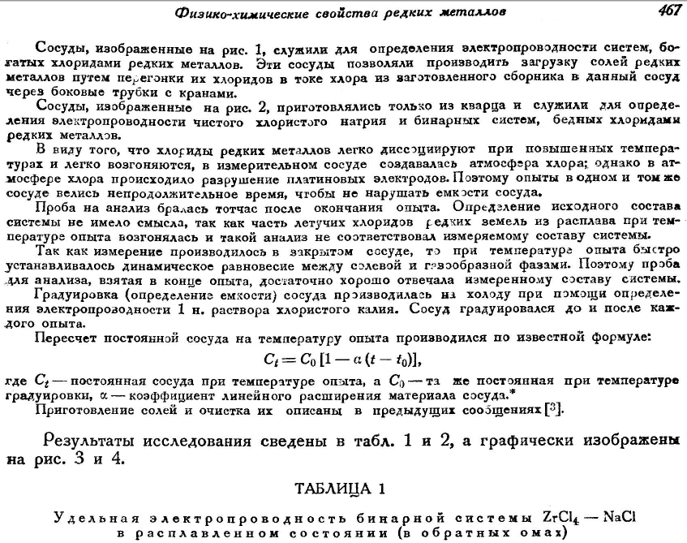

*Physical-chemical properties of rare metals* 467

Cells, which are illustrated in Fig.1, were used to determine the electrical conductivities of the rare - metal chlorides rich systems. These cells allowed loading the rare-metal salts by their chlorides sublimation in the chlorine flow from the prepared collecting tank to the vessel through the side tubes with taps.

Cells illustrated in Fig. 2 were prepared from quartz and served for determination of the electrical conductivity of pure sodium chloride and rare metal chlorides poor binary systems.

Due to the fact that rare metal chlorides dissociate easily at high temperatures and are easily sublimated, we prepared a chlorine-containing atmosphere in the measuring cell; but platinum electrodes were damaged in the chlorine-containing atmosphere. That is why the experiment duration in the same cell was short to maintain the cell constant.

The melt sampling was performed immediately after the experiment termination. The determination of the initial composition of the system was useless, because a part of the volatile chlorides of rare earth metals from the melt were sublimated at the experiment temperature and therefore such analysis did not correspond to the measured composition of the system.

The measurements were performed in the closed cell and the dynamic equilibrium between the salt and gaseous phases was rapidly established at the experiment temperature. That is why the sampling after the experiment termination corresponded well to the measured composition of the system.

The cell calibration test was performed in cold using a potassium chloride solution to determine the electrical conductivity. The cell was calibrated before and after each experiment.

Recalculation of the cell constant according to the experiment temperature was performed using the known formula:

C*t* = *C*0 [1 – (*t* – *t*0)],

where *Ct* is the cell constant at the experiment temperature, *C*0 is the cell constant at the calibration temperature, α is the coefficient of the cell material linear expansion *.

The salts preparation and their purification were described in previous works.

The results of the studies are provided in Tables 1 and 2, and graphically illustrated in Figs. 3 and 4.

TABLE 1

Specific electrical conductivity of the binary ZrCl4 - NaCl system in the molten state (-1)

|  |  |  |
| --- | --- | --- |
| Salt phase composition, wt. % | Molar composition of salt phase | ᵒC |

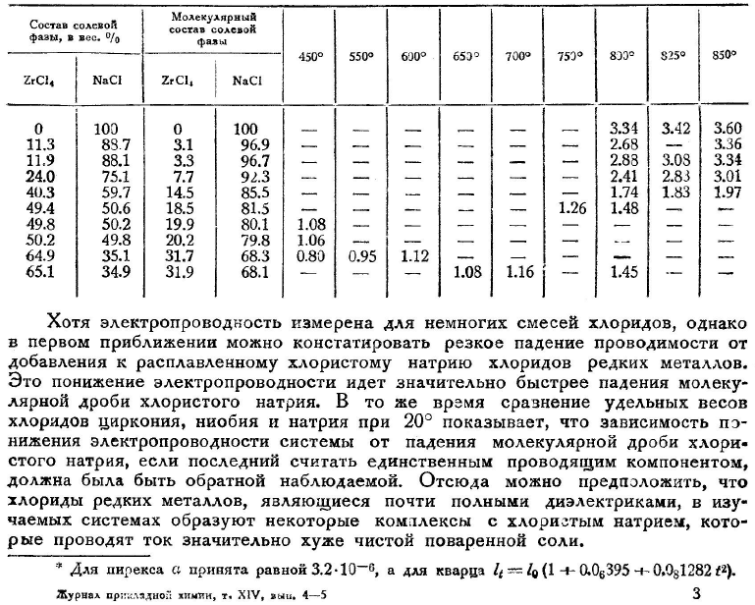

ºC

Despite the fact that the electrical conductivity was measured in few chloride systems, at first approximation we may state that addition of rare metal chlorides to molten sodium chloride results in an abrupt decrease in the electrical conductivity. The electrical conductivity decreases significantly faster than the decrease in the sodium chloride mole fraction. At the same time the comparison of the specific weights of zirconium, niobium and sodium chlorides at 20 ᵒC demonstrates that the dependence of the electrical conductivity decreases on the sodium chloride decrease (if we consider the latter to be a unique current conducting component) should be reverse. Therefore, we may assume that rare metal chlorides that are almost completely dielectric form with sodium chloride current-conducting complexes, but their electrical conductivities are significantly worse than that of sodium salt.

*for pyrex α is equal 3.2·10-6, for quartz *lt* = *l*0 (1 + 0.06395 + 0.081282 *t*2).