Syntheses and structures of two new complexes

Electronic Supporting Information (ESI)

Two novel copper(II) supramolecular complexes: synthesis, crystal structures, and Hirshfeld surface analysis

Yuzhu Song1,2, Chang Xu2, Tianyu Bai2, Xiuyan Wang1,2*

1Key Laboratory of Preparation and Applications of Environmental Friendly Materials, Jilin Normal University, Ministry of Education, Changchun 130103, China

2Department of Chemistry, Jilin Normal University, Siping 136000, China

* Correspondence author (e-mail: [wangxiuyanjlnu2004@163.com](mailto:wangxiuyanjlnu2004@163.com))

## Hirshfeld surface analysis of complex (1)

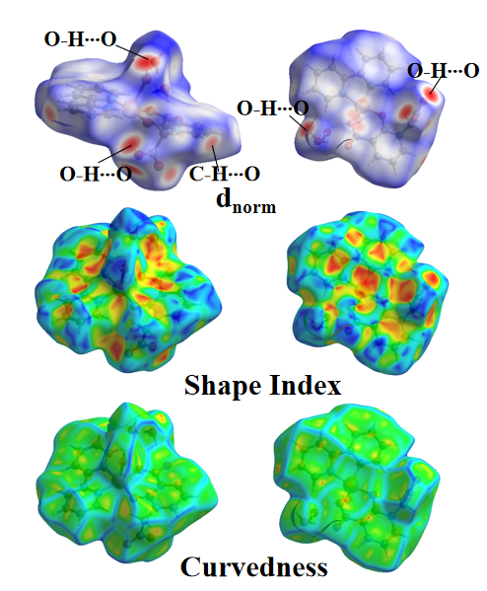

**Figure S1.** Surface distribution situation of complex **(1)**.

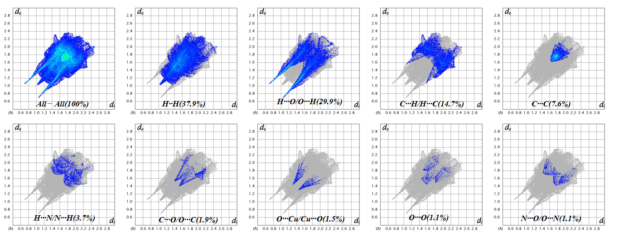

**Figure S2.** The 2D fingerprint plot of complex **(1)**.