**Supplementary Information**

**Synthesis of schafarzikite-type (PbBi)(Fe1-*x*Mn*x*)O4: a study on structural, spectroscopic and thermogravimetric properties**

Carla M. Uribe1, Thorsten M. Gesing1,2 M. Mangir Murshed1,2*

1University of Bremen, Institute of Inorganic Chemistry and Crystallography, Leobener Straße 7, D-28359 Bremen, Germany

2University of Bremen, MAPEX Center for Materials and Processes, Bibliothekstraße 1, Universität Bremen, D-28359 Bremen, Germany

*Corresponding author: murshed@uni-bremen.de,

ORCID:

CMUR: 0009-0008-8486-6376

TMG: 0000-0002-4119-2219

MMM: 0000-0002-9063-372X

**Table S1:** X-ray powder diffraction data Rietveld refined metric parameters of(PbBi)(Fe1-*x*Mn*x*)O4 in the space group *P*42/*mbc*, where the R-factors are given in %.

|  |  |  |  |  |  |  |
| --- | --- | --- | --- | --- | --- | --- |
| Atom | Site | Occupancy | *x* | *y* | *z* | *B*/ 104pm2 |
| (PbBi)FeO4, Rwp = 6.3, Rp = 4.7, GOF = 2.1 | | | | | | |
| Pb1/Bi1 | 8*h* | 0.5/0.5  0.48(5)/0.52(5)† | 0.15463(16) | 0.1570(16) | 0 | 0.73(1) |
| Fe | 4*d* | 1 | 0 | ½ | ¼ | 0.20(6) |
| O1 | 8*g* | 1 | 0.66870(8) | 0.16870(8) | ¼ | 2.05(2) ‡ |
| O2 | 8*h* | 1 | 0.08918(13) | 0.6313(12) | 0 | 2.05(2) ‡ |
| (PbBi)(Fe0.9Mn0.1)O4, Rwp = 6.3, Rp = 4.8, GOF = 2.1 | | | | | | |
| Pb1/Bi1 | 8*h* | 0.5/0.5  0.49(5)/0.51(5) † | 0.15463(16) | 0.1570(16) | 0 | 0.50(1) |
| Fe1/Mn1 | 4*d* | 0.9/0.1  0.90(3)/0.10(3) † | 0 | ½ | ¼ | 0.20(6) |
| O2 | 8*g* | 1 | 0.66870(8) | 0.16870(8) | ¼ | 0.99(18) ‡ |
| O2 | 8*h* | 1 | 0.08918(12) | 0.6313(11) | 0 | 0.99(18)‡ |
| (PbBi)(Fe0.8Mn0.2)O4, Rwp = 6.3, Rp = 4.8, GOF = 1.9 | | | | | | |
| Pb1/Bi1 | 8*h* | 0.5/0.5  0.48(5)/0.52(6) † | 0.15463(15) | 0.1570(15) | 0 | 0.82(1) |
| Fe1/Mn1 | 4*d* | 0.8/0.2  0.79(4)/0.21(3) † | 0 | ½ | ¼ | 0.20(6) |
| O2 | 8*g* | 1 | 0.66868(7) | 0.16868(7) | ¼ | 1.30(2) ‡ |
| O2 | 8*h* | 1 | 0.08919(11) | 0.63125(10) | 0 | 1.30(2) ‡ |
| (PbBi)(Fe0.7Mn0.3)O4, Rwp = 5.9, Rp = 4.5, GOF = 1.8 | | | | | | |
| Pb1/Bi1 | 8*h* | 0.5/0.5  0.49(6)/0.51(6) † | 0.15463(15) | 0.1570(15) | 0 | 0.65(1) |
| Fe1/Mn1 | 4*d* | 0.7/0.3  0.70(4)/0.30(4) † | 0 | ½ | ¼ | 0.20(5) |
| O2 | 8*g* | 1 | 0.6687(7) | 0.1687(7) | ¼ | 1.29(16)‡ |
| O2 | 8*h* | 1 | 0.0902(10) | 0.63124(10) | 0 | 1.29(16) ‡ |
| (PbBi)(Fe0.6Mn0.4)O4, Rwp = 7.5, Rp = 5.8, GOF = 2.1 | | | | | | |
| Pb1/Bi1 | 8*h* | 0.5/0.5  0.49(6)/0.51(6) † | 0.15463(2) | 0.1570(2) | 0 | 0.20(1) |
| Fe1/Mn1 | 4*d* | 0.6/0.4  0.59(3)/0.41(3) † | 0 | ½ | ¼ | 0.20(7) |
| O2 | 8*g* | 1 | 0.6687(9) | 0.1687(9) | ¼ | 1.04(2)‡ |
| O2 | 8*h* | 1 | 0.08918(15) | 0.6313(14) | 0 | 1.04(2)‡ |
| (PbBi)(Fe0.5Mn0.5)O4, Rwp = 6.2, Rp = 4.7, GOF = 1.9 | | | | | | |
| Pb1/Bi1 | 8*h* | 0.5/0.5  0.49(6)/0.51(6) † | 0.1546(1) | 0.1570(1) | 0 | 0.82(1) |
| Fe1/Mn1 | 4*d* | 0.5/0.5  0.49(3)/0.51(3) † | 0 | ½ | ¼ | 0.20(5) |
| O2 | 8*g* | 1 | 0.6687(8) | 0.1687(7) | ¼ | 1.82(17) ‡ |
| O2 | 8*h* | 1 | 0.08918(11) | 0.63072(11) | 0 | 1.82(17) ‡ |
| (PbBi)(Fe0.4Mn0.6)O4, Rwp = 6.4, Rp = 4.8, GOF = 1.9 | | | | | | |
| Pb1/Bi1 | 8*h* | 0.5/0.5  0.49(5)/0.51(5) † | 0.1546(2) | 0.1570(1) | 0 | 0.92(1) |
| Fe1/Mn1 | 4*d* | 0.4/0.6  0.38(3)/0.62(3) † | 0 | ½ | ¼ | 0.20(6) |
| O2 | 8*g* | 1 | 0.6687(7) | 0.1687(7) | ¼ | 1.47(17)‡ |
| O2 | 8*h* | 1 | 0.0891(11) | 0.6312(11) | 0 | 1.47(17)‡ |
| (PbBi)(Fe0.3Mn0.7)O4, Rwp = 7.4, Rp = 5.3, GOF = 2.1 | | | | | | |
| Pb1/Bi1 | 8*h* | 0.5/0.5  0.49(5)/0.51(5) † | 0.1546(2) | 0.1570(2) | 0 | 0.84(1) |
| Fe1/Mn1 | 4*d* | 0.3/0.7  0.30(3)/0.70(3) † | 0 | ½ | ¼ | 0.20(6) |
| O2 | 8*g* | 1 | 0.6686(9) | 0.1686(9) | ¼ | 2.06(21)‡ |
| O2 | 8*h* | 1 | 0.0891(14) | 0.6312(13) | 0 | 2.06(21)‡ |
| (PbBi)(Fe0.2Mn0.8)O4, Rwp = 7.0, Rp = 5.2, GOF = 2.0 | | | | | | |
| Pb1/Bi1 | 8*h* | 0.5/0.5  0.49(5)/0.51(5) † | 0.1541(2) | 0.1569(2) | 0 | 0.94(1) |
| Fe1/Mn1 | 4*d* | 0.2/0.8  0.22(3)/0.78(3) † | 0 | ½ | ¼ | 0.20(6) |
| O2 | 8*g* | 1 | 0.6686(8) | 0.1686(8) | ¼ | 2.31(20) ‡ |
| O2 | 8*h* | 1 | 0.0892(13) | 0.6312(11) | 0 | 2.31(20) ‡ |
| (PbBi)(Fe0.1Mn0.9)O4, Rwp = 8.8, Rp = 6.7, GOF = 2.2 | | | | | | |
| Pb1/Bi1 | 8*h* | 0.5/0.5  0.49(5)/0.51(5) † | 0.1545(2) | 0.1570(2) | 0 | 0.20(2) |
| Fe1/Mn1 | 4*d* | 0.1/0.9  0.09(3)/0.91(3) † | 0 | ½ | ¼ | 0.20(9) |
| O2 | 8*g* | 1 | 0.6687(12) | 0.1687(12) | ¼ | 2.58(31) ‡ |
| O2 | 8*h* | 1 | 0.0891(19) | 0.6313(18) | 0 | 2.58(31) ‡ |
| (PbBi)MnO4, Rwp = 8.7, Rp = 6.4, GOF = 2.4 | | | | | | |
| Pb1/Bi1 | 8*h* | 0.5/0.5  0.49(5)/0.51(5) † | 0.1546(2) | 0.1562(2) | 0 | 0.56(2) |
| Mn1 | 4*d* | 1 | 0 | ½ | ¼ | 0.20(8) |
| O2 | 8*g* | 1 | 0.6687(11) | 0.1658(11) | ¼ | 3.15(29)‡ |
| O2 | 8*h* | 1 | 0.0891(18) | 0.6247(17) | 0 | 3.15(29)‡ |

†Compositional values form ten point-measurement and three mappings of each sample on SEM-EDX with the corresponding standard deviation.

‡Constrains of isotropic displacement parameter for a physically meaningful convergence.

**Table S2:** Metric parameters, averaged crystalline size (LVol(IB)) and macrostrain (ε0) of (PbBi)(Fe1-xMnx)O4.

|  |  |  |  |  |  |
| --- | --- | --- | --- | --- | --- |
| **PbLMO4** | ***a*  /pm** | ***c*  /pm** | ***V*  /106 pm3** | ***L*Vol(IB)**  **/nm** | ***0* /10-6** |
| (PbBi)FeO4 | 850.08(3) | 610.75(4) | 441.35(4) | 206(2) | 180(2) |
| (PbBi)(Fe0.9Mn0.1)O4 | 850.51(4) | 610.73(4) | 441.78(5) | 199(2) | 200(2) |
| (PbBi)(Fe0.8Mn0.2)O4 | 850.84(8) | 610.07(5) | 441.65(7) | 126(6) | 130(2) |
| (PbBi)(Fe0.7Mn0.3)O4 | 851.19(5) | 609.47(5) | 441.58(6) | 135(7) | 160(2) |
| (PbBi)(Fe0.6Mn0.4)O4 | 851.57(5) | 609.02(5) | 441.65(6) | 135(9) | 170(2) |
| (PbBi)(Fe0.5Mn0.5)O4 | 851.88(4) | 608.27(4) | 441.42(5) | 204(2) | 180(2) |
| (PbBi)(Fe0.4Mn0.6)O4 | 851.94(5) | 607.83(4) | 441.16(6) | 167(2) | 170(2) |
| (PbBi)(Fe0.3Mn0.7)O4 | 852.11(5) | 607.48(5) | 441.09(6) | 132(7) | 150(2) |
| (PbBi)(Fe0.2Mn0.8)O4 | 852.14(5) | 606.97(5) | 440.75(6) | 132(6) | 120(2) |
| (PbBi)(Fe0.1Mn0.9)O4 | 852.62(5) | 606.50(5) | 440.90(6) | 87(4) | 110(2) |
| (PbBi)MnO4 | 852.60(5) | 606.32(8) | 440.76(7) | 182(2) | 180(2) |

**Table S3:** Interatomic bond distances /pm, angles /°.

|  |  |  |  |  |  |
| --- | --- | --- | --- | --- | --- |
| **Compound** | ***M*-O1 x2** | ***M*-O2 x4** | ***L*-O1 x2** | ***L*-O2** | ***L*-O2** |
| (PbBi)FeO4 | 202.8(1) | 203.8(7) | 213.1(4) | 218.9(11) | 274.5(11) |
| (PbBi)(Fe0.9Mn0.1)O4 | 202.9(9) | 203.8(6) | 213.1(4) | 219.0(10) | 274.6(10) |
| (PbBi)(Fe0.8Mn0.2)O4 | 203.0(9) | 203.7(6) | 213.1(4) | 219.1(10) | 274.8(9) |
| (PbBi)(Fe0.7Mn0.3)O4 | 203.1(9) | 203.9(6) | 213.0(4) | 218.3(9) | 275.5(9) |
| (PbBi)(Fe0.6Mn0.4)O4 | 203.2(12) | 203.6(8) | 213.0(5) | 219.3(13) | 275.0(12) |
| (PbBi)(Fe0.5Mn0.5)O4 | 293.2(6) | 203.2(6) | 212.9(4) | 219.4(10) | 275.4(10) |
| (PbBi)(Fe0.4Mn0.6)O4 | 203.3(9) | 203.4(6) | 212.8(4) | 219.4(10) | 275.1(10) |
| (PbBi)(Fe0.3Mn0.7)O4 | 203.3(10) | 203.3(7) | 212.8(5) | 219.4(12) | 275.2(12) |
| (PbBi)(Fe0.2Mn0.8)O4 | 203.3(10) | 203.2(7) | 212.7(5) | 229.8(11) | 274.9(11) |
| (PbBi)(Fe0.1Mn0.9)O4 | 203.4(15) | 203.2(11) | 212.7(7) | 219.6(16) | 275.2(16) |
| (PbBi)MnO4 | 200.0(7) | 200.2(7) | 214.6(7) | 220.1(16) | 279.4(9) |
|  | **O1-*M*-O1** | **O1-*M*-O2 x4** | **O2-*M*-O2**  **x4** | **O1-*L*-O1** | **O1-*L*-O2**  **x2** |
| **O2-*L*-O2** |
| (PbBi)FeO4 | 180.0(2) | 82.9(3) | 82.9(3) | 91.5(2) | 65.6(3) |
| 97.1(3) | 98.9(5) | 144.8(2) | 90.8(3) |
| (PbBi)(Fe0.9Mn0.1)O4 | 180.0(3) | 82.9(3) | 83.0(4) | 91.5(2) | 65.6(3) |
| 97.1(3) | 98.8(4) | 144.8(2) | 90.8(2) |
| (PbBi)(Fe0.8Mn0.2)O4 | 180.0(3) | 82.9(3) | 82.9(3) | 91.4(2) | 65.5(2) |
| 97.1(3) | 98.8(4) | 144.8(2) | 91.4(2) |
| (PbBi)(Fe0.7Mn0.3)O4 | 180.0(1) | 83.0(3) | 83.3(4) | 91.3(2) | 65.6(2) |
| 97.0(3) | 98.4(4) | 144.9(2) | 90.8(2) |
| (PbBi)(Fe0.6Mn0.4)O4 | 179.9(1) | 82.8(3) | 83.2(5) | 91.3(3) | 65.5(3) |
| 97.2(3) | 98.6(5) | 144.8(3) | 90.8(3) |
| (PbBi)(Fe0.5Mn0.5)O4 | 180.0(2) | 82.9(3) | 83.1(4) | 90.9(2) | 65.4(2) |
| 97.1(3) | 98.6(4) | 144.8(2) | 91.2(2) |
| (PbBi)(Fe0.4Mn0.6)O4 | 179.9(3) | 82.8(3) | 83.3(4) | 90.8(2) | 65.5(2) |
| 97.2(3) | 98.5(4) | 144.8(2) | 91.1(2) |
| (PbBi)(Fe0.3Mn0.7)O4 | 180.0(1) | 82.8(3) | 83.3(3) | 80.8(3) | 65.5(3) |
| 97.2(3) | 98.4(5) | 144.8(2) | 91.1(3) |
| (PbBi)(Fe0.2Mn0.8)O4 | 180.0(1) | 82.8(3) | 83.4(4) | 90.7(3) | 62.5(3) |
| 97.2(3) | 98.4(5) | 144.7(2) | 91.0(2) |
| (PbBi)(Fe0.1Mn0.9)O4 | 179.9(5) | 82.8(4) | 83.5(7) | 90.8(4) | 65.5(4) |
| 97.2(4) | 98.3(7) | 144.7(3) | 91.0(4) |
| (PbBi)MnO4 | 180.0(1) | 81.5(1) | 83.8(1) | 89.8(1) | 63.9(1) |
| 96.1(1) | 99.8(1) | 145.1(5) | 92.4(1) |

**Table S4:** Irreducible representations for the nonequivalent atomic sites for the 42/mbc space group of L2MO4 with two formula units per unit cell.

|  |  |  |
| --- | --- | --- |
| **Atom** | **Wyckoff** | **Irreducible representation** |
| *M* | 4*d* | A2g + A2u + B1g + B1u + 2Eu + 2Eg |
| *L* | 8*h* | 2A1g + A1u + 2A2g + A2u + 2B1g + B1u + 2B2g + B2u + 4Eu + 2Eg |
| O1 | 8*g* | A1g + A1u + 2A2g + 2A2u + 2B1g + 2B1u + 1B2g + B2u + 3Eu + 3Eg |
| O2 | 8*h* | 2A1g + A1u + 2A2g + A2u + 2B1g + B1u + 2B2g + B2u + 4Eu + 2Eg |
| GRaman: 5A1g + 7B1g + 5B2g + 9Eg  GIR: 4A2u + 12Eu  Gacoustic: A2u + Eu  Gsilent: 3A1u + 7A2g+ 5B1u + 3B2u | | |

**Table S5:** Band-gap energies of the (PbBi)(Fe1-xMnx)O4 solid solution calculated from the UV/Vis diffuse reflectance spectra using Tauc’s and DASF methods.

|  |  |  |  |  |  |
| --- | --- | --- | --- | --- | --- |
| **PbBiFe1-xMnxO₄** | **(h*v*\*F(*R*))½**  **/eV** | **(h*v*\*F(*R*))²**  **/eV** | **DASF**  ***Eg* /eV** | **DASF**  ***Fg* /eV** | **Assigned  type** |
| PbBiFeO₄ | 1.95(3) | 2.23(3) | 2.24(1) | 0.32(2) | Direct |
| PbBiFe₀․₉Mn₀․₁O₄ | 1.95(3) | 2.23(3) | 2.24(2) | 0.32(5) | Direct |
| PbBiFe₀․₈Mn₀․₂O₄ | 1.54(3) | 1.78(3) | 1.77(2) | 0.29(4) | Direct |
| PbBiFe₀․₇Mn₀․₃O₄ | 1.62(3) | 1.82(3) | 1.75(1) | 0.29(4) | Direct |
| PbBiFe₀․₆Mn₀․₄O₄ | 1.64(3) | 1.75(3) | 1.80(1) | 0.23(3) | Direct |
| PbBiFe₀․₅Mn₀․₅O₄ | 1.60(3) | 1.75(3) | 1.82(7) | 0.25(8) | Direct |
| PbBiFe₀․₄Mn₀․₆O₄ | 1.61(3) | 1.76(3) | 1.82(4) | 0.26(3) | Direct |
| PbBiFe₀․₃Mn₀․₇O₄ | 1.58(3) | 1.77(3) | 1.87(1) | 0.25(2) | Direct |
| PbBiFe₀․₂Mn₀․₈O₄ | 1.62(3) | 1.74(3) | 1.74(3) | 0.23(9) | Direct |
| PbBiFe₀․₉Mn₀․₁O₄ | 1.66(3) | 1.73(3) | 1.73(1) | 0.39(5) | Direct |
| PbBiMnO₄ | 1.79(3) | 1.72(3) | 1.72(1) | 0.46(8) | Direct |

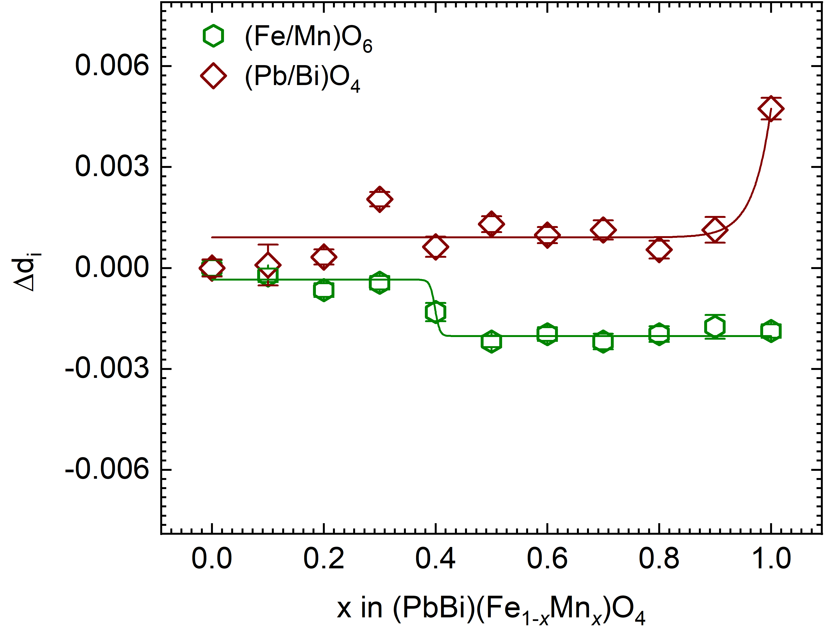

**Figure S1:** Deviationof the bond length distortion (Δdi) in the (Pb/Bi)O3 and (Fe/Mn)O6 polyhedra with respect to the chemical composition x in (PbBi)(Fe1-xMnx)O4. The solid lines are eye guidelines.



**Figure S2:** Low spin and high spin cationic radii of Fe+3 and Mn+3 in the corresponding concentrations vs lattice parameters.



**Figure S3:** Selective Raman spectroscopic peak shifts with respect to compositional x-value in (PbBi)(Fe1-xMnx)O4.



**Figure S4:** Selective FTIR spectroscopic peak shifts with respect to compositional x-value in (PbBi)(Fe1-xMnx)O4.

Ein Bild, das Screenshot, Kunst enthält.

**Figure S5:** UV/Vis diffuse reflectance (R), Kubelka-Munk transformed absorption spectra (A), Tauc plots for indirect (Ei) and direct (Ed) band-gap transitions (T), and DASF plot (D) of (PbBi)FeO4.

Ein Bild, das Screenshot, Reihe, Nacht, Licht enthält.

**Figure S6:** UV/Vis diffuse reflectance (R), Kubelka-Munk transformed absorption spectra (A), Tauc plots for indirect (Ei) and direct (Ed) bandgap transitions (T), and DASF plot (D) of (PbBi)MnO4 (bottom).

Ein Bild, das Text, Screenshot, Diagramm, Schrift enthält.

**Figure S7:** Decomposition temperature of (PbBi)(Fe1-xMnx)O4.