6-Bromo-3-butyl-2-(4-chlorophenyl)-3H-imidazo[4,5-b]pyridine and its 4-butyl regioisomer: Synthesis and analysis of supramolecular assemblies

Selma Bourichi,ª Khalid Boujdi,^{b,c} Rachida Amanarne,^{b} Younes Ouzidan,^{b,*} Youssef Kandri Rodi,ª Fouad Ouazzani Chahdi,ª Sang Loon Tan^{d} and Edward R. T. Tiekink^{e,*}

ª Laboratoire de Chimie-Physique et Biotechnologie des Biomolécules et Matériaux, Faculté des Sciences et Techniques, Université Hassan II, BP 146, Mohammedia 28800, Morocco
^{b} Laboratoire de Chimie Organique Appliquée, Faculté des Sciences et Techniques, Université Sidi Mohamed Ben Abdallah, Route d’Immouzzer, BP 2202 Fez, Morocco
^{c} Univ. Bordeaux, CNRS, Bordeaux INP, CBMN, UMR 5248, 33600 Pessac, France
^{d} Sunway Biofunctional Molecules Discovery Centre, School of Medical and Life Sciences, Sunway University, 47500 Bandar Sunway, Selangor Darul Ehsan, Malaysia
^{e} Department of Chemistry, Universitat de les Illes Balears, Crta de Valldemossa km 7.5, 07122 Palma de Mallorca, Spain

Correspondence authors:
E-mail addresses: younes.ouzidan@fstm.ac.ma (Y. Ouzidan) and edward.tiekink@uib.es (E.R.T. Tiekink)

*** SUPPLEMENTARY MATERIALS ***
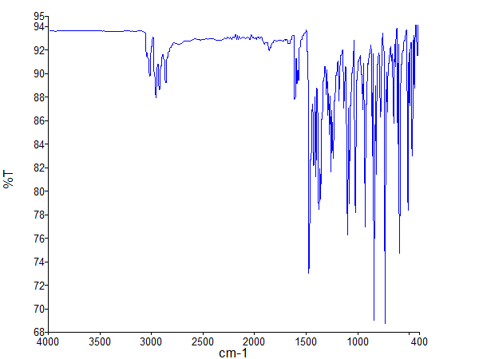
Figure S1: The Fourier transform infrared (FTIR) spectrum for 2 was measured on a Perkin Elmer Spectrum two FT-IR spectrophotometer in the range of 450 to 4000 cm⁻¹.

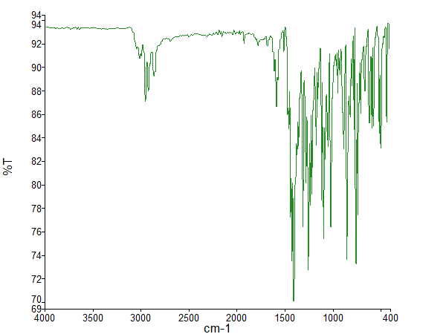
Figure S2: The Fourier transform infrared (FTIR) spectrum for 3 was measured on a Perkin Elmer Spectrum two FT-IR spectrophotometer in the range of 450 to 4000 cm⁻¹.

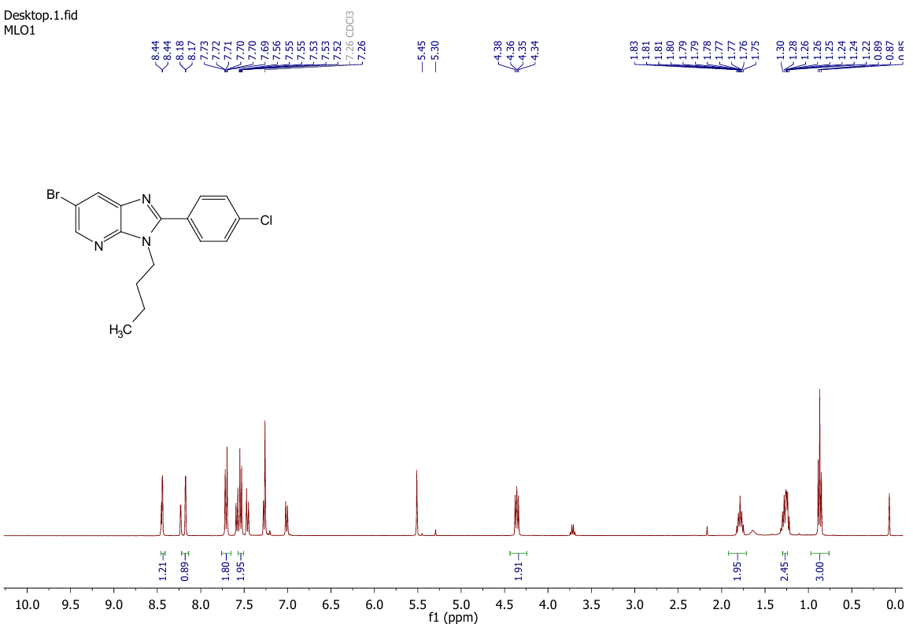
Figure S3: The ¹H NMR spectrum for 2 measured on a Bruker Avance NEO 400 spectrometer in CDCl₃ solution.

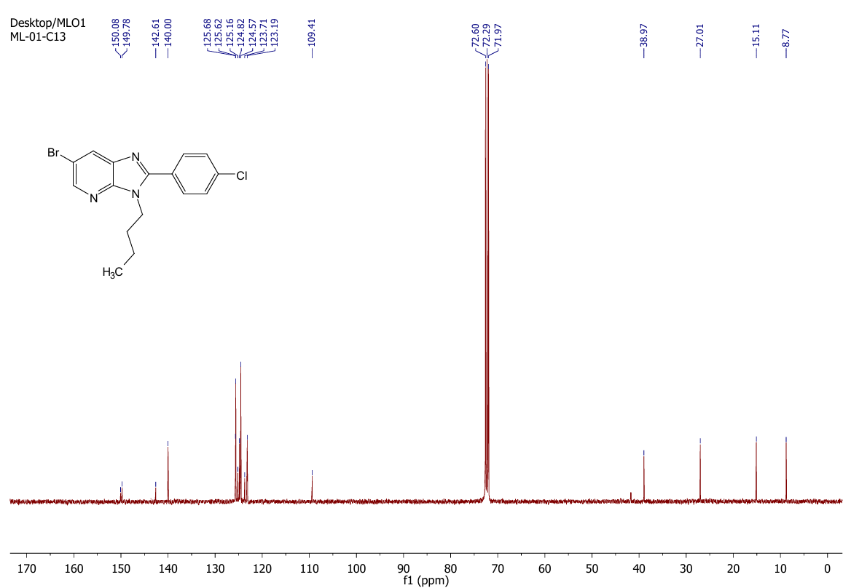
Figure S4: The ¹³C NMR spectrum for 2 measured on a Bruker Avance NEO 400 spectrometer in CDCl₃ solution.

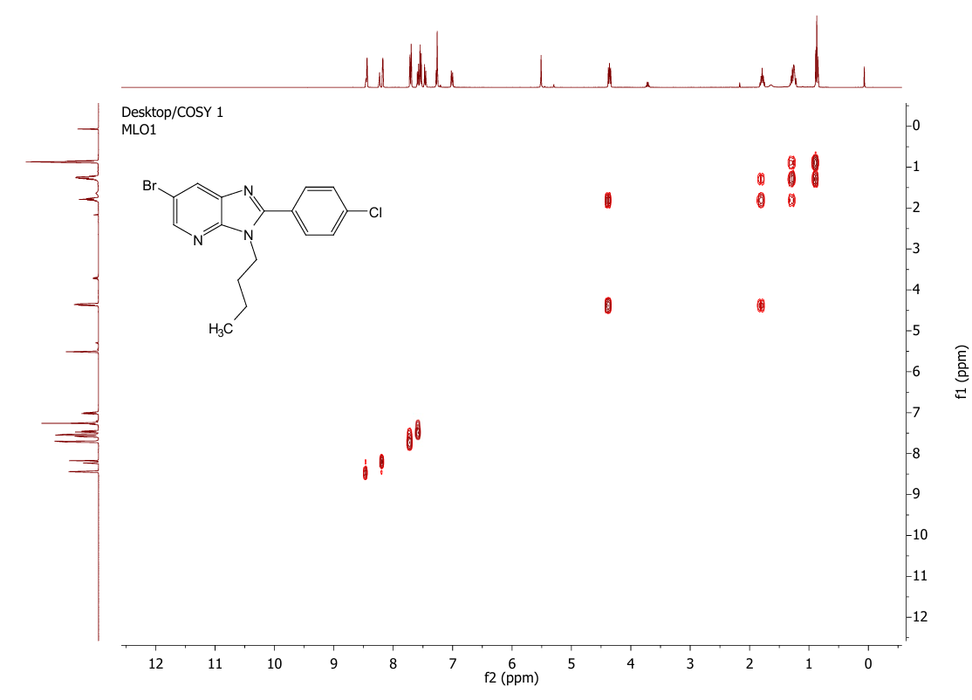
Figure S5: The COSY spectrum of compound 2 showing ¹H–¹H coupling correlations in CDCl₃ solution.

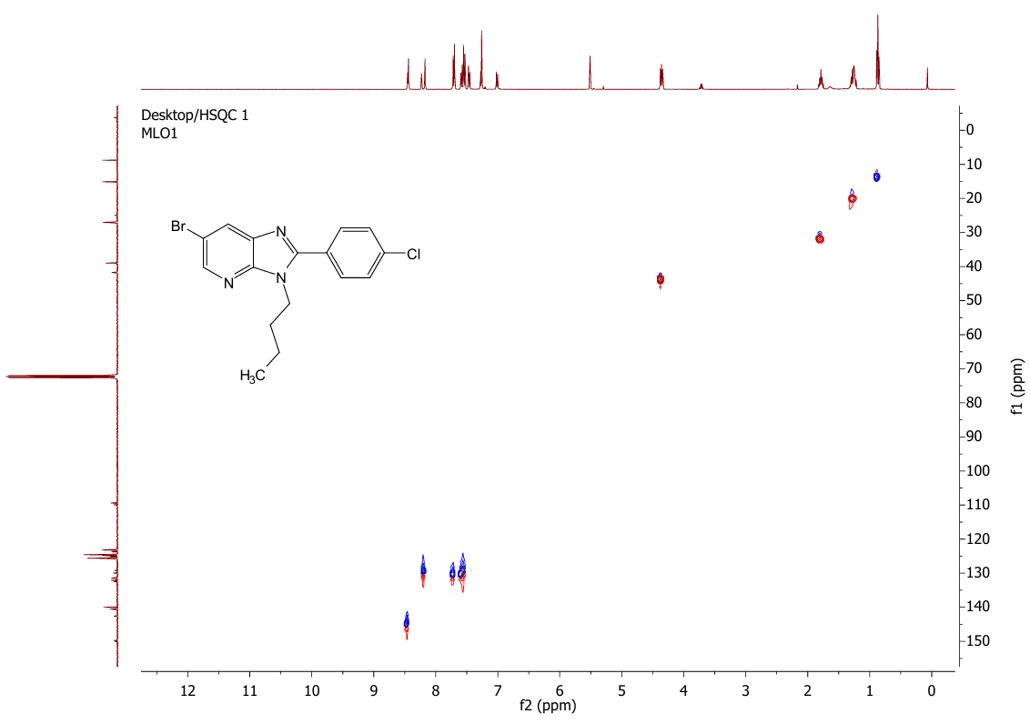
Figure S6: The HSQC spectrum of compound 2 with ¹H–¹³C correlations in CDCl₃ solution.

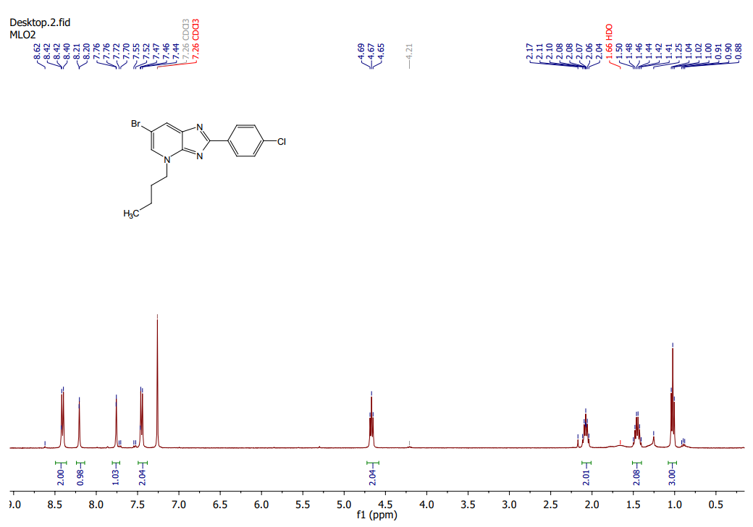
Figure S7: The ¹H NMR spectrum for compound 3 measured on a Bruker Avance NEO 400 spectrometer in CDCl₃ solution.

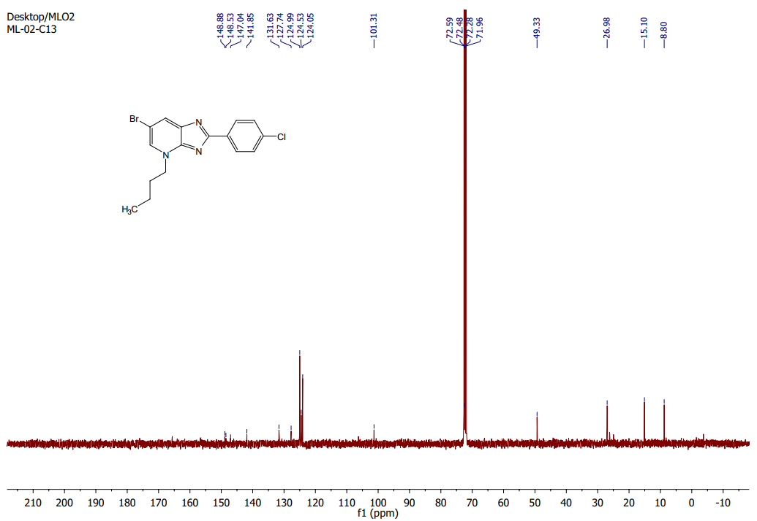
Figure S8: The ¹³C NMR spectrum for compound 3 measured on a Bruker Avance NEO 400 spectrometer in CDCl₃ solution.

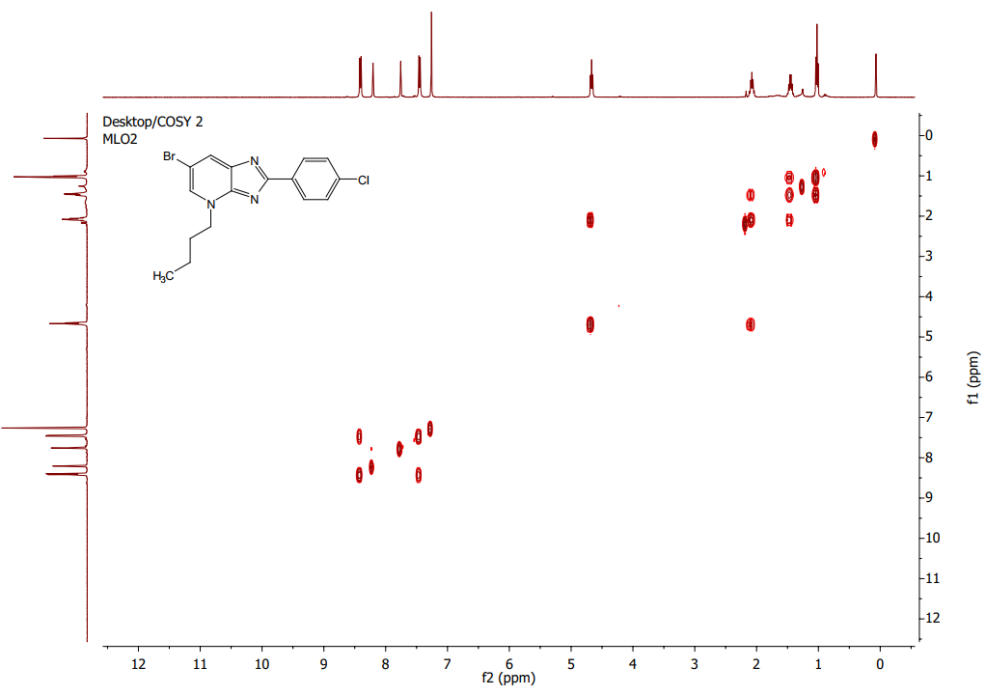
Figure S9: The COSY spectrum of compound 3 showing ¹H–¹H coupling correlations in CDCl₃ solution.

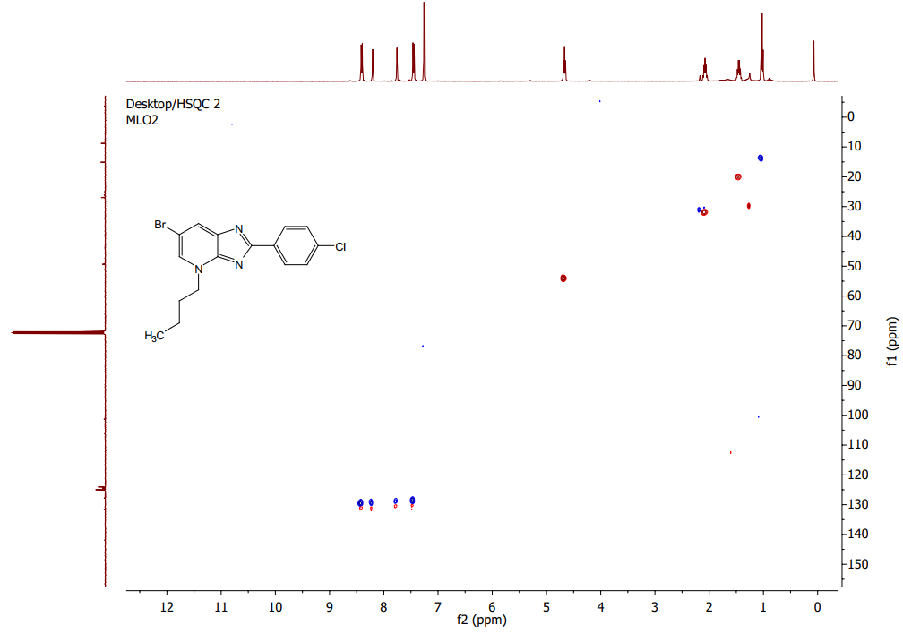
Figure S10: The HSQC spectrum of compound 3 with ¹H–¹³C correlations in CDCl₃ solution.

Figure S11: The HPLC/MS spectrum (positive ion mode) for compound 2 measured on an Ultimate 3000 coupled to the Thermo Scientific brand Exactive Plus mass spectrometer.

Figure S12: The HPLC/MS spectrum (positive ion mode) for compound 3 measured on an Ultimate 3000 coupled to the Thermo Scientific brand Exactive Plus mass spectrometer.

Table S1
Geometric parameters (Å, °) for the experimental structures of 2 and 3, and the geometry-optimised structures, opt-2 and opt-3.
Parameter | 2 | opt-2 | 3 | opt-3
N1–C2 | 1.323(2) | 1.319 | 1.346(2) | 1.341
N1–C7a | 1.379(2) | 1.370 | 1.367(2) | 1.355
N3–C2 | 1.383(2) | 1.387 | 1.375(2) | 1.376
N3–C3a | 1.377(2) | 1.379 | 1.333(2) | 1.322
N3–C31 | 1.468(2) | 1.462 | - | -
N4–C41 | - | - | 1.483(2) | 1.474
N4–C3a | 1.331(2) | 1.323 | 1.355(2) | 1.354
N4–C5 | 1.339(2) | 1.333 | 1.357(2) | 1.361
C2–C21 | 1.470(2) | 1.469 | 1.466(2) | 1.462
C7–C7a | 1.397(2) | 1.392 | 1.383(2) | 1.380
C6–Br1 | 1.900(1) | 1.911 | 1.891(2) | 1.907
C24–Cl1 | 1.744(1) | 1.743 | 1.740(2) | 1.746
Br1–C6–C5 | 116.9(1) | 118.4 | 117.3(1) | 117.9
N1–C2–N3 | 113.4(1) | 112.9 | 117.5(1) | 116.6
N3–C2–C21 | 123.7(1) | 125.2 | 119.2(1) | 121.1
N4–C3a–N3 | 126.2(1) | 127.2 | 127.5(1) | 128.4
C2–N3–C3a | 105.6(1) | 105.7 | 101.2(1) | 101.9
C3a–N4–C5 | 113.9(1) | 114.8 | 119.3(1) | 119.1
C7a–N1–C2 | 104.9(1) | 105.5 | 102.6(1) | 103.5
C23–C24–Cl1 | 119.2(1) | 119.6 | 118.7(1) | 119.5
C31–N3–C2 | 130.4(1) | 130.8 | - | -
C32–C31–N3 | 113.4(1) | 113.6 | - | -
C41–N4–C3a | - | - | 119.6(1) | 120.0
C42–C41–N4 | - | - | 112.5(1) | 112.6
N1–C2–C21–C22 | -141.0(2) | -145.5 | 175.2(1) | 179.9
N1–C2–C21–C26 | 36.9(2) | 32.0 | -4.5(2) | -0.1
N3–C2–C21–C22 | 37.9(2) | 35.7 | -4.4(2) | -0.1
N3–C2–C21–C26 | -144.3(1) | -146.9 | 175.8(1) | 179.9
C31–N3–C2–C21 | 10.7(2) | 6.8 | - | -
C31–N3–C2–N1 | -170.4(1) | -172.1 | - | -
C32–C31–N3–C2 | -112.0(2) | -108.0 | - | -
C33–C32–C31–N3 | -176.2(1) | -179.4 | - | -
C34–C33–C32–C31 | -175.3(1) | 179.3 | - | -
C41–N4–C3a–N3 | - | - | -0.0(2) | -1.8
C42–C41–N4–C3a | - | - | -108.0(2) | -85.2
C43–C42–C41–N4 | - | - | 175.2(1) | 179.1
C44–C43–C42–C41 | - | - | 178.8(1) | 179.9

Table S2
The energy-converged coordinates obtained from B3LYP/Def2TZVPP for molecule of 2, i.e. opt-2, in mol2 format.
# T2_SB-12a_Cryst_Opt_b3lyp_def2tzvpp
# Created by GaussView 6.0.16
#

#
#

@<TRIPOS>MOLECULE
Molecule Name
36 38
SMALL
NO_CHARGES

@<TRIPOS>ATOM
1 Br1 5.5241 -1.0975 -0.1695 Br
2 Cl2 -6.5867 -1.7760 -0.0945 Cl
3 N3 0.1555 -1.5079 -0.2388 N
4 N4 -0.1098 0.6545 0.3448 N
5 N5 2.2208 1.2851 0.5132 N
6 C6 -0.7143 -0.5531 0.0284 C
7 C7 1.2476 0.4237 0.2675 C
8 C8 3.4519 0.7930 0.3745 C
9 H9 4.2754 1.4676 0.5667 H
10 C10 3.7064 -0.5335 -0.0022 C
11 C11 2.6791 -1.4311 -0.2482 C
12 H12 2.8654 -2.4568 -0.5310 H
13 C13 1.3897 -0.9286 -0.1009 C
14 C14 -2.1629 -0.7940 0.0050 C
15 C15 -3.0984 0.1593 -0.4079 C
16 H16 -2.7763 1.1338 -0.7427 H
17 C17 -4.4542 -0.1375 -0.4420 C
18 H18 -5.1694 0.6017 -0.7721 H
19 C19 -4.8852 -1.4003 -0.0608 C
20 C20 -3.9744 -2.3708 0.3406 C
21 H21 -4.3220 -3.3523 0.6284 H
22 C22 -2.6238 -2.0657 0.3676 C
23 H23 -1.9049 -2.8140 0.6675 H
24 C24 -0.6788 1.9047 0.8443 C
25 H25 -0.0653 2.2137 1.6917 H
26 H26 -1.6776 1.6943 1.2212 H
27 C27 -0.7034 3.0243 -0.1963 C
28 H28 0.3171 3.2004 -0.5420 H
29 H29 -1.2776 2.7054 -1.0710 H
30 C30 -1.2916 4.3187 0.3654 C
31 H31 -0.7129 4.6256 1.2415 H
32 H32 -2.3091 4.1327 0.7235 H
33 C33 -1.3102 5.4552 -0.6549 C
34 H34 -0.3020 5.6882 -1.0024 H
35 H35 -1.7325 6.3649 -0.2267 H
36 H36 -1.9082 5.1918 -1.5297 H
@<TRIPOS>BOND
1 1 10 1
2 2 19 1
3 3 6 2
4 3 13 Ar
5 4 6 1
6 4 7 Ar
7 4 24 1
8 5 7 2
9 5 8 Ar
10 6 14 1
11 7 13 Ar
12 8 9 1
13 8 10 Ar
14 10 11 Ar
15 11 12 1
16 11 13 Ar
17 14 15 Ar
18 14 22 Ar
19 15 16 1
20 15 17 Ar
21 17 18 1
22 17 19 Ar
23 19 20 Ar
24 20 21 1
25 20 22 2
26 22 23 1
27 24 25 1
28 24 26 1
29 24 27 1
30 27 28 1
31 27 29 1
32 27 30 1
33 30 31 1
34 30 32 1
35 30 33 1
36 33 34 1
37 33 35 1
38 33 36 1

Table S3
The energy-converged coordinates obtained from B3LYP/Def2TZVPP for molecule 3, i.e. opt-3, in mol2 format.
# T2_SB-12d_Cryst_Opt_b3lyp_def2tzvpp
# Created by GaussView 6.0.16
#

#
#

@<TRIPOS>MOLECULE
Molecule Name
36 38
SMALL
NO_CHARGES

@<TRIPOS>ATOM
1 Br1 -4.8261 -1.9835 0.1384 Br
2 Cl2 7.2322 -0.4824 0.0836 Cl
3 N3 0.5398 -1.6647 0.2240 N
4 N4 0.5230 0.5559 -0.4189 N
5 N5 -1.8698 0.7936 -0.5722 N
6 C6 1.2444 -0.5637 -0.0734 C
7 C7 -0.7213 0.1167 -0.3333 C
8 C8 -3.0595 0.1507 -0.4224 C
9 H9 -3.9459 0.7284 -0.6267 H
10 C10 -3.1106 -1.1699 -0.0364 C
11 C11 -1.9538 -1.9193 0.2214 C
12 H12 -2.0116 -2.9551 0.5224 H
13 C13 -0.7470 -1.2685 0.0688 C
14 C14 2.7061 -0.5395 -0.0361 C
15 C15 3.4119 0.6254 -0.3543 C
16 H16 2.8611 1.5128 -0.6300 H
17 C17 4.7977 0.6482 -0.3193 C
18 H18 5.3421 1.5484 -0.5656 H
19 C19 5.4871 -0.5042 0.0373 C
20 C20 4.8084 -1.6746 0.3578 C
21 H21 5.3615 -2.5611 0.6327 H
22 C22 3.4235 -1.6873 0.3198 C
23 H23 2.8785 -2.5873 0.5652 H
24 C24 -1.8213 2.2182 -0.9481 C
25 H25 -2.7053 2.4253 -1.5507 H
26 H26 -0.9392 2.3467 -1.5723 H
27 C27 -1.7547 3.1426 0.2657 C
28 H28 -0.8771 2.8792 0.8591 H
29 H29 -2.6317 2.9748 0.8976 H
30 C30 -1.6836 4.6149 -0.1411 C
31 H31 -0.8059 4.7707 -0.7747 H
32 H32 -2.5533 4.8665 -0.7561 H
33 C33 -1.6193 5.5570 1.0594 C
34 H34 -2.5000 5.4478 1.6953 H
35 H35 -1.5671 6.5986 0.7411 H
36 H36 -0.7403 5.3526 1.6734 H
@<TRIPOS>BOND
1 1 10 1
2 2 19 1
3 3 6 Ar
4 3 13 Ar
5 4 6 Ar
6 4 7 2
7 5 7 Ar
8 5 8 Ar
9 5 24 1
10 6 14 1
11 7 13 Ar
12 8 9 1
13 8 10 2
14 10 11 Ar
15 11 12 1
16 11 13 2
17 14 15 Ar
18 14 22 Ar
19 15 16 1
20 15 17 Ar
21 17 18 1
22 17 19 Ar
23 19 20 Ar
24 20 21 1
25 20 22 2
26 22 23 1
27 24 25 1
28 24 26 1
29 24 27 1
30 27 28 1
31 27 29 1
32 27 30 1
33 30 31 1
34 30 32 1
35 30 33 1
36 33 34 1
37 33 35 1
38 33 36 1

Table S4
The hybrid composition of selected natural bonding orbitals for opt-1 and opt-2.
X···Y |  | Opt-1 |  |  | Opt-2
 |  | Overall Occupancy (%) | s  (%) | p  (%) | Overall Occupancy (%) | s  (%) | p  (%)
C2–N1 | N1 | 56.9 | 33.5 | 65.8 | 57.7 | 32.8 | 66.6
 | C2 | 43.1 | 33.7 | 66.2 | 42.4 | 33.2 | 66.8
C7a–N1 | N1 | 56.4 | 30.7 | 68.8 | 55.9 | 31.2 | 68.2
 | C7a | 43.6 | 31.9 | 68.7 | 44.1 | 32.9 | 67.0
C2–N3 | N3 | 61.9 | 33.3 | 66.5 | 58.2 | 30.7 | 68.7
 | C2 | 38.1 | 29.9 | 70.1 | 41.8 | 31.8 | 68.2
C3a–N3 | N3 | 61.2 | 31.7 | 68.1 | 56.1 | 32.4 | 66.9
 | C3a | 38.8 | 29.2 | 70.7 | 43.9 | 34.9 | 65.0
C3a–C7a | C3a | 50.6 | 35.0 | 64.9 | 51.0 | 33.5 | 66.4
 | C7a | 49.4 | 30.3 | 69.5 | 49.0 | 28.8 | 71.1
C3a–N4 | N4 | 56.8 | 33.6 | 65.9 | 61.7 | 34.2 | 65.6
 | C3a | 43.2 | 35.8 | 64.1 | 38.3 | 31.6 | 68.3
C5–N4 | N4 | 58. | 35.3 | 64.2 | 62.3 | 34.5 | 65.2
 | C5 | 41.3 | 33.2 | 66.8 | 37.7 | 30.4 | 69.5
C5–C6 | C5 | 49.2 | 37.4 | 62.5 | 50.5 | 39.0 | 60.9
 | C6 | 50.8 | 37.9 | 62.0 | 49.5 | 37.8 | 62.1
C6–C7 | C6 | 49.8 | 39.1 | 60.8 | 50.5 | 38.9 | 61.0
 | C7 | 50.2 | 35.6 | 64.2 | 49.5 | 34.7 | 65.1
C7–C7a | C7 | 48.9 | 34.1 | 65.7 | 49.2 | 35.1 | 64.7
 | C7a | 51.1 | 37.8 | 62.1 | 50.8 | 38.3 | 61.6
C2–C21 | C2 | 50.1 | 36.3 | 63.6 | 50.5 | 35.1 | 64.9
 | C21 | 49.9 | 30.5 | 69.4 | 49.5 | 31.3 | 68.6
C21–C22 | C21 | 51.2 | 35.1 | 64.9 | 51.2 | 34.4 | 65.6
 | C22 | 48.8 | 35.3 | 64.6 | 48.8 | 35.0 | 64.8
C21–C26 | C21 | 51.5 | 34.3 | 65.7 | 51.3 | 34.3 | 65.7
 | C26 | 48.5 | 34.9 | 65.0 | 48.7 | 34.8 | 65.0
C22–C23 | C22 | 49.8 | 35.9 | 63.9 | 49.5 | 35.8 | 64.1
 | C23 | 50.2 | 36.2 | 63.7 | 50.5 | 36.2 | 63.6
C23–C24 | C23 | 49.4 | 34.8 | 65.0 | 49.3 | 34.7 | 65.1
 | C24 | 50.6 | 38.1 | 61.9 | 50.7 | 38.2 | 61.7
C24–C25 | C24 | 50.8 | 38.1 | 61.9 | 50.7 | 38.2 | 61.8
 | C25 | 49.2 | 34.6 | 65.2 | 49.3 | 34.6 | 65.2
C25–C26 | C25 | 50.4 | 36.2 | 63.7 | 50.5 | 36.2 | 63.6
 | C26 | 49.6 | 35.9 | 64.0 | 49.5 | 35.8 | 64.1

Table S5
A comparison of ESP fitted charges for selected atoms between opt-2 and opt-3.
Atom | ESP charge, ρ (a.u.)
Atom | Opt-2 | Opt-3
Br1 | -0.05 | -0.01
Cl1 | -0.01 | -0.11
N1 | -0.62 | -0.72
N3 | -0.17 | -0.57
N4 | -0.60 | 0.13
C2 | 0.37 | 0.70
C21 | 0.20 | -0.09
C22 | -0.31 | -0.13
C23 | 0.01 | -0.07
C24 | -0.03 | 0.03
C25 | 0.03 | -0.08
C26 | -0.29 | -0.09
C3a | 0.50 | 0.29
C5 | 0.41 | -0.05
C6 | -0.38 | -0.24
C7 | 0.04 | -0.09
C7a | 0.15 | 0.32
C31 | -0.33 | -
C41 | - | -0.3

