Supplementary Information

Synthesis, characterization and structure-property relations in mullite-type Pb₂(Pb_{1-x}Sn_{x})O₄ solid solution.

Christopher S. Reuter¹, M. Mangir Murshed^{1,2}*, Michael Fischer^{2,3,4}, Thorsten. M. Gesing^{1,2}

¹University of Bremen, Institute of Inorganic Chemistry and Crystallography, Leobener Straße 7, D-28359 Bremen, Germany
²University of Bremen, MAPEX Center for Materials and Processes, Bibliothekstraße 1, D-28359 Bremen, Germany
³University of Bremen, Crystallography, Faculty of Geosciences, Klagenfurter Straße 2-4, D-28359 Bremen, Germany
⁴University of Bremen, BCCMS Bremen Center for Computational Materials Science, Am Fallturm 1, D-28359 Bremen, Germany
*Corresponding author: e-mail address: murshed@uni-bremen.de, phone: +49 (0)421 218 63144

#ORCID:
CSR: 0000-0002-7983-7457
MMM: 0000-0002-9063-372X
MF: 0000-0001-5133-1537
TMG: 0000-0002-4119-2219

Table S1: Evolution of the bond length and angular changes index of Pb₂(Pb_{1-x}Sn_{x})O₄ with respect to compositional x.
 | Pb₂(Pb_{1-x}Sn_{x})O₄
x | 0 | 0.3 | 0.4 | 0.5 | 0.6 | 0.7 | 0.8 | 0.9 | 1
 | bond length/ pm
M-O(2) x2 | 239.76(4) | 243.19(1) | 220.39(1) | 214.13(1) | 217.73(1) | 212.59(1) | 205.85(1) | 203.47(1) | 205.98(1)
M-O(11) x2 | 214.15(1) | 214.71(1) | 212.26(1) | 211.79(1) | 206.75(1) | 208.86(1) | 206.64(1) | 203.68(1) | 209.63(1)
M-O(12) x2 | 214.15(1) | 203.89(1) | 192.27(1) | 202.69(1) | 206.89(1) | 209.43(1) | 207.30(1) | 208.82(1) | 193.93(1)
Pb(21)-O(2) x2 | 211.93(3) | 215.11(1) | 223.17(1) | 234.46(1) | 234.29(1) | 237.43(1) | 230.03(1) | 230.42(1) | 224.79(1)
Pb(22)-O(2) x2 | 211.93(3) | 205.33(1) | 210.66(1) | 204.65(1) | 202.69(1) | 202.04(1) | 211.45(1) | 211.97(1) | 214.57(1)
Pb(21)-O(11) x1 | 239.23(4) | 216.76(1) | 227.65(1) | 218.38(1) | 228.64(1) | 228.88(1) | 234.58(1) | 235.44(1) | 229.08(1)
Pb(21)-O(11) x1 | 274.32(4) | 290.00(1) | 281.55(1) | 293.00(1) | 285.94(1) | 280.27(1) | 276.46(1) | 278.89(1) | 281.82(1)
Pb(22)-O(12) x1 | 239.23(4) | 248.97(1) | 272.94(1) | 255.39(1) | 243.72(1) | 238.27(1) | 239.33(1) | 236.47(1) | 253.44(1)
Pb(22)-O(12) x1 | 274.32(4) | 280.36(1) | 273.38(1) | 274.25(1) | 279.51(1) | 282.44(1) | 280.79(1) | 280.15(1) | 278.74(1)
 | dihedral angle/ °
O(2)-O(12)-O(12)-O(2) x2 | 69.55(1) | 76.96(1) | 74.28(1) | 74.04(1) | 73.62(1) | 72.82(1) | 74.22(1) | 74.91(1) | 75.36(1)
O(2)-O(11)-O(11)-O(2) x2 | 69.55(1) | 65.58(1) | 73.88(1) | 76.24(1) | 73.77(1) | 76.36(1) | 77.66(1) | 77.65(1) | 75.91(1)
Pb(22)-O(2)-O(12)-O(11) x2 | 138.92(1) | 135.49(1) | 131.23(1) | 134.49(1) | 139.80(1) | 138.45(1) | 135.78(1) | 136.76(1) | 132.42(1)
Pb(21)-O(2)-O(11)-O(12) x2 | 138.92(1) | 144.78(1) | 144.72(1) | 138.26(1) | 133.50(1) | 133.77(1) | 135.52(1) | 133.64(1) | 138.72(1)
 | angle/ °
O(11)-M-O(12) x2 | 101.43(2) | 105.90(1) | 109.25(1) | 103.26(1) | 102.51(1) | 100.42(1) | 101.32(1) | 101.00(1) | 104.38(1)
O(12)-M-O(12) x1 | 79.91(1) | 66.39(1) | 60.65(1) | 69.19(1) | 73.17(1) | 74.74(1) | 75.57(1) | 77.57(1) | 70.27(1)
O(11)-M-O(11) x1 | 79.91(1) | 88.43(1) | 84.41(1) | 85.95(1) | 83.40(1) | 86.06(1) | 83.82(1) | 82.24(1) | 82.82(1)
O(2)-M-O(11) x2 | 96.17(1) | 91.66(1) | 95.29(1) | 91.48(1) | 91.72(1) | 94.06(1) | 96.99(1) | 96.16(1) | 93.72(1)
O(2)-M-O(11) x2 | 83.83(1) | 89.25(1) | 87.65(1) | 93.49(1) | 91.77(1) | 91.48(1) | 87.34(1) | 87.73(1) | 87.49(1)
O(2)-M-O(12) x2 | 83.83(1) | 73.72(1) | 79.12(1) | 77.64(1) | 79.22(1) | 79.08(1) | 81.89(1) | 82.14(1) | 82.55(1)
O(2)-M-O(12) x2 | 96.17(1) | 105.18(1) | 97.42(1) | 96.69(1) | 96.98(1) | 94.84(1) | 93.50(1) | 93.83(1) | 96.11(1)
O(2)-Pb(21)-O(2) x2 | 101.53(2) | 93.42(1) | 95.21(1) | 91.30(1) | 88.34(1) | 89.21(1) | 91.09(1) | 89.74(1) | 90.83(1)
O(11)-Pb(21)-O(11) x2 | 145.93(1) | 147.56(1) | 146.57(1) | 148.31(1) | 146.03(1) | 145.32(1) | 144.26(1) | 144.24(1) | 146.23(1)
O(2)-Pb(22)-O(2) x2 | 101.53(2) | 109.74(1) | 97.47(1) | 97.76(1) | 101.75(1) | 97.92(1) | 93.04(1) | 92.92(1) | 93.03(1)
O(12)-Pb(22)-O(12) x2 | 145.93(1) | 138.56(1) | 140.85(1) | 143.13(1) | 145.07(1) | 145.83(1) | 145.90(1) | 146.21(1) | 143.51(1)

Table S2: Crystallographic parameters of Pb₂(Pb_{1-x}Sn_{x})O₄ in mullite-type setting
x = 0 |  |  |  |  |  |  | x = 1.0
Atom | Ox. | Wyck. | Site | x | y | z | Atom | Ox. | Wyck. | Site | x | y | z
Pb1 | 4 | 4d | 2.22 | 0 | ½ | ¼ | Sn1 | 4 | 4e | ..2 | 0 | 0 | 0.2489(2)
Pb2 | 2 | 8h | m.. | 0.1646(2) | 0.1409(2) | 0 | Pb21 | 2 | 4g | ..m | 0.1420(5) | 0.3392(4) | 0
O2 | -2 | 8g | ..2 | 0.1923(3) | 0.6923(3) | ¼ | Pb22 | 2 | 4h | ..m | 0.3398(4) | 0.1419(4) | ½
O1 | -2 | 8h | m.. | 0.1272(1) | 0.4097(1) | 0 | O11 | -2 | 4g | ..m | 0.4015(4) | 0.3756(4) | 0
 |  |  |  |  |  |  | O12 | -2 | 4h | ..m | 0.3955(4) | 0.4266(4) | ½
 |  |  |  |  |  |  | O2 | -2 | 8i | 1 | 0.1720(5) | 0.1611(5) | 0.2535(2)
 |  |  |  | x = 0.3 |  |  | x = 0.4 |  |  | x = 0.5
Atom | Ox. | Wyck. | Site | x | y | z | x | y | z | x | y | z
Sn1 | 4 | 4e | ..2 | 0 | 0 | 0.2371(2) | 0 | 0 | 0.2432(6) | 0 | 0 | 0.2407(6)
Pb1 | 4 | 4e | ..m | 0 | 0 | 0.2371(2) | 0 | 0 | 0.2432(6) | 0 | 0 | 0.2407(6)
Pb21 | 2 | 4g | ..m | 0.1465(7) | 0.3397(5) | 0 | 0.1446(6) | 0.3382(5) | 0 | 0.1445(7) | 0.3394(6) | 0
Pb22 | 2 | 4h | 1 | 0.3352(6) | 0.1429(5) | ½ | 0.3386(6) | 0.1423(4) | ½ | 0.3386(5) | 0.1423(5) | ½
O11 | -2 | 4g | ..m | 0.3912(4) | 0.3689(4) | 0 | 0.4016(4) | 0.3708(4) | 0 | 0.3904(5) | 0.3772(6) | 0
O12 | -2 | 4h | ..2 | 0.3799(4) | 0.4589(4) | ½ | 0.4030(4) | 0.4470(4) | ½ | 0.3897(5) | 0.4290(5) | ½
O2 | -2 | 8i | ..m | 0.2071(4) | 0.1832(4) | 0.2412(6) | 0.1832(5) | 0.1712(4) | 0.2550(8) | 0.1859(3) | 0.1573(3) | 0.2605(5)
 |  |  |  | x = 0.6 |  |  | x = 0.7 |  |  | x = 0.8
Atom | Ox. | Wyck. | Site | x | y | z | x | y | z | x | y | z
Sn1 | 4 | 4e | ..2 | 0 | 0 | 0.2408(7) | 0 | 0 | 0.2392(7) | 0 | 0 | 0.2420(7)
Pb1 | 4 | 4e | ..m | 0 | 0 | 0.2408(7) | 0 | 0 | 0.2392(7) | 0 | 0 | 0.2420(7)
Pb21 | 2 | 4g | ..m | 0.1435(6) | 0.3409(6) | 0 | 0.1419(6) | 0.3405(7) | 0 | 0.1421(6) | 0.3410(6) | 0
Pb22 | 2 | 4h | 1 | 0.3384(5) | 0.1430(5) | ½ | 0.3387(6) | 0.1430(5) | ½ | 0.3379(5) | 0.1416(5) | ½
O11 | -2 | 4g | ..m | 0.4016(6) | 0.3778(6) | 0 | 0.4015(7) | 0.3704(7) | 0 | 0.4084(5) | 0.3715(5) | 0
O12 | -2 | 4h | ..2 | 0.3864(5) | 0.4170(5) | ½ | 0.3853(5) | 0.4110(6) | ½ | 0.3853(4) | 0.4110(5) | ½
O2 | -2 | 8i | ..m | 0.1931(2) | 0.1557(2) | 0.2546(5) | 0.1876(2) | 0.1530(3) | 0.2612(5) | 0.1726(4) | 0.1594(4) | 0.2584(6)
 |  |  |  | x = 0.9
Atom | Ox. | Wyck. | Site | x | y | z
Sn1 | 4 | 4e | ..2 | 0 | 0 | 0.2426(8)
Pb1 | 4 | 4e | ..m | 0 | 0 | 0.2426(8)
Pb21 | 2 | 4g | ..m | 0.1426(7) | 0.3418(7) | 0
Pb22 | 2 | 4h | 1 | 0.3375(6) | 0.1407(6) | ½
O11 | -2 | 4g | ..m | 0.4097(4) | 0.3761(6) | 0
O12 | -2 | 4h | ..2 | 0.3823(5) | 0.4076(5) | ½
O2 | -2 | 8i | ..m | 0.1713(4) | 0.1571(4) | 0.2584(7)

Table S3: Irreducible representations for the non-equivalent atomic sites of Pb₃O₄ compounds in two different space groups.

Space group : P4₂/mbc |  |  | Space group: Pbam
Atom | Wyckoff | Irreducible Rep. | Atom | Wyckoff | Irreducible Rep.
Pb1 | 4d | B_{1g} + 2E_{g} + A_{2u} + 2E_{u} | Pb1 | 4f | A_{g} + B_{1g} + 2B_{2g} + 2B_{3g} + B_{1u} + 2B_{2u} + 2B_{3u}
Pb2 | 8h | 2A_{1g} + 2B_{1g} + 2B_{2g} +  A_{2u} + 4E_{u} | Pb21 | 4g | 2A_{g} + 2B_{1g} + B_{2g} + B_{3g} + B_{1u} + 2B_{2u} + 2B_{3u}
O2 | 8g | A_{1g} + 2B_{1g} + B_{2g} + 3E_{g} + 2A_{2u} + 3E_{u} | Pb22 | 4h | 2A_{g} + 2B_{1g} + B_{2g} + B_{3g} + B_{1u} + 2B_{2u} + 2B_{3u}
O1 | 8h | 2A_{1g} + 2B_{1g} + 2B_{2g} +  A_{2u} + 4_{Eu} | O2 | 8i | 3A_{g} + 3B_{1g} + 3B_{2g} + 3B_{3g} + 3B_{1u} + 3B_{2u} + 3B_{3u}
 |  |  | O11 | 4g | 2A_{g} + 2B_{1g} + B_{2g} + B_{3g} +  B_{1u} + 2B_{2u} + 2B_{3u}
 |  |  | O12 | 4h | 2A_{g} + 2B_{1g} + B_{2g} + B_{3g} +  B_{1u} + 2B_{2u} + 2B_{3u}
Γ_{Raman}: 5A_{1g} + 7B_{1g} + 5B_{2g} + 9E_{g}  Γ_{IR}: 4A_{2u} + 12E_{u}  Γ_{acoustic}: A_{2u} + E_{u} |  |  | Γ_{Raman}: 12A_{g} + 12B_{1g} + 9B_{2g} + 9B_{3g}  Γ_{IR}: 7B_{1u} + 12B_{2u} + 12B_{3u}  Γ_{acoustic}: 7B_{1u} + 12B_{2u} + 12B_{3u}  Γ_{silent}: 8A_{u}

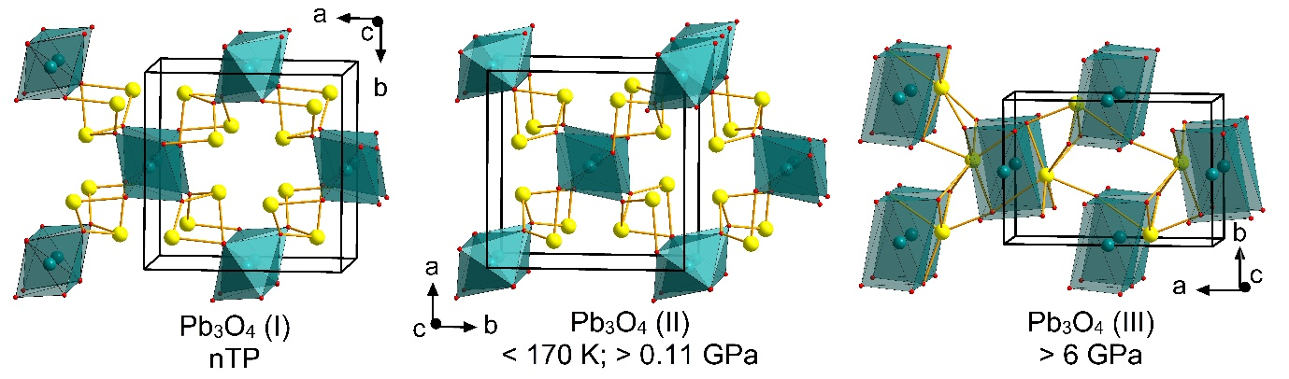

Figure S1: Crystal structures of Pb₃O₄ at ambient conditions (nTP), at low temperatures or increased pressure (phase II), and at high pressure (phase III), showing the change of the Pb⁴⁺O₆ octahedra and their connectivity to Pb²⁺O₄.

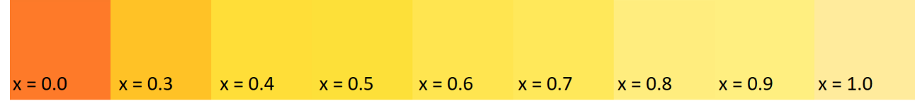
Figure S2: Changes of colors with respect to the compositional x in Pb₂(Pb_{1-x}Sn_{x})O₄ compounds. Each square block refers to digital photograph of the respective sample surface.

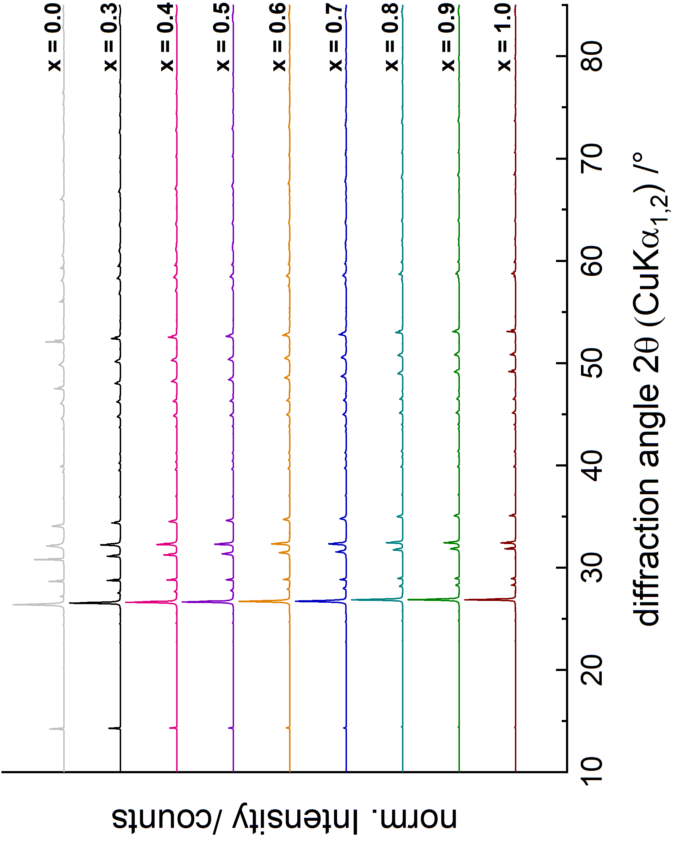
Figure S3: Stack plots of the X-ray powder diffraction patterns (normalized to 211 reflection at around 26 – 27 2θ) of the Pb₂(Pb_{1-x}Sn_{x})O₄ compounds.

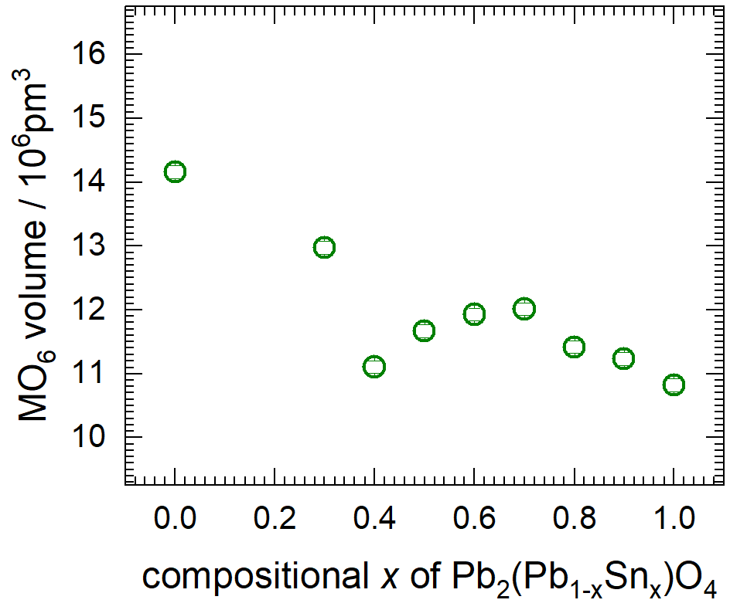
Figure S4: Change of the MO₆ octahedral volume in Pb₂(Pb_{1-x}Sn_{x})O₄ with respect to compositional x.

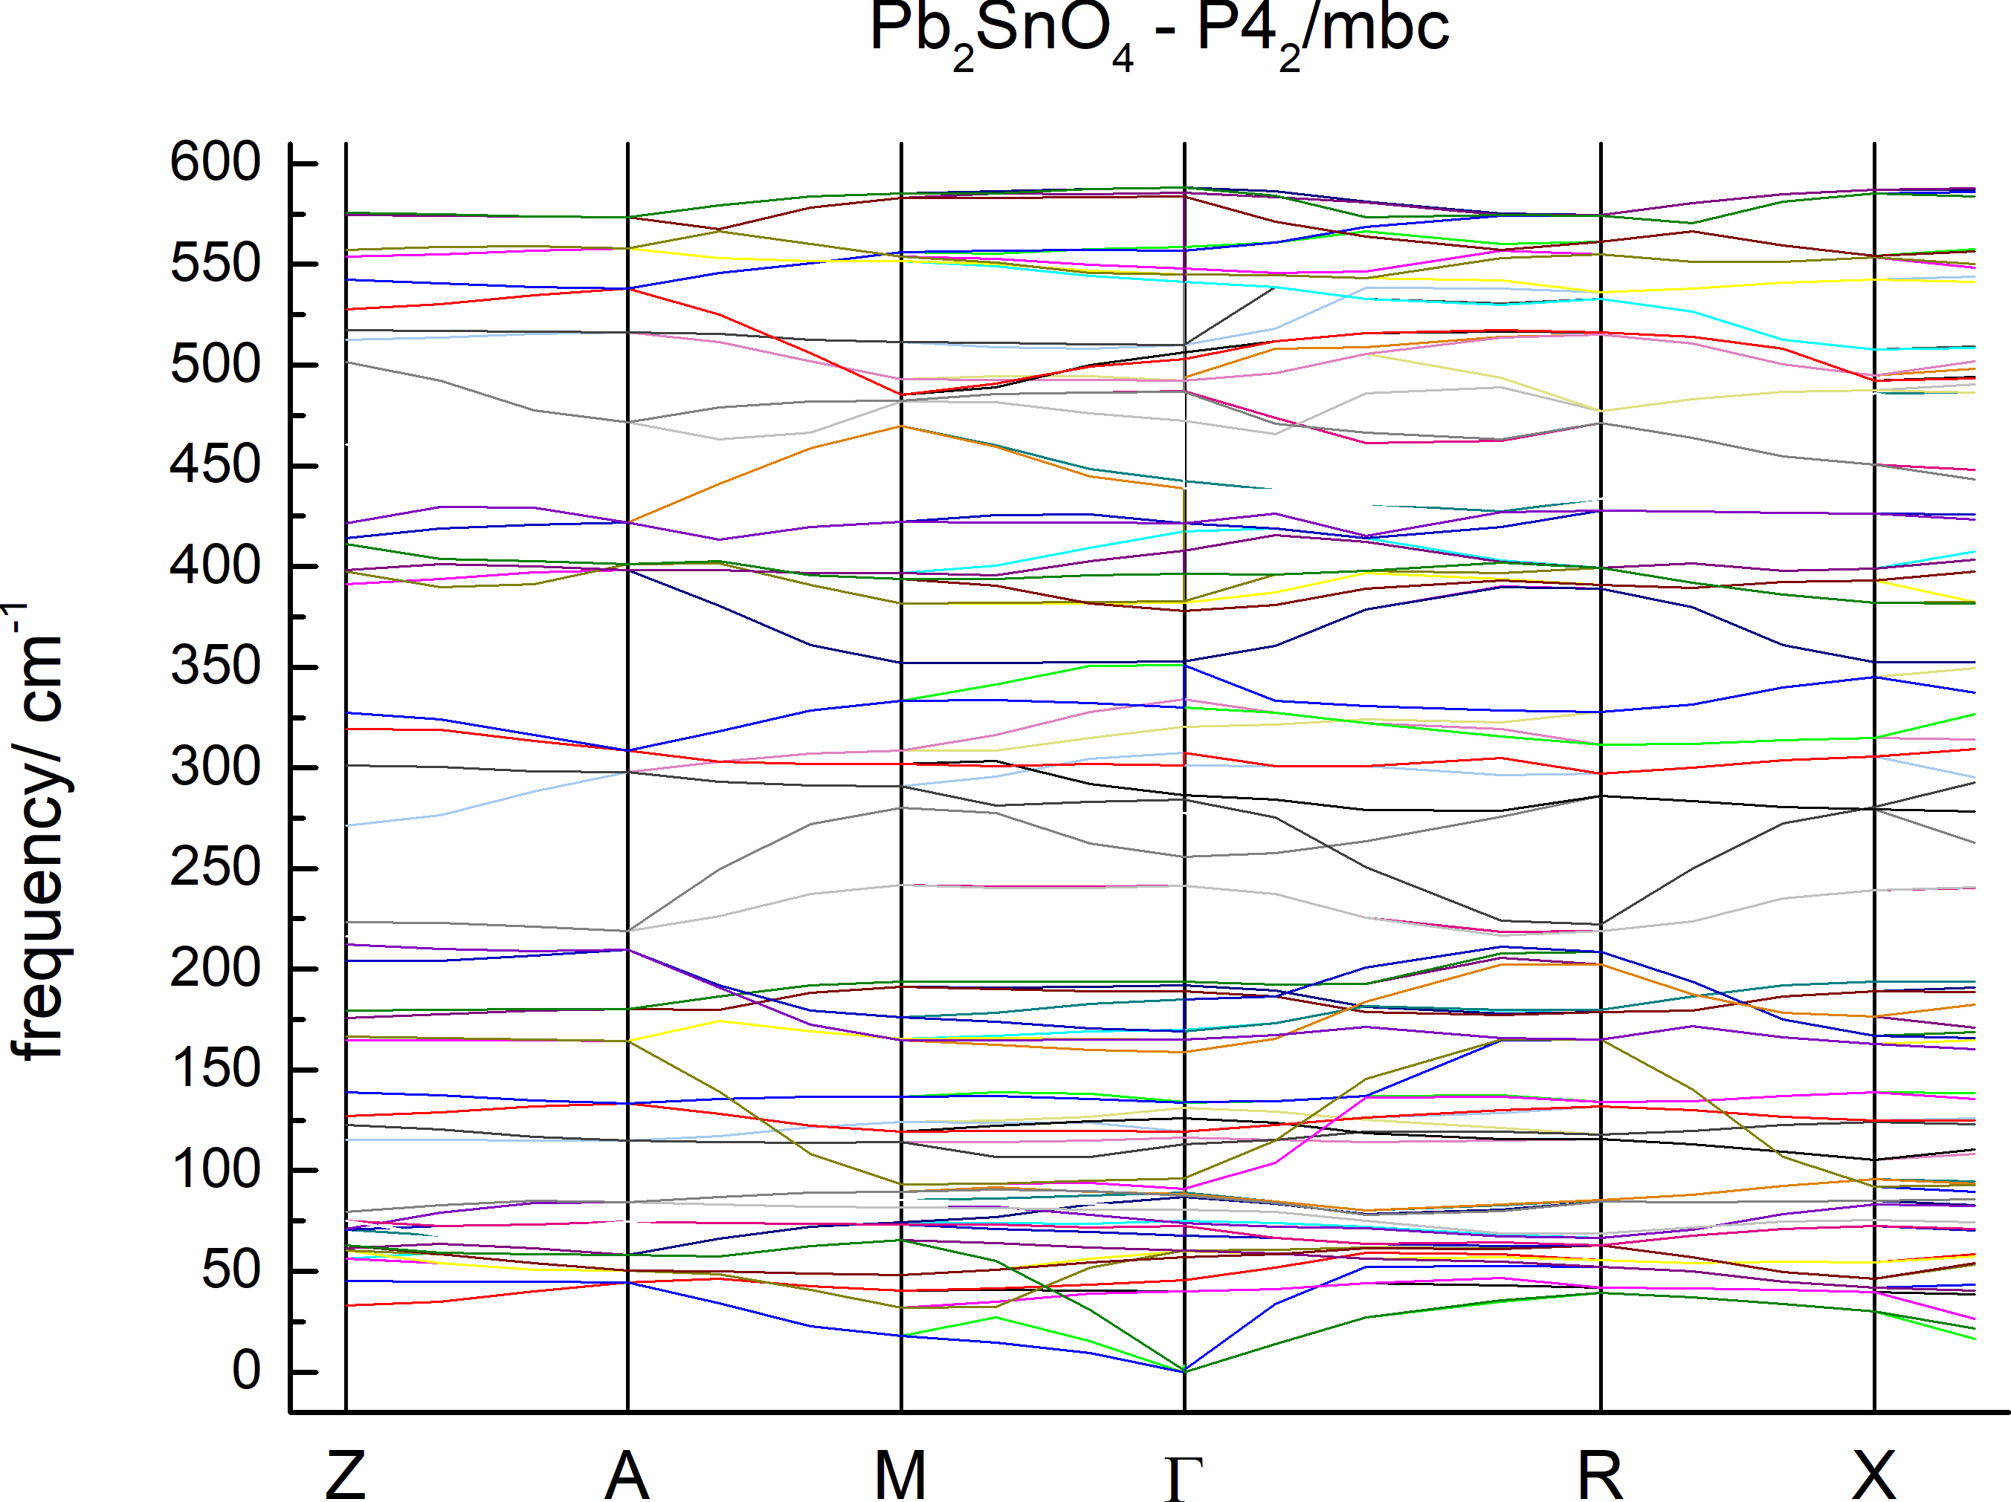
Figure S5: Phonon dispersions of tetragonal (P4₂/mbc) Pb₂SnO₄ in some high symmetry directions.

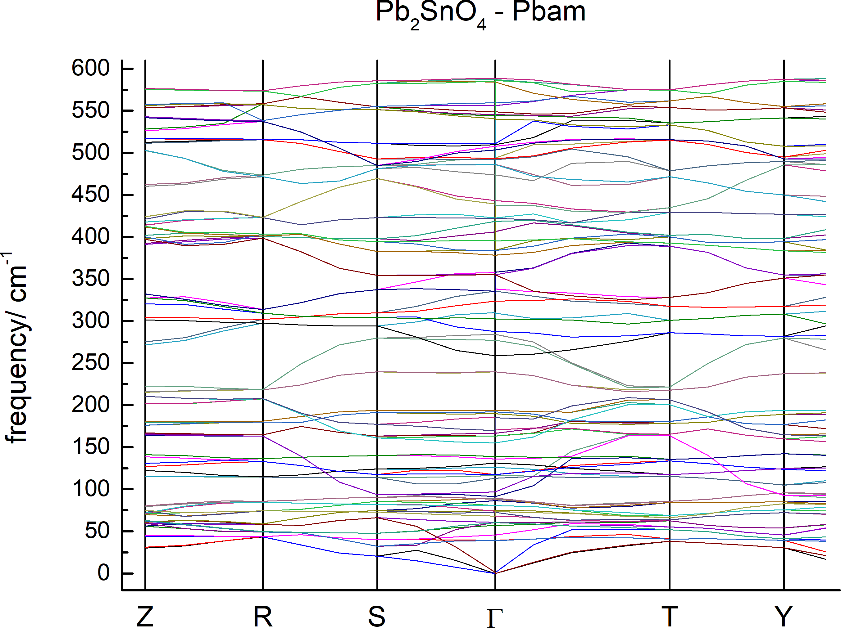
Figure S6: Phonon dispersions of orthorhombic (Pbam) Pb₂SnO₄ in some high symmetry directions.

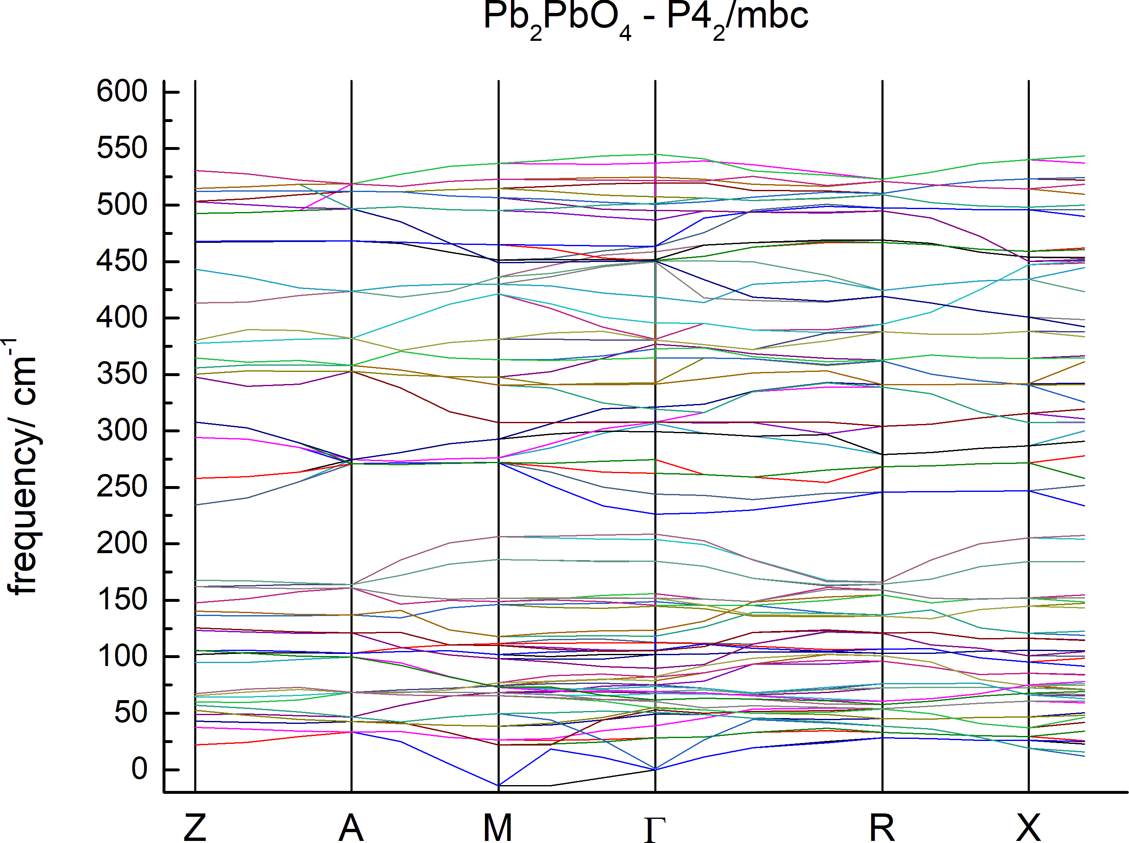
Figure S7: Phonon dispersions of tetragonal (P4₂/mbc) Pb₂PbO₄ in some high symmetry directions.

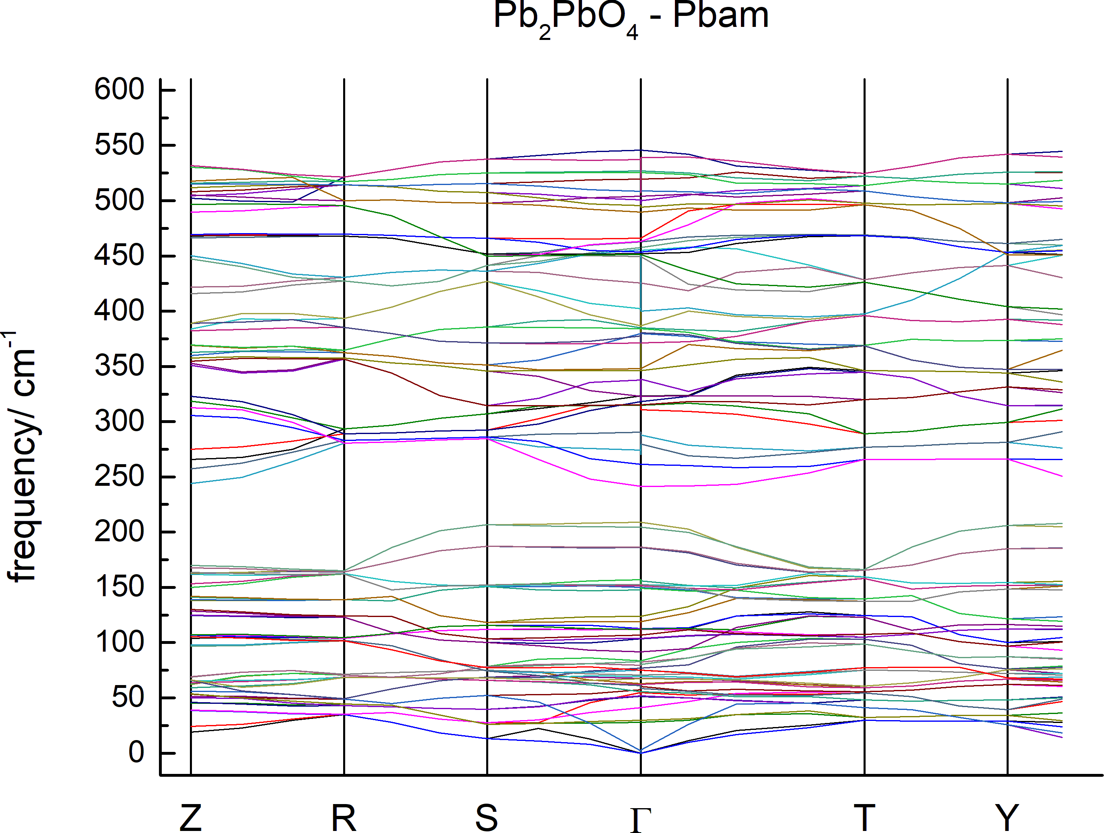
Figure S8: Phonon dispersions of orthorhombic (Pbam) Pb₂PbO₄ in some high symmetry directions.

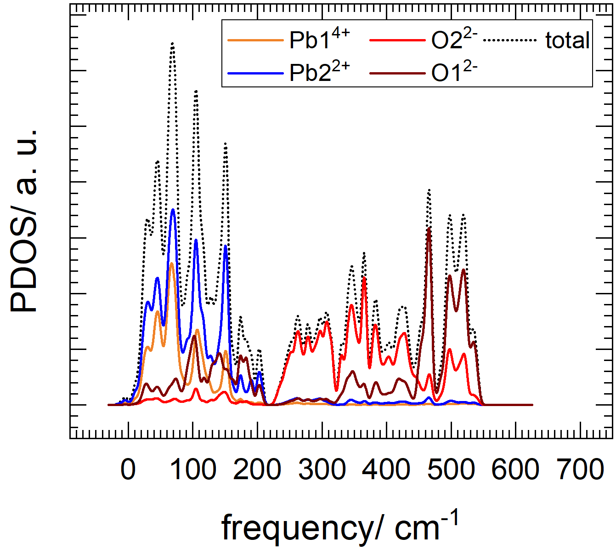
Figure S9: PDOS of tetragonal Pb₂PbO₄ (space group P4₂/mbc).
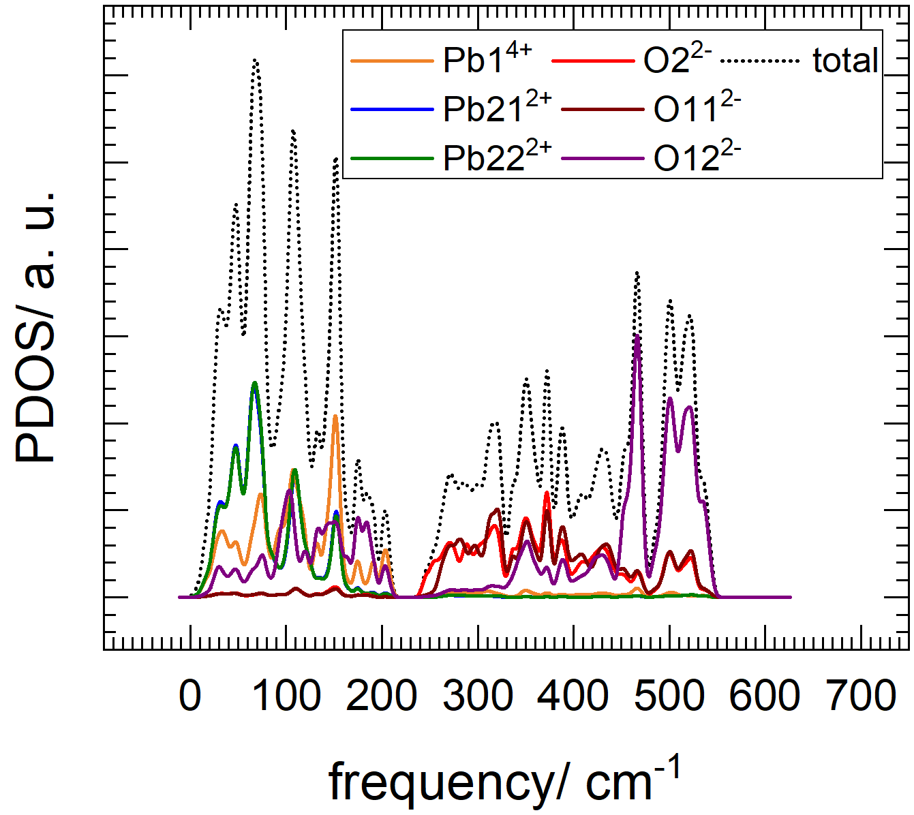
Figure S10: PDOS of orthorhombic Pb₂PbO₄ (space group Pbam).
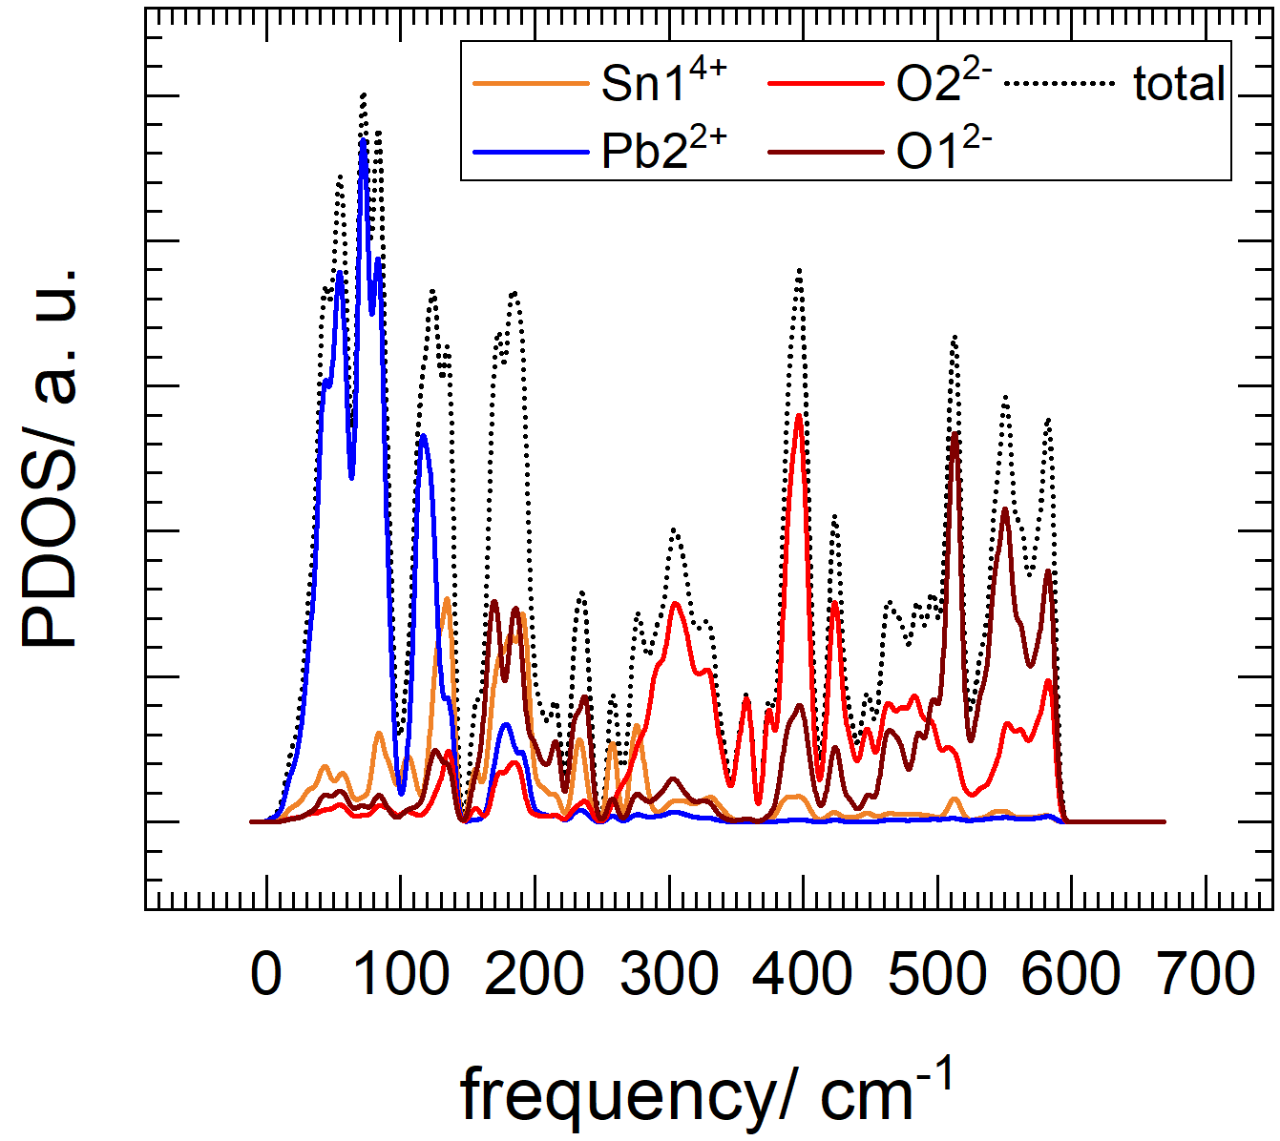
Figure S11: PDOS of tetragonal Pb₂SnO₄ (space group P4₂/mbc).

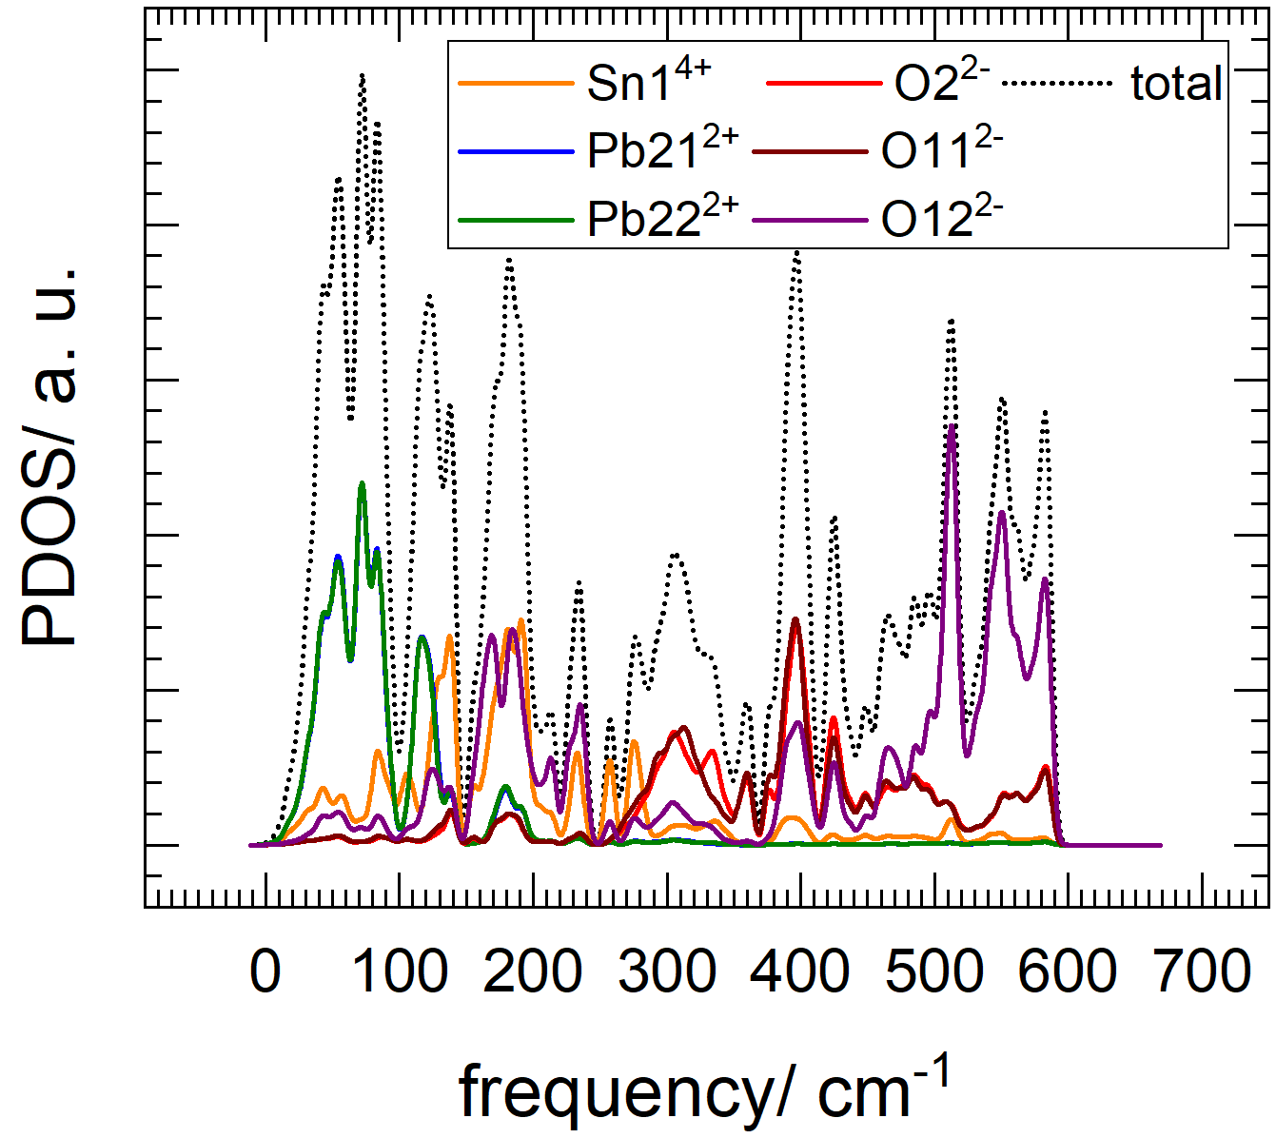
Figure S12: PDOS of orthorhombic Pb₂SnO₄ (space group Pbam).

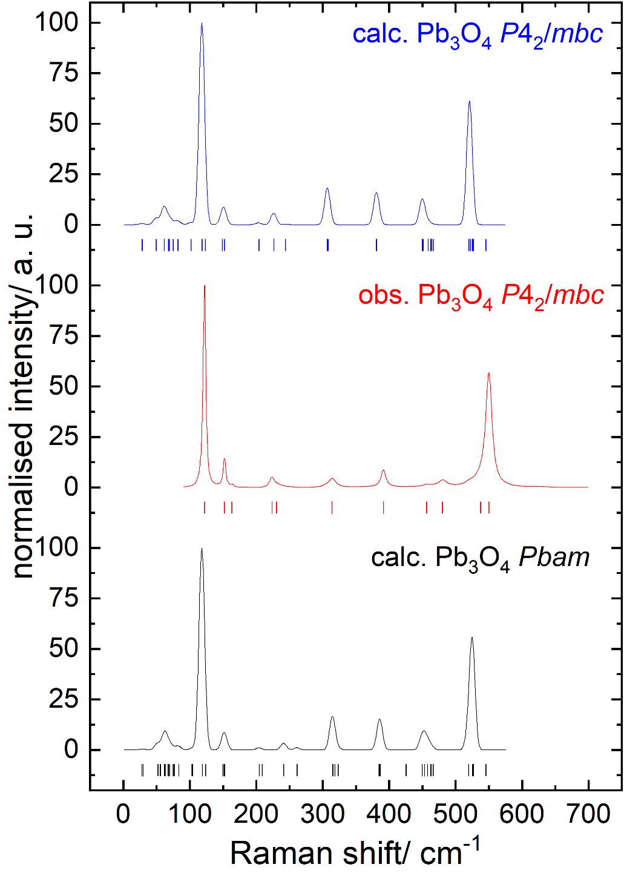
Figure S13: DFT calculated and observed Raman spectra for Pb₂PbO₄. The vertical bars elsewhere show the fitted peak positions.

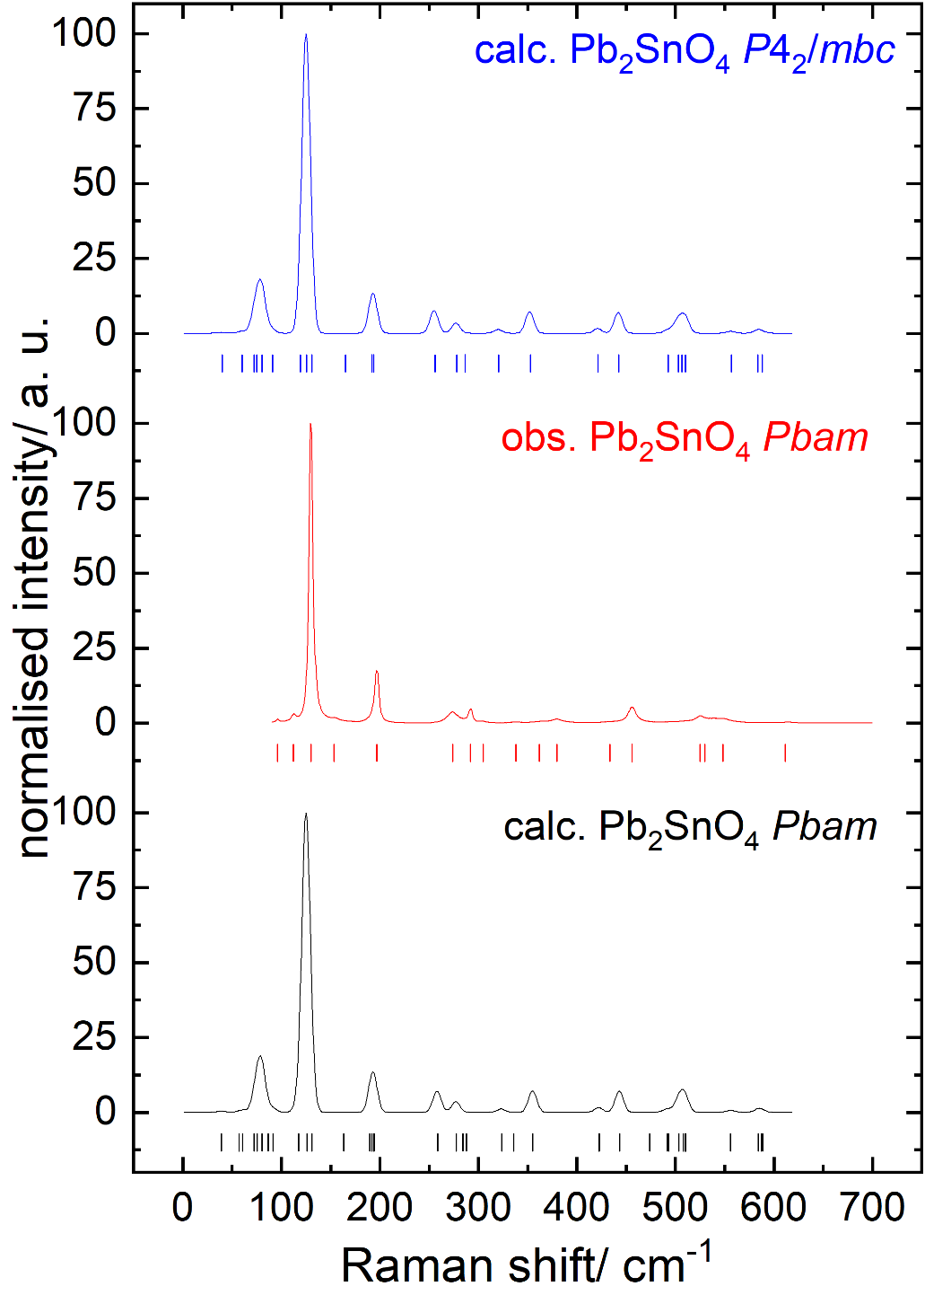
Figure S14: DFT calculated and observed Raman spectra for Pb₂SnO₄. The vertical bars elsewhere show the fitted peak positions.

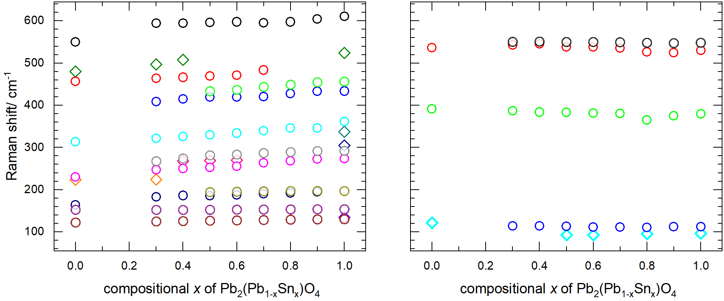
Figure S15: Hardening (left) and softening (right) of the Raman peak maxima of the Pb₂(Pb_{1-x}Sn_{x})O₄ compounds.

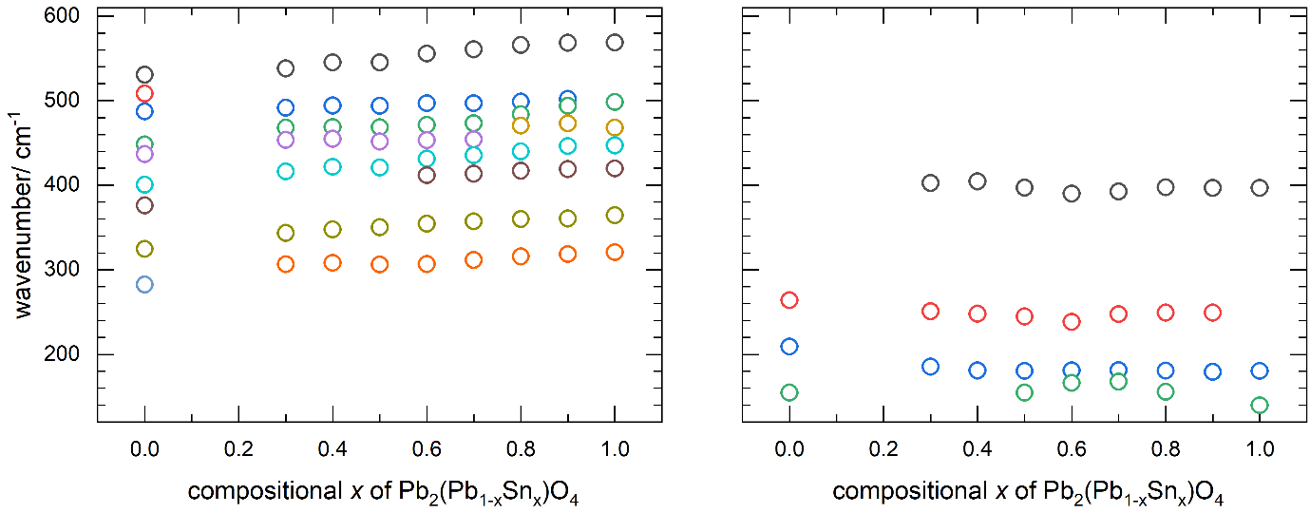
Figure S16: Hardening (left) and softening (right) of the FTIR peak maxima of the Pb₂(Pb_{1-x}Sn_{x})O₄ compounds.

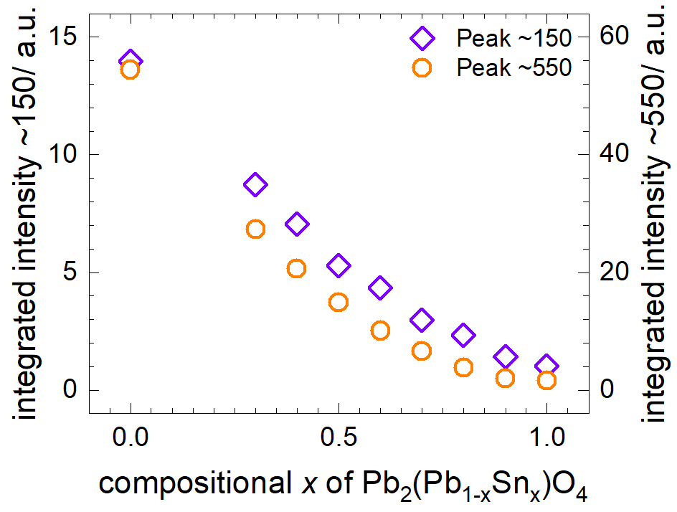
Figure S17: Change of the integrated intensity of the peaks measured around ~150 cm⁻¹ and ~550 cm⁻¹ in Pb₂(Pb_{1-x}Sn_{x})O₄ with respect to compositional x.

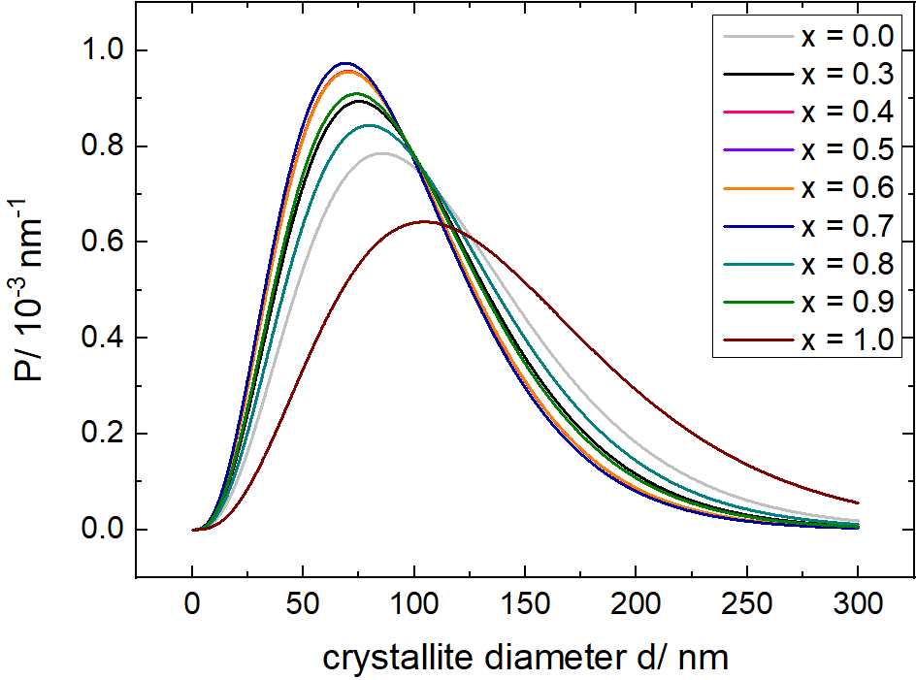
Figure S18: EnvACS crystallite diameter distribution in Pb₂(Pb_{1-x}Sn_{x})O₄ with respect to compositional x.

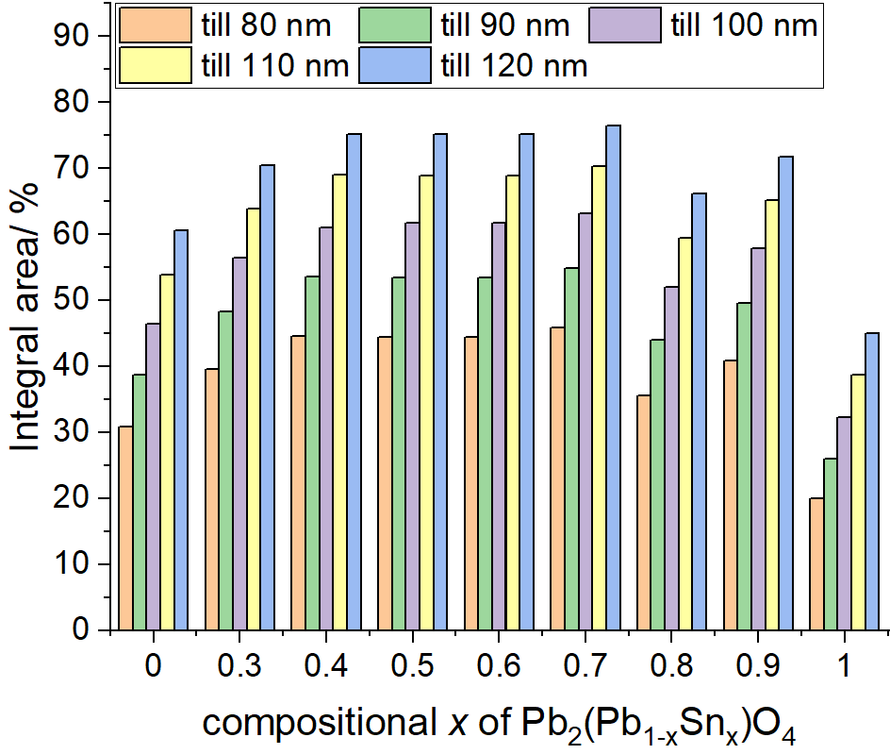
Figure S19: EnvACS crystallite diameter distribution area integral from 80- to 120 nm in Pb₂(Pb_{1-x}Sn_{x})O₄ with respect to compositional x.

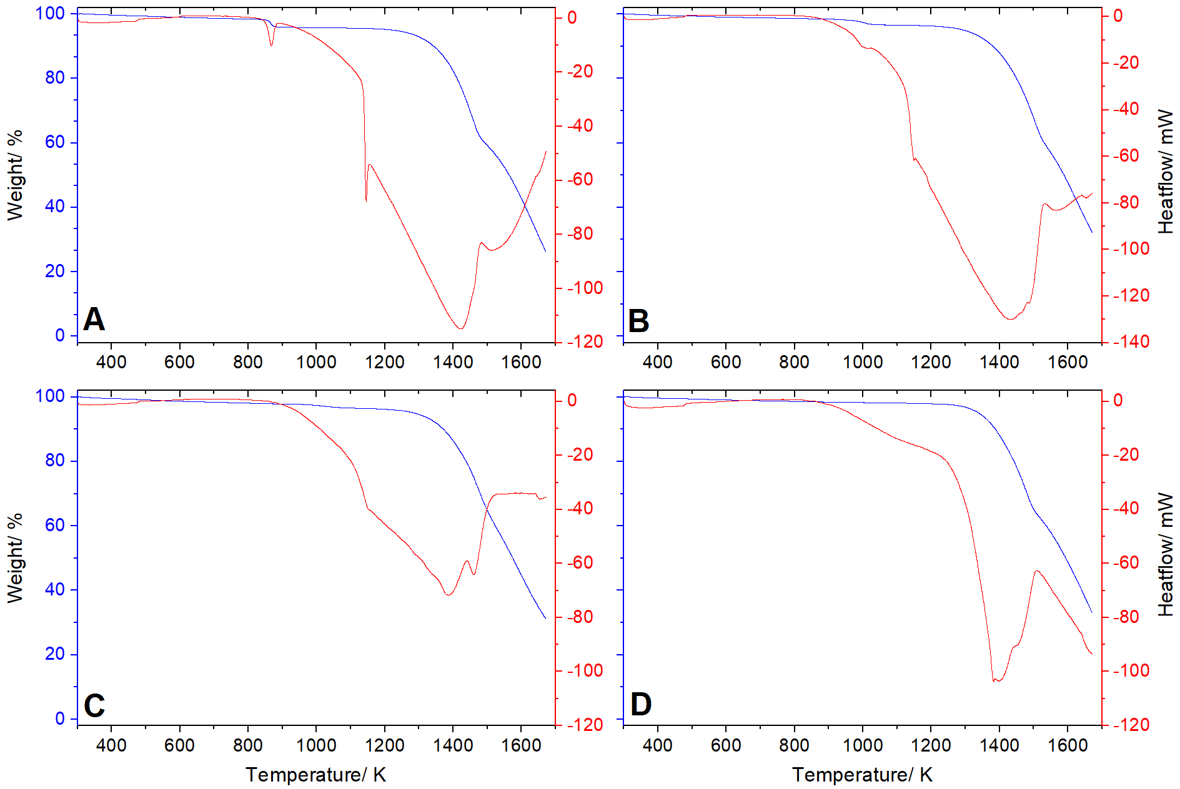
Figure S20: TG-DSC for Pb₂(Pb_{1-x}Sn_{x})O₄ for x = 0 (A), 0.3 (B), 0.6 (C) and 1.0 (D).

