SUPPLEMENTARY INFORMATION

A novel crystallographic location of rattling atoms in filled Eu_{x}Co₄Sb₁₂ skutterudites prepared under high-pressure conditions

J. E. Rodrigues,^{1,2} J. Gainza,¹ F. Serrano-Sánchez,¹ N. M. Nemes,³ O. J. Dura,⁴ J. L. Martínez,¹ J. A. Alonso^{1*}

¹Instituto de Ciencia de Materiales de Madrid (ICMM). Consejo Superior de Investigaciones Científicas (CSIC). Sor Juana Inés de la Cruz 3, E-28049, Madrid, Spain.
²European Synchrotron Radiation Facility (ESRF), 71 Avenue des Martyrs, 38000 Grenoble, France. ³Departamento de Física de Materiales, Universidad Complutense de Madrid, E-28040 Madrid, Spain. ⁴Departamento de Física Aplicada, Universidad de Castilla-La Mancha, Ciudad Real, E-13071, Spain.

*Corresponding author: ja.alonso@icmm.csic.es

Table S1. Crystallographic parameters for Eu_{x}Co₄Sb₁₂ prepared under high-pressure conditions, refined from SXRD data at 473 K.
Crystal data
Cubic, $Im\overline{3}$ |  | SXRD, λ= 0.45861 Å
a = 9.05127(2) Å |  | V = 741.53(1) Å³
Z = 2

Refinement
R_{p} = 11.36% |  | R_{wp} = 19.59%
R_{exp} = 5.57% |  | R_{Bragg} = 2.40%
χ² = 5.39

Fractional atomic coordinates and isotropic or equivalent isotropic displacement parameters (Å²)
 | Site | x | y | z | U_{iso}*/U_{eq} | Occ. (<1)
Co | 8c | 1/4 | 1/4 | 1/4 | 0.0085(4)
Sb | 24g | 0 | 0.33483(6) | 0.15793(6) | 0.0107(4) | 0.992(4)
Eu | 12d | 0.25(3) | 0 | 0 | 0.02533* | 0.0026(12)

Atomic displacement parameters (Å²)
 | U¹¹ | U²² | U³³ | U¹² | U¹³ | U²³
Co | 0.0085(4) | 0.0085(4) | 0.0085(4) | 0.0003(5) | 0.0003(5) | 0.0003(5)
Sb | 0.0088(3) | 0.0128(4) | 0.0106(4) | 0.00000 | 0.00000 | 0.0010(3)

Table S2. Crystallographic parameters for Eu_{x}Co₄Sb₁₂ prepared under high-pressure conditions, refined from SXRD data at 673 K.
Crystal data
Cubic, $Im\overline{3}$ |  | SXRD, λ= 0.45861 Å
a = 9.069007(19) Å |  | V = 745.90(1) Å³
Z = 2

Refinement
R_{p} = 10.75% |  | R_{wp} = 19.30%
R_{exp} = 5.57% |  | R_{Bragg} = 2.40%
χ² = 4.95

Fractional atomic coordinates and isotropic or equivalent isotropic displacement parameters (Å²)
 | x | y | z | U_{iso}*/U_{eq} | Occ. (<1)
Co | 1/4 | 1/4 | 1/4 | 0.0112(4)
Sb | 0 | 0.33469(6) | 0.15792(7) | 0.0141(4) | 0.985(4)
Eu | 0.24(3) | 0 | 0 | 0.03800* | 0.0024(12)

Atomic displacement parameters (Å²)
 | U¹¹ | U²² | U³³ | U¹² | U¹³ | U²³
Co | 0.0112(4) | 0.0112(4) | 0.0112(4) | 0.0012(5) | 0.0012(5) | 0.0012(5)
Sb | 0.0111(3) | 0.0175(4) | 0.0138(4) | 0.00000 | 0.00000 | 0.0015(3)

Table S3. Crystallographic parameters for Eu_{x}Co₄Sb₁₂ prepared under high-pressure conditions, refined from SXRD data at 873 K.
Crystal data
Cubic, $Im\overline{3}$ |  | SXRD, λ= 0.45861 Å
a = 9.08701(2) Å |  | V = 750.35(1) Å³
Z = 2

Refinement
R_{p} = 13.44% |  | R_{wp} = 24.57%
R_{exp} = 5.59% |  | R_{Bragg} = 3.14%
χ² = 5.76

Fractional atomic coordinates and isotropic or equivalent isotropic displacement parameters (Å²)
 | x | y | z | U_{iso}*/U_{eq} | Occ. (<1)
Co | 1/4 | 1/4 | 1/4 | 0.0140(5)
Sb | 0 | 0.33445(8) | 0.15792(8) | 0.0187(5) | 0.985(4)
Eu | 0.24000 | 0 | 0 | 0.03800* | -0.0014(14)

Atomic displacement parameters (Å²)
 | U¹¹ | U²² | U³³ | U¹² | U¹³ | U²³
Co | 0.0140(5) | 0.0140(5) | 0.0140(5) | 0.0009(6) | 0.0009(6) | 0.0009(6)
Sb | 0.0146(4) | 0.0236(5) | 0.0180(5) | 0.00000 | 0.00000 | 0.0023(3)

Figure S1. Two Fourier difference plots for z= 0, a) before and b) after the introduction of Eu at 12d positions

Figure S2. Observed (red crosses), calculated profile (black line), difference (blue line) and Bragg reflections (green symbols) SXRD pattern for Eu_{x}Co₄Sb₁₂ at (a) 473 K and (b) 673 K. The insets show the quality of the fits in the high-angle region.
Figure S3. Additional SEM micrographs of the as-grown pellets of Eu_{0.02(1)}Co₄Sb₁₂. (a) x6000 and (b) x8000 magnification.

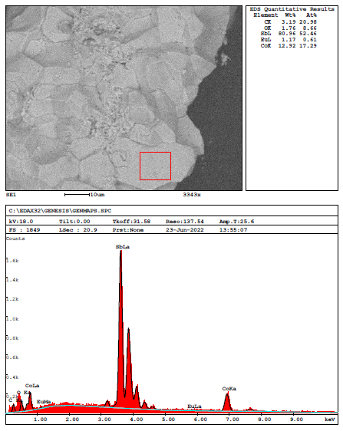
Figure S4. Upper panel: SEM image where the EDX spectrum was collected, and relative contents of Sb, Co, and Eu. Lower panel: typical EDX spectrum.
Figure S5. Thermoelectric figure of merit as a function of temperature for the Eu_{0.5}Co₄Sb₁₂ compound, and La_{0.5}Co₄Sb₁₂ synthesized under high-pressure. Both compositions refer to their nominal chemical formula.

