**Electronic Supplementary Information**

Nataliya L. Gulay, Guido Kreiner, Yaroslav M. Kalychak and Rainer Pöttgen*

Lu37Ru16.4In4 – coloring and vacancy formation in a new 8 × 8 × 8 *bcc* superstructure

DOI: 10.1515/zkri-2022-####

Received April ##, 2022

**\*Corresponding author: Rainer Pöttgen**, Institut für Anorganische und Analytische Chemie, Universität Münster, Corrensstrasse 30, 48149 Münster, Germany, e-mail: pottgen@uni-muenster.de

**Nataliya L. Gulay**: Institut für Anorganische und Analytische Chemie, Universität Münster, Corrensstrasse 30, 48149 Münster, Germany

**Guido Kreiner**: Institut für Anorganische Chemie und Strukturchemie, Lehrstuhl II: Material- und Strukturforschung, Heinrich Heine Universität Düsseldorf, Universitätsstraße 1, 40225 Düsseldorf, Germany

**Yaroslav M. Kalychak:** Department of Analytical Chemistry, Ivan Franko National University of Lviv, Kyryla i Mefodiya Street 6, 79005 Lviv, Ukraine

# Similar to Lu37Ru16.4In4, also the structure of V11Cu9Ga46 [1] can be described as an 8 × 8 × 8 supercell of the *bcc* type. The corresponding group-subgroup scheme [2-5] is presented in Figures S1-S3. The V11Cu9Ga46 superstructure corresponds to a separate branch in the tree for the *bcc* superstructures [5-7]. Due to the many steps of symmetry reduction one gets a larger number of Wyckoff positions in space group *Pmn*. The group-subgroup scheme starts with space group *Imm*. This corresponds to the third step of the subgroup scheme of Lu37Ru16.4In4 presented in the main document. For better readability, the group subgroup scheme is divided into three trees (Figures S1-S3).

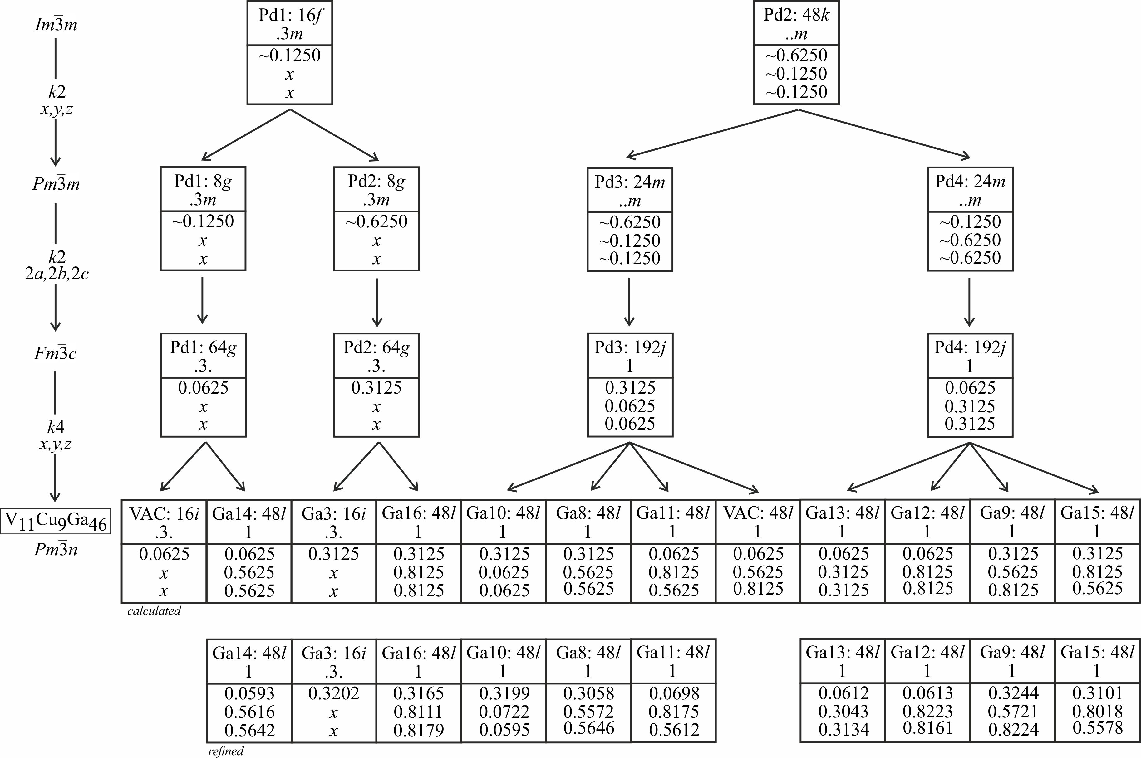

**Fig. S1:** Group-subgroup scheme in the Bärnighausen formalism [2-5] for the structures of LuPd2In (Heusler type phase) [8] and V11Cu9Ga46 [1]. The indices of the *klassengleiche* (*k*) symmetry reductions and the evolution of the atomic parameters are given. VAC denotes ordered vacancies. Note that the group-subgroup scheme starts at space group *Imm*. This corresponds to the third step in the Bärnighausen tree of Lu37Ru16.4In4. Due to the manifold of Wyckoff sites, the tree is continued in Figures S2 and S3.

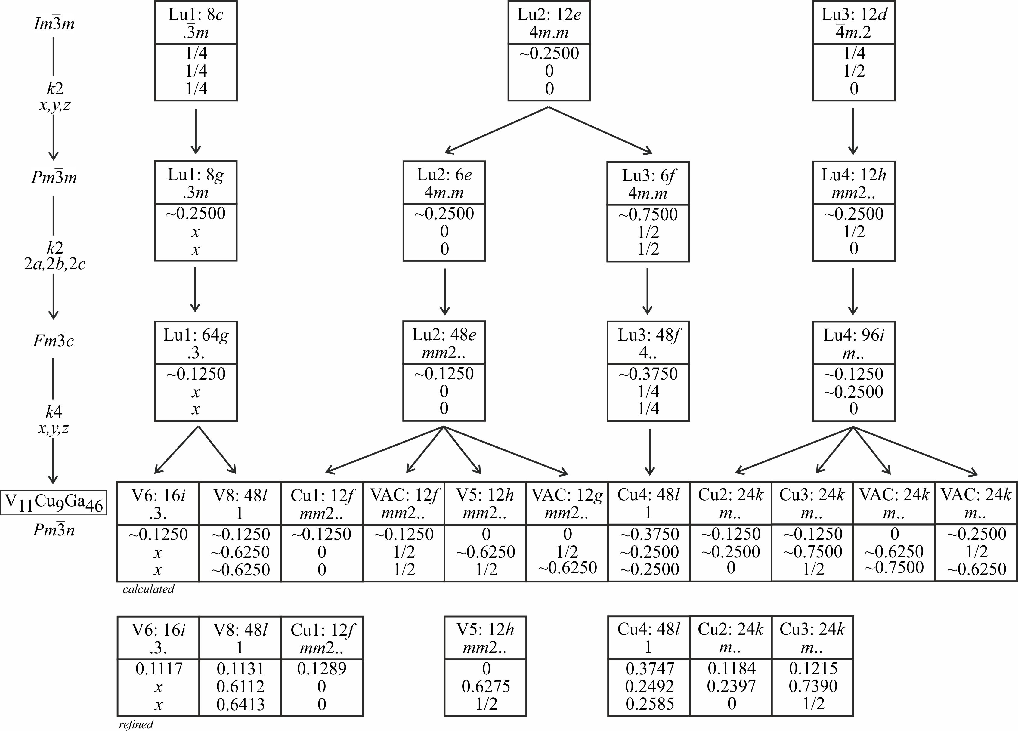

**Fig. S2:** Continuation of Figure S1; continued in Figure S3.

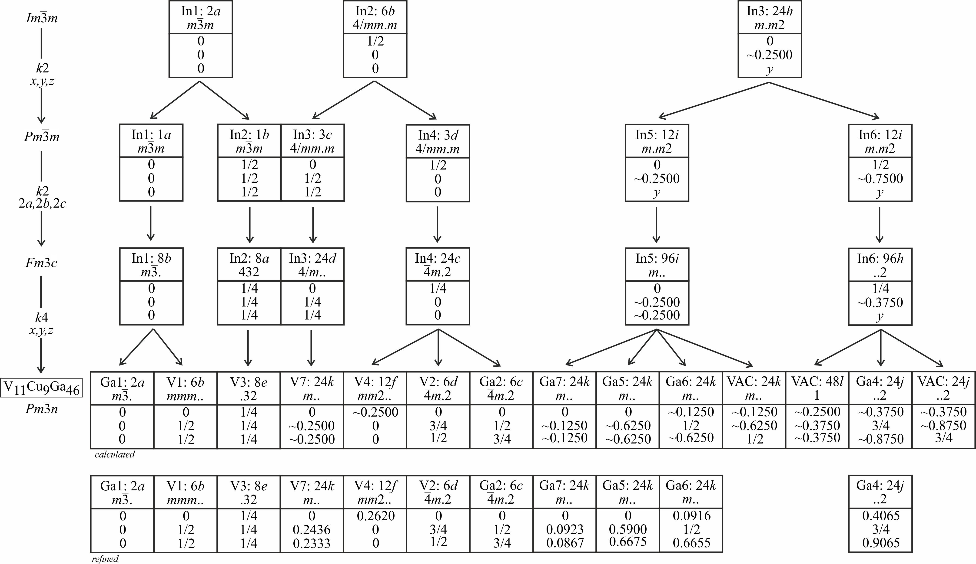

**Fig. S3:** Continuation of Figure S2.

**References**

1. [1] Lux R., Kuntze V., Hillebrecht H. *Solid State Sci*. 2012, *14*, 1445–1453.

[2] Bärnighausen H. *Commun. Math. Chem.* 1980, *9*, 139–175.

[3] Müller U. *Z. Anorg. Allg. Chem*. 2004, *630*, 1519–1537.

[4] Müller U. *International Tables for Crystallography*, *Vol.* *A1*, *Symmetry relations between space groups,* John Wiley & Sons: Chichester, United Kingdom, 2010.

[5] Müller U. *Symmetriebeziehungen zwischen verwandten Kristallstrukturen*, Vieweg + Teubner Verlag: Wiesbaden, Germany, 2012.

[6] Müller U. *Inorganic structural chemistry*, 2nd edition. Wiley: Chichester, 2007.

[7] Pöttgen R. *Z. Anorg. Allg. Chem*. 2014, *640*, 869–891.

[8] Dwight A. E., Kimball C.W. *J. Less-Common Met*. 1987, *127*, 179–182.