Supporting Information
Photophysical property change of N-(5-Bromo-salicylidene)-3-aminoethylpyridine monohydrated crystals via dehydration phase transition

Haruki Sugiyama*
Research and Education Center for Natural Sciences, Keio University, Hiyoshi 4-1-1, Kohoku, Yokohama

1H-NMR Spectrum (400 MHz, CDCl₃ with TMS)
Sample : 1A

Assign. | Shift (ppm)
a | 8.57
b | 7.16-7.13
c | 7.60
d | 7.16-7.13
e | 3.18
f | 4.04
g | 8.20
h | 7.29
i | 7.35
j | 6.83

Figure and Tables

Captions
Table S1 Tortion angles, dihedral angles, and Kitaigorodskii packing index (K.P.I.).
Table S2 Calculated HOMO-LUMO energy gaps.
Figure S1 Photochromic reaction process is illustrated by a yellow line form the enol to trans-keto form. On the other hand, ESIPT fluorescence process is illustrated by a green line.
Figure S2 The molecular stacking via weak C-H…π and π-π interaction in the crystal structure of 1H.
Figure S3 Intermolecular interaction in the crystal structure of 1A; the C-H…O hydrogen bonding (a) and C-H…N hydrogen bonding (b).
Figure S4 Some weak C-H…π interactions in the crystal structure of 1A.
Figure S5 Structure overlay of the 5Br-SAEP molecules in 1H (red) and 1A (blue and green).
Figure S6 Powder X-ray diffraction patterns of 1H after 2, 4, 6 hours, 1 week and 2 weeks. The result pattern change suggested that 1H transformed gradually to 1A under an ambient condition (25 °C, 70% R.H.).
Figure S7 TG-DTA curves of 1H. The weight loss of 5.39% at 46.8 °C was consisitent with the desorption of one water molecule.
Figure S8 TG-DTA curves of 1A. There is no change in the sample weight up to 150 °C. An endothermic peak at 72.2 °C is due to the sample melt.
Figure S9 Powder X-ray diffraction patterns of 1H after storing under the several humidity conditions, 23, 43, 70, 76, and 85 % R.H. for one week. Pink arrows suggested the appearance of the unknown intermediate phase.
Figure S10 Powder X-ray diffraction patterns of 1H after storing under the several humidity conditions, 23, 43, 70, 76, and 85 % R.H. for one month.
Figure S11 Normalized emission spectra in the solid-state of 1A with excitation wavelength of 365(blue), 400(orange), and 420(green) nm. Because I used other sample holder, the spectrum shape was slightly different compared to Figure 6.
Figure S12 Calculated HOMO and LUMO orbital of the enol form.
Figure S13 Calculated HOMO and LUMO orbital of the cis-keto form.

Table S1 Tortion angles, dihedral angles, and Kitaigorodskii packing index (K.P.I.).
 | 1H | 1A |  | 3OMe-SAEA  (QEYFAC) | 4OMe-SAEA  (QEVSOA)
C8=N9-C10-C11 / ° | 105.6(2) | 107.0(3) | 103.4(3) | 110.9(4) | 110.0(2)
N9-C10-C11-C12 / ° | -179.9(2) | 176.4(2) | 166.5(2) | -175.3(3) | 171.6(1)
C10-C11-C12-C13 / ° | -112.7(2) | 103.0(3) | 99.2(3) | -97.8(5) | 2.6(2)
Dihedral angle between two aromatic rings/ ° | 9.49(10) | 31.16(13) | 18.06(14) | 12.7(2) | 68.91(8)
K.P.I. | 68.3 | 68.6  SAEP  SAEA |  | 67.8 | 68.8

Table S1 Calculated HOMO-LUMO energy gaps
 | HOMO(eV) | LUMO(eV) | Gap (eV)
enol form
1H | -6.12 | -1.75 | 4.37
1A-Mol.A | -6.14 | -1.79 | 4.35
1A-Mol.B | -6.14 | -1.78 | 4.36
cis-keto form
1H | -5.49 | -2.02 | 3.47
1A Mol.A | -5.50 | -2.04 | 3.46
1A Mol.B | -5.50 | -2.04 | 3.46

Figure S1
Figure S2
Figure S3
Figure S4

Figure S5
Figure S6

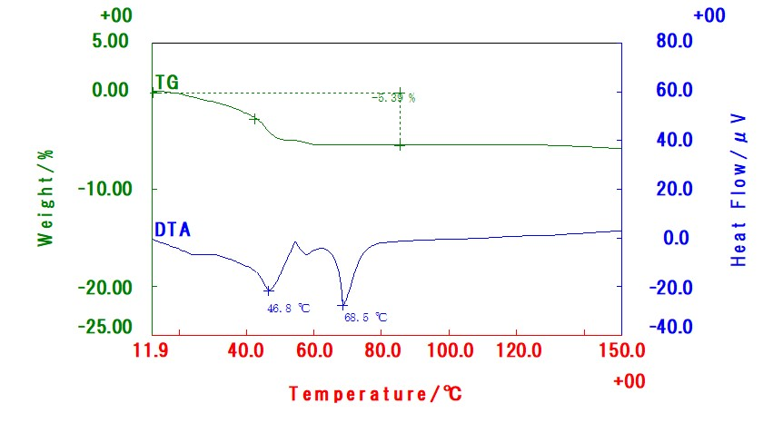 Figure S7

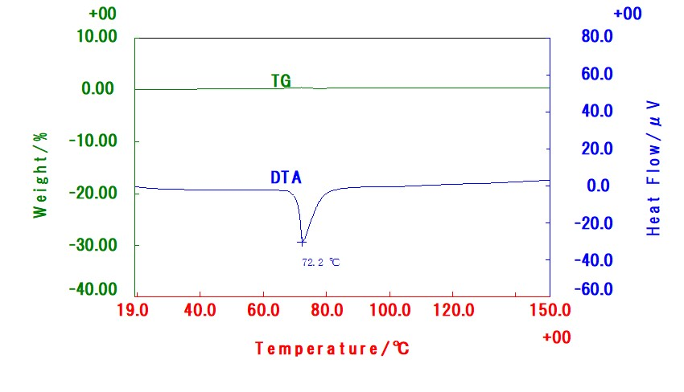

Figure S8

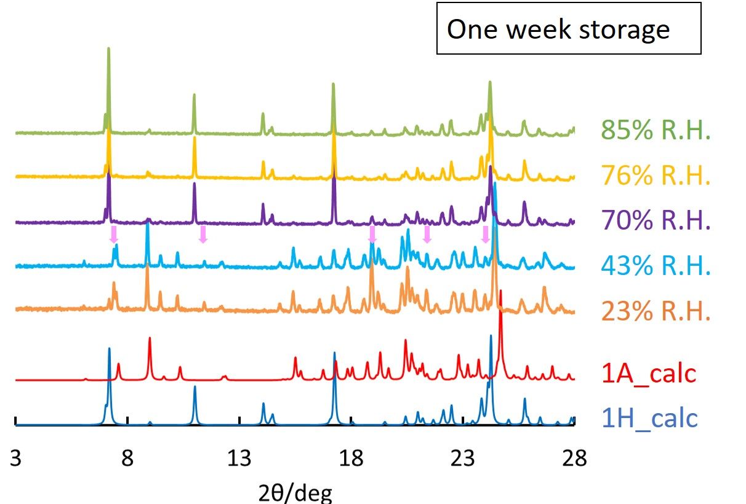
Figure S9

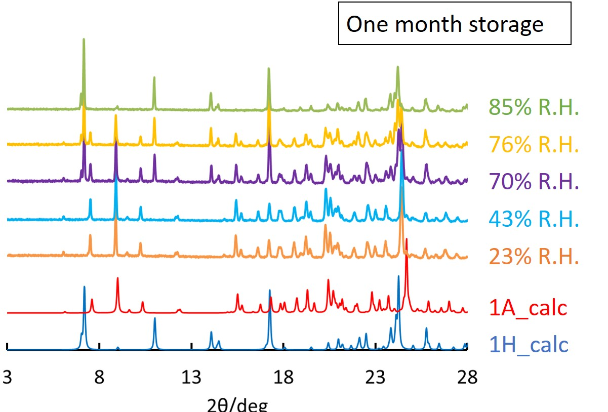

Figure S10

Figure S11

Figure S12
Figure S13

