Theoretical and experimental solid state studies of Ethyl 1-benzyl-2-(thiophen-3-yl)-1H-benzo[d]imidazole-5-carboxylate

Madan Kumar S.,^{1*} Vasantha Kumar,^{2,3} Mohammed Al-Ghorbani,^{4,5} Shivaram Holla B,² Boja Poojary,³ Praveen P,⁶ Chandra Nayak S.,⁷ Jnani S. Mohan,⁸ Thamotharan S.,⁸ Shamprasad V. R.,⁹ Lokanath N. K.¹⁰ Nabil Al-Zaqri,¹¹ Ali Alsalme,¹¹

¹IOE, Vijnana Bhavan, University of Mysore, Mysore, India 57006
² Department of Chemistry, SDM College (Autonomous), Ujire, India 574 240
³Department of Chemistry, Mangalore University, Mangalagangothri, India 574199
⁴Department of Chemistry, Ulla Science and Arts College, Taibah University, Kingdom of Saudi Arabia
⁵Department of Chemistry, University of Thamar, Yemen
⁶Department of Materials Science, Mangalore University, Mangalagangothri, India 574199
⁷Department of Studies in Biotechnology, University of Mysore, Mysore, India 57006
⁸Biomolecular Crystallography Laboratory, Department of Bioinformatics, School of Chemical and Biotechnology,SASTRA Deemed University, Thanjavur 613 401
⁹Neurogenetics lab, Dept of Applied Zoology, Mangalore University, Mangalagangothri, India 574199
¹⁰ Department of Studies in Physics, University of Mysore, Mysore 570006
¹¹Department of Chemistry, College of Science, King Saud University, P. O. Box 2455, Riyadh 11451, Saudi Arabia

*Correspondence author: madan.mx@gmail.com;

S1: Table Dihedral angles of the molecules A and B.

Ring (Centroid) | Ring (Centroid) | Angle (⁰)
A
S1A/C1A-C4A (Cg1) | C7A-C12A (Cg3) | 69.9(2)
S1A/C1A-C4A (Cg1) | N1A/C5A/N2A/C13A-C18A (Cg5) | 28.70(17)
C7A-C12A (Cg3) | N1A/C5A/N2A/C13A-C18A (Cg5) | 78.63(17)
B
S1B/C1B-C4B (Cg6) | C7B-C12B (Cg8) | 70.2(2)
S1B/C1B-C4B (Cg6) | N1B/C5B/N2B/C13B-C18B (Cg10) | 28.57(17)
C7B-C12B (Cg8) | N1B/C5B/N2B/C13B-C18B (Cg10) | 78.09(18)

Table S2: (a) Interaction energies (kJ/mole) of the molecular pairs calculated from energy framework calculation of BI: Molecule A, molecule B and Overall energy profiles. (b) Interaction energies listed. Scale factors for benchmarked energy models (See Ref. 32).

Molecule A energy profile Molecule B energy profile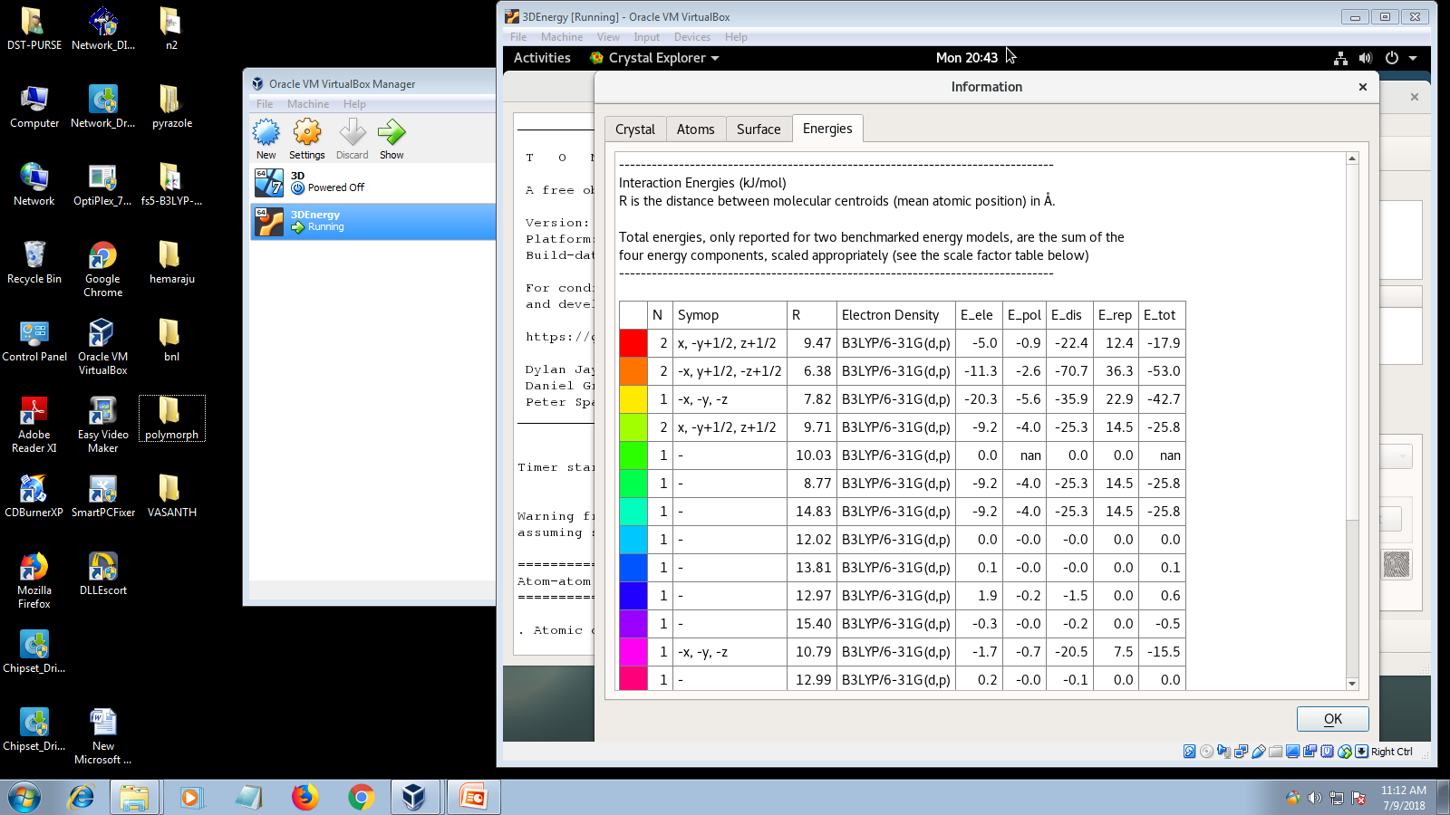 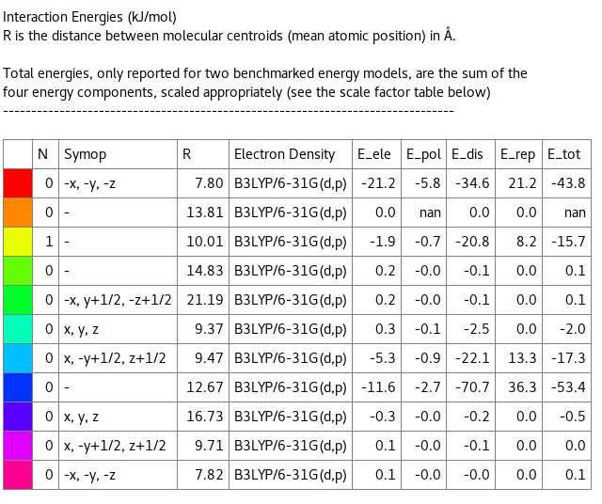
Overall energy profile
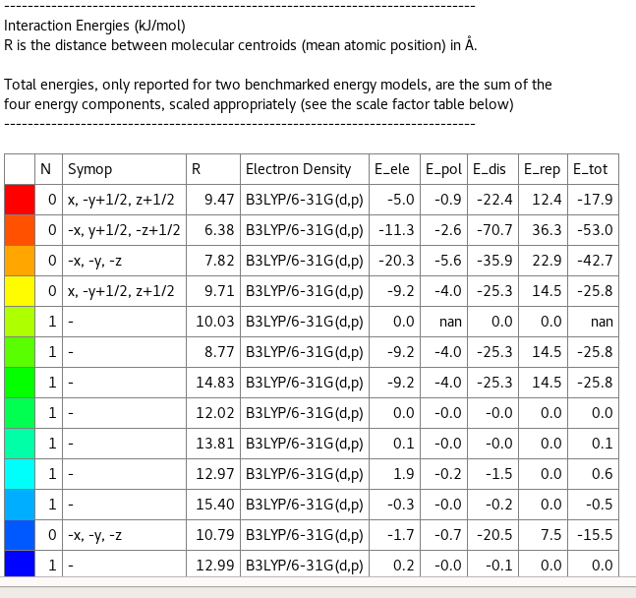
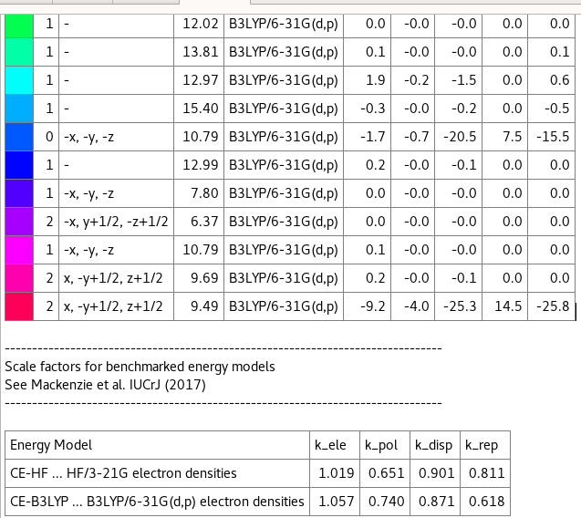
(a)

 | Eele | Epol | Edis | Erepl | Etot | Average Etot (kJ/mole)
BI | --64.5 | -27.9 | -274.9 | 144.6 | -247.4 | -123.7
(b)
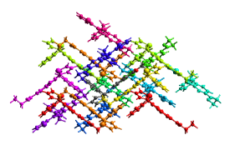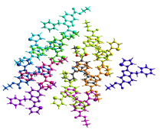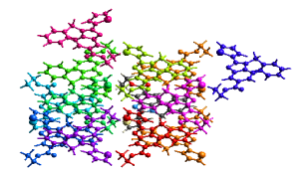
Molecule A
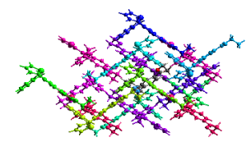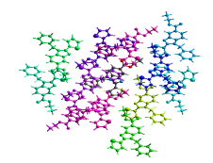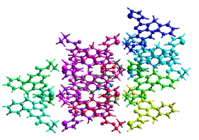
Molecule B
Figure S3: Color coding of neighbouring molecules with respect to the central molecule (gray) of the BI. A view along a,b,c-axis.

Figure S4: Geometrical parameters comparison of theoretical and experimental geometry.

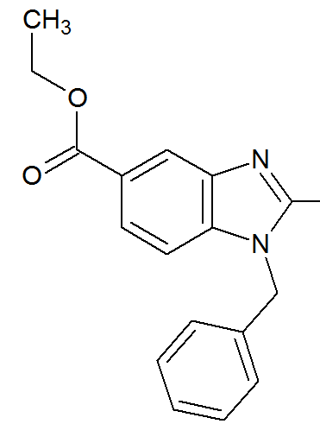

Figure S5: BI molecule backbone used for CSD search and structural comparison.

Table S7. Bond length
Bond length | A mol (Xray) | B3LYP/6-311++G(d,p)
S1A C1A | 1.740(5) | 1.728
S1A C4A | 1.656(4) | 1.748
O1A C19A | 1.335(4) | 1.352
O1A C20A | 1.451(5) | 1.449
O2A C19A | 1.192(4) | 1.213
N1A C5A | 1.384(4) | 1.396
N1A C6A | 1.466(4) | 1.454
N1A C13A | 1.382(4) | 1.381
N2A C5A | 1.310(4) | 1.316
N2A C18A | 1.382(4) | 1.380
C1A C2A | 1.336(7) | 1.368
C2A C3A | 1.355(6) | 1.421
C3A C4A | 1.410(5) | 1.378
C4A C5A | 1.462(5) | 1.452
C6A C12A | 1.508(5) | 1.520
C7A C8A | 1.381(5) | 1.395
C7A C12A | 1.382(5) | 1.395
C8A C9A | 1.355(7) | 1.393
C9A C10A | 1.377(7) | 1.396
C10A C11A | 1.376(6) | 1.392
C11A C12A | 1.382(5) | 1.399
C13A C14A | 1.381(4) | 1.396
C13A C18A | 1.402(4) | 1.414
C14A C15A | 1.385(5) | 1.386
C15A C16A | 1.404(4) | 1.414
C16A C17A | 1.373(5) | 1.396
C16A C19A | 1.488(5) | 1.488
C17A C18A | 1.389(4) | 1.395
C20A C21A | 1.455(8) | 1.520

Table S8. Bond angle
Angle | A mol  (Xray) | B3LYP/6-311++G(d,p)
C4A S1A C1A | 92.9(2) | 91.3
C19A O1A C20A | 117.9(3) | 117.0
C5A N1A C6A | 130.7(3) | 128.6
C13A N1A C5A | 106.1(3) | 106.3
C13A N1A C6A | 122.7(3) | 125.0
C5A N2A C18A | 105.3(3) | 105.7
C2A C1A S1A | 110.2(3) | 112.1
C1A C2A C3A | 113.4(4) | 112.7
C2A C3A C4A | 114.1(4) | 113.0
C3A C4A S1A | 109.3(3) | 110.9
C3A C4A C5A | 131.1(3) | 130.5
C5A C4A S1A | 119.5(3) | 118.6
N1A C5A C4A | 123.7(3) | 123.8
N2A C5A N1A | 113.0(3) | 112.5
N2A C5A C4A | 123.3(3) | 123.7
N1A C6A C12A | 113.7(3) | 114.7
C8A C7A C12A | 120.3(4) | 120.3
C9A C8A C7A | 120.8(4) | 120.3
C8A C9A C10A | 119.5(4) | 119.6
C11A C10A C9A | 120.4(4) | 120.0
C10A C11A C12A | 120.5(4) | 120.6
C7A C12A C6A | 122.6(3) | 121.9
C7A C12A C11A | 118.6(3) | 119.2
C11A C12A C6A | 118.8(3) | 118.9
N1A C13A C18A | 105.5(3) | 105.5
C14A C13A N1A | 131.4(3) | 132.1
C14A C13A C18A | 123.1(3) | 122.4
C13A C14A C15A | 116.1(3) | 116.8
C14A C15A C16A | 122.0(3) | 121.6
C15A C16A C19A | 117.2(3) | 117.3
C17A C16A C15A | 120.8(3) | 121.1
C17A C16A C19A | 122.0(3) | 121.7
C16A C17A C18A | 118.6(3) | 118.0
N2A C18A C13A | 110.1(3) | 110.0
N2A C18A C17A | 130.4(3) | 129.9
C17A C18A C13A | 119.5(3) | 120.1
O1A C19A C16A | 111.4(3) | 112.4
O2A C19A O1A | 124.4(3) | 123.1
O2A C19A C16A | 124.1(4) | 124.4
O1A C20A C21A | 110.4(5) | 111.4

Table S9.Torsion angle

Torsion | A mol  (Xray) | B3LYP/6-311++G(d,p)
S1A C1A C2A C3A | -1.4(6) | -0.4
S1A C4A C5A N1A | -152.8(3) | -152.3
S1A C4A C5A N2A | 27.2(5) | 26.5
N1A C6A C12A C7A | 43.2(5) | -14.6
N1A C6A C12A C11A | -139.3(3) | 165.6
N1A C13A C14A C15A | 178.4(3) | 179.8
N1A C13A C18A N2A | 0.0(4) | 0.7
N1A C13A C18A C17A | -179.1(3) | -179.8
C1A S1A C4A C3A | -1.3(3) | -0.6
C1A S1A C4A C5A | -178.8(3) | -178.6
C1A C2A C3A C4A | 0.5(6) | -0.1
C2A C3A C4A S1A | 0.8(4) | 0.5
C2A C3A C4A C5A | 177.9(4) | 178.1
C3A C4A C5A N1A | 30.3(6) | 30.2
C3A C4A C5A N2A | -149.6(4) | -150.9
C4A S1A C1A C2A | 1.6(4) | 0.6
C5A N1A C6A C12A | -109.0(4) | -91.5
C5A N1A C13A C14A | -178.0(3) | 178.8
C5A N1A C13A C18A | 0.2(3) | -1.0
C5A N2A C18A C13A | -0.3(4) | -0.0
C5A N2A C18A C17A | 178.7(3) | -179.5
C6A N1A C5A N2A | -172.4(3) | -174.9
C6A N1A C5A C4A | 7.7(5) | 4.1
C6A N1A C13A C14A | -5.3(5) | -5.1
C6A N1A C13A C18A | 173.0(3) | 175.1
C7A C8A C9A C10A | 0.4(7) | -0.1
C8A C7A C12A C6A | 177.0(3) | -179.7
C8A C7A C12A C11A | -0.4(5) | 0.0
C8A C9A C10A C11A | 0.1(7) | 0.0
C9A C10A C11A C12A | -0.8(7) | 0.2
C10A C11A C12A C6A | -176.6(4) | 179.6
C10A C11A C12A C7A | 0.9(6) | -0.2
C12A C7A C8A C9A | -0.2(6) | 0.1
C13A N1A C5A N2A | -0.5(4) | 1.1
C13A N1A C5A C4A | 179.6(3) | -180.0
C13A N1A C6A C12A | 80.2(4) | 93.2
C13A C14A C15A C16A | -0.3(5) | 0.2
C14A C13A C18A N2A | 178.5(3) | -179.1
C14A C13A C18A C17A | -0.7(5) | 0.4
C14A C15A C16A C17A | 0.4(5) | 0.1
C14A C15A C16A C19A | -177.2(3) | 179.9
C15A C16A C17A C18A | -0.7(5) | -0.2
C15A C16A C19A O1A | -175.2(3) | 180.0
C15A C16A C19A O2A | 7.0(6) | -0.1
C16A C17A C18A N2A | -178.2(3) | 179.3
C16A C17A C18A C13A | 0.8(5) | 0.0
C17A C16A C19A O1A | 7.2(5) | -0.1
C17A C16A C19A O2A | -170.5(4) | 179.8
C18A N2A C5A N1A | 0.5(4) | -0.6
C18A N2A C5A C4A | -179.6(3) | -179.6
C18A C13A C14A C15A | 0.4(5) | -0.5
C19A O1A C20A C21A | 96.2(5) | 81.5
C19A C16A C17A C18A | 176.8(3) | 180.0
C20A O1A C19A O2A | 0.7(7) | 0.9
C20A O1A C19A C16A | -177.1(4) | -179.2

