Water soluble biguanide salts and their 1,3,5-triazine derivatives as inhibitors of acetylcholinesterase and α-glucosidase

Ozge Gungorª, Seda Nur Kertmen Kurtar^{b}, Muhammet Koseª

ªChemistry Department, Kahramanmaras Sutcu Imam University, Kahramanmaras, 46050, Turkey
^{b}Material Science and Engineering Department, Kahramanmaras Sutcu Imam University, Kahramanmaras, 46050, Turkey

Corresponding authors*: Dr. Muhammet KOSE
Email: muhammetkose@ksu.edu.tr

Table of contents
Fig. S1 ¹H-NMR spectrum of [HL¹]Cl. 3
Fig. S2 ¹³C-NMR spectrum of [HL¹]Cl. 4
Fig. S3 ¹H-NMR spectrum of [HL²]Cl. 5
Fig. S4 ¹³C-NMR spectrum of [HL²]Cl. 6
Fig. S5 ¹H-NMR spectrum of [HL³]Cl. 7
Fig. S6 ¹H-NMR spectrum of [HL⁴]Cl. 8
Fig. S7 ¹³C-NMR spectrum of [HL⁴]Cl. 9
Fig. S8 ¹H-NMR spectrum of [HL⁵]Cl. 10
Fig. S9 ¹³C-NMR spectrum of [HL⁵]Cl. 11
Fig. S10 ¹H-NMR spectrum of [H₂L⁶]Cl₂. 12
Fig. S11 ¹³C-NMR spectrum of [H₂L⁶]Cl₂. 13
Fig. S12 ¹H-NMR spectrum of [H₂L⁷]Cl₂. 14
Fig. S13 ¹H-NMR spectrum of [HL^{1a}]Cl. 15
Fig. S14 ¹³C-NMR spectrum of [HL^{1a}]Cl. 16
Fig. S15 ¹H-NMR spectrum of [HL^{2a}]Cl. 17
Fig. S16 ¹³C-NMR spectrum of [HL^{2a}]Cl. 18
Fig. S17 ¹H-NMR spectrum of [HL^{3a}]Cl. 19
Fig. S18 ¹H-NMR spectrum of [HL^{4a}]Cl. 20
Fig. S19 ¹³C-NMR spectrum of [HL^{4a}]Cl. 21
Fig. S20 ¹H-NMR spectrum of [HL^{5a}]Cl. 22
Fig. S21 ¹³C-NMR spectrum of [HL^{5a}]Cl. 23
Fig. S22 FT-IR spectrum of [HL¹]Cl. 24
Fig. S23 FT-IR spectrum of [HL²]Cl. 25
Fig. S24 FT-IR spectrum of [HL³]Cl. 26
Fig. S25 FT-IR spectrum of [HL⁴]Cl. 27
Fig. S26 FT-IR spectrum of [HL⁵]Cl. 28
Fig. S27 FT-IR spectrum of [H₂L⁶]Cl₂. 29
Fig. S28 FT-IR spectrum of [H₂L⁷]Cl₂. 30
Fig. S29 FT-IR spectrum of [HL^{1a}]Cl. 31
Fig. S30 FT-IR spectrum of [HL^{2a}]Cl 32
Fig. S31 FT-IR spectrum of [HL^{3a}]Cl. 33
Fig. S32 FT-IR spectrum of [HL^{4a}]Cl. 34
Fig. S33 FT-IR spectrum of [HL^{5a}]Cl 35
Fig. S34 π-electron delocalization in biguanidine derivatives and their 1,3,5-triazine derivatives. 36
Fig. S35 The NH∙∙∙∙Cl hydrogen bond network in [H₂L⁷]Cl₂. 37
Fig. S36 Packing diagram of [H₂L⁷]Cl₂. 38
Fig. S37 Packing diagram of [HL^{1a}]Cl showing the NH∙∙∙∙Cl hydrogen bond network. 39

Fig. S1 ¹H-NMR spectrum of [HL¹]Cl.

Fig. S2 ¹³C-NMR spectrum of [HL¹]Cl.

Fig. S3 ¹H-NMR spectrum of [HL²]Cl.

Fig. S4 ¹³C-NMR spectrum of [HL²]Cl.
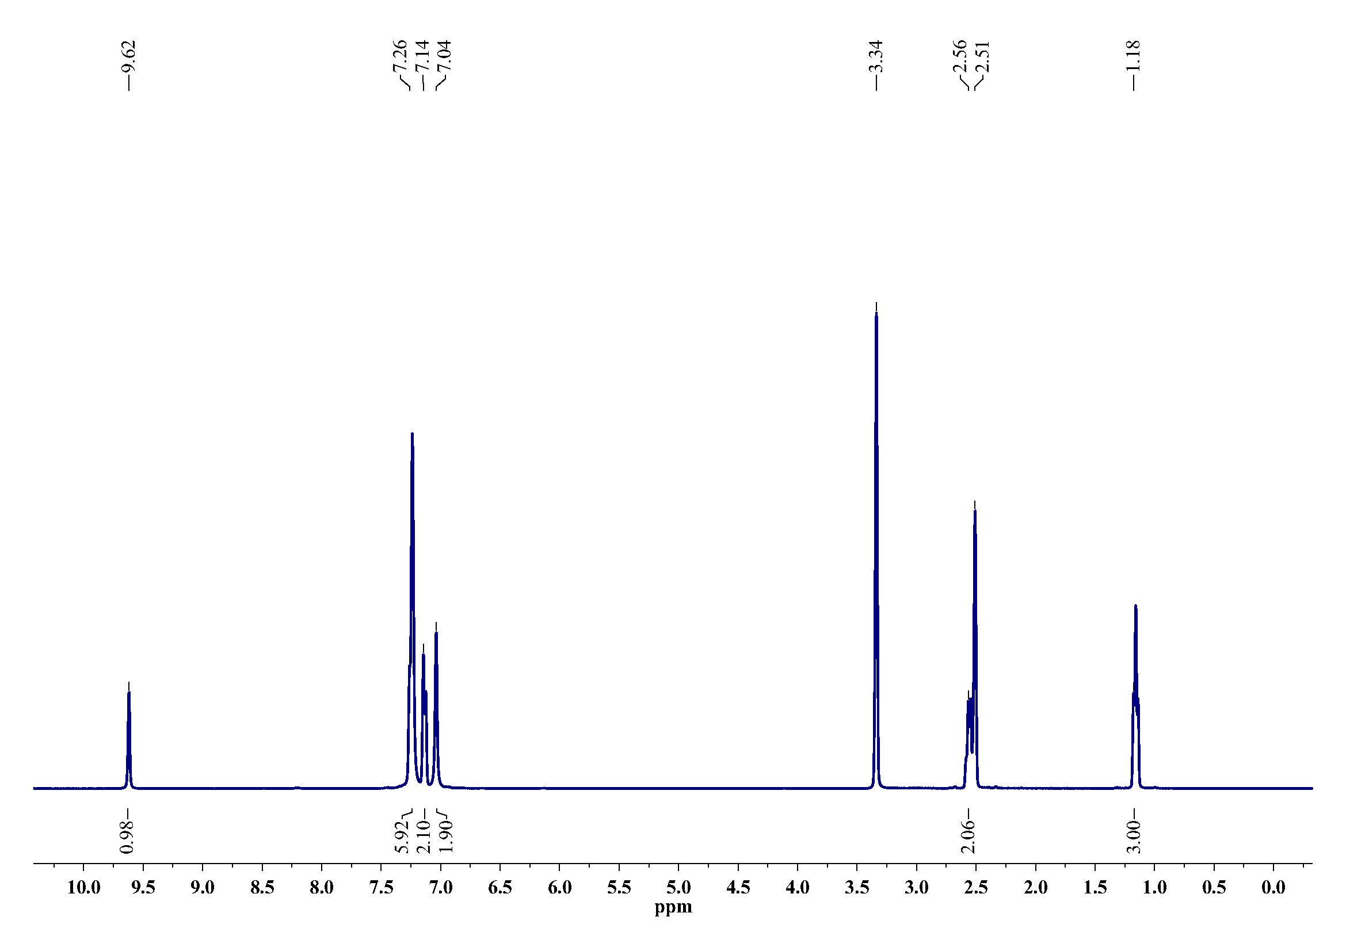
Fig. S5 ¹H-NMR spectrum of [HL³]Cl.

Fig. S6 ¹H-NMR spectrum of [HL⁴]Cl.

Fig. S7 ¹³C-NMR spectrum of [HL⁴]Cl.
Fig. S8 ¹H-NMR spectrum of [HL⁵]Cl.
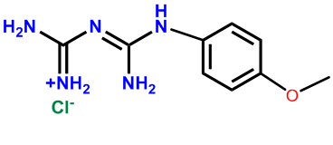
Fig. S9 ¹³C-NMR spectrum of [HL⁵]Cl.

Fig. S10 ¹H-NMR spectrum of [H₂L⁶]Cl₂.

Fig. S11 ¹³C-NMR spectrum of [H₂L⁶]Cl₂.

Fig. S12 ¹H-NMR spectrum of [H₂L⁷]Cl₂.

Fig. S13 ¹H-NMR spectrum of [HL^{1a}]Cl.

Fig. S14 ¹³C-NMR spectrum of [HL^{1a}]Cl.

Fig. S15 ¹H-NMR spectrum of [HL^{2a}]Cl.
Fig. S16 ¹³C-NMR spectrum of [HL^{2a}]Cl.

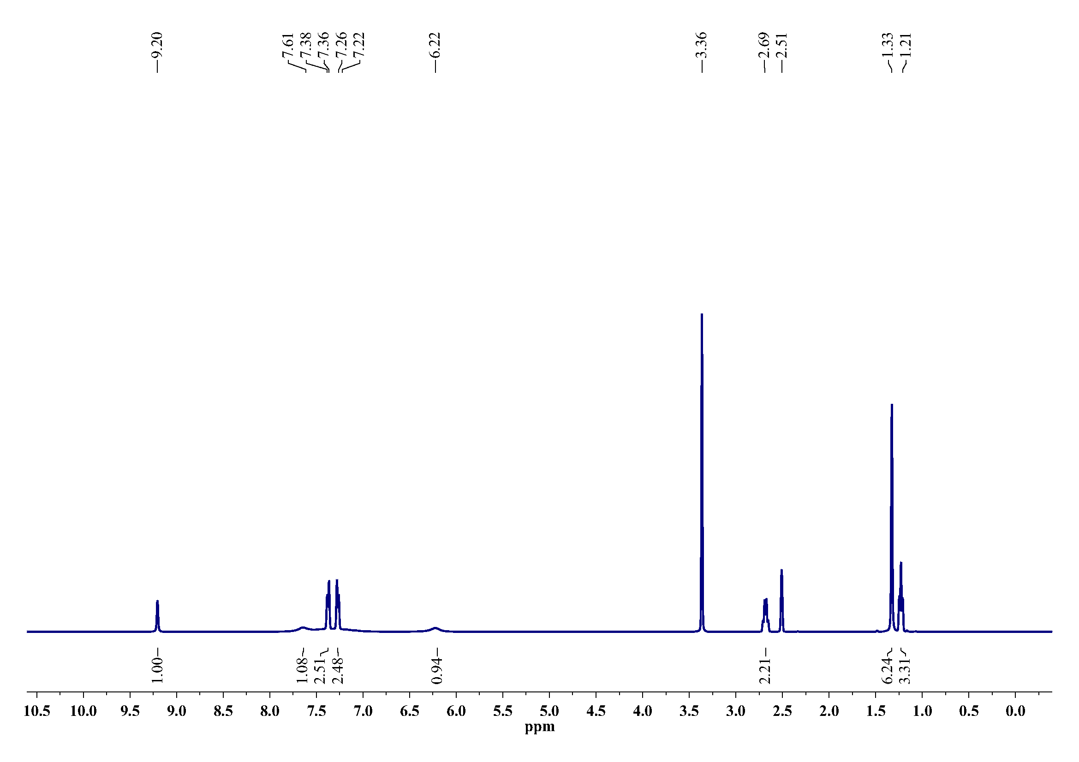
Fig. S17 ¹H-NMR spectrum of [HL^{3a}]Cl.

Fig. S18 ¹H-NMR spectrum of [HL^{4a}]Cl.

Fig. S19 ¹³C-NMR spectrum of [HL^{4a}]Cl.
Fig. S20 ¹H-NMR spectrum of [HL^{5a}]Cl.
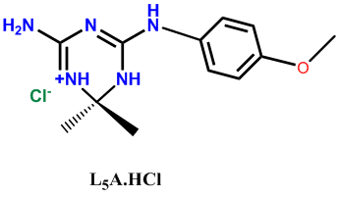
Fig. S21 ¹³C-NMR spectrum of [HL^{5a}]Cl.

Fig. S22 FT-IR spectrum of [HL¹]Cl.

Fig. S23 FT-IR spectrum of [HL²]Cl.

Fig. S24 FT-IR spectrum of [HL³]Cl.

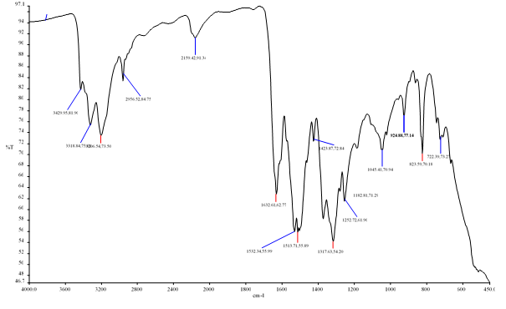
Fig. S25 FT-IR spectrum of [HL⁴]Cl.

Fig. S26 FT-IR spectrum of [HL⁵]Cl.

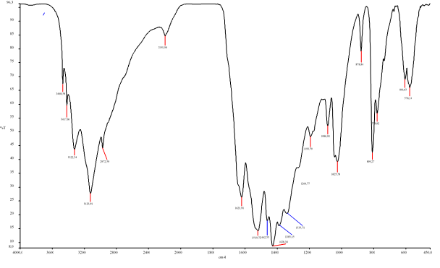
Fig. S27 FT-IR spectrum of [H₂L⁶]Cl₂.

Fig. S28 FT-IR spectrum of [H₂L⁷]Cl₂.

Fig. S29 FT-IR spectrum of [HL^{1a}]Cl.

Fig. S30 FT-IR spectrum of [HL^{2a}]Cl

Fig. S31 FT-IR spectrum of [HL^{3a}]Cl.

Fig. S32 FT-IR spectrum of [HL^{4a}]Cl.

Fig. S33 FT-IR spectrum of [HL^{5a}]Cl
Fig. S34 π-electron delocalization in biguanidine derivatives and their 1,3,5-triazine derivatives.

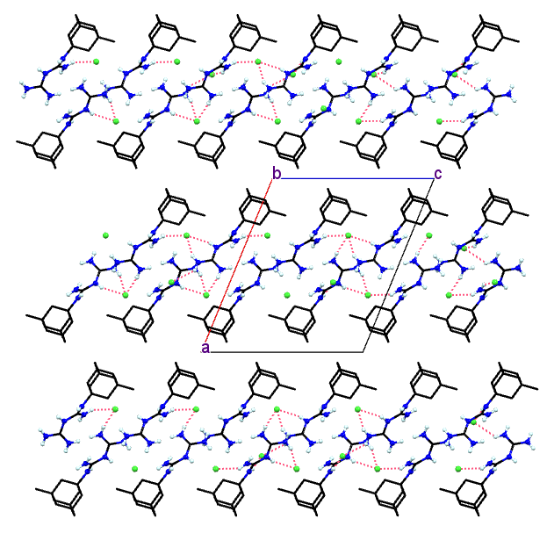
Fig. S35 The NH∙∙∙∙Cl hydrogen bond network in [H₂L⁷]Cl₂.

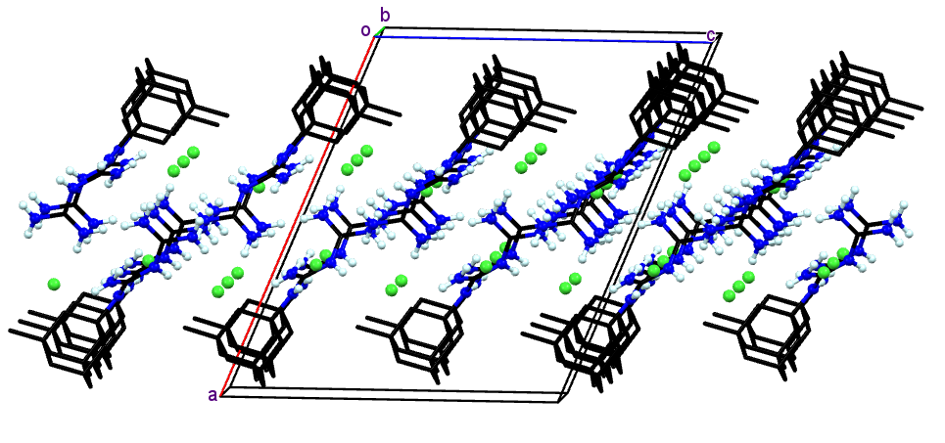
Fig. S36 Packing diagram of [H₂L⁷]Cl₂.

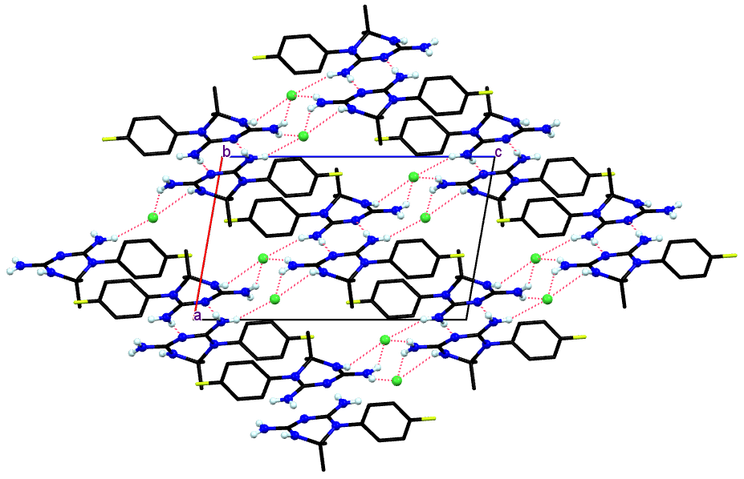
Fig. S37 Packing diagram of [HL^{1a}]Cl showing the NH∙∙∙∙Cl hydrogen bond network.

