**Supporting Information**

**Table S1:** Selected geometric parameters (Å, º).

|  |  |  |  |  |  |
| --- | --- | --- | --- | --- | --- |
| P1—O2 | 1.573 (3) | P14—O15 | 1.575 (3) | P27—O28 | 1.577 (3) |
| P1—O5 | 1.476 (3) | P14—O18 | 1.473 (3) | P27—O31 | 1.476 (3) |
| P1—O6 | 1.567 (3) | P14—O19 | 1.570 (3) | P27—O32 | 1.567 (3) |
| P1—N9 | 1.637 (4) | P14—N22 | 1.634 (4) | P27—N26 | 1.640 (4) |
| O2—C90 | 1.470 (9) | O15—C16 | 1.458 (5) | O28—C29 | 1.463 (5) |
| O6—C7 | 1.441 (6) | O19—C20 | 1.451 (6) | O32—C33 | 1.460 (6) |
| N9—C10 | 1.414 (5) | N22―C23 | 1.419 (5) | N26―C25 | 1.411 (5) |
| O2—P1—O5 | 113.95 (19) | O15—P14—O18 | 114.19 (17) | O28—P27—O31 | 115.36 (19) |
| O2—P1—O6 | 102.00 (19) | O15—P14—O19 | 101.65 (17) | O28—P27—O32 | 101.72 (18) |
| O5—P1—O6 | 115.96 (18) | O18—P14—O19 | 115.70 (17) | O31—P27—O32 | 115.50 (19) |
| O2—P1—N9 | 107.75 (19) | O15—P14—N22 | 108.50 (18) | O32—P27—N26 | 105.3 (2) |
| O5—P1—N9 | 111.39 (19) | O18—P14—N22 | 111.01 (19) | O28—P27—N26 | 107.49 (19) |
| O6—P1—N9 | 104.9 (2) | O19—P14—N22 | 104.96 (18) | O31—P27—N26 | 110.6 (2) |
| P1—O2—C90 | 117.3 (8) | P14—O15—C16 | 118.2 (3) | P27—O28—C29 | 120.1 (3) |
| P1—O6—C7 | 121.4 (3) | P14—O19—C20 | 120.7 (3) | P27—O32—C33 | 120.6 (3) |
| P1—N9—C10 | 129.3 (3) | P14—N22—C23 | 130.1 (3) | P27—N26—C25 | 129.2 (3) |
|  |  |  |  |  |  |
| P38—O39 | 1.583 (3) | P51—O52 | 1.579 (3) | P62—O63 | 1.562 (3) |
| P38—O42 | 1.573 (3) | P51—O55 | 1.574 (3) | P62—O66 | 1.581 (3) |
| P38—O45 | 1.473 (3) | P51—O58 | 1.473 (3) | P62—O69 | 1.471 (3) |
| P38—N46 | 1.629 (4) | P51―N50 | 1.622 (4) | P62—N70 | 1.633 (4) |
| O39—C40 | 1.459 (5) | O52—C53 | 1.445 (6) | O63—C64 | 1.444 (6) |
| O42—C43 | 1.452 (6) | O55—C56 | 1.430 (7) | O66—C67 | 1.431 (6) |
| N46―C47 | 1.406 (5) | N50―C49 | 1.411 (5) | N70―C71 | 1.406 (5) |
| O39—P38—O42 | 101.35 (17) | O52—P51—O55 | 101.4 (2) | O63—P62—O66 | 101.00 (19) |
| O39—P38—O45 | 113.86 (18) | O52—P51—O58 | 114.55 (19) | O63—P62—O69 | 115.40 (18) |
| O42—P38—O45 | 115.90 (17) | O55—P51—O58 | 116.21 (18) | O66—P62—O69 | 114.84 (19) |
| O39—P38—N46 | 108.41 (19) | N50—P51—O52 | 107.94 (19) | O63—P62—N70 | 105.77 (19) |
| O42—P38—N46 | 105.63 (18) | N50—P51—O55 | 104.8 (2) | O66—P62—N70 | 107.69 (19) |
| O45—P38—N46 | 110.9 (2) | N50—P51—O58 | 111.1 (2) | O69—P62—N70 | 111.2 (2) |
| P38—O39—C40 | 117.7 (3) | P51—O52—C53 | 117.6 (3) | P62—O66—C67 | 117.4 (3) |
| P38—O42—C43 | 120.5 (3) | P51—O55—C56 | 121.7 (4) | P62—O63—C64 | 120.9 (3) |
| P38—N46—C47 | 130.3 (3) | P51—N50—C49 | 128.6 (3) | P62—N70—C71 | 130.1 (3) |

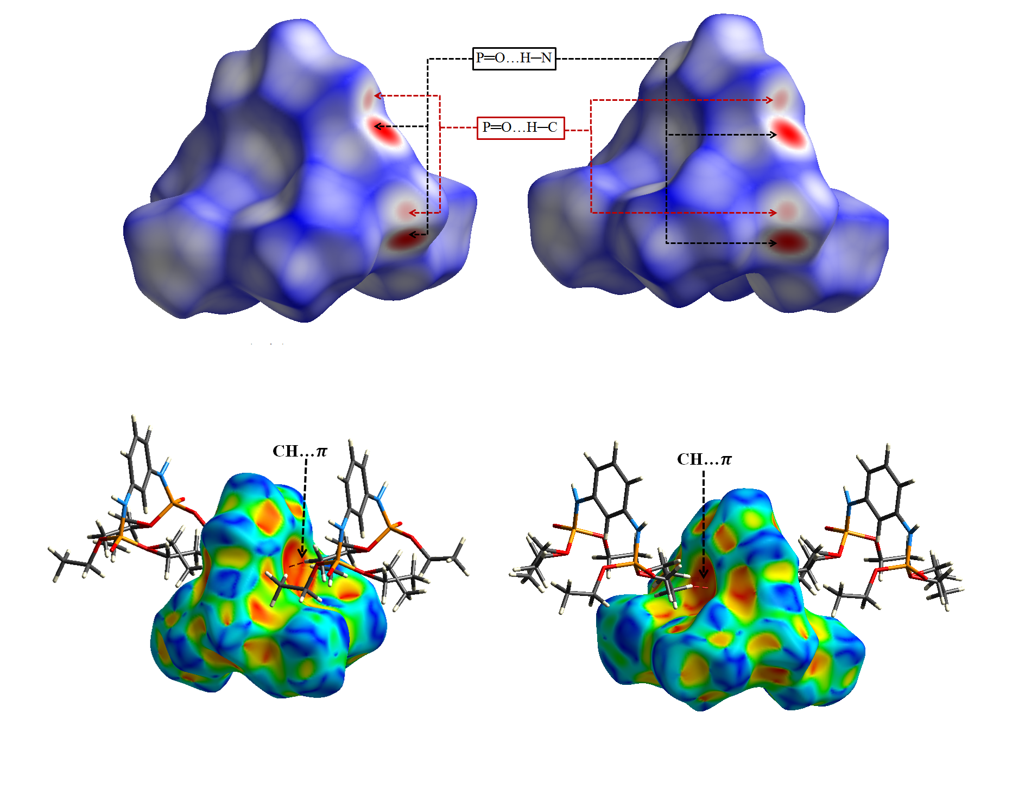

**Fig. S1:** Up: *d*norm Hirshfeld surface for molecule (P62, P62b). Down: Views of Hirshfeld surface mapped with the shape index for (P62, P62b), surrounded by neighboring molecules associated with close contacts.

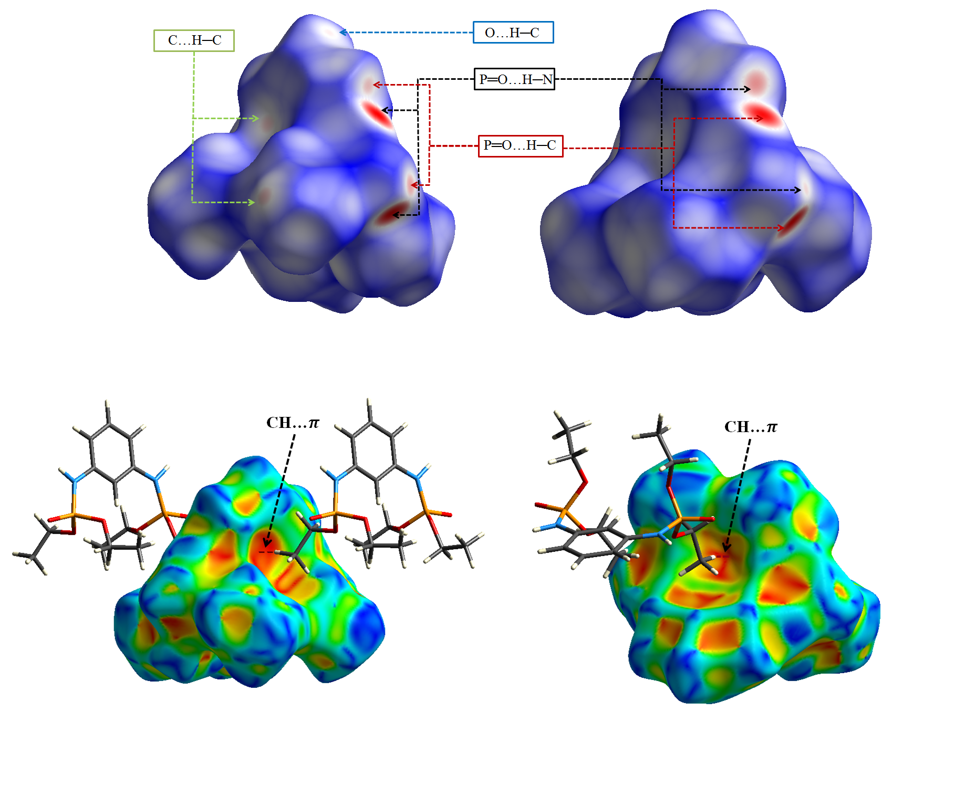

**Fig.S2:** Up: *d*norm Hirshfeld surface plotted for (P14, P27). Down: Views of Hirshfeld surface mapped with shape index for (P14, P27), surrounded by neighboring molecules associated with close contacts.

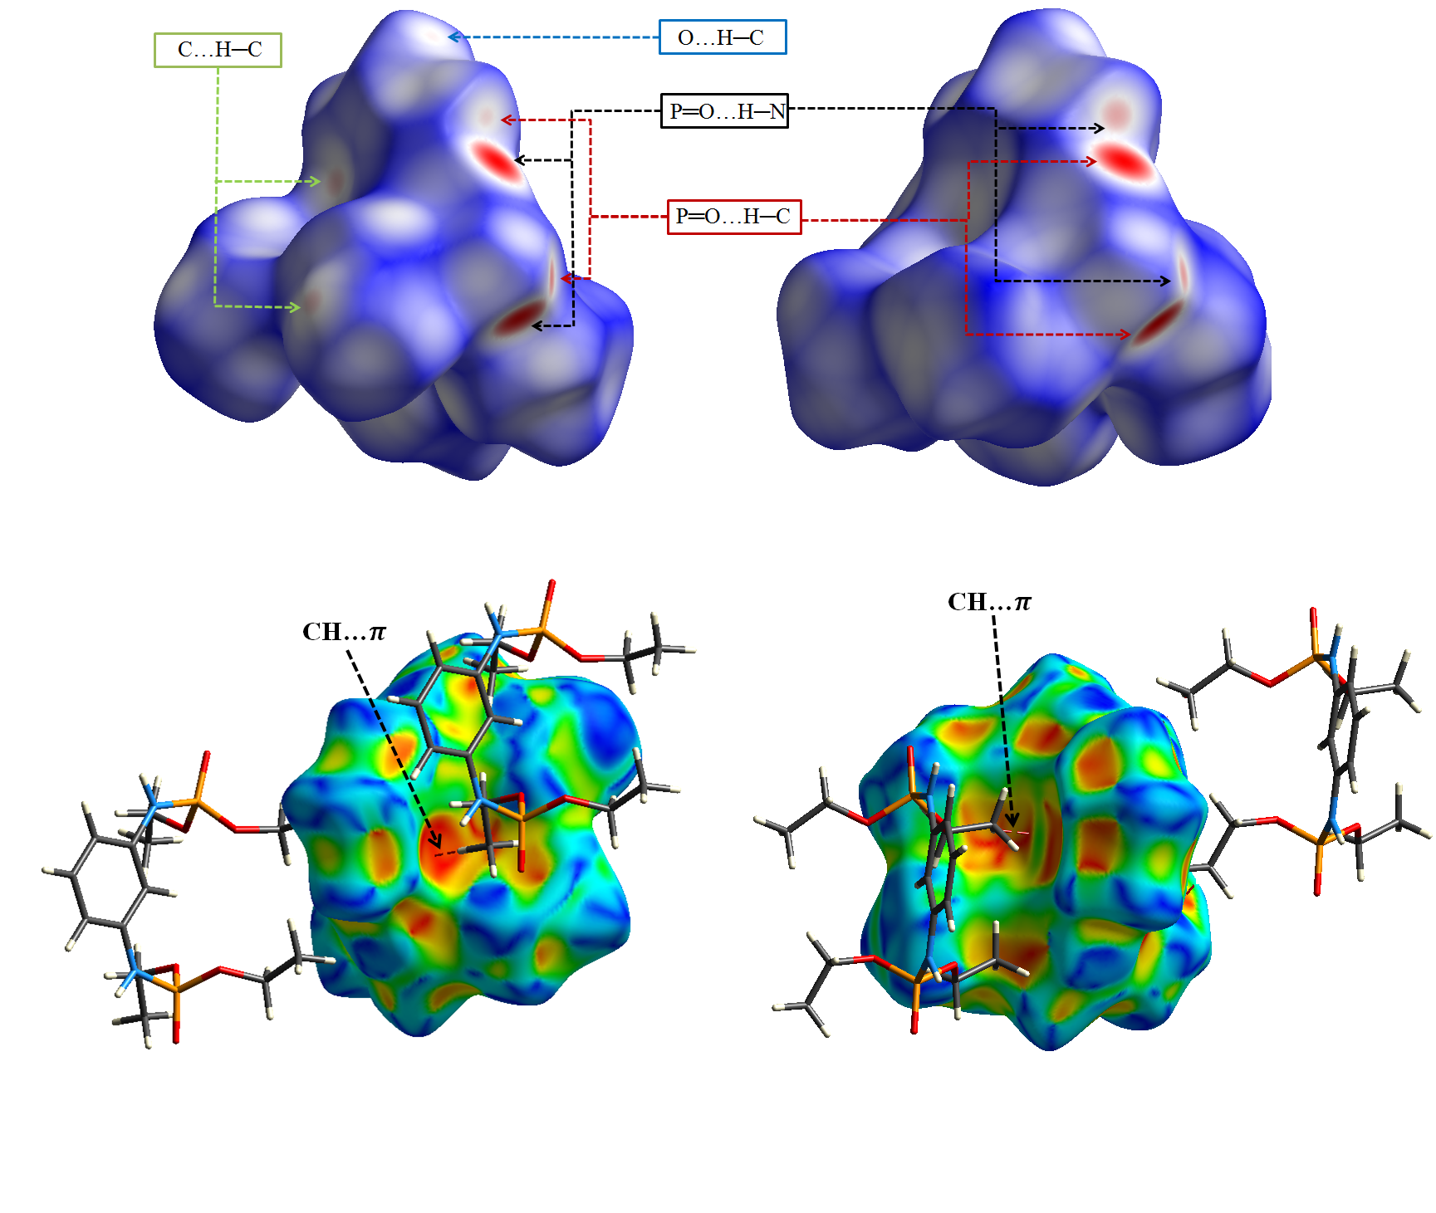

**Fig. S3:** Up: *d*norm Hirshfeld surface for molecule (P38, P51). Down: Views of Hirshfeld surface mapped with shape index for (P38, P51), surrounded by neighboring molecules associated with close contacts.

**Figure S4.tif**

**Fig. S4:** The proportions of various intermolecular X…H/H…X contacts (X = H, C, O and N) to the total Hirshfeld surface area and corresponding decomposed fingerprint plots (FPs) for molecule (P62, P62b) of the studied structure. The full fingerprint is shown at the top.

**Figure S5.tif**

**Fig. S5:** The proportions of various intermolecular X…H/H…X contacts (X = H, C, O and N) to the total Hirshfeld surface area and corresponding decomposed fingerprint plots (FPs) for molecule (P14, P27) of the studied structure. The full fingerprint is shown at the top.

**Figure S6.tif**

**Fig. S6:** The proportions of various intermolecular X…H/H…X contacts (X = H, C, O and N) to the total Hirshfeld surface area and corresponding decomposed fingerprint plots (FPs) for molecule (P38, P51) of the studied structure. The full fingerprint is shown at the top.