Fundamental theoretical and practical investigations of  
the polymorph formation of small amphiphilic molecules,  
their co-crystals and salts

Thomas Martin1, Paul Niemietz1, Dominik Greim1, Philipp Ectors2, Jürgen Senker1*, Dirk Zahn2*, Josef Breu1*

1 Universität Bayreuth, Universitätsstrasse 30, 95440 Bayreuth

2 Universität Erlangen-Nürnberg, Nägelsbachstrasse 25, 91052 Erlangen

**Supporting Information**

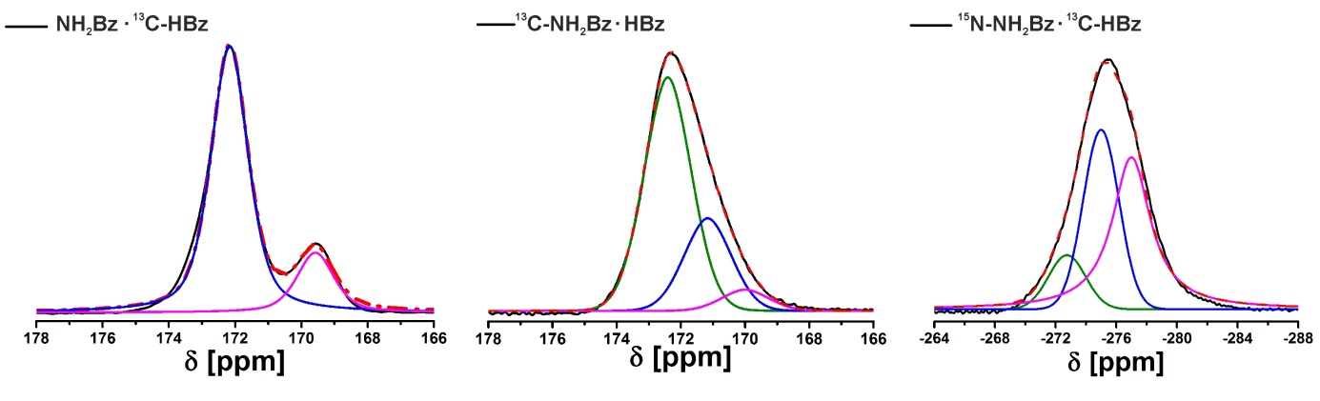

Fig. S1 Deconvoluted 1D-Spectra (black solid line) of NH2Bz • 13C-HBz (left), NH2Bz • 13C-HBz (mid) and 15N-NH2Bz • 13C-HBz (right) and. Each signal in the deconvolution can be assigned to a new chemical surrounding/different packing motif in the cocrystal indicating a highly disordered system.

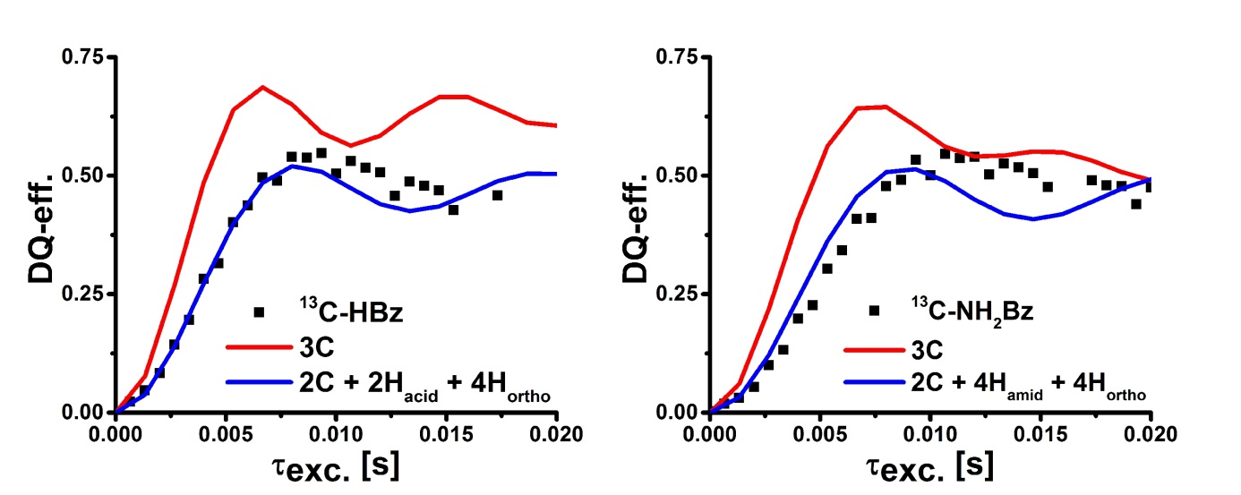

Fig. S2 Comparison of the DQ build up curves of pure benzoic acid (left) and pure benzamide (right) with different simulation models. The red fits take only the two shortest carbon carbon distances into account, the one along the pi-stacking and of the dimer itself. The slope of those curves are way steeper than the measurements (black squares) indicating additional influences of the DQ-build up. To fit the build-up the influence of the protons has to be considered as shown by the blue fit with the nearest protons included, for both systems all the protons of the functional group and the ones in ortho position.