*Zoulikha Khiati 1, Abdelmoumin Mezrai2, Lahouari Mrah3\**

**Improvement in the thermal, mechanical and rheological properties of polyAmide-11(PA11) nanobiocomposite films as a result of the influence of the composition and type of nanofiller.**

1 Laboratory for Organic Synthesis, Physical Chemistry, Biomolecules and the Environment (LSPBE), University of Science and Technology of Oran, Mohamed Boudiaf, USTO-MB, BP 1505, El M’naouer, Oran 31000, Algeria and Department of Physical Chemistry, Faculty of Chemistry, University of Science and Technology of Oran, Mohamed. Boudiaf, BP 1505 El M'naouer, 31000 Oran, Algeria.

2Laboratory of Organic Chemistry, Natural Substances and Analyses (COSNA), University Aboubakr Belkaid-Tlemcen,P.O. Box 119 Tlemcen 13000, Algeria and Higher School of Electrical and Energy Engineering, Oran, Chemin Vicinal N°9, 31000, Algeria.

**3** Laboratory of Polymer Chemistry, University Oran 1 Ahmed Ben Bella, BP 1524 El M’nouer, 31000 Oran, Algeriaand Higher School of Electrical and Energy Engineering, Oran, Chemin Vicinal N°9, 31000, Algeria.

\***Corresponding author:** Lahouari Mrah: e-mail: [houarimrah3@gmail.com](mailto:houarimrah3@gmail.com)

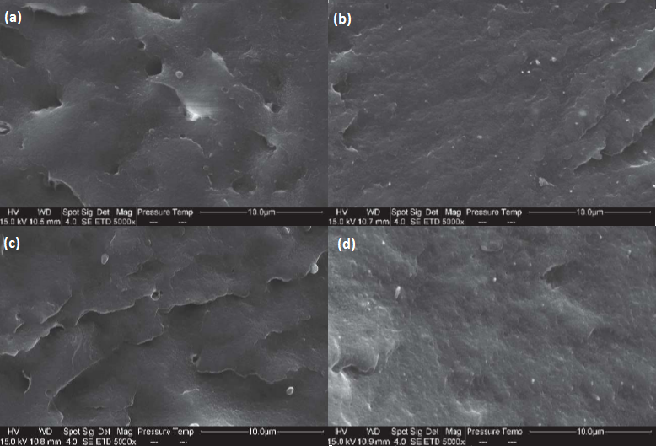

**Figure ES1**: SEM images of (a) PA11/Mag-CTA1%, (b) PA11/Mag-CTA3%, (c) PA11/Mag-CTA5%, and (d) PA11/Mag-CTA7%, nanocomposites.

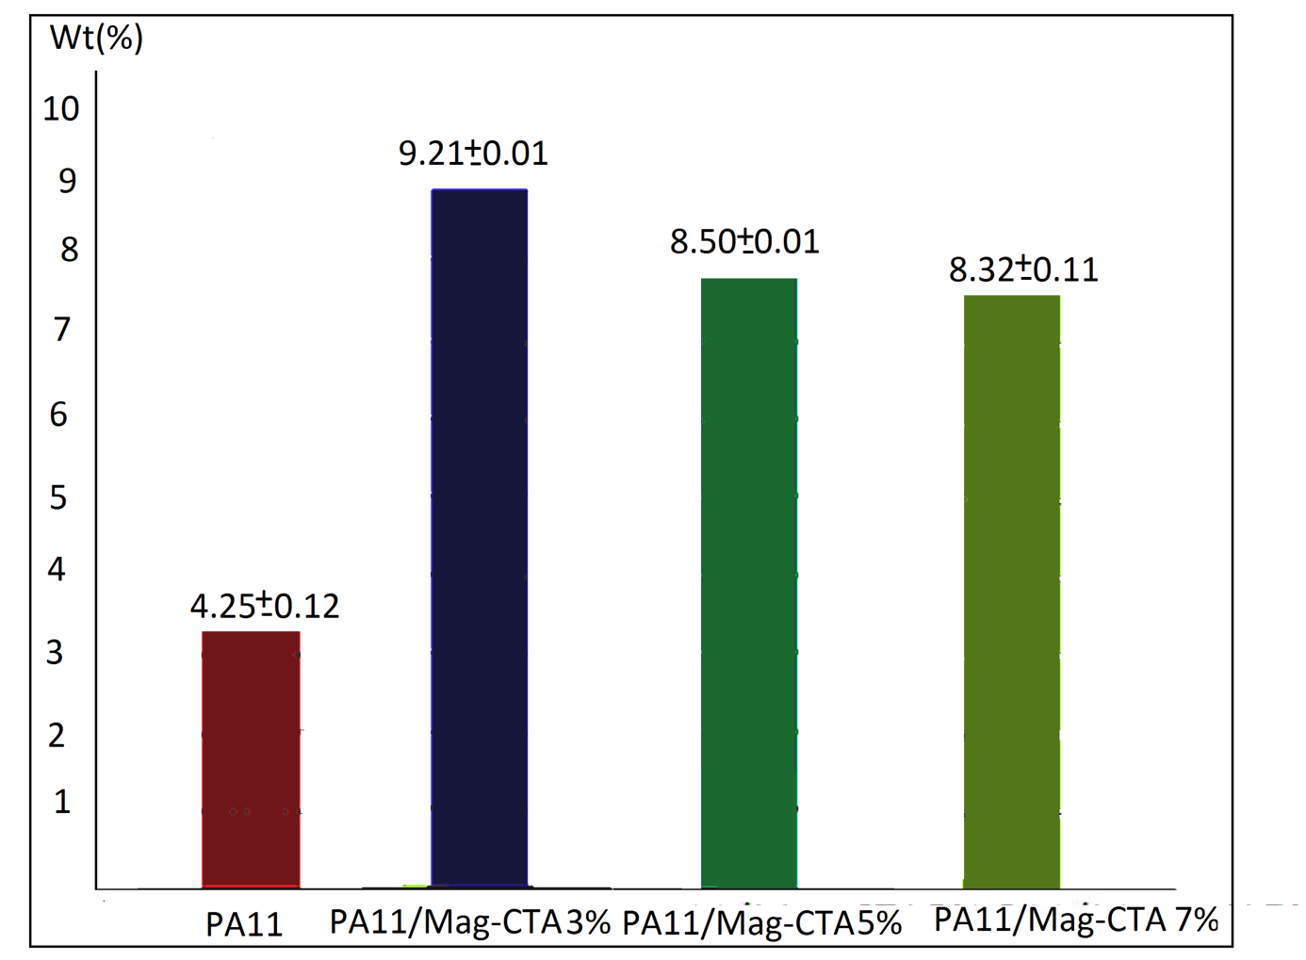

**Figure ES2:** Absorption rates for PA11 and PA11/Mag-CTA nanobiocomposites.