Supplementary data S5: Description of the determination of the soil removal index (SRI) for CFT-tile photos via automatic image analysis using MATLAB.
The following processing is suited for big data amounts in in any folder structure. The code searches JPGs in all subdirectories of a file folder. JPGs must be backuped because code processing delets older files in intermediate steps.
Description of steps and example | MATLAB Codes
Step 1: Tile(s) on photo(s) gets recognized, cut out and saved as new JPG-File.  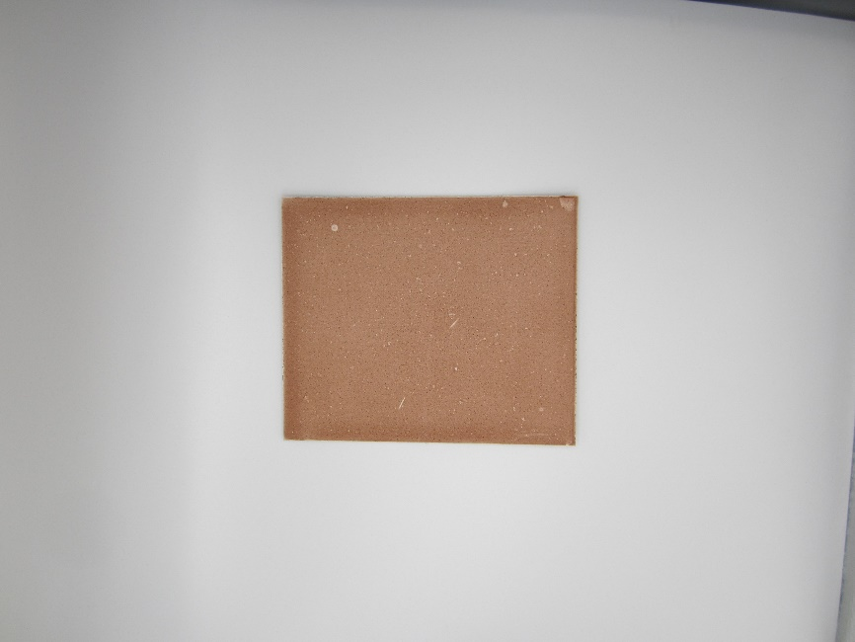  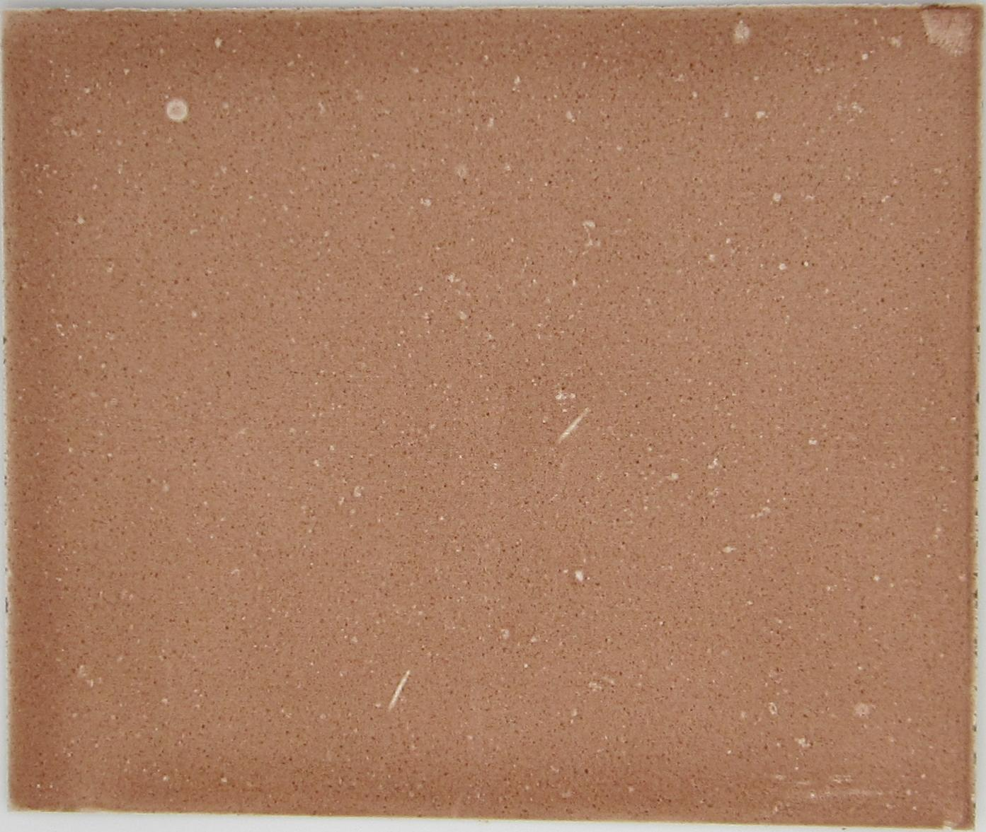 | % Get the current directory  currentDir = pwd;  % Recursively search for JPG files in the current folder and all its subfolders  fileList = dir(fullfile(currentDir, '**', '*.jpg'));  filePaths = fullfile({fileList.folder}, {fileList.name});  % Iterate over each JPG file  for i = 1:numel(filePaths)  % Read the input image  inputImage = imread(filePaths{i});  % Convert the image to grayscale  grayImage = rgb2gray(inputImage);  % Enhance the contrast of the grayscale image using histogram equalization  eqImage = histeq(grayImage);  % Perform edge detection  edgeImage = edge(eqImage, 'Canny', 0.2, 4);  % Perform morphological operations to enhance the boundaries  se = strel('rectangle', [5, 5]);  dilatedImage = imdilate(edgeImage, se);  filledImage = imfill(dilatedImage, 'holes');  % Find the connected components in the image  cc = bwconncomp(filledImage);  % Calculate the bounding box of each region  props = regionprops(cc, 'BoundingBox');  % Find the edges within the bounding boxes  edgeProps = regionprops(cc, 'PixelList');  % Find the largest rectangular region (tile) based on edge information  maxArea = 0;  maxIndex = 0;  for j = 1:cc.NumObjects  edgePoints = edgeProps(j).PixelList;  x = edgePoints(:, 1);  y = edgePoints(:, 2);  xmin = min(x);  xmax = max(x);  ymin = min(y);  ymax = max(y);  area = (xmax - xmin) * (ymax - ymin);  if area > maxArea  maxArea = area;  maxIndex = j;  tileBounds = [xmin, ymin, xmax - xmin, ymax - ymin];  end  end  % Extract the tile from the input image using estimated boundaries  tile = imcrop(inputImage, tileBounds);  % Create the output directory if it doesn't exist  outputDir = fullfile(fileList(i).folder, 'Tiles');  if ~isfolder(outputDir)  mkdir(outputDir);  end  % Generate the output file name  [~, name, ext] = fileparts(filePaths{i});  tileFileName = [name, '_tile', ext];  % Save the extracted tile in the appropriate folder  outputFilePath = fullfile(outputDir, tileFileName);  imwrite(tile, outputFilePath);  end
Step 2: All files exept for the new (cut out) files get deleted in the folder and subdirectories. | % Get the current directory  currentDir = pwd;  % Recursively search for JPG files in the current directory and all subdirectories  fileList = dir(fullfile(currentDir, '**', '*.jpg'));  filePaths = fullfile({fileList.folder}, {fileList.name});  % Loop through each file path  for i = 1:numel(filePaths)  % Check if the file name contains the word "tile"  [~, name, ~] = fileparts(filePaths{i});  if ~contains(name, 'tile')  % Delete the file  delete(filePaths{i});  end  end
Step 3: Second trimming (Since the tiles are not 100% at right angles and edges can influence the Lab* value, another trimming follows.)  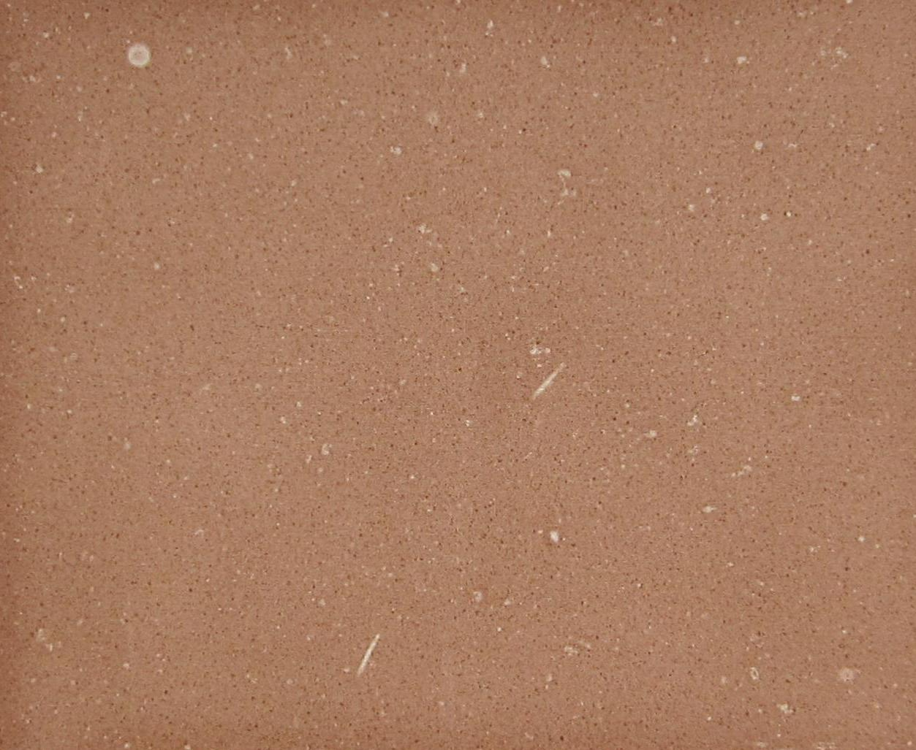 | % Get the current directory  currentDir = pwd;  % Recursively search for JPG files in the current folder and all its subfolders  fileList = dir(fullfile(currentDir, '**', '*.jpg'));  filePaths = fullfile({fileList.folder}, {fileList.name});  % Iterate over each file  for i = 1:numel(filePaths)  % Read the image  image = imread(filePaths{i});  % Perform cropping  croppedImage = image(81:end-70, 61:end-80, :);  % Create the output directory if it doesn't exist  outputDir = fullfile(fileList(i).folder, 'Cropped');  if ~isfolder(outputDir)  mkdir(outputDir);  end  % Generate the output file name  [~, name, ext] = fileparts(filePaths{i});  newFileName = [name, '_cropped', ext];  % Save the cropped image in the appropriate folder  outputFilePath = fullfile(outputDir, newFileName);  imwrite(croppedImage, outputFilePath);  end
Step 4: All files exept for the final cutted files get deleted in the folder and subdirectories. | % Get the current directory  currentDir = pwd;  % Recursively search for all files in the current directory and subdirectories  fileList = dir(fullfile(currentDir, '**', '*.jpg'));  filePaths = fullfile({fileList.folder}, {fileList.name});  % Loop through each file path  for i = 1:numel(filePaths)  % Check if the file name does not contain the word "cropped"  [~, name, ~] = fileparts(filePaths{i});  if ~contains(name, 'cropped')  % Delete the file  delete(filePaths{i});  end  end
Step 5: Determine Lab* value and create table that can be used to make predictions with the models.  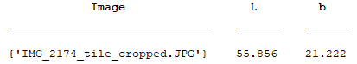 | % Get the current directory  % Attention! Step can last very long depending on number and size of images  currentDir = pwd;  % Recursively search for JPEG files in the current folder and all its subfolders  imageFiles = dir(fullfile(currentDir, '**', '*.jpg'));  imagePaths = fullfile({imageFiles.folder}, {imageFiles.name});  % Create empty arrays to store the results  imageNames = {};  LValues = [];  bValues = [];  % Loop through each image file  for i = 1:numel(imagePaths)  % Read the image  image = imread(imagePaths{i});  % Convert the image to Lab color space  labImage = rgb2lab(image);  % Calculate the average Lab* value  averageLab = mean(mean(labImage, 1), 2);  % Store the results  imageNames{i} = imageFiles(i).name;  LValues(i) = averageLab(1);  bValues(i) = averageLab(3);  end  % Create the results table  resultsTable = table(imageNames', LValues', bValues', ...  'VariableNames', {'Image', 'L', 'b'});  % Display the results table  disp(resultsTable);  % Extract columns 2 and 3 as arrays from the existing table (L&b)  L = resultsTable(:, 2).Variables;  b = resultsTable(:, 3).Variables;  % Create a new table "val_Table" with the extracted arrays  valTable = table(L, b, 'VariableNames', {'L', 'b'});
Step 6: Make Predictions for SRI (load models beforehand).  Model parameters:  ¹ Number of data points for calibration.  ² L* and b* values from photos.  ³ Root mean square error.  ⁴ Five-fold cross-validation | % Get the number of rows in the valTable  numRows = size(valTable, 1);  % Define the order of the models  modelOrder = {'BEY', 'DM', 'BC', 'MS', 'DT'};  % Initialize the predictedAll array  predictedAll = cell(numRows, 1);  % Loop through each row in valTable  for i = 1:numRows  % Get the current model index based on the row position  modelIndex = mod(i - 1, numel(modelOrder)) + 1;  % Get the current model name  modelName = modelOrder{modelIndex};  % Get the prediction for the current row using the corresponding model  prediction = eval([modelName '.predictFcn(valTable(i,:))']);  % Store the prediction in the predictedAll array  predictedAll{i} = prediction;  end  % Combine all predictions into a single matrix  predictedAll = vertcat(predictedAll{:});
   |  | Observations¹ | Predictors² | Model Type | RMSE³  (Validation)⁴ | R² (Validation)
  Soil | BEY | 12 | 2 | Linear Regression | 11.85 | 0.9209
  Soil | BC | 12 | 2 | Linear Regression | 5.66 | 0.9845
  Soil | DM | 12 | 2 | Linear Regression | 12.42 | 0.9205
  Soil | MS | 12 | 2 | Linear Regression | 13.57 | 0.9102
  Soil | DT | 12 | 2 | Linear Regression | 5.69 | 0.9816

