**Supplementary Figure**

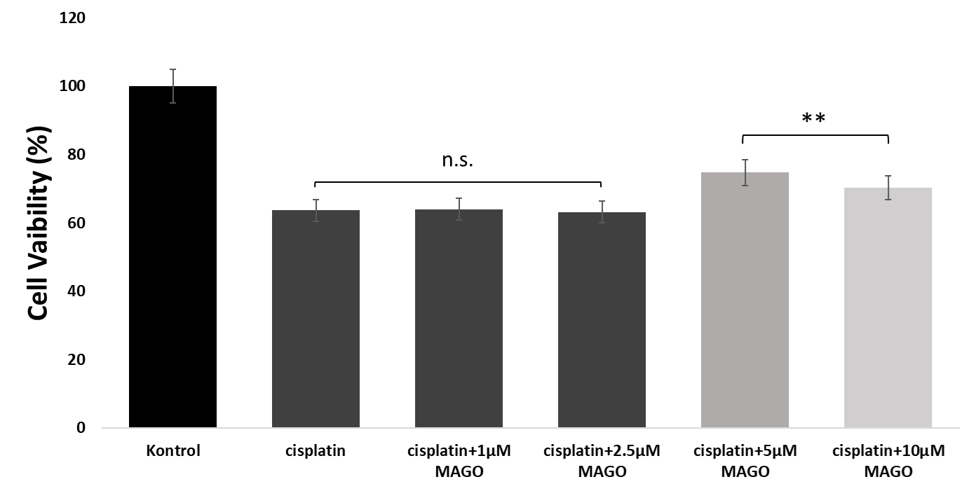

*Supplementary Figure 1: Preliminary study of cisplatin and MAGO on cell viability. 5 µM MAGO treated group **p<0.01 vs. 10 µM MAGO treated group.*