SUPPLEMENTARY MATERIAL

Antioxidant and alpha-glucosidase inhibitory activities of flavonoids isolated from fermented leaves of Camellia chrysantha (Hu) Tuyama
Tran Thi Nhu Hang (https://orcid.org/0009-0006-7989-1193)^{a,b}, Tran Thi Tuyen (https://orcid.org/0009-0003-1825-7381)ª, Pham Cao Bach (https://orcid.org/0000-0003-0999-4534)ª, Hoang Kim Chi (https://orcid.org/0000-0001-9231-0927)ª, Nguyen Tien Quan (https://orcid.org/0009-0009-9351-5497)^{a,b}, Trinh Anh Vien (https://orcid.org/0009-0008-3375-5713)^{c}, Nguyen Thi Hong Van (https://orcid.org/0000-0003-4152-1630)^{a,b*}
ªInstitute of Natural Products Chemistry (INPC), Vietnam Academy of Science and Technology (VAST), 18 Hoang Quoc Viet, Cau Giay, Hanoi, Vietnam
^{b}Graduate University of Science and Technology, Vietnam Academy of Science and Technology (VAST), 18 Hoang Quoc Viet, Cau Giay, Hanoi, Vietnam
^{c}Department of Assessment and Quality assurance, Hanoi Medical University-Thanh Hoa Campus, Thanh Hoa, Vietnam
*E-mail: nguyenthihongvan.inpc.vast@gmail.com
Phone: +84989939681

Abstract
Objectives
Microbial fermentation has long been known as a method for processing teas to raise products with novel biological activities. Our study aimed to chemically characterize flavonoid components in fungal mediated biotransformed Camellia chrysantha (Hu) Tuyama leaves.
Methods
The fermented leaves of Camellia chrysantha were prepared by inoculation with an Eurotium cristatum fungal consortium and extracted with ethanol combining ultrasound-assisted technique, before introducing to chemical characterization. Normal and reverse phase C18 column chromatography and thin layer chromatography were applied for fractionation and isolation of compounds from the ethanolic extract. Nuclear magnetic resonance spectra (¹H NMR, ¹³C NMR, HSQC and HMBC) were recorded for structure determination, while in vitro bioassays of free radical scavenging capacity and α-glucosidase inhibition were employed to assess anti-oxidative and anti-diabetic properties of isolated compounds.
Results
Four flavonoids, i.e. quercitrin (1), afzelin (2), (-)-epicatechin (3), and engelitin (4) were isolated from fermented Camellia chrysantha (Hu) Tuyama leaves. Compounds 1 and 3 were found to exhibit scavenging property against both DPPH and ABTS. Compound 2 was noticeably the most effective against α-glucosidase, presenting an IC₅₀ of 78.25 μg/mL.
Conclusions
The investigation on chemical composition of microbial fermented leaves of Camellia chrysantha (Hu) Tuyama brought out flavonoid compounds with significant biological activities, which could serve as a basis for further possible application in manufacturing of health protecting natural products.

Keywords
Keywords: Camellia chrysantha, fermented leaves, flavonoids, antioxidant, α-glucosidase.

CONTENTS OF SUPPORTING INFORMATION
Contents Page
I. Spectra of compound 1 4
II. Spectra of compound 2 8
III. Spectra of compound 3 12
IV. Spectra of compound 4 16
V. ¹H NMR and ¹³C NMR data of compounds 1, 2, 3, 4 and reported data of quercitrin 20
VI. Scavenging capacities against DPPH, ABTS and α-glucosidase inhibitory activity of compounds 1-4 22

I. Spectra of compound 1
Fig. SI-1. ¹H NMR spectrum of compound 1
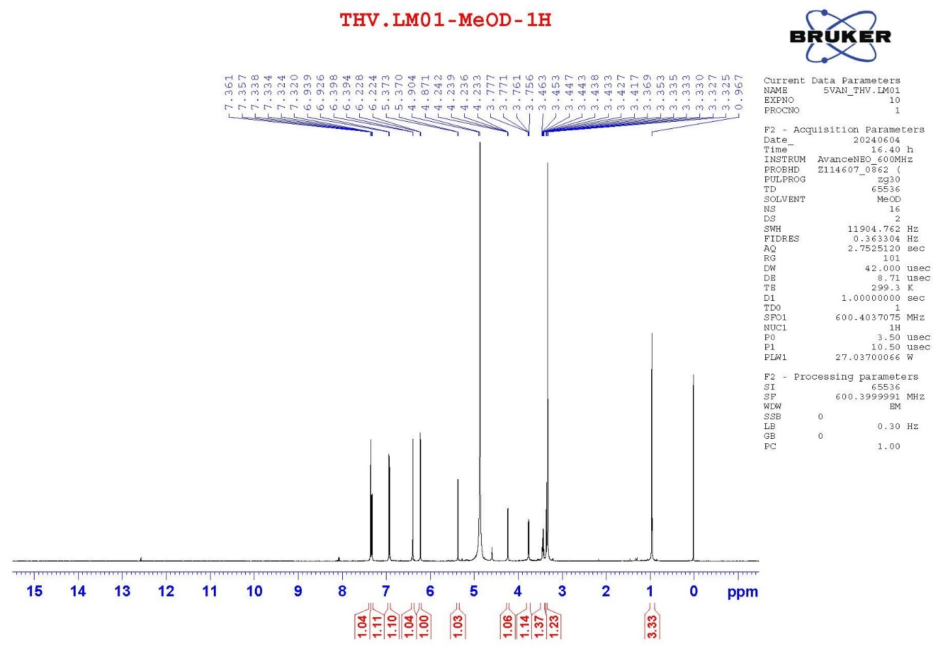

Fig. SI-2. ¹³C NMR spectrum of compound 1
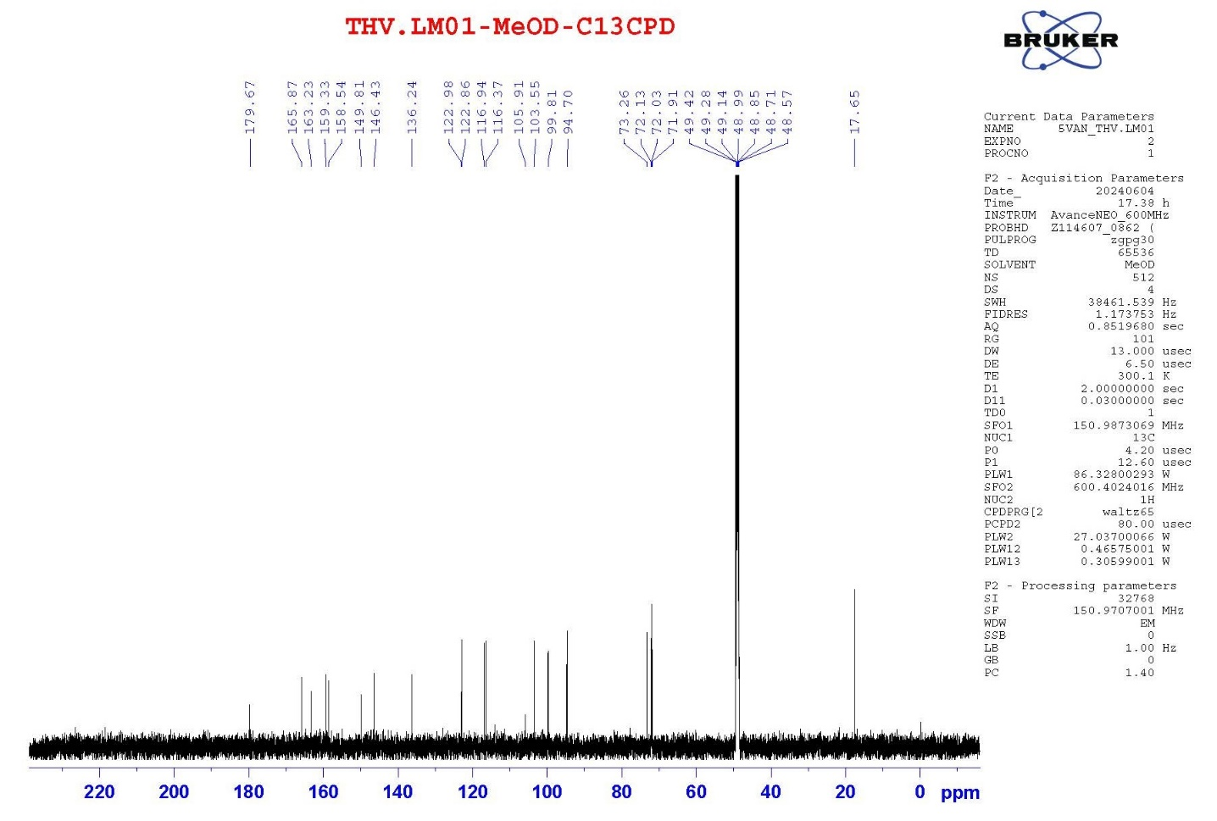

Fig. SI-3. HMBC spectrum of compound 1
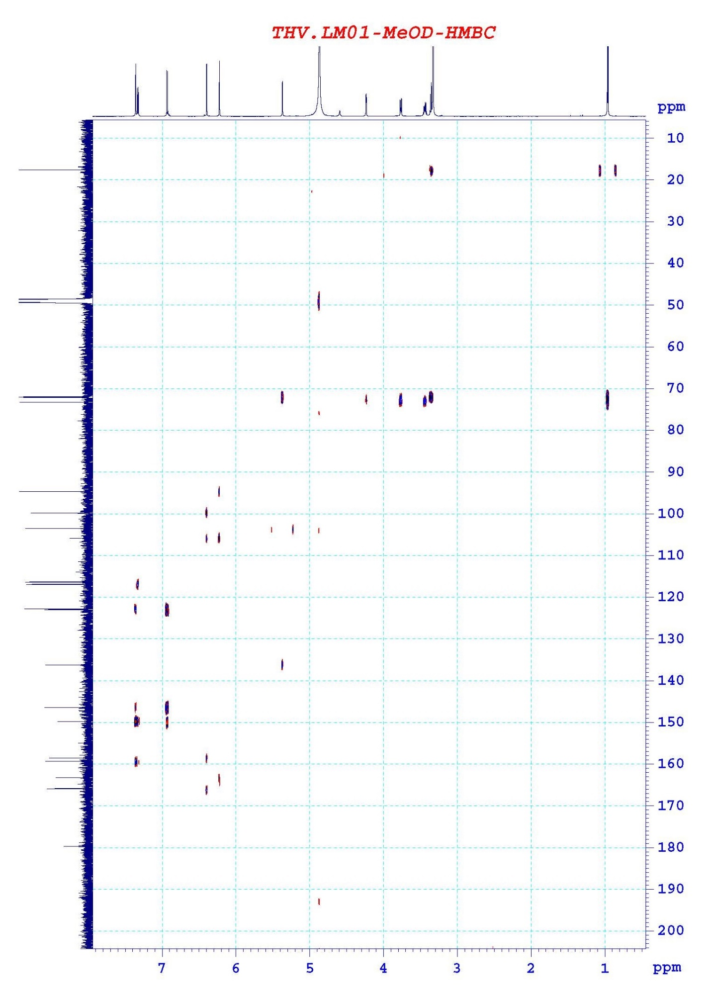

Figure SI-4. HSQC spectrum of compound 1
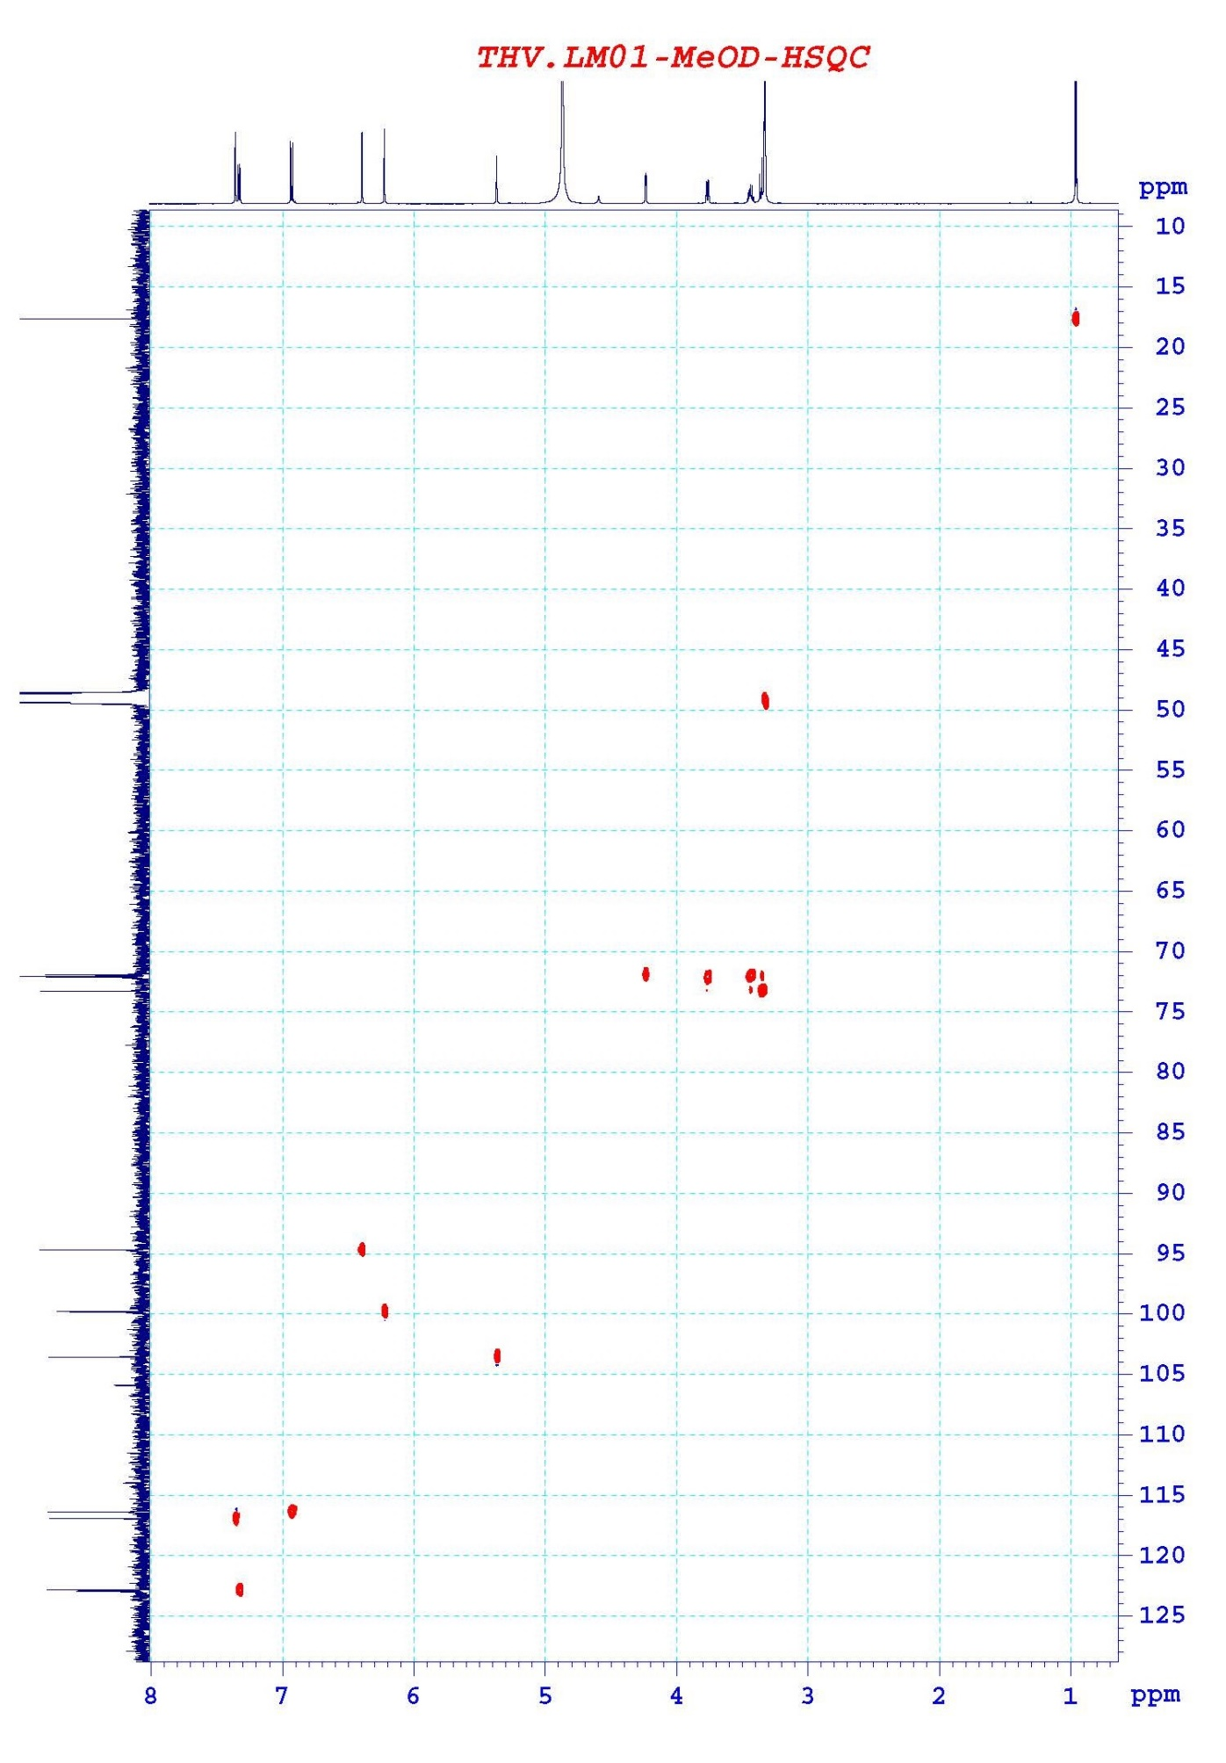

II. Spectra of compound 2
Fig. SII-1. ¹H NMR spectrum of compound 2
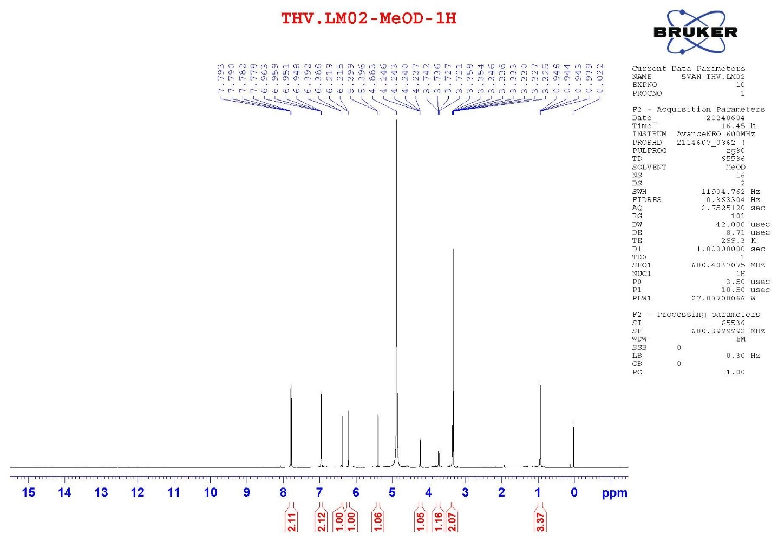

Fig. SII-2. ¹³C NMR spectrum of compound 2
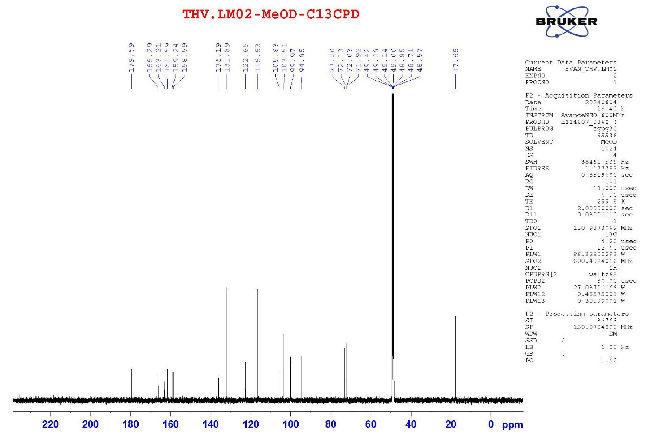

Fig. SII-3. HMBC spectrum of compound 2
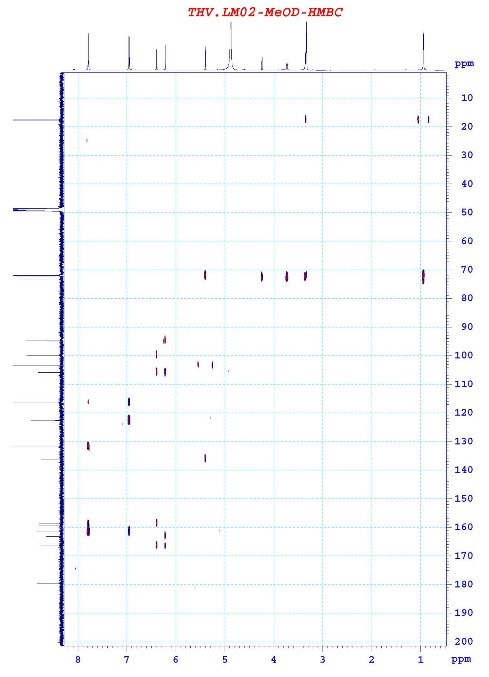

Fig. SII-4. HSQC spectrum of compound 2
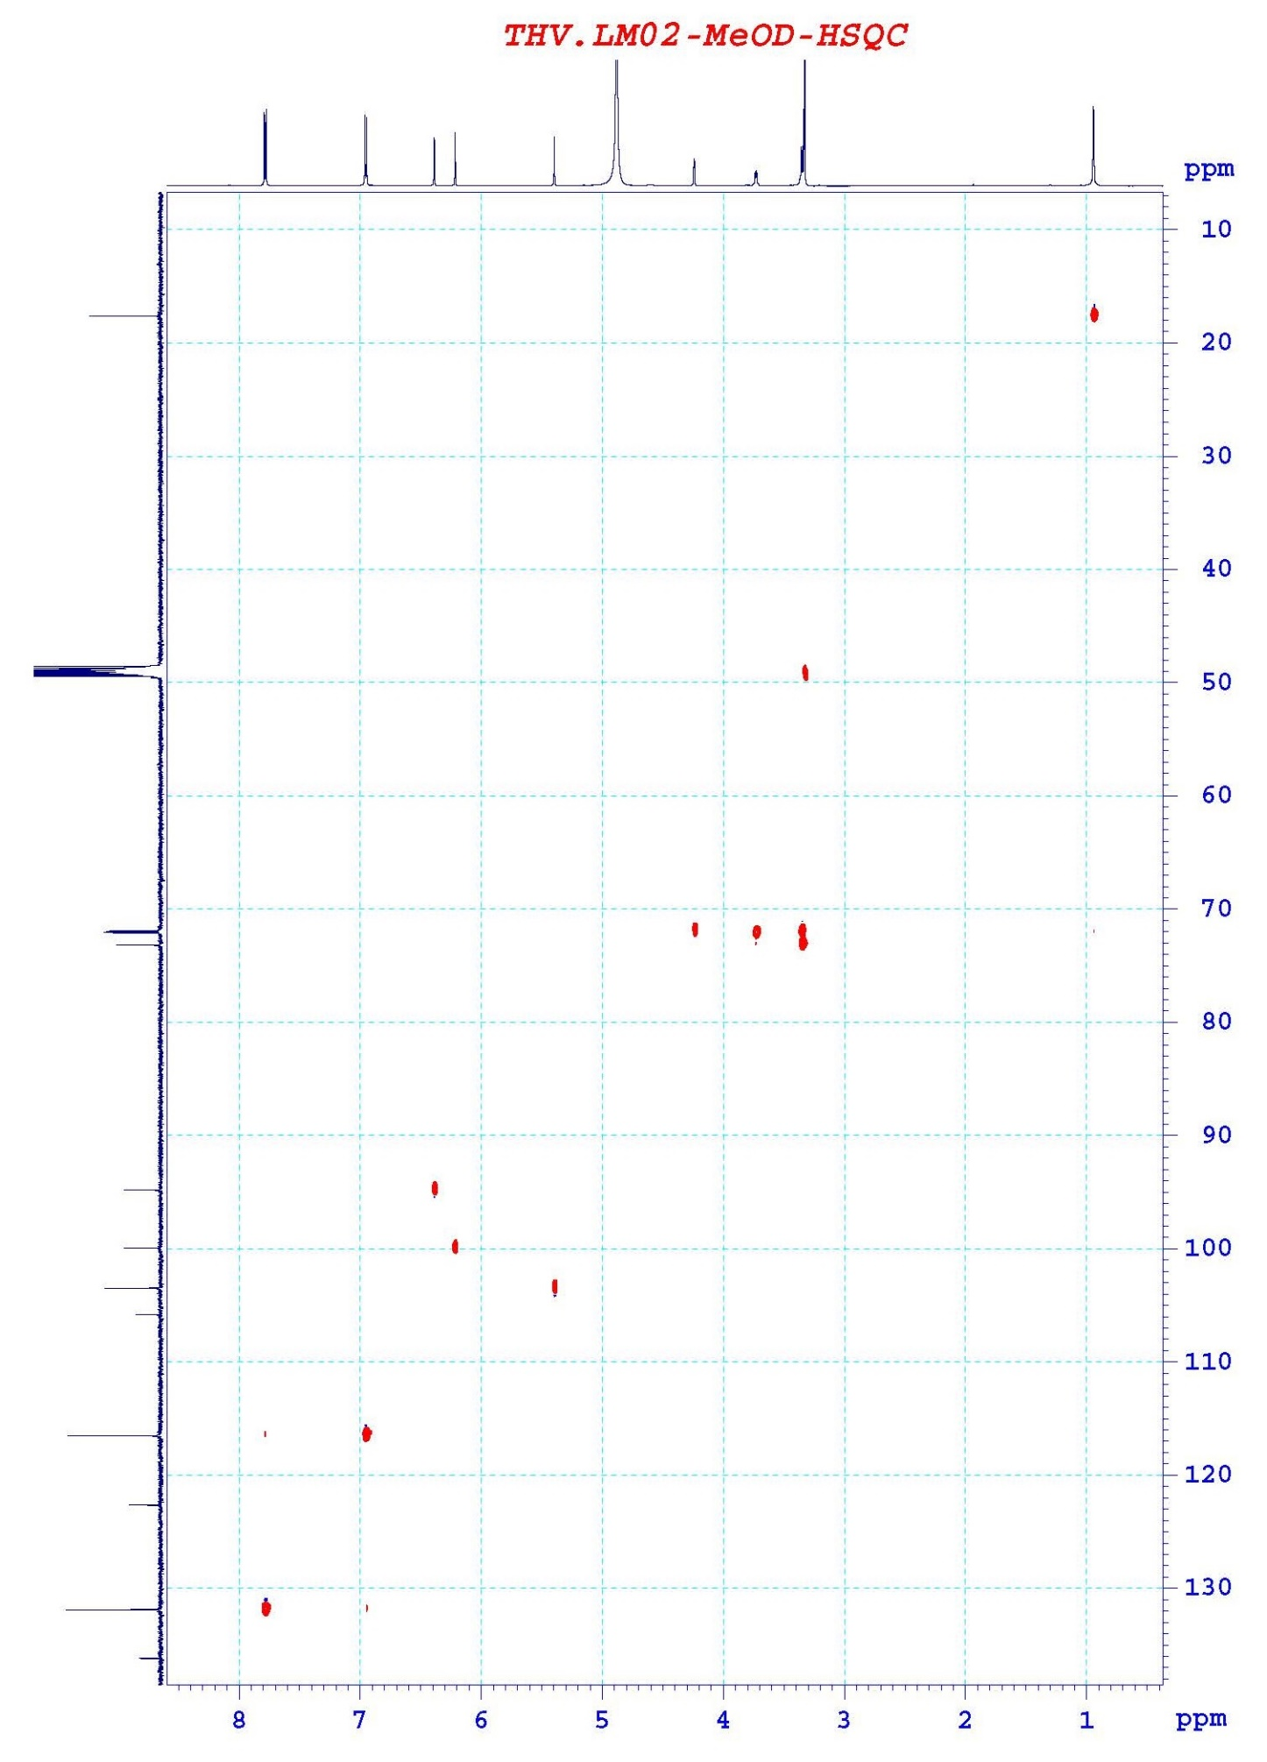

III. Spectra of compound 3
Fig. SIII-1. ¹H NMR spectrum of compound 3
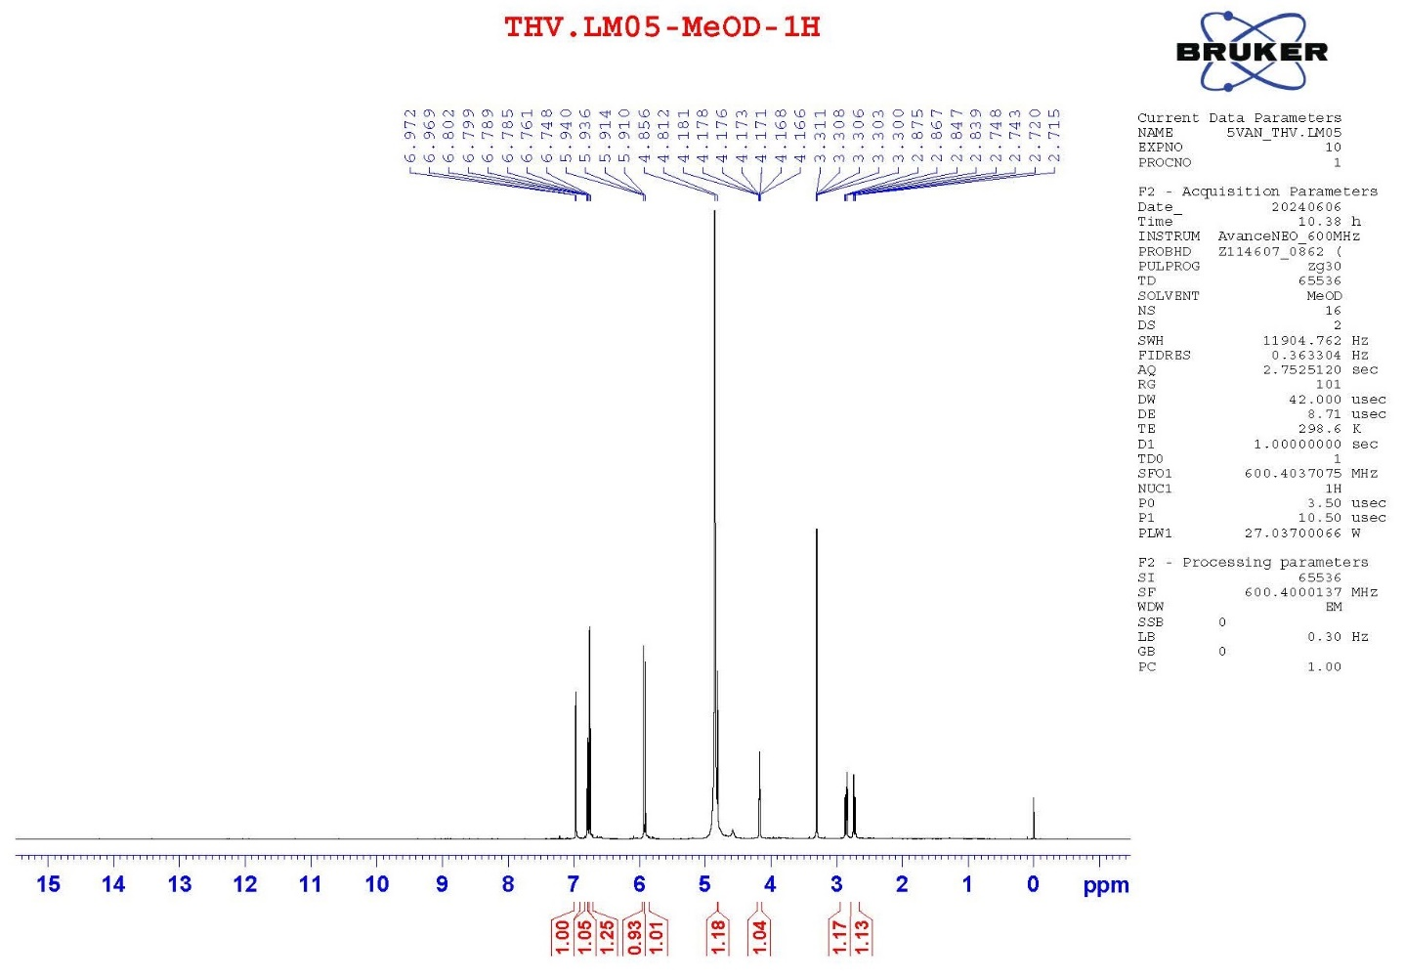

Fig. SIII-2. ¹³C NMR spectrum of compound 3
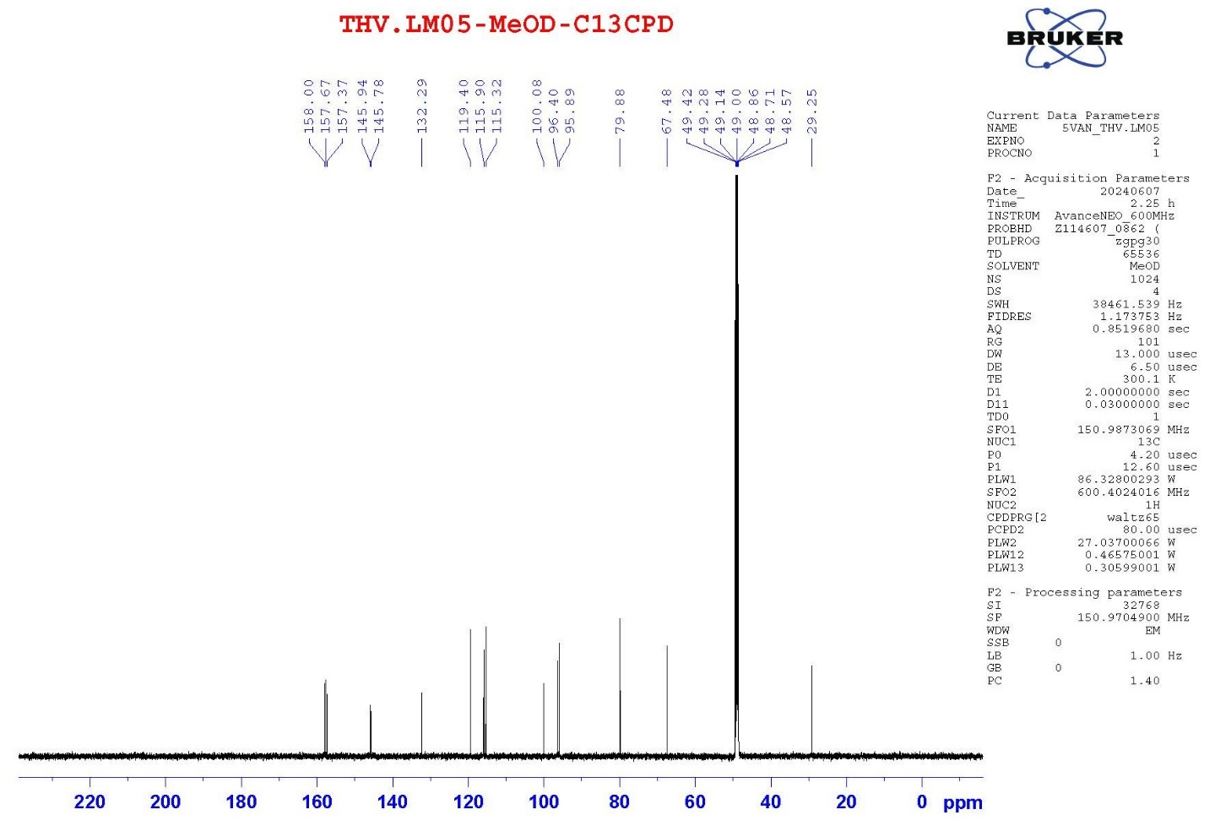

Fig. SIII-3. HMBC spectrum of compound 3
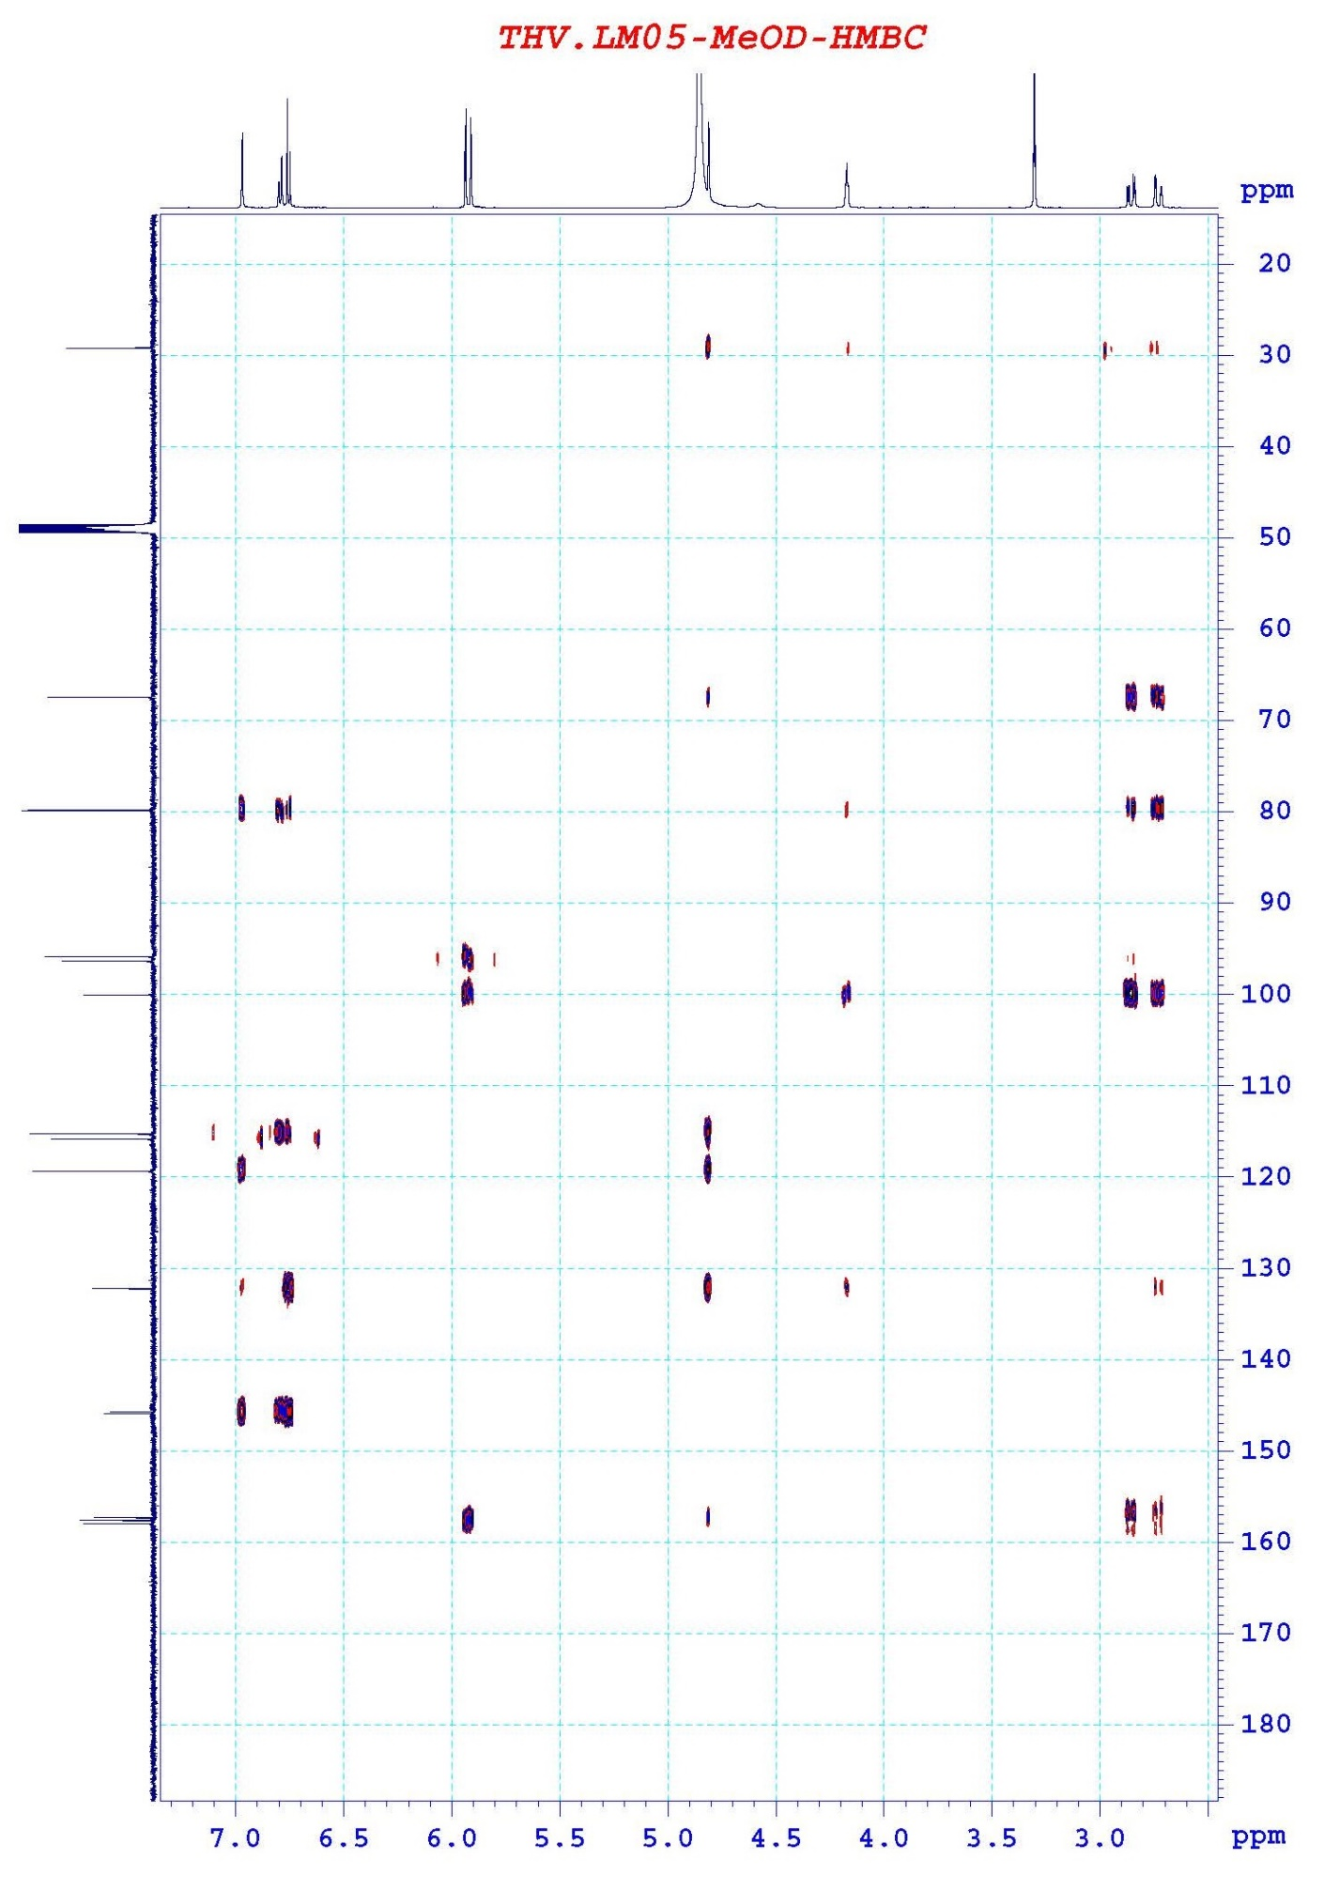

Fig. SIII-4. HSQC spectrum of compound 3
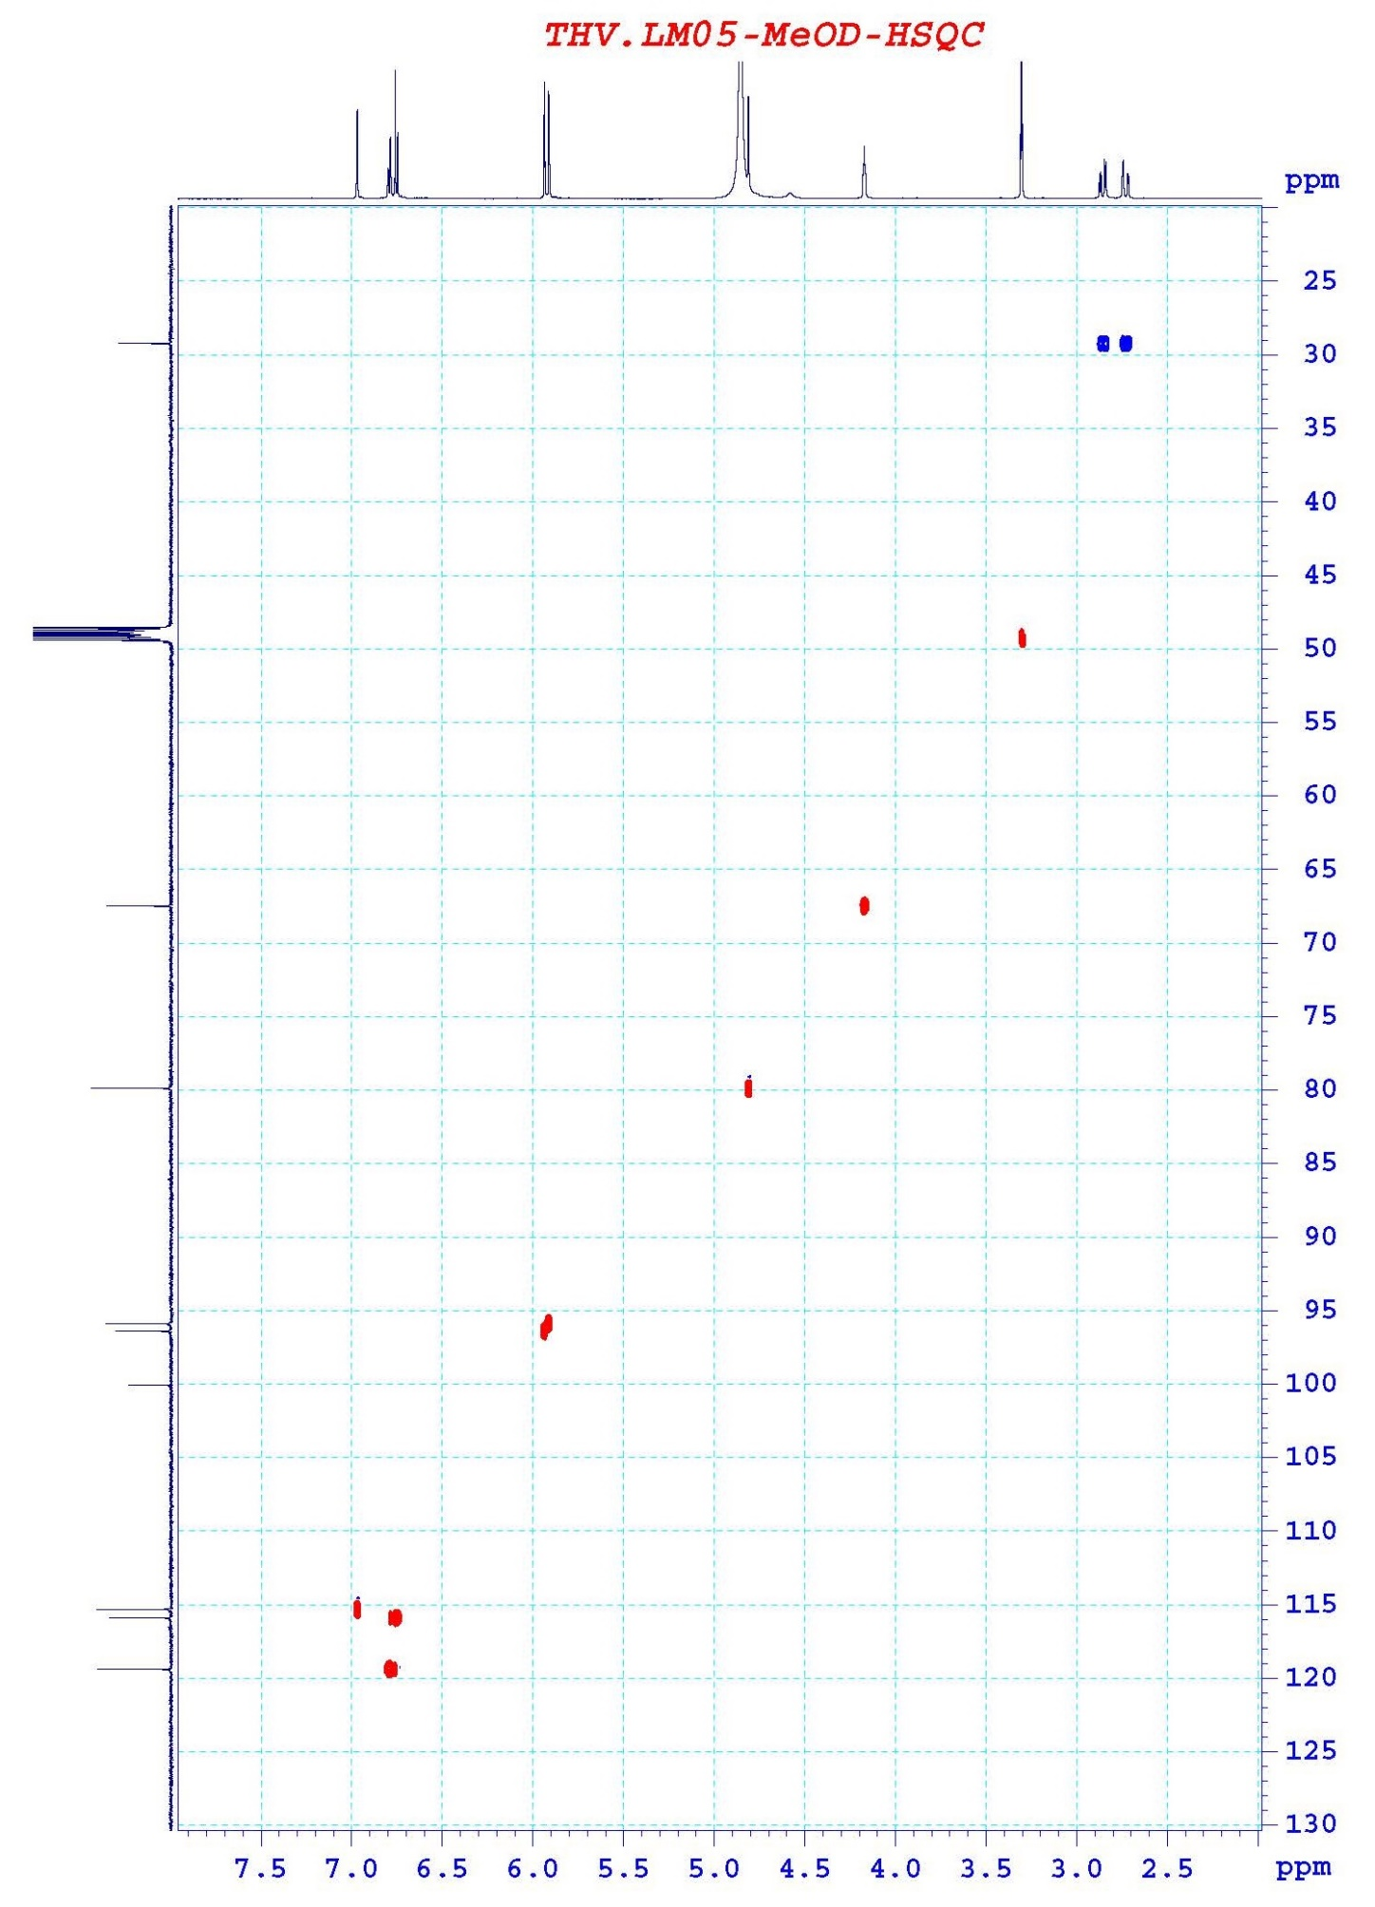

IV. Spectra of compound 4
Fig. SIV-1. ¹H NMR spectrum of compound 4
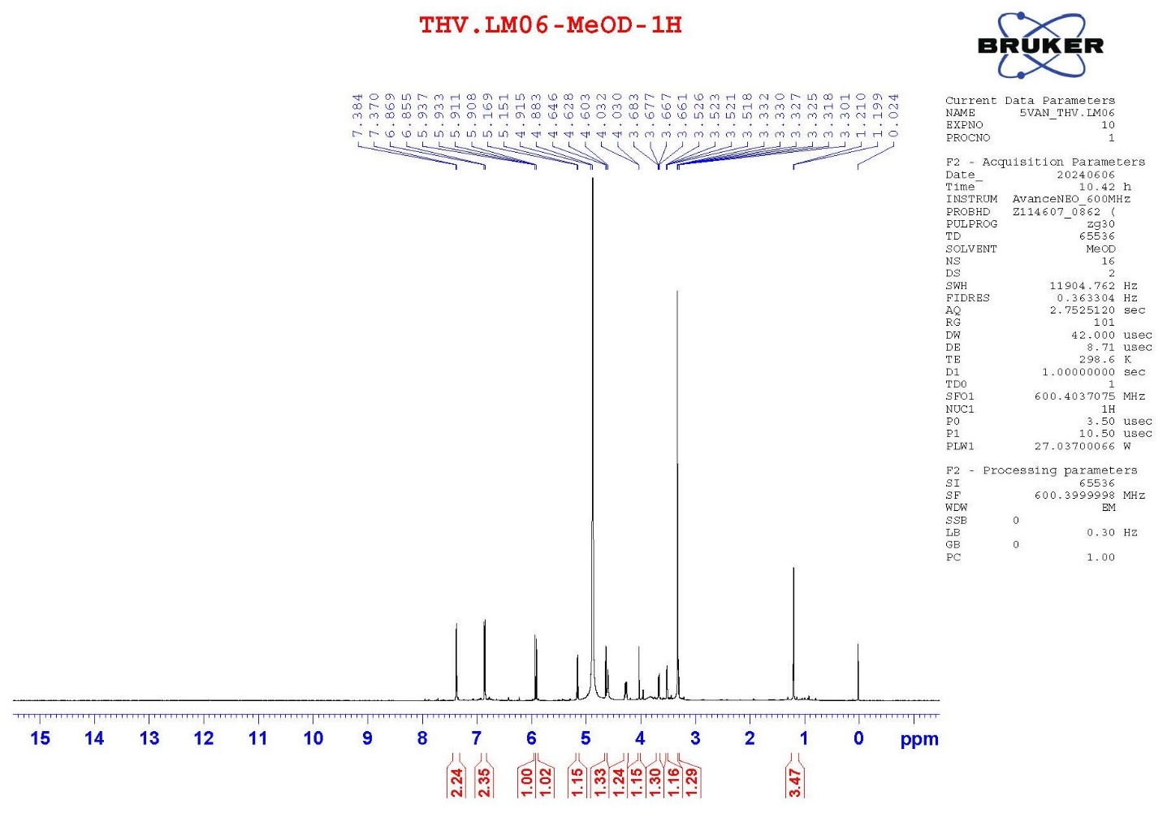

Fig. SIV-2. ¹³C NMR spectrum of compound 4
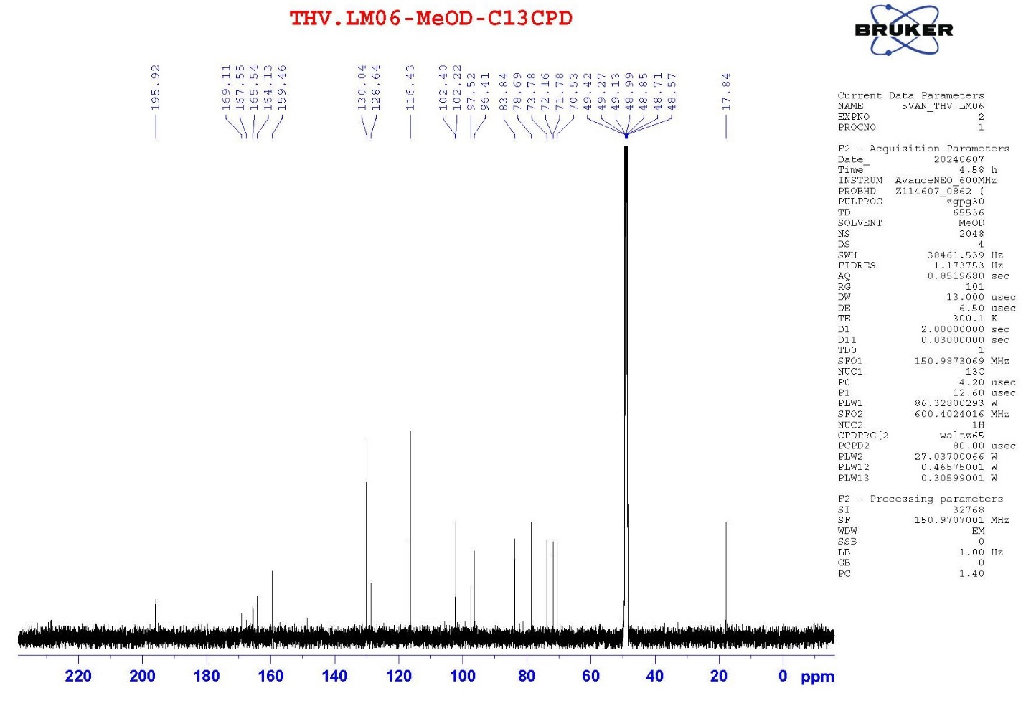

Fig. SIV-3. HMBC spectrum of compound 4
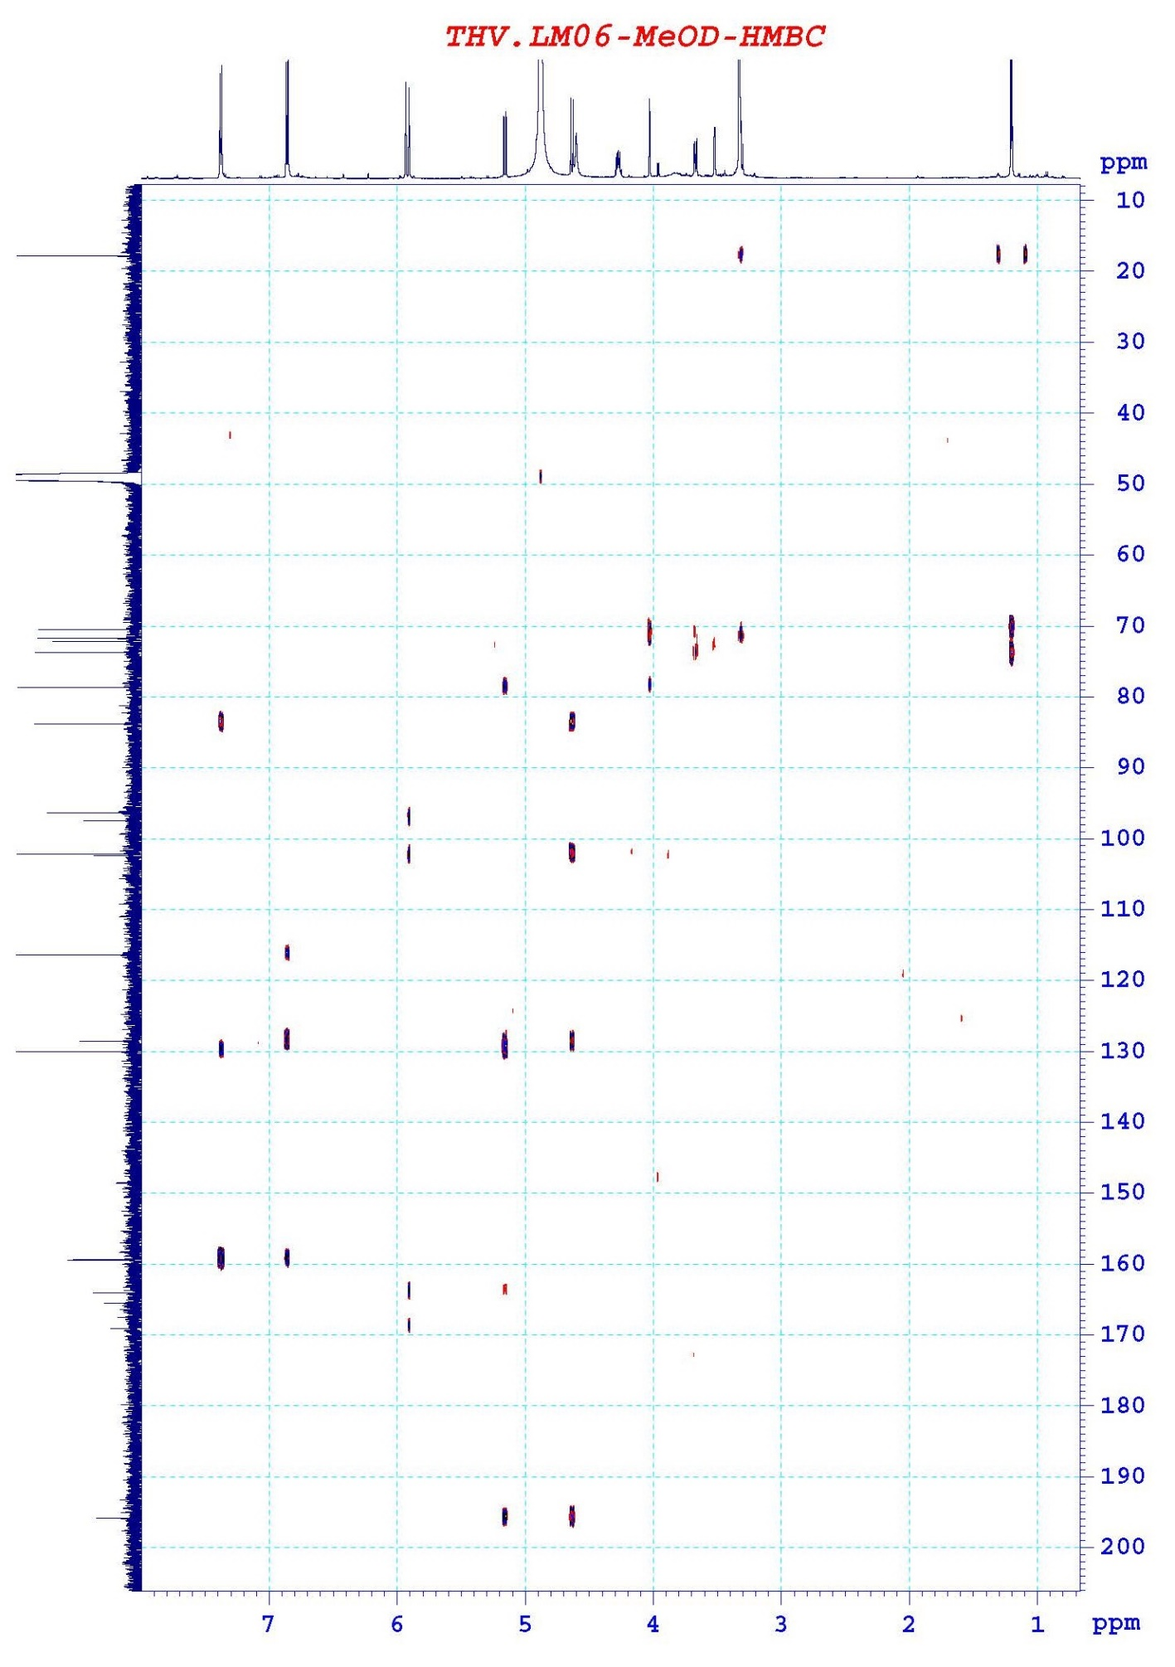

Fig. SIV-4. HSQC spectrum of compound 4
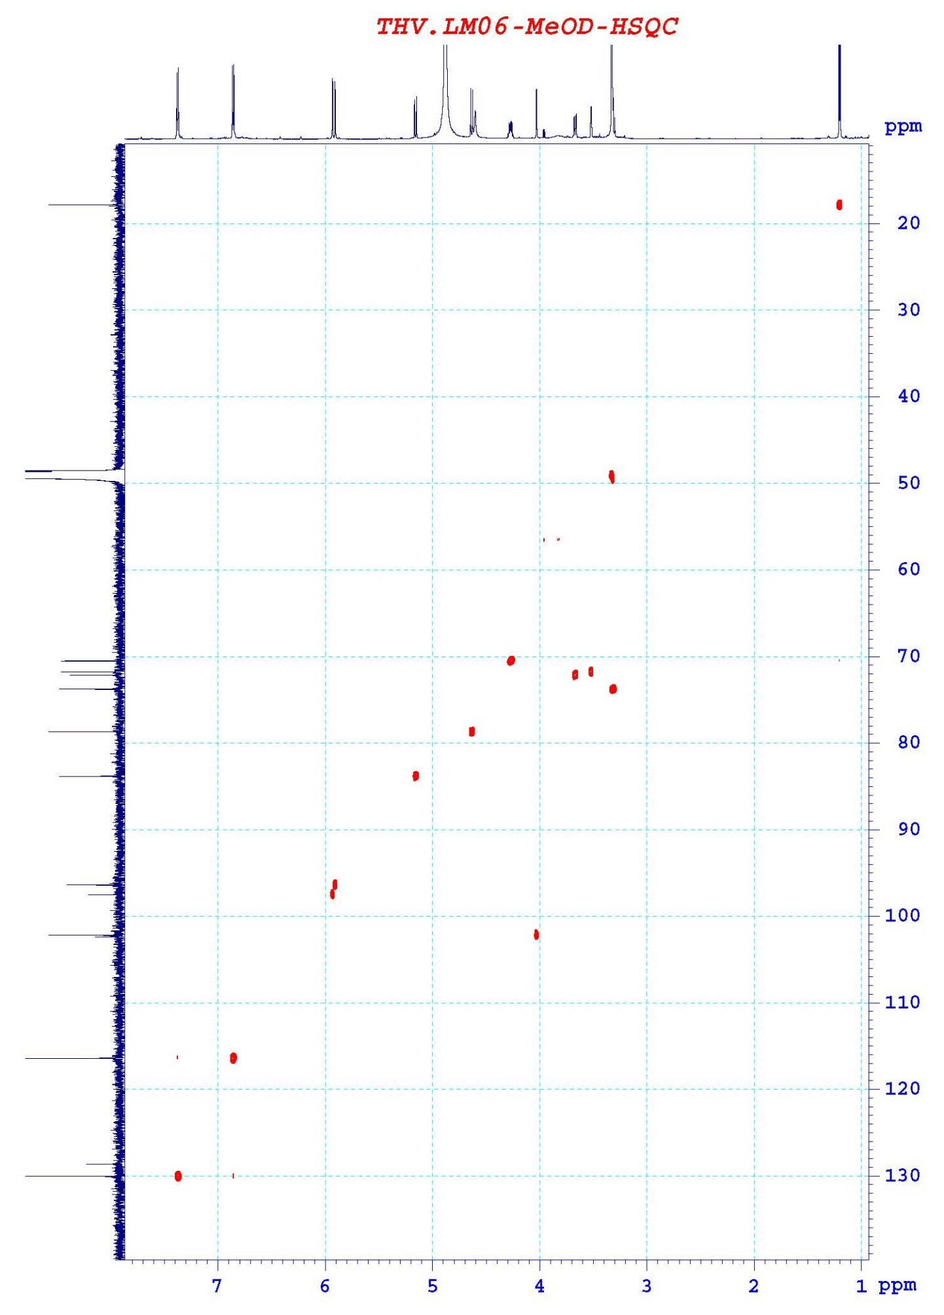

V. ¹H NMR and ¹³C NMR data of compounds 1, 2, 3, 4 and reported data of quercitrin
Table SV-1. ¹H NMR data of compounds 1, 2, 3, 4 and reported data of quercitrin
Pos. | 1 | 2 | 3 | 4 | Quercitrin [9]
Pos. | δ_{H}^{a,b}, J (Hz) | δ_{H}^{a,b}, J (Hz) | δ_{H}^{a,b}, J (Hz) | δ_{H}^{a,b}, J (Hz) | δ_{H}^{d,e}, J (Hz)
Aglycone
2 | - | - | 4.81 (br s) | 5.15 (d, 10.8) | -
3 | - | - | 4.17 (m) | 4.62 (d, 10.8) | -
4 | - | - | 2.85 (dd, 4.8/16.8),  2.73 (dd, 3.0/16.8) | - | -
5 | - | - | - | -
6 | 6.22 (d, 2.4) | 6.21 (d, 2.4) | 5.93 (d, 2.4) | 5.93 (d, 2.4) | 6.21 (d, 2.0)
7 | - | - | - | - | -
8 | 6.39 (d, 2.4) | 6.38 (d, 2.4) | 5.91 (d, 2.4) | 5.90 (d, 1.8) | 6.47 (d, 2.0)
9 | - | - | - | - | -
10 | - | - | - | - | -
1′ | - | - | - | - | -
2′ | 7.35 (d, 2.4) | 7.79 (dd, 1.8/9.0) | 6.75 (d, 7.8) | 7.37 (d, 8.4) | 7.64 (d, 2.0)
3′ | - | 6.96 (dd, 2.4/9.0) | - | 6.86 (d, 8.4) | -
4′ | - | - | - | - | -
5′ | 6.93 (d, 7.8) | 6.96 (dd, 2.4/9.0) | 6.97 (d, 1.8) | 6.86 (d, 8.4) | 6.95 (d, 8.0)
6′ | 7.32 (dd, 2.4/8.4) | 7.79 (dd, 1.8/9.0) | 6.79 (dd, 1.8/7.8) | 7.37 (d, 8.4) | 7.51 (d, 2.0/8.0)
3-O-L-Rham
1′′ | 5.37 (d, 1.8) | 5.37 (d, 1.8) | 5.39 (d, 1.8) | 4.03 (d, 1.2) | 5.33 (d, 2.0)
2′′ | 4.23 (m) | 4.23 (m) | 3.35 (m) | 3.52 (dd, 1.8/3.0) | -
3′′ | 3.43 (m) | 3.43 (m) | 3.73 (m) | 3.3 (d, 10.2) | -
4′′ | 3.36 (m) | 3.36 (m) | 3.34 (m) | 4.27 (m) | -
5′′ | 3.76 (m) | 3.76 (m) | 4.24 (m) | 3.67 (dd, 3.6/9.6) | -
6′′ | 0.96 (d, 6.0) | 0.96 (d, 6.0) | 0.94 (d, 5.4) | 1.20 (d, 6.6) | 0.79 (d, 6.0)
ª in CD₃ỌD, ^{b}600 MHz, ^{d}400MHz, ^{e}100MHz, [9]: in DMSO-d₆

Table SV-2. ¹³C NMR data of compounds 1, 2, 3, 4 and reported data of quercitrin
Pos. | 1 | 2 | 3 | 4 | Quercitrin [9]
Pos. | δ_{C}^{a,b} | δ_{C}^{a,b} | δ_{C}^{a,b} | δ_{C}^{a,b} | δ_{C}^{d,e}
Aglycone
2 | 159.33 | 161.59 | 79.88 | 83.84 | 158.6
3 | 136.24 | 136.19 | 67.48 | 78.69 | 136.3
4 | 179.67 | 179.59 | 29.25 | 195.91 | 179.7
5 | 163.23 | 163.21 | 157.37 | 165.54 | 163.3
6 | 99.81 | 99.97 | 96.40 | 97.52 | 99.8
7 | 165.87 | 166.29 | 158.0 | 169.11 | 165.9
8 | 94.70 | 94.85 | 95.89 | 96.41 | 94.7
9 | 158.54 | 158.59 | 157.67 | 164.13 | 159.3
10 | 105.91 | 105.83 | 100.08 | 102.40 | 105.9
1′ | 122.98 | 122.65 | 132.29 | 128.64 | 122.9
2′ | 116.94 | 131.89 | 115.90 | 130.04 | 116.4
3′ | 146.43 | 116.53 | 145.94 | 116.43 | 146.4
4′ | 149.81 | 159.24 | 145.78 | 159.46 | 149.8
5′ | 116.37 | 116.53 | 115.32 | 116.43 | 116.4
6′ | 122.86 | 131.89 | 119.40 | 130.04 | 123.0
3-O-L-Rham
1′′ | 103.55 | 103.51 |  | 102.22 | 103.6
2′′ | 71.91 | 72.03 |  | 71.78 | 72.1
3′′ | 72.03 | 72.13 |  | 73.78 | 72.1
4′′ | 73.26 | 73.20 |  | 70.53 | 73.3
5′′ | 72.13 | 71.92 |  | 72.16 | 71.9
6′′ | 17.65 | 17.65 |  | 17.84 | 17.7
ª CD₃OD, ^{b}150MHz; ^{d}400MHz, ^{e}100MHz, [9]: in DMSO-d₆

VI. Scavenging capacities against DPPH, ABTS and α-glucosidase inhibitory activity of compounds 1-4
Table SVI-1. Scavenging capacities against DPPH and ABTS of compounds 1-4
No | Sample | Sample conc. (μg/ml) | DPPH assay |  | ABTS assay
No | Sample | Sample conc. (μg/ml) | SC (%) | SC₅₀ (μg/mL) | SC (%) | SC₅₀ (μg/mL)
1 | THV-LM01 (1) | 100 | 62.67±0.61 | 52.38±0.4 | 93.68±0.14 | 14.47±0.29
1 | THV-LM01 (1) | 50 | 48.72±0.52 | 52.38±0.4 | 90.61±0.23 | 14.47±0.29
1 | THV-LM01 (1) | 25 | 29.16±0.48 | 52.38±0.4 | 74.11±0.18 | 14.47±0.29
2 | THV-LM02 (2) | 100 | 20.13±0.65 | - | 63.14±0.22 | 57.54±0.18
2 | THV-LM02 (2) | 50 | - | - | 45.74±0.25 | 57.54±0.18
2 | THV-LM02 (2) | 25 | - | - | 31.5±0.34 | 57.54±0.18
3 | THV-LM05 (3) | 100 | 73.5±0.41 | 28.74±0.28 | 95.01±0.27 | 8.81±0.21
3 | THV-LM05 (3) | 50 | 67.25±0.29 | 28.74±0.28 | 92.34±0.21 | 8.81±0.21
3 | THV-LM05 (3) | 25 | 44.27±0.31 | 28.74±0.28 | 87.67±0.27 | 8.81±0.21
4 | THV-LM06 (4) | 100 | 41.94±0.47 | - | 83.73±0.18 | 34.19±0.14
4 | THV-LM06 (4) | 50 | - | - | 59.98±0.26 | 34.19±0.14
4 | THV-LM06 (4) | 25 | - | - | 35.24±0.22 | 34.19±0.14
 | Positive control  (Ascorbic acid) | 50 | 85.72±0.31 | 10.87±0.25 | 95.58±0.35 | 7.02±0.27
 | Negative control  (DMSO) | - | 0.0±0.0 | - | 0.0±0.0 | -

Table SVI-2. α-glucosidase inhibitory activity of compounds 1-4
Sample name | Sample conc. (μg/ml) | Inhibition (%) | IC₅₀ (μg/ml)
Positive control  (Acarbose) | 50 | 79.62±0.42 | 12.28±0.27
Negative control (DMSO) | - | 0.0±0.0 | -
THV-LM01 (1) | 100 | 0.865±0.72 | -
THV-LM02 (2) | 100 | 61.13±0.36 | 78.25±0.88
THV-LM02 (2) | 50 | 39.5±0.28 | 78.25±0.88
THV-LM02 (2) | 25 | 21.87±0.28 | 78.25±0.88
THV-LM05 (3) | 100 | 39.42±0.27 | -
THV-LM06 (4) | 100 | 27.38±0.81 | -

