**Gene mining, recombinant expression and enzymatic characterization of N-acetylglucosamine deacetylase**

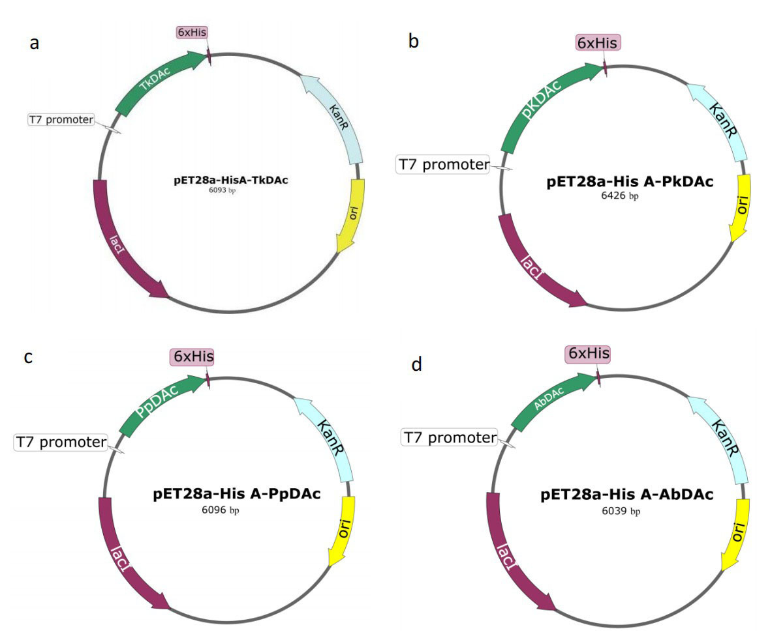

**Supplementary Figure** **1.** Recombinant plasmid map.

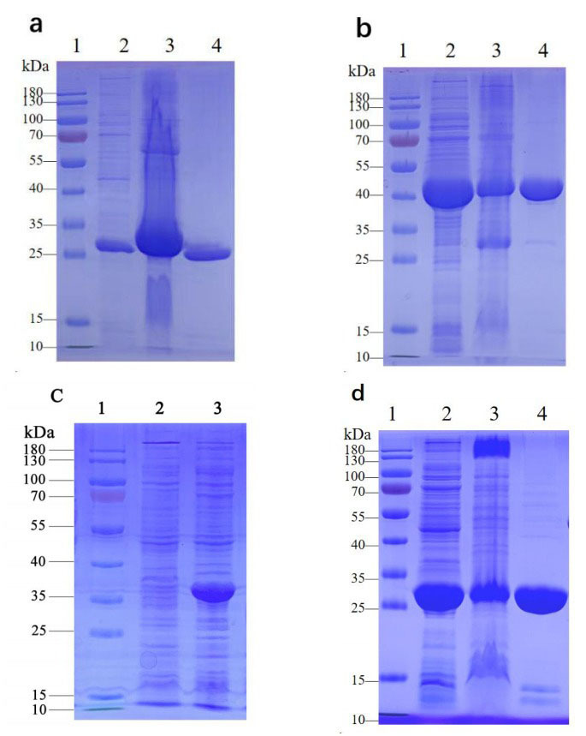

**Supplementary Figure 2.** Recombinant plasmid map and SDS-PAGE profile.

a: SDS-PAGE analysis of *Tk*DAc (1:protein marker; 2:*Tk*DAc supernatant; 3:*Tk*DAc precipitate; 4:the purified *Tk*DAc); b: SDS-PAGE analysis of *Pk*DAc (1:protein marker; 2:*Pk*DAc supernatant; 3:*Pk*DAc precipitate; 4:the purified *Pk*DAc); c: SDS-PAGE analysis of *Pp*DAc (1:protein marker; 2:*Pp*DAc supernatant; 3:*Pp*DAc precipitate); d:SDS-PAGE analysis of *Ab*DAc (1:protein marker; 2:*Ab*DAc supernatant; 3:*Ab*DAc precipitate; 4:the purified *Ab*DAc)

**Supplementary Table 1.** Genes and their sources.

|  |  |
| --- | --- |
| **Name** | **Source** |
| *Tk*DAc | *Thermococcus kodakarensis* |
| *Pp*DAc | *Palaeococcus pacificus* |
| *Ab*DAc | *Anaerolineales bacterium* |
| *Pk*DAc | *Pyrococcus kukulkanii* |

**Supplementary Table 2.** Primers designed to both ends of the solubilization labels using pET28a-HisA-*Pp*DAc as the carrier.

|  |  |
| --- | --- |
| Primer | Sequences of primers (5' to 3') |
| names |
| DAc-F | GAGAACCTGTACTTCCAGGGCCATATGTTCGAAGATATCGATACCTTTG |
| DAc-R | TCAGTGGTGGTGGTGGTGGTGCTCGAGTTAAATCAGATCGGTAAACGG |